Running head: REMEMBER OUR VOICES ARE OUR TOOLS

“Remember our Voices are our Tools:” Sexual Self-Advocacy as Defined by People with Intellectual and Developmental Disabilities

Carli Friedman, Catherine K. Arnold, Aleksa L. Owen, and Linda Sandman

Disability and Human Development, University of Illinois at Chicago, USA

Correspondence concerning this article should be addressed to

Carli Friedman

Disability and Human Development

University of Illinois at Chicago

1640 W. Roosevelt Road, MC 626, Chicago, IL, 60608, USA

Email: cfried6@uic.edu

Phone: 1-312- 355-4688

Conflict-of-interest statement: The authors declare that they have no conflict of interest.

Acknowledgement: This paper was sponsored in part by a grant from the Institute on Policy and Civic Engagement at the University of Illinois at Chicago.
Abstract
This exploratory study examines how people with intellectual and developmental disabilities define and experience sexuality in the context of their identities as self-advocates. Using nominal group technique this study found self-advocates described sexual self-advocacy as relating to knowing and respecting themselves, respect for others, choices, speaking up, having their rights respected, getting information, healthy relationships, and interdependence. They also explained facilitators that would increase their sexual self-advocacy such as expanding access to information and sexual health services, removing systemic barriers, educating others, increasing access to counseling, and developing opportunities for sexual expression. The significance of the study is the expansion of research on sexual self-advocacy by bringing the sexuality and self-advocacy literatures together, reinforces the value of people with intellectual and developmental disabilities as legitimate sources of information about their own experiences, and provides a sustainable and accessible research method for working with people with intellectual and developmental disabilities.

Keywords: sexual self-advocacy; self-advocacy; intellectual and developmental disabilities; sexuality; sexual health; social work; United States
“Remember our Voices are our Tools:” Sexual Self-Advocacy as
Defined by People with Intellectual and Developmental Disabilities
People with disabilities have the same basic rights to sexual and reproductive health as their non-disabled peers, yet societal attitudes and practices have limited people with disabilities’ opportunities to enact these rights [1]. There is a lack of evidence-based research and general knowledge about the core barriers and facilitators of effective policies, services, and practices regarding the sexuality of people with disabilities. While national and transnational disability rights movements have worked for increased social rights, there have been tensions among different constituencies. For example, physically or sensorially disabled people have, at times, distanced themselves from people with intellectual and developmental disabilities (IDD) [2,3]. People with IDD formed the self-advocacy movement – the human and civil rights movement for and by people with IDD – out of the lack of support for their unique needs.
Beginning in the 1970s, and rising to prominence in the 1990s, the self-advocacy movement has been shaped by the individual and collective experiences of people with IDD [4,5]. Many self-advocates identify the collective experience of disempowerment and oppression [6,7]. The self-advocacy movement responded to oppression by basing the movement on the concept of self-determination, which has four principles: freedom, authority, support, and responsibility [8]. Because self-advocates still struggle to be identified as full citizens deserving of rights, much of the focus of the movement has on issues such as housing, employment, and the right to vote. One aspect of self-advocacy that has not been addressed in the literature is sexuality.
Historically, the sexuality of people with IDD has only been acknowledged in the context of pathology. The mistaken assumption that people with IDD lack capacity to have sexual relationships was evidenced by the sterilization policies of the early 20th century, in addition to the gender-segregated institutional settings in which adults with IDD were placed [9,10]. Although beginning in the 1970s and 1980s more research was done investigating the sexuality of people with IDD, it was from the perspective of service providers and parents [11,12]. The dominant narratives of women with IDD as potential victims and men with IDD as potential aggressors was also put forth and maintained through this time period [13]. The overall findings of these research projects focused on creating strategies to manage, control, and limit the sexual practices of people with IDD [14].
More recently, literature has focused on investigating the sexual experiences and identity perceptions of adults with IDD [13-18]. This literature aims to establish people with IDD as sexual beings using the voices of people with IDD [19]. Personal agency, autonomy, and choice are emphasized within these findings [13,15,17] However, most of this literature was based on small samples of women with disabilities.
Gaining retrospective and concurrent insight from adults with IDD regarding their experience with sexuality and how those experiences have impacted their perceptions of sexual self-advocacy is important. Yet, existing definitions of sexual self-advocacy are rare. Green Mountain Self-Advocates in Vermont’s definition of sexual self-advocacy includes “feeling good about yourself, knowing your rights and responsibilities when in a relationship, and knowing about birth control and safe sex,” and this paper seeks to build upon their current working definition [20]. In research literature there has been very little discussion about how self-advocacy movements and groups could be used as a way to catalyze and promote discussions of sexuality among people with IDD. However, Azzopardi-Lane and Callus [15] presented conversations about sexuality as a method of advocating for oneself and Graham et al. [21] discussed the potential for working with self-advocates so that they can practice sexual self-advocacy. In attempt to move this literature further, this paper uses the insights of self-advocates to demonstrate how sexuality, for adults with IDD, is woven into the concepts of the self-advocacy movement. In doing so, the increased focus both in policy and practice in understanding the unique knowledges that self-advocates possess regarding sexual self-advocacy.
This exploratory study examines how people with IDD define and experience sexuality in the context of their identities as self-advocates. Seeking out self-advocates’ perspectives on sexual self-advocacy, also provides self-advocates’ recommendations for change. This became an important component of the data collection and analysis. This study is significant because the study expands research on sexual self-advocacy by bringing the sexuality and self-advocacy literatures together, reinforces the value of people with IDD as legitimate sources of information about their own experiences, and provides a sustainable and accessible research method for working with people with IDD.

Methods

Participants
After obtaining ethical approval from the university Institutional Review Board, the planning team recruited a purposive convenience sample of people with IDD that identified as self-advocates through self-advocacy groups, word of mouth, and disability advocacy and service agencies in the Chicago area. This study included 35 male and female adult self-advocates with IDD, about 50% of which were people of color. If participants were not their own guardians, their guardians consented to their involvement in the study in addition to the self-advocates’ assent. A handful of support staff were present at the research forum; however, they served strictly in a support capacity by helping people with IDD participate and did not contribute their own ideas or influence the people they were supporting.

Researchers
Qualitative research relies on the researchers as instruments [22,23]. For this reason, researchers should identify their values, assumptions, and potential biases [24]. The research team was comprised of four academics – two Ph.D. candidates, one community educator, and one clinical professor – housed within a university department on disability and human development in Chicago.
No members of the research team identify as having a disability but all consider themselves allies and/or family members. All members are interested in promoting healthy sexuality for people with IDD and had previous experience with sexual self-advocacy and therefore had certain expectations. However, these biases were accounted for by using the constant comparative method to ensure the results were grounded in the data [23].

Measure
The data collection occurred during an all day community research forum in Chicago. The community research forum was a collaborative process organized by a planning committee which included the research team and two self-advocates. On the day of the forum, 35 self-advocates gathered for a discussion about sexual self-advocacy, small group role-plays, the nominal group technique (the focus of this paper), and a circle closure discussion.
Nominal group technique (NGT) [25-27], the primary research method that was used in this study, has been employed as a valuable tool to examine the positions and beliefs of people with intellectual disabilities [28,29]. Despite stereotypes of people with IDD, they are valuable research participants [30,31]. Not only does NGT provide a non-critical atmosphere for discussion, NGT provides clear structure that makes the NGT easy to conduct and easy for participants to understand [26]. The nominal group technique was utilized to ensure that every self-advocate had the opportunity to share their input.

Procedure
NGT is a group discussion that is first based on written responses [26]. NGT in this instance involved giving participants time to answer the question: ‘what does sexual self-advocacy mean to me?’ Participants either wrote or drew their responses on two separate pieces of paper. This was done to ensure that participants had space to think through their thoughts with support people present. After time for individual brainstorming, participants shared their ideas one at a time and their papers were collected. When participants written responses were not clear (e.g., only said ‘harassment’), one of the researchers who served as the facilitator prompted them to elaborate orally about what they meant. As ideas were shared, two research members grouped the written ideas by themes. Each person shared one piece of paper and then had a second opportunity to share an additional idea. After every self-advocate presented all their ideas, group members were asked to rank their top three theme choices with stickers. Self-advocates were told they could place multiple stickers on one theme or each on different themes. Because two themes were tied for second, the participants voted to select the second theme. Finally, the self-advocates participated in a facilitated discussion answering the question: ‘what needs to change so that people can exercise sexual self-advocacy?’

Analysis
Data analysis occurred both through inductive content analysis and statistical analysis of rankings using the NGT mixed methods approach [25-27]. Three different data sources emerged: the raw data self-advocates wrote down on sheets of paper; the headings/themes under which researchers placed each card during the NGT; and, the transcript of the NGT as there were several discussions that occurred as a part of the NGT that demonstrated important components of self-advocacy that would not have been otherwise captured in the cards.
As aforementioned, self-advocates answered the NGT question ‘what does sexual self-advocacy mean to me,’ two researchers organized their cards into themes during the NGT process. This was necessary so the participants could vote to rank the themes in accordance with NGT [25-27]. Because the researchers who organized the cards into themes did so intuitively during the NGT, the organization of cards was preserved, but also recoded the cards after the event. The data sources were treated as distinct but overlapping, and after recoding, all four members of the research team reconciled the two sets of codes with each other, in addition to the coded audio transcript of the NGT. This study employed the constant comparison method of data analysis (CCM), which has to do with forming and testing categories while looking for patterns [33-35]. The themes that emerged during the NGT are discussed in relation to the NGT ranking below. Although themes that emerged during the recoding after the event were not radically different, the layered analysis did result in the renaming of some themes, the combining of some themes, and the creation of additional themes so are differentiated.
The participants’ hand written cards from initial NGT individual brainstorming and the audio transcript of the larger group discussions were treated as two different sources of data. Although there was some overlap between these data sources, the transcript was coded because the audio was contextualized and expounded upon in ways that the data may not have been otherwise without facilitation. To be clear, the NGT facilitator did not interpret the data in her own words but prompted the participants for more than they may have originally given and that is why each data source was analyzed separately before bringing them together for constant comparison.
Coding. After all of the data was transcribed, the research team individually reviewed the transcription of the cards to re-familiarize themselves with the data. Each researcher then open coded [22,23,36] the data from the cards for themes. After this step the research team met on several occasions to discuss themes. Once themes were agreed upon the research team also worked together to create definitions of each theme. Next the audio transcript was similarly individually reviewed and coded by the research team. The themes developed from the cards informed the transcript analysis. The team again met to discuss themes as well as the overlap between the two sources of data. Interrater reliability was strengthened both by having four separate coders as well as because of these meetings where themes and definitions were agreed upon.
Member checking. After the data was analyzed, the results were made into an accessible format and presented to two self-advocates who attended the community research forum. The feedback provided by the self-advocates was incorporated and ensured the research team that core themes extracted from the data were indeed what the self-advocates believed occurred. This member checking served as a form of validity [22,23].

Results and Discussion

Quantitative Nominal Group Technique Ranking
During the NGT answers to ‘what does sexual self-advocacy mean to me?’ were organized into themes that were intuitively created by two researchers during the NGT process. These themes included: speaking up for yourself; speaking up for others; getting information; being confident in myself; my choices; rights; respect for others; and, speaking out against abuse. My choices (n = 18) was rated most important with 20.7% of the vote. Speaking up for myself (n = 12) was rated second most important with 13.8%. Although they were originally tied for third, each with 12.6% of the vote, the self-advocates voted to break the tie and rights (n = 11) was rated third and respect for others (n = 11) was fourth. Speaking up for others (n = 10), getting information (n = 10) and being confident in myself (n = 10) were all tied for fifth with 11.5%. Finally, speaking out against abuse (n = 5) was the lowest ranked theme receiving 5.7% of the vote.

What is Sexual Self-Advocacy?

Using the data analysis process described above, seven themes emerged from the self-advocates’ discussion of sexual self-advocacy: knowing and respecting myself; respect for others; my choices; speaking up; respect my rights; getting information; and, healthy relationships. Each theme is exemplified using direct quotes from the transcript and discussed in relation to other themes. When the research team coded each theme, there was one theme that served as an interlocular with the rest, two larger strands that each encapsulated three themes, and one overarching macro-theme that demonstrates sexual self-advocacy’s embeddedness within self-advocacy. These relationships are visually represented in Figure 1.
Central interlocular theme: My choices. My choices emerged as the central component of sexual self-advocacy, both through the self-advocates’ votes and through the researchers’ coding sessions. Being able to make one’s own choices about what one wants and how one expresses one’s sexuality is at the core of sexual self-advocacy. Choices are unique to that individual and informed by one’s life experiences and values, often related to values surrounding sex, relationships, and marriage. For example, one self-advocate commented, their choice included “what I will or will not consent to in an intimate relationship.” While another self-advocate commented he wanted to “not have sex until [he is] married.” Another self-advocate said choices are “what you want in life and [you can] choose to have sex with your partner if that’s what you want.”
Self-advocates too often experience choice as out of reach, removed from their domain. Having choice represents critical decision-making capacity to act on one’s own behalf. The larger society calls into question this decision-making capacity when talking about people with disabilities. Those with intellectual disabilities face great obstacles when engaged in choice-making because their capacity to consent to sexual practices has been doubted. Yet, self-advocates claim their right to choice-making as adults competent to participate in adult roles.
Having choice is central to the idea that people with disabilities can act purposively in their relationships with others, rather than passively accept the relationships others choose for them. Self-advocates are saying that others should not assume they know the choice a person with a disability might make about sexuality. Self-advocates acknowledge the key role others can play in their lives and want the support they receive to work in tandem with a recognition of their choices, such as the ability to choose whether to be in relationship with another, to choose intimacy or not, to choose how and with whom to expresses one’s sexuality.
Macro strand: Communication. One of the two thematic strands identified is communication. The three themes encompassed in the area of communication are speaking up, getting information, and healthy relationships (see figure 2). Communication is a way of practicing sexual self-advocacy and a means of conveying sexual self-advocacy to others outside the self-advocacy movement. In many ways, the work done at the research forum demonstrated the potential for empowering methods of communication within sexual self-advocacy. Communication is a reciprocal skill through which people with disabilities can learn to speak and other people can learn to listen more effectively. Professionals and families can play an important role in teaching and modeling communication skills as well as providing opportunities for people with disabilities to practice and strengthen communication skills.
Speaking up, the first theme in this strand, is about using one’s voice to advocate for oneself and others. Everyone has an opinion that is important and deserves to be heard and respected. Speaking up for others recognizes interdependence as well as supports other self-advocates. One can speak up for oneself or others in relationships, including with friends, partners, family, staff, and law enforcement. Two self-advocates defined speaking up for oneself more broadly when one person said speaking up meant, “telling someone what you want and what you don’t want,” and another said “I have the right to speak up when other people talk about me.” However, another self-advocate believed this meant “the freedom to speak what’s on your mind and how you feel about being in a relationship.” As one self-advocate stated, speaking up involved the ability to decide how they believe the relationship is going and making their own choice about if they want to continue or not. They said,
You can speak your mind. What I’m meaning by that is like if say you’re in a relationship and you don’t know if it’s going to work but you do spend a couple weeks with the person and then you’re kind of like it’s not going to work out so then you decide if you want to stay with the person or if you want to part. That’s your decision.

Another aspect of this theme included speaking up for oneself even amongst pressure. One self-advocate explained this meant “expressing my own thoughts and needs in a relationship without hesitation.” Another self-advocate purported self-advocates had the right to “not feel like a victim when you’re saying something important…don’t judge or discredit my opinions.” Similarly, this self-advocate later commented,
we need to talk about law enforcement too if it gets to that level of that dangerous situation… like how they can make us feel, they can intimidate us, and how they can use their power to make it seem like we’re the victim instead of we’re trying to save a victim… So just try to stand firm and be strong in your convictions.

For others an important part of this theme involved speaking up for others. One self-advocate said, sexual self-advocacy is important to “speak up for those who need help talking about self-advocacy.” Another commented sexual self-advocacy meant, “helping those I love to understand this idea.” Again highlighting the idea of interdependence and support, another self-advocate commented that speaking up for others was important because “if someone has trouble, maybe they need help.”
Getting information includes learning about relationships, sex, and safety. This theme is included in the communication strand because some people with disabilities may not know what information they need or might not know how to talk about sexuality with their support people. Families and professionals should be attuned to the needs of the people they support and provide information on various sexuality topics in a way that is accessible for that individual. Because of current educational disparities, families and staff may need to spend time doing research to find the information the person needs and then translate the information into a format that the person can understand. Ultimately, however, self-advocates should be able to choose how they access information and from whom. Information should be accessible and include individualized supports that are meaningful and relevant to self-advocates. According to the self-advocates, this includes the importance of learning about both LBGTQ relationships and different types of relationships more generally. One self-advocate commented,
since we’re dealing with sexual self-advocacy I’m just wondering what about the different types of relationships. There is heterosexual, which is men and women, and there are other relationships of the same sex, there are different types of relationships. I’m not saying we need to engage in that but we need to have information as a community about what is out there so we can make informed choices so we can choose so we know everything we have to choose from. So if someone asks us to engage in something we’re not familiar with we’re not opening ourselves up to something we don't really know what because we’re not informed.

As far as whom they could go to for information, one self-advocate suggested, “family can help you learn,” while another participant stressed communication between partners. Sometimes fears and assumptions of family and professionals come into play related to sexuality information. For example, people may have assumptions about an individual’s sexual orientation, interest in sexual expression, and fears about reproduction or sexual abuse. These fears and assumptions can lead to withholding information, whether intentionally or unintentionally, from people with disabilities.
In the third theme of this strand, healthy relationships, communication and mutual respect were valuable to self-advocates. When a relationship is healthy, self-advocates feel comfortable, loved, happy, and successful. They accept responsibility and express their sexuality in safe and healthy ways. For example, one self-advocate said “sexual self-advocacy means being equal in a partnership that involves individuals being respectful of each other’s sexuality in a healthy way.” Speaking up, getting information, and healthy relationships are all facets of sexual self-advocacy that facilitate, reproduce, and nurture sexual self-advocacy.
Macro strand: Respect. The second strand of themes identified is respect. Three of the themes described by self-advocates fell under the larger concept of respect: knowing and respecting myself, respect for others, and respect my rights (see figure 3). These themes were maintained as separate because they work with one another, especially in relation to the central theme, my choices.
The first theme in the respect strand is knowing and respecting myself. This theme discusses being comfortable with oneself and respecting oneself. This is a process of constant learning that includes some level of self-concept in terms of wants, needs, desires, and identity, as well as learning to love oneself. One self-advocate explained this included “respect [and] dignity for oneself.” Another self-advocate commented, the theme meant “being comfortable with myself and feeling healthy whole physically in my self worth even if the relationship ends.” Self-advocates were well-aware that respect begins with one’s own self knowledge and acceptance.
Because many, if not all, have experienced disenfranchisement through others, self-advocates showed a keen awareness of the importance of respect for others. This theme is about respecting other people in the way they express their sexuality and the choices they make. Self-advocates believed in the importance of “respect[ing] other people’s wishes in a relationship.” This included “attending to the needs of my partner and respecting [them]” and “being respectful of others sexuality in a healthy way.” This also included respecting others by not abusing them. One self-advocate commented, this meant “keeping your hands to yourself” and another said not to “force [them] to have sex.” Respect for others takes into account the reciprocal nature of relationships and that healthy relationships are founded on mutual respect.
The third aspect of respect was self-advocates’ crucial demand that others need to respect my rights. This theme showed an understanding of rights both as an aspect that each individual has, as well as one that is larger than the individual. The recognition of rights is a relational concept under which all people are protected. Self-advocates know that they have rights and that other people should respect their rights. Demonstrating this, one self-advocate said “I have the right to have my opinions,” while another commented “I have the right to share my opinions” (emphasis added). Self-advocates were clear that they have rights in the area of sexuality and those rights need to be recognized and respected by others. They reminded each other of the importance of “standing up for your rights and telling someone your rights” and they warned others “don’t judge or discredit my opinions.”
The right to be respected also included the right to be oneself. For example, one self-advocate said, “[you] have the right to be yourself,” while another mentioned this included the “right to express yourself.” One self-advocate also implied self-advocates have the right to a same-sex relationship if they want when he said, “if two guys want to get it. If two girls want to get it” they have the right.
Many self-advocates also spoke about their right to be in a relationship and have sex if they so choose. For example, one self-advocate purported, “I have the right to have a boyfriend and to have sex when I want.” One self-advocate also commented not only do they have the right to be in relationships, they also have the right to get married and have children when she said, “boyfriends and girlfriends or husbands and wives…that means they’re dating and they’re a couple. And if they want to have kids it’s their right.”
Similarly, rights also included being able to stand up to family and make their own choices. For example, one self-advocate said, “I have the right to do stuff like I have friends over when your family controls you.” On the other hand, another self-advocate commented, they had a right to involve their family. They said, “I have the right to let my family know about my wellness.”
Rights also included the right to not be abused or harassed. This included the importance of consent. One self-advocate asserted, “I have the right to say no to sex and abuse and neglect.” Another self-advocate explained what sexual harassment was to the group and how one should report harassment. She said, “sexual harassment means that if somebody trying to get you pregnant and you not want to become pregnant and they do it to you anyway it is called rape.” She continued, about how one should report abuse saying, “you can call 911 and get them…arrested.”
Respect, like communication, is a cyclical and reciprocal process. As one acknowledges his or her own sexuality by accepting oneself, one can gain insight into the needs of others. As one treats others with respect, one’s own self-esteem increases. As full and equal participants in society, self-advocates claimed their sexual rights and demanded those rights be respected. Ultimately, respect involves choices. To advocate for one’s sexual rights is a choice. To expect recognition of those rights by others signifies respect for one’s identity as a sexual being. When others acknowledge that people with disabilities have capacity for choice and have sexual rights they convey a sense of mutual respect which reinforces the four themes shown here.
Overarching macro-theme: Interdependence. These seven themes are related together, and the two thematic strands help conceptualize how sexual self-advocacy can and should operate. However, when coding all of the researchers kept coming back to the concept of interdependence. The research team identified interdependence as a macro-theme that both undergirded and sheltered the other themes. Sexual self-advocacy, much in keeping with the concept of self-advocacy, does not function as an isolated or individual unit. Instead, bodies participate with one another in practicing sexual self-advocacy, including but not limited to intimate (romantic) relationships. Friends and family, who often play a role in providing help, support, and assistance, are seen as co-enactors of sexual self-advocacy even as they help adults with IDD build skills that foster (intimate) romantic relationships. The meanings of the seven core themes were centrally social and interdependent.

The concept of interdependence encompassed all seven themes that define sexual self-advocacy. For each theme, people with disabilities stated they may need the support of other people in their lives in order to enact sexual self-advocacy. However, self-advocates said the person with disabilities should be the one in control of the choices he or she makes with regard to sexuality. Self-advocates who participated in this study identified the principle of self-determination in identifying what sexual self-advocacy meant to them. Self-advocates wanted support people to facilitate communication and respect so they can make their own choices.

Additionally, there is a reciprocal dynamic of each theme that both acts as a facilitator and a producer of sexual self-advocacy. By practicing sexual self-advocacy, a person is not only benefiting him or herself individually, but also benefits the larger community. The concepts included in sexual self-advocacy are universal and positive for people with and without disabilities. For example, the more a person speaks up, the more other people are able to learn from him or her. Similarly, the more that person speaks up, the more he or she is able to learn and engage with others. Instead of people with disabilities being passively acted upon by others, when they are speaking up and engaged, dynamic relationship are created. Furthermore, the more a person respects others, the more that person will be respected. By practicing and embodying these concepts, people become change agents.
Recommendations
After the self-advocates participated in the NGT ranking, there was a large group discussion to answer the question ‘what needs to change so that people can exercise sexual self-advocacy?’ This conversation resulted in five themes: expanding access to information and sexual health services; removing systemic barriers; educating others; increasing access to counseling; and, developing opportunities for sexual expression. The answers to this question have implications for policy and practice, but they also point to themes within sexual self-advocacy itself that only emerged when this question was asked.
Expanding access to information and sexual health services. Self-advocates identified increased access to information about sex, including safe sex practices, different types of relationships, and different sexual orientations as a priority. Self-advocates stated that access to sexuality education classes and accessible health services is important. They wanted to be able to get information about sexual health from multiple sources, such as partners, family, health professionals, and staff.
Pointing to the need for more information about different types of relationships, one self-advocate commented,
the different sexual practices that are out there. That content needs to be in those sex education classes. Not just about the changes in the female or male body but the changes in what people consider common practice sexually and the different types of relationships that there are, same-sex, transgender. All those different things that weren’t around – they weren’t exposed – they were always around but there wasn’t exposure.

Participants also mentioned that expansion of sex education classes would be a useful way to access information. Information should also be made more appealing and accessible through use of diagrams and pictures. Suggestions included watching videos about sexually transmitted infections (STIs), having diagrams of female and male sex organs, and using models to practice putting on condoms. Another self-advocate suggested sex education should include role-plays as an opportunity to practice.
Removing systemic barriers. Self-advocates believed that multiple levels of systemic barriers need to be identified and dismantled so that people with IDD can exercise sexual self-advocacy. Systemic barriers can include physical inaccessibility of clinic locations, legal issues pertaining to guardianship, and professionals who do not treat people with disabilities with respect. For example, pointing to the inaccessibility of services, one self-advocate said,
a lot of people utilize free clinics for information. I’m not saying it’s not a good resource but a lot of times free clinics are not accessible for people with disabilities, particularly on the south side [of Chicago]. So we need to advocate to be able to get the information.

Attitudes need to change so that others will accept self-advocates’ sexual rights and guardians will support self-advocates’ choices. Care providers need to respect the privacy and confidentiality of people with IDD regarding their sexual health and sexual expression.
In a long side discussion, self-advocates also mentioned guardianship, confidentiality, and infantilization as often intertwined systemic issues. After one self-advocate said,
when you go to the doctor they give you an exam and I’m not talking about the men… they do not keep your information private! They will give it out on you without you giving the consent… you need to give the consent! Before they do it!

Another self-advocate commented,
I basically just wanted to comment on what [they] said. I go to the doctor and he has a hard time looking at me. My staff is usually in the room with me and he looks at my staff and talks to my staff instead of looking at me and talking to me.

Another self-advocate chimed in “you shouldn't have to take that from nobody. Doctors should talk to you not your staff.” Another self-advocate also commented, “the same thing I was just going to tell you that you can tell your staff not to go into the doctor’s office with you!” Leading the original self-advocate to ask, “but what if you have no choice?” and one of the other self-advocates to immediately shout, “you have a choice!”
Educating others. Self-advocates believed educating other people, such as doctors, staff, and guardians, is important so they can provide respectful support. This includes training others on disability awareness and how to address sexuality questions for people with disabilities in an accessible manner. For example, one self-advocate suggested,
professionals sometimes are scared to talk about it because they don't know what’s appropriate and what’s not… so I think they should have classes for professionals and teach their staff that don't shy around from it. People like us need to have relationships too.

Increasing access to counseling. Self-advocates wanted people with disabilities to have increased access to counseling as a supportive service so they can talk about their feelings related to their sexuality. One participant said that “talking about how you’re feeling” would be helpful. The term counseling is used to denote supportive relationships that have the goal of increasing and facilitating sexual self-advocacy whenever possible within a safe space.
Developing opportunities for sexual expression. Self-advocates believed that people with IDD need more access to opportunities for sexual expression, including private space and private time to express themselves sexually in the way they choose. They also need more opportunities to meet potential partners, practice, and build skills for dating and relationships. Opportunities to practice included going “to a place where nobody can see you;” this implies that privacy is important to be able to practice sexuality.
Implications
An expanded conceptualization of sexual self-advocacy can and should lead to wider discourse on the topic at multiple levels. Interdependence emerged as a core value of sexual self-advocacy and ran throughout the seven themes presented here. Additionally, communication and respect played dual roles as facilitators and outcomes of sexual self-advocacy. These three threads connected the themes that self-advocates talked about, and demonstrated a platform from which to approach policy, practice, and research implications. While self-advocates who participated in this community forum were given the opportunity to name their own experiences, much work remains to enact policies at the community, state, and federal levels to ensure that sexual self-advocacy is practiced.
Potential policy applications of this study include directing state and local agencies to increase the quality and content of education for staff, professionals, and families on the sexual health needs of people with disabilities. A public awareness campaign would educate others about IDD and sexuality while also attending to systemic barriers, including attitudes and access. Educating others is an important step toward changing the mindset of key stakeholders and gatekeepers. In doing so, family members and guardians can further understand how to foster self-determination and provide support that aligns with the desires and needs of the individual with disabilities. Community members and service providers can better develop inclusive practices where people with disabilities can get the information and services they need. Moreover, policymakers will hopefully take into account the perspective of people with disabilities and reframe decisions by questioning where individual and social rights are being diminished.
Self-advocates identified getting information as a key feature of sexual self-advocacy, but also recognized the lack of accessible information through sexuality education. Moras [3] has called for exploring sexuality education through the lens of expanding sexual consent capacity, rather than simply confirming the presence or absence of sexual consent capacity. Under this rubric, sexuality education should focus on building practical skill sets, such as how to properly put on a condom, while at the same time, providing more holistic strategies that incorporate the values of interdependence and positive self-esteem.
There are a number of ways that this study impacts practice. Using a method similar to the NGT to facilitate discussions within small group residential and community settings provides both structure and access. The NGT is particularly well-suited to discussions around sexuality, as it provides time to process and think through answers even as the group dynamic provides a unique perspective that would not equal additive individual answers to the same questions. Additionally, staff could use the NGT to incorporate self-advocates’ input regarding policies about privacy, sexual activity, and/or facilitation, as well as safety. Talking about sexuality with self-advocates as a part of community life should be the standard, not the exception.
At a state and federal policy level, the systemic and structural barriers to sexual self-advocacy must be addressed. The issues around attitudinal barriers of professionals towards people with IDD as well as the ways in which many states’ guardianship laws are structured can sometimes prevent self-advocates from enacting sexual self-advocacy. Sexual self-advocacy can be a useful prism through which to look when formulating policies that impact adults with IDD. Indeed, sexual self-advocacy may prompt policy-makers to reframe decisions in terms of asking where individual and group rights are being diminished.

Conclusion

In this study, self-advocates described sexual self-advocacy as relating to knowing and respecting themselves, respect for others, choices, speaking up, having their rights respected, getting information, and healthy relationships. They also explained facilitators that would increase their sexual self-advocacy such as expanding access to information and sexual health services, removing systemic barriers, educating others, increasing access to counseling, and developing opportunities for sexual expression.

Qualitative methods are useful for describing complex phenomena which cannot necessarily be quantified, such as sexual self-advocacy. As qualitative methods explore the how and why, they help us understand how people interpret concepts. Qualitative methodology, particularly the participatory method NGT, was selected for this study, to increase the voice of self-advocates, who are often disenfranchised. The research team wanted to make sure they were the ones defining what self-advocacy was to them. The research team also wanted to reduce some of the power discrepancies often created by research.
Despite these benefits, this study did have limitations. The study was limited by the small sample size. As with all qualitative research, the findings are also not generalizable in the sense of assumed representativeness of the study’s sample [38,39]. Although participants were diverse in terms of race and gender, all participants were from the Chicago metropolitan area known as Chicagoland. Rural areas can have different health disparities than urban ones [40-44]. However, Chicagoland is also located in a state that still has one of the highest rates of institutionalization in the nation [45-47] and has many financial problems [48,49] that can result in a lower priority of certain disability needs. There is a possibility that participants in the study experience sexual self-advocacy differently than those in the rest of the country. While this is a limitation, this is also an invitation to future research on sexual self-advocacy.

This study is one of the first steps in creating a more holistic understanding of sexual self-advocacy in research. Future research should examine what sexual self-advocacy means to self-advocates on a much larger and in depth scale with wider diversity. As the participants in the study recommended training for staff and health professionals, future research should measure the impact of trainings co-run by a self-advocate and an ally to these groups about sexual self-advocacy and IDD more generally. Future research should also examine how the barriers the self-advocates described in the study impact self-advocates’ feelings of community inclusion and satisfaction. Finally, the NGT is a method that may be suited to adaptation as a survey measure. A ‘group process survey’ should be used to further explore sexual self-advocacy with self-advocates.

In conceptualizing sexual self-advocacy through the voice and perspective of self-advocates with intellectual and developmental disabilities, this study brings together the work done by the self-advocacy movement to advance the rights and practices of people with IDD. The roots of self-advocacy grew out of a response to oppression and segregation of a community of people who are labeled with intellectual and developmental disabilities. The term sexual self-advocacy draws on the definition of self-advocacy and applies it to the specific area of sexuality. Sexuality is a central part of being human and a core aspect of many people’s identity. Yet, people with disabilities have a long history of being denied this aspect of their personhood. The community forum provided a rare space for self-advocates to share their ideas and perspectives on sexuality in order to define sexual self-advocacy. This reversed the typical power dynamics and allowed people with intellectual disabilities to serve as the experts on the topic.

References
1. United Nations: Convention on the Rights of People with Disabilities. http://www.un.org/disabilities/convention/conventionfull.shtml (2006).
2. Linton, S.: Reassigning meaning. In: Linton, S. (ed.) Claiming disability, knowledge and identity. pp. 8-33. New York University Press, New York (1998)
3. Moras, R.J.: Feminism, rape culture and intellectual disability: Incorporating sexual self-advocacy and sexual consent capacity. In: Wappett, M., Arndt, K. (eds.) Emerging perspectives on disability studies. pp. 189-207. Palgrave Macmillan, New York (2013)
4. Hayden, M.F., Nelis, T.: Self-advocacy. In: Schalock, R.L., Baker, P.C., Croser, M.D. (eds.) Embarking on a new century: Mental retardation at the end of the 20th century. pp. 221-234. American Association on Mental Retardation, Washington, DC (2002)
5. Shapiro, J.: People First. In: No pity: People with disabilities forging a new civil rights movement. pp. 184-210. Random House LLC, New York (1994)
6. Armstrong, D.: The politics of self-advocacy and people with learning disabilities. Policy & Politics 30(3), 333-345 (2002).
7. Dybwad, G., Bersani, H.: New voices: Self-advocacy by people with disabilities. Brookline Books. , Cambridge, MA (1996)
8. Pennell, R.L.: Self-determination and self-advocacy: Shifting the power. Journal of Disability Policy Studies 11(4), 223-227 (2001).
9. Kempton, W., Kahn, E.: Sexuality and people with intellectual disabilities: A historical perspective. Sexuality & Disability 9(2), 91-111 (1991).
10. Tilleya, E., Walmsleya, J., Earlea, S., Atkinsona, D.: ‘The silence is roaring’: Sterilization, reproductive rights and women with intellectual disabilities. Disability & Society 27(3), 413-426 (2012).
11. Andron, L., Ventura, J.: Sexual dysfunction in couples with learning handicaps. Sexuality & Disability 8(1), 25-35 (1987).
12. Mattison, J.: Marriage and mental handicap. Duckworth, London, UK (1970)
13. McCarthy, M.: Women with intellectual disability: Their sexual lives in the 21st century. Journal of Intellectual and Developmental Disability ahead of print, 1-8 (2014).
14. Bernert, D.J.: Sexuality and disability in the lives of women with intellectual disabilities. Sexuality & Disability 29(2), 129-141 (2011).
15. Azzopardi-Lane, C., Callus, A.: Constructing sexual identity: People with intellectual disability talking about sexuality. British Journal of Learning Disabilities ahead of print, 1-8 (2014).
16. Fitzgerald, C., Withers, P.: ‘I don’t know what a proper woman means’: What women with intellectual disabilities think about sex, sexuality and themselves. British Journal of Learning Disabilities 41(1), 5-12 (2011).
17. Swango-Wilson, A.: Systems theory and the development of sexual identity for individuals with intellectual/developmental disability. Sexuality & Disability 28(3), 157-164 (2010).
18. Taylor Gomez, M.: The s words: Sexuality, sensuality, sexual expression and people with intellectual disability. Sexuality & Disability 30(2), 237-245 (2012).
19. Winges-Yanez, N.: Why all the talk about sex? An autoethnography identifying the troubling discourse of sexuality and intellectual disability. Sexuality & Disability 32(2), 107-116 (2014).
20. Planned Parenthood of Northern New England, Green Mountain Self-Advocates: Sexuality education for adults with developmental disabilities. In. Planned Parenthood of Northern New England, Burlington, VT, (2009)
21. Graham, B., Nelis, T., Sandman, L., Arnold, C.K., Parker, S.: Promoting sexual citizenship and self-advocacy for people with intellectual and developmental disabilities: The sexuality and disability consortium. The Community Psychologist 44(1), 8-11 (2011).
22. Merriam, S.B.: Qualitative research: A guide to design and implementation. Jossey-Bass, San Francisco, CA (2009)
23. Patton, M.Q.: Qualitative evaluation and research methods, 3rd ed. Sage Publications, Inc., Thousand Oaks, CA (2002)
24. Sue, D.W., Capodilupo, C.M., Nadal, K.L., Torino, G.C.: Racial microaggressions and the power to define reality. American Psychologist 63(4), 277-279 (2008). doi:http://dx.doi.org/10.1037/0003-066X.63.4.277
25. Becker, A., Israel, B., Gustat, J., Reyes, A., Allen, A.J.I.: Strategies and techniques for effective group process in CBPR partnerships. In: Israel, B., Eng, E., Schultz, A., Parker, E. (eds.) Methods for Community-Based Participatory Research for Health. Jossey-Bass, San Francisco (2012)
26. McMurray, A.R.: Three decision-making aids: Brainstorming, nominal group, and delphi technique. Journal of Nursing Staff Development 10(2), 62-65 (1994).
27. Van de Ven, A.H., Delbecq, A.L.: The effectiveness of nominal, Delphi, and interacting group decision making processes. Academy of Management Journal 17(4), 605-621 (1974). doi:10.2307/255641
28. Roeden, J., Maaskant, M., Curfs, L.: The views of clients with mild intellectual disabilities regarding their working relationships with caregivers. Journal of Applied Research in Intellectual Disabilities 24(5), 398-406 (2011).
29. Tuffrey-Wijne, I., Bernal, J., Butler, G., Hollins, S., Curfs, L.: Using Nominal Group Technique to investigate the views of people with intellectual disabilities on end-of-life care provision. Journal of Advanced Nursing 58(1), 80-89 (2007).
30. Mactavish, J., Mahon, M., Lutfiyya, Z.M.: "I can speak for myself": Involving individuals with intellectual disabilities as research participants. Mental Retardation 38(2), 216-227 (2000).
31. Nind, M.: Conducting qualitative research with people with learning, communication and other disabilities: Methodological challenges. National Centre for Research Methods, Southampton, UK (2008)
32. Boeije, H.: A purposeful approach to the constant comparison method in the analysis of qualitative interviews. Quality & Quantity 36, 391-409 (2002).
33. Glaser, B.G.: Emergence vs. forcing: Basics of grounded theory analysis. Sociology Press, Mill Valley (1992)
34. Glaser, B.G., Strauss, A.L.: The discovery of grounded theory: Strategies for qualitative research. Aldine, Chicago (1967)
35. Tesch, R.: Qualitative research: Analysis types and software. Falmer Press, London (1990)
36. Holton, J.A.: The coding process and its challenges. The Grounded Theory Review 9(1), 21-40 (2010).
37. Metzl, J.M., Kirkland, A. (eds.): Against health: How health became the new morality. New York University Press, New York and London (2010)
38. Morse, J.: Qualitative generalizability. Qualitative Health Research 9(5), 5-6 (1999).
39. Myers, M.: Qualitative research and the generalizability question: Standing firm with Proteus. (2000).
40. Phillips, C., McLeroy, K.: Health in rural America: Remembering the importance of place. American Journal of Public Health 94(10), 1661-1663 (2004).
41. Sparks, J.: Rural health disparities. In: Kulcsar, L., Curtis, K. (eds.) International handbook of rural demography, vol. 3. pp. 255-271. (2012)
42. Wallace, A., Weeks, W., Wang, S., Lee, A., Kazis, L.: Rural and urban disparities in health-related quality of life among veterans with psychiatric disorders. Psychiatric Services 57(6), 851-856 (2006).
43. Weeks, W., Kazis, L., Shen, Y., Cong, Z., Ren, X., Miller, D., Lee, A., Perlin, J.: Differences in health-related quality of life in rural and urban veterans. American Journal of Public Health 94(10), 1762-1767 (2004).
44. Weeks, W., Wallace, A., Wang, S., Lee, A., Kazis, L.: Rural-urban disparities in health-related quality of life within disease categories of veterans. The Journal of Rural Health 22(3), 204-211 (2006). doi:10.1111/j.1748-0361.2006.00033.x
45. Braddock, D., Hemp, R., Rizzolo, M.C., Tanis, E.S., Haffer, L., Lulinski, A., Wu, J.: The state of the states in developmental disabilities 2013: The great recession and its aftermath (preliminary edition). Department of Psychiatry and Coleman Institute, University of Colorado and Department of Disability and Human Development, University of Illinois at Chicago., Boulder (2013)
46. Braddock, D., Hemp, R., Rizzolo, M.C.: Services and funding for people with developmental disabilities: How does Illinois compare to other states? In. University of Illinois at Chicago and University of Colorado, Chicago and Boulder, (2011)
47. Nelis, T., Rizzolo, M.C., Hemp, R.: Use of state institutions for people with intellectual disabilities in Illinois: Fiscal Year 2009. In. University of Illinois at Chicago and University of Colorado, Chicago, Illinois and Boulder, Colorado, (2011)
48. Associated Press: Illinois’ stack of overdue bills falls to $7.6 billion. http://www.chicagobusiness.com/article/20131230/NEWS02/131239989/illinois-stack-of-overdue-bills-falls-to-7-6-billion (2013).
49. Reuters: Illinois in poorest fiscal condition of all states. http://articles.chicagotribune.com/2012-06-21/business/chi-illinois-in-poorest-fiscal-condition-of-all-states-20120621_1_unfunded-pension-liability-general-fund-state-funds (2012).

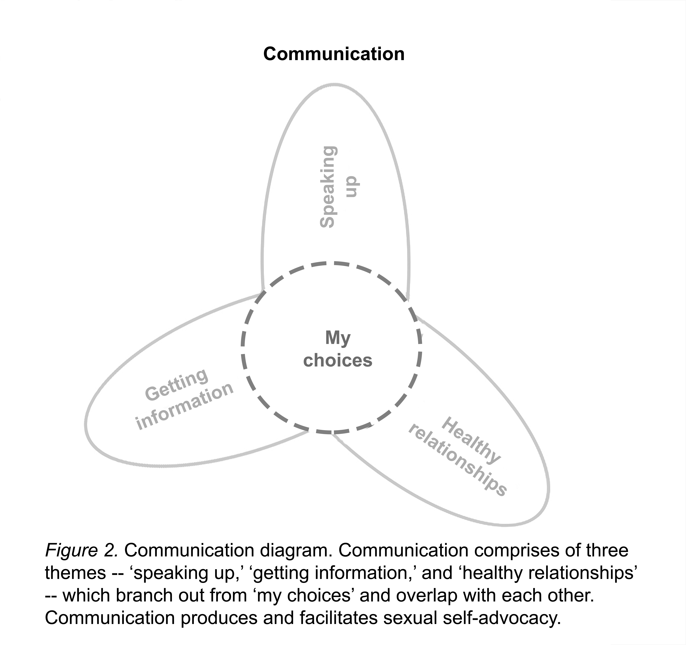

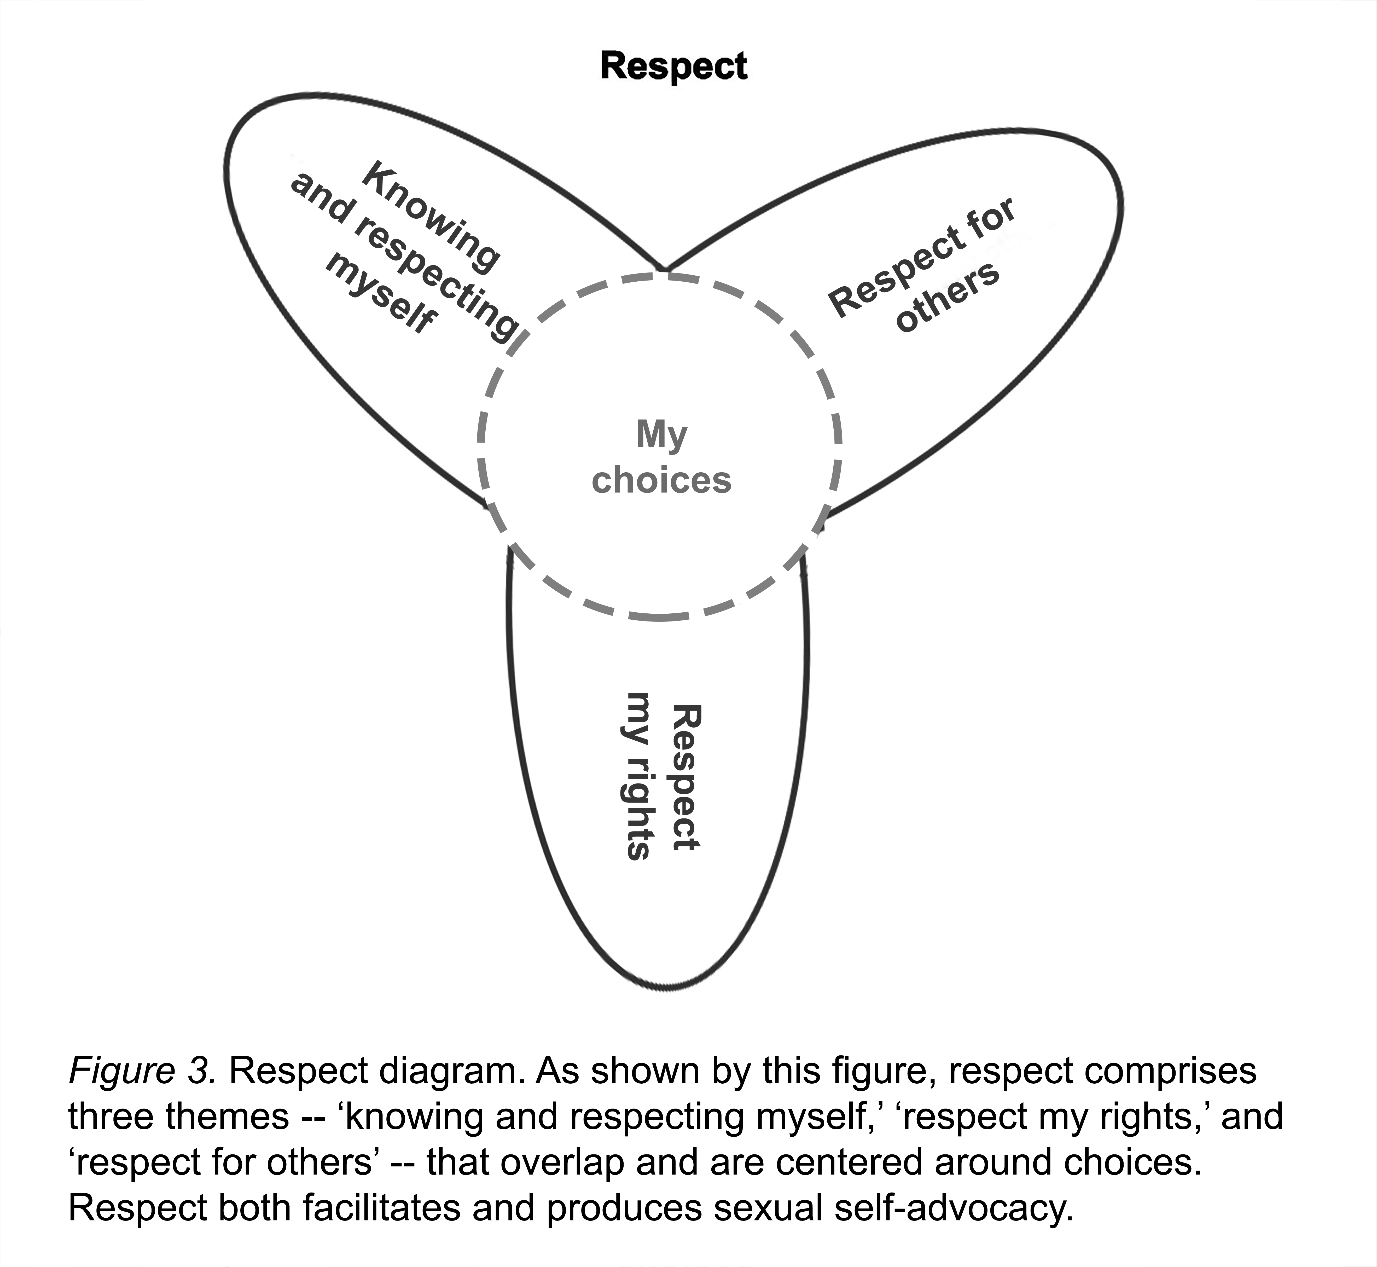

Within the self-advocacy movement, multiple groups in the U.S. have made strides in furthering the conversation about sexuality and how sexuality impacts the lives of people with IDD. However as this paper is largely focusing on disparities within research literature so discussion of these more ‘informal’ references is outside the scope of this paper.
Boeije [32] provides explicit guidance in how to carry out CCM, especially in how to use theoretical sampling. In coding the material, ‘self-advocacy’ was used as the theoretical sample-a trajectory for the themes and ultimately the theoretical conception of self-advocacy.
The term ‘healthy’ is used here not to denote a connection between morality and health (see [37]) but rather to demonstrate that adults with IDD can and do experience relationships in ranges similar to adults without IDD.

