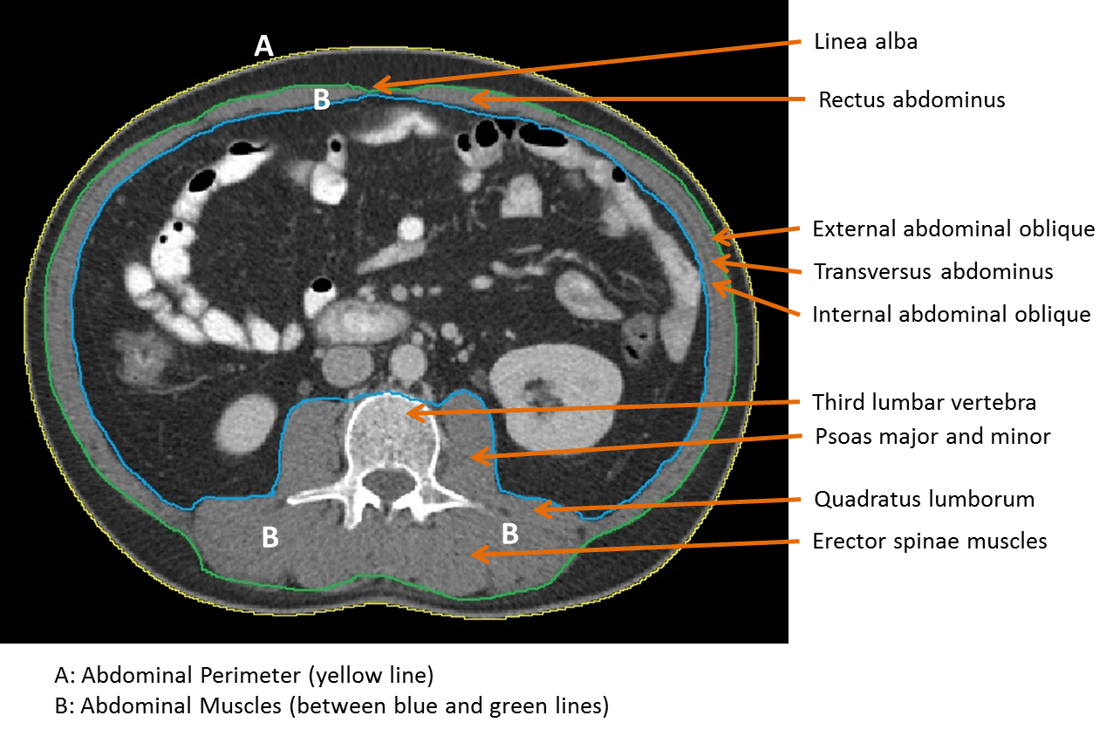
Figure 2. High quality third lumbar (L3) cross-sectional image with major skeletal muscles labeled.

