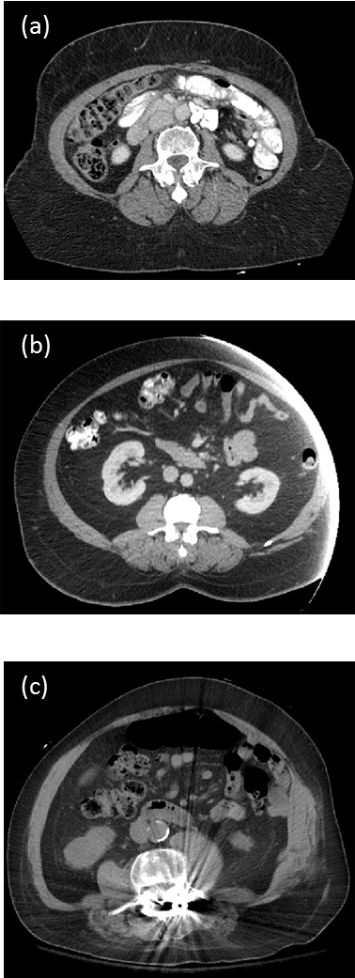

Figure 3. Examples of poor quality cross-sectional third lumbar (L3) images. (a) Incomplete abdominal perimeter will yield inaccurate waist circumference. (b) Incomplete abdominal perimeter and abdominal skeletal muscle mass. (c) Metal artifact interferes with thresholding.

