Getting Started | Open DICOM image file, to do this select FILE then OPEN. To increase the size of the DICOM image go to IMAGE then In[+] or Out[-]. The ImageJ window will increase or decrease accordingly.
Waist circumference  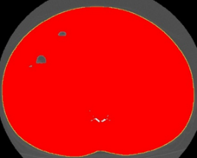 | Step 1. To assess waist circumference using the abdominal perimeter of the cross-sectional image.  - Start at IMAGE then ADJUST then THRESHOLD.  - Threshold box opens, click SET and change LOWER threshold to ‘250’ and UPPER threshold to ‘1000.’  - Click OK to Exit this window.  - Select ‘Wand (Tracing) Tool’ icon on the IMAGEJ control box.  - Click on the outer surface of threshold-highlighted area. The tracing tool has now delineated the abdominal perimeter.  - To set the correct measurement unit, go to ANALYZE then SET MEASUREMENTS and select AREA and PERIMETER.  - To quantify the abdominal perimeters, click on ANALYZE then MEASURE. A new RESULTS window emerges on computer screen with measures for AREA and PERIMETER. The unit for AREA (mm²) and PERIMETER unit is in centimeters (mm).
Outer muscle perimeter for skeletal muscle mass  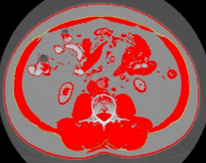 | Step 2. The outer perimeters of the abdominal muscles is needed for assessment of skeletal muscle mass.  - Go to Threshold box, ADJUST then THRESHOLD.  - Threshold box opens, click SET and change LOWER threshold to ‘-250’ and UPPER threshold to ‘-250.’ This returns image to original grey color and allows the anatomical features at the L3 to be easily determined.  - Exit this window by clicking OK.  - Click on ‘Freehands selection’ tool and click on image to remove the yellow line surrounding abdominal perimeter.  - Using the stylus, trace the outer muscle perimeter. Then, return to THRESHOLD box and change LOWER value to ‘-29’ and UPPER value to ‘+150.’  - To set the correct measurement units, go to ANALYZE, then SET MEASUREMENTS and select AREA, PERIMETER and LIMIT TO THRESHOLD.  - To quantify the outer muscle perimeter, click on ANALYZE then MEASURE.  - In the RESULTS window, a second set of measurements will appear for AREA and PERIMETER. The unit for AREA (mm²) and PERIMETER unit is in centimeters (mm).
Inner muscle perimeter for skeletal muscle mass  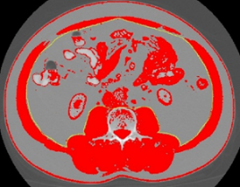 | Step 3. The inner perimeters of the abdominal muscles is needed for assessment of skeletal muscle mass.  - Go to Threshold box, ADJUST then THRESHOLD.  - Threshold window opens, click SET and change LOWER threshold to ‘-250’ and UPPER threshold to ‘-250.’  - Exit this window by clicking OK.  - Using the stylus, trace the inner muscle perimeter. Then, return to THRESHOLD window and change LOWER value to ‘-29’ and UPPER value to ‘+150.’  - To quantify the inner muscle perimeter, click on ANALYZE then MEASURE.  - In the RESULTS window, a third set of measurements appear.
Unit conversion process to cm and cm² | Step 4. Transfer of data to excel spreadsheet for unit conversions.  - Copy and paste these measurements to an EXCEL spreadsheet.  - To copy and paste the data, in RESULTS window, highlight each measurement with the mouse then right click on mouse, select COPY.  - Open Excel spreadsheet and paste the measurements.  - Plug in the data into the following calculations to derive waist and skeletal muscle areas.  - For waist circumference (WC) do the following: Measurement 1 (Perimeter, mm) divided by 10.  - For Skeletal Muscle Mass (SM) do the following: Measurement 2 (outer area) – Measurement 3 (inner area) divided by 100.
Closing IMAGEJ | To close ImageJ, click on in corner of ImageJ window. All windows associated with ImageJ will close.

Figure 4. Summary of steps for body composition analysis using National Institutes of Health ImageJ.

