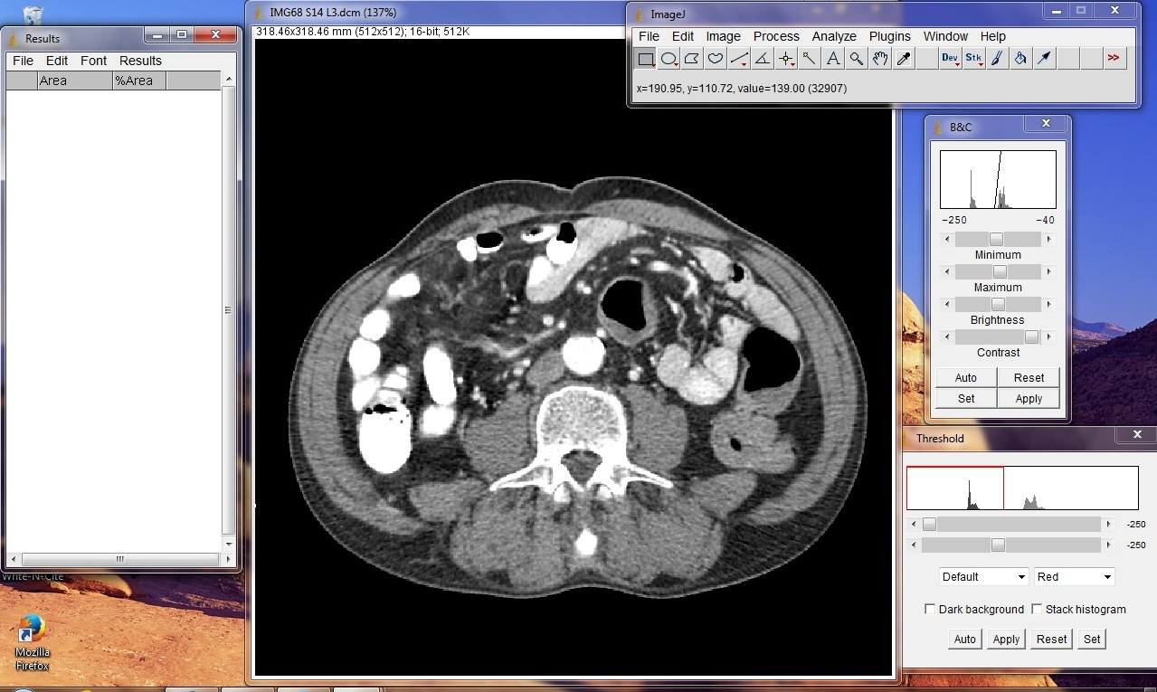
Figure 5. ImageJ software launched on computer screen according to imaging protocol.

