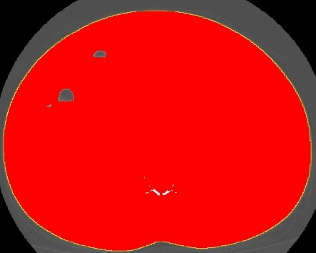
Figure 6. Abdominal perimeter delineated with the ‘wand’ tool. The yellow line represents the abdominal perimeter (waist circumference).

