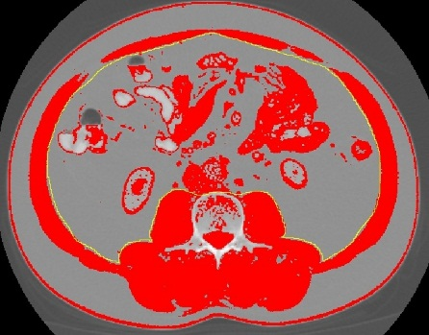
Figure 8. Inner abdominal musculature delineated with ImageJ ‘freehands selection’ tool.

