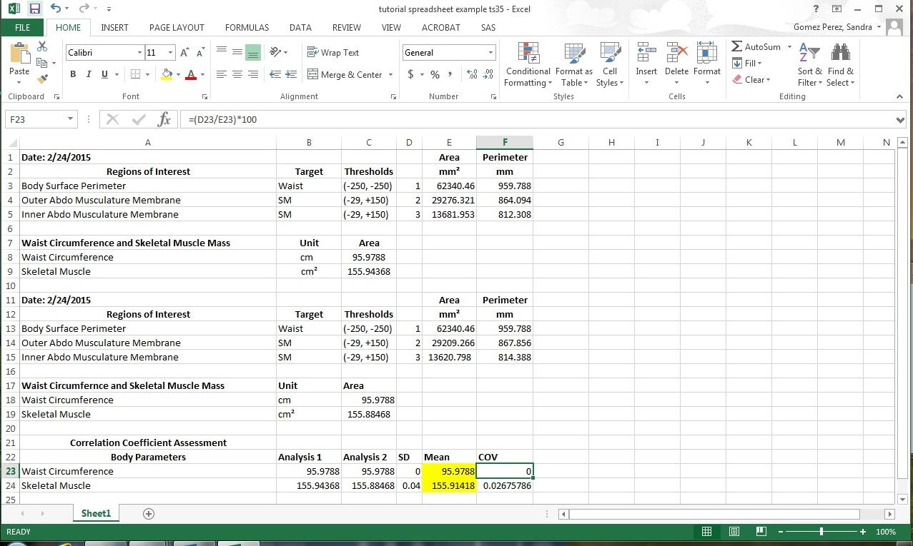
Figure 9. Example of CT body composition imaging results entered on preprogrammed template.

