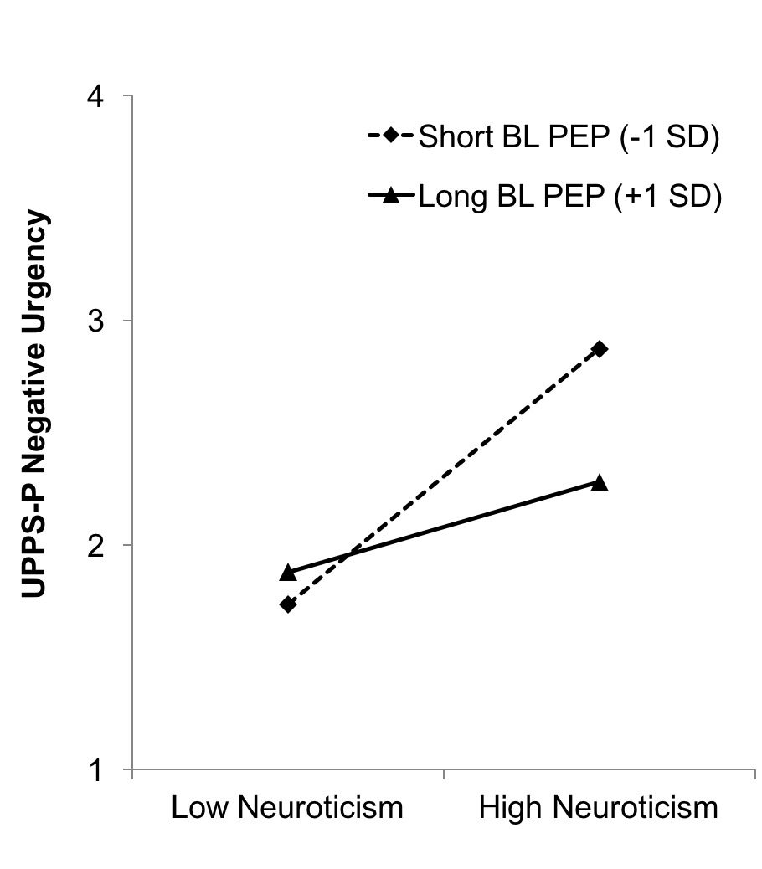
Figure 1. Interaction of Neuroticism and Baseline Cardiac Pre-Ejection Period Predicting Negative Urgency (Interactions Between Continuous Variables Probed at -1/+1 SD).

