The effects of amygdala and cortical inactivation on taste neophobia

Jian-You Lin, Joe Arthurs, Steve Reilly
Department of Psychology, University of Illinois at Chicago, Chicago, IL 60607,
United States

Correspondence: Jian-You Lin
Department of Psychology
Brandeis University
415 South Street
Waltham, MA 02453
Email: jylin@brandeis.edu

Steve Reilly
Department of Psychology
University of Illinois at Chicago
1007 West Harrison Street
Chicago, IL 60607
Fax: (312) 413-4122
Email: sreilly@uic.edu

Submitted for publication to: Neurobiology of Learning and Memory, August 2018.
ABSTRACT
The current study examined the effects of transient inactivation of the basolateral amygdala (BLA; Experiment 1) and gustatory cortex (GC; Experiment 2) on the expression of taste neophobia and its recovery. We found that inactivation (induced by infusions of baclofen/muscimol) of each structure before exposure to a novel saccharin (0.5%) solution elevated intake on Trial 1 (i.e., taste neophobia was attenuated) and, surprisingly, decreased intake on Trial 2. It seems unlikely that this intake reduction on Trial 2 can be attributed to taste aversion learning caused by drug infusions because in the subsequent experiments with the same set of the implanted animals, the rats did not decrease intake when baclofen/muscimol was infused after taste presentation on Trial 1. The latter result suggests that BLA or GC inactivation that attenuates taste neophobia may also impair memory consolidation of a safe taste experience.

Keywords:
Taste neophobia
Novelty detection
Threat assessment
Taste memory
Rat

- Introduction

The decision to ingest a familiar food depends on prior experience with that food. However, such knowledge is not available when a novel food is encountered. In the latter circumstance, the hungry animal is faced with a dilemma: to eat or not to eat. To cope with this situation, animals often show a reluctance to consume a novel food. This phenomenon is termed taste neophobia and is viewed as an innate defensive behavior motivated by the threat posed by the possibility that the unknown food may be poisonous, a behavior traditionally viewed as a fear-evoked response (e.g., Barnett, 1963; Corey, 1978; Domjan, 1977; Hill, 1978; Rozin, 1976; for reviews see Reilly, 2018a). If no aversive systemic effects follow this initial exposure, then intake will increase in subsequent encounters with the food (i.e., taste neophobia habituates). On the other hand, if the food is toxic, and the animal survives the poisoning, the food becomes devalued and avoided in future encounters. This learned defensive behavior is termed conditioned taste aversion (CTA), in which the taste of the food (conditioned stimulus or CS) is associated with the aversive post-ingestive consequence (unconditioned stimulus or US; for reviews see Barker, Best & Domjan, 1977; Braveman & Bronstein, 1985; Bureš, Bermudez-Rattoni & Yamamoto, 1998; Milgram, Krames & Alloway, 1977; Reilly & Schachtman, 2009). Given the relevance to the current topic, it is worth noting that taste neophobia has an important role in CTA acquisition; that is, CTA develops at a much slower rate to a familiar and safe food than to a novel one (a phenomenon termed latent inhibition; Lubow, 1989, 2009). Such a critical involvement in both innate and acquired feeding defensive behaviors encourages investigation of the neural mechanisms underlying taste neophobia (for a review see Reilly, 2018b).
Research from our laboratory demonstrates that the basolateral amygdala (BLA) and the gustatory cortex (GC) are each critically involved in taste neophobia. For instance, Lin, Roman, St. Andre and Reilly (2009) found that, relative to neurologically intact control animals, rats with bilateral lesions of either the BLA or GC over-consumed a novel tastant (also see Lin, Arthurs & Reilly, 2011). Thus, we hypothesized that the BLA and GC have a role in detection/responsivity to the novelty of a taste. This hypothesis receives further support from research that examined the effects of bilateral lesions on CTA acquisition. These studies found that permanent lesions of either structure did not prevent learning. Rather, rats with either BLA or GC lesions required more CS-US pairings to acquire the same magnitude of CTA as control subjects. Indeed, as revealed in these studies, the lesioned subjects acquired CTAs at the same slow rates as that found in non-lesioned rats that were conditioned with a familiar taste (Roman, Lin, & Reilly, 2009; St. Andre & Reilly, 2007). In other words, BLA- (BLAx) or GC-lesioned (GCx) rats appear to treat a novel taste as if it were familiar and safe, and thereby produce a latent inhibition-like effect on CTA acquisition (for reviews see Reilly, 2009; Reilly & Bornovalova, 2005).
Lin, Arthurs and Reilly (2015) conducted a retention experiment to determine the nature of the taste deficits shown in GCx rats. In that experiment, the rats were given a single taste trial, followed by toxicosis or no toxicosis, and, three days later, received either GC lesions or no lesions. Subsequent, the rats were tested on taste-only trials. Lin et al. hypothesized that in the CTA acquisition studies a lesion-induced attenuation of taste neophobia might result from either an impairment in taste novelty detection or a failure to properly react to the potential danger conveyed by the taste. If the former is correct, normal CTA expression would be expected because CTA retention does not require taste novelty detection. On the other hand, a retention deficit should emerge if GC is involved in the reaction to the danger conveyed by the taste. As shown in Lin et al. (2015), post-acquisition GC lesions attenuated CTA retention. It should be noted that such a deficit could not be attributed to a lesion-induced failure to recall the taste. This is because a control group in that experiment, which had comparable GC lesions but received a taste-no toxicosis trial prior to surgery, showed normal recovery from taste neophobia, indicating that taste memory was intact in the GCx rats. This pattern of results suggests that the GC, and possibly other components in the same circuit (e.g., BLA), has a role in processing taste-evoked threat responses.
To strengthen the conclusion that taste neophobia is a BLA-GC dependent behavior, the current study employed transient bilateral neural inactivation to refine understanding of the nature of the involvement of BLA and GC in taste neophobia. That is, prior to exposure to a novel taste the BLA (Experiment 1A) or GC (Experiment 2A) were inactivated with intracranial infusions of GABA receptor agonists (baclofen and muscimol; BM), a well-established approach that has been used to examine a range of behaviors (Baker & Ragozzino, 2014; Fuchs, Branham, & See, 2006; McFarland & Kalivas, 2001). A benefit of using transient inactivation is that, unlike permanent lesions, intracranial infusions of BM have been shown to decrease neural activity within minutes (<5-min; Baker & Ragozzino, 2014; Hikosaka & Wurtz, 1985; Krupa, Ghazanfar & Nicolelis,1999) and last over 40-min (Baker & Ragozzino, 2014; Kawabe, Chitravanshi, Kawabe & Sapru, 2008; McMullan & Pilowsky, 2012). Thus, transient inactivation of neural activity can be used to determine the involvement of a target structure at a specific time in a behavioral process. Additionally, the transient nature of the neural inactivation minimizes the likelihood of the development of any compensatory mechanisms that might be seen following permanent neural manipulations. Furthermore, with transient inactivation we could potentially uncover the influence of the disruption of taste neophobia on taste processing by examining performance during non-inactivated encounters with the taste stimulus. To maintain comparability with prior work from our laboratory (e.g., Lin et al., 2009; Lin et al., 2011; Lin, Amodeo, Arthurs & Reilly, 2012). and the literature (e.g., Gutiérrez, Rodriguez-Ortiz, De La Cruz, Núñez-Jaramillo & Bermudez-Rattoni, 2003; Monk, Rubin, Keene & Katz, 2013; Wilkins & Bernstein, 2006), we used 0.5% saccharin as the stimulus for taste neophobia testing because it evokes a significant neophobic reaction that habituates after 1 or 2 benign exposures. To provide comparability across experiments, in the current experiment our standard taste neophobia procedure was used in which rats were given daily 15-min access to saccharin until asymptotic intake of the taste was reached.
Based on the results from our prior lesion studies, we have proposed that the BLA- or GC-lesioned rats fail to respond to the threat conveyed by a novel taste. If this analysis is correct, then the inactivation of the BLA or GC before the novel taste exposure was expected to increase Trial 1 intake (i.e., when taste neophobia is maximal) but have little influence on subsequent trials as the taste becomes safe/familiar. This prediction was confirmed. Unexpectedly, a reduction in intake was also found on Trial 2 in the rats that received BM infusions before Trial 1, an outcome that does not occur following permanent lesions. One potential interpretation of this Trial 2 intake reduction is that the intracranial BM somehow functioned as a US to support the acquisition of a CTA. Therefore, using the same set of rats to assure the location of intracranial infusions, follow-up experiments (Experiment 1B and 2B) were conducted in the same way as the main experiments, except that quinine (0.0001 M) was used as the taste stimulus and BM was infused after the Trial 1 taste exposure. CTAs can be acquire after a single CS-US pairing and to a wide variety of taste stimuli, including sweet, sour, salty and bitter tastants (for bibliographies see, Riley & Clarke, 1977; Riley & Tuck, 1985). Therefore, if the intake reduction on Trial 2 of the main experiments was due to the acquisition of a CTA we might expect to observe a more pronounced reduction in taste intake on Trial 2 in Experiments 1B and 2B.

- Experimental procedures

2.1. Animals
The subjects were 72 naïve male Sprague-Dawley rats (275-300 g) obtained from Charles River Laboratory (Wilmington, MA). The rats were individually housed in polycarbonate cages (26.5 x 48 x 20 cm) in a vivarium maintained at 21ºC with a 12-h light cycle (light on at 7:30 am). Food and water were available at all times except during behavioral testing (see below). Animal care and experimental procedures were approved by Animal Care Committee of University of Illinois at Chicago and in accordance with the guidelines set by the American Psychological Association (2012) and National Institutes of Health (2011).

2.2. Surgery
Thirty-six rats were used in each experiment: 26 were given cannulation surgery and 10 served as non-surgical control subjects that were anesthetized (ketamine/ xylazine; 100/10 mg/kg) but received no surgical procedures. For cannulations, each rat was anesthetized, shaved and fixed in a stereotaxic instrument (David Kopf Instruments, Tujunga, CA) with blunt ear bars and a bite bar. Thereafter, a midline incision was made to expose the skull sutures and a trephine hole (~3 mm diameter) was drilled above the target structure in each hemisphere. A 22-gauge stainless steel cannula (Plastics One, Roanoke, VA) was then lowered to a position 2 mm above the center of the target structure (coordinates shown in Table 1). The cannulas were fixed in place at those locations with 4 screws secured in the skull and dental cement. During surgery, body temperature was monitored with a rectal thermometer and maintained at ~37ºC with a heating pad (Harvard Apparatus, Holliston, MA). When the dental cement hardened, a stainless steel dummy cannula was inserted into each guide cannula to protect the brain and maintain patency. After recovery from anesthesia, the rat was returned to the vivarium.

--- INSERT TABLE 1 ABOUT HERE ---

2.3. Apparatus
All behavioral testing occurred in the home cages. Water and taste stimuli were presented in 100-ml graduated cylinders with silicone stoppers and open tip stainless drinking tubes that could be attached to the front panel of the cage. Intake was measured with a resolution of 0.5 ml.

2.4. Drug infusions
Bilateral infusions of sterilized saline or the BM cocktail (1.0 mM baclofen hydrochloride and 0.1 mM muscimol hydrobromide; Sigma-Aldrich, St. Louis, MO) were made through 28-gauge injectors that extended 2 mm below the guide cannulas. Each infusion contained 0.5 µl of vehicle or BM and was delivered at a rate of 0.5 µl/min for 60 sec via a 10 μl Hamilton syringe controlled by an automated infusion pump (Cole-Parmer, Vernon Hills, IL). The injectors remained in situ for an additional 60 sec to allow diffusion. Thereafter, the animals were returned to their home cages. To familiarize the rats to the infusion procedure, a mock infusion was conducted on the day before the first neophobia trial.

2.5. Experiment 1: Basolateral amygdala and taste neophobia
Experiment 1A: BLA inactivation before Trial 1. Following recovery from surgery, the rats were placed on a water deprivation schedule that allowed 15-min water access twice per day: in the morning and, 4 hr later, in the afternoon. Once morning water intake stabilized taste neophobia testing commenced. Counterbalanced by water baseline intake, rats were randomly assigned into three groups: Handle (n = 10), Saline (n = 12), and BM (n = 14). A taste neophobia trial consisted of 15-min access to 0.5% sodium saccharin (w/v) in the morning trial. Twenty min before Trial 1, while Group Handle received a mock infusion and handling, Groups Saline and BM were given bilateral intra-BLA infusions of, respectively, physiological saline or BM. Immediately after handling or infusion, rats were returned to their home cage. A total of 5 taste trials were given. Taste trials occurred every third day (i.e., 72 hours apart) with water access being given on the two intervening days.
Experiment 1B: BLA inactivation after Trial 1. After the completion of Experiment 1A, the rats were given ad libitum food and water for several days and then returned to the water deprivation schedule employed in Experiment 1A. Once the morning water intake stabilized again, neophobia testing was conducted with a new taste stimulus (0.0001 M quinine hydrochloride). Intracranial infusions occurred 5 min after Trial 1 access. Group assignment was counterbalanced based on the drug infused in Experiment 1A with half the subjects from each previous infusion group (Saline and BM) assigned into each new infusion group (Saline and BM). The same rats served in Group Handle for both Experiments 1A and 1B.

2.6. Experiment 2: Gustatory cortex and taste neophobia
Experiment 2A: GC inactivation before Trial 1. As described in Experiment 1A.
Experiment 2B: GC inactivation after Trial 1. As described in Experiment 1B.

2.7. Histological analysis
Following completion of all behavioral testing, rats with brain cannula were overdosed with ketamine and xylazine (200/20 mg/kg) and perfused transcardially with physiological saline and then 10% formalin. The brains were extracted and stored in 4% buffered formalin for 2 days and 20% sucrose solution for additional 2 days. Thereafter, the brains were frozen and sliced at 50 µm on a cryostat (Leica Biosystems Inc., Buffalo Grove, IL). After staining with cresyl violet, the slices were mounted on slides and examined for the location of cannulas using a Zeiss Axioskop 40 light microscope.

2.8. Data analysis
In each experiment, the data from Groups Handle and Saline were collapsed into a single group (Group Control) because statistical analyses revealed no significant differences between these two control groups (the smallest p value = 0.11). Fluid consumption was analyzed with 2-way mixed design analysis of variance (ANOVA) involving Group as the between-subject variable and Trial as the within-subject variable. If needed, simple main effects (with adjusted error terms taken from the overall ANOVA) were conducted to determine the nature of difference. The alpha level was set at .05 for overall ANOVA and .01 for simple main effects to reduce the opportunity of committing Type I error. All analyses were conducted using Statistica software (6.0; StatSoft, Tulsa, OK).

3. Results

3.1. Anatomical: BLA and GC cannulations

Figures 1 and 2 show the locations of the tips of the injectors in, respectively, the BLA and GC. Animals with misplaced cannulas in one or both hemispheres were excluded. After completion of Experiment 2A, two cannula-implanted rats became ill and thus were dropped from Experiment 2B. The final sample size for each group in each experiment is listed in Table 2.

--- INSERT TABLE 2 ABOUT HERE ---

--- INSERT FIGURES 1 and 2 ABOUT HERE ---

3.2. Experiment 1: Basolateral amygdala and taste neophobia
Baseline water consumption: An ANOVA conducted on the morning water intake data obtained on the three days immediately prior to the first taste trial found no significant main effect of group (F = 2.88, p > .05) or Group X Day interaction (F < 1). Mean water intake (± SE), averaged across the 3 days, for Group Control and Group BM was, respectively, 15.12 (± 0.71) ml and 14.13 (± 0.80) ml.

--- INSERT FIGURE 3 ABOUT HERE ---

Experiment 1A: BLA inactivation before Trial 1. As shown in Figure 3A, Group Control displayed a strong neophobia response to the novel saccharin solution, a response that habituated by Trial 3. On the other hand, BLA inactivation prior to the first taste trial almost completely abolished the neophobic reaction on Trial 1 and caused a decrease in saccharin intake on Trial 2 down to the level of the control group on that trial. These impressions of the data were supported by statistical analysis that found a significant main effect of Trial, F(4, 104) = 25.57, p < .05, and a significant Group X Trial interaction, F(4, 104) = 12.28, p < .05; the main effect of Group was not significant (F < 1). Follow-up analyses with simple main effects confirmed that Group BM consumed significantly more of the novel saccharin solution than Group Control on Trial 1 (p < .01) and that the difference between groups was not significant on Trials 2 - 5 (ps > .01). Additional analyses that examined the recovery course confirmed that Group BM decreased saccharin intake from Trial 1 to Trial 2 (p < .01) but increased from Trial 2 to Trial 3 (p < .01); no significant between-trial differences were found on Trials 3 - 5 (ps > .01).
Experiment 1B: BLA inactivation after Trial 1. Inspection of Figure 4B suggests that BM treated rats suppressed taste intake relative to the control subjects. The overall ANOVA found a significant main effect of Group, F(1, 26) = 6.15, p < .05, and a main effect of Trial, F(2, 52) = 16.14, p < .05, but the Group X Trial interaction was not significant, F(2, 52) = 1.57, p > .05. Simple main effects conducted on the significant main effect of Trial indicate that animals increased intake on Trial 2 relative to Trial 1 (p < .01) but consumed a comparable amount of quinine on Trials 2 and 3 (p > .01). The reason for the significant group difference is not immediately clear. Although the BLA-inactivated rats drank less than the control rats on Trial 2, both groups increased intake on Trial 2 (and Trial 3) relative to Trial 1. At first glance, the lower intake of BM-infused rats might suggest a mild aversion. However, because there is a main effect of Group and no significant Group x Trial interaction, any interpretation of the results must account for a group difference across all three trials, not just Trials 2 and 3. While the main effect of Group may indicate a previously unappreciated role for the BLA that will require further study, it also indicates that a BM-induced CTA is inconsistent with the pattern of results obtained in Experiment 1B, and that a BM-induced CTA likely does not contribute to the intake reduction found on Trial 2 of Experiment 1A.

3.3. Experiment 2: Gustatory cortex and taste neophobia
Baseline water consumption: Confirming that water intake was stable over the three days before neophobia testing, an ANOVA found no significant main effects or interaction (ps > .05). The 3-day water intake mean (± SE) for Groups Control and BM was, respectively, 17.40 (± 0.76) ml and 17.35 (± 0.50) ml.

Experiment 2A: GC inactivation before Trial 1. It will be apparent from inspection of Figure 4A that the control subjects showed a neophobia response that habituated over trials. It will also be apparent that inactivation of the GC prior to the first taste trial had a clear effect on performance, increasing intake of Trial 1 and decreasing intake on Trial 2. The overall ANOVA conducted on the data summarized in Figure 4A found a significant main effect of Trial, F(4, 116) = 47.58, p < .05, and a significant Group x Trial interaction, F(4, 116) = 26.89, p < .05; the main effect of Group was not significant (F < 1). Simple main effects revealed that Group BM consumed significantly more novel saccharin than Group Control on Trial 1 (p < .01) but significantly less saccharin on Trial 2 (p < .01). There were, however, no between-group intake differences on Trials 3 – 5 (ps > .01), where intake for each group was at asymptote.

--- INSERT FIGURE 4 ABOUT HERE ---
Experiment 2B: GC inactivation after Trial 1. Inspection of Figure 4B suggests that GC inactivation following the first taste trial had no influence on subsequent performance. The overall ANOVA found no significant main effect of Group (F < 1) and no significant Group x Trial interaction, F(2, 54) = 1.53, p > .05. There was, however, a significant main effect of Trial, F(2, 54) = 33.64, p < .05. Follow-up analyses (i.e., simple main effects) revealed that each group significantly increased intake across trials (ps < .01; i.e., showed a gradual attenuation of neophobia).

4. Discussion

Using intracranial infusions of the BM cocktail, we investigated the temporal involvement of the BLA and GC in taste neophobia. Neuronal inactivation prior to access to the novel saccharin solution resulted in elevated intake on Trial 1 (Experiments 1A and 2A) to a level significantly higher than that of the control subjects. These findings refine our conclusions, based on the use of permanent lesions, that neural activity within the BLA and GC is essential for the occurrence of taste neophobia (e.g., Lin & Reilly, 2012; Lin et al., 2009).
One potential interpretation of the Trial 1 performance found in Experiments 1A and 2A is that the BLA and GC inactivation disrupted the perceived concentration of the tastant such that the rats treated those stimuli as if they were more dilute. However, for two reasons this analysis seems untenable. First, unlike the GC, the BLA is not a component of the central gustatory system (for reviews see: Lundy & Norgren, 2014; Norgren, 1984; Pritchard & DiLorenzo, 2015), and therefore there is no reason to suggest that the BLA is involved in basic processing of taste stimuli. Second, if GC lesions caused a reduction in perceived stimulus intensity, deficits would be evident in the unconditioned concentration-dependent preferences/aversions for gustatory stimuli. Incompatible with this analysis, GCx rats show no such impairments in responsivity to tastants, including saccharin (Benjamin, 1955; Braun, Lasiter & Kiefer, 1982; Dunn & Everitt, 1988; Lasiter, Deems, Oetting & Garcia, 1985). Thus, we consider a lesion-induced reduction in perceived taste intensity to be an untenable account of the present results.
A second potential interpretation of the elevated intake on Trial 1 of Experiments 1A and 2A is that inactivation might have produced an internal context than was not present on later trials. Given that habituation is context specific, by this analysis any habituation that occurred on Trial 1 during BM inactivation would not transfer to the non-inactivated context present on Trials 2 - 5. This explanation cannot account for the two definitive behavioral deficits found in rats with BLA or GC cell loss: the attenuation of taste neophobia (an effect that occurs on first exposure to a novel taste) and a delay in the acquisition of a CTA (an effect that occurs after the first trial). In addition, this internal context hypothesis cannot account for the finding that post-Trial 1 GC lesions do not influence the recovery from taste neophobia on Trial 2 (Lin et al., 2015). If the internal context hypothesis was correct, then a recovery deficit should be found given the difference in the internal state on Trial 1 (GC was intact) and Trial 2 (GC was lesioned).
Our research indicates that rats with either BLA or GC lesions treat the novel (and therefore potentially dangerous) tastant as-if it were more safe/familiar than it is. As discussed, lesions of BLA or GC have no influence on the perceived strength of taste stimuli. We therefore proposed that the lesion-induced deficit (i.e., reduction in taste neophobia) is a consequence of the failure to respond to the danger conveyed by the taste stimulus, an effect that is not related to taste encoding. This interpretation accounts for elevated intake on first exposure to a novel tastant and, due to latent inhibition, also explains why BLAx or GCx rats require more CS-US pairings to develop a CTA than non-lesioned rats. This analysis accounts for elevated taste intake on Trial 1 in the BLA and GC inactivated rats in Experiments 1A and 2A.
Unexpectedly, on Trial 2 a significant reduction of saccharin intake was found in the animals that had received BM infusions 72 hr earlier, an effect that was more pronounced in the GC- than BLA-inactivated rats. Indeed, the Trial 2 performance of the GC treated group was more like that of their control group on Trial 1.
Perhaps the most obvious explanation for the Trial 2 saccharin intake reduction in the BLA- and GC-inactivated groups is that, in addition to the attenuation of taste neophobia on Trial 1, the BM infusions on Trial 1 also produced an aversive internal state (i.e., served as a US) that supported the development of a CTA to the taste stimulus (functioning as a CS), which was responsible for the intake reduction on Trial 2. If this analysis is correct, then, given the time course of the neural inactivation, a more pronounced intake reduction would be anticipated if BM was infused after the first taste trial, because CS-US conditioning produces stronger CTAs than US-CS conditioning (Boland, 1973; Huang & Hsiao, 2008). In each of the follow-up experiments, however, we did not find intake reductions on Trial 2 in the rats that received BM infusions after the taste exposure on Trial 1. On the contrary, intake increased from Trial 1 to Trial 2 for those rats. Because we did not expect to be conducting follow-up experiments, the taste stimuli (saccharin and quinine) were not counterbalanced across procedures. The lack of counterbalancing may raise some concern that differences in the associability of each taste may have contributed to the absence of taste aversion leaning in the follow-up experiments. However, the literature suggests that quinine is more associable than saccharin in aversion learning (e.g., Kutscher, Wright, & Lisch, 1977). For this reason we are inclined to the view that the lack of stimulus counterbalancing did not influence the outcomes of the follow-up experiments and, therefore, that the lower intake on Trial 2 of Experiments 1A and 2A was likely not caused by the development of a BM-induced taste aversion.
If not CTA how is the Trial 2 performance of the BM-treated rats to be explained? Before this question can be addressed it is instructive to discuss the results obtained by Lin et al. (2015) who investigated the post-operative retention in GCx rats of a taste that pre-operatively had been paired with either toxicosis (i.e., CTA group) or no toxicosis (i.e., taste neophobia group). It should be noted that the bilateral GC lesions were induced three days after the pre-operative taste trial. On the post-operative retention trial the GCx-no toxicosis group increased saccharin intake (i.e., showed normal habituation of taste neophobia) whereas the GCx-toxicosis group consumed the same amount of saccharin as on the first taste trial (i.e., showed no evidence of the pre-operatively acquired CTA). Presumably, the three-day interval between the first taste trial and the GC lesions was sufficient for the initially unknown taste to be revalued as either safe (in the no toxicosis rats) or unsafe (in the toxicosis rats). Accordingly, the normal habituation of taste neophobia in the GCx-no toxicosis group suggests that the GC is not necessary for the retention of, or performance based upon, a safe taste memory. On the other hand, the absence of a CTA in the GCx-toxicosis group suggests that the GC is necessary for the retention of, or performance based upon, an unsafe taste memory.
Returning to the present results, the intake reduction on Trial 2 of Experiment 2A for the GC-treated rats resembles the performance evoked in normal animals by a novel taste (i.e., a taste with unknown and potentially dangerous post-ingestive consequences). This characterization of Trial 2 performance of GC treated rats, that they responded to the taste as if it were novel, encourages the view that the BM infusions disrupted taste memory processing on Trial 1. Accepting this analysis, the normal performance of the GC-treated rats elsewhere in these experiments provides some illumination on the nature of taste memory and the role of the GC in that process.
If inactivation of the GC during the taste experience disrupts the formation and/or consolidation of taste memory (of a safe taste in this case; also see Adaikkan & Rosenblum, 2015) then the finding that post-Trial 1 BM infusions had no influence on Trial 2 intake in Experiment 2B suggests that the formation/consolidation of the safe taste memory occurred fairly rapidly (approximately 20 min or so; i.e., 15 min taste access and 5 min prior to BM infusions). Furthermore, as alluded to above, storage of the consolidated safe taste memory must occur outside the GC because GCx rats show normal performance in the retention of a pre-operatively acquired safe taste memory (Lin et al., 2015).
This discussion has focused on the performance of the GC-treated rats because their performance in the present experiments appears more clear-cut than that of the BLA-treated animals. That is, it is not obvious in the present results whether the differences in performance of the two sets of BM treated rats is quantitative or qualitative. If the former then the analysis of GC function may also apply to the BLA. Indeed, we have proposed that the BLA and GC form a functional unit operating together during taste neophobia (e.g., Lin & Reilly, 2012; Lin et al., 2009). If the latter (as exemplified by the finding of no significant difference between the BLA-treated rats and their controls on Trial 2 of Experiment 1A relative to the large and significant difference between the GC-treated rats and their controls on Trial 2 of Experiment 2A) then this would be the first empirical evidence that the BLA and GC serve inter-dependent rather than identical functions during taste neophobia. To provide insight into this issue it would be interesting to use asymmetric inactivations to determine whether the mechanism(s) involved in the Trial 2 intake reduction requires a functional BLA-GC circuit. Another future direction concerns how these two brain regions differentially participate in taste neophobia, one approach would be to determine the directionality of information flow between the BLA and GC, an undertaking that will require the use of techniques to selectively excite, inhibit, or inactivate specific populations of neurons or pathways within and between these structures. Given the close relationship between taste neophobia and CTA, the outcome of these studies will benefit a more general understanding of the mechanisms by which the brain (the forebrain, in particular) processes taste information and modulates taste-guided behavior.

Acknowledgements

This work was supported by grants DC06456 from the National Institute of Deafness and Other Communication Disorders. Joe Arthurs is now at the Department of Biochemistry, University of Washington, Seattle, WA 98195, USA.
References

Adaikkan, C., & Rosenblum, K. (2015). A molecular mechanism underlying gustatory memory trace for an association in the insular cortex. Elife, 4, e07582.
American Psychological Association (2012). Guidelines for ethical conduct in the care and use of nonhuman animals in research. Washington DC: American Psychological Association.
Baker, P.M., & Ragozzino, M.E. (2014). Contralateral disconnection of the rat prelimbic cortex and dorsomedial striatum impairs cue-guided behavioral switching. Learning and Memory, 21, 368-379.
Barker, L.M., Best, M.R., & Domjan, M. (Eds.). (1977). Learning mechanisms in food selection. Waco, Texas: Baylor University Press.
Barnett, S.A. (1963). The rat: A study in behavior. Chicago: Aldine.
Benjamin, R.M. (1955). Cortical taste mechanisms studied by two different test procedures. Journal of Comparative & Physiological Psychology, 48,119–122.
Best, M.R., & Barker, L.M. (1977). The nature of’’ learned safety’’ and its role in the delay of reinforcement gradient. In L.M. Barker, M.R. Best, & M. Domjan (Eds.), Learning mechanisms in food selection (pp. 295–325). Waco, Texas: Baylor University Press.
Boland, F.J. (1973). Saccharin aversions induced by lithium chloride toxicosis in a backward conditioning paradigm. Animal Learning & Behavior, 1, 3-4.
Braun, J.J., Lasiter, P.S., & Kiefer, S.W. (1982). The gustatory neocortex of the rat. Physiological Psychology, 10, 13-45.
Braveman, N.S., & Bronstein, P. (Eds.) (1985). Experimental assessments and clinical applications of conditioned food aversions. Annals of the New York Academy of Sciences (Vol. 443, pp. 1–441).
Bureš, J., Bermudez-Rattoni, F., & Yamamoto, T. (1998). Conditioned taste aversion: Memory of a special kind. Oxford University Press, Oxford, UK.
Corey, D.T. (1978). The determinants of exploration and neophobia. Neuroscience and Biobehavioral Reviews, 2, 235–253.
Domjan, M. (1977). Attenuation and enhancement of neophobia for edible substances. In L.M. Barker, M.R. Best, & M. Domjan (Eds.), Learning mechanisms in food selection (pp. 151–179). Waco, Texas: Baylor University Press.
Dunn, L.T., & Everitt, B.J. (1988). Double dissociations of the effects of amygdala and insular cortex lesions on conditioned taste aversion, passive avoidance, and neophobia in the rat using the excitotoxin ibotenic acid. Behavioral neuroscience, 102, 3-23.
Flynn, F.W., Grill, H.J., Schwartz, G.J., & Norgren, R. (1991). Central gustatory lesions: I. Preference and taste reactivity tests. Behavioral Neuroscience, 105, 933-943.
Fuchs, R.A., Branham, R.K., & See, R.E. (2006). Different neural substrates mediate cocaine seeking after abstinence versus extinction training: a critical role for the dorsolateral caudate-putamen. Journal of Neuroscience, 26, 3584-3588.
Gutiérrez R, Rodriguez-Ortiz CJ, De La Cruz V, Núñez-Jaramillo L, & Bermudez-Rattoni F. (2003). Cholinergic dependence of taste memory formation: evidence of two distinct processes. Neurobiology of Learning and Memory, 80, 323-331.
Hikosaka, O. & Wurtz, R.H. (1985). Modification of saccadic eye movements by GABA-related substances. I. Effect of muscimol and bicuculline in monkey superior colliculus. Journal of Neurophysiology, 53, 266-291.
Hill, W.F. (1978). Effect of mere exposure on preference in nonhuman animals. Psychological Bulletin, 85,1177-1198.
Huang, A.C.W., & Hsiao, S. (2008). Re-examination of amphetamine-induced conditioned suppression of tastant intake in rats: The task-dependent drug effects hypothesis. Behavioral Neuroscience, 122, 1207-1216.
Kawabe, T., Chitravanshi, V.C., Kawabe, K., & Sapru, H.N. (2008). Cardiovascular function of a glutamatergic projection from the hypothalamic paraventricular nucleus to the nucleus tractus solitarius in the rat. Neuroscience, 153, 605-617.
Krupa, D.J., Ghazanfar, A.A., Nicolelis, M.A. (1999). Immediate thalamic sensory plasticity depends on corticothalamic feedback. Proceeding of the National Academy of Science, 96, 8200-8205.
Kutscher, C.L., Wright, W.A., & Lisch, M. (1977). NaCl and LiCl efficacy in the induction of aversion for quinine and saccharin solutions immediately following injection. Pharmacology Biochemistry & Behavior, 6, 567-569.
Lasiter, P.S., Deems, D.A., Oetting, R.L., & Garcia, J. (1985). Taste discriminations in rats lacking anterior insular gustatory neocortex. Physiology & Behavior, 35, 277-285.
Lin, J.-Y., Amodeo, L.R., Arthurs, J., & Reilly, S. (2012). Taste neophobia and palatability: The pleasure of drinking. Physiology and Behavior, 106, 515-519.
Lin, J.-Y., Arthurs, J., & Reilly, S. (2011). Role of the insular cortex in morphine-induced conditioned taste avoidance. Brain Research, 1384, 80-88.
Lin, J.-Y., Arthurs, J., & Reilly, S. (2015). Gustatory insular cortex, aversive taste memory and taste neophobia. Neurobiology of Learning and Memory, 119, 77-84.
Lin, J.-Y., & Reilly, S. (2012). Amygdala-gustatory insular cortex connections and taste neophobia. Behavioral Brain Research, 235, 182-188.
Lin, J.-Y., Roman, C., St. Andre, J., & Reilly, S. (2009). Taste, olfactory and trigeminal neophobia in rats with forebrain lesions. Brain Research. 1251, 195-203.
Lubow, R.E. (1989). Latent inhibition and conditioned attention theory. Cambridge, England: Cambridge University Press.
Lubow, R.E. (2009). Conditioned taste aversion and latent inhibition: A review. In: S. Reilly & T. R. Schachtman (Eds.), Conditioned taste aversion: Behavioral and neural processes (pp. 37–57). New York, USA: Oxford University Press.
Lundy, R.F., Jr., Norgren, R. (2014). Gustatory system. In: G. Paxinos (Ed.), The Rat Nervous System (pp. 731-750)(3rd ed.). San Diego: Academic Press.
McFarland, K., & Kalivas, P.W. (2001). The circuitry mediating cocaine-induced reinstatement of drug-seeking behavior. Journal of Neuroscience, 21, 8655-8663.
McMullan, S. & Pilowsky, P.M. (2012). Sympathetic premotor neurons project to and are influenced by neurons in the contralateral rostral ventrolateral medulla of the rat in vivo. Brain Research, 1439, 34-43.
Milgram, N.W., Krames, L., & Alloway, T. (Eds.). (1977). Food aversion learning. New York: Plenum Press.
Monk, K.J., Rubin, B.D., Keene, J.C., & Katz, D.B. (2013). Licking microstructure reveals rapid attenuation of neophobia. Chemical Senses, 39, 203-213.
National Institutes of Health (2011). Guide for the care and use of laboratory animals. Washington DC: National Academy Press.
Norgren, R. (1984). Central neural mechanisms of taste. In: I. Darien-Smith (Ed.). Handbook of physiology: The nervous system. III. Sensory processes (pp. 1087-1128.) Bethesda, MD: American Physiological Society; 1984.
Paxinos, G., & Watson, C. (2005). The rat brain in stereotaxic coordinates (5th ed.). San Diego, California: Academic Press.
Pritchard, T.C., DiLorenzo, P.M. (2015). Central taste anatomy and physiology in rodents and primates. In Doty, R.F. (Ed.), Handbook of olfaction and gustation (pp. 701-725)(3rd ed.). Hoboken, NJ: Wiley.
Reilly, S. (2009). Central gustatory system lesions and conditioned taste aversion. In S. Reilly & T.R. Schachtman (Eds.), Conditioned taste aversion: Behavioral and neural processes (pp. 309–327). New York: Oxford University Press.
Reilly, S. (Ed.). (2018a). Food neophobia: Behavioral and biological influences. Elsevier.
Reilly, S. (2018b). Taste neophobia: Neural substrates and palatability. In S. Reilly (Ed.), Food neophobia: Behavioral and biological influences (pp. 77–109). Elsevier.
Reilly, S., & Bornovalova, M., 2005. Conditioned taste aversion and amygdala lesions in the rat: A critical review. Neuroscience and Biobehavioral Reviews, 29, 1067-1088.
Reilly, S., & Pritchard, T.C. (1996). Gustatory thalamus lesions in the rat: I. Innate taste preferences and aversions. Behavioral Neuroscience, 110, 737-745.
Reilly, S., & Schachtman, T.R. (Eds.). (2009). Conditioned taste aversion: Behavioral and neural processes. New York: Oxford University Press.
Riley, A.L., & Clarke, C.M. (1977). Conditioned taste aversions: A bibliography. In L.M. Barker, M.R. Best, & M. Domjan, M. (Eds.), Learning mechanisms in food selection (pp. 593–661). Waco, Texas: Baylor University Press.
Riley, A.L., & Tuck, D.L. (1985). Conditioned food aversions: A bibliography. In N.S. Braveman, & P. Bronstein (Eds.), Experimental assessments and clinical applications of conditioned food aversions. Annals of the New York Academy of Sciences (Vol. 443, pp. 381-437).
Roman, C., Lin, J.-Y., & Reilly, S. (2009). Conditioned taste aversion and latent inhibition following extensive taste preexposure in rats with insular cortex lesions. Brain Research, 1259, 68–73
Rozin, P. (1976). The selection of food by rats, humans and other animals. In: Rosenblatt, J., Hinde, R.A., Beer, C., Shaw, E. (Eds.), Advances in the Study of Behavior, Volume 6. Academic Press, New York, pp. 21-76.
St. Andre, J., & Reilly, S. (2007). Effects of central and basolateral amygdala lesions on conditioned taste aversion and latent inhibition. Behavioral Neuroscience, 121, 90-99.
Wilkins, E.E., & Bernstein, I.L. (2006). Conditioning method determines patterns of c-fos expression following novel taste-illness pairing. Behavioural brain research, 169, 93-97.

Table 1
Stereotaxic coordinates (relative to bregma in mm) used for cannulation placements in the BLA and GC. For the GC placements, the cannulas were lowered at an angle of 10° in the ML plane.

---------------------------------------------------------------------------------------------------------------------
Site AP ML DV
---------------------------------------------------------------------------------------------------------------------
BLA -2.5 ±5.0 -5.5
GC +1.2 ±3.0 -5.0
---------------------------------------------------------------------------------------------------------------------
AP: Antero-posterior; ML; Medio-lateral; DV; Dorso-ventral; BLA; Basolateral amygdala; GC; Gustatory insular cortex.

Table 2
Number of rats in each group that contributed behavioral data in Experiments 1 and 2.

------------------------------------------------------------------------------------------
Experiment Handle Saline BM
------------------------------------------------------------------------------------------
1A 9 6 13
1B 9 7 12

2A 10 8 14
2B 10 10 10
------------------------------------------------------------------------------------------

Figure captions
Fig. 1. Placement of the injection cannula tips in the basolateral amygdala (black triangle) for the rats employed in Experiment 1. Diagrams were adapted with permission from the Paxinos and Watson (2005) atlas.

Fig. 2. Placement of the injection cannula tips in the gustatory cortex (black triangle) for the rats employed in Experiment 2. Diagrams were adapted with permission from the Paxinos and Watson (2005) atlas.

Fig. 3. Experiment 1: Mean (±SE) fluid intake for the control subjects (Control) and rats that received temporary inactivation of the basolateral amygdala (BM). The arrows indicate when neural inactivation was induced: either 20-min before (Panel A) or 5-min after (Panel B) the first taste trial.

Fig. 4. Experiment 2: Mean (±SE) fluid intake for the control subjects (Control) and rats that received temporary inactivation of the gustatory cortex (BM). The arrows indicate the time when neural inactivation was induced: either 20-min before (Panel A) or 5-min after (Panel B) the first taste trial.

Figure 1
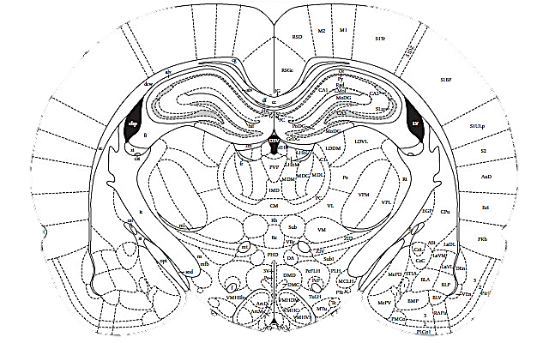
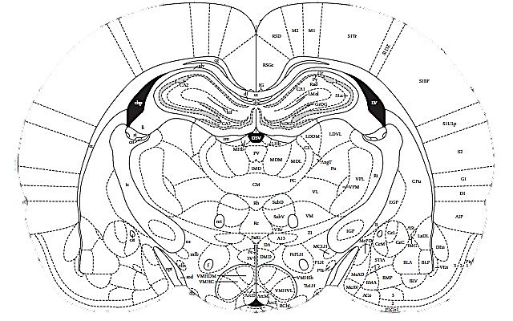
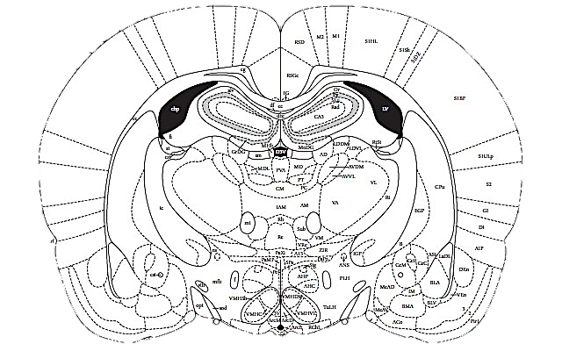

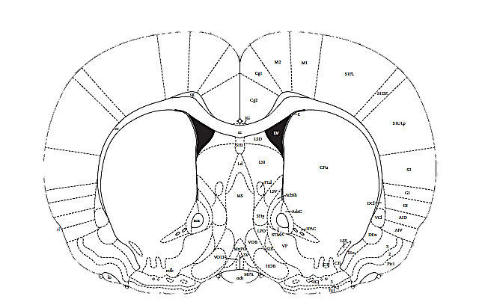
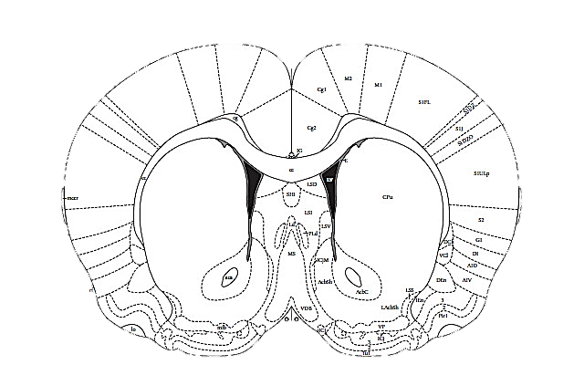
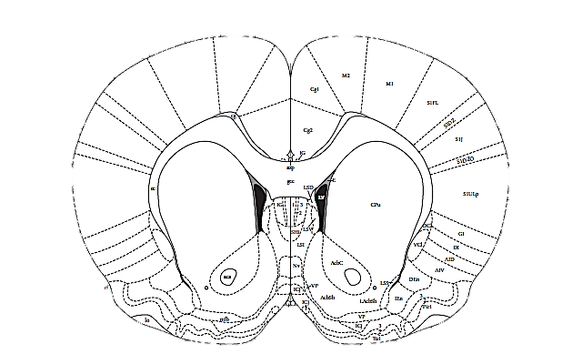
Figure 2

Figure 3
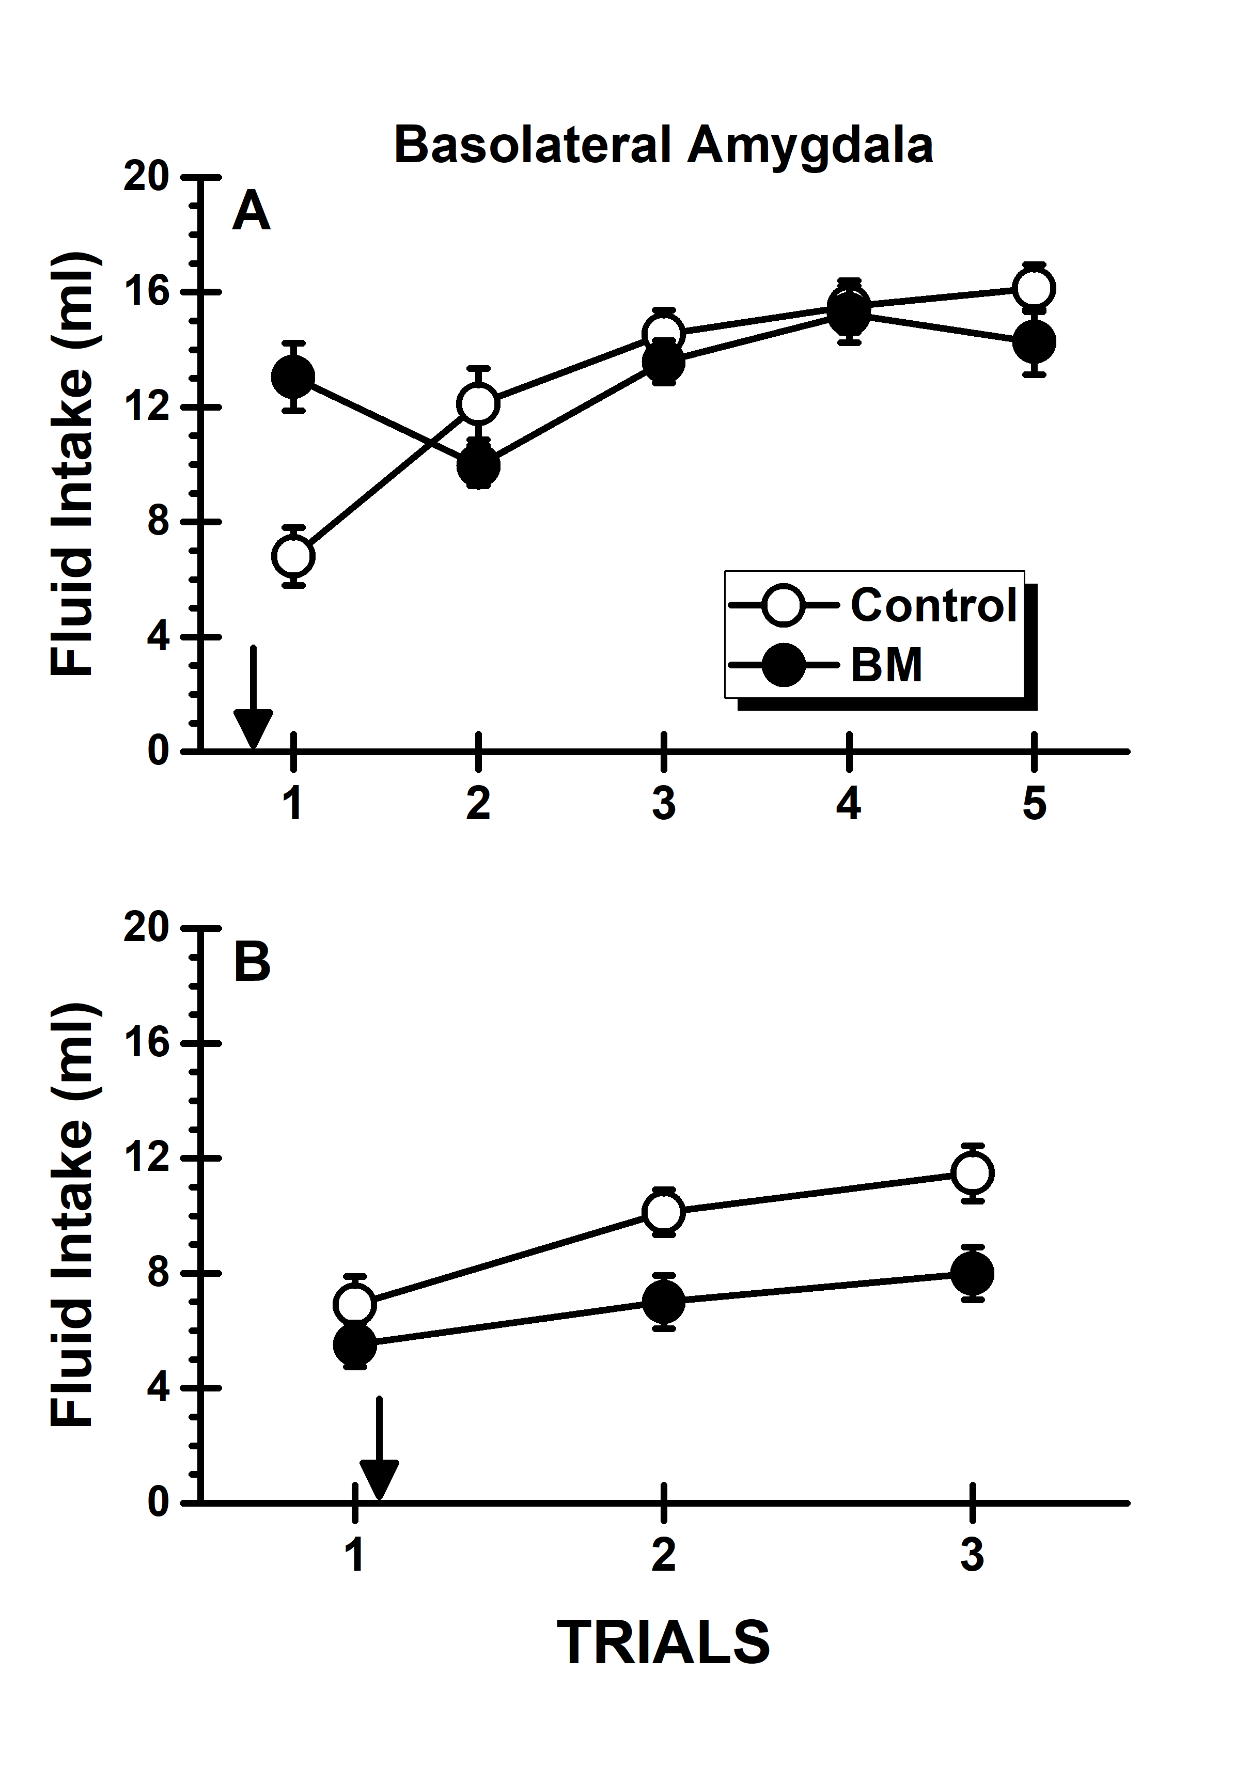

Figure 4
