On the Role of Nbp35 in Cytosolic Iron-Sulfur Assembly

BY
KELLY A. GAY
B.A., Biochemistry, Smith College, 2003

THESIS
Submitted as partial fulfillment of the requirements
for the degree of Doctor of Philosophy in Microbiology and Immunology
in the Graduate College of the
University of Illinois at Chicago, 2014
Chicago, Illinois

Committee Members

Dr. William E. Walden, Chair and Advisor
Dr. Karl Volz, Dept of Microbiology and Immunology
Dr. Nancy Freitag, Dept of Microbiology and Immunology
Dr. Bin He, Dept of Microbiology and Immunology
Dr. Marcelo Bonini, Dept of Pharmacology
To the memory of my mother, who believed, without reservation, that I could do anything. And who loved me like a rock. Rest in peace.

To my husband, Stephen, whom I love more today than yesterday.
And to my children, Rowan (and now Caitlin too) and Dylan, to whom I hope I am an example. Pursue your dreams with dedication, hard work, and clear vision. All my love.

To paraphrase many great thinkers, it is not the path which defines success, rather the ability to continue on the path with discipline, enthusiasm, fidelity, and grace, despite an occasional loss of direction or velocity.

Acknowledgements

It is with deepest respect and appreciation that I thank my advisor, Dr. William E. Walden, for the opportunity to complete my thesis in the Walden Lab. Thank you for your support and guidance, and for the opportunity to study a remarkable system. If I am a competent independent investigator, it is in great part due to you and your influence.
I would like to acknowledge past and present Walden Lab members; especially A.K. Sharma, L.J. Pallesen, and R.J. Spang, for providing yeast strains, plasmids, template DNA, and established protocols, and for insightful discussions. Thank you for an enjoyable environment to do science - for many late nights, working in the lab with good music and good company. Thanks also to Jeremiah Furman for valuable lab support and a positive attitude. Best of luck to you all.
I would also like to acknowledge the Department of Microbiology and Immunology, in particular Dr. Prabhakar and Dr. McLachlan, for allowing me to complete my degree in this department. I remain eternally grateful for the opportunity, and for your encouragement and advice.
Thank you to my committee members for their advice and assistance in completing this work. In particular, thank you to Dr. Karl Volz and to Dr. Nancy Freitag for helpful discussions.
Lastly, but not in any way least, I would like to thank my in-laws, Dr John and Dr. Judith Gay, for their support and encouragement in continuing my education. And my husband and children, for their love and patience, especially while separated by a thousand miles. Thank you and all my love.

TABLE OF CONTENTS
CHAPTER PAGE
I. LITERATURE REVIEW 1
A. Introduction 1
B. FeS Clusters – Versatile Protein Co-factors 2
1. Physiochemical Versatility and Biological Roles 2
2. Relevance to Human Health 9
C. FeS Biogenesis 10
1. The Biological Imperative for a Dedicated FeS Machinery 10
2. The Prokaryotic NIF Machinery for Nitrogen Fixation 12
3. The Prokaryotic and Eukaryotic ISC Machineries 12
4. The Prokaryotic and Plastidal SUF Machinery 13
5. The Eukaryotic CIA Machinery 14
6. Universal Requirements for FeS Biogenesis 15
7. Possible Sources of Iron 17
8. The Biological Mobilization of Sulfur 18
9. The Role of Electrons 19
10. The Role of FeS Scaffolds 19
11. A Model for Fe₂S₂ and Fe₄S₄ Assembly by a Scaffold 21
12. Role of Nucleotide Binding and Hydrolysis in FeS Biogenesis 24
13. Requirement for FeS Proteins in Metallo-Cofactor Assembly 27
14. Summary 31
D. The CIA System 31
1. Background and Biological Significance 31
2. Dependence on the ISC and Mitochondrial Export Systems 44
3. Grx3/4 - A Potential Intermediary Between the ISC and CIA Systems 45
4. Dre2:Tah18 – A Cytosolic Electron Transport Chain 49
5. Nbp35:Cfd1 – The Molecular Scaffold for FeS Assembly/Transfer 51
6. Nar1 – An Intermediary Between Early and Late CIA 66
7. Cia1/2 and Mms19 – A “Late CIA Targeting Complex” 68
8. A Model for the Mechanism of FeS Assembly by the CIA System 71
TABLE OF CONTENTS (continued)
CHAPTER PAGE
II. MATERIALS AND METHODS 77
A. Design and Rationale 77
B. Yeast Strains 78
C. Plasmid Constructs and Site-Directed Mutagenesis 79
D. Culture Conditions and Media 83
E. Viability 83
F. Glutamate Auxotrophy 84
G. c-Aconitase Activity 84
H. Co-Immunoprecipitation 84
I. ⁵⁵Fe Immunoprecipitation (Pulse and Steady-State Radio-labeling) 85
III. THE ROLE OF NBP35 P-LOOP AND SWITCH I RESIDUES 87
A. Introduction – P-Loop Lysines and Switch I Aspartic Acids 87
B. Results 90
1. Requirement for the Nbp35 NTPase Domain in Yeast 90
2. Effect of Mutation at G80 on Nbp35 Function in Yeast 94
3. Select P-Loop and Switch I Mutations are Inhibitory to Growth 101
4. Effect of Inviable P-Loop and Switch I Mutations on Nbp35 Function 104
C. Discussion 113
IV. THE ROLE OF NBP35 “SIGNALING HELIX” RESIDUES 123
A. Introduction – The ‘Signaling Helix’ in SIMIBI NTPases 123
B. Results 133
1. Helix Residues are Required for Nbp35 Function in Yeast 133
2. Effect of Helix Mutation on Nbp35 Complex Formation 139
3. Effect of Helix Mutation on Iron Binding by Nbp35 141
C. Discussion 144
TABLE OF CONTENTS (continued)
CHAPTER PAGE
V. CONCLUSIONS AND FUTURE PERSPECTIVES 150
CITED LITERATURE 157
VITA 208
LIST OF TABLES
TABLE PAGE
I. EXTRA-MITOCHONDRIAL FES PROTEINS IN HUMANS 35
II. PLASMIDS USED FOR THESE STUDIES 80
III. MUTANT PLASMIDS GENERATED FOR THESE STUDIES 81

LIST OF FIGURES
FIGURE PAGE
1. FeS Clusters 3
2. Universal requirements for FeS cluster biogenesis 16
3. Compartmentalization of FeS biogenesis in eukaryotes 32
4. Mammalian IRP1 is a dual function protein 39
5. (A) Crystal Structure of PDB 3KB1 53
5. (B) Nbp35 and Cfd1 protein schematics and sequence alignments 54
6. Comparison of homo-dimeric SIMIBI NTPases 61
7. FeS Assembly by the Cytosolic Iron-Sulfur Assembly System 72
8. Nbp35 protein schematic and sequence alignment 91
9. Complementation of viability in yeast by plasmid shuffle 93
10. (A) Ability of Nbp35 G80 mutants to complement glutamate auxotrophy 95
10. (B) Ability of Nbp35 G80 mutants to complement c-aconitase activities 95
11. (A) Effect of G80 mutations on complex formation with Nbp35^{WT} 98
11. (B) Effect of G80 mutations on complex formation with Cfd1 98
12. Effect of G80 mutations on iron binding by Nbp35 98
13. (A) Growth inhibition on selective plates 102
13. (B) Growth inhibition in liquid selective media 103
14. (A) Effect of Nbp35 mutation on complex formation with Nbp35^{WT} 105
14. (B) Effect of Nbp35 mutation on complex formation with Cfd1 105
15. (A) Rapid acquisition of iron by Nbp35 mutants 108
15. (B) Kinetics of iron binding by K81A 109
15. (C) Steady-state iron binding to Nbp35 mutants 110
16. Effect of Nbp35 mutation on stable expression of Nar1 112
17. (A) Conservation of HELIX²²¹ in SIMIBI NTPases 125
LIST OF FIGURES (continued)
FIGURE PAGE
17. (B) Nbp35 Schematic and Sequence Alignment for Helix²²¹ 126
18. (A) Ligand Plot for Get3 Bound to ADP-AIF (PDB WOJ) 128
18. (B) Ligand Plot for Af_226 Bound to ADP (PDB 3KB1) 129
18. (C) Ligand Plot for MinD Bound to ATP (PDB 3Q9L) 130
19. (A) Ability of Nbp35 helix mutants to complement viability 135
19. (B) Plasmid shuffle on 5-FOA for isolation of viable Nbp35 mutants 136
20. (A) Ability of Nbp35 helix mutants to complement c-aconitase activities 138
20. (B) Ability of Nbp35 helix mutants to complement glutamate auxotrophy 138
21. (A) Effect of helix mutation on complex formation with Nbp35^{WT} 140
21. (B) Effect of helix mutation on complex formation with Cfd1 140
22. Effect of helix mutation on iron binding by Nbp35 143
23. Crystal structure of Af_226 bound to ADP as a monomer 148

LIST OF ABBREVIATIONS
FeS Iron-Sulfur
NTPase Nucleotide Tri-Phosphatase
Nbp35 Nucleotide Binding Protein of 35 kilodaltons
Cfd1 Cytosolic FeS Deficient 1
SIMIBI Signal recognition particle, MinD, and BioD
ROS Reactive Oxygen Species
RNS Reactive Nitrogen Species
SAM S-Adenosyl Methionine
GSH Glutathione
IRP1 Iron Regulatory Protein 1
TCA Tri-Carboxylic Acid
UTR Un-Translated Region
TZD Thiazolidinedione
Grx Glutaredoxin
BER Base Excision Repair
NER Nucleotide Excision Repair
NIF Nitrogen Fixation
ISC Iron-Sulfur Cluster
SUF Sulfur mobilization
CIA Cytosolic Iron-sulfur cluster Assembly
CSD Cysteine Sulfinate Desulfinase
MLO Mitochondrion-Like Organelle
LIST OF ABBREVIATIONS (continued)
PLP Pyridoxal 5’-Phosphate
ABC ATPase Binding Cassette
OAS Oligo-Adenylate Synthetase
APP Amyloid Precursor Protein
CISD CDGSH Iron-Sulfur Domain
LECA Last Eukaryotic Common Ancestor
SNP’s Single Nucleotide Polymorphisms
IMS Inter-Membrane Space
Dre2 Derepressed for Ribosomal protein S14 Expression
Tah18 Top1T722-A mutant Hypersensitive
MTOC Micro-Tubule Organizing Center
Nar1 Nuclear Architecture-Related 1
Cia1/2 Cytosolic Iron-sulfur Assembly factors 1 and 2
ORF Open Reading Frame
TSM Translation Start codon Mutation
CEN Centromeric sequence
ARS Autonomously Replicating Sequence
MCS Multiple Cloning Site
MET Methionine
5-FOA 5-Fluoroorotic Acid
NBT Nitro Blue Tetrazolium chloride
BCIP 5-Bromo-4-Chloro-1H-Indol-3-yl) dihydrogen Phosphate
LIST OF ABBREVIATIONS (continued)
BIP 2,2-Bipyridyl
P-Loop Phosphate-binding Loop

SUMMARY
Iron-sulfur (FeS) clusters are perhaps the most structurally and functionally versatile of all protein cofactors, and cluster biogenesis is essential to life. Apbc/Nbp35 P-Loop NTPases are required for FeS biogenesis in virtually all organisms from archaea to humans, and are proposed to function as a scaffold for assembly of nascent cluster. Nbp35 functions independently in numerous organisms. However, Nbp35 functions in hetero-complex with the homologous NTPase Cfd1 in yeast and higher eukaryotes, leading to questions regarding the specific roles of these proteins in cluster assembly. Therefore, these investigations focused on the role of nucleotide binding and hydrolysis by Nbp35 in extra-mitochondrial FeS assembly, in the model organism Saccharomyces cerevisiae.
In order to investigate the role of Nbp35 in cluster assembly, conserved residues within cognate NTPase motifs were targeted by directed mutagenesis, and the ability of these variants to complement the wild-type protein was assessed in vivo. These investigations confirm a requirement for the nucleotide domain in Nbp35 physiological function, and provide additional insight into the role of Nbp35 activities in FeS cluster assembly. Although stably expressed and competent for complex formation, these mutants were defective for the acquisition of iron, as assessed by in vivo radio-labeling. Of note, each Nbp35 monomer binds a stable FeS cluster, required for physiological function. Results presented herein suggest that Nbp35 activities may be required for self-maturation, prior to the assembly of labile cluster for transfer.
Nbp35 is a member of the SIMIBI family of P-Loop NTPases, which function as obligate dimers, and share significant architectural and mechanistic similarities. These investigations additionally identify a helical region conserved in this family of NTPases, and confirm a requirement for residues within this region for Nbp35 function in yeast. These results extend a requirement for this region to Nbp35, suggesting that this region may constitute an additional conserved feature in the SIMIBI family.
Collectively, these results demonstrate that Nbp35 activities are required for the acquisition of iron by Nbp35 and the Npb35:Cfd1 hetero-complex. These investigations confirm a requirement for the Nbp35 nucleotide domain in the assembly of extra-mitochondrial FeS clusters in yeast. Furthermore, these results provide additional evidence that Nbp35 functions as an ATPase, with similarities to other SIMIBI NTPases, and suggest additional avenues for further investigation.

CHAPTER I: LITERATURE REVIEW
A. Introduction
Iron sulfur (FeS) clusters are ancient and ubiquitous protein cofactors required for fundamental processes throughout the cell, including aerobic respiration, co-factor assembly, intermediary metabolism, protein biosynthesis, and genome expression and integrity (1-5). FeS proteins play essential roles in virtually all organisms. In addition, FeS proteins are required for the global nitrogen, carbon, and hydrogen cycles (6-10). Abiotic FeS clusters may have played a foundational role in the emergence and evolution of life on earth, further underscoring the importance of these co-factors, and their biogenesis (11,12). FeS clusters can assemble spontaneously; however, the requisite concentrations of iron and sulfur would likely be toxic in vivo. Therefore virtually all organisms encode dedicated systems for FeS biogenesis, and these systems are essential for life (13-23). Although distinct systems have evolved in different organisms and cellular compartments, all cluster assembly systems appear to conserve fundamental mechanistic features including sources of iron and sulfur, and a scaffold for the assembly of nascent cluster. The major bacterial and eukaryotic systems for cluster assembly have been extensively studied and reviewed (2,5,24-33). However, new FeS proteins, and novel roles for known ones, continue to be discovered. Additionally, research into the biological assembly of extra-mitochondrial FeS clusters in eukaryotes is a rapidly growing field.

FeS proteins are required for numerous processes in human cells, and defects in these proteins, and in cluster biogenesis, are associated with complex, wide-ranging pathologies including diabetes, cardiovascular disease, neuro-muscular disorders, and numerous cancer syndromes (4,5,34-75). Recent studies have uncovered novel roles for human FeS proteins in DNA replication and repair (76,77), the innate immune response (78), and in the differentiation and development of multi-cellular organisms (79-84). Insight into the plethora of physiological roles played by FeS clusters, and the biological imperatives for their assembly, will lead to a deeper understanding of their roles in human cellular processes and pathologies. Therefore, this review will summarize our current understanding of the physiochemical features contributing to the versatility of FeS clusters, the physiological roles they play, and the mechanisms for their biogenesis, with an emphasis on these processes in eukaryotes. However, examples from bacteria have been included in order to illustrate specific points.
B. FeS Clusters – Versatile Protein Co-factors
1. Physiochemical Versatility and Biological Roles
FeS clusters are among the most structurally and functionally versatile of protein cofactors (1,2). They can range from simple Fe₂S₂ clusters to Fe₈S₇ or Fe₇S₉ clusters, adopt unique geometries or protein coordination, and incorporate additional elements or complex moieties (Figure 1).

Figure 1. FeS Clusters. Model of a simple rhombic Fe₂S₂ cluster, the cubane Fe₄S₄ cluster, and the complex Fe₇S₉ cluster (M cluster) from the Nitrogenase MoFe protein. The MoFe M cluster is one of the most complex metallo-cofactors in nature, and incorporates an additional molybdenum moiety and a centrally coordinated carbide atom.

Clusters can be buried within the protein core or solvent accessible, and may be stably or transiently bound. Proteins and protein complexes often employ multiple clusters, which may perform distinct or coordinate functions. For example, FeS clusters are integral to oxidative respiration, with as many as 12 clusters shuttling electrons through respiratory complexes I-III (65,85-90), depending on the organism. FeS clusters are widely utilized for electron transport, as electrons are readily de-localized over both iron and sulfur, and cluster potentials can be tuned over large ranges in response to the micro-environment (91,92). However, their structural diversity and biochemical sensitivity additionally allow FeS cofactors to participate in redox and non-redox catalysis, contribute to structural stability, regulate protein function, and respond to environmental conditions/cues (1,2,35,93-102).
The simplest and most common FeS clusters are the rhombic Fe₂S₂ and cubane Fe₄S₄ types. More complex clusters are generated via reductive coupling of two smaller clusters, and/or the incorporation of additional metal ions (103,104), Fe centers (105,106), or other complex moieties (107-109). Canonically, FeS clusters are tetrahedrally ligated via cysteine residues. Additional amino acids (histidine, arginine, aspartic acid, serine), the amide backbone, or other moieties (H₂O, citrate, GSH, SAM, CO, or CN⁻) can also serve as ligands for FeS clusters (91). These structural modifications and alternative coordination strategies allow proteins to finely tune the stability, bioreactivity, and/or redox properties of each cluster, and contribute to the exceptional functional versatility of FeS co-factors (2,110). Ligand swapping can also occur, inducing local and/or global protein rearrangements, and dramatically altering cluster environment and character; disulfide reductases, including plant ferredoxin:thioredoxin reductases, utilize an FeS cluster to control disulfide reduction via formation of transient thiolate-cluster ligands (111,112). The ability to swap ligands may be particularly critical for the assembly of FeS on a molecular scaffold, in order to stably accommodate a growing cluster, then efficiently transfer the mature cluster to an appropriate target (113-115).
Given their unparalleled physiochemical plasticity and sensitivity, FeS clusters are ideally suited for responding to a range of environmental cues. FeS proteins are important for maintaining iron and redox homeostases (96,101,116-119), and for responding to small moieties and external stimuli, including metals and ROS and RNS (93), microbial and viral infections (78,120), and specific wavelengths of light (121,122). In many instances, cluster occupancy and/or cluster-dependent complex formation determine the specific response to a given stimuli. For example, IscR is a transcriptional regulator of FeS assembly and iron-responsive genes in bacterial cells. Although both apo- and FeS-IscR bind elements in DNA, the two forms activate different subsets of genes. Therefore cluster occupancy directly regulates gene expression in response to iron and FeS availability (123). IscR additionally controls expression of virulence genes in human bacterial pathogens, including Vibrio species and Pseudomonas aeruginosa, suggesting a broader role in the bacterial adaptation to iron stress, including iron-sequestration by the human host (124,125).
The recently discovered CDGSH-domain family (containing the consensus sequence [C-X-C-X2-(S/T)-X3-P-X-C-D-G-(S/A/T)-H]) of proteins also utilizes a dynamic FeS cluster for function. CDGSH-domain proteins are widely distributed in all kingdoms of life, and conserved to humans (126). Although their precise functions are unknown, these proteins appear to play a role in metal and redox homeostases (66,69,127-129). CDGSH proteins bind an FeS cluster, uniquely ligated via two non-cysteinyl histidine residues, which becomes unstable under acidic and oxidative conditions. It has been suggested that cluster occupancy contributes to the sensing functions of these proteins, including human MitoNEET. MitoNEET has recently gained attention as a validated target of the thiazolidinedione (TZD) class of anti-diabetes drugs, whose mechanism of action appears to involve stabilization of the iron and redox responsive FeS cluster (35).
A surprising number of FeS proteins are involved in DNA and RNA metabolism and repair, and in the regulation of gene expression, via direct interaction with nucleotide (67,130-134). In many cases, the role of the FeS cluster is unknown. In several instances the stable, non-redox active cluster is proposed to play a structural role, either in stabilizing connections between distinct protein domains, or in distorting and positioning DNA for base removal (135-138). However, an intriguing hypothesis has emerged regarding the role of the redox active FeS cluster in a large family of FeS DNA glycosylases and helicases engaged in various aspects of DNA metabolism from replication, recombination, transcription, and repair, to chromatin remodeling, chromosome segregation, and telomere maintenance (133,134).
Accumulating evidence demonstrates that the cluster in these enzymes senses disruptions in charge transfer along intact DNA, due to lesions occurring during replication, or as a result of DNA damage (139-142). Collectively, results suggest these proteins may communicate with each other via DNA-dependent changes in FeS redox potential in order to scan for lesions or distortions in DNA. These proteins then coordinately localize to regions of substrate DNA, where they may displace or recruit other proteins, or even repair oxidative DNA damage directly, via FeS-mediated electron transfer (143). Of note, mutations to these genes are associated with human pathologies including accelerated aging, neuro-degenerative disorders, and cancers, and several clinically relevant variants have been shown or are predicted to affect cluster binding (67,68,75,132,144-146).
FeS clusters can also be ligated via residues from more than one polypeptide, forming a “bridging” cluster at a protein interface. This composite arrangement is seen in a number of glutaredoxins (Grx’s) involved in FeS biogenesis, iron trafficking, and iron and redox homeostases, including yeast Grx3/4 (147-149). Grx3 and 4 form an FeS bridged heterodimer, with two molecules of glutathione (GSH). The FeS cluster is (or at least can be) coordinated via one thiol from each monomer, and one from each molecule of GSH. Grx4 is not conserved to humans, but Grx3 (PICOT in humans) is required for FeS biogenesis and iron trafficking in humans, although the mechanisms by which it participates in these processes remain undetermined (148,150). Of note, FeS bridged complexes are also formed by members of the ApbC/Nbp35 family of proteins, required for FeS assembly, where the labile, bridging cluster is destined for apo-proteins (151).
This is only a small sampling of the wide-ranging physiochemical functions of these adaptable protein co-factors. For example, FeS clusters play newly discovered roles in light-sensing by bacterial cells, including transcriptional regulation in Actinobacteria species (121,152), and the light-dependent modulation of circadian rhythm in cyanobacteria (122). FeS clusters play other specialized roles in extremeophiles, directly contributing to their ability to inhabit unique environmental niches (153). Identification of FeS proteins is often complicated by expression in heterologous systems and/or aerobic purification, as these proteins may not be properly matured in exogenous organisms, or may lose a cluster due to oxidative decomposition (154-157). For example, it was only recently discovered that all three eukaryotic replicative polymerases (Polα, δ, and ε) are FeS proteins, and that these clusters are essential for physiological function (130). However, new FeS proteins, and newly discovered functions for previously known FeS proteins, continue to be identified and characterized.

2. Relevance to Human Health
It is increasingly apparent that FeS clusters, and their biogenesis, are critically important to human health (4,5,27,61,65,68,158,159). FeS proteins are implicated in the uptake of aminoglycoside antibiotics by bacterial cells, and in their primary mechanism of bactericidal action (97,160). Furthermore, disruption of FeS biogenesis or damage to FeS proteins may contribute to the well-documented toxicity associated with clinical use of these drugs (161,162). Proteins required for FeS assembly are being actively pursued as targets in infectious diseases, including tuberculosis and malaria (163-165). FeS clusters have been identified as primary targets of ROS and RNS (94,98,166) and other reactive species, including metals (100,102), in organisms from bacteria to humans, and may be a key factor in their toxicities. FeS-nitrosylation is an important regulatory signal, and Di-Nitrosyl Iron Complexes (DNIC) may have clinical utility as enzymatic activators of pro-drugs, including promising new anti-proliferatives (167-169). In addition, low-molecular weight DNIC may act as nitric oxide (NO) donors, and mimic the activities of endogenous NO (170,171). These moieties may have broad therapeutic potential as effective vasodilators, anti-proliferatives, or cyto-toxic agents. Human FeS proteins also play a critical, emerging role in the innate immune response to bacterial and viral infections (78,120), further underscoring the relevance of FeS cofactors to human health.
Genomic instability and accumulating damage are hallmarks of normal aging and cancer, and FeS biogenesis has been directly linked to the replication and maintenance of the genome in human cells (131,172,173). Defects in FeS proteins and FeS biogenesis are associated with wide-ranging and complex pathologies, including cardiomyopathies (42,54,174,175), diabetes (43,69), muscular and neuro-degenerative disorders (34,176,177), ataxias (46), premature aging syndromes (40,45,47,57,62,67,75,175,178,179), and cancers (45,47,48,57,66,72-75,180-182). Additionally, recent studies have uncovered novel roles for FeS proteins/biogenesis in maintaining planar cell polarity, and in the differentiation and development of multi-cellular organisms, including humans (79,82-84,183,184). Much is known about the biological assembly and targeting of FeS clusters. However, additional insight into the mechanisms and regulation of FeS biogenesis will undoubtedly lead to a deeper appreciation of the importance of these versatile protein cofactors to human health, and new FeS-targeted therapies for human disease.
C. FeS Biogenesis
1. The Biological Imperative for a Dedicated FeS Machinery
FeS clusters can assemble spontaneously, given sufficient concentrations of iron, sulfur, and reducing equivalents (185,186). There is compelling evidence to suggest that FeS clusters arose abiotically, at hydrothermal vents, and were instrumental in the genesis and diversification of life on earth (11,12,187). Certainly they were among the earliest of protein co-factors; recent analyses indicate that primordial membranes contained sites, or “nests” for both phosphate (GTP) and FeS binding, and that these groups were likely utilized as “key components of the earliest metabolism…at the very dawn of life” (188). However, organisms have evolved dedicated systems to optimize and regulate cluster assembly, and virtually all organisms, from archaea to humans, conserve dedicated systems for FeS biogenesis. Four distinct systems, the Nitrogen Fixation (NIF) (189,190), the generalized Iron Sulfur Cluster (ISC) (23), the Sulfur mobilization (SUF) (191), and the Cytosolic Iron-sulfur cluster Assembly (CIA) machineries (192), have been shown to catalyze the assembly and targeting of biological FeS clusters, operating, and cooperating, in various organisms and cellular compartments (21,191,193-195). The prokaryotic systems are encoded as operons, underscoring their cooperative and systemic nature. Prokaryotes additionally encode the recently discovered Cysteine Sulfinate Desulfinase (CSD) machinery (196), which may provide an alternative pathway for sulfur acquisition by bacterial SUF systems and/or may utilize an unknown CSD-specific scaffold as a fifth, novel FeS assembly system. CSD activities appear to be associated with bacterial motility; however, the physiological targets and relevance of this system remain elusive. Although Archaea encode homologs of various assembly components (197,198), the mechanisms of archaeal FeS assembly are not well understood.
2. The Prokaryotic NIF Machinery for Nitrogen Fixation
The existence of the NIF system was discovered in the late 1980’s (189,190), during investigations into the mechanisms for maturation of nitrogenase, the complex enzyme responsible for the biological fixation of molecular nitrogen (199,200). Thus nitrogenase and the NIF system are critical to nitrogen cycling, and the global food chain (7). Seminal studies of the NIF system in Azotobacter vinlandii revealed the biological imperative for a dedicated FeS machinery, and provided a foundational understanding of the mechanisms of FeS biogenesis (2,189,190). The NIF system specifically operates in anaerobic microorganisms, including azototrophs, which require complex FeS cofactors to reduce atmospheric nitrogen (N₂) for utilization as a physiological nitrogen source. However, components of the NIF system have additionally been found in non-nitrogen-fixing microorganisms lacking an ISC machinery, including pathogenic parasites such as Entamoeba histolytica (26,201,202). Therefore, some NIF proteins have become attractive targets for novel anti-protozoals (24,26,203).
3. The Prokaryotic and Eukaryotic ISC Machineries
Genetic analyses revealed the presence of the ISC system, which functions as a generalized FeS assembly system in prokaryotic and eukaryotic organisms (21,23,204). The eukaryotic ISC machinery functions in the mitochondria (193,205), and in the “relict” mitochondrion-like organelles (MLOs) of amitochondriate protozoans (26,28). The ISC system is highly conserved, and the core constituents are essential for life from bacteria to human cells, underscoring the biological imperative for FeS biosynthesis (5,17,20,38,61,63,158,205,206). With few exceptions, primarily from Archaea, all organisms encode for a core ISC machinery, consisting at least of an FeS scaffold protein and cysteine desulfurase (IscU and IscS). IscU is one of the most highly conserved of all gene products (207), further highlighting the critical and conserved nature of FeS biosynthesis. In fact, there is some evidence to suggest that FeS biogenesis may be the only truly essential function of mitochondria and MLO’s (16,17,26,28). Although isolated ISC components have been localized to the cytosol and nucleus of eukaryotic cells (208-211), the physiological significance of this finding is not known.
4. The Prokaryotic and Plastidal SUF Machinery
The SUF machinery is conserved in many prokaryotes, where it functions primarily under oxidative stress and iron deprivation (21,191,204), and in the plastids of higher plants and plastid-bearing protists (24,26,212), including the causative agent of malaria, Plasmodium falciparum and related species. Recent studies demonstrate that SUF-mediated FeS biosynthesis is required for maintenance of the apicoplast and parasite viability (163,164), and suggest that FeS and isoprenoid biosyntheses are the only essential function of the apicoplast during the blood stages of Plasmodium lifecycle. Several components of the SUF system bear little homology to their counterparts in the eukaryotic machineries, and are being actively pursued as promising targets of novel antibiotics and anti-malarials (24,26,163,164,166). Intriguingly, despite little homology between the two systems, the SUF system can partially complement the ISC system in some prokaryotes where they co-exist (21,191,204), explaining the non-essential nature of the ISC system in these organisms.
5. The Eukaryotic CIA Machinery
In eukaryotes, the mitochondrial ISC system is required for assembly of all cellular FeS clusters (14,16-19,194,205). However, the CIA machinery is additionally required for maturation of extra-mitochondrial FeS proteins (29,31,192,213-215). CIA activities depend upon export of at least one uncharacterized signal or substrate from a functional core ISC machinery (193,216-218). The sub-cellular compartmentalization of FeS assembly may facilitate the maturation of FeS proteins in various micro-environments, and/or the coordination of metabolic processes with metabolite availability and flux (211,219,220). Targets of the CIA system include essential proteins required for protein biosynthesis and nucleotide metabolism and repair, including all three major eukaryotic polymerases, only recently identified as FeS proteins (67,130,131,133,134,172). While the mitochondrial ISC machinery is relatively well characterized, the mechanism of cytosolic cluster assembly has not been clearly elucidated. However a model is beginning to emerge as individual factors required for CIA have been identified and characterized, particularly in the model organism, Saccharomyces cerevisiae.

6. Universal Requirements for FeS Biogenesis
As described, distinct FeS assembly systems have evolved in different organisms and cellular compartments. However, all systems appear to share fundamental mechanistic features and universal requirements for FeS biogenesis (2,20,21,205), including sources of iron and sulfur, electrons, and a scaffold protein for the assembly of cluster (Figure 2). All known systems additionally require the activities of accessory proteins, including NTPases, heat shock proteins, or other chaperones to facilitate the protein-assisted transfer of nascent cluster from the scaffold to appropriate apo-targets. In some cases these accessory proteins assist in the differential maturation of distinct sub-sets of apo-proteins, or they may enhance transfer of the mature cluster from the scaffolding complex.

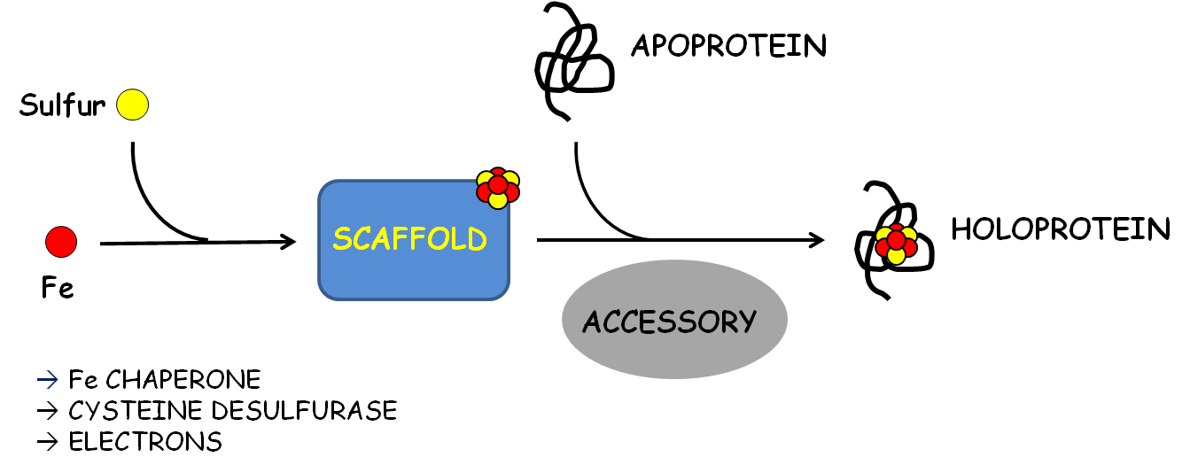
Figure 2. Universal requirements for FeS cluster biogenesis. All cluster assembly systems require cellular sources of iron and sulfur, and electrons for the reduction of liberated sulfide. All systems require a molecular scaffold for the de novo assembly of nascent cluster, and accessory proteins for the efficient targeting and transfer of FeS to the appropriate apo-proteins. Iron (Fe) is depicted as a RED CIRCLE, and sulfur as a YELLOW CIRCLE.

7. Possible Sources of Iron
The identity of the iron donor for FeS biosynthesis is still a matter of debate, but increasing evidence suggests that the iron-binding protein frataxin may act as a general source (221-225). For example, loss or inhibition of frataxin impairs FeS biogenesis via the ISC system in organisms from E. coli to humans (226-229). This includes the rare autosomal genetic disorder Freidriech’s Ataxia, caused by a partial loss of function in human frataxin, and characterized primarily by significant defects in cellular FeS biogenesis and the pathological distribution of iron (159,230,231). Frataxin and its orthologs have been shown to interact, both physically and functionally, with ISC and SUF scaffolding complexes in vitro, and in bacterial, yeast, plant, and mammalian cells (227,232-239). Of note, recent biochemical and spectroscopic analyses of the murine ISC scaffolding complex, with and without the addition of frataxin, suggest that frataxin may control the acquisition of iron for FeS assembly, at least in mammalian cells (240). Nevertheless, definitive in vivo confirmation of the role of frataxin in FeS assembly remains elusive. Additional candidates for iron donors include monothiol glutaredoxins (Grx’s) and small molecules such as glutathione; compelling evidence supports their roles in the mobilization of iron for cluster biogenesis (149,225,241-243), perhaps in addition, or as an alternative, to frataxin. However, again, their definitive physiological roles in FeS assembly have yet to be determined.

8. The Biological Mobilization of Sulfur
In contrast to iron acquisition, the biological mobilization of sulfur for FeS assembly is well-characterized, and requires the activities of a Pyridoxal 5’-Phosphate (PLP)-dependent cysteine desulfurase (IscS, using ISC nomenclature) (244-248). Desulfurases interact directly with the FeS scaffolding complex to provide the sulfur for cluster assembly. This reaction proceeds via formation of a persulfide intermediate from a conserved cysteine residue, and additionally requires a source of electrons, often ferredoxin, for reduction of the liberated sulfane during assembly on the scaffolding complex. Desulfurase activities are tightly controlled, and the rate of sulfur mobilization can be adjusted depending on the presence of additional factors in the scaffolding complex, including frataxin (232,236,239). All systems, with the exception of the CIA system, encode for a PLP-dependent cysteine desulfurase. The source of sulfur for extra-mitochondrial cluster assembly in eukaryotes is not known. However, as previously stated, CIA activities depend upon core elements of the ISC machinery, and a mitochondrial export system. In addition, there is evidence to suggest that this unknown signal or substrate may be a sulfur-containing moiety (249-252). And components of the mitochondrial ISC, including the IscS desulfurase, have been localized to the cytosol and nucleus of fungal and animal cells.

9. The Role of Electrons
FeS-Ferredoxins supply the electrons for FeS biogenesis in organisms from bacteria to humans, required for the reduction of sulfane to sulfide for cluster assembly (235,239,253-255). This requirement is well established for the ISC, SUF, and NIF machineries. However, it is possible that ferredoxin-mediated electron transfer is additionally required at other steps in the assembly or transfer of FeS. For example, electrons could be required for the mobilization of iron, the transfer of cluster, and/or the regeneration of scaffolding proteins. Bacterial ferredoxin is encoded in the ISC operon and cooperatively expressed with other components of the housekeeping ISC (22). Bacterial ferredoxin has been shown to bind directly to the IscS cysteine desulfurase, supply an electron for cluster assembly, and to be effectively displaced by frataxin (235). The orthologous yeast Yah1 protein comprises the electron transport chain for mitochondrial FeS assembly with the ferredoxin reductase, Arh1 (253). This function appears conserved to humans, as depletion of ferredoxins 1 or 2, or ferredoxin reductase, dramatically inhibits FeS biogenesis in human cells (255-257).
10. The Role of FeS Scaffolds
All FeS biogenesis requires a molecular scaffold for de novo assembly of FeS from iron and sulfur. The ISC, SUF and NIF assembly systems all encode for a U and/or an A-type scaffold, so designated based on homology to the proto-typical NifU and NifA type scaffolds (2). These proteins are proposed to function as monomers or dimers, capable of assembling one Fe₂S₂ cluster per monomer. Formation of a higher order scaffolding complex has been proposed, in order to provide a solvent-protected environment for cluster assembly. Again, the exception is the CIA system, which lacks a proto-typical U or A-type scaffold, and instead encodes for two homologous P-Loop NTPases, Nbp35 and Cfd1 (151,258). Nbp35 and Cfd1 are proposed to function in complex as the scaffold for assembly of extra-mitochondrial clusters in eukaryotes. This sub-family additionally includes the mitochondrial ISC factor Ind1, reportedly involved in the assembly or trafficking of FeS specifically targeted to the Complex I component of the mitochondrial respiratory chain, required for the oxidative phosphorylation of adenine to ATP (259,260).
Scaffold proteins are competent for rapid cluster reconstitution and transfer to apo-target in vitro (2,20,261). In fact, this is a standard test for classification as an FeS scaffold. Additionally, scaffolds interact directly with the designated cysteine desulfurase (or an intermediate source of sulfur), and are essential for cluster biogenesis by their respective systems. There is debate as to whether A-type proteins constitute true physiological scaffolds, or function as carrier proteins, which accept a pre-formed cluster from the resident house-keeping system for additional assembly and/or transfer to apo-target (262-267). However, the physiological reality may be that they are capable of functioning as both.
Scaffold proteins perform important functions in complex biosynthetic processes. They increase the effective concentrations of required partners and substrates by providing a hub for interactions, and accommodate unique biochemistry by co-localizing partners with distinct activities in a transient and highly coordinated manner (268,269). Scaffolds for FeS biosynthesis must coordinate the ordered interactions with cellular sources of iron, sulfur, and electrons, and stably accommodate a growing cluster with a dynamic electro-physical structure. They must then efficiently transfer this nascent cluster to the appropriate apo-targets, either directly, or via additional interactions with FeS chaperones. Perhaps not surprisingly, recent investigations suggest that scaffolding proteins do not play a passive role in cluster biogenesis (270-272). Rather, cluster assembly is a dynamic process, and scaffolding proteins appear to be active, and reactive, participants.
11. A Model for Fe₂S₂ and Fe₄S₄ Assembly by a Scaffold
Elegant structural, biochemical, and spectroscopic analyses of the ISC scaffold:desulfurase complex (IscU:IscS), from both prokaryotic and eukaryotic systems, have suggested a more complete, but evolving model for the de novo assembly of Fe₂S₂ cluster on a physiological scaffold (113-115,158,233,272-277). The apo-IscU scaffold appears to be partially disordered, but to adopt a more ordered conformation upon binding to the IscS cysteine desulfurase. Assembly initiates as sulfur is liberated and transferred to cysteine residues in the scaffold. Assembly proceeds as iron, an additional sulfur atom, and electrons are acquired, and the iron and sulfur atoms are rearranged to form a Fe₂S₂ cluster. Biochemical and crystallographic studies indicate that both ligand swapping and considerable conformational flexibility are required for the assembly of cluster by the scaffolding protein (278-280). Further analyses suggest that binding of the mature cluster induces additional conformational shifts, and stabilizes the scaffold in a highly structured state. These structural rearrangements recruit chaperones (the HscA-type ATPase, and HscB co-chaperone, from the bacterial ISC system), displace the desulfurase, and position the cluster for transfer via additional ligand swapping and increased solvent exposure (233,281-283). Binding to IscU and HscB synergistically increases the low basal ATPase activities of HscA by over 400-fold in vitro, suggesting that this is the catalytic transfer complex (284).
At this point, the Fe₂S₂ cluster can be directly transferred to an apo-target or intermediate carrier protein, via formation of a transient, cluster-mediated complex between IscU-HscA-FeS and a thiol from the proximal apo-protein (113,115,281,284-288). Consequent conformational shifts activate ATP hydrolysis by the HscA ATPase-chaperone and return the IscU protein to its disordered state, resulting in the efficient, protein-directed transfer of the mature cluster to the target protein, and release of the matured FeS-target. Finally, the bound ADP is exchanged for ATP, releasing the scaffold protein, and restoring both proteins to a catalytically ready state. Collectively, these results suggest that the physiological assembly of FeS on a scaffolding complex is more dynamic and complex than previously appreciated. Investigations of the bacterial NIF and SUF scaffolding complexes additionally support these findings of an active, conformationally dynamic scaffolding complex, and generally extend them to these systems (156,270,271,289). However, the SufS cysteine desulfurase interacts indirectly with the SufB scaffold protein through the intermediate sulfur carrier, SufE. Although not clearly elucidated and definitively established, it appears there may be a fundamentally conserved mechanism for the de novo assembly of Fe₂S₂ in vivo.
A mechanism for the assembly of Fe₄S₄ clusters is not as clearly elucidated. But it appears they can be formed on the same scaffold used to form Fe₂S₂ (273,290). FeS scaffolding proteins function as dimers, able to assemble two Fe₂S₂ clusters per catalytic unit. Evidence suggests that Fe₄S₄ clusters can be formed at the dimer interface via the reductive coupling of the two adjacent clusters. Of note, other proteins are required for the maturation of specific sub-sets of FeS proteins, including Fe₄S₄ proteins, and additional evidence suggests they may play a role in the assembly of these clusters (241,265,266,291-293). Perhaps most likely, there are distinct sub-pathways for the assembly of Fe₄S₄, membrane-bound, and other complex clusters, and for the maturation of distinct sub-sets of targets. Intriguingly, the scaffolds for the CIA system likely function as a hetero-tetramer, with two composite sites for assembly/binding of a labile cluster (151,258,294). Biochemical and spectroscopic investigations of the purified yeast proteins demonstrate that the hetero-tetramer is able to assemble two labile Fe₄S₄ clusters per catalytic unit in vitro. However the mechanism of assembly by Nbp35:Cfd1, and their physiological substrates, remain elusive.
12. The Role of Nucleotide (ATP) Binding and Hydrolysis in FeS Biogenesis
Although nucleotide binding and hydrolysis are not established universal requirements, they play essential roles in divergent assembly systems (23,295-300). The ISC system requires the activities of an HscA-type ATPase, from bacteria to humans. Bacterial HscA is not required for the de novo assembly of cluster on the scaffolding complex (285,301). Rather, ATP binding and hydrolysis are required for the efficient transfer of cluster and recycling of the catalytic scaffolding complex, as outlined above. Corresponding investigations of the orthologous yeast and human mitochondrial Hsc ATPases indicate that this role is functionally conserved to humans (281,302,303). Again, the human HscB-like co-chaperone (HSC20) preferentially binds the IscU-FeS scaffold with a mature Fe₂S₂, and recruits the HscA-like ATPase (mtHSP70), resulting in hydrolysis, transfer of FeS to an apo-target, and regeneration of the pre-catalytic state. An absolute requirement for both ATP and GTP has been shown for mitochondrial FeS biogenesis in the yeast S. cerevisiae; however, the role of GTP in mitochondrial cluster biogenesis remains undetermined (304,305).
In contrast, the ATP binding and hydrolysis activities of the non-homologous SufC ATP-Binding Cassette (ABC)-like ATPase may be required for the acquisition of iron by the SufB scaffolding complex. In vitro analyses of the purified proteins suggest that ATP hydrolysis has minimal effect on the transfer of cluster. While ATP binding appears to inhibit transfer to known carrier or target proteins, results suggest there may be differential effects, depending on the specific identity (intermediate carrier or apo-target) of the target protein (306). Instead, ATP binding and hydrolysis by SufC have been shown to enhance complex formation, acquisition of iron, and FeS assembly by the catalytically active SufB:SufC:SufD scaffolding complex (212,307,308). These results strongly suggest that ATP binding and hydrolysis may play distinct roles in different organisms and cellular compartments. Further, that distinct biochemistries may be required (that the mechanism of assembly may be tailored, or modified,) in order to optimize FeS biogenesis in different micro-environments.
The NIF system is specifically required for maturation of the complex metallo-enzyme Nitrogenase, and the biological fixation of nitrogen. Nitrogenase is comprised of multiple sub-units of the Nitrogenase Fe-only (NifH) ATPase and Molybdenum-Fe (MoFe) catalytic subunits (300,309-313). A NifH dimer binds two ATP and a stable, bridging Fe₄S₄ cluster, required for its dual functions in assembly of the complex MoFe co-factor, and in electron transfer to the catalytic MoFe core. The NIF system does not require an ATPase for the de novo assembly of Fe₂S₂ or Fe₄S₄ on the NifU:NifS scaffold, or for transfer of nascent Fe₄S₄ cluster to apo-NifH or intermediate scaffolds (NifB, NifE:NifN), required for the multi-step assembly of the M-cluster. In fact, the NIF system processes pre-formed Fe₄S₄ clusters, obtained from the resident ISC (265,300,314). Instead, ATP is required for electron transfer to the MoFe catalytic center, which uses these electrons to reduce nitrogen. And additionally, for final assembly of the complex M-cluster on the NifE:NifN intermediate scaffold, and efficient transfer of the mature M-cluster to apo-MoFe (310).
Crystallographic and biochemical analyses suggest that binding of NifH induces conformational rearrangements in NifE:NifN-Fe₈S₉ which position the cluster for insertion of Mo and homocitrate (315-317). Further, that ATP hydrolysis is required for M-cluster maturation, and for additional conformational shifts required for efficient transfer of the mature cluster, somewhat reminiscent of the HscA-type ISC ATPases (318). However, the role of NifH appears far more complex; NifH can act as a donor of Mo and homocitrate to the NifE:NifN-Fe₈S₉ intermediate in vitro (319). Additional biochemical and spectroscopic analyses suggest NifH may mobilize Mo for insertion into the Fe₈S₉ precursor by altering its electronic and/or ligation state, using ATP hydrolysis and its stably bound Fe₄S₄ cluster.
NifH is a member of the Signaling particle, MinD, BioD (SIMIBI) family of P-Loop NTPases (320). Intriguingly, several bacterial members of this small family are also involved in metal insertion, metal efflux, and the assembly of FeS or complex metallo-clusters. This includes UreG (321-324), required for nickel insertion into urease, CooC1, required for nickel insertion into the complex C-cluster of carbon monoxide dehydrogenase (325,326), ArsA, required for cellular efflux of arsenite and antimony (327-329), and HydF, the proposed scaffold for assembly of the complex H-cluster in FeFe-Hydrogenase (330-332).
This family also includes the ApbC/Nbp35 sub-family of proteins, required for FeS biogenesis from archaea to humans (30,197,258,333-338). Eukaryotic Nbp35 and Cfd1, the proposed scaffolding complex for FeS assembly by the eukaryotic CIA system, belong to this specific sub-class of SIMIBI NTPases. Although both proteins require a functional NT domain for biological function, definitive roles for nucleotide binding and hydrolysis in CIA have yet to be determined (151). Cumulative work suggests that there may be conserved mechanistic features for the biological mobilization and insertion of metals by SIMIBI NTPases (321,326,327,339-342). An appreciation of the molecular mechanisms and physiological roles of SIMIBI NTPases in other systems may provide valuable insight into the mechanisms of FeS assembly by Nbp35 and Cfd1 in the eukaryotic cytosol.
13. The Requirement for FeS Proteins in Metallo-Cofactor Assembly
A number of stable FeS proteins are recognized FeS assembly factors themselves, and are thus both FeS apo-targets and components of the same or co-existing FeS machineries (151,155,185,235,242,258,343). This does not include scaffold or carrier proteins known to transiently bind nascent clusters destined for delivery to target proteins. In many cases the precise function of FeS clusters in FeS biogenesis remain ambiguous or entirely unknown. However, these FeS clusters may be required for electron transfer, protein stability/structure, or regulation of protein function. They may catalyze the activation and/or insertion of Fe or sulfur, the de novo assembly of FeS on a scaffolding complex, and/or the transfer of nascent FeS to the appropriate downstream apo-targets. For example, FeS-Ferredoxins supply the electrons for FeS biogenesis in various organisms, as outlined above.
FeS proteins may also play a regulatory role in FeS biogenesis; a requirement for an intermediate or product of a biosynthetic pathway in the function of that pathway often indicates the presence of feedback inhibition or other regulatory mechanisms, at that particular step (344,345). FeS proteins play established roles in environmental sensing and the maintenance of cellular homeostasis in many systems and pathways, including FeS biogenesis. For example, the aforementioned FeS protein IscR, encoded as the first gene in the ISC operon, is a negative transcriptional regulator of ISC expression (123). However, when the need for FeS increases, particularly due to iron deprivation or changes in oxygen homeostasis, IscR loses its FeS cluster, and ceases to repress expression of the ISC. Apo-IscR also acts as a transcriptional activator of the bacterial SUF system under oxidative stress (124,125). Therefore as iron levels decrease, or oxygen increases, the equilibrium shifts toward apo-IscR, increasing expression of the ISC and/or SUF systems, as needed. Collectively, these studies suggest that IscR regulates FeS biogenesis via a complex feedback mechanism, based on changing metabolic requirements and environmental conditions. IscR is not conserved in the eukaryotic ISC system, and little is known about the regulation of FeS biogenesis in eukaryotic organisms. However, the presence of other FeS proteins in the eukaryotic ISC and CIA systems suggests the possibility of unidentified regulatory mechanisms involving specific steps in these systems.
Intriguingly, several components of the CIA machinery are identified as stable FeS proteins. In fact, of eight known CIA factors, three bind at least one stable FeS cluster required for physiological function in FeS biogenesis (155,192,213,258,294,343,346,347). In addition, FeS-Grx3/4 (or Grx3, PICOT in humans) are cytosolic mono-thiol glutaredoxins required for CIA activity. These proteins bind a bridging Fe₂S₂ cluster cooperatively, with two additional molecules of glutathione (149,150). They also form a larger complex with other proteins involved in iron sensing, at least in yeast (348,349). Grx3/4 are proposed to play a role in the mobilization of iron for CIA activities. However, their precise role in cluster assembly has yet to be determined. As these proteins play additional roles in maintaining cellular redox, and in iron trafficking to other systems, they are not strictly considered CIA factors (149,265).
Dre2 is a bone fide CIA factor. Dre2 binds two Fe₂S₂ clusters, with differential binding stabilities (215), and forms part of an electron chain required for the assembly of cluster on the CIA scaffold (346,347,350). Dre2 is one of very few extra-mitochondrial FeS proteins that do not require the CIA machinery for FeS maturation, but rely only on a functional mitochondrial ISC and export system (346). In fact, to my knowledge, Grx3/4 and Dre2 are the only extra-mitochondrial FeS proteins known to acquire their FeS independently of the CIA system (149). It is possible that these clusters originate with the mitochondrial ISC (351), although the mechanisms by which Grx3/4 and Dre2 obtain their clusters are not known. The CIA factor Nar1 does require upstream CIA proteins for FeS maturation, including Dre2 and the Nbp35:Cfd1 scaffolding complex (258,294,346). Nar1 is a protein with homology to bacterial Fe-only hydrogenases (213). Nar1 binds two Fe₄S₄ clusters, one more stably ligated than the other (155,343). The precise role of Nar1 and its FeS clusters remain obscure (19,155). However, Nar1 may be required for the effective transfer of mature cluster to the CIA FeS targeting complex, and/or regeneration of an active scaffolding complex.
Finally, Nbp35, the proposed scaffold for cytosolic and nuclear FeS biogenesis, has been shown to bind FeS at different sites, with differential stabilities (151,192,258,294,336). NBP35 and CFD1 both encode for a C-terminal CXXC motif, required for assembly of a bridging Fe₄S₄ cluster, likely destined for transfer to apo-targets. However, NBP35 additionally encodes for an N-terminal ferredoxin-like motif. Therefore an Nbp35 homo-dimer is able to bind three Fe₄S₄ clusters: one cluster coordinated via the N-terminal ferredoxin motif of each monomer, and one at the dimer interface, via the C-terminal CXXC motif. As Nbp35 binds both stable and labile iron, and ferredoxins generally bind FeS stably, it has been proposed that the N-terminal clusters are stably bound (258). CFD1 does not encode the N-terminal extension, and Cfd1 protein does not bind significant FeS in vivo, except in complex with Nbp35 (294). The role of the stable clusters on Nbp35 are not known; however, they are required for FeS biogenesis and the support of viability in yeast (151). Nbp35 FeS maturation reportedly requires the activities of the ISC machinery and the Dre2:Tah18 electron transport chain (192,347).
14. Summary
Seminal studies of the bacterial NIF system have provided the foundation for our understanding of biological FeS assembly and FeS-protein maturation. The bacterial and eukaryotic ISC and SUF machineries have since been extensively characterized, and comprehensively reviewed. However, the mechanism of FeS assembly by the CIA machinery is not as clearly elucidated, and has not been as extensively reviewed. Additionally, these investigations were focused on the role of Nbp35 activities in the assembly of extra-mitochondrial FeS clusters in yeast. Nbp35 is the proposed scaffold for FeS assembly by the CIA system. Therefore, the remainder of this review will focus on the significance and mechanisms of the CIA system.
D. The CIA System
1. Background and Biological Significance
Iron sulfur (FeS) clusters are perhaps the most structurally and functionally versatile of all protein cofactors. FeS proteins have been localized to the mitochondrion, cytosol, endoplasmic reticulum, and nucleus of eukaryotic cells (Figure 3), where they participate in diverse cellular processes, including

Figure 3 Compartmentalization of FeS biogenesis in eukaryotes. Cartoon of a eukaryotic cell showing the mitochondrial ISC and extra-mitochondrial CIA FeS assembly systems. The CIA system depends upon export of an unknown substrate or signal from the ISC. FeS proteins have been localized to the mitochondria, endoplasmic reticulum, and nucleus, where they participate in numerous cellular processes, as indicated.

ISC – Iron Sulfur Cluster assembly system
CIA – Cytosolic Iron-sulfur cluster Assembly system

aerobic respiration, intermediary metabolism, and the replication, expression, and maintenance of the nuclear genome (18,25,158,215).
Eukaryotes possess two distinct systems for cluster biogenesis (Figure 3). The mitochondrial ISC assembly system is required for assembly of all FeS clusters (19,205). However, maturation of extra-mitochondrial FeS proteins additionally requires the activity of the Cytosolic Iron-sulfur Assembly, or CIA system (215). CIA activities depend upon export of at least one uncharacterized signal or substrate from a functional core ISC machinery (193,216-218). Known targets of the CIA system include FeS proteins required for protein biosynthesis (352), iron and redox homeostases (126,214,353,354), nucleotide metabolism and repair (67,130-134), and the innate immune response (78,108,120). Defects in these proteins have been implicated in complex human pathologies, including diabetes, cardiomyopathies, neurodegenerative disorders, accelerated aging syndromes, and various cancers, underscoring the relevance of the CIA system to human health.
CIA targets include a surprising number of proteins required for DNA replication and repair, including primases (355), polymerases (130,356,357), nucleases, and helicases (Table I.1) (67,132,134,139,358). Extra-mitochondrial FeS proteins are required for almost every step of DNA metabolism, from the biosynthesis and recycling of purine and pyrimidine bases, to basal replication, Base and Nucleotide Excision Repair (BER and NER), histone acetylation, chromatin remodeling, chromosomal segregation, and telomere stability. For

Extra-Mitochondrial FeS Proteins in Humans
Protein | Localization | Activity | Proposed Function | Associated Disorders
DNA Metabolism and Genome Integrity
PRIM2 | NUCLEUS | Primase | Synthesis of RNA primers for DNA replication |  | NOT REPORTED
POLA1 | NUCLEUS | DNA Polymerase | Catalytic subunit of DNA polymerase α, DNA replication |  | NOT REPORTED
POLE1 | NUCLEUS | DNA Polymerase | Catalytic subunit of DNA polymerase ε, DNA replication |  | Colorectal cancer⁽³⁵⁹⁾, FILS syndrome⁽³⁶⁰⁾
POLD1 | NUCLEUS | DNA Polymerase | Catalytic subunit of DNA polymerase δ, DNA replication |  | Colorectal cancer⁽³⁵⁹⁾, MDPL syndrome⁽³⁶¹⁾
REV3L | NUCLEUS | DNA Polymerase | Catalytic subunit of DNA polymerase ζ, DNA repair |  | Breast⁽³⁶²⁾ and lung⁽³⁶³⁾ cancers
XPD | NUCLEUS | DNA Helicase | Subunit of Transcriptional Initiation Factor II, transcription-coupled DNA repair |  | XPD, Cockayne, TDD, and COFS syndromes, cancers^{(145,364-372)}
BRIP1 | NUCLEUS | DNA Helicase | DNA Repair |  | Fanconi anemia⁽³⁷³⁾, cancers⁽³⁷⁴⁻³⁷⁶⁾
RTEL1 | NUCLEUS | DNA Helicase | DNA repair and telomere maintenance |  | Dyskeratosis congenital 4⁽³⁷⁷⁾, Hoyeraal-Hreidarsson syndrome⁽³⁷⁸⁾, cancers^{(379,380)}
CHLR1 | NUCLEUS | DNA Helicase | DNA repair and chromosome segregation |  | Warsaw Breakage syndrome⁽³⁸¹⁾
DNA2 | NUCLEUS | DNA Helicase | DNA repair and Okasaki fragment processing |  | Bloom syndrome⁽³⁸²⁾, dwarfism⁽³⁸³⁾, PEOA6⁽³⁸⁴⁾
NTHL1 | NUCLEUS | DNA Glycosylase | DNA repair |  | NOT REPORTED
MUTYH | NUCLEUS | DNA Glycosylase | DNA repair |  | Colorectal cancer and inherited polyopsis⁽³⁸⁵⁻³⁸⁷⁾
Protein Biosynthesis
ABCE1 | CYTOSOL | ATPase | Ribosome assembly and translation initiation/termination |  | HIV1⁽³⁸⁸⁻³⁹¹⁾, lung and prostate cancers^{(51,52,56,64,392)}
ELP3 | CYTOSOL | HAT, MTT (?) | Catalytic subunit of Elongator complex, transcription-coupled histone acetylation and DNA demethylation |  | Amyotrophic lateral sclerosis⁽³⁹³⁾, familial dysautonomia⁽³⁹⁴⁾
TYW1 | CYTOSOL | MTT | tRNA wybutosine biosynthesis |  | NOT REPORTED
CDKAL1 | CYTOSOL | MTT | tRNA modification |  | Psoriasis, Crohn’s Disease, Diabetes mellitus II⁽³⁹⁵⁾
CDKRAP1 | CYTOSOL | MTT | tRNA modification |  | Vitiligo (?)⁽³⁹⁶⁾
Iron Homeostasis and FeS Biogenesis
NUBP1 | CYTOSOL/NUCLEUS | Metal-binding ATPase | FeS biogenesis |  | NOT REPORTED
CIAPIN1 | CYTOSOL/NUCLEUS | Electron Transfer | FeS biogenesis |  | Cancers⁽³⁹⁷⁻⁴⁰¹⁾
IOP1 | CYTOSOL/NUCLEUS | Unknown | FeS biogenesis |  | NOT REPORTED
PICOT | CYTOSOL | Mono-thiol Glutaredoxin | Intra-cellular iron-trafficking and homeostasis |  | NOT REPORTED
IRP1* | CYTOSOL | RNA Binding | Translational regulation of iron-related genes, cellular iron homeostasis |  | Parkinsons, Alzheimers, Down syndrome^{(36,402-404)}, Hereditary hyperferritinemia cataract syndrome⁽⁴⁰⁵⁾
Intermediary Metabolism
IRP1* | CYTOSOL | Aconitase | Citrate metabolism |  | SEE ABOVE
GPAT | CYTOSOL | Amidotransferase | Purine nucleotide biosynthesis |  | NOT REPORTED
XDH | CYTOSOL | Dehydrogenase | Purine nucleotide biosynthesis |  | Xanthinuria, respiratory distress syndrome, Amyotrophic lateral sclerosis (?)⁽⁴⁰⁶⁻⁴¹⁰⁾
DPYD | CYTOSOL | Dehydrogenase | Pyrimidine nucleotide catabolism |  | Dihydropyrimidine dehydrogenase deficiency syndrome⁽⁴¹¹⁻⁴¹⁵⁾
AOX1 | CYTOSOL | Aldehyde oxidase | Xenobiotic catabolism |  | Amyotrophic lateral sclerosis (?)⁽⁴⁰⁶⁾
SNAP-25 | PM | t-SNARE component | Synaptic fusion and neurotransmission |  | Neurological disorders, ADHD⁽⁴¹⁶⁻⁴²⁰⁾
Other
Viperin | ER | Radical SAM | Innate immune response | NOT REPORTED
Sprouty2 | CYTOSOL | Unknown | Inhibitor of tyrosine kinase signaling, differentiation and proliferation | Schizophrenia, Bipolar Disorder⁽⁴²¹⁾, cancers⁽⁴²²⁻⁴²⁷⁾
MitoNEET | MOM | Redox (?) | Metal and Redox Homeostases | Cystic fibrosis⁽⁴²⁸⁾, Diabetes mellitus⁽⁴²⁹⁻⁴³¹⁾, neurodegenerative disorders⁽⁴³²⁾, breast cancer⁽⁴³³⁾
Miner1 | ER | Redox (?) | Metal and Redox Homeostases | Wolfram Syndrome II⁽⁴³⁴⁾, Diabetes mellitus and insipidus⁽⁶⁹⁾, Alzheimers⁽⁴³⁵⁾, aging⁽⁴¹⁾, breast cancer⁽⁴³³⁾
Miner2 | MOM | Redox (?) | Metal and Redox Homeostases | NOT REPORTED
*IRP1 is a dual function protein, which functions as a translational regulator of iron-related genes and as an FeS-dependent cytosolic aconitase (see text).

Table I. EXTRA-MITOCHONDRIAL FES PROTEINS IN HUMANS.

Abbreviations
PM - Plasma Membrane
ER - Endoplasmic Reticulum
MOM - Mitochondrial Outer Membrane
HAT - Histone Acetyltransferase
MTT - Methylthioltransferase
SAM – S-Adenosyl Methionine
FILS - Facial dysmorphism, Immunodeficiency, Livedo, and Short stature
MDPL - Mandibular hypoplasia, Deafness, Progeroid features, and Lipodystrophy syndrome
XPD - Xeroderma Pigmentosum, Group D
TTD - Trichothiodystrophy
COFS - Cerebro-oculo-facio-skeletal
PEOA6 - Progressive External Ophthalmoplegia with mitochondrial DNA Deletions, Autosomal dominant, 6
HIV1 - Human Immunodeficiency Virus I
example, it was recently discovered that all three replicative polymerases (Polα, δ, and ε) are FeS proteins, and that these clusters are essential for physiological function (130). This is particularly significant as eukaryotic polymerases have been purified aerobically and studied for decades, without an FeS cluster. Therefore, the physiological relevance of experiments performed with these heterologously purified, cluster-less proteins may need to be revisited.
This family of proteins includes the p58 subunit of DNA primase, required for the initiation of cellular DNA replication (355,436), and XPD, a core component of Transcription Factor II (TFII) (132,138,145). XPD binds a Fe₄S₄ cluster, required for the melting of duplex DNA formed during basal transcription, and for the NER of badly damaged DNA. Significantly, mutations in the human gene for XPD are associated with six distinct autosomal recessive disorders, collectively designated NER syndromes, including Xeroderma pigmentosum (XP) (59,144). Perhaps the most striking phenotype in these patients is the premature appearance of features of normal aging including photo-aging of the skin and eyes, progressive tissue deterioration, and a marked predisposition to cancers (45,47,58,437,438). This family also includes other human proteins required for maintenance of genomic integrity via the NER and BER mediated repair of DNA damage (67,132,134). Mutations to several of these encoding genes are associated with complex human pathologies, including neurodegenerative disorders and cancers. Of note, several clinically relevant variants have been shown or are predicted to affect cluster binding (67,68,75,132,144-146).
The ATPase Binding Cassette (ABC)-type Rli1 protein is an essential target of the CIA system (352). RLI1 is encoded in all organisms except eubacteria, and is one of the most highly conserved of all genes in the archaeal and eukaryotic kingdoms (439,440). Rli1 (ABCE1 in humans) appears universally required for ribosome assembly and translation initiation/termination in archaeal and eukaryotic organisms (352,440-443). Rli1 binds two Fe₄S₄ proteins, acquired from the CIA system, and essentially required for physiological function and cellular/organismal viability (444). Host Rli1 also interacts with HIV-1 and 2 Gag proteins immediately following translation, and is required for the ATP-dependent assembly of viral capsid, and encaspidation of HIV genomic RNA and proteins (389,391,445).
The FeS clusters on Rli1 are “notoriously RN/OS-labile”, and a recent study demonstrated that disruption of FeS binding by Rli1 is largely responsible for the growth inhibition in yeast exposed to pro-oxidants, including copper and H₂O₂ (94). These investigators suggest that Rli1 may be a primary target of ROS and RNS in eukaryotic cells, and that Rli1 coordinates protein biosynthesis with changes in the redox environment, further underscoring the importance of RLi1 protein and FeS maturation to eukaryotic life and human health (446). A number of additional CIA targets are implicated in other steps in RNA processing and protein biosynthesis, including Elp3, required for efficient transcription of mRNA as a component of Transcription Factor II (TFII) (447,448), and several proteins engaged in the modification of tRNA’s (70,71,449-451).
Another important CIA target is the bi-functional protein, Iron Regulatory Protein 1 (IRP1) (29,294,452). IRP1 is expressed in animal cells, including humans. Under favorable conditions, IRP1 binds a stable Fe₄S₄ cluster and functions as a cytosolic aconitase, catalyzing the reversible conversion of citrate to isocitrate (Figure 4) (452-455). However, when FeS biogenesis is disrupted, iron is limiting, or ROS and RNS levels increase critically, IRP1 loses its FeS cluster and gains function as a translational regulator of a sub-set of iron-related gene products, including proteins required for iron transport and storage (93,95,214,456,457). Thus, apo-IRP1 actively increases transport of iron into the cell, and decreases the storage/utilization of iron, as necessary. This situation can be rapidly reversed when conditions favoring the FeS-IRP1 form are restored, thus serving to maintain cellular iron homeostasis under changing conditions.
IRP1 also regulates expression of Hif2α, and coordinates iron and oxygen sensing with iron absorption and erythropoiesis (458-460). Thus the IRP1/Hif2α axis has been identified as a potential target in hematologic and oncologic disorders, including leukemias and lymphomas (458,460,461). More recently, IRP1 was shown to control expression of the neuronal Amyloid Precursor Protein (APP) in human cells (403). Intra-cellular aggregation of APP

Figure 4. Mammalian IRP1 is a dual function protein. Mammalian IRP1 functions as a cytosolic aconitase under iron replete conditions. However, IRP1 loses its FeS cluster upon iron depletion, ROS and RNS exposure, or inhibition of cytosolic FeS biogenesis, and gains function as a translational regulator of iron-related genes. A ribbon diagram of the crystal structure of IRP1 bound to transferrin receptor IRE B RNA (PDB 3SN2) is shown on the left, and the structure of the protein in the FeS-bound cytosolic (c-) aconitase (PDB 2B3Y) is shown on the right (453,462).
CIA – Cytosolic Iron-sulfur cluster Assembly system
RN/OS – Reactive Nitrogen Species or Reactive Oxygen Species

and associated iron deposition are the pathological hallmarks of Alzheimer’s Disease (AD) (44,50,463,464). APP protein reportedly functions as an iron export ferroxidase, and plays a protective role in protecting neuronal cells from iron and oxidative stress. Therefore the directed regulation of APP expression via targeting of the APP 5’ UTR/IRP1 interaction provides a novel approach for the treatment of AD and related pathologies (36,37). Several drugs that act via APP/IRP1-dependent mechanisms have recently been approved for the treatment of Alzheimer’s by the FDA. These compounds are particularly promising, as they act to restore iron homeostasis AND prevent amyloid aggregation via the normalization of APP expression and processing.
The human SAM enzyme viperin has received increasing attention due to an emerging role in the innate immune response, and an ability to inhibit a broad range of viruses in vitro, in human cell culture, and in animal models (78,108,120,465-467). Viperin is one of very few interferon-induced genes to show direct anti-viral activity, and appears effective against a broad range of viruses, including HIV, influenza A, hepatitis C, and West Nile virus. Viperin seems to play a critical role in the activation and differentiation of T-cells in response to an immune challenge (468). In addition, viperin is directly required for the activation of TLR’s in dendritic cells, and for the induction of interferon-regulated gene transcription. It is increasingly clear that the FeS protein viperin is integral to immune signaling and the innate immune response in humans.
Other extra-mitochondrial FeS proteins include the CDGSH Iron-Sulfur Domain (CISD) family of proteins, present in all three kingdoms of life, and conserved to humans (126). Although their precise functions are unknown, these proteins appear to play conserved roles in metal and redox homeostases. Currently, three CISD proteins have been identified in humans: Miner1 (also CISD2, or NAF-1 in humans), Miner 2 (also CISD 3), and MitoNEET (also CISD1). The CISD2 gene is located on the “human longevity locus”, with many genes known to be important for aging, and loss of this gene resulted in decreased life span in mice (40,41,179,469). Miner 1 and MitoNEET have recently gained attention as validated targets of the thiazolidinedione (TZD) class of anti-diabetes drugs, whose mechanism of action appears to involve stabilization of the iron and redox responsive FeS cluster (35). Recent studies suggest these proteins are also central to human breast cancer proliferation and tumor growth (66). CISD dysfunction is associated with several human pathologies, including diabetes mellitus (69), Cystic fibrosis (41), Wolfram syndrome 2 (43), neurodegeneration (470), and muscle atrophy (39).
Eukaryotes rely on extra-mitochondrial FeS proteins for essential processes including DNA metabolism and protein biosynthesis. In fact, FeS maturation of extra-mitochondrial FeS proteins such as Rli1 and DNA polymerases may be the only essential function of mitochondria and mitochondrial-like organelles (16,17,26,28). Defects in extra-mitochondrial FeS proteins, or the factors required for their maturation, are associated with complex human pathologies, developmental defects, and peri-natal death. Truly, human life and health depend upon the CIA system for the maturation of this ever-expanding repertoire of extra-mitochondrial FeS proteins, implicated in almost every aspect of extra-mitochondrial metabolism and homeostasis in eukaryotic cells.
The existence a cytosolic system for FeS assembly was first recognized with the discovery of Cytosolic FeS cluster Deficient 1 (Cfd1) protein (214). Cfd1 was initially identified in an elegant genetic screen for yeast defective in the FeS-dependent maturation of an extra-mitochondrial target, cytosolic mammalian IRP1. Although not an endogenous protein in yeast, previous work had determined that plasmid-driven expression of mammalian IRP1 rescued the glutamate auxotrophy in yeast lacking an endogenous mitochondrial aconitase (454,471). Mammalian IRP1 lacks a mitochondrial targeting sequence, and is thus restricted to the cytosol of eukaryotic cells. As Cfd1 also localized to the cytosol, and maturation of mitochondrial FeS proteins appeared unaffected in Cfd1-deficient cells, this suggested the existence of a distinct system for the maturation of extra-mitochondrial FeS proteins, designated the Cytosolic Iron-sulfur Assembly, or CIA system. The existence of the CIA system was confirmed with the discovery of three additional factors required specifically for the assembly and targeting of extra-mitochondrial FeS clusters; Nucleotide Binding Protein 35 (Nbp35) (192), Nuclear Architecture-Related 1 (Nar1) (343), and Cytosolic Iron-sulfur protein Assembly 1 (Cia1) (472).
To date, eight proteins have been identified as components of the CIA machinery, including Nbp35, Cfd1, Tah18, Dre2, Nar1, Cia1, Cia2, and Mms19 proteins, using the yeast nomenclature (29,215). All core CIA factors except Mms19 are essential in yeast, and all CIA components exhibit genetic and mechanistic conservation from yeast to humans. Depletion of core CIA factors slows growth, and loss is embryonic lethal in animal cells, underscoring the essential nature of extra-mitochondrial FeS assembly (82,84,172,337,473,474). Recent phylogenomic analyses suggest that all eight components originated before eukaryotic diversification, and that the Last Eukaryotic Common Ancestor (LECA) possessed a “complete and functional CIA pathway” (30). While some components are almost universally conserved in the eukaryotic lineage (Nbp35, Nar1, Cia1, and Cia2), the requirement for other CIA factors (particularly Cfd1 and Mms19) appears far more evolutionarily plastic. There is little conservation between CIA and the other recognized FeS assembly systems: Cia2 appears homologous to SufT, an uncharacterized component of the SUF operon, and Nbp35 and Cfd1 share homology with Ind1 (259,260), a component of the late ISC machinery required for maturation of respiratory complex I in higher eukaryotes, including humans.
Defects in CIA factors have not been directly linked with human disease. However, the fact that genome replication/integrity and protein biosynthesis depend on extra-mitochondrial FeS proteins suggests that even mild defects in CIA would likely be detrimental to human health; significant impairment of CIA function may be incompatible with human life. Interestingly, non-synonymous Single Nucleotide Polymorphisms (SNP’s) have been identified in the coding regions of all known human CIA factors, and mutated alleles have been identified in clinical tumor samples. A greater understanding of the mechanism of CIA will undoubtedly inform our understanding of its significance to human health. Although the mechanism for cytosolic FeS cluster assembly is not fully elucidated, a model is beginning to emerge as individual factors required for CIA are identified and characterized, particularly in the model organism, Saccharomyces cerevisiae.
2. Dependence on the ISC Machinery and Mitochondrial Export System
CIA depends upon export of at least one uncharacterized signal or substrate from a functional core ISC machinery (216,217). Specifically, the mitochondrial scaffold protein (IscU) and cysteine desulfurase complex (Nfs1-Isd11) are required for CIA, as depletion of these factors impairs maturation of all cellular FeS proteins, including cytosolic and nuclear targets (194,216). Although these proteins have been localized to the cytosol and nucleus of animal cells, these iso-forms were unable to rescue CIA defects due to depletion of the mitochondrially-targeted forms. Recent studies indicate an additional requirement for Grx5, a late-stage component of the mitochondrial ISC, for assembly of all cellular Fe₄S₄, at least in yeast (475). Two other mitochondrial proteins are additionally required for CIA activity. Atm1 is an ABC transporter located in the inner mitochondrial membrane, which presumably transports a CIA substrate from the matrix into the Inter-Membrane Space (IMS) (440). Although the identity of this substrate is unknown, Atm1 may prefer cysteine-rich peptides (249), and to transport small ligands such as glutathione, and glutathione-linked moieties (250-252,476).
The IMS-located Erv1 sulfhydryl oxidase is also required for CIA activity (217). Erv1 functions in complex with Mia40 protein to introduce disulfide bonds into IMS proteins (477). Atm1 and Erv1 may shuttle the mitochondrially-derived substrate to the CIA system, possibly as a signal of mitochondrial function and status (478). Intriguingly, Mia40/Erv1 activity requires reduced GSH and produces oxidized GSH as a by-product (479). The reduced sulfhydryl group in GSH, when oxidized, readily forms disulfides, and functions in redox homeostasis, often in conjunction with Grx’s (480,481). GSH forms a Fe₂S₂-linked hetero-complex with cytosolic monothiol Glutaredoxins 3 and 4 (Grx3/4), and functions in iron sensing and trafficking (147-150). This complex acquires its Fe₂S₂ cluster independently of the CIA system, and these factors (GSH and Grx3/4) are additionally required for CIA activities from yeast to humans (148-150). The source of the Grx3/4-GSH ligated Fe₂S₂ cluster has not been ascertained.
3. Grx3/4 - A Potential Intermediary Between the ISC and CIA Systems
As stated, Grx3/4 (Grx3, or PICOT in humans) are cytosolic mono-thiol (CGFS active-site) glutaredoxins, required for iron trafficking, iron sensing, and cytosolic FeS assembly (149). Grx3 and 4 form a Fe₂S₂ bridged hetero-dimer, with two additional molecules of GSH, obtained independently of the CIA system (149,482). This cluster is coordinated via one thiol from each monomer, and one from each molecule of GSH. As these proteins play established roles in maintaining cellular redox and in iron trafficking to other systems, they are not strictly considered CIA factors, and the precise role of FeS-Grx3/4:GSH in CIA is not known. A study by Muhlenhoff et al. provided compelling evidence that Grx3/4 are required for the intracellular trafficking of iron, as depletion of Grx3/4 specifically impaired the maturation of iron-dependent proteins, including those containing di-iron centers, heme, and FeS clusters. Additionally, Grx3/4 cooperate with the CIA factors Dre2 and Tah18 in maturation of a radical di-ferric-tyrosyl cofactor for the β’-subunit of Ribonucleotide Reductase (RNR) (483). Furthermore, the double loss of Grx3/4 is lethal in yeast, suggesting these proteins share an essential, perhaps over-lapping, function (484). Collectively, these results have led to speculation that Grx3/4 may provide the iron for biosynthesis of extra-mitochondrial iron-containing co-factors, including FeS clusters.
More recent work supports this hypothesis, and considerably extends our understanding of the possible roles played by mono-thiol Grx’s, including Grx3/4, in FeS assembly. Initial evidence for the role of mono-thiol Grx’s in FeS biogenesis came from genetic studies in yeast, as deletion of the gene encoding mitochondrial Grx5 impaired the maturation of mitochondrial apo-targets, including m-Aconitase (485). In vivo studies revealed that Grx5 interacts with intermediate A-type scaffold proteins, including the ISC factors Isa1 and 2 (264). Additional experiments have established a requirement for mitochondrial Grx5 in the maturation of all cellular FeS in yeast, a phenotype rescued by over-expression of Isa1 or Isa2 (475). However, recent studies more broadly implicate mono-thiol glutaredoxins (Grx3, 4, and 5) in the intermediate trafficking and delivery of pre-formed FeS clusters, obtained from the resident house-keeping system (i.e. the ISC), and delivered directly from Grx’s to apo-targets (149,241,242,265,292,486). Formation of a persulfide via a transient disulfide with an apo-target may provide the signal for transfer of the Grx3/4-ligated cluster. Mono-thiol Grx’s may even be capable of participating in the in situ assembly of Fe₄S₄ clusters, not by reductive coupling, but “de novo”, by the addition of iron and sulfur to a Fe₂S₂ base (293). Perhaps more importantly, these investigations suggest that mono-thiol Grx’s including Grx3, 4, and 5 cooperate with A-type carriers in the distribution of ISC-derived FeS, and may act as intermediaries between distinct FeS assembly systems, at least the bacterial and plant NIF, SUF, and ISC.
Taken collectively, this leads to the highly speculative, but intriguing possibility that pre-formed clusters could be shuttled out of the mitochondria via Grx5, glutathione, and the Atm1/Erv1 export machinery. These Fe₂S₂ clusters could be delivered to the Nbp35:Cfd1 scaffolding complex via a cytosolic Fe₂S₂-GSH-Grx3/4 complex for additional assembly, and for targeting to appropriate apo-targets via the recently characterized “late CIA targeting complex”, and any additional, undiscovered CIA targeting mechanisms. Fe₄S₄ assembly could proceed either via the reductive coupling of two Fe₂S₂ clusters, and/or the “de novo” synthesis of Fe₄S₄ and other complex extra-mitochondria clusters by the addition of elemental iron and sulfur. Mono-thiol Grx’s have also been proposed to participate in the replacement and repair of damaged clusters. The bacterial mono-thiol GrxD was recently shown to interact with the A-type carrier NfuA, and these proteins may function cooperatively to repair the sacrificial FeS cluster in MiaB, a sulfur-donating methyltransferase (292). It is possible that Grx3/4 provide elemental iron and/or sulfur directly to the scaffold, and/or assist in the delivery of iron and/or sulfur indirectly, through the activities of another cytosolic source(s).
The sources of iron and sulfur for cytosolic FeS assembly, the identity of the substrate supplied by the mitochondrial ISC, and the mechanism of Fe₄S₄ assembly by the Nbp35:Cfd1 scaffolding complex remain undetermined. However, these initial findings and speculation lay a foundation for future investigations into the mechanism of FeS assembly by the CIA system. Of note, although highly speculative, this mechanism is consistent with current understanding of all the factors involved. In addition, this mechanism is consistent with the proposed mechanism for assembly of other complex FeS-containing cofactors by proteins with homology to the CIA scaffolds, Nbp35 and Cfd1 (321,326,327,339-342). This small family of P-Loop NTPases includes several proteins required for the maturation of complex FeS-containing metallo-enzymes. It is known that some of these proteins require a pre-formed FeS cluster from the generalized ISC (215,265,300,314,475). It was recently proposed that these proteins may proceed via a shared mechanism of NT-dependent assembly, using a pre-formed FeS cluster obtained from the resident ISC as a foundational substrate for in situ assembly and transfer of a more complex metallo-cluster to specific targets.
4. Dre2:Tah18 – A Cytosolic Electron Transport Chain
CIA additionally requires the combined activities of Derepressed for Ribosomal protein S14 Expression (Dre2) and Top1T722-A mutant Hypersensitive (Tah18) (346). Dre2 forms a stable complex with Tah18 (NDOR in humans), a cytosolic NADPH-dependent diflavin oxidoreductase (347). Dre2:Tah18 appears to function as a cytosolic equivalent to the mitochondrial Yah1:Arh1 complex, which acts as the electron transport chain for FeS assembly by the mitochondrial ISC (487). Tah18 transfers electrons from NADPH via its flavin co-factors to a Fe₂S₂ cluster in Dre2, for subsequent transfer to acceptor proteins. The precise physiological requirement for Dre2:Tah18 in CIA in unknown. Electrons may be required for the reduction of sulfur, the mobilization of iron, or the reductive coupling of two Fe₂S₂. Dre2:Tah18 are required for incorporation of the stably bound Fe₄S₄ clusters into Nbp35, which forms part of the catalytic CIA scaffolding complex (347). Electrons also may be required for the regeneration of active cysteine residues in the scaffolding proteins: in order to ensure the uni-directional flow of biosynthetic partial reactions.
Recent reports demonstrate that Tah18/Dre2 is required for maturation of the diferric tryosyl radical on Ribo-Nucleotide Reductase 2 (Rnr2), specifically for the acquisition of iron from Grx3/4 and glutathione (483). As Grx3/4 play pleiotropic roles in extra-mitochondrial iron trafficking, it seems plausible that Dre2:Tah18 cooperate with these Grx’s in the delivery of iron/FeS to multiple systems. In addition, the Dre2:Tah18 complex dissociates upon exposure to high doses of H₂O₂, and Tah18 relocates to the mitochondria, where it controls mitochondrial integrity and apoptotic cell death (488). Therefore although considered dedicated CIA factors, Dre2:Tah18, like Grx3/4 and GSH, play important roles in other cellular processes, in addition to their support of CIA activity.
Dre2 is both an FeS protein and an essential FeS assembly component. Dre2 (CIAPIN1, or Anamorsin in humans) binds two FeS clusters, obtained independently of the Nbp35:Cfd1 scaffolding complex and down-stream CIA machinery (347). Dre2 is additionally required for FeS maturation of Nbp35, and the subsequent assembly of cytosolic FeS by the Nbp35:Cfd1 CIA scaffolding complex (346). However, the source of FeS for maturation of Dre2 remains to be determined, and the roles of these clusters in CIA are not understood. Recent NMR analyses of Dre2 from yeast revealed previously unidentified structural homology to the radical SAM methyltransferase family, which utilize SAM to generate a radical oxidizing agent using electrons transferred from a stably bound FeS cluster (350). Some radical SAM proteins have been shown to cooperate with mono-thiol Grx’s and utilize a second FeS cluster for catalysis of sulfur transfer reactions (292,451). However, purified Dre2 has not demonstrated methyltransferase activities to date. Additional studies are required to determine the mechanisms for FeS maturation of Dre2, and the precise role(s) of Dre2:Tah18 in the CIA.
5. Nbp35 and Cfd1 – The Molecular Scaffold for FeS Assembly/Transfer
Nbp35 and Cfd1 (NUBP1 and 2 in humans) are highly conserved, homologous proteins required for CIA and viability in higher eukaryotes, including yeast and human cells (84,192,337). Nbp35 and Cfd1 form stable homo- and hetero-complexes, and these interactions are required for physiological function (151,258,294). Accumulating evidence suggests that Nbp35:Cfd1 functions as the physiological scaffold for assembly of a labile, bridging Fe₄S₄ cluster, which is delivered to apo-proteins via the recently characterized “late CIA targeting complex”. The two proteins, alone and in complex, are competent for rapid chemical FeS reconstitution and transfer to apo-target in vitro, an ability apparently conserved in all Apbc/Nbp35 proteins, from archaea to humans (197,258,260,336,337,489). BIO-chemical reconstitution of FeS on Nbp35:Cfd1 reportedly requires intact mitochondria, iron, cysteine, matrix ATP, and membrane potential, under anaerobic conditions (Dutkiewicz, unpublished) (490). In vivo studies further support a scaffolding role, as depletion of Nbp35 or Cfd1 impairs maturation of extra-mitochondrial FeS proteins, Nbp35:Cfd1 binds iron transiently in vivo, and cysteines required for iron binding are essential for physiological function in yeast (151,192,258,294,337). Both proteins are classified as metal-binding P-Loop NTPases on the basis of sequence homology and genetic analyses (151,338).
Nbp35 and Cfd1 encode a conserved C-terminal CPXC motif, and these cysteines are required for complex formation, iron binding, and viability in yeast (151). In addition, spectroscopic analyses of the reconstituted proteins suggest coordination of a bridging Fe₄S₄ cluster via the CPXC cysteines at an Nbp35 and/or Cfd1 dimer interface. There are no structural data available for Nbp35 and/or Cfd1. However, the presence of a bridging cluster is further supported by the structure of an archaeal Apbc/Nbp35 protein, Af_226 (PDB 3KB1) (Figure 5A). Af_226 resolved as a dimer, bound to 2 ADP and a bridging zinc ion (a common artifact in heterologous/aerobic purification of FeS proteins), with the NT binding pockets and CPXC motifs at the dimer interface. Af_226 is approximately as homologous to Nbp35 and Cfd1 as they are to one another (~45% sequence identity). Although uncharacterized, it retains all the functionally important motifs present in Nbp35 and Cfd1, including the NTPase domain and CPXC motif (Figure 5B). In addition, all Apbc/Nbp35 homologs characterized to date, including several bacterial and archaeal homologs, appear to function in FeS biogenesis (151,197,258-260,334,335,337,338,489).

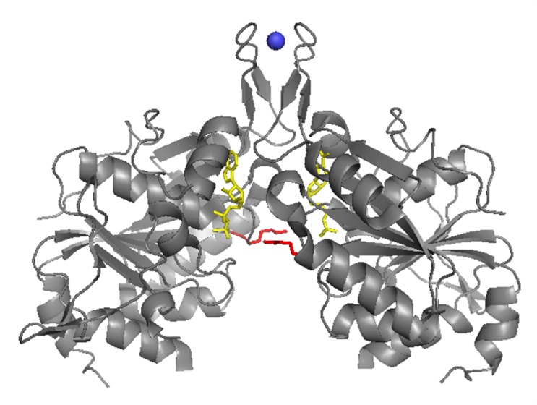
Figure 5. (A) Crystal Structure of Af_226. Ribbon diagram of the crystal structure of Af_226, in complex with ADP and Zinc, at 2.9 A (PDB 3KB1). Like Nbp35 and Cfd1, Af_226 is classified as an Mrp/MinD SIMIBI NTPase. The side-chains for the ‘signature’ lysines, corresponding to ScNbp35K81, are shown in RED, positioned to reach across monomers in a closed conformation. The ADP moiety bound to each monomer is colored in YELLOW, and the bridging zinc atom, ligated via a CPXC motif from each monomer, is shown in BLUE. The physiological ligand is unknown; however, zinc is a common artifact in the purification of FeS proteins.

Protein Schematics and Multiple Sequence Alignments for Nbp35 and Cfd1

Multiple Alignment of Eukaryotic Nbp35 and Cfd1 Homologs

N-Terminal FeS Binding
H sapiens -MEEVP-------------------HDCPGADSAQAGRGASCQGCPNQRLCASGAGATP 41
M musculus -MEEAP-------------------HGCPGADSAQAGRGASCQGCPNQRLCASGAGAAP 41
D rerio -MADVPN-DAP--------------EHCPGTSSDQAGKSSACQGCPNQSICASGATKAP 45
D melangaster -MQAPPP------------------EHCPGVESEEAGKGSACSGCPNQGLCSDPNKKLE 42
C elegans -MSDVPDDAN---------------AGCPGTGSAGAGKASGCAGCPNQGSCATGQGPPP 45
S cerevisiae -MTEILPHVNDEVLPAEYELNQPEPEHCPGPESDMAGKSDACGGCANKEICESLP-KGP 59
A thaliana -MENGDIPEDAN-------------EHCPGPQSESAGKSDSCAGCPNQEACATAP-KGP 46

H sapiens ------------------------------------------------------------
M musculus ------------------------------------------------------------
D rerio ------------------------------------------------------------

Af_226(3KB1) ------------------------------------------------------------

P-LOOP
H sapiens DT-----AIEEIKEKMKTVKHKILVLSGKGGVGKSTFSAHLAHGLAEDE-NTQIALLDI 94
M musculus DP-----AVEEIREKMKTVRHKLLVLSGKGGVGKSTFSAHLAHGLAEDG-DTQVALLDI 94
D rerio DP-----AIEEIKQKMTSVKHKILVLSGKGGVGKSTFSAHLSHALASDS-SKEVALLDV 98
D melangaster DP-----GKALVVESMKDVKHKLLILSGKGGVGKSTVTSLLTRYLARSNPDSNFGVLDI 96
C elegans DA-----DVPKIQDRFSRIKHKILILSGKGGVGKSTLTSNLARALASDP-SKQVAILDV 98
S cerevisiae DP-----DIPLITDNLSGIEHKILVLSGKGGVGKSTFAAMLSWALSADE-DLQVGAMDL 113
A thaliana DP-----DLVAIAERMSTVKHKILVLSGKGGVGKSTFSAQLSFALAG-M-DHQVGLMDI 98

H sapiens --MEAAA----EPGNLAGVRHIILVLSGKGGVGKSTISTELALALRHAGKKVGI--LDV 31
M musculus --MEAAAGERAEPGNLAGVRHIILVLSGKGGVGKSTISTELALALRHQGKKVGI--LDV 35
D rerio --MDGSG-----KGNLDQVKHVLLVLSGKGGVGKSTITTELALAFRHAGKKVGI--LDV 30
D melangaster --------------MLDKVKNVIVVLSGKGGVGKSTVSTQLSLALRKNGFKVGL--LDI 23
S cerevisiae --MEEQE-IGVPAASLAGIKHIILILSGKGGVGKSSVTTQTALTLCSMGFKVGV--LDI 34

Af_226(3KB1) --MQKRVTDEDIKERLDKIGFRIAVMSGKGGVGKSTVTALLAVHYAKQGKKVGI--LDA 55
** * *

I
H sapiens DICGPSIPKIMGLEGEQVHQSGSGWSPVYVEDNLG----VMSVGFLLSSPDDAVIWRGP 144
M musculus DICGPSIPKIMGLEGEQVHQSGSGWSPVYVDDNLG----VMSVGFLLSSPDDAVIWRGP 144
D rerio DICGPSIPKIMGLEGEQVHQSGSGWSPVYVEDNLA----VMSIGFLLSSPDDAVIWRGP 148
D melangaster DICGPSQPRLMGALGESVHQSGYGWSPVGIEDNVC----LMSIGFLLGSVDDAIIWRGP 146
C elegans DICGPSQPRMMGVEDEEVHNSADGWTPVGIQPNLT----LMSIAFLLGDKNDAVIWRGA 148
S cerevisiae DICGPSLPHMLGCIKETVHESNSGWTPVYVTDNLA----TMSIQYMLPEDDSAIIWRGS 162
A thaliana DICGPSIPKMLGLEGQEIHQSNLGWSPVYVEDNLG----VMSIGFMLPNSDEAVIWRGP 148

H sapiens DLCGPSIPRMLGAQGRAVHQCDRGWAPVFLDREQSISLMS--VGFLLEKPDEAVVWRGP 105
M musculus DLCGPSIPHMLRAQGKAVHQCDNGWVPVFVDQEQSISLMS--VGFLLENPDEAVVWRGP 109
D rerio DLCGPSIPRMLSVGKPEVHQCDSGWVPVYADPQQQQLALMS-IAFLLEDSDEAVIWRGP 105
D melangaster DLCGPSVPYLLGLEGRDIFQCDDGWVPVYTDESQTLAVMS--IGFLLKNREDPVIWRGP 97
S cerevisiae DLTGPSLPRMFGLENESIYQGPEGWQPVKVETNSTGSLSVISLGFLLGDRGNSVIWRGP 110

Af_226(3KB1) DFLGPSIPHLFGLEKGKVAVSDEGLEPVLTQRLGIKVMSIQ---FLLPKRETPVIWRGP 111
*

II
H sapiens KKNGMIKQFLRDVDWGEVDYLIVDTPPGTSDEHLSVVRYLATAHID---GAVIITTPQE 297
M musculus KKNGMIKQFLRDVDWGDVDYLIVDTPPGTSDEHLSVVQYLAAAHID---GAVILTTPQE 297
D rerio KKNGMIKQFLRDVDWGEVDYLIVDTPPGTSDEHLSIVQYLSGAGID---GAVIITTPQE 201
D melangaster KKNGMIRQFLSEVDWGNLDLLLLDTPPGTSDEHLSVVSYLKDDANPESLRAVMVTTPQE 207
C elegans RKNGMIKQFLKDVDWGEVDYLLIDTPPGTSDEHISLVQFLLQAGP--LDGALIVSTPQE 207
S cerevisiae KKNLLIKKFLKDVDWDKLDYLVIDTPPGTSDEHISINKYMRESGID---GALVVTTPQE 221
A thaliana RKNGLIKQFLKDVYWGEIDYLVVDAPPGTSDEHISIVQYLLPTG----DGAIIVTTPQE 306

H sapiens KKNALIKQFVSDVAWGELDYLVVDTPPGTSDEHMATIEALRPYQPL---GALVVTTPQA 152
M musculus KKHALIKQFVSDVAWGQLDYLVVDTPPGTSDEHMATMEALRPYRPL---GALVVTTPQA 156
D rerio KKTALIGQFVSDVAWGELDILLVDTPPGTSDEHLAVLENLRKHRVD---GAVLVTTPQA 132
D melangaster KKTMMIRQFLTDVRWDELDYLIIDTPPGTSDEHITVMECLKEVGCH---GAIIVTTPQE 124
S cerevisiae KKTSMIKQFISDVAWGELDYLLIDTPPGTSDEHISIAEELRYSKPD---GGIVVTTPQS 139

Af_226(3KB1) LIAGMIREFLGRVAWGELDYLLIDLPPGTGDAPLTVMQDAKPN------GAVIVSTPQE 164
* *

“III” CPXC MOTIF
H sapiens VSLQDVRKEINFCRKVKLPIIGVVENMSGFICP----------------------KCK 235
M musculus VALQDVRKEISFCHKVKLPIIGVVENMSGFICP----------------------KCK 235
D rerio VSLQDVRKEIRFCKKVNLPILGVIENMSGFVCP----------------------KCK 239
D melangaster VSLLDVRKEINFCKKQNIPIVGVIENMSSFRCG----------------------HCG 240
C elegans VSLLDVRKEVSFCVKTKVPILGVVENMARFVCP----------------------NCA 240
S cerevisiae VALLDVRKEIDFCKKAGINILGLVENMSGFVCP----------------------NCK 253
A thaliana VSLIDVRKEVSFCKKVGVPVLGVVENMSGLSQPLKDVKFMKLATETGSSINVTEDVIA 267

H sapiens VSVGDVRRELTFCRKTGLRVMGIVENMSGFTCP----------------------HCT 188
M musculus VSIGDVRRELTFCKKTGLQVIGVIENMSGFTCP----------------------HCA 192
D rerio VSTGDVRREITFCKKTNLKILGIVENMSGFVCP----------------------HCS 188
D melangaster VALDDVRKEITFCKKTGINILGIVENMSGFVCP----------------------HCT 180
S cerevisiae VATADVKKEINFCKKVDLKILGIIENMSGFVCP----------------------HCA 193

Af_226(3KB1) LTAAVVEKAITMAEQTKTAVLGIVENMAYFECP----------------------NCG 200
*

H sapiens KESQIFPPTT--GGAELMCQDLEVPLLGRVPLDPLIGKNCDKGQSFFIDAPDSPATLAY 294
M musculus KESQIFPPTT--GGAEAMCQDLRIPLLGKVPLDPHIGKSCDKGQSFFVEAPDSPATAAY 294
D rerio NTSQIFPPTT--GGAQRMCEELNLPLLGRIPLDPRIGKSCDEGKSFLTEVPDSPAAAAY 298
D melangaster NSSEIFPAKT--GGAAAMCAEMGIPLLGSLPLDQQISKACDSGED-LTEFKN-VTTEAL 299
C elegans HTTLLFPTST--GGAEQMCKDSNLELLAQLPLEPALAKALDNGEDFFETNPDSTLAKSF 299
S cerevisiae GESQIFKATT--GGGEALCKELGIKFLGSVPLDPRIGKSCDMGESFLDNYPDSPASSAV 312
A thaliana CLRKNAPELLDIVACSEVFDSSGGGAERMCREMGVPFLGKVPMDPQLCKAAEQGKSCFE 332

H sapiens ECTSVF--SR--GGGEELAQLAGVPFLGSVPLDPALMRTLEEG---HD-FIQEFPGSPA 249
M musculus ECTNVF--SS--GSGEELARLAGVPFLGSVPLDSQLTRSLEEG---RD-FIQEFPKSTA 253
D rerio ECSNIF--SK--GGGEELAKLTGSAFLGSVPLDPLLTESLEEG---RD-FLQAFPESST 249
D melangaster SCTNIF--SS--NGGVSLATYAQVPHLGTLPIDPRVGILAGTT---TS-VLDELPDSTT 241
S cerevisiae ECTNIF--SS--GGGKRLSEQFSVPYLGNVPIDPKFVEMIENQVSSKKTLVEMYRESSL 254

Af_226(3KB1) ERTYLF----GEGKASELARKYKIEFITEIPIDSDLLKLSDLGRVEEYEPDWFEFFPYL 253

H sapiens RSIIQRIQEFCNLHQSKEENLISS---------------------- 320
M musculus RSIIQRIRDFCNSHQSHAETLISP---------------------- 320
D rerio QSIVQKIRDYCASHSASDVSC------------------------- 321
D melangaster EGICSKIMASFS---------------------------------- 311
C elegans LDLAEKVKAKLV---------------------------------- 313
S cerevisiae LNVVEALRDAVGDV-------------------------------- 328
A thaliana DNKCLISAPALKSIIQKVVPSTVMTE-------------------- 350

H sapiens FAALTSIAQKILDATPACLP-------------------------- 271
M musculus YSALTSIAQRVVHRMSALCS-------------------------- 275
D rerio FTAISHIANTLLNSLNA----------------------------- 268
D melangaster AEVLTHIVEKLKTMLVS----------------------------- 260
S cerevisiae CPIFEEIMKKLRKQDTTTPVVDKHEQPQIESPK------------- 293

Af_226 E--------------------------------------------- 256

(B) Nbp35 and Cfd1 protein schematics and sequence alignments. Protein schematics and multiple sequence alignment of Nbp35 and Cfd1 homologs showing conservation of key residues within cognate NTPase motifs. Although uncharacterized, Af_226 is as homologous to Nbp35 and Cfd1 as they are to one another (~45% ID), and encodes all of the same functionally important motifs.
Protein alignment generated by CLUSTALW (http://www.ebi.ac.uk/Tools/msa/clustalw2/) using protein sequences of eukaryotic homologs as compiled by HOMOLOGENE at NCBI (http://www.ncbi.nlm.nih.gov/homologene/).
Nbp35 schematic and alignments are highlighted in GRAY.

N-terminal FeS Binding – Conserved N-terminal ferredoxin motif in Nbp35 homologs, required for binding of a stable Fe₄S₄ cluster.
I – Switch I II – Switch II III – “Switch III”
CPXC – Conserved C-terminal CPXC motif in Nbp35 and Cfd1 homologs, required for binding of a labile, bridging Fe₄S₄ cluster.
Cysteines required for FeS binding are highlighted in RED
Residues chosen for mutagenesis shown are in BOLD in the sequence alignment, and further denoted by a.
Nbp35 and Cfd1 are homologous, but they are not functionally redundant. Both proteins are essential in yeast, and they appear to have distinct functions in FeS assembly (192,294). Both proteins encode the essential C-terminal CPXC motif; however, they differ at the third position. ScNbp35 encodes an asparagine at this position, but the identity of this residue can vary within eukaryotes, with lysine being the most common side chain. In contrast, Cfd1 encodes a highly conserved CPHC motif, with an almost invariant histidine at the critical third position (Figure 5B). This is a rare motif, particularly in the eukaryotic cytosol, as it has previously been found only in proteins involved in oxidative protein folding (sulfhydryl oxidation) and protein disulfide isomerization (491-496).
This suggests that Cfd1 may participate in redox activities, including electron transfer or cysteine oxidation. Cfd1 could conceivably function to activate cysteines in Nbp35: to facilitate alternative liganding strategies required to accommodate a growing cluster, and/or to enable effective transfer of the mature cluster. Cfd1 could also act on other targets in order to mobilize iron for cluster assembly, or FeS for apo-incorporation. Intriguingly, human Cfd1 was among several CIA factors identified in a screen for hyper-reactive cysteines, along with several downstream CIA factors (Nar1, Cia2A and B, and Mms19) while Nbp35 was not (497). However, it is unknown if Cfd1 participates in redox biochemistry. And although each protein can chemically constitute a Fe₄S₄ cluster via the CPXC motif, the physiological ligands for the homo- and hetero-complexes are not known.
In addition to this labile, bridging Fe₄S₄ cluster, each Nbp35 monomer ligates an additional Fe₄S₄ cluster, via an N-terminal extension not present in Cfd1 (192,197,214,258) (Figure 5B). In fact, this is one of few defining features between the two proteins at the sequence level. The N-terminal cluster is bound via a conserved ferredoxin-like motif, and is essentially required for Nbp35 physiological function. As ferredoxins generally bind FeS stably, it has been proposed that the N-terminal clusters are stably-bound, and required for Nbp35 function in assembly/transfer of the labile, bridging cluster, destined for transfer to apo-targets (258). In vivo radio-labeling revealed the differential stability of iron bound to Nbp35, as incubation with an intra-cellular chelator displaced only half the ⁵⁵Fe bound to Nbp35 precipitated from yeast (294). This is consistent with a proposed tetrameric catalytic complex, with two stable Fe₄S₄ clusters bound to the N-terminus of each Nbp35 monomer, and two labile, bridging Fe₄S₄ clusters, ligated via the composite C-terminal CPXC motifs, perhaps at an Nbp35:Cfd1 interface. However, the arrangement of the Nbp35:Cfd1 catalytic complex, the Nbp35:Cfd1 interaction interfaces, and the role of Nbp35’s N-terminal FeS clusters have not been determined. FeS maturation of Nbp35 and assembly of the labile cluster on Nbp35:Cfd1 require the mitochondrial ISC and export machineries, and the activities of cytosolic Grx3/4, and a functional Dre2:Tah18 complex (13,149,194,216,347). Nbp35:Cfd1 are additionally required for FeS maturation of all downstream CIA targets, including the CIA factor Nar1, which binds at least one stable cluster required for function in cytosolic FeS biogenesis (155,192).
Phylogenomic analyses suggest that both Nbp35 and Cfd1 were present and functionally conserved in the Last Common Eukaryotic Ancestor (LECA) (30). To our knowledge, all organisms known to metabolize iron encode an Nbp35 homolog, and the protein is highly conserved from archaea to humans (197). In contrast, the requirement for Cfd1 appears far more evolutionarily plastic; Cfd1 is absent in bacteria, and in autotrophs (carbon-fixers), (including Viridiplantae, Stramenopiles, and Apicomplexans,) as well as the human pathogen Giardia intestinalis, and the free-living nematode, Caenorhabditis elegans (30,335). Intriguingly, absence of Cfd1 correlates strongly with a variable insertion at the Nbp35 C-terminal CPXC motif, including loss of the amino-terminal cysteine (Figure 5B, see sequence for A. thaliana Nbp35). This suggests Cfd1 is evolutionarily linked with the specific mechanism of assembly and/or transfer of the labile, bridging cluster, an inference corroborated by in vivo investigations (294). However, the mechanism of FeS assembly by the Nbp35:Cfd1 scaffold and the precise roles of Nbp35 and Cfd1 in cluster biogenesis remain undetermined.
Nbp35 and Cfd1 are classified as P-loop NTPases by sequence homology (498), including conservation of cognate motifs, such as the P-loop and Switches I and II, which play conserved, essential roles in nucleotide binding/hydrolysis in the P-Loop family. Specifically, Nbp35 and Cfd1 are members of the Mrp/MinD sub-family of SIMIBI NTPases, characterized by a deviant P-loop motif encoding for an additional, “signature lysine” (GKGGXGKS/T) (320). SIMIBI proteins function obligate homo-dimers, with the nucleotide binding pockets at the dimer interface (Figure 6). The signature lysine from each monomer extends across the dimer interface to interact with the γ-phosphate of the NTP bound to the opposite monomer, providing the catalytic impetus for hydrolysis. Several members (including NifH, MinD, and Get3) have crystallized as comparable dimers in various nucleotide-bound states, and have been extensively characterized, both structurally and biochemically (321,326,339,340,342,499-505). Of note, this is the same dimer interface observed in the crystal structure of the Nbp35/Cfd1 ortholog Af_226, which resolved bound to two ADP. Consistent with other resolved SIMIBI NTPases, the signature lysine in PDB 3KB1 appears to be reaching across the dimer interface, positioned to make contact with the terminal phosphate in a more closed, ATP-bound conformation.
Although Nbp35 and Cfd1 are classified as P-Loop NTPases, nucleotide binding or hydrolysis activities have not been detected for the purified proteins, alone or in complex. However, cumulative evidence strongly suggests these proteins function as NTPases in vivo. It was known previously that Nbp35 and Cfd1 require an invariant P-Loop lysine (Nbp35^{K86}) to support viability in yeast (338). A recent report, published as these investigations were proceeding, establishes a requirement for this residue in Nbp35 and Cfd1 function in cluster biogenesis. (151). In addition, archaeal and bacterial ApbC/Nbp35 homologs have demonstrated in vitro activities, and/or an in vivo requirement for this same lysine (197,334,506). Although nucleotide binding and hydrolysis are not established universal requirements for FeS biogenesis, they are

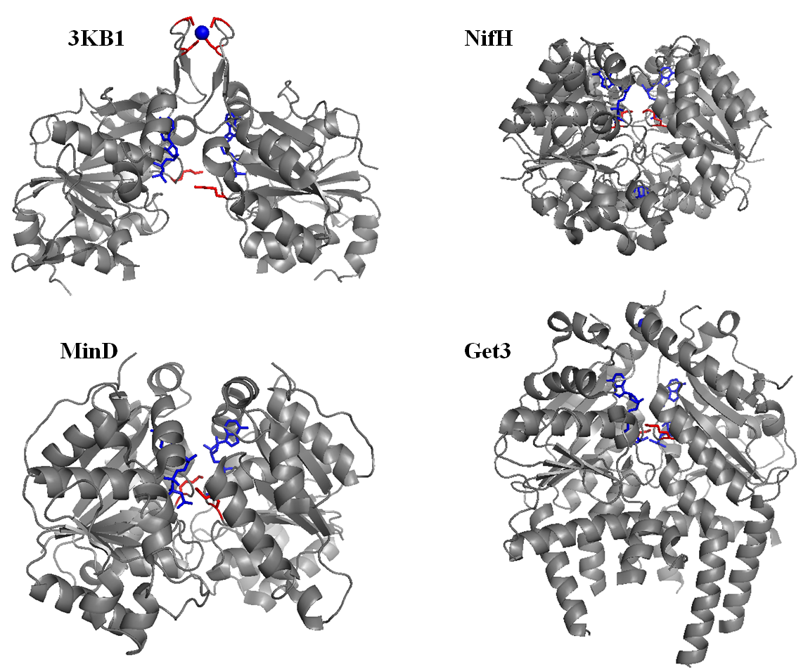

Figure 6. Comparison of homo-dimeric SIMIBI NTPases. Ribbon diagrams of the crystal structures of homologous SIMIBI NTPases, highlighting the conserved ‘signature lysine’. The signature lysine is shown in RED. The bound ATP or non-hydrolyzable analogs are shown in BLUE. Structures include MinD PDB 3Q9L, NifH PDB 1FP6, Get3 PDB 3ZS9, and the uncharacterized archaeal ApbC/Nbp35 homolog, Af_226 PDB 3KB1.

required in other FeS assembly systems, where they have been linked with the acquisition of iron and/or transfer of nascent cluster (288,301,304,307). It will be of great interest to identify the molecular consequences of nucleotide binding and hydrolysis by Nbp35 and Cfd1. Insight into the precise roles of these proteins will undoubtedly provide valuable insight into the molecular mechanisms of extra-mitochondrial FeS biogenesis, and the function(s) of Nbp35 and Cfd1 in the eukaryotic cell.
Nbp35 and Cfd1 are classified as dedicated CIA factors, and comprise the presumed scaffold for assembly of virtually all extra-mitochondrial FeS. However they have not been shown to interact physically with other components of the CIA machinery, including potential sources of substrate, other CIA factors, or known targets, except perhaps Nar1, which is both a stable apo-target and an essential CIA factor. Nar1 functions immediately downstream of the Nbp35:Cfd1 targeting complex, and reportedly precipitates stably with both Nbp35 and Cfd1, although perhaps in minor fractions (Personal Communications, and Unpublished Reports - (215). However, metazoan Nbp35 and Cfd1 have been shown to interact with components of the actin cytoskeleton (82,83,507), including sub-units of the CCT/TRIC chaperonin complex, which mediates folding of tubulin and actin, major cyto-skeletal components (508). In addition, Nbp35 and Cfd1 have been proposed to function as integral components of Micro-Tubule Organizing Centers (MTOC’s – the centrosome and ciliary basal bodies), and regulators of cytokinesis and ciliogenesis in multi-cellular organisms from nematodes to mammals, including human cells.
Previously, the requirements for Nbp35 and Cfd1 had not been thoroughly investigated, beyond their essential requirements for normal growth and viability, and for extra-mitochondrial FeS biogenesis. However, recent studies have uncovered novel roles for Cfd1, and primarily for Nbp35, in cytokinesis, cytoskeletal dynamics, and the differentiation and development of multi-cellular organisms (82-84,507). Nbp35 is maternally expressed throughout all stages of development in various cell types (especially neurons), and has been localized to the mitotic spindle as well as the apical cytoskeleton of metazoan cells. Nbp35 is required for centrosomal duplication/dynamics, ciliogenesis, cytoskeletal organization/dynamics, and for convergent extension movements essential for differentiation and development in multi-cellular organisms. Complete loss of Nbp35 is embryonic lethal, and insufficiency resulted in defects in formation of the anterior-posterior axis and neural tube closure (including Spina bifida), in the clawed frog, Xenopus laevis (82). A forward genetic approach additionally revealed a pivotal role for Nbp35 in controlling cell polarity, centrosomal dynamics, and cell division in human and murine cells (84). Mice expressing mutated Nbp35 displayed gross syntactdyly and limb deformation, eye cataracts, and severe lung hypoplasia, and these mice died immediately upon birth from suffocation. It is likely that this is an incomplete inventory of defects in these mice, and that these phenotypes resulted from only a partial loss of function in Nbp35, as genomic loss of Nbp35 is embryonic lethal.
It is currently unknown if these effects are primarily due to defects in the maturation of pivotal FeS proteins (including Pol’s α, δ, and ε, XPD, Sprouty 2, Rli1) or if Nbp35 and/or Cfd1 activities modulate depending on cellular conditions and metabolite availability. However, cysteine desulfurases (including the ISC factor NFS1) have been physically and functionally linked with the centrosome and primary cilia of fungal and human cells (509-511). One intriguing possibility is that CIA activity is constitutive under certain physiological conditions, but spatially and/or temporally gated when cellular resources are limited, at different stages of the cell cycle, and/or during certain developmental stages in multi-cellular organisms. This seems reasonable, as many CIA targets are engaged in metabolite requiring anabolic activities, such as amino acid and nucleotide biosyntheses, DNA replication and repair, transcription, and translation, which must all be coupled with the cell cycle and developmental/environmental cues. Nbp35 and Cfd1 may assist in the targeting of FeS to essential targets under limiting conditions, or at distinct developmental stages. Or, Nbp35 and/or Cfd1 may play distinct roles in divergent processes, depending on cellular conditions.
This “moon-lighting” feature is not unheard of amongst FeS proteins, which can modulate activities based on the presence or absence of FeS, or physiochemical changes in a stable cluster. For example, the CIA target IRP1 functions as a cytosolic aconitase under iron replete conditions. However, IRP1 loses its FeS cluster, gains the ability to bind to elements in mRNA, and functions as a translational regulator of iron-related genes in mammalian cells upon iron depletion or exposure to ROS or RNS (452,453,457). And again, Ind1 is a mitochondrial Apbc/Nbp35 homolog and late ISC factor, reportedly required for maturation of RCI in plants and higher eukaryotes (259,260). Like Af_226 (PDB 3KB1), Ind1 is roughly as homologous to Nbp35 and Cfd1 as they are to one another, and retains all functionally important residues and motifs. In fact, this is one of only two instances of homology between the CIA system, which appears to have evolved independently, and the other FeS biogenesis machineries. Intriguingly, depletion of Ind1 results in defects in gametophytic cytokinesis and mitochondrial translation in Arabadopsis thaliana; investigators postulate that Ind1 may play distinct roles in different cellular processes, depending on metabolite availability or environmental conditions (512). Of note, other SIMIBI NTPases may also play distinct, even nucleotide-independent, roles in the same or divergent pathways, depending on metabolite availability, or other environmental/contextual cues (NifH, Get3, MinD) (298,312,319,513-515). It is possible that this may be a shared mechanism in a sub-set of SIMIBI NTPases; a way for the cell to coordinate complex, energy and resource requiring processes with a fluid environment, and the changing needs of the cell.
Nbp35 and Cfd1 are essential components of the early CIA machinery, required for assembly of virtually all extra-mitochondrial FeS, including clusters destined for proteins essential for DNA metabolism and repair, and protein biosynthesis (192,258,337). However, they appear to co-localize with major MTOC’s, and their depletion or loss is associated with specific defects in centrosomal/cytoskeletal dynamics and cell division and differentiation, effects not specifically reported for other CIA factors (82-84,498,507). Significant progress has been made in unraveling the roles of Nbp35 in Cfd1 in extra-mitochondrial FeS assembly, and in uncovering their apparently specific requirements for cell division and differentiation. It will be of interest to further elucidate the biochemical and molecular bases of Nbp35 and Cfd1 function, their precise roles in FeS biogenesis and the determination of cell fate, and ultimately, their full relevance to human life and health.
6. Nar1 – An Intermediary Between Early and Late CIA
The CIA factor Nar1 (NARF in humans) is a eukaryotic protein with structural homology to bacterial iron-only hydrogenases (343). Nar1 is an essential protein in yeast, and appears functionally conserved to humans (343,354,473,516). Nar1 binds two essential Fe₄S₄ clusters, required for protein stability and function in CIA (155). FeS maturation of Nar1 requires the activity of all four early-acting CIA factors (Dre2, Tah18, Nbp35, and Cfd1) (258,347), but not Cia1, a component of the “late-acting CIA transfer complex” (472). Additionally, Nar1 has been reported to immunoprecipitate with both early (unpublished) and late acting components of the CIA pathway (131,172,173,517). Thus Nar1 is both a CIA factor AND a target of the CIA machinery. The precise role of Nar1 remains undetermined; however, the two clusters are reportedly bound with differential stabilities (155), and the protein appears positioned to act as an intermediary between assembly of labile Fe₄S₄ cluster on the Nbp35:Cfd1 scaffold, and transfer of nascent cluster to apo-targets via the CIA targeting-complex (215).
Human Nar1 was originally identified as an interaction partner of prenylated Prelamin A (518). A recent report confirmed this interaction, and identified the late CIA factor Cia2 (FAM96B) as an additional Prelamin A partner (519). Overexpression of Prelamin A resulted in mislocalization of Cia2 to the nuclear periphery, suggesting that this interaction may regulate the sub-cellular localization of the late CIA targeting complex. Of note, a C-terminal fragment was sufficient to support this interaction in vivo. The C-terminal region of Prelamin A is extensively modified before being cleaved from mature Lamin A, which is required for formation of the nuclear lamina (520-523). Mutations to this region result in accumulation and aggregation of the Prelamin A form, and are associated with the accelerated aging syndrome progeria (522-526). Prelamin A also accumulates in primary cells from aged individuals, and may be associated with age-related cellular dysfunction (527-530). The authors speculate that regulation of CIA activities may explain, at least in part, the connection between Prelamin A and normal and accelerated age-related cellular changes (519). Of note, depletion of Nar1 is associated with genomic instability and decreased replicative lifespan in yeast, and increased sensitivity to the superoxide-generating toxin, paraquat (531). Collectively, these results further underscore the importance of CIA to eukaryotic life and health, and the need for additional insight into the molecular mechanisms of extra-mitochondrial FeS biogenesis.
7. Cia1/2 and Mms19 – A “Late CIA Targeting Complex”
Elegant work from several groups has resulted in the recent identification and rapid characterization of a stable sub-complex formed by several late CIA factors, now referred to as the “late CIA targeting complex” (131,172,173,517,532). This complex interacts with Nar1 and known CIA targets, including nuclear targets required for genome replication and repair. Cia1 (human CIAO1) is member of the large WD40 repeat family of proteins, which form a circular beta propeller structure around a central axis, and generally function as docking sites for proteins in many systems, in order to co-localize and position different components for productive interaction (472,533). Cia1 forms a fusion protein with Cfd1 in the fission yeast, Schizosaccharomyces pombe, suggesting the two proteins function close to one another in the same pathway (472). In addition, Cia1 immunoprecipitates with Nar1, again positioning it immediately downstream of assembly on the Nbp35:Cfd1 scaffold.
Mms19 (also Met18, or human MMS19) is a heat repeat protein (534), and is the only non-essential component of the CIA machinery in yeast. However, the involvement of Mms19 in the maturation of numerous cytosolic and nuclear FeS proteins explains the pleiotropic phenotypes associated with loss of Mms19 in eukaryotic cells (131,172,517,535-537). For example, loss of Mms19 is associated with methionine auxotrophy (538) and increased sensitivity to DNA damaging agents in yeast (535,539), phenotypes now explained by the requirement for Mms19 in the maturation of proteins involved in methionine metabolism and DNA metabolism and repair. Human Mms19 has been identified as a component of the Mms19:Cia2B:XPD (MMXD) complex, required for chromosome segregation, mitotic spindle formation, and cytokinesis in human cells (540). Depletion of Mms19 in human cells largely phenocopies the cellular defects seen in cells from patients with the rare autosomal genetic disorder, Xeroderma pigmentosum, which is caused by mutation to the human gene encoding XPD (47,59,62,131,178,438,517,536,540-542). Of note, these defects also partially phenocopy the defects associated with depletion of Nbp35. However, this does not account for the localization of Nbp35 and Cfd1 to the major MTOC’s in eukaryotic cells, or their specific requirements in the development and differentiation of metazoan cells.
Cia2 (human CIA2B or FAM96B) has been physically and functionally linked with numerous CIA targets, including proteins involved in DNA metabolism and protein translation (532). Cia2 is a small acidic protein, containing a C-terminal Domain of Unknown Function 59 (DUF59) (543,544). Cia2 forms a stable complex with Cia1 and Mms19, and complex formation is required for CIA function. The Cia2:Mms19 interaction is sensitive to expression of Cia1 and known CIA targets, suggesting that the targeting complex is formed or stabilized in the presence of substrate (545). A recent study identified an additional Cia2 isoform in mammalian cells, Cia2A (human CIA2A or FAM96A), apparently exclusively dedicated to FeS maturation of cytosolic Iron Regulatory Protein 1 (IRP1), a bi-functional metazoan protein required for FeS-dependent cytosolic aconitase activities and the maintenance of cellular iron homeostasis (532). Cia2B and Mms19 have additionally shown evidence of substrate specificity, suggesting that components of the targeting complex may preferentially target distinct sub-sets of client proteins (545). Collectively, these results provide the physical link between the early CIA machinery and downstream apo-targets, and initial evidence of the differential targeting of FeS by the CIA machinery. However, this does not preclude the existence of additional regulatory or targeting mechanisms, perhaps involving components of the early CIA machinery.
Intriguingly, several CIA factors (Cfd1, Nar1, Cia1 and 2, and Mms19), including three of four components in the targeting complex, were identified in a screen for hyper-reactive cysteines in human proteins, using very low level exposure (low micromolar vs standard millimolar concentrations) to an affinity labeled, thiol-reactive probe, Iodoacetamide (biotinylated-IA) (497). Thus defined, hyper-reactivity was a rare feature among cysteines, and was found to specify a number of physiological activities, including nucleophilic and reductive catalysis, redox-active disulfide formation, and sites of oxidative modification, including glutathionylation. Many details of the mechanism of assembly by the CIA machinery remain unknown. However, components of the CIA machinery exhibit little genetic homology to other FeS assembly machineries, and it is likely that the mechanism of CIA is tailored to optimize FeS biogenesis in the eukaryotic cytosol. It will be of enormous interest to determine the role of these hyper-reactive cysteines in the various CIA factors, and the reasons why more than half of all CIA factors, most required late in the pathway, possess hyper-reactive cysteine residues, an apparently rare commodity in the eukaryotic cytosolic milieu.
8. A Model for the Mechanism of FeS Assembly by the CIA System
As reviewed in the previous sections, FeS clusters are ubiquitous and versatile protein co-factors, with essential roles in virtually all living cells. FeS proteins have been localized to the mitochondria, cytosol, endoplasmic reticulum, and nucleus of eukaryotic cells, where they play essential roles in foundational cellular processes, including aerobic respiration, energy and intermediary metabolism, genome replication and repair, protein expression, iron and redox homeostases, and in the differentiation and development of multi-cellular organisms, including humans. It has been just over a decade since the discovery of Cfd1 indicated the presence of a previously unidentified system for the assembly of extra-mitochondrial FeS in the eukaryotic cytosol, designated as the CIA system. Significant progress has been made in the identification and characterization of the known CIA factors, and a rapidly evolving model for the mechanism of CIA has emerged in the intervening years (Figure 7).

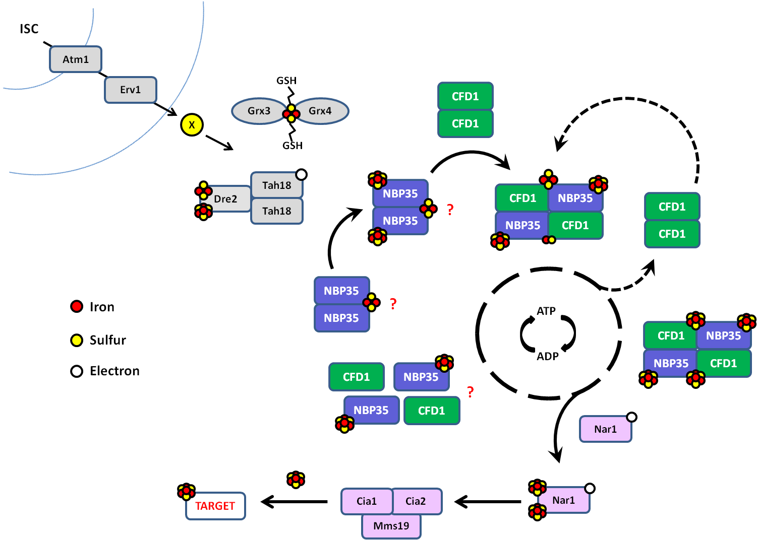

Figure 7. FeS Assembly by the Cytosolic Iron-Sulfur Assembly System. The physiological ligand coordinated at the Nbp35 CPXC motif, and the mechanism of assembly on Nbp35 and the Nbp35:Cfd1 complex, have yet to be determined. In addition, it is not known if the Nbp35:Cfd1 hetero-complex dissociates upon completion of the catalytic cycle and reassembles de novo, or not. However, evidence supports formation of a stable complex in yeast. See text for additional details.

It is proposed that the CIA system depends on the function of the mitochondrial ISC system, as depletion of core ISC components impairs FeS maturation of cytosolic and nuclear targets, including the dedicated CIA components (194,216). Two additional mitochondrial proteins are specifically required for CIA activity. Atm1 is an ABC transporter located in the inner mitochondrial membrane, which transports an unknown substrate (X) required for CIA activity from the matrix in the Inter-Membrane Space (IMS) (440). Although the identity of this substrate is unknown, Atm1 appears to prefer cysteine-rich peptides, and to transport only small ligands, such as glutathione (249,476). A recent report identified glutathione-complexed Fe₂S₂ clusters as a likely physiological substrate for Atm1, and provided a model for the Atm1-Fe₂S₂-GSH structure. The inter-membrane space Erv1 sulfhydryl oxidase is also required for CIA activity (217). Erv1 functions in complex with Mia40 protein to introduce disulfide bonds into IMS proteins. Atm1 and Erv1 appear to shuttle the mitochondrially-derived substrate to the CIA system, and possibly to signal mitochondrial function and status as well (478). Intriguingly, Mia40:Erv1 activity requires reduced glutathione and produces oxidized glutathione as a by-product (479).
Cytosolic FeS biogenesis additionally requires the activities of the cytosolic mono-thiol glutaredoxins, Grx3 and 4, and the tri-peptide, glutathione (149,546). Grx3/4 bind a bridging Fe₂S₂ cluster at the hetero-dimer interface, additionally ligated via two molecules of glutathione. Specifically, GSH-FeS-Grx3/4 is required for FeS maturation of Dre2, Nar1, and downstream CIA targets. Accumulating evidence suggests that monothiol Grx’s, including Grx3/4 may function as intermediate carriers of FeS from the housekeeping (ISC, or sometimes SUF) assembly system to apo-targets, or even to other FeS assembly systems, for additional processing and/or targeting to distinct sub-sets of apo-proteins (241,242,264,265). Grx3/4 performs additional roles in iron sensing, at least in yeast, and this complex is additionally required for iron trafficking to all extra-mitochondrial heme, di-iron, and FeS cluster proteins (149). Notably, Grx3/4 have been shown to act coordinately with the CIA factors, Dre2 and Tah18, in the transfer of iron to other cytosolic systems (483).
The Dre2:Tah18 hetero-complex functions as a cytosolic electron transfer chain, and is required for FeS maturation of Nbp35, Nar1, and all CIA target proteins (346,347). Electrons are transferred from cytosolic NADPH via the flavin cofactors in the reductase Tah18 to an FeS cluster in Dre2, for subsequent transfer to acceptor proteins (487). Recent reports demonstrate that electron transfer through Tah18:Dre2 is required for iron transfer in other cytosolic pathways, as Tah18:Dre2 is required for maturation of the di-ferric tryosyl radical on ribonucleotide reductase 2 (Rnr2), specifically for the acquisition of iron from Grx3/4 and GSH (483). Cumulative evidence suggests that NADPH-Tah18:Dre2-FeS supplies electrons required for the FeS maturation of Nbp35, and for the transfer of iron and/or FeS from GSH-FeS-Grx3/4 to the Nbp35:Cfd1 scaffold, for assembly and transfer to Nar1 and all CIA targets (148,149,241,242,265,346,347,483,486).
Nbp35 and Cfd1 are proposed to function in hetero-complex as the scaffold for extra-mitochondrial FeS assembly (258). In vivo investigations demonstrate that Nbp35 and Cfd1 exist in equilibrium as stable homo- and hetero-complexes in yeast (294). The structural arrangements of the Nbp35 and Cfd1 complexes are unknown. However, the shared C-terminal metal-binding CPXC motifs are required for homo- and hetero-complex formation, absolutely in the case of Nbp35, and cumulative evidence suggests that the hetero-tetramer functions as the catalytic scaffolding complex (151,258,294). Nbp35 and Cfd1 are classified as P-loop ATPases on the basis of sequence homology and directed mutagenesis, and a nucleotide-dependent cycle has been proposed for the assembly and/or transfer of nascent cluster by Nbp35:Cfd1 (29). Initial results suggest that nucleotide binding and hydrolysis by both proteins is required prior to acquisition of iron by the scaffolding complex. Additional phylogenomic analyses and in vivo investigations suggest that Cfd1 may be required for assembly and/or transfer of the labile FeS by the Nbp35:Cfd1 scaffold (294). However, direct evidence of nucleotide binding and hydrolysis by Nbp35 and/or Cfd1 has not been demonstrated, and the precise roles of their putative NTPase activities have yet to be determined. Of note, Nbp35 and Cfd1 have not been shown to interact with other components of the CIA pathway, with the possible exception of Nar1 (personal communications and unpublished observations). The identity of the ISC-derived signal or substrate, the sources of iron and sulfur, and the mechanism of assembly by the Nbp35:Cfd1 scaffolding complex have additionally yet to be determined.
The Nbp35:Cfd1 scaffolding complex is required for FeS maturation of Nar1, prior to transfer of nascent cluster to apo-targets via Nar1 and the recently characterized late CIA targeting complex (258). Although the role of Nar1 in CIA is not clear, the protein is not required for FeS maturation of other CIA factors, but is required for maturation of CIA targets. In addition, Nar1 has immuno-precipitated with both early (personal communications) and late components of the CIA machinery (131,172,173,517). Thus Nar1 appears positioned to act as an intermediary between assembly of FeS by Nbp35:Cfd1, and the distribution of this FeS by the CIA targeting complex. The stable CIA targeting complex is comprised of the Cia1, Cia2, and Mms19 proteins, and appears to function primarily in the differential targeting of cluster to distinct sub-sets of apo-targets, including numerous nuclear proteins required for DNA metabolism and maintenance (13,149,194,216,347).

CHAPTER II: MATERIALS AND METHODS
A. Design and Rationale
Nbp35 is the proposed scaffold for extra-mitochondrial FeS biogenesis. However, the precise role of Nbp35 in cluster assembly remains obscure. Nbp35 is classified as a metal-binding NTPase by sequence homology, and it was known previously that a functional NT domain is required for viability in yeast. Specifically, Nbp35 is a member of the SIMIBI sub-class of P-Loop NTPases. Despite diverse functions and low sequence homology, these proteins display considerable structural and mechanistic conservation. In general, SIMIBI proteins harness energy from NT hydrolysis to control complex multi-step processes requiring ordered reaction steps and/or interactions.
Intriguingly, several members of the SIMIBI family are involved in metal efflux, metal insertion, and complex metallo-cluster assembly. In addition, nucleotide binding and hydrolysis is utilized in non-homologous FeS assembly systems for metal acquisition and/or the transfer of nascent cluster. Therefore it was hypothesized that nucleotide binding and hydrolysis is required for Nbp35 function in FeS biogenesis. Furthermore, that nucleotide binding and hydrolysis by Nbp35 may mediate complex formation and/or metal transfer, as observed in homologous SIMIBI NTPases.
The aim of these investigations was to more thoroughly elucidate the role of Nbp35 nucleotide binding and hydrolysis in extra-mitochondrial FeS assembly. However, despite repeated efforts by multiple groups, Nbp35 has exhibited no
direct evidence of nucleotide binding or hydrolysis to date. Therefore, in order to investigate the role of Nbp35 activities in FeS biogenesis, conserved residues within cognate NTPase motifs were targeted by site-directed mutagenesis, and the effect of these mutations on FeS biogenesis, complex formation, and iron binding by Nbp35 were assessed in the model organism, Saccharomyces cerevisiae.
B. Yeast Strains
The Saccharomyces cerevisiae strain 0615d (MATa, ura3-52, trp1-∆63, his3-∆200, aco1-1, ade2. IDP^{UP}) was used as the parental strain for these studies, and has been previously described (454). The nbp35 deletion strain (∆NK1) was generated previously by replacement of the NBP35 open-reading frame (ORF) with the KANMX cassette (294). As NBP35 encodes an essential gene, viability of this strain was maintained by plasmid-driven expression of Nbp35 at all times. Yeast were transformed using the lithium acetate method (547). NBP35 mutants were initially transformed into an NBP35 shuffle strain, with NBP35^{WT} encoded on a URA3 selective plasmid (pRS316), to assess viability. Mutants unable to support autonomous growth were additionally transformed into the nbp35^{TSM} (Translation Start Codon Mutation - TSM) strain, for further analyses. This strain expresses sufficient Nbp35^{WT} to support viability and normal growth (~10% endogenous gene levels), but is unable to complement cytosolic FeS-dependent defects in the 0615d background (294).
C. Plasmid Constructs and Site-Directed Mutagenesis
The pRS series of yeast shuttle vectors was used for ectopic expression of the various genes (548). The vectors used contain the yeast centromere sequence (CEN) and an autonomously replicating sequence (ARS) for maintenance of a single copy in yeast. The ORF for each gene, with any associated epitope tag, was previously inserted directly into the multiple cloning site (MCS) under control of the indicated promoter (Table 1).
NBP35 mutants were generated by site-directed mutagenesis (Quikchange II Kit, Stratagene), according to manufacturer’s instructions. The NBP35 alleles were initially placed under control of a minimal ADH1 promoter, with the aim of inducing moderate, constitutive expression in yeast (549). Template DNA included a C-terminal MYC epitope tag to facilitate isolation of the expressed protein from total cell extracts. Mutations were validated by sequencing of the complete insert. Sequencing was performed by staff at the UIC Research Resource Center sequencing facility, and results were compared to published sequences deposited with the Saccharomyces Genome Database (www.sgd.org).
Some of these mutations induced a dominant inhibitory phenotype in homologous proteins (502,550-552). Therefore, the NBP35 alleles were subsequently placed under control of a methionine repressible promoter (MET3.1) (553), in order to control expression of potentially toxic proteins, and minimize cellular adaptations to their prolonged expression. The ORF and C-terminal MYC tag were excised and ligated into the destination vector, under control of the MET-regulatable promoter. Stable expression of all mutants was confirmed by immuno-staining of total cell lysates.

Table II. PLASMIDS USED FOR THESE STUDIES.
Vector | Promoter | Gene Product | Epitope Tag | Used For
pYADFRP1 | ADH | IRP1 | - | Glutamate Auxotrophy, c-Aconitase Activity
pYESHISIRP | ADH | IRP1 | C-MYC | Glutamate Auxotrophy, c-Aconitase Activity
316-NBP35 | ADH | Nbp35^{WT} | - | To maintain viability and assess viability
313-TSM | TSM | Nbp35^{TSM} | - | To maintain viability and assess inviable mutants
314-EV | ADH | EV | - | Empty vector control
314-NBP35 | ADH | Nbp35^{WT} | C-MYC | Wild type control and template DNA for mutagenesis
314-MET EV | MET3.1 | EV | - | Empty vector control
314-MET NBP35 | MET3.1 | Nbp35^{WT} | C-MYC | Wild type control and destination vector
NBP35-HA | ADH | Nbp35^{WT} | C-HA | Co-immunoprecipitation
CFD1-HA | ADH | Cfd1^{WT} | C-HA | Co-immunoprecipitation
NAR1-HA | ADH | Nar1^{WT} | C-HA | Co-immunoprecipitation

Table III. MUTANT PLASMIDS GENERATED FOR THESE STUDIES.
Vector | Promoter | Gene Product | Epitope Tag | Used For
pRS314 | ADH | Nbp35^{G80A} | MYC-C | Viability, Glutamate Auxotrophy, Aconitase Activities, Co-IP
pRS314 | ADH | Nbp35^{G80D} | MYC-C | Viability, Glutamate Auxotrophy, Aconitase Activities, Co-IP
pRS314 | ADH | Nbp35^{G80Y} | MYC-C | Viability, Glutamate Auxotrophy, Aconitase Activities
pRS314 | ADH | Nbp35^{K81A} | MYC-C | Viability, Glutamate Auxotrophy, Aconitase Activities, Co-IP
pRS314 | ADH | Nbp35^{K81Q} | MYC-C | Viability, Glutamate Auxotrophy, Aconitase Activities
pRS314 | ADH | Nbp35^{K81R} | MYC-C | Viability, Glutamate Auxotrophy, Aconitase Activities
pRS314 | ADH | Nbp35^{K86A} | MYC-C | Viability, Glutamate Auxotrophy, Aconitase Activities
pRS314 | ADH | Nbp35^{K86Q} | MYC-C | Viability, Glutamate Auxotrophy, Aconitase Activities
pRS314 | ADH | Nbp35^{K86R} | MYC-C | Viability, Glutamate Auxotrophy, Aconitase Activities
pRS314 | ADH | Nbp35^{D109A} | MYC-C | Viability, Glutamate Auxotrophy, Aconitase Activities
pRS314 | ADH | Nbp35^{D109E} | MYC-C | Viability, Glutamate Auxotrophy, Aconitase Activities
pRS314 | ADH | Nbp35^{D109N} | MYC-C | Viability, Glutamate Auxotrophy, Aconitase Activities
pRS314 | ADH | Nbp35^{D111A} | MYC-C | Viability, Glutamate Auxotrophy, Aconitase Activities
pRS314 | ADH | Nbp35^{D111E} | MYC-C | Viability, Glutamate Auxotrophy, Aconitase Activities
pRS314 | ADH | Nbp35^{D111N} | MYC-C | Viability, Glutamate Auxotrophy, Aconitase Activities
pRS314 | ADH | Nbp35^{D189A} | MYC-C | Viability, Glutamate Auxotrophy, Aconitase Activities
pRS314 | ADH | Nbp35^{D189E} | MYC-C | Viability, Glutamate Auxotrophy, Aconitase Activities
pRS314 | ADH | Nbp35^{D189N} | MYC-C | Viability, Glutamate Auxotrophy, Aconitase Activities
pRS314 | ADH | Nbp35^{E221A} | MYC-C | Viability, Glutamate Auxotrophy, Aconitase Activities, Co-IP
pRS314 | ADH | Nbp35^{E221D} | MYC-C | Viability, Glutamate Auxotrophy, Aconitase Activities, Co-IP
pRS314 | ADH | Nbp35^{E221N} | MYC-C | Viability, Glutamate Auxotrophy, Aconitase Activities, Co-IP
pRS314 | ADH | Nbp35^{D226A} | MYC-C | Viability, Glutamate Auxotrophy, Aconitase Activities, Co-IP
pRS314 | ADH | Nbp35^{D226E} | MYC-C | Viability, Glutamate Auxotrophy, Aconitase Activities, Co-IP
pRS314 | ADH | Nbp35^{D226N} | MYC-C | Viability, Glutamate Auxotrophy, Aconitase Activities, Co-IP
pRS314 | ADH | Nbp35^{N247A} | MYC-C | Viability, Glutamate Auxotrophy, Aconitase Activities
pRS314 | ADH | Nbp35^{N247D} | MYC-C | Viability, Glutamate Auxotrophy, Aconitase Activities
pRS314 | ADH | Nbp35^{N247Q} | MYC-C | Viability, Glutamate Auxotrophy, Aconitase Activities
pRS314 | MET3.1 | Nbp35^{K81A} | MYC-C | Inhibition (Growth and Glutamate Auxotrophy), Co-IP
pRS314 | MET3.1 | Nbp35^{K81Q} | MYC-C | Inhibition (Growth and Glutamate Auxotrophy), Co-IP
pRS314 | MET3.1 | Nbp35^{K86A} | MYC-C | Inhibition (Growth and Glutamate Auxotrophy), Co-IP
pRS314 | MET3.1 | Nbp35^{K86Q} | MYC-C | Inhibition (Growth and Glutamate Auxotrophy), Co-IP
pRS314 | MET3.1 | Nbp35^{D109A} | MYC-C | Inhibition (Growth and Glutamate Auxotrophy), Co-IP
pRS314 | MET3.1 | Nbp35^{D109N} | MYC-C | Inhibition (Growth and Glutamate Auxotrophy), Co-IP
pRS314 | MET3.1 | Nbp35^{D111A} | MYC-C | Inhibition (Growth and Glutamate Auxotrophy), Co-IP
pRS314 | MET3.1 | Nbp35^{D111N} | MYC-C | Inhibition (Growth and Glutamate Auxotrophy), Co-IP

Co-IP – Co-immunoprecipitation

D. Culture Conditions and Media
Yeast were cultured at 30°, in minimal selective defined media (SD) (554). Additional supplemented nutrients were omitted to maintain plasmid selection, as necessary. Cells were grown to mid-log phase (OD₆₀₀ ~ 0.8) for all experiments. However, initial cell densities were adjusted to account for growth inhibition in some Nbp35 mutant strains (resulting in fewer cell doublings for these inhibitory strains). Addition of 2mM methionine efficiently repressed expression of NBP35 under control of the MET3.1 promoter. Subsequent washing (3X with MilliQ Water) and growth in media lacking methionine resulted in rapid, robust expression, as assessed by immuno-blot of total cell lysates.
E. Viability
The ability of the Nbp35 variants to support autonomous growth was assessed by plasmid shuffle of the wild-type protein in the presence of 5-Fluoroorotic Acid (5-FOA, Sigma-Aldrich), following published protocols (555,556). Cells were initially applied to plates (+/- 0.1% 5-FOA) at a low cell density, in order to isolate single colonies of Nbp35 mutants able to support viability in yeast. Cells were subsequently applied to the selective plates at a higher density, using a pinning tool, for presentation.

F. Glutamate Auxotrophy
Briefly, genetic ablation of mitochondrial aconitase (aco1-1) in the 0615d strain results in glutamate auxotrophy (454). This phenotype is rescued by up-regulation of the IDP2 gene and plasmid-driven expression of mammalian cytosolic IRP1, which requires cytosolic cluster assembly for FeS-dependent aconitase activity. Thus, glutamate-dependent growth and c-aconitase activity provide convenient, albeit indirect, assays of CIA function in this strain. The TSM strain is unable to complement cytosolic FeS-dependent defects in the 0615d background (294). TSM cells expressing IRP1 were transformed with plasmid containing empty vector, wild-type, or the indicated NBP35 allele. Log phase cells were washed to remove excess media, applied to selective plates +/- glutamate, and incubated at 30° for 5 days.
G. c-Aconitase Activity
c-Aconitase activity assays were performed as previously described (454).
H. Co-Immunoprecipitation
Co-immunoprecipitations of the epitope-tagged proteins were performed essentially as described (294). Cleared cell lysates were precipitated using Protein G Plus Agarose (Santa Cruz), and HA- or MYC-tagged mouse monoclonal antibody (Cell Signaling), as indicated. The presence of both proteins was confirmed by immuno-blot of the precipitated samples, using these same primary antibodies. Secondary antibody was covalently linked to alkaline phosphatase (Sigma-Aldrich), and blots were visualized using Alkaline Phosphatase Buffer (100 mM Tris-Hcl pH 9.5, 100 mM NaCl, 5 mM MgCl₂, plus addition of nitro blue tetrazolium chloride (NBT) and (5-bromo-4-chloro-1H-indol-3-yl) dihydrogen phosphate (BCIP) immediately prior to use. Protein concentrations were determined spectrophotometrically (557). Relative protein expression was determined by immunoblot performed on total cell lysate (471).
I. ⁵⁵Fe Immunoprecipitation (Pulse and Steady-State Radio-labeling)
The physiological acquisition of iron by Nbp35 was determined by radio-labeling with ⁵⁵Fe and liquid scintillation, essentially as described (294). Briefly, TSM cells harboring EV, WT, or the indicated Nbp35 allele were grown in selective media (2mM methionine), washed, and radiolabeled with ⁵⁵FeCl₃ (Perkin Elmer), as indicated. Iron-free media for pulse labeling experiments was prepared using a nitrogen source lacking iron (YNB without Copper Sulfate/Ferric Chloride, MP Biomedicals), supplemented with Cupric Sulfate (40 ug/L, Sigma-Aldrich), as per manufacturer’s instructions. Media was additionally supplemented with ascorbic acid (1 mM, Fisher Scientific) and ⁵⁵FeCl₃, immediately prior to pulse radio-labeling. Glassware for radio-labeling experiments was processed by hand, soaked in citrate buffer and dilute acid to remove trace elements and detergents, and rinsed in de-ionized water prior to sterilization.
Pulse labeling. Cells were incubated for 4 hours in 0.5X volume selective media, lacking methionine and containing the intracellular chelator, 2,2-bipyridyl (100 uM BIP, Sigma-Aldrich), to allow expression of Nbp35 and deplete the cells of iron (558), respectively. Cells were washed, radiolabeled in 0.1X volume iron-free media supplemented with ⁵⁵FeCl₃ (1 uCi/mL) for 30 minutes, and harvested by the addition of ice.
Kinetics of iron acquisition by pulse labeling. Cells were incubated for 4 hours in 0.5X volume selective media, lacking methionine and containing 100 uM BIP. Cells were washed, and radiolabeled in 0.1X volume iron-free media supplemented with ⁵⁵FeCl₃ (1 uCi/mL). Cells were harvested at the indicated times by the addition of ice.
Steady-state labeling. Cells were radiolabeled in selective media lacking methionine and supplemented with ⁵⁵FeCl₃ (1 uCi/mL) for 12 hours, and harvested.
Cells were lysed and subjected to immunoprecipitation with MYC specific antibody under anaerobic conditions, and ⁵⁵Fe associated with Nbp35 was determined by liquid scintillation of the immunoprecipitates. Relative protein was determined by densitometry of immunoblot images, using ImageJ quantitation software (http://imagej.nih.gov/ij/index.html).

CHAPTER III: THE ROLE OF NBP35 P-LOOP AND SWITCH I RESIDUES
A. Introduction – P-Loop Lysines and Switch I Aspartic Acids
FeS biogenesis consists of the assembly of FeS on a scaffold from cellular sources of iron and sulfur, and the subsequent transfer of nascent cluster to the appropriate apo-proteins. Nbp35 and Cfd1 have been proposed to function in complex as the scaffold for extra-mitochondrial FeS biogenesis (258,294). However, recent investigations suggest that Nbp35 functions as the scaffold for cluster assembly, and that Cfd1 may play a role in the assembly and/or transfer of cluster on Nbp35 (294). Significant progress has been made in uncovering the roles of these proteins in extra-mitochondrial FeS assembly and the cell. However, the mechanisms of cluster assembly by the Nbp35:Cfd1 scaffolding complex, and the precise roles of the two proteins in FeS biogenesis, have yet to be determined. Therefore the aim of these investigations was to elucidate role of Nbp35 activities to extra-mitochondrial FeS biogenesis.
Nbp35 and Cfd1 are homologous, but they are not functionally redundant. To our knowledge, all organisms known to metabolize iron encode an Nbp35 ortholog (197), while the requirement for Cfd1 appears far more evolutionarily plastic (30,335). Both proteins can reconstitute a labile bridging Fe₄S₄ via a highly conserved C-terminal CPXC motif, alone or in hetero-complex. And these cysteines are essential for viability, iron binding, and complex formation in yeast (151). However, previous investigations by this group demonstrate that Nbp35 binds most of its iron (~80% of maximal iron) independently of Cfd1. In
contrast, Cfd1 binds iron only in complex with Nbp35. In addition, interaction with Cfd1 increased the lability of iron bound to Nbp35, suggesting that Cfd1 is required for efficient transfer of cluster from the Nbp35 scaffold, an inference corroborated by phylogenomic analyses; the absence of Cfd1 correlates strongly with a variable insertion at the Nbp35 C-terminal CPXC motif, including loss of the amino-terminal cysteine, suggesting Cfd1 is evolutionarily linked with the specific mechanism of assembly and/or transfer of the labile, bridging cluster (294).
In addition to this labile, bridging cluster, each Nbp35 monomer ligates an additional Fe₄S₄ cluster, via an N-terminal extension not present in Cfd1 (192,197,214,258). In fact, this is one of few defining features between the two proteins at the sequence level. The N-terminal cluster is bound via a conserved ferredoxin-like motif, and is essentially required for Nbp35 physiological function. It has been proposed that the N-terminal cluster is more stably bound, and in vivo radio-labeling revealed the differential stability of iron bound to Nbp35, as incubation with an intra-cellular chelator displaced only half the ⁵⁵Fe bound to Nbp35 precipitated from yeast (294). However, the function of the N-terminal clusters, and the physiological stabilities of the different clusters bound to Nbp35 have yet to be definitively determined. FeS maturation of Nbp35 and assembly of the labile cluster requires the mitochondrial ISC and export machineries, and the activities of upstream CIA factors (13,149,194,216,347). Nbp35:Cfd1 are additionally required for FeS maturation of all downstream CIA targets, including the CIA factor Nar1, which binds at least one stable cluster required for function in cytosolic FeS biogenesis (155,192).
Nbp35 and Cfd1 are classified as P-loop NTPases by sequence homology (498), including conservation of cognate motifs such as the Phosphate-binding Loop (P-loop) (GXXXXGKS/T) and Switches I and II, which play conserved, essential roles in nucleotide binding and hydrolysis (320,559). P-loop residues, including the invariant lysine, make stabilizing contacts with the β- and γ-phosphates of the bound nucleotide. The switch regions coordinate a requisite magnesium ion and attacking water molecule, and signal nucleotide status to distal regions by adopting distinct nucleotide-dependent conformations. More specifically, Nbp35 and Cfd1 are members of the SIMIBI sub-family of ATPases, characterized by a deviant P-loop motif encoding an additional, “signature” lysine (GKGGXGKS/T) (320,339). These proteins function as obligate homo- or hetero-dimers, with the nucleotide binding pockets at the dimer interface. Dimerization results in assembly of the catalytic machinery, as the signature lysine from each monomer extends across the dimer interface to interact with the γ-phosphate of the NTP bound to the opposite monomer, providing the catalytic impetus for hydrolysis (327,502). Several SIMIBI proteins (including NifH, MinD, and Get3) have crystallized as comparable dimers in various nucleotide-bound states, and have been extensively characterized, both structurally and biochemically (321,326,339,340,342,499-505).
Although Nbp35 and Cfd1 are classified as NTPases, nucleotide binding or hydrolysis have not been detected for the purified proteins, alone or in complex (151). However, archaeal and bacterial ApbC/Nbp35 homologs have demonstrated in vitro activities, and/or an in vivo requirement for the invariant P-Loop lysine (197,334,506). Previous investigations have established a requirement for this residue in Nbp35 and Cfd1 in cluster biogenesis, but the precise roles of nucleotide binding and hydrolysis have remained elusive (151). Therefore these investigations were designed to elucidate the roles of nucleotide binding and hydrolysis by Nbp35. To this end, conserved residues within cognate NTPase motifs were targeted by site-directed mutagenesis, and the effects of these mutations on known Nbp35 functions were assessed in the model organism, Saccharomyces cerevisiae. Results presented herein suggest that Nbp35 nucleotide binding and/or hydrolysis are required for self-maturation, prior to assembly and transfer of labile cluster by the Nbp35:Cfd1 hetero-complex.
B. Results
1. Requirement for the Nbp35 NTPase Domain in Yeast
To investigate the role of nucleotide binding and hydrolysis by Nbp35, conserved residues in putative NTPase motifs were targeted by site-directed mutagenesis of the encoding allele. Comparison with homologous members of the SIMIBI family of ATPases identified four conserved regions predicted to be involved in nucleotide binding and hydrolysis (Figure 8).

Figure 8. Nbp35 protein schematic and sequence alignment. Schematic of Nbp35 protein showing the relative positions of cognate NTPase motifs, and cysteines required for FeS binding. Multiple sequence alignment of Nbp35 and additional SIMIBI NTPases, showing the conservation of key residues within these motifs. The NBS is absent in E. coli MinD. It is present only in a subset of SIMIBI NTPases.
The position of cysteines required for FeS binding are shown as RED lines in the schematic. Residues chosen for mutagenesis are shown in BOLD in the sequence alignment. The signature lysine (Nbp35^{K81A}) is shown by the .
P – P-Loop I – Switch I II – Switch II N – Nucleotide Binding Sequence
Sc – Saccharomyces cerevisiae, Af – Archaeoglobus fulgidus, Av – Azotobactor vinlandii,
Ec – Escherichia coli

Key residues within these regions were mutated to alanine, and substitutions were designed to further probe the roles of specific side-chains at these positions. These directed mutations were predicted to impact nucleotide binding or hydrolysis based on crystallographic and biochemical analyses of homologous proteins (325,327,500-502,551,560-563). As purified Nbp35 has not previously exhibited NT binding/hydrolysis activities, it was not possible to assess these activities directly. However, the ability of the different alleles to support Nbp35 function was assessed by complementation of Nbp35^{WT} in yeast.
The ability of the different nbp35 alleles to support viability was assessed by growth in the presence of 5-FOA (5-Flouroorotic Acid) (555,556). 5-FOA is toxic in the presence of an intermediate of uracil biosynthesis. Therefore only cells that lose the URA3 plasmid will survive selection on 5-FOA. Cells were grown in the presence of 5-FOA to select for loss of the plasmid-borne Nbp35^{WT} (Figure 9). With few exceptions, mutations at within the four nucleotide motifs were lethal, underscoring the importance of these residues, and nucleotide binding and hydrolysis, to Nbp35 function. Of seven residues initially targeted, the P-Loop glycine (G80) was the only residue permissive to change. G80 mutants were able to support viability, although G80D displayed reduced autonomous growth (Figure 9). Surprisingly, K81A showed minimal autonomous growth (data not shown), demonstrating that suppressors of this mutation could be isolated. Even conservative substitutions, such as aspartic to glutamic acid, resulted in lethality in yeast, suggesting a specific role for these residues in Nbp35 function, presumably in nucleotide binding and hydrolysis.

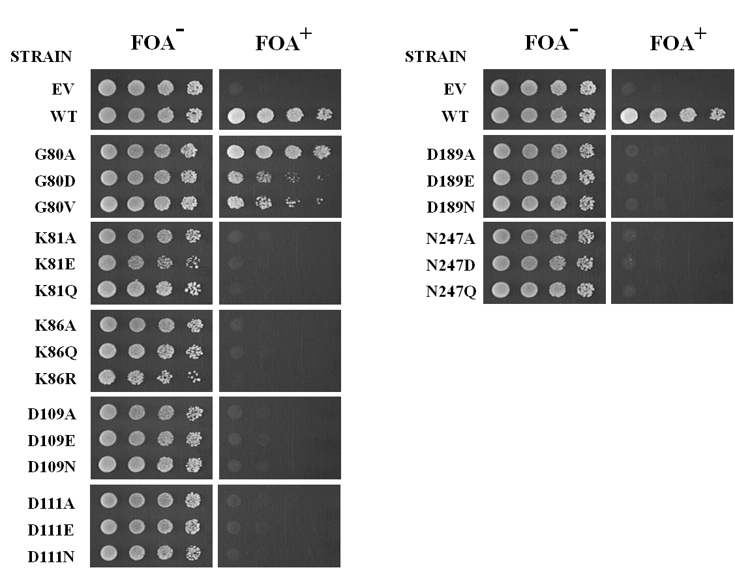

Figure 9. Complementation of viability in yeast by plasmid shuffle. Nbp35∆ cells co-expressing wild-type protein from a uracil selective plasmid, and empty vector (EV), wild-type (WT), or the indicated Nbp35 allele from an additional plasmid were grown to log phase. Cells were adjusted to OD₆₀₀ = 2.0, and 5X serial dilutions were applied to selective plates +/- 0.1% 5-FOA. Plates were grown at 30° for 5 days. Results are representative of 3 independent experiments.
5-FOA – 5-Flouroorotic Acid

2. Effect of Mutation at G80 on Nbp35 Function in Yeast
P-Loop and Switch I residues are highly conserved across the P-Loop family, and these residues play established roles in nucleotide binding and hydrolysis in homologous P-Loop NTPases. It was therefore of interest to assess the effect of these mutations on indicators of CIA activity. It has been shown that yeast lacking m-aconitase are autotrophic for glutamate biosynthesis, and that this defect is rescued by exogenous expression of mammalian IRP1, given functional CIA to provide an FeS required for IRP1 aconitase activity (454). In addition, the enzymatic activity of IRP1 correlates closely with the Fe content of IRP1 and endogenous apo-targets precipitated from yeast (294). Thus both glutamate-dependent growth and c-Aconitase activity are rapid yet accurate indicators of CIA activity in yeast lacking m-aconitase. As the G80 mutants were able to support autonomous growth, these mutants were analyzed in the ∆NK1 background, with the plasmid-borne mutants as the only NBP35 gene in these strains.
G80A only partially rescued the glutamate auxotrophy in yeast lacking m-aconitase, and the aconitase activities of exogenous mammalian IRP1 was decreased to approximately 25% of the activity observed in a wild-type strain (Figures 10A and B). Although able to support viability, the G80D mutant was unable to rescue glutamate auxotrophy or c-aconitase activities. This strain also exhibited reduced ability to support growth in the presence 5-FOA (Figure 9). Therefore even the addition of a methyl group to the side-chain at Nbp35^{G80}

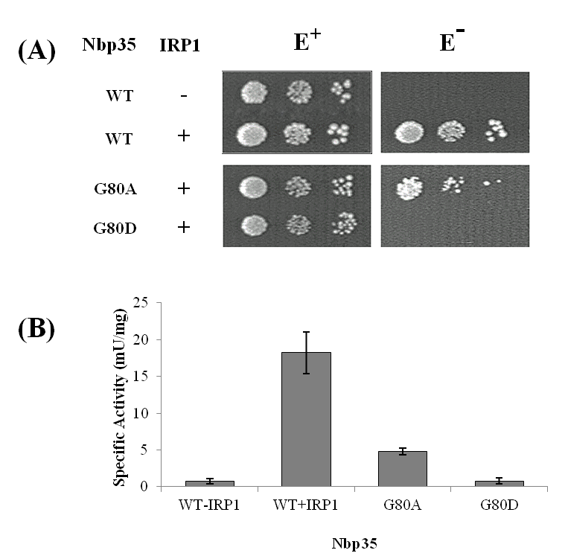

Figure 10. Ability of Nbp35 G80 mutants to complement CIA-dependent
(A) Glutamate auxotrophy. ∆NK1 cells expressing exogenous IRP1 were transformed with plasmid containing empty vector (EV), wild-type (WT), or the indicated Nbp35 allele. Log phase cells were washed with de-ionized water and adjusted to OD₆₀₀ = 2.0, in same. 5X serial dilutions were applied to selective plates +/- glutamate, as indicated. Plates were incubated at 30° for 5 days. Results are representative of 3 independent experiments.
(B) FeS-dependent c-aconitase activities. ∆NK1 cells co-expressing WT or the indicated Nbp35 allele and exogenous IRP1 were grown to log phase in selective media, harvested, and analyzed for CIA-dependent c-aconitase activity. Error bars are calculated from three independent samples. Results are representative of two independent experiments.
E⁺ – Plates supplemented with glutamate E⁻ - Plates lacking glutamate

significantly impaired cytosolic FeS biogenesis in yeast. This phenotype is reminiscent of the TSM strain, which expresses sufficient wild-type protein to support viability (~10% endogenous wild-type expression), and displays similar defects in CIA-dependent activities. Thus, mutation of the conserved P-Loop glycine at G80 results in partial disruption of activity, providing valuable hypomorphic strains for analysis of Nbp35 function in the absence of wild-type protein.
It is known that Nbp35 and Cfd1 form homo- and hetero-complexes, and that these interactions are required for physiological function (151,258,294). In addition, nucleotide binding and hydrolysis control complex formation in homologous SIMIBI NTPases (502,561). It was therefore of interest to evaluate whether mutation at G80 would impact complex formation by Npb35. With this aim, yeast expressing epitope-tagged versions of the G80 variants (C-terminal MYC) were additionally transformed with epitope-tagged Nbp35^{WT} OR Cfd1^{WT} (C-terminal HA). The MYC-tagged Nbp35 mutants were stably expressed in yeast, at levels roughly equivalent to the wild-type version as expressed from the same promoter (Figure 11). G80A efficiently precipitated with both Nbp35^{WT} and Cfd1 from yeast. Substitution with the much larger aspartic acid at this position (G80D) dramatically attenuated interaction with Nbp35WT. However, complex formation with Cfd1 appeared unaffected by this mutation.
The rapid acquisition/transfer of iron is critical to an FeS scaffolding function, and Nbp35^{WT} has been shown to acquire and transfer iron efficiently in yeast (294). Additionally, a number of homologous proteins require NTPase activities for metal acquisition and/or transfer (321,326,564,565), and nucleotide-dependent cycles control metal acquisition and/or cluster transfer in non-homologous FeS cluster assembly systems (288,301,304,307). Therefore the ability of these mutants to rapidly acquire and transfer iron was assessed by pulse-chase analysis. Iron-starved yeast were labeled for 45 minutes in iron-free media supplemented with ⁵⁵Fe (1uCi/mL, ~1.2 uM), followed by a 45 minute chase with an excess of non-radioactive iron (100 uM FeCl₃). Cells were lysed and precipitated anaerobically, and iron associated with Nbp35 was determined by liquid scintillation of the MYC precipitated cell extracts. As these strains did not require expression of wild-type protein to support viability, it was not possible to normalize to an empty vector control. Therefore each strain included a beads-only control immunoprecipitation, and counts associated with these controls were subtracted from the corresponding samples. Consistent with previous results, Nbp35^{WT} had accumulated significant counts at 45 minutes, and this iron was partially displaced by the addition of non-radioactive iron (by 34%) (Figure 12). Thus, as expected, Nbp35^{WT} bound significant iron, and some of this iron was labile. The pattern of iron-binding and release was distinct in the different mutant strains. G80A, which exhibited partial activities, bound approximately 60% of the iron as wild-type NBP35, and this iron was normally displaced over the 45 minute chase. G80D bound considerably less iron (~30%), but this iron also appeared normally displaced at 45 minutes.

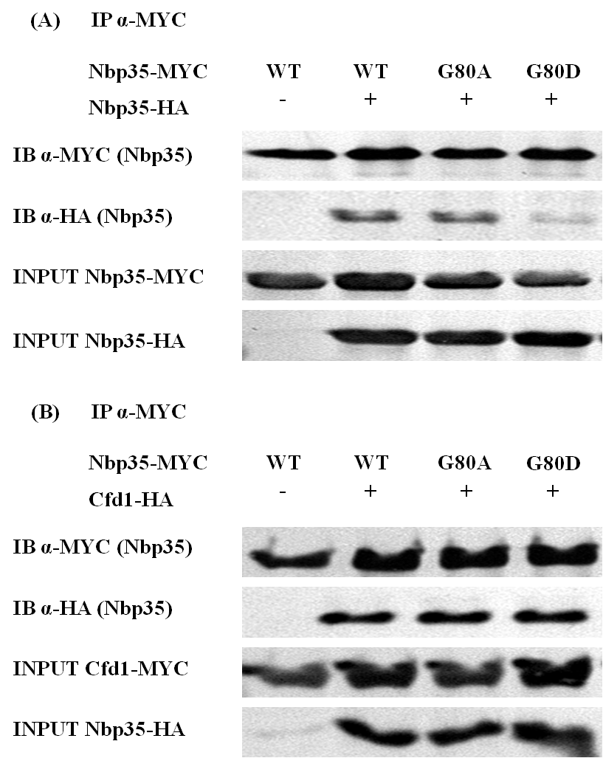
Nbp35-MYC
Cfd1-HA
(Cfd1)

Figure 11. Effect of G80 mutations on complex formation. ∆NK1 cells expressing wild-type (WT) or the indicated Nbp35 allele were transformed with plasmid containing. EV or (A) HA-tagged Nbp35^{WT} or (B) HA-tagged Cfd1 Log phase cells were harvested, prepared, and subjected to co-immunoprecipitation with MYC specific antibody as described. Co-immunoprecipitation of HA-tagged Nbp35 or Cfd1 was detected by immunoblot with MYC and HA specific antibodies. The relative expression of each allele was determined by immunoblot performed on total cell lysate. Blots are representative of independent experiments.

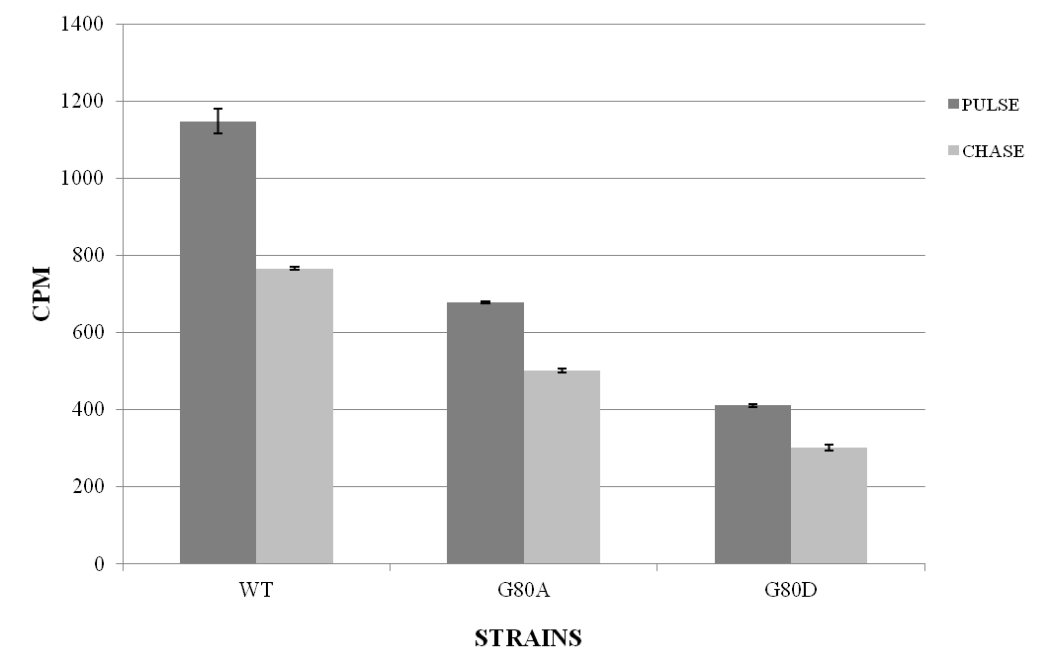

Figure 12. Effect of G80 mutations on iron binding and transfer by Nbp35. ∆NK1 cells harboring WT or the indicated Nbp35 allele were grown in selective media, washed, and radiolabeled with ⁵⁵Fe for 45 minutes followed by chase with excess of non-radioactive iron for an additional 45 minutes. Cells were subjected to immunoprecipitation with MYC specific antibody under anaerobic conditions, and ⁵⁵Fe associated with Nbp35 was determined by liquid scintillation of the immunoprecipitates. The relative protein expression was determined densitometry of immunoblot images. Error bars represent the mean from three independent immunoprecipitations, and these data are representative of 2 independent experiments.

The remaining P-Loop and Switch I mutants (K81A/Q, K86A/Q, D109A/N and D111A/N), which were unable to support viability, were transformed into the NBP35^{TSM} (Translation Start-codon Mutant - TSM) strain for further analyses. This strain expresses sufficient wild-type Nbp35 to maintain viability (~10% endogenous levels), but is unable to complement the glutamate auxotrophy in aco1 yeast expressing IRP1, indicating decreased cytosolic FeS assembly (294). Additional expression of Nbp35^{WT} restored growth on plates not supplemented with glutamate. However, none of the inviable Nbp35 P-Loop and Switch I mutants rescued glutamate-dependent growth in the TSM background (data not shown). These results demonstrate that conserved residues in Nbp35 P-Loop and Switch I regions are required for Nbp35 function in cytosolic FeS biogenesis.
In several cases, specific mutation to the second, more conserved Switch I aspartic acid (D111A or D111N) resulted in a hydrolysis-deficient protein with a dominant-inhibitory phenotype, due to formation of a non-dissociating or conformationally defective complex (502,551,561,566). Thus, it was not unexpected that the same mutations might result in an inhibitory phenotype in Nbp35, as was seen on selective plates. Therefore the inviable P-Loop and Switch I mutants were placed under control of a methionine-repressible promoter (MET3.1) to control expression of potentially toxic proteins, and to limit cellular adaptations to their prolonged expression. All subsequent experiments were performed with these conditionally expressed, c-terminally MYC tagged constructs. Expression of these proteins was efficiently repressed by methionine (2 mM). Washing of cells and removal of supplemental methionine from media resulted in rapid and robust induction. All of the mutants were stably expressed in yeast relative to the wild-type protein.
3. Select P-Loop and Switch I Mutations are Inhibitory to Growth
Controlled expression of K86Q, D111A, or D111N resulted in an inhibitory phenotype in the TSM background (Figures 13A and B). Expression of these mutants decreased colony formation by ≥ 70% on selective plates (data not shown), and effectively tripled the doubling times of these strains in selective media. Although inhibitory to growth, these strains were stably expressed at levels similar to the wild-type protein for at least 12 hours post-induction. K86A was inhibitory on solid media, but was not as inhibitory under liquid culture conditions. These strains were difficult to culture, further complicating additional characterization of these alleles. In fact, it was necessary to adjust initial cell densities to account for growth inhibition for subsequent analyses, resulting in fewer cell doublings for these inhibitory strains. Additional ectopic expression of Nbp35^{WT} largely relieved the growth inhibition in these yeast, consistent with a defect in complex formation or localization in these mutants (data not shown).

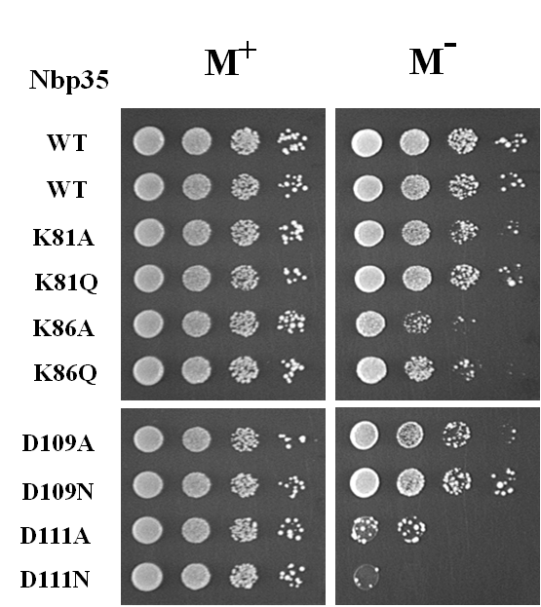
(A)

Figure 13. Growth inhibition
(A) on selective plates. TSM cells were transformed with plasmid containing EV, WT, or the indicated Nbp35 allele, under control of a methionine repressible promoter. Cells were grown to log phase in media supplemented with methionine (2 mM), washed with de-ionized water, and adjusted to an OD600 = 2.0, in same. 5X serial dilutions were prepared and applied to selective plates +/- methionine, as indicated. Plates were incubated at 30° for 3 days. Results are representative of 3 independent experiments.
M⁺ - Plates supplemented with 2 mM Methionine M⁻ - Plates lacking methionine

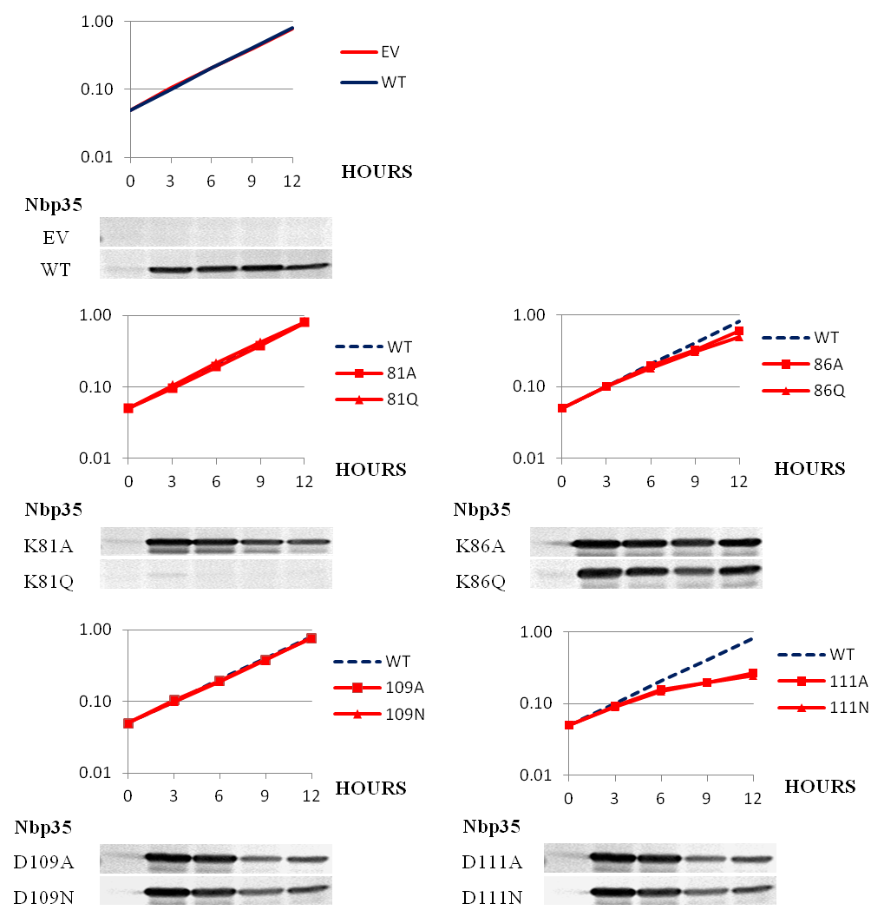
(B)

(B) in liquid selective media. TSM cells were grown to log phase and washed as for (A), and resuspended in selective media lacking methionine at OD₆₀₀ = 0.05. Optical densities were measured at the indicated timepoints, and linear portions of the resulting growth curves were plotted on a Log₁₀ scale. Aliquots were harvested at the same indicated timepoints, and the relative expression of each allele over time was determined by immunoblot (α-MYC) of 100 ug total cell lysate. Error bars represent the deviation from the mean of three independent cultures. Results are representative of 3 independent experiments.

4. Effect of Inviable P-Loop and Switch I Mutations on Nbp35 Function
Nucleotide binding and hydrolysis are required for complex formation in other SIMIBI NTPases, and expression of G80D impaired interaction with Nbp35^{WT}. It was therefore important to assess the effect of mutations to these critical P-loop lysines and Switch I aspartic acids, catalytically required for nucleotide binding and hydrolysis across the P-Loop family. TSM yeast expressing epitope-tagged versions of the inviable mutants (C-terminal MYC) were additionally transformed with epitope-tagged Nbp35^{WT} OR Cfd1^{WT} (C-terminal HA), and the ability of these mutants to interact was assessed by immuno-precipitation. However, these variants efficiently co-precipitated with both Nbp35^{WT}-HA (Figure 14A) and Cfd1-HA (Figure 14B). These results suggest that that nucleotide binding and hydrolysis are not required for Nbp35:Nbp35 or Nbp35:Cfd1 interactions, and are consistent with previous characterizations of these complexes as stable in yeast (258,294). Of note, Cfd1-HA was not expressed in the K86A strain, likely due to investigator error during co-transformation.

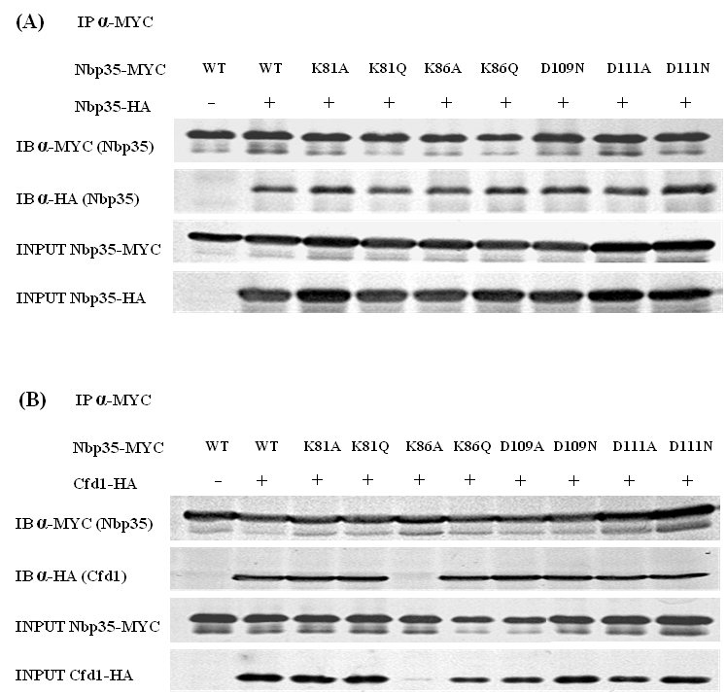

Figure 14. Effect of Nbp35 mutation on complex formation. TSM cells expressing EV or (A) HA-tagged Nbp35^{WT} or (B) HA-tagged Cfd1 were transformed with plasmid containing wild-type (WT) or the indicated Nbp35 allele. Log phase cells were harvested, prepared, and subjected to co-immunoprecipitation with MYC specific antibody as described. Co-immunoprecipitation of HA-tagged Nbp35 or Cfd1 was detected by immunoblot with MYC and HA specific antibodies. The relative expression of each allele was determined by immunoblot performed on total cell lysate. Blots are representative of independent experiments.

Preliminary results suggested that mutation at G80 impaired cluster assembly and iron binding to Nbp35. To further investigate the roles of nucleotide binding and hydrolysis in FeS assembly, we probed the ability of the inviable Nbp35 variants to rapidly acquire iron by in vivo radio-labeling. TSM yeast expressing the epitope-tagged Nbp35 mutants were pulse-labeled for 30 minutes in iron-free media supplemented with ⁵⁵Fe (1uCi/mL, ~1.2 uM), and iron associated with Nbp35 was determined by liquid scintillation (Figure 15A). Counts associated with expression of the empty vector were subtracted from each sample, and results were normalized to account for variability in protein expression. Although Nbp35^{WT} had acquired significant ⁵⁵Fe at 30 minutes, iron binding to the mutant proteins was dramatically decreased, by almost 90% in all cases, with one exception. Notably, K81A precipitated approximately 35% iron relative to the wild-type protein at 30 minutes.
To further delineate the defect associated with K81A, the effect of this mutation on the kinetics of iron binding by Nbp35 was investigated. Yeast expressing Nbp35^{WT} or the K81A variant were pulse labeled as described, aliquots were harvested at indicated time-points after addition to media containing ⁵⁵Fe, and the resultant cell lysates were analyzed for iron binding to Nbp35, over time. (Figure 15B). Under these conditions Nbp35^{WT} accumulated iron rapidly and steadily over the 90 minute period. However, the kinetics of iron binding to K81A were significantly slower, although the K81A protein also continued to accumulate iron over the entire period, indicating a defect in the acquisition of iron from a cellular source.
To gain additional insight into the role of Nbp35 activities in FeS cluster assembly on/by Nbp35, these strains were labeled to steady-state in selective minimal media containing ⁵⁵FeCl₃ (1 uCi/mL 55Fe, ~2.25 uM total iron), and analyzed for iron bound to precipitated Nbp35 (Figure 15C). First, with the exception of K81A, all mutants were severely deficient for iron binding at steady-state, binding only about 20% iron relative to wild-type protein. However, all of these mutants, which were competent for both homo- and hetero-complex formation, consistently bound some iron over background associated with empty vector at steady-state. Of note, these mutants retained the conserved C-terminal CXXC motif required for complex formation, iron binding, and cluster assembly (151), but were predicted to be deficient for nucleotide binding/hydrolysis. Second, K81A again exhibited unique behavior, binding almost two-thirds the iron relative to Nbp35^{WT} at steady-state. Collectively, these results demonstrate that mutations predicted to abolish nucleotide binding or hydrolysis impair Nbp35 physiological function in CIA, and specifically the impair the assembly of FeS cluster on Nbp35.

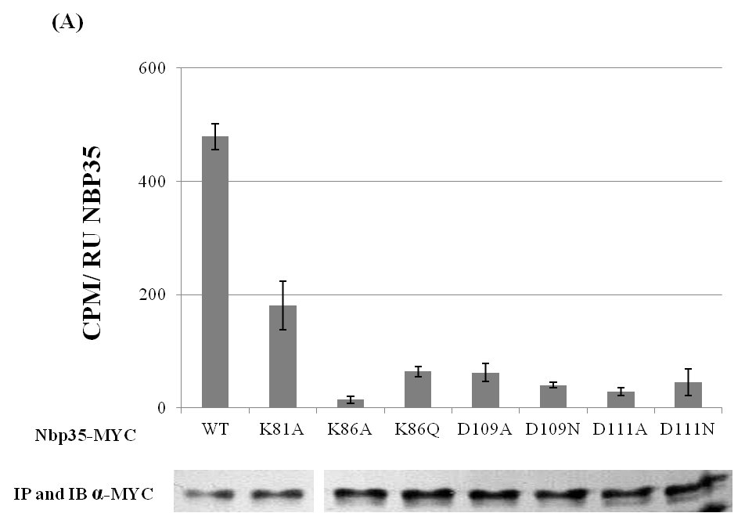

Figure 15. Effect of Nbp35 mutation on the acquisition of iron by Nbp35. TSM cells harboring EV, WT, or the indicated Nbp35 allele, were grown in selective media (2mM MET), washed, and radiolabeled with ⁵⁵Fe for (A), (B), and (C), as indicated. Cells were subjected to immunoprecipitation with MYC specific antibody under anaerobic conditions, and ⁵⁵Fe associated with Nbp35 was determined by liquid scintillation of the immunoprecipitates. The relative protein expression was determined densitometry of immunoblot images. Error bars represent the mean from three independent immunoprecipitations, and these data are representative of 2 independent experiments.

(A) Rapid acquisition of iron by Nbp35 mutants. TSM cells were incubated for 4 hours in 0.5X volume selective media, lacking methionine and containing the intracellular chelator, BIP (100 uM), to allow expression of Nbp35 and deplete the cells of iron, respectively. Cells were washed, radiolabeled in 0.1X volume iron-free media supplemented with ⁵⁵FeCl₃ (1 uCi/mL) for 30 minutes, and harvested by the addition of ice.

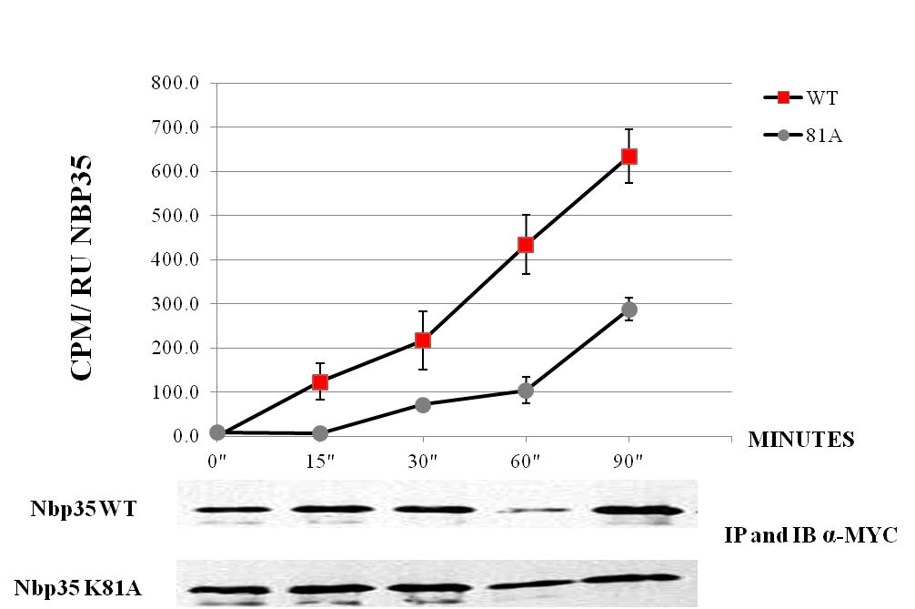

(B) Kinetics of iron acquisition by K81A. TSM cells were incubated for 4 hours, as indicated for Figure 14A. Cells were washed, and radiolabeled in 0.1X volume iron-free media supplemented with ⁵⁵FeCl₃ (1 uCi/mL), and harvested at the indicated times by the addition of ice.

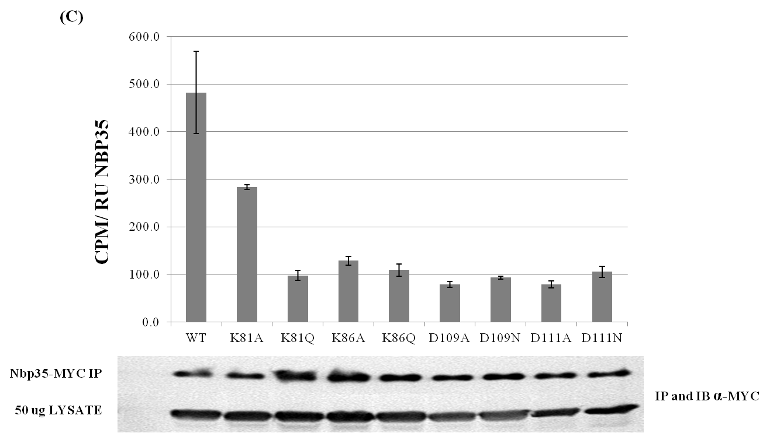

(C) Steady-state labeling to Nbp35 mutants. TSM cells were radiolabeled in selective media supplemented with ⁵⁵FeCl₃ (1 uCi/mL, ~2.3 uM total iron) for 12 hours, and harvested.

It has been reported that Nbp35 co-precipitates with the down-stream CIA factor Nar1 (215). There are no published data in support of these statements; however, depletion of Nbp35 or Cfd1 impairs the acquisition of FeS by Nar1 in vivo (258), and Nar1 appears to function downstream of the Nbp35:Cfd1 scaffolding complex. Therefore, these strains were transformed with Nar1-HA to investigate the potential for interaction between Nar1 and the Nbp35 mutants, and with the aim of assessing iron binding to Nar1 in the mutant strains. However, expression of Nar1 was largely attenuated in the TSM and NTPase mutant-expressing strains (Figure 16). Ectopic expression of Nbp35^{WT} appeared to stabilize the Nar1 protein, as there was more immuno-reactive protein in equivalent volumes of normalized lysate, both total and HA-precipitated. This is consistent with previous reports linking Nar1 protein stability to FeS binding (149), and suggests that incorporation of FeS into Nar1 is impacted upon mutation of key Nbp35 P-Loop and Switch I residues. These results additionally support the thesis that nucleotide binding/hydrolysis by Nbp35 are required for cytosolic FeS assembly in yeast, as Nar1 is an endogenous target of Nbp35 and the early CIA machinery. Expression of K81A appeared to augment stable expression of Nar1 in the TSM background, although not to the same extent as Nbp35^{WT}. These results suggest that this mutant, which showed minimal autonomous growth and was able to bind some iron, may possess some activity relative to the other Nbp35 P-Loop and Switch I mutants, or may exhibit a distinct molecular defect.

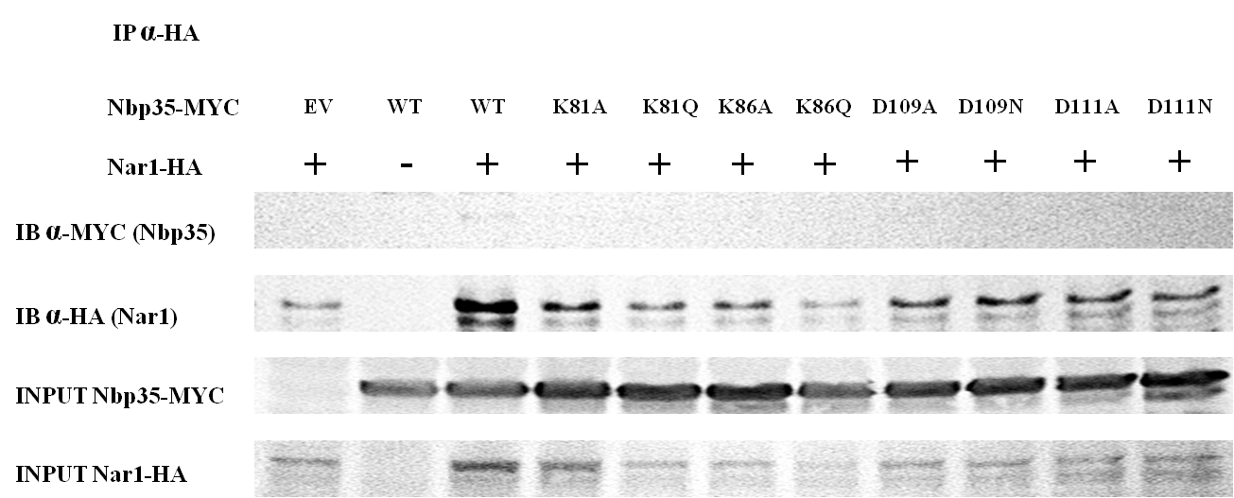

Figure 16. Effect of Nbp35 mutation on stable expression of Nar1. Nar1 is a known CIA factor and target of Nbp35:Cfd1, and Nar1 protein stability depends on FeS maturation by Nbp35:Cfd1. TSM cells co-expressing HA-tagged Nar1 AND WT or the indicated Nbp35 allele were cultured, prepared, and subjected to co-immunoprecipitation with HA specific antibody, as described. Co-immunoprecipitation of MYC-tagged Nbp35 was probed by immunoblot with MYC and HA specific antibodies. The relative expression of each allele was determined by immunoblot performed on total cell lysate.

Although Nar1 expression was significantly attenuated in these strains, Nar1 was efficiently immunoprecipitated from all strains, although to varying degrees. Careful examination suggests that Nar1 and Nbp35^{WT} may form a minor complex in vivo, as Nar1 precipitated a faint MYC-reactive band at the correct molecular weight for Nbp35, only when the two proteins were co-expressed (Figure 16). However, this band was very faint, and was not present in strains expressing the Nbp35 P-Loop and Switch I mutants, including K81A. Additional interpretation of these results was complicated by the stated effects on stable expression of Nar1 in these Nbp35-deficient strains. However, it is apparent that the inhibitory mutants do not form a stable, non-dissociating complex with Nar1.
C. Discussion
P-Loop NTPases such as Nbp35 share significant architectural and mechanistic similarities, including a requirement for conserved residues within cognate NTPase motifs. To assess the requirement for nucleotide binding and hydrolysis by Nbp35, we targeted four residues with conserved, established roles in nucleotide binding and hydrolysis in homologous proteins. The two P-Loop lysines (K81 and K86) make conserved contacts with the phosphate tail of the bound NTP in the solved structures of homologous proteins (297,500,502-505,560,562,567-571). The two Switch I aspartic acids (D109 and D111) make conserved contacts with catalytic cation and H₂O molecules, and communicate nucleotide status to distal regions via nucleotide-dependent rearrangements (561,563,572-575). These residues are essentially required for nucleotide binding and/or hydrolysis in numerous P-Loop NTPases, and these specific mutations were predicted to disrupt binding and/or hydrolysis based on extensive structural and biochemical analyses in a number of well-characterized homologs (325,327,500-502,551,560-563). Mutation to any of these cognate residues in Nbp35 resulted in a non-functional protein, unable to support viability (Figure 9) or to rescue CIA-related defects in an Nbp35^{WT}-deficient background (Figures 10A and B, and data not shown). Nbp35 showed almost no tolerance to change at these positions, underscoring their importance to Nbp35 function.
A P-Loop glycine (G80), proximal to the signature lysine, was additionally targeted. Although able to support viability (Figure 9), yeast expressing these mutants were profoundly defective for indicators of CIA activity (Figure 10A and B). The G80A mutant, which retained approximately 25% wild-type c-aconitase activities, supported normal autonomous growth. The G80D mutation ablated glutamate dependent growth and c-aconitase activities, and this mutant only partially complemented growth in yeast. Intriguingly, and consistent with previous results, the cell appears rather insensitive to profound defects in CIA, and to require minimal CIA activity to maintain viability and normal cell growth (294). This is surprising given the essentiality of all core components, and the profound defects associated with partial loss of Nbp35 in several species (82-84,498).
In order to gain additional insight into the specific role(s) of the Nbp35 NT domain, we assessed the effect of these mutations on activities known to be physiologically relevant, including complex formation and the acquisition of iron. Homologous NTPases function as obligate dimers, and utilize nucleotide status to control complex formation and/or conformation. These Nbp35 P-Loop and Switch I mutants were stably expressed, and were competent for complex formation (Figures 11 and 14). This is consistent with previous characterizations of Nbp35:Cfd1 as stable, and suggests that complex formation proceeds independently of nucleotide status. Nbp35/Cfd1 may function like NifH and Get3, which form stable, but conformationally dynamic complexes (515,573,576). These proteins utilize nucleotide status in order to spatially and temporally gate formation of a productive complex, competent for sequential interactions with down-stream effectors, and consequent nucleotide hydrolysis.
Of note, the interaction between G80D and Nbp35^{WT} was significantly attenuated (Figure 11A). In contrast, complex formation with Cfd1 appeared unaffected by this substitution (Figure 11B). The P-Loop glycines are believed to provide conformational flexibility required for effective and dynamic interactions with the phosphate tail (559,577). Substitution of an aspartic acid at this position is extremely non-conservative. This substitution would introduce rigidity and a negative charge at this site, conceivably disrupting essential bonding networks in the catalytic pocket. In addition, this mutation might alter local conformation due to steric and charge considerations, and would reasonably be expected to alter interactions at a dimer interface. This suggests that the Nbp35:Nbp35 dimer utilizes a similar interface to that seen in PDB 3KB1 and other homologous SIMIBI proteins, but that the Nbp35:Cfd1 interaction may require a distinct interface. This is consistent with formation of a catalytic hetero-tetramer, which would require distinct Nbp35:Nbp35 and Nbp35:Cfd1 interfaces. These results are also consistent with previous investigations suggesting that these proteins may utilize distinct interaction interfaces (151,294). In particular, mutation of the Nbp35 C-terminal CXXC cysteines has been shown to ablate Nbp35:Nbp35 interactions, while only minimally impacting complex formation with Cfd1.
The ability to acquire and transfer iron is critical to an FeS scaffolding function, and nucleotide binding and hydrolysis have been linked with the acquisition of iron or transfer of cluster in other assembly systems (288,301,304,307). In addition, a recent report (published as these investigations were proceeding) suggests nucleotide binding and/or hydrolysis are required for cytosolic FeS assembly, as mutation at K86 impaired iron binding to Nbp35, as assessed at 2 hours radio-labeling. Pulse labeling with ⁵⁵Fe demonstrates that these additional P-Loop and Switch I mutants are defective for the rapid mobilization of iron from a cellular source (Figures 12 and 15A). This is consistent with a defect in the assembly of labile cluster by the Nbp35:Cfd1 scaffold, and would explain the observed defects in CIA activities. However Nbp35 binds both stable and labile FeS, and steady-state labeling indicates that these proteins are defective for assembly of both types of cluster on Nbp35, as with the exception of K81A, these mutants bound only about 20% of the iron as wild-type protein (Figure 15C).
Significantly, K81A bound significant iron at steady-state (~60% wild-type) (Figure 15C). Preliminary results from pulse-chase analysis indicate that the iron bound to K81A is stably bound (data not shown). This suggests K81A may acquire stable cluster, but remains defective for assembly of labile FeS for transfer. In contrast, the other inviable mutants appear defective for assembly of both stable and labile FeS, as discussed above. Results from these studies suggest that nucleotide binding by Nbp35 is required for the acquisition of stable FeS, prior to assembly of labile cluster. Furthermore, that Nbp35 activities are additionally required for assembly of this labile cluster, presumably via the C-terminal CPXC motifs. Phylogenomic analyses and in vivo studies suggest Cfd1 is specifically required for assembly and/or transfer of the labile bridging cluster, but not for assembly of the stable cluster (30,294). Collectively, these results indicate that nucleotide binding and hydrolysis by Nbp35 are required for self-maturation and assembly of the labile cluster for transfer. These findings suggest that the early stages of CIA, assembly of FeS on the Nbp35:Cfd1 scaffold, may be more complex than previously thought.
With the exception of the Nbp35:Cfd1 hetero-system (and the distantly related SRP system), SIMIBI proteins function as obligate homo-dimers, with the two nucleotide binding pockets located symmetrically at the dimer interface (320,339). The “universally” conserved P-Loop lysine (K86) contacts the β and γ-phosphates of substrate nucleotide bound to the same monomer in virtually all P-Loop NTPases (320,559,577). These contacts may stabilize interaction with substrate, as mutation at this position generally impairs nucleotide binding. A defining feature of SIMIBI NTPases is the presence of an additional “signature” P-Loop lysine (K81), required for hydrolysis in trans, and making conserved contacts with the terminal phosphate across the dimer interface in the NTP (or non-hydrolysable analog) bound structures (339,502,551).
The signature lysine may stabilize the building charge on the hydrolysis transition state, analogous to the “arginine finger” present in small GTPase Activating Proteins (GAP’s). In addition, this residue may control/gate hydrolysis by positioning the γ-phosphate for in-line attack by the catalytic H₂O. This signature lysine is one of only three residues making conserved contacts with nucleotide across the dimer interface in the SIMIBI family, and is catalytically required in all homologous proteins where the requirement has been tested (339). Importantly, mutation at this position is generally predicted to impair hydrolysis, without impacting the ability to bind nucleotide, as this residue acts on (contacts) the bound nucleotide only in trans.
Intriguingly, K81A was minimally able to complement the wild-type protein, although the K81E and K81Q variants were not. Significantly, K81A could acquire iron, although not as efficiently as the wild-type protein (Figures 15A-C). Expression of K81A increased stable expression of Nar1, a known CIA factor and target of the CIA machinery (Figure 16), and could support minimal autonomous growth (Figure 9). It is possible that the alanine substitution, although unable to participate in catalysis, does not block the protein from randomly achieving hydrolysis, while the bulkier glutamine residue sterically hinders the protein from achieving a catalytically active conformation. K81E would additionally repel the positively charged phosphate groups, precluding any stabilizing interactions between the signature lysine and the phosphate tail. Additional studies will be required to determine if the K81A protein retains partial activity, and the molecular defect associated with this specific mutation. Of note, glutamate biosynthesis was not restored by expression of K81A, and c-aconitase activities were undetectable in this strain (data not shown). This suggests an ability to differentially target CIA activities when resources/CIA activities are limited, as the Nar1 protein appeared visibly stabilized in this strain.
The D111A and D111N mutations were inhibitory to growth in the TSM background (Figures 13A and B). This was not unexpected, as these specific mutations have consistently produced an inhibitory phenotype in homologous SIMIBI NTPases (502,551,561,566). Although the K86Q mutant is not widely considered to produce an inhibitory phenotype, careful survey of literature suggests the corresponding mutation may be inhibitory in homologous NifH and MinD proteins. These results suggest that Nbp35 likely functions as an NTPase, analogous to other SIMIBI NTPases. However, additional work will be required to determine the molecular defect(s) associated with K86Q and D111A/N. Corresponding inhibitory mutants have provided structural and mechanistic insight in homologous proteins. For example, mutation of this residue in a eukaryotic homolog (Get3D57E) resulted in a localization defect, and revealed a novel, nucleotide-independent role for this protein under energy-limiting conditions (glucose starvation and ATP depletion) (515). These variants may prove valuable probes of the mechanism of cytosolic FeS assembly, and the physiological functions of Nbp35 and Cfd1 in CIA and the cell.
The CIA factor Nar1 binds two essential Fe₄S₄ clusters, required for function in CIA (155). FeS maturation of Nar1 requires the activity of Nbp35 and Cfd1 (258). Nar1 is thus both a CIA factor AND a target of the CIA machinery. It was therefore of interest to investigate the interaction of Nbp35 with Nar1, and to evaluate iron binding to Nar1, in the various Nbp35 mutant strains (Figure 16). However, expression of tagged-Nar1 was severely attenuated in the wild-type deficient TSM strain. Additional expression of Nbp35^{WT} increased stable expression of Nar1 in this strain. This is not unexpected, as Nar1 protein stability depends upon acquisition of FeS from Nbp35:Cfd1 (258). With the exception of K81A, which supported minimal autonomous growth, none of the P-Loop or Switch I Nbp35 mutants increased stable expression of Nar1 in the TSM strain. These results demonstrate that the Nbp35 nucleotide domain, and presumably nucleotide binding and hydrolysis, are required for FeS cluster assembly in yeast. Furthermore, these results additionally distinguish K81A from the other mutations to the “catalytic” P-Loop and Switch I residues.
There are no structural data available for Nbp35 and/or Cfd1. However, a similar dimeric arrangement is suggested by the structure of an archaeal Apbc/Nbp35 protein, Af_226 (PDB 3KB1) (Figure 5A). This general arrangement is further supported by previous investigations which identified a conserved phenylalanine, required for stable complex formation by Nbp35 and Cfd1; this phenylalanine is located at the dimer interface in PBD 3KB1, where it participates in π-stacking with the corresponding residue in the opposing monomer. This is the same interface observed in other SIMIBI NTPases, with the signature lysine reaching across the conserved dimer interface (Figure 6). The inhibition by D111A/N and the unique behavior of the K81A variant additionally suggest that Nbp35 conserves both structural and mechanistic features with other SIMIBI proteins, and suggest additional avenues for further investigation.
In conclusion, we have demonstrated that key residues within cognate NTPase motifs are required for Nbp35 function in yeast, including FeS biogenesis. Most mutations to these residues were lethal, underscoring their essential contributions to Nbp35 function. Although stably expressed and competent for complex formation, these mutants were defective for the acquisition of iron, as assessed by in vivo radio-labeling. The results presented herein demonstrate that Nbp35 activities are required for self-maturation and assembly of labile cluster destined for transfer to target proteins. These investigations indicate that Nbp35 exhibits structural and mechanistic similarities with homologous proteins, and suggest additional avenues for exploration based on studies in these systems. Further investigations will undoubtedly provide additional insight into the precise roles of Nbp35 and Cfd1 in FeS biogenesis, and the mechanisms of cluster assembly by Nbp35 and the Nbp35:Cfd1 complex.

CHAPTER IV: THE ROLE OF NBP35 ‘SIGNALING HELIX’ RESIDUES
A. Introduction – The ‘Signaling Helix’ in SIMIBI NTPases
As stated previously, Nbp35 is a member of the SIMIBI sub-family of P-Loop NTPases, characterized by a deviant P-loop motif encoding for an additional, ‘signature lysine’ (GKGGXGKS/T), catalytically required for hydrolysis (151,320,338,339). These proteins participate in diverse cellular processes, including control of bacterial cell division (560,578), metal efflux (327,579), targeting and insertion of eukaryotic tail-anchored proteins (570,571,576), and complex metallo-cofactor assembly. Despite diverse roles in distinct cellular processes, these proteins share significant architectural and mechanistic similarities (339,342). For example, SIMIBI proteins function as obligate homo- or hetero-dimers, with the nucleotide binding pockets at the dimer interface. Dimerization results in assembly of the catalytic machinery, as the signature lysines are required in trans to complete the two composite active sites (327,502).
SIMIBI proteins display additional architectural and mechanistic similarities, including conservation of the canonical Switch I and II regions (561,563,573,580). Conserved residues within these motifs make contacts with catalytic magnesium and water molecules, and function as conformational ‘switches’ by translating nucleotide status into conformational changes required for hydrolysis, and for ordered reactions with downstream effectors. In general, nucleotide binding and dimerization generate the composite
interaction interfaces required for interaction with these effectors, including substrate moieties, other proteins, or cellular structures (339,341,342,574). Nucleotide hydrolysis by SIMIBI NTPases is additionally gated by an apparent requirement for activation by binding of an activator molecule, a requirement which has been demonstrated in several homologous systems, including the bacterial MinD and NifH SIMIBI ATPases (561,573,581,582).
These architectural and mechanistic features have been well-characterized, and are well-conserved across the SIMIBI family, with some exceptions and subtle distinctions, allowing activities to be precisely tailored to specific cellular function. Several SIMIBI proteins have been extensively characterized, both structurally and functionally. Careful examination of structures deposited with the Protein Data Bank (PDB) reveals the presence of a conserved helix at the dimer interface of these proteins (Figure 17A). This helix is not as highly conserved at the sequence level across the SIMIBI family. However, the region is highly conserved within orthologous proteins, and residues within this helix make conserved contacts with the ribose ring, and with P-Loop residues, including the signature lysine, in various SIMIBI NTPases. Many SIMIBI proteins conserve a negatively charged residue (Nbp35 E221) at the N-terminus of this dynamic helical region (Figure 17B). As these studies were focused on Nbp35, this conserved helix will be referred to as HELIX²²¹ herein.

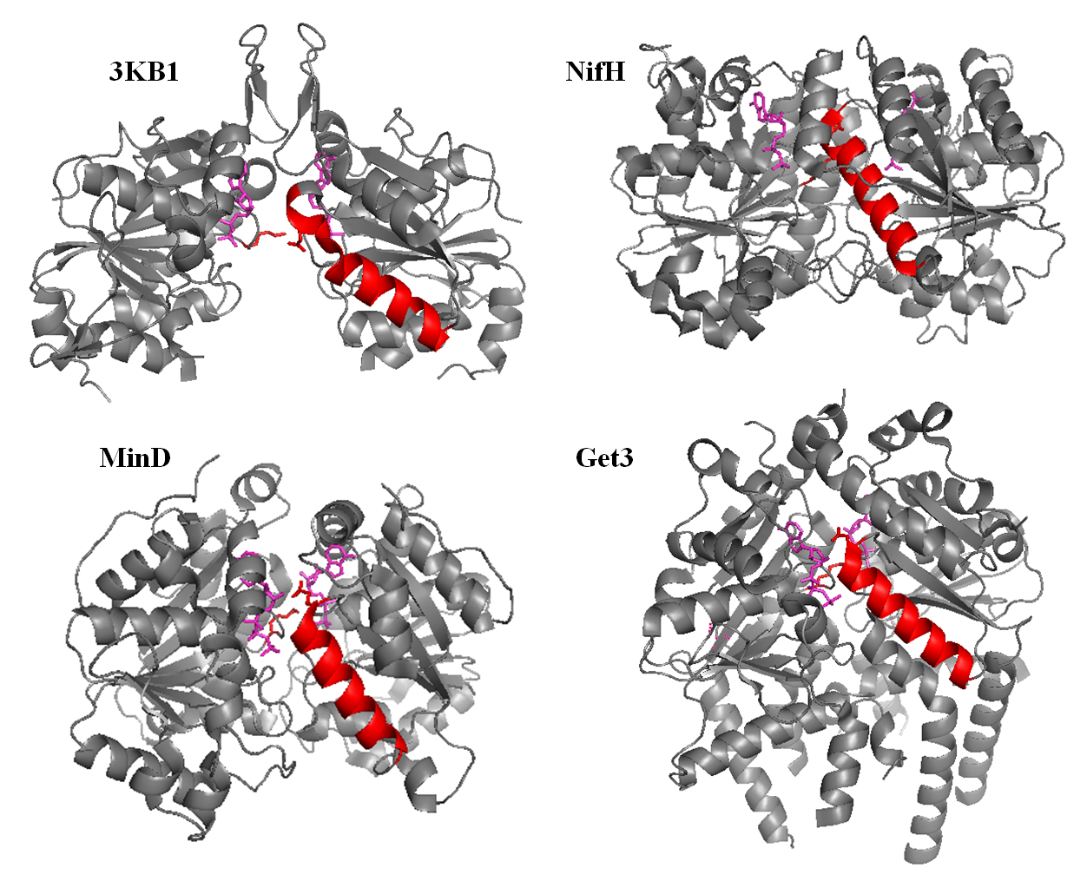

Figure 17 (A) Conservation of HELIX²²¹ in SIMIBI NTPases. Ribbon diagrams of the crystal structures of homologous SIMIBI NTPases, highlighting the conserved inter-monomeric signaling helix. Helix residues, and the side-chains for the residues corresponding to the signature lysine and Nbp35 E221 are shown in RED. The bound ATP or non-hydrolyzable analogs are shown in MAGENTA. Structures include the archaeal ApbC/Nbp35 homolog, Af_226 PDB 3KB1, NifH PDB 1FP6, MinD PDB 3Q9L, and Get3 PDB 3ZS9.

(B) Nbp35 Schematic and Sequence Alignment for Helix²²¹. Protein schematic for Nbp35 showing cognate motifs required for nucleotide binding and hydrolysis in homologous NTPases. Conserved residues chosen for mutagenesis in Nbp35 are shown in BOLD, and in RED for Nbp35. Nbp35^{E221} is highly conserved across the SIMIBI family, with the exception of the Nbp35 paralog and partner protein, Cfd1. Note that the E221 equivalent is conserved in additional SIMIBI proteins, but not in Cfd1 orthologs!

MinD is a SIMIBI ATPase required for bacterial cytokinesis and chromosome segregation. MinD has been crystallized in various nucleotide-bound states, and has been extensively characterized (502,503,513,560,562,563,578,581-587). In the ADP-bound MinD^{WT} monomer (PDB 1G3Q), the signature lysine makes extensive contacts with residues in HELIX²²¹ (MinD HELIX 7), including the N-terminal glutamate (E146) and a conserved aspartate (D152) (560). In the ATP-bound MinD^{D40A} dimer (PDB 3Q9L), the signature lysine is released from these residues to make almost exclusive contact with the γ-phosphate of the ATP bound to the opposing monomer (502). This additionally frees E146 to contact the ribose ring across monomers. This N-terminal glutamate is one of only three residues to make inter-monomeric contacts with NTP (or non-hydrolyzable analog) across the SIMIBI family: the signature lysine and the preceding P-Loop glycine make contact with the γ-phosphate across the dimer interface in several SIMIBI proteins, and this helix-initiating negative (E or D) residue makes conserved contacts with the ribose ring (Figures 18 A, B, and C).
Analysis of B-factors from the MinD ADP and AMP-PCP bound structures suggests that the P-Loop, Switch I/II, and HELIX²²¹ regions are “strikingly mobile” and responsive to nucleotide (560). Directed mutagenesis of E146 and D152 resulted in a protein competent for complex formation, and for nucleotide binding and basal hydrolysis (560,582,584). However, hydrolysis was not stimulated by binding to the physiological activator, MinE (582). Residues in HELIX²²¹, including D152, are required for sequential interactions with protein
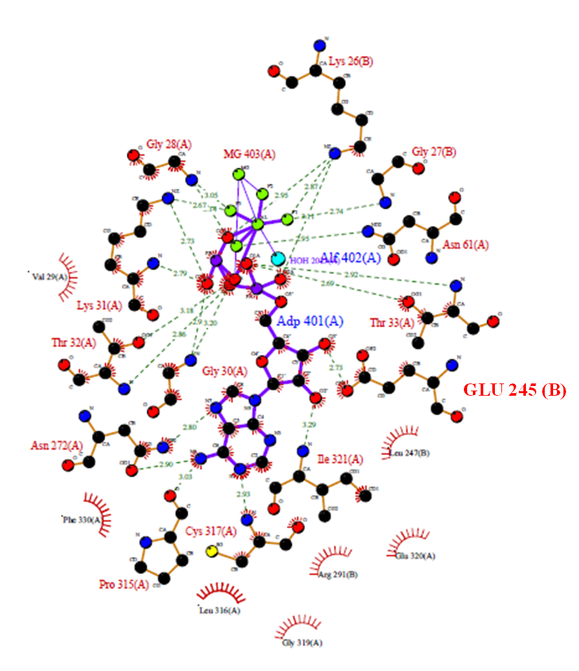

Figure 18 (A). Ligand Plot for Get3 Bound to ADP-AIF (PDB WOJ). Ligand plot showing contacts with ADP-AIF, including INTER-MONOMERIC contact between the “SWITCH III” residue GLU245 and the ribose ring. Note that this residue is one of only three residues to make inter-monomeric contact with the ligand, including the signature lysine and an adjoining P-Loop glycine. Figure generated using PDB SUM (www.ebi.ac.uk/pdbsum/).

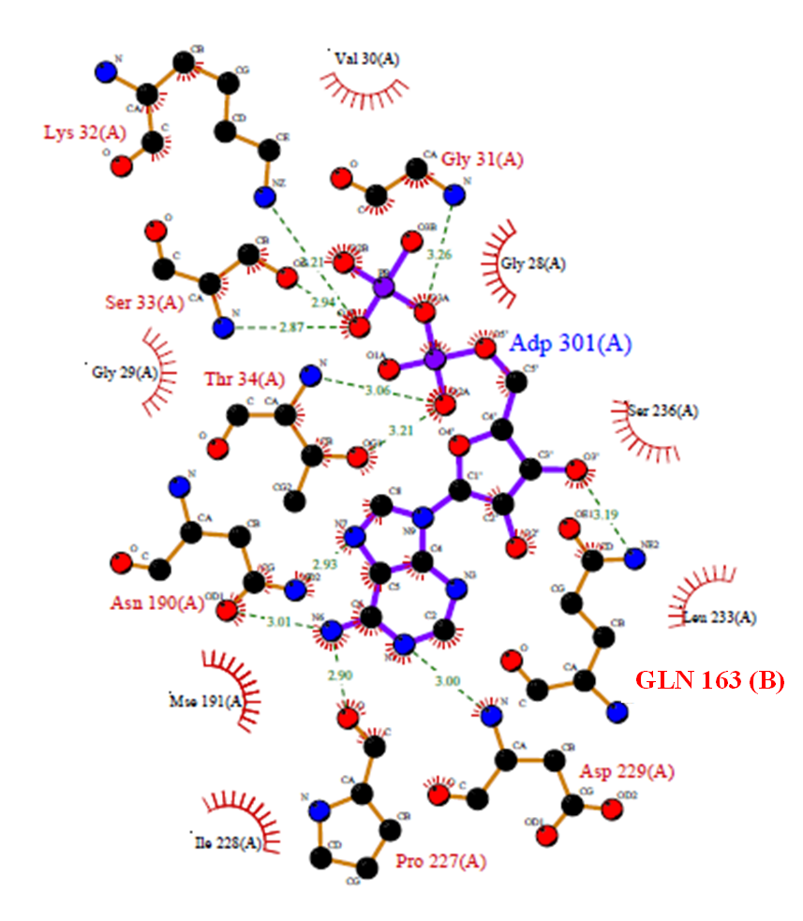

(B). Ligand Plot for Af_226 Bound to ADP (PDB 3KB1). Ligand plot showing contacts with ADP, including INTER-MONOMERIC contact between the “SWITCH III” residue GLN163 (next to GLU164) and the ribose ring. Note that this residue is the only residue making inter-monomeric contact with the ligand in the ADP-bound structure. The signature lysine does not make contact with ligand in this structure. Figure generated using PDB SUM (www.ebi.ac.uk/pdbsum/).

(C). Ligand Plot for MinD Bound to ATP (PDB 3Q9L). Ligand plot showing contacts with ATP, including INTER-MONOMERIC contact between the “SWITCH III” residue GLU146 and the ribose ring. Note that this residue is one of only three residues to make inter-monomeric contact with the ligand in the ADP-bound structure, including the signature lysine and an adjacent P-Loop glycine. Figure generated using PDB SUM (www.ebi.ac.uk/pdbsum/).

partners (502,582-586). E221 and D152 make dynamic, NT-dependent intra-monomeric contacts with critical P-Loop and Switch I residues, including the signature lysine (582,585,586). Although the role of HELIX²²¹ has not been explicitly defined, cumulative results establish a requirement for this helix in MinD nucleotide-dependent function, specifically in signaling nucleotide-status between distal regions, and in the activation of hydrolysis in response to MinE.
NifH is a SIMIBI ATPase required for the biological fixation of nitrogen (309,313). Like MinD, NifH has been extensively characterized, both structurally and biochemically (299,309,499-501,551,567,568,572,573,575,588-596). Of note, both HELIX²²¹ (NifH α-helix 5, residues 151-176) and E154 (the Nbp35 E221 equivalent) have been identified as critical to NifH nucleotide-dependent physiological function. E154 has been proposed to stabilize interaction with the adenine base and ribose ring through dynamic nucleotide-dependent interactions, both within and across monomers (500,569,593). E154 is in close proximity (within 4 Å) to P-Loop residues including the signature lysine in the nucleotide-free and ADP-bound complex structures, and may transduce information between the signature lysines and nucleoside binding regions, within and across the dimer interface (569). NifH E154 appears to play an important role in communicating nucleotide status to critical regions of the protein, and has been proposed to function as a “signaling molecule” unto itself.
Similar to MinD, NifH HELIX²²¹ has been identified as highly mobile in response to nucleotide status and complex formation, along with the P-Loop and Switch I/II regions (593,594). C-terminal residues in this helix interact directly with the MoFe protein (501,573), and this helix becomes “kinked” and significantly displaced upon complex formation (573,593,597). N-terminal residues in this helix mediate dynamic intra- and inter-monomeric interactions with critical P-Loop and Switch I residues, and the nucleoside-binding region of the protein (597,598). This helix has been proposed to coordinate communication between the P-Loop (including the signature lysine), Switch I, nucleoside, and MoFe-binding regions of the NifH protein, within and across the dimer interface. And this helix is specifically required for the NifH conformational response to ATP-binding and complex formation with MoFe, and for consequent nucleotide hydrolysis.
There are no structural data available for Nbp35. However, a similar architectural arrangement is suggested by the structure of an archaeal Apbc/Nbp35 protein, Af_226 (PDB 3KB1) (Figure 5A). Af_226 is highly homologous to Nbp35 on a primary level (~45% sequence identity), and retains all the functionally important motifs present in Nbp35 and Cfd1. In addition, all Apbc/Nbp35 homologs characterized to date, including several bacterial and archaeal homologs, appear to function in FeS biogenesis (30,197,258,334-337,506). HELIX²²¹ is present in the crystal structure of Af_226 (PDB 3KB1), in the same position as in other SIMIBI proteins, at the dimer interface (Figure 17A). The N-terminal glutamate is conserved in Af_226 and Nbp35 (Figure 17B), and is essentially invariant among Nbp35 orthologs. Automated homology modeling suggests that residues mapping to this region (E221-K236) may also form a helix in Nbp35 (http://swissmodel.expasy.org/).
Cumulative results suggest that this region is structurally and functionally conserved in homologous SIMIBI NTPases. Further, residues in this region may play conserved roles in the conformational response to nucleotide binding and complex formation, and in the activation of hydrolysis. Therefore residues mapping to this region were targeted by site-directed mutagenesis, and the effect of these mutations on known Nbp35 functions were assessed in the model organism Saccharomyces cerevisiae. Results of these studies extend a requirement for these residues to Nbp35, indicating this region may constitute a novel NTPase motif in the SIMIBI family. Additionally, these results suggest that nucleotide hydrolysis by Nbp35 may be required for the assembly of labile cluster, after the (nucleotide-dependent) acquisition of stable cluster for the FeS maturation of Nbp35.
B. Results
1. Identification of Helix Residues Required for Nbp35 Function in Yeast
Careful survey of literature and structures deposited at the PDB revealed the presence of a conserved helix in SIMIBI NTPases, and suggested that residues in this helix play conserved roles in nucleotide hydrolysis in this family. Two of these residues are highly conserved among Nbp35 orthologs, as assessed by multiple sequence alignments generated using both CONSURF (http://consurf.tau.ac.il/) and NCBI Homologene (http://www.ncbi.nlm.nih.gov/homologene) databases (Figure 5B). To investigate a requirement for this region in Nbp35, and to further probe the role of Nbp35 activities in FeS biogenesis, these residues (E221 and D226) were targeted by site-directed mutagenesis of the encoding allele. Both residues were mutated to alanine, and substitutions were designed to further probe the roles of specific side-chains at these positions. Purified Nbp35 has not previously exhibited NT binding/hydrolysis activities. Therefore, the ability of the different alleles to support Nbp35 function was assessed by complementation of Nbp35^{WT} in yeast.
As NBP35 encodes an essential gene, the ability of the variant proteins to support viability was determined by plasmid shuffle of the wild-type protein in the presence of 5-FOA, as described (Chapter III.B.1). In general, mutation of these residues did not impair the ability of the protein to support autonomous growth in yeast (Figure 19A). The E221N mutant was lethal, as initially assessed. However, additional analyses demonstrated that it is possible to isolate a population of cells able to support autonomous growth. This is reminiscent of the phenotype displayed by the K81A mutant, which also supported minimal growth in the presence of 5-FOA (Figure 19B). K81A and E221 appear to be structurally and functionally linked in other proteins. Therefore K81A was included in these characterizations, in the ∆NK1 background, in order to provide a basis for comparison with results obtained for the P-Loop and Switch I mutants in the TSM background.

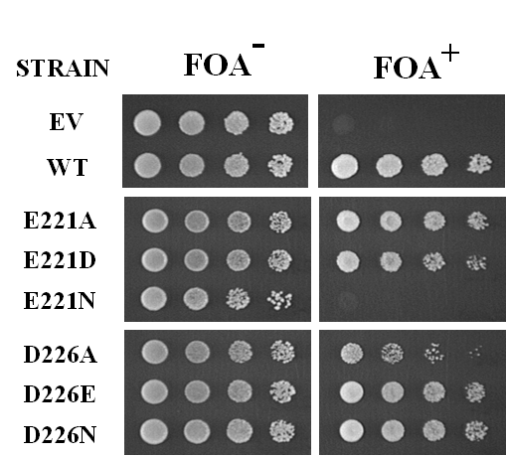

Figure 19. (A) Ability of Nbp35 Helix mutants to complement viability. ∆NK1 cells co-expressing wild-type protein from a uracil selective plasmid, and empty vector (EV), wild-type (WT), or the indicated nbp35 allele were grown to log phase. Cells were adjusted to OD₆₀₀ = 2.0, and 5X serial dilutions were applied to selective plates +/- 0.1% 5-FOA. Plates were grown at 30° for 5 days. Results are representative of 3 independent experiments. These strains were additionally streaked onto these plates at a lower density, in order to isolate independent colonies for additional analyses, as shown in the lower panel (B).

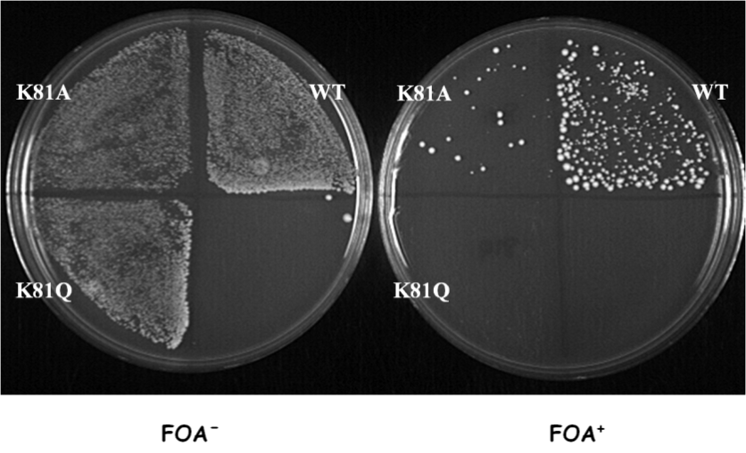
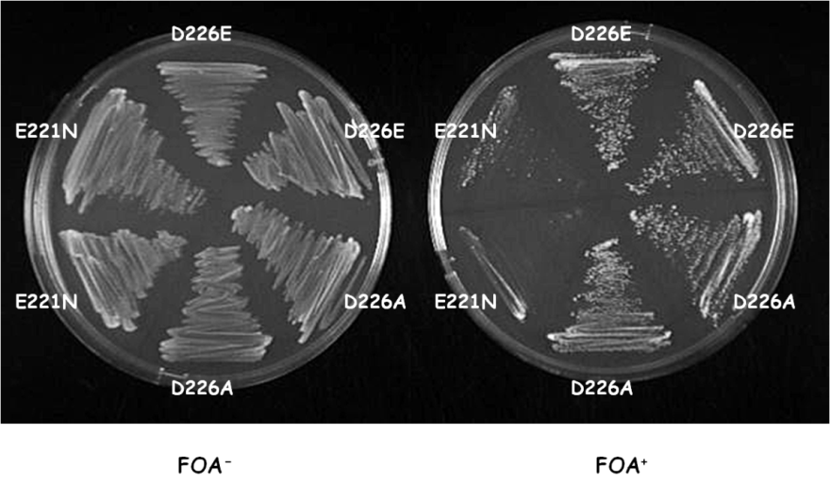

(B) Plasmid shuffle on 5-FOA for isolation of viable Nbp35 mutants. Cells were streaked onto selective plates +/- 0.1% %-FOA and incubated at 30° for 5 days

5-FOA – 5-Flouro-orotic Acid

Nbp35 is the scaffold for CIA (29,258), and it was therefore of interest to assess the effect of these mutations on indicators of CIA activity. As outlined in the previous chapter, glutamate dependent growth and c-aconitase activity correlate with CIA activity in the yeast background utilized for these investigations. Therefore, the ability of the E221 and D226 mutants to support these activities was assessed, relative to Nbp35^{WT}. Although able to support autonomous growth, these mutants were significantly impaired for CIA-dependent c-aconitase activities and glutamate prototrophy (Figures 20A and B). The E221 mutants were unable to support glutamate-dependent growth or aconitase activities. Even the relatively conservative E221D substitution ablated glutamate-dependent growth and decreased aconitase activities by almost 90%, and the alanine and asparagine substitutions decreased activities to background levels (Figure 20A). Although deleterious to function, mutation at D226 did not as severely impact the function of the protein, as these mutants retained some c-aconitase activities, and partial ability to support glutamate-dependent growth.

Figure 20. Ability of Nbp35 helix mutants to complement
(A) c-Aconitase activities. ∆NK1 cells co-expressing WT or the indicated Nbp35 allele and exogenous IRP1 were grown to log phase in selective media, harvested, and evaluated for CIA-dependent aconitase activity. Error bars are calculated from three independent samples. Results are representative of two independent experiments.
(B) glutamate auxotrophy. Or, cells were washed with de-ionized water and adjusted to OD₆₀₀ = 2.0, in same. 5X serial dilutions were applied to selective plates +/- glutamate, as indicated. Plates were incubated at 30° for 5 days. Results are representative of 3 independent experiments.
GLU⁺ - Plates supplemented with glutamate GLU⁻ - Plates lacking glutamate
2. Effect of Helix Mutation on Nbp35 Complex Formation
It is known that Nbp35 and Cfd1 form homo- and hetero-complexes, and that these interactions are required for physiological function (151,258,294). In addition, nucleotide binding and hydrolysis control complex formation in homologous SIMIBI NTPases (502,561). Although mutation of Nbp35 P-Loop and Switch I residues did not generally affect interaction with Nbp35^{WT} or Cfd1 (Chapter III.3), it was of interest to evaluate whether mutations to the putative signaling helix would impact complex formation by Npb35. With this aim, yeast expressing epitope-tagged versions of the Npb35 variants (C-terminal MYC) were additionally transformed for co-expression of epitope-tagged Nbp35^{WT} OR Cfd1 (C-terminal HA). All of the MYC-tagged Nbp35 variants tested were stably expressed in yeast, at levels roughly equivalent to the wild-type version as expressed from the same promoter (ADH). Mutation to this region differentially influenced homo- and hetero-complex formation Figures 21A and B). Although all variants were competent for interaction with Nbp35WT-HA and Cfd1-HA, the Nbp35:Nbp35 interaction appeared sensitive to mutation at E221. In particular, E221N was attenuated for stable interaction with Nbp35^{WT} In contrast, co-precipitation with Cfd1-HA appeared unaffected by mutation at E221 or D226 (Figure 21B).

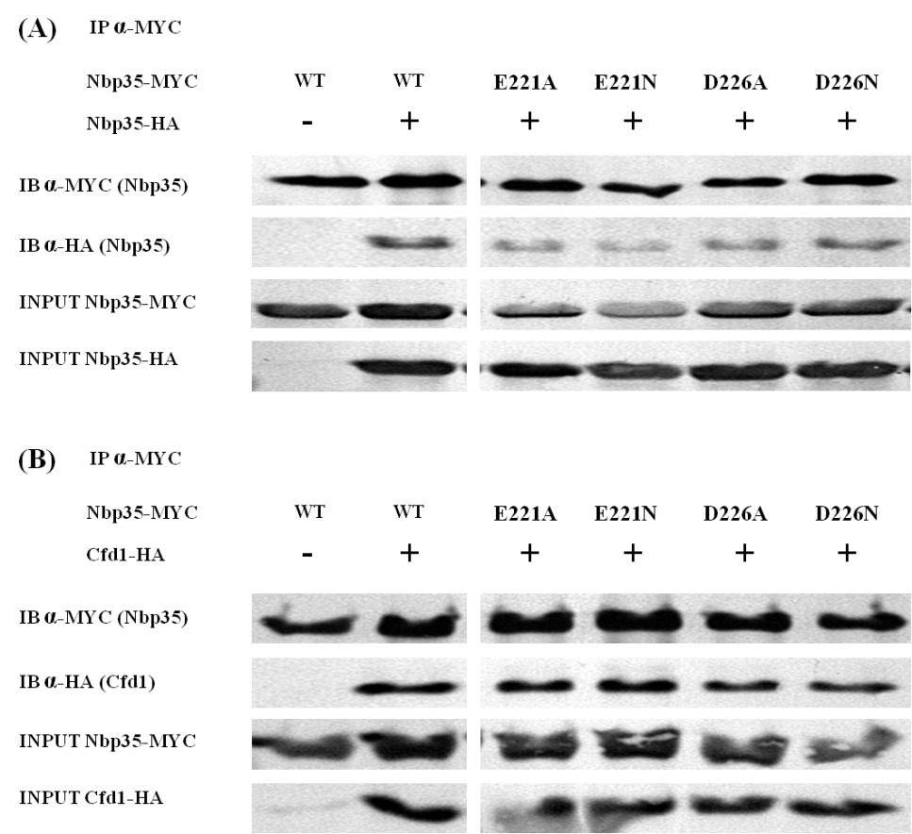

Figure 21. Effect of helix mutation on complex formation. ∆NK1 cells expressing wild-type (WT) or the indicated Nbp35 allele were transformed with plasmid containing EV or (A) HA-tagged Nbp35^{WT} or (B) HA-tagged Cfd1. Log phase cells were harvested, prepared, and subjected to co-immunoprecipitation with MYC specific antibody as described. Co-immunoprecipitation of HA-tagged Nbp35 or Cfd1 was detected by immunoblot with MYC and HA specific antibodies. The relative expression of each allele was determined by immunoblot performed on total cell lysate. Blots are representative of independent experiments.

3. Effect of Helix Mutation on Iron Binding by Nbp35
Results presented in the previous chapter demonstrate that nucleotide binding and hydrolysis are required for the physiological acquisition of iron by Nbp35 (Figures 12 and 15A-C). Mutations E221 and D226 are specifically predicted to impair the allosteric responses required for efficient nucleotide hydrolysis. Therefore the ability of these Nbp35 helix mutants to rapidly acquire and transfer iron was assessed by pulse-chase analysis. Iron-starved yeast were labeled for 45 minutes in iron-free media supplemented with ⁵⁵Fe (1uCi/mL, ~1.2 uM), followed by a 45 minute chase with an excess of non-radioactive iron (100 uM FeCl₃). Cells were lysed and precipitated anaerobically, and iron associated with Nbp35 was determined by liquid scintillation of the MYC precipitated cell extracts. A beads-only control was included for each strain, and counts associated with these controls were subtracted from the corresponding samples. As the K81A mutant was able support autonomous growth, yeast expressing this strain were included to allow comparison of results between mutants expressed in the Nbp35 deletion and TSM strains.
Consistent with previous results, Nbp35^{WT} accumulated significant ⁵⁵Fe at 45 minutes, and this iron was partially displaced by the addition of non-radioactive iron (by 34%) (Figure 22). Thus, as expected, Nbp35^{WT} bound significant iron, and some of this iron was labile. However, the pattern of iron-binding and release was distinct in the different mutant strains. Consistent with results obtained in the TSM strain, K81A accumulated only about 1/3 of the iron as Nbp35^{WT} at 45 minutes. Further, this iron was stably bound throughout the 45 minute pulse. Iron binding to the E221 mutants was remarkably similar to K81A, and was similarly resistant to displacement over 45 minutes. D226A, which exhibited evidence of partial activities, bound approximately 60% of wild-type protein. Still, little or none of this iron was displaced over 45 minutes, suggesting iron associated with these mutants is more stably bound than iron associated with wild-type Nbp35.

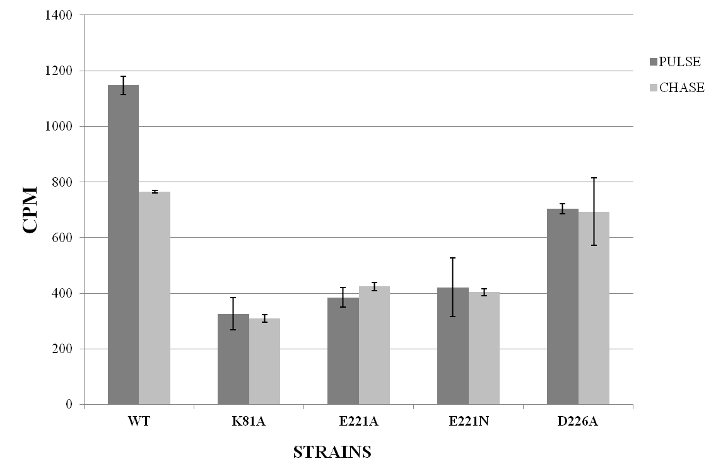
Figure 22. Effect of helix mutation on iron binding by Nbp35. ∆NK1 cells harboring WT or the indicated Nbp35 allele were grown in selective media, washed, and radiolabeled with ⁵⁵Fe for 45 minutes followed by chase with excess of non-radioactive iron for an additional 45 minutes. Cells were subjected to immunoprecipitation with MYC specific antibody under anaerobic conditions, and ⁵⁵Fe associated with Nbp35 was determined by liquid scintillation of the immunoprecipitates. The relative protein expression was determined densitometry of immunoblot images. Error bars represent the mean from three independent immunoprecipitations, and these data are representative of 2 independent experiments.

C. Discussion
Analyses of the atomic structures of homologous SIMIBI NTPases deposited at the PDB revealed the presence of a conserved helical region (HELIX²²¹) in this family. HELIX²²¹ is positioned at the dimer interface, in close proximity to the composite nucleotide binding pockets. Genetic, biochemical, and in vivo investigations of the MinD, NifH, and Get3 SIMIBI NTPases demonstrate a requirement for residues within this region, including a highly conserved glutamic acid (corresponding to Nbp35 E221), at the N-terminus of this dynamic helical region (500,502,560,569,582-585,593,597,598). Results presented herein extend that requirement to Nbp35, as mutations to residues mapped to this region, including E221, are deleterious to Nbp35 physiological function. Furthermore, these mutations impaired the rapid acquisition and transfer of iron by Nbp35, additionally corroborating a requirement for nucleotide binding and hydrolysis by Nbp35 in cytosolic FeS assembly.
Although able to support autonomous growth in yeast (Figure 19A), mutation to E221 and D226 dramatically impacted CIA-dependent activities such as c-aconitase activities and glutamate prototrophy (Figures 20A and B). As seen with the P-Loop and Switch I mutants, complex formation did not require these residues, as in general, these mutants precipitated Nbp35^{WT} and Cfd1 efficiently from yeast (Figures 21A and B). These results again suggest that nucleotide binding and hydrolysis are not required for complex formation by Nbp35 and Cfd1, and are consistent with formation of stable homo- and hetero-complexes, independent of the NT and iron status of Nbp35. However, mutation at E221 (and E221N in particular) reduced stable Nbp35:Nbp35 interaction, without visibly affecting the Npb35:Cfd1 interaction. E221 is predicted to lie at the dimer interface, and the mutation to asparagine could reasonably be expected to impact dimer formation from the PDB 3KB1 structure. This is consistent with the observations reported in Chapter III for the G80D mutation. G80D was also defective for interaction with Nbp35, but appeared unaffected for complex formation with Cfd1 (Figures 11A and B). This suggests that the Nbp35:Nbp35 dimer utilizes a similar interface to that seen in PDB 3KB1 and other homologous SIMIBI proteins, but that the Nbp35:Cfd1 interaction may require a distinct interface. This is consistent with formation of a catalytic hetero-tetramer, as suggested by previous investigations, and which would require distinct Nbp35:Nbp35 and Nbp35:Cfd1 interfaces (151,294).
Mutation at E221 was especially deleterious to Nbp35 physiological function. Even the relatively conservative E221D mutation ablated CIA-dependent functions (Figures 20A and B), suggesting a very specific role for this residue in Nbp35. E221N displayed only minimal growth on 5-FOA (Figures 19A and B), raising the possibility that the cell has compensated with a suppressor mutation. These yeast grew normally after the selection process, despite an almost total lack of function as assessed by CIA-dependent glutamate growth and c-aconitase activities. This is reminiscent of the phenotype displayed by the K81A mutant, which also demonstrated a limited ability to support autonomous growth (Figure 19B). Iron-binding was remarkably similar in these strains as well, as the K81A and E221N mutants accumulated only about 1/3 the iron relative to Nbp35^{WT} at 45 minutes pulse-labeling, and this iron was resistant to displacement by non-radioactive iron over an additional 45 minute period (Figure 22). These results suggest that K81 and E221 may act at the same step in the nucleotide cycle, and that these residues are jointly required for the rapid acquisition of iron by Nbp35, perhaps for assembly of the labile cluster on the Nbp35 scaffold. Intriguingly, K81A was the only catalytic residue to accumulate significant iron at steady-state (~60%) (Figure 15C), and K81A was predicted to exhibit a hydrolysis defect without impacting nucleotide binding, similar to residues in this helix. These results suggest that nucleotide hydrolysis by Nbp35 may be required for assembly or transfer of labile cluster, after assembly of the more stable FeS required for Nbp35 function in CIA. It would be of enormous interest to determine the steady-state iron binding of E221A/N relative to Nbp35^{WT} and K81A, and the stability of the iron bound to these variants at steady-state.
E221 is highly conserved in Nbp35 orthologs, and across the SIMIBI family of NTPases. This residue is conserved in Af_226, the uncharacterized archaeal Apbc/Nbp35 homolog (and probable ortholog), which crystallized as a dimer, bound to ADP and a bridging zinc atom (PDB 3KB1). In the crystal structure, the Nbp35 E221 equivalent, E164, makes significant and almost exclusive contacts with the signature lysine, which appears poised to contact the phosphate tail across the dimer interface, in a more closed, ATP-bound conformation (Figure 23). This interaction is conserved in the structure of the NT-free MinD monomer, where the E221 and D226 equivalents make multiple contacts with the signature lysine (582). However D226 is not conserved in Af_226. Collectively, these results suggest that the function of the signature lysine (Nbp35K81) and the conserved glutamate (Nbp35E221) are tightly linked, and conserved across at least a subset of SIMIBI NTPases, including Nbp35.
Although mutation at D226 was not as deleterious to function, mutation at this site significantly impaired CIA-dependent activities, and the pattern of iron binding and release by D226A was distinct from the wild-type protein. Sterics was important at this position, as D226A was better able to complement the wild-type protein than the larger D226E substitution, which retains a negative charge but incorporates an additional methyl group. This was also true for E221, as only the E221N mutation impaired the ability of this strain to support viability in yeast. As these residues are predicted to lie at the dimer interface, it is not unexpected that replacement with a larger asparagine would be more disruptive than the alanine substitution. D226A was the most functional of these Nbp35 variants, and it bound approximately 60% iron as wild-type at 45 minutes, almost twice as much as the K81A and E221A/N mutants. However, like the other mutants, iron bound to D226A was stable over the 45 minute chase, suggesting that this residue may be specifically required for the effective assembly/transfer of labile cluster by Nbp35. It would be insightful to assess

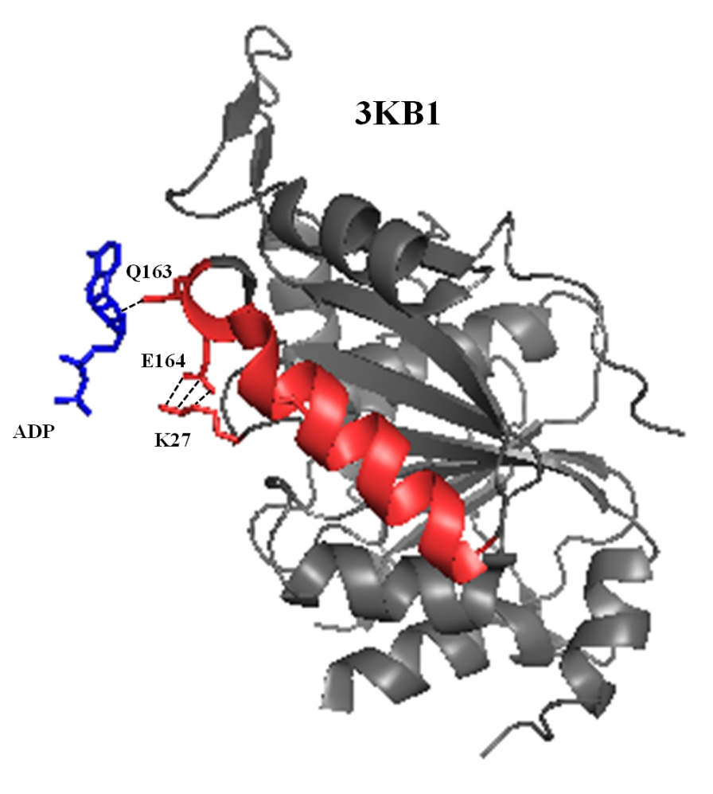
Figure 23. Crystal structure of Af_226 bound to ADP, as a monomer. Ribbon diagram of the crystal structure of Af_226 bound to ADP, shown as a monomer. The signature lysine (K27) makes almost exclusive contacts with E164 (the Nbp35E221 equivalent). Q163 makes significant contacts with the ribose ring of the ADP bound to the opposite monomer. The ‘signaling helix’ is shown in RED. The side chains for the signature lysine (K27) and helix residues E164 and Q163 are additionally shown in RED. ADP bound to the opposite monomer is shown in BLUE.

the iron bound to D226A at steady-state, and the stability of this iron in response to chelation.
These studies identify a dynamic helical region, structurally and functionally conserved across the SIMIBI sub-family of P-Loop NTPases, and extend a requirement for residues in this region to Nbp35. These observations suggest that this region may constitute a novel motif in this family, with conserved roles in the allosteric regulation of nucleotide hydrolysis. These mutants were partially functional, but displayed significant defects in cluster assembly, including the acquisition and transfer of iron. Preliminary results suggest that these residues may be required for assembly and/or transfer of labile cluster by Nbp35. These studies provide additional evidence that Nbp35 functions as an ATPase, with structural and mechanistic similarities to other SIMIBI NTPases, suggesting additional avenues for further investigation. Additional work will be required in order to determine the roles of nucleotide binding and hydrolysis by Nbp35, and the mechanisms of assembly by Nbp35 and the Nbp35:Cfd1 complex.

CHAPTER V: CONCLUSIONS AND FUTURE PERSPECTIVES
Apbc/Nbp35 P-Loop NTPases are required for FeS cluster biogenesis in virtually all organisms, and are proposed to function as a scaffold for assembly of nascent cluster. These investigations were designed to elucidate the roles of nucleotide binding and hydrolysis by Nbp35 in FeS biogenesis. Nbp35 is a P-Loop NTPase by sequence homology, and it was known previously that a conserved residue, required for nucleotide binding and hydrolysis in virtually all P-Loop NTPases, is required for Nbp35 function (338). Therefore, conserved residues in cognate NTPase motifs were targeted by directed mutagenesis, and the effects of these mutations on known Nbp35 functions were assessed in yeast. Targeted motifs included the P-Loop and Switch I, which play established roles in nucleotide binding, hydrolysis, or the signaling of nucleotide status in homologous proteins (297,500,502-505,560-563,567-575).
Most mutations to these motifs were lethal, underscoring their importance to Nbp35 function. Although stably expressed and competent for complex formation, these mutants were defective for the acquisition of iron, as assessed by in vivo radio-labeling. In general, these mutants bound minimal iron, even at steady-state. Each Nbp35 dimer can conceivably bind three clusters: two coordinated via N-terminal ferredoxin-like motifs, and one bridging cluster via the C-terminal CPXC motifs. Previous studies have demonstrated that Nbp35 binds FeS with differential stabilities, and established a requirement for iron-binding at both sites (151,192,294). Results presented herein suggest that
Nbp35 activities may be required for self-maturation, prior to assembly of the more labile FeS by Nbp35.
Most of the mutations to the P-Loop and Switch I motifs could conceivably impact binding and/or hydrolysis, based on analyses of homologous proteins, with one exception – K81A. This mutation is predicted to impair hydrolysis, without impacting nucleotide binding to the protein or disrupting local conformation due to steric considerations or charge. Importantly, K81A bound significant iron at steady state (~60% wild-type), suggesting that this mutant can acquire cluster. K81A acquired iron steadily over a 90 minute period, and preliminary results suggest that the iron bound to K81A was not as labile as iron bound to the wild-type protein, as assessed by pulse-chase. These results suggest that K81A can acquire stably bound cluster, but remains defective for assembly of labile cluster for transfer to apo-target. It would be of interest to determine the lability of the iron bound to K81A at steady-state to corroborate this hypothesis. As IRP1 is not an endogenous target of the CIA system in yeast, it would also be of interest to determine if the maturation of endogenous targets, including essential targets such as Nar1 and Rli1, are as dramatically affected in these strains. It is possible that there are unidentified targeting mechanisms directly involving Nbp35.
These investigations targeted two additional residues (E221 and D226), conserved in homologous NTPases. Although outside established NTPase motifs, these residues map to a conserved region, and are required for hydrolysis and allosteric signaling in homologous proteins (500,502,560,569,582-585,593,597,598). These residues maintain conserved but dynamic contacts with nucleotide, and with functionally important motifs (P-loop and Switch regions), across a conserved dimer interface. Residues in this region mediate interaction with proteins required for physiological function, including nucleotide hydrolysis, in several homologs. Nbp35 mutants targeting these residues were partially functional, but displayed defects in cluster assembly, including the acquisition of iron.
Although this helix has been identified as a critical element in individual SIMIBI NTPases, it has not previously been proposed to constitute a conserved structural and mechanistic feature in this family. However, examination/analysis of the structures of homologous SIMIBI NTPases deposited with the PDB database reveals the structural conservation of this helix in the SIMIBI family, and survey of the literature suggests the functional conservation of residues mapping to this region. These studies acknowledge the structural and mechanistic conservation of this helix in previously characterized SIMIBI NTPases, and extend a requirement for this region to Nbp35, suggesting this region may constitute a novel motif in this family. This helix may signal nucleotide status to distal regions and partners, and may function as an inter-monomeric signaling or switch region in at least a sub-set of SIMIBI NTPases.
In contrast to the mutations targeting residues in the P-Loop and Switch I motifs, mutations targeting the signaling helix are generally predicted to impact hydrolysis, and the allosteric response (103,500,502,560,569,572,582-585,593,597,598). The pattern of iron binding to these mutants was similar to that observed for K81A. In particular, mutation at E221 phenocopied the effect of the K81A substitution, and was particularly deleterious. These mutants were defective for the rapid acquisition of iron, but bound as much or more iron than the K81A mutant, as expressed in the same genetic background. Collectively, these results indicate that Nbp35 activities are required for self-maturation and the subsequent assembly of labile cluster for transfer. However, as for the K81A mutant, it would be important to determine the extent and dynamics of iron binding to the E221 and D226 mutants at steady-state. The model presented here predicts that these mutants would bind significant iron at steady-state, but that this iron would be resistant to chelation, or stably-bound.
Nbp35 functions in complex with the homologous NTPase Cfd1 in yeast and metazoan cells. Although the E221 equivalent is highly conserved in Nbp35 and across the SIMIBI family, this residue is not conserved in Cfd1 (Figure 5B). Cfd1 instead encodes for an alanine or serine at this position. In fact, this residue is one of very few defining features between Nbp35 and Cfd1 at the sequence level, within functionally important domains. As Nbp35 and Cfd1 are two of only seven known hetero-dimeric SIMIBI NTPases (including the “pseudo-dimeric ArsA – a monomer comprised of two non-identical NT domains linked by a flexible linker domain), it is possible that this residue confers specificity to Nbp35 and Cfd1 physiological function. This residue is conserved in only one of the ArsA pseudo-dimers (B – E500), and nucleotide binding/hydrolysis by the two ArsA NT domains are proposed to occur independently, and to be functionally non-equivalent (328,599-601).
Previous investigations have also indicated the catalytic non-equivalence of both the MinD and Get3 dimers (583,585,586,602), and a recent review suggested that catalytic asymmetry may be a conserved regulatory feature in the SIMIBI family (339). Like Nbp35:Cfd1 and ArsA, the distantly related Signal Recognition Particle (SRP) GTPases also form both homo- an hetero-dimers, and cumulative evidence supports catalytic asymmetry and coordinated activation of the two non-equivalent catalytic sites in both homo- and hetero-dimeric contexts (603,604). It would be of interest to determine the effect of the analogous mutations to the corresponding residue in Cfd1 (Cfd1 S163), and the effect of substitutions switching the identity of this residue between Nbp35 and Cfd1 (e.g. Nbp35 E221S and Cfd1 S163E). It would also be insightful to investigate the effect of P-Loop and Switch I mutations to Cfd1 on iron binding and release by Nbp35, as these mutations are known to impact Cfd1 function in yeast (Spang, unpublished results).
One final observation from these investigations is that nucleotide binding and hydrolysis by Nbp35, and FeS maturation of Nbp35 are not required for Nbp35 and Cfd1 complex formation. Nbp35 is the proposed scaffold for extra-mitochondrial FeS biogenesis – an essential function in all fungal and metazoan cells. However, Nbp35 mutants defective for nucleotide binding/hydrolysis, and for assembly of both stable and labile FeS on Nbp35 were stably expressed and competent for complex formation in yeast. This is consistent with previous characterizations of these complexes as stable, even in the presence of 15 mM EDTA (258). This suggests that the N-termina cluster, although essential for function, is not required for protein stability or as a prerequisite for assembly of the catalytic complex. In addition, these results suggest that these stable homo- and hetero-complexes can exist in the cell, but must be “activated” by the nucleotide-dependent FeS self-maturation of Nbp35, prior to assembly of labile cluster by Nbp35 and the Nbp35:Cfd1 complex. Previous investigations have established that Nbp35 absolutely requires the C-terminal CPXC motif for interaction (151). Of note, mutations predicted to abolish nucleotide binding and hydrolysis by Nbp35 did not completely ablate iron binding to Nbp35 (these studies). Collectively, these results suggest that Nbp35 may require some form of iron at the C-terminal site for interaction.
Recent investigations have uncovered novel roles for Nbp35 and Cfd1 in cytokinesis, planar cell polarity, and the differentiation and development of multi-cellular organisms, and these proteins have been localized to the major microtubule organizing centers in the cell (82-84,507). It is not clear whether these pleiotropic effects are due to the numerous cytosolic and nuclear FeS proteins which depend on CIA activities, or if Nbp35 and Cfd1 play separable roles in distinct cellular processes. One intriguing possibility is that CIA activity is constitutive under certain physiological conditions, but can be spatially and/or temporally gated when cellular resources are limited, at different stages of the cell cycle, and/or during certain developmental stages in multi-cellular organisms. This seems reasonable, as many CIA targets are engaged in metabolite requiring anabolic activities, such as amino acid and nucleotide biosyntheses, DNA replication and repair, transcription, and translation, which must all be coupled with the cell cycle and developmental/environmental cues. Nbp35 and Cfd1 may assist in the targeting of FeS to essential targets under limiting conditions, or at distinct developmental stages. Or, Nbp35 and/or Cfd1 may play distinct roles in divergent processes, depending on cellular conditions. Recent investigations involving homologous SIMIBI proteins have suggested distinct roles and gating mechanisms in these proteins (298,312,319,513-515). Additional studies will be required in order to resolve these and additional questions regarding the roles of Nbp35 and Cfd1 in cluster biogenesis and fungal and metazoan cellular biology.
CITED LITERATURE
1. Beinert, H., Holm, R. H., and Munck, E. (1997) Iron-sulfur clusters: nature's modular, multipurpose structures. Science 277, 653-659

2. Johnson, D. C., Dean, D. R., Smith, A. D., and Johnson, M. K. (2005) Structure, function, and formation of biological iron-sulfur clusters. Annual review of biochemistry 74, 247-281

3. Roche, B., Aussel, L., Ezraty, B., Mandin, P., Py, B., and Barras, F. (2013) Reprint of: Iron/sulfur proteins biogenesis in prokaryotes: formation, regulation and diversity. Biochimica et biophysica acta 1827, 923-937

4. Beilschmidt, L. K., and Puccio, H. M. (2014) Mammalian Fe-S cluster biogenesis and its implication in disease. Biochimie

5. Stehling, O., Wilbrecht, C., and Lill, R. (2014) Mitochondrial iron-sulfur protein biogenesis and human disease. Biochimie

6. Bender, G., Pierce, E., Hill, J. A., Darty, J. E., and Ragsdale, S. W. (2011) Metal centers in the anaerobic microbial metabolism of CO and CO2. Metallomics : integrated biometal science 3, 797-815

7. Halbleib, C. M., and Ludden, P. W. (2000) Regulation of biological nitrogen fixation. The Journal of nutrition 130, 1081-1084

8. Hanke, G., and Mulo, P. (2013) Plant type ferredoxins and ferredoxin-dependent metabolism. Plant, cell & environment 36, 1071-1084

9. Poehlein, A. e. a. (2012) An ancient pathway combining carbon dioxide fixation with the generation and utilization of a sodium ion gradient for ATP synthesis. PloS one 7, e33439

10. Thauer, R. K. (2011) Hydrogenases and the Global H2 Cycle. Eur. J. Inorg. Chem 2011, 919-921

11. Pratt, A. J. (2011) Prebiological evolution and the metabolic origins of life. Artificial life 17, 203-217

12. Wang, W., Yang, B., Qu, Y., Liu, X., and Su, W. (2011) FeS/S/FeS(2) redox system and its oxidoreductase-like chemistry in the iron-sulfur world. Astrobiology 11, 471-476

13. Biederbick, A., Stehling, O., Rosser, R., Niggemeyer, B., Nakai, Y., Elsasser, H. P., and Lill, R. (2006) Role of human mitochondrial Nfs1 in cytosolic iron-sulfur protein biogenesis and iron regulation. Molecular and cellular biology 26, 5675-5687

14. Craig, E. A., and Marszalek, J. (2002) A specialized mitochondrial molecular chaperone system: a role in formation of Fe/S centers. Cellular and molecular life sciences : CMLS 59, 1658-1665

15. Jung, Y. S., Gao-Sheridan, H. S., Christiansen, J., Dean, D. R., and Burgess, B. K. (1999) Purification and biophysical characterization of a new [2Fe-2S] ferredoxin from Azotobacter vinelandii, a putative [Fe-S] cluster assembly/repair protein. The Journal of biological chemistry 274, 32402-32410

16. Lill, R., Diekert, K., Kaut, A., Lange, H., Pelzer, W., Prohl, C., and Kispal, G. (1999) The essential role of mitochondria in the biogenesis of cellular iron-sulfur proteins. Biological chemistry 380, 1157-1166

17. Lill, R., Fekete, Z., Sipos, K., and Rotte, C. (2005) Is there an answer? Why are mitochondria essential for life? IUBMB life 57, 701-703

18. Lill, R., Hoffmann, B., Molik, S., Pierik, A. J., Rietzschel, N., Stehling, O., Uzarska, M. A., Webert, H., Wilbrecht, C., and Muhlenhoff, U. (2012) The role of mitochondria in cellular iron-sulfur protein biogenesis and iron metabolism. Biochimica et biophysica acta 1823, 1491-1508

19. Lill, R., and Kispal, G. (2000) Maturation of cellular Fe-S proteins: an essential function of mitochondria. Trends in biochemical sciences 25, 352-356

20. Lill, R., and Muhlenhoff, U. (2005) Iron-sulfur-protein biogenesis in eukaryotes. Trends in biochemical sciences 30, 133-141

21. Tokumoto, U., Kitamura, S., Fukuyama, K., and Takahashi, Y. (2004) Interchangeability and distinct properties of bacterial Fe-S cluster assembly systems: functional replacement of the isc and suf operons in Escherichia coli with the nifSU-like operon from Helicobacter pylori. Journal of biochemistry 136, 199-209

22. Tokumoto, U., and Takahashi, Y. (2001) Genetic analysis of the isc operon in Escherichia coli involved in the biogenesis of cellular iron-sulfur proteins. Journal of biochemistry 130, 63-71

23. Zheng, L., Cash, V. L., Flint, D. H., and Dean, D. R. (1998) Assembly of iron-sulfur clusters. Identification of an iscSUA-hscBA-fdx gene cluster from Azotobacter vinelandii. The Journal of biological chemistry 273, 13264-13272

24. Ali, V., and Nozaki, T. (2013) Iron-sulphur clusters, their biosynthesis, and biological functions in protozoan parasites. Advances in parasitology 83, 1-92

25. Couturier, J., Touraine, B., BRIAT, J.-F., Gaymard, F., and Rouhier, N. (2013) The iron-sulfur cluster assembly machineries in plants: current knowledge and open questions. Frontiers in Plant Science 4

26. Dellibovi-Ragheb, T. A., Gisselberg, J. E., and Prigge, S. T. (2013) Parasites FeS up: iron-sulfur cluster biogenesis in eukaryotic pathogens. PLoS pathogens 9, e1003227

27. Rouault, T. A. (2012) Biogenesis of iron-sulfur clusters in mammalian cells: new insights and relevance to human disease. Disease models & mechanisms 5, 155-164

28. Seeber, F. (2002) Biogenesis of iron-sulphur clusters in amitochondriate and apicomplexan protists. International journal for parasitology 32, 1207-1217

29. Sharma, A. K., Pallesen, L. J., Spang, R. J., and Walden, W. E. (2010) Cytosolic iron-sulfur cluster assembly (CIA) system: factors, mechanism, and relevance to cellular iron regulation. The Journal of biological chemistry 285, 26745-26751

30. Tsaousis, A. D., Gentekaki, E., Eme, L., Gaston, D., and Roger, A. J. (2014) Evolution of the cytosolic iron-sulfur cluster assembly machinery in Blastocystis species and other microbial eukaryotes. Eukaryotic cell 13, 143-153

31. Xu, X. M., and Moller, S. G. (2011) Iron-sulfur clusters: biogenesis, molecular mechanisms, and their functional significance. Antioxidants & redox signaling 15, 271-307

32. Balk, J., and Pilon, M. (2011) Ancient and essential: the assembly of iron-sulfur clusters in plants. Trends in plant science 16, 218-226

33. Roche, B., Aussel, L., Ezraty, B., Mandin, P., Py, B., and Barras, F. (2013) Iron/sulfur proteins biogenesis in prokaryotes: formation, regulation and diversity. Biochimica et biophysica acta 1827, 455-469

34. Ajit Bolar, N., Vanlander, A. V., Wilbrecht, C., Van der Aa, N., Smet, J., De Paepe, B., Vandeweyer, G., Kooy, F., Eyskens, F., De Latter, E., Delanghe, G., Govaert, P., Leroy, J. G., Loeys, B., Lill, R., Van Laer, L., and Van Coster, R. (2013) Mutation of the iron-sulfur cluster assembly gene IBA57 causes severe myopathy and encephalopathy. Human molecular genetics 22, 2590-2602

35. Bak, D. W., Zuris, J. A., Paddock, M. L., Jennings, P. A., and Elliott, S. J. (2009) Redox characterization of the FeS protein MitoNEET and impact of thiazolidinedione drug binding. Biochemistry 48, 10193-10195

36. Bandyopadhyay, S., Cahill, C., Balleidier, A., Huang, C., Lahiri, D. K., Huang, X., and Rogers, J. T. (2013) Novel 5' untranslated region directed blockers of iron-regulatory protein-1 dependent amyloid precursor protein translation: implications for down syndrome and Alzheimer's disease. PloS one 8, e65978

37. Bandyopadhyay, S., and Rogers, J. T. (2014) Alzheimer's disease therapeutics targeted to the control of amyloid precursor protein translation: Maintenance of brain iron homeostasis. Biochemical pharmacology

38. Cameron, Jessie M., Janer, A., Levandovskiy, V., MacKay, N., Rouault, Tracey A., Tong, W.-H., Ogilvie, I., Shoubridge, Eric A., and Robinson, Brian H. (2011) Mutations in Iron-Sulfur Cluster Scaffold Genes NFU1 and BOLA3 Cause a Fatal Deficiency of Multiple Respiratory Chain and 2-Oxoacid Dehydrogenase Enzymes. The American Journal of Human Genetics 89, 486-495

39. Chang, N. C., Nguyen, M., Bourdon, J., Risse, P. A., Martin, J., Danialou, G., Rizzuto, R., Petrof, B. J., and Shore, G. C. (2012) Bcl-2-associated autophagy regulator Naf-1 required for maintenance of skeletal muscle. Human molecular genetics 21, 2277-2287

40. Chen, Y. F., Kao, C. H., Chen, Y. T., Wang, C. H., Wu, C. Y., Tsai, C. Y., Liu, F. C., Yang, C. W., Wei, Y. H., Hsu, M. T., Tsai, S. F., and Tsai, T. F. (2009) Cisd2 deficiency drives premature aging and causes mitochondria-mediated defects in mice. Genes & development 23, 1183-1194

41. Chen, Y. F., Wu, C. Y., Kirby, R., Kao, C. H., and Tsai, T. F. (2010) A role for the CISD2 gene in lifespan control and human disease. Annals of the New York Academy of Sciences 1201, 58-64

42. Chen, Y. R., and Zweier, J. L. (2014) Cardiac mitochondria and reactive oxygen species generation. Circulation research 114, 524-537

43. Conlan, A. R., Axelrod, H. L., Cohen, A. E., Abresch, E. C., Zuris, J., Yee, D., Nechushtai, R., Jennings, P. A., and Paddock, M. L. (2009) Crystal structure of Miner1: The redox-active 2Fe-2S protein causative in Wolfram Syndrome 2. Journal of molecular biology 392, 143-153

44. Crespo, A. C., Silva, B., Marques, L., Marcelino, E., Maruta, C., Costa, S., Timoteo, A., Vilares, A., Couto, F. S., Faustino, P., Correia, A. P., Verdelho, A., Porto, G., Guerreiro, M., Herrero, A., Costa, C., de Mendonca, A., Costa, L., and Martins, M. (2014) Genetic and biochemical markers in patients with Alzheimer's disease support a concerted systemic iron homeostasis dysregulation. Neurobiology of aging 35, 777-785

45. Emmert, B., Hallier, E., Schon, M. P., and Emmert, S. (2011) [Xeroderma pigmentosum (XP) : A genetic disease sheds light on UV-induced skin cancer]. Der Hautarzt; Zeitschrift fur Dermatologie, Venerologie, und verwandte Gebiete 62, 91-97

46. Evans-Galea, M. V., Lockhart, P. J., Galea, C. A., Hannan, A. J., and Delatycki, M. B. (2014) Beyond loss of frataxin: the complex molecular pathology of Friedreich ataxia. Discovery medicine 17, 25-35

47. Fan, L., Fuss, J. O., Cheng, Q. J., Arvai, A. S., Hammel, M., Roberts, V. A., Cooper, P. K., and Tainer, J. A. (2008) XPD helicase structures and activities: insights into the cancer and aging phenotypes from XPD mutations. Cell 133, 789-800

48. Feng, Z., Ni, Y., Dong, W., Shen, H., and Du, J. (2012) Association of ERCC2/XPD polymorphisms and interaction with tobacco smoking in lung cancer susceptibility: a systemic review and meta-analysis. Molecular biology reports 39, 57-69

49. Guo, M., Vidhyasagar, V., Ding, H., and Wu, Y. (2014) Insight into the Roles of Helicase Motif Ia by Characterizing Fanconi Anemia Group J Protein (FANCJ) Patient Mutations. Journal of Biological Chemistry

50. Hadzhieva, M., Kirches, E., and Mawrin, C. (2013) Iron metabolism and the role of iron in neurodegenerative disorders. Neuropathology and applied neurobiology

51. Hlavac, V., Brynychova, V., Vaclavikova, R., Ehrlichova, M., Vrana, D., Pecha, V., Kozevnikovova, R., Trnkova, M., Gatek, J., Kopperova, D., Gut, I., and Soucek, P. (2013) The expression profile of ATP-binding cassette transporter genes in breast carcinoma. Pharmacogenomics 14, 515-529

52. Hlavata, I., Mohelnikova-Duchonova, B., Vaclavikova, R., Liska, V., Pitule, P., Novak, P., Bruha, J., Vycital, O., Holubec, L., Treska, V., Vodicka, P., and Soucek, P. (2012) The role of ABC transporters in progression and clinical outcome of colorectal cancer. Mutagenesis 27, 187-196

53. Huang, B., Gong, X., Zhou, H., Xiong, F., and Wang, S. (2014) Depleting ABCE1 expression induces apoptosis and inhibits the ability of proliferation and migration of human esophageal carcinoma cells. International journal of clinical and experimental pathology 7, 584-592

54. Ichikawa, Y., Bayeva, M., Ghanefar, M., Potini, V., Sun, L., Mutharasan, R. K., Wu, R., Khechaduri, A., Jairaj Naik, T., and Ardehali, H. (2012) Disruption of ATP-binding cassette B8 in mice leads to cardiomyopathy through a decrease in mitochondrial iron export. Proceedings of the National Academy of Sciences of the United States of America 109, 4152-4157

55. Liu, D., Wu, D., Li, H., and Dong, M. (2014) The effect of XPD/ERCC2 Lys751Gln polymorphism on acute leukemia risk: A systematic review and meta-analysis. Gene 538, 209-216

56. Liu, D. Z., Tian, D. L., and Ren, Y. (2008) [Expression and clinical significance of ABCE1 in human lung adenocarcinoma]. Zhonghua zhong liu za zhi [Chinese journal of oncology] 30, 296-297

57. Ma, Q., Qi, C., Tie, C., and Guo, Z. (2013) Genetic polymorphisms of xeroderma pigmentosum group D gene Asp312Asn and Lys751Gln and susceptibility to prostate cancer: a systematic review and meta-analysis. Gene 530, 309-314

58. Mantha, A. K., Sarkar, B., and Tell, G. (2013) A short review on the implications of base excision repair pathway for neurons: Relevance to neurodegenerative diseases. Mitochondrion

59. Moriel-Carretero, M., and Aguilera, A. (2010) Replication fork breakage and re-start: New insights into Rad3/XPD-associated deficiencies. Cell cycle (Georgetown, Tex.) 9, 2958-2962

60. Moriwaki, S. (2013) Hereditary Disorders with Defective Repair of UV-Induced DNA Damage. Japanese clinical medicine 4, 29-35

61. Navarro-Sastre, A. e. a. (2011) A Fatal Mitochondrial Disease Is Associated with Defective NFU1 Function in the Maturation of a Subset of Mitochondrial Fe-S Proteins. The American Journal of Human Genetics 89, 656-667

62. Niedernhofer, L. J., Bohr, V. A., Sander, M., and Kraemer, K. H. (2011) Xeroderma pigmentosum and other diseases of human premature aging and DNA repair: molecules to patients. Mechanisms of ageing and development 132, 340-347

63. Nordin, A., Larsson, E., Thornell, L. E., and Holmberg, M. (2011) Tissue-specific splicing of ISCU results in a skeletal muscle phenotype in myopathy with lactic acidosis, while complete loss of ISCU results in early embryonic death in mice. Human genetics 129, 371-378

64. Ren, Y., Li, Y., and Tian, D. (2012) Role of the ABCE1 gene in human lung adenocarcinoma. Oncology reports 27, 965-970

65. Sharma, L. K., Lu, J., and Bai, Y. (2009) Mitochondrial respiratory complex I: structure, function and implication in human diseases. Current medicinal chemistry 16, 1266-1277

66. Sohn, Y. S. e. a. (2013) NAF-1 and mitoNEET are central to human breast cancer proliferation by maintaining mitochondrial homeostasis and promoting tumor growth. Proceedings of the National Academy of Sciences of the United States of America 110, 14676-14681

67. Suhasini, A. N., and Brosh, R. M., Jr. (2013) DNA helicases associated with genetic instability, cancer, and aging. Advances in experimental medicine and biology 767, 123-144

68. Suhasini, A. N., and Brosh, R. M., Jr. (2013) Disease-causing missense mutations in human DNA helicase disorders. Mutation research 752, 138-152

69. Tamir, S., Zuris, J. A., Agranat, L., Lipper, C. H., Conlan, A. R., Michaeli, D., Harir, Y., Paddock, M. L., Mittler, R., Cabantchik, Z. I., Jennings, P. A., and Nechushtai, R. (2013) Nutrient-deprivation autophagy factor-1 (NAF-1): biochemical properties of a novel cellular target for anti-diabetic drugs. PloS one 8, e61202

70. Wei, F. Y., Suzuki, T., Watanabe, S., Kimura, S., Kaitsuka, T., Fujimura, A., Matsui, H., Atta, M., Michiue, H., Fontecave, M., Yamagata, K., Suzuki, T., and Tomizawa, K. (2011) Deficit of tRNA(Lys) modification by Cdkal1 causes the development of type 2 diabetes in mice. The Journal of clinical investigation 121, 3598-3608

71. Wei, F. Y., and Tomizawa, K. (2011) Functional loss of Cdkal1, a novel tRNA modification enzyme, causes the development of type 2 diabetes. Endocrine journal 58, 819-825

72. Wei, S. Z., Zhan, P., Shi, M. Q., Shi, Y., Qian, Q., Yu, L. K., and Song, Y. (2011) Predictive value of ERCC1 and XPD polymorphism in patients with advanced non-small cell lung cancer receiving platinum-based chemotherapy: a systematic review and meta-analysis. Medical oncology (Northwood, London, England) 28, 315-321

73. Yin, M., Yan, J., Martinez-Balibrea, E., Graziano, F., Lenz, H. J., Kim, H. J., Robert, J., Im, S. A., Wang, W. S., Etienne-Grimaldi, M. C., and Wei, Q. (2011) ERCC1 and ERCC2 polymorphisms predict clinical outcomes of oxaliplatin-based chemotherapies in gastric and colorectal cancer: a systemic review and meta-analysis. Clinical cancer research : an official journal of the American Association for Cancer Research 17, 1632-1640

74. Zhang, J., Gu, S. Y., Zhang, P., Jia, Z., and Chang, J. H. (2010) ERCC2 Lys751Gln polymorphism is associated with lung cancer among Caucasians. European journal of cancer (Oxford, England : 1990) 46, 2479-2484

75. Zhu, H., Cao, S., Liu, Y., Ding, X., Wu, Q., and Ma, H. (2013) Genetic polymorphisms of xeroderma pigmentosum group D and prostate cancer risk: a meta-analysis. Journal of cancer research and therapeutics 9, 187-192

76. Romano, C. A., Sontz, P. A., and Barton, J. K. (2011) Mutants of the base excision repair glycosylase, endonuclease III: DNA charge transport as a first step in lesion detection. Biochemistry 50, 6133-6145

77. Sontz, P. A., Mui, T. P., Fuss, J. O., Tainer, J. A., and Barton, J. K. (2012) DNA charge transport as a first step in coordinating the detection of lesions by repair proteins. Proceedings of the National Academy of Sciences of the United States of America 109, 1856-1861

78. Helbig, K. J., and Beard, M. R. (2014) The Role of Viperin in the Innate Antiviral Response. Journal of molecular biology 426, 1210-1219

79. Gross, I., Armant, O., Benosman, S., de Aguilar, J. L., Freund, J. N., Kedinger, M., Licht, J. D., Gaiddon, C., and Loeffler, J. P. (2007) Sprouty2 inhibits BDNF-induced signaling and modulates neuronal differentiation and survival. Cell death and differentiation 14, 1802-1812

80. Guy, G. R., Wong, E. S., Yusoff, P., Chandramouli, S., Lo, T. L., Lim, J., and Fong, C. W. (2003) Sprouty: how does the branch manager work? Journal of cell science 116, 3061-3068

81. Wu, X., Alexander, P. B., He, Y., Kikkawa, M., Vogel, P. D., and McKnight, S. L. (2005) Mammalian sprouty proteins assemble into large monodisperse particles having the properties of intracellular nanobatteries. Proceedings of the National Academy of Sciences of the United States of America 102, 14058-14062

82. Ioannou, A., Santama, N., and Skourides, P. A. (2013) Xenopus laevis nucleotide binding protein 1 (xNubp1) is important for convergent extension movements and controls ciliogenesis via regulation of the actin cytoskeleton. Developmental biology 380, 243-258

83. Kypri, E., Christodoulou, A., Maimaris, G., Lethan, M., Markaki, M., Lysandrou, C., Lederer, C. W., Tavernarakis, N., Geimer, S., Pedersen, L. B., and Santama, N. (2014) The nucleotide-binding proteins Nubp1 and Nubp2 are negative regulators of ciliogenesis. Cellular and molecular life sciences : CMLS 71, 517-538

84. Schnatwinkel, C., and Niswander, L. (2012) Nubp1 is required for lung branching morphogenesis and distal progenitor cell survival in mice. PloS one 7, e44871

85. Hinchliffe, P., and Sazanov, L. A. (2005) Organization of iron-sulfur clusters in respiratory complex I. Science 309, 771-774

86. Hirst, J. (2013) Mitochondrial complex I. Annual review of biochemistry 82, 551-575

87. Refojo, P. N., Teixeira, M., and Pereira, M. M. (2012) The Alternative complex III: properties and possible mechanisms for electron transfer and energy conservation. Biochimica et biophysica acta 1817, 1852-1859

88. Roehm, K.-H. (2001) Electron Carriers: Proteins and Cofactors in Oxidative Phosphorylation. In: eLS. John Wiley & Sons Ltd, Chichester. http://www.els.net

89. Schafer, G., Purschke, W., and Schmidt, C. L. (1996) On the origin of respiration: electron transport proteins from archaea to man. FEMS microbiology reviews 18, 173-188

90. Sun, F., Huo, X., Zhai, Y., Wang, A., Xu, J., Su, D., Bartlam, M., and Rao, Z. (2005) Crystal structure of mitochondrial respiratory membrane protein complex II. Cell 121, 1043-1057

91. Bak, D. W., and Elliott, S. J. (2014) Alternative FeS cluster ligands: tuning redox potentials and chemistry. Current opinion in chemical biology 19C, 50-58

92. Johnson, M. K. (1994) Iron-Sulfur Proteins. in in: Encyclopedia of Inorganic Chemistry (King, R. B. ed.), 2nd Ed., ohnson, M.K. and Smith, A.D. (2005) Iron–sulfur proteins in: Encyclopedia of Inorganic Chemistry (King, R.B., Ed.), 2nd edn, John Wiley & Sons, Chichester., Chichester. pp

93. Rouault, T. A., and Klausner, R. D. (1996) Iron-sulfur clusters as biosensors of oxidants and iron. Trends in biochemical sciences 21, 174-177

94. Alhebshi, A., Sideri, T. C., Holland, S. L., and Avery, S. V. (2012) The essential iron-sulfur protein Rli1 is an important target accounting for inhibition of cell growth by reactive oxygen species. Molecular biology of the cell 23, 3582-3590

95. Cairo, G., Ronchi, R., Recalcati, S., Campanella, A., and Minotti, G. (2002) Nitric oxide and peroxynitrite activate the iron regulatory protein-1 of J774A.1 macrophages by direct disassembly of the Fe-S cluster of cytoplasmic aconitase. Biochemistry 41, 7435-7442

96. Crack, J. C., Green, J., Thomson, A. J., and Le Brun, N. E. (2012) Iron–sulfur cluster sensor-regulators. Current opinion in chemical biology 16, 35-44

97. Kohanski, M. A., Dwyer, D. J., Hayete, B., Lawrence, C. A., and Collins, J. J. (2007) A common mechanism of cellular death induced by bactericidal antibiotics. Cell 130, 797-810

98. Landry, A. P., and Ding, H. (2014) Redox Control of Human Mitochondrial Outer Membrane Protein MitoNEET [2Fe-2S] Clusters by Biological Thiols and Hydrogen Peroxide. The Journal of biological chemistry 289, 4307-4315

99. Landry, A. P., Duan, X., Huang, H., and Ding, H. (2011) Iron-sulfur proteins are the major source of protein-bound dinitrosyl iron complexes formed in Escherichia coli cells under nitric oxide stress. Free radical biology & medicine 50, 1582-1590

100. Macomber, L., and Imlay, J. A. (2009) The iron-sulfur clusters of dehydratases are primary intracellular targets of copper toxicity. Proceedings of the National Academy of Sciences of the United States of America 106, 8344-8349

101. Sideri, T. C., Willetts, S. A., and Avery, S. V. (2009) Methionine sulphoxide reductases protect iron-sulphur clusters from oxidative inactivation in yeast. Microbiology (Reading, England) 155, 612-623

102. Xu, F. F., and Imlay, J. A. (2012) Silver(I), Mercury(II), Cadmium(II), and Zinc(II) Target Exposed Enzymic Iron-Sulfur Clusters when They Toxify Escherichia coli. Applied and Environmental Microbiology 78, 3614-3621

103. Blank, M. A., Lee, C. C., Hu, Y., Hodgson, K. O., Hedman, B., and Ribbe, M. W. (2011) Structural models of the [Fe4S4] clusters of homologous nitrogenase Fe proteins. Inorganic chemistry 50, 7123-7128

104. Doukov, T. I., Iverson, T. M., Seravalli, J., Ragsdale, S. W., and Drennan, C. L. (2002) A Ni-Fe-Cu center in a bifunctional carbon monoxide dehydrogenase/acetyl-CoA synthase. Science 298, 567-572

105. Susanti, D., and Mukhopadhyay, B. (2012) An intertwined evolutionary history of methanogenic archaea and sulfate reduction. PloS one 7, e45313

106. Zhou, T., Mo, Y., Liu, A., Zhou, Z., and Tsai, K. R. (2004) Enzymatic mechanism of Fe-only hydrogenase: density functional study on H-H making/breaking at the diiron cluster with concerted proton and electron transfers. Inorganic chemistry 43, 923-930

107. Cheek, J., and Broderick, J. B. (2001) Adenosylmethionine-dependent iron-sulfur enzymes: versatile clusters in a radical new role. Journal of biological inorganic chemistry : JBIC : a publication of the Society of Biological Inorganic Chemistry 6, 209-226

108. Duschene, K. S., and Broderick, J. B. (2010) The antiviral protein viperin is a radical SAM enzyme. FEBS letters 584, 1263-1267

109. Frey, P. A. (2001) Radical mechanisms of enzymatic catalysis. Annual review of biochemistry 70, 121-148

110. Lindahl, P., and Kovacs, J. (1990) Reactivities and biological functions of iron-sulfur clusters. J Clust Sci 1, 29-73

111. Dai, S., Friemann, R., Glauser, D. A., Bourquin, F., Manieri, W., Schurmann, P., and Eklund, H. (2007) Structural snapshots along the reaction pathway of ferredoxin-thioredoxin reductase. Nature 448, 92-96

112. Duin, E. C., Madadi-Kahkesh, S., Hedderich, R., Clay, M. D., and Johnson, M. K. (2002) Heterodisulfide reductase from Methanothermobacter marburgensis contains an active-site [4Fe-4S] cluster that is directly involved in mediating heterodisulfide reduction. FEBS letters 512, 263-268

113. Kim, J. H., Fuzery, A. K., Tonelli, M., Ta, D. T., Westler, W. M., Vickery, L. E., and Markley, J. L. (2009) Structure and dynamics of the iron-sulfur cluster assembly scaffold protein IscU and its interaction with the cochaperone HscB. Biochemistry 48, 6062-6071

114. Mansy, S. S., Wu, S. P., and Cowan, J. A. (2004) Iron-sulfur cluster biosynthesis: biochemical characterization of the conformational dynamics of Thermotoga maritima IscU and the relevance for cellular cluster assembly. The Journal of biological chemistry 279, 10469-10475

115. Markley, J. L., Kim, J. H., Dai, Z., Bothe, J. R., Cai, K., Frederick, R. O., and Tonelli, M. (2013) Metamorphic protein IscU alternates conformations in the course of its role as the scaffold protein for iron-sulfur cluster biosynthesis and delivery. FEBS letters 587, 1172-1179

116. Auchere, F., Santos, R., Planamente, S., Lesuisse, E., and Camadro, J. M. (2008) Glutathione-dependent redox status of frataxin-deficient cells in a yeast model of Friedreich's ataxia. Human molecular genetics 17, 2790-2802

117. Bulteau, A. L., Planamente, S., Jornea, L., Dur, A., Lesuisse, E., Camadro, J. M., and Auchere, F. (2012) Changes in mitochondrial glutathione levels and protein thiol oxidation in yfh1 yeast cells and the lymphoblasts of patients with Friedreich's ataxia. Biochimica et biophysica acta 1822, 212-225

118. Poor, C. B., Wegner, S. V., Li, H., Dlouhy, A. C., Schuermann, J. P., Sanishvili, R., Hinshaw, J. R., Riggs-Gelasco, P. J., Outten, C. E., and He, C. (2014) Molecular mechanism and structure of the Saccharomyces cerevisiae iron regulator Aft2. Proceedings of the National Academy of Sciences of the United States of America

119. Stys, A., Galy, B., Starzynski, R. R., Smuda, E., Drapier, J. C., Lipinski, P., and Bouton, C. (2011) Iron regulatory protein 1 outcompetes iron regulatory protein 2 in regulating cellular iron homeostasis in response to nitric oxide. The Journal of biological chemistry 286, 22846-22854

120. Mattijssen, S., and Pruijn, G. J. (2012) Viperin, a key player in the antiviral response. Microbes and infection / Institut Pasteur 14, 419-426

121. Gaskell, A. A., Crack, J. C., Kelemen, G. H., Hutchings, M. I., and Le Brun, N. E. (2007) RsmA is an anti-sigma factor that modulates its activity through a [2Fe-2S] cluster cofactor. The Journal of biological chemistry 282, 31812-31820

122. Katayama, M., Kondo, T., Xiong, J., and Golden, S. S. (2003) ldpA encodes an iron-sulfur protein involved in light-dependent modulation of the circadian period in the cyanobacterium Synechococcus elongatus PCC 7942. Journal of bacteriology 185, 1415-1422

123. Rajagopalan, S., Teter, S. J., Zwart, P. H., Brennan, R. G., Phillips, K. J., and Kiley, P. J. (2013) Studies of IscR reveal a unique mechanism for metal-dependent regulation of DNA binding specificity. Nature structural & molecular biology 20, 740-747

124. Lim, J. G., and Choi, S. H. (2014) IscR Is a Global Regulator Essential for Pathogenesis of Vibrio vulnificus and Induced by Host Cells. Infection and immunity 82, 569-578

125. Romsang, A., Duang-Nkern, J., Leesukon, P., Saninjuk, K., Vattanaviboon, P., and Mongkolsuk, S. (2014) The Iron-Sulphur Cluster Biosynthesis Regulator IscR Contributes to Iron Homeostasis and Resistance to Oxidants in Pseudomonas aeruginosa. PloS one 9, e86763

126. Lin, J., Zhang, L., Lai, S., and Ye, K. (2011) Structure and molecular evolution of CDGSH iron-sulfur domains. PloS one 6, e24790

127. Wiley, S. E., Murphy, A. N., Ross, S. A., van der Geer, P., and Dixon, J. E. (2007) MitoNEET is an iron-containing outer mitochondrial membrane protein that regulates oxidative capacity. Proceedings of the National Academy of Sciences of the United States of America 104, 5318-5323

128. Wiley, S. E., Paddock, M. L., Abresch, E. C., Gross, L., van der Geer, P., Nechushtai, R., Murphy, A. N., Jennings, P. A., and Dixon, J. E. (2007) The outer mitochondrial membrane protein mitoNEET contains a novel redox-active 2Fe-2S cluster. The Journal of biological chemistry 282, 23745-23749

129. Bak, D. W., and Elliott, S. J. (2013) Conserved hydrogen bonding networks of MitoNEET tune Fe-S cluster binding and structural stability. Biochemistry 52, 4687-4696

130. Netz, D. J., Stith, C. M., Stumpfig, M., Kopf, G., Vogel, D., Genau, H. M., Stodola, J. L., Lill, R., Burgers, P. M., and Pierik, A. J. (2012) Eukaryotic DNA polymerases require an iron-sulfur cluster for the formation of active complexes. Nature chemical biology 8, 125-132

131. Stehling, O., Vashisht, A. A., Mascarenhas, J., Jonsson, Z. O., Sharma, T., Netz, D. J., Pierik, A. J., Wohlschlegel, J. A., and Lill, R. (2012) MMS19 assembles iron-sulfur proteins required for DNA metabolism and genomic integrity. Science 337, 195-199

132. White, M. F. (2009) Structure, function and evolution of the XPD family of iron-sulfur-containing 5'-->3' DNA helicases. Biochemical Society transactions 37, 547-551

133. White, M. F., and Dillingham, M. S. (2012) Iron-sulphur clusters in nucleic acid processing enzymes. Current opinion in structural biology 22, 94-100

134. Wu, Y., and Brosh, R. M., Jr. (2012) DNA helicase and helicase-nuclease enzymes with a conserved iron-sulfur cluster. Nucleic acids research 40, 4247-4260

135. Chepanoske, C. L., Golinelli, M.-P., Williams, S. D., and David, S. S. (2000) Positively Charged Residues within the Iron–Sulfur Cluster Loop of E. coli MutY Participate in Damage Recognition and Removal. Archives of Biochemistry and Biophysics 380, 11-19

136. Guan, Y., Manuel, R. C., Arvai, A. S., Parikh, S. S., Mol, C. D., Miller, J. H., Lloyd, S., and Tainer, J. A. (1998) MutY catalytic core, mutant and bound adenine structures define specificity for DNA repair enzyme superfamily. Nature structural biology 5, 1058-1064

137. Porello, S. L., Cannon, M. J., and David, S. S. (1998) A Substrate Recognition Role for the [4Fe-4S]2+ Cluster of the DNA Repair Glycosylase MutY†. Biochemistry 37, 6465-6475

138. Spies, M. (2014) Two steps forward, one step back: Determining XPD helicase mechanism by single-molecule fluorescence and high-resolution optical tweezers. DNA repair

139. Boal, A. K., Yavin, E., and Barton, J. K. (2007) DNA repair glycosylases with a [4Fe-4S] cluster: a redox cofactor for DNA-mediated charge transport? Journal of inorganic biochemistry 101, 1913-1921

140. Pheeney, C. G., Arnold, A. R., Grodick, M. A., and Barton, J. K. (2013) Multiplexed electrochemistry of DNA-bound metalloproteins. Journal of the American Chemical Society 135, 11869-11878

141. Sontz, P. A., Muren, N. B., and Barton, J. K. (2012) DNA charge transport for sensing and signaling. Accounts of chemical research 45, 1792-1800

142. Yavin, E., Boal, A. K., Stemp, E. D., Boon, E. M., Livingston, A. L., O'Shea, V. L., David, S. S., and Barton, J. K. (2005) Protein-DNA charge transport: redox activation of a DNA repair protein by guanine radical. Proceedings of the National Academy of Sciences of the United States of America 102, 3546-3551

143. Benjdia, A. (2012) DNA photolyases and SP lyase: structure and mechanism of light-dependent and independent DNA lyases. Current opinion in structural biology 22, 711-720

144. Schafer, A., Gratchev, A., Seebode, C., Hofmann, L., Schubert, S., Laspe, P., Apel, A., Ohlenbusch, A., Tzvetkov, M., Weishaupt, C., Oji, V., Schon, M. P., and Emmert, S. (2013) Functional and molecular genetic analyses of nine newly identified XPD-deficient patients reveal a novel mutation resulting in TTD as well as in XP/CS complex phenotypes. Experimental dermatology 22, 486-489

145. Wolski, S. C., Kuper, J., and Kisker, C. (2010) The XPD helicase: XPanDing archaeal XPD structures to get a grip on human DNA repair. Biological chemistry 391, 761-765

146. Wu, Y., Suhasini, A. N., and Brosh, R. M., Jr. (2009) Welcome the family of FANCJ-like helicases to the block of genome stability maintenance proteins. Cellular and molecular life sciences : CMLS 66, 1209-1222

147. Feng, Y., Zhong, N., Rouhier, N., Hase, T., Kusunoki, M., Jacquot, J.-P., Jin, C., and Xia, B. (2006) Structural Insight into Poplar Glutaredoxin C1 with a Bridging Iron−Sulfur Cluster at the Active Site†,‡. Biochemistry 45, 7998-8008

148. Li, H., and Outten, C. E. (2012) Monothiol CGFS glutaredoxins and BolA-like proteins: [2Fe-2S] binding partners in iron homeostasis. Biochemistry 51, 4377-4389

149. Muhlenhoff, U., Molik, S., Godoy, J. R., Uzarska, M. A., Richter, N., Seubert, A., Zhang, Y., Stubbe, J., Pierrel, F., Herrero, E., Lillig, C. H., and Lill, R. (2010) Cytosolic monothiol glutaredoxins function in intracellular iron sensing and trafficking via their bound iron-sulfur cluster. Cell metabolism 12, 373-385

150. Li, H., Mapolelo, D. T., Randeniya, S., Johnson, M. K., and Outten, C. E. (2012) Human glutaredoxin 3 forms [2Fe-2S]-bridged complexes with human BolA2. Biochemistry 51, 1687-1696

151. Netz, D. J., Pierik, A. J., Stumpfig, M., Bill, E., Sharma, A. K., Pallesen, L. J., Walden, W. E., and Lill, R. (2012) A bridging [4Fe-4S] cluster and nucleotide binding are essential for function of the Cfd1-Nbp35 complex as a scaffold in iron-sulfur protein maturation. The Journal of biological chemistry 287, 12365-12378

152. Ramon-Garcia, S., Ng, C., Jensen, P. R., Dosanjh, M., Burian, J., Morris, R. P., Folcher, M., Eltis, L. D., Grzesiek, S., Nguyen, L., and Thompson, C. J. (2013) WhiB7, an Fe-S-dependent transcription factor that activates species-specific repertoires of drug resistance determinants in actinobacteria. The Journal of biological chemistry 288, 34514-34528

153. Schafer, G., Purschke, W. G., Gleissner, M., and Schmidt, C. L. (1996) Respiratory chains of archaea and extremophiles. Biochimica et biophysica acta 1275, 16-20

154. Ramelot, T. A., Cort, J. R., Goldsmith-Fischman, S., Kornhaber, G. J., Xiao, R., Shastry, R., Acton, T. B., Honig, B., Montelione, G. T., and Kennedy, M. A. (2004) Solution NMR structure of the iron-sulfur cluster assembly protein U (IscU) with zinc bound at the active site. Journal of molecular biology 344, 567-583

155. Urzica, E., Pierik, A. J., Muhlenhoff, U., and Lill, R. (2009) Crucial role of conserved cysteine residues in the assembly of two iron-sulfur clusters on the CIA protein Nar1. Biochemistry 48, 4946-4958

156. Wollers, S., Layer, G., Garcia-Serres, R., Signor, L., Clemancey, M., Latour, J.-M., Fontecave, M., and Ollagnier de Choudens, S. (2010) Iron-Sulfur (Fe-S) Cluster Assembly: THE SufBCD COMPLEX IS A NEW TYPE OF Fe-S SCAFFOLD WITH A FLAVIN REDOX COFACTOR. Journal of Biological Chemistry 285, 23331-23341

157. Crack, J. C., Green, J., Thomson, A. J., and Le Brun, N. E. (2014) Techniques for the production, isolation, and analysis of iron-sulfur proteins. Methods in molecular biology (Clifton, N.J.) 1122, 33-48

158. Stehling, O., and Lill, R. (2013) The role of mitochondria in cellular iron-sulfur protein biogenesis: mechanisms, connected processes, and diseases. Cold Spring Harbor perspectives in biology 5, a011312

159. Vaubel, R. A., and Isaya, G. (2013) Iron-sulfur cluster synthesis, iron homeostasis and oxidative stress in Friedreich ataxia. Molecular and cellular neurosciences 55, 50-61

160. Ezraty, B., Vergnes, A., Banzhaf, M., Duverger, Y., Huguenot, A., Brochado, A. R., Su, S. Y., Espinosa, L., Loiseau, L., Py, B., Typas, A., and Barras, F. (2013) Fe-S cluster biosynthesis controls uptake of aminoglycosides in a ROS-less death pathway. Science 340, 1583-1587

161. Commandeur, J. N. M., and Vermeulen, N. P. E. (1990) Molecular and biochemical mechanisms of chemically induced nephrotoxicity: a review. Chemical Research in Toxicology 3, 171-194

162. Ling, J., Cho, C., Guo, L. T., Aerni, H. R., Rinehart, J., and Soll, D. (2012) Protein aggregation caused by aminoglycoside action is prevented by a hydrogen peroxide scavenger. Molecular cell 48, 713-722

163. Gisselberg, J. E., Dellibovi-Ragheb, T. A., Matthews, K. A., Bosch, G., and Prigge, S. T. (2013) The suf iron-sulfur cluster synthesis pathway is required for apicoplast maintenance in malaria parasites. PLoS pathogens 9, e1003655

164. Haussig, J. M., Matuschewski, K., and Kooij, T. W. (2014) Identification of vital and dispensable sulfur utilization factors in the Plasmodium apicoplast. PloS one 9, e89718

165. Sharma, A. K., Naithani, R., Kumar, V., and Sandhu, S. S. (2011) Iron regulation in tuberculosis research: promise and challenges. Current medicinal chemistry 18, 1723-1731

166. Dixon, S. J., and Stockwell, B. R. (2014) The role of iron and reactive oxygen species in cell death. Nature chemical biology 10, 9-17

167. Graf, N., and Lippard, S. J. (2012) Redox activation of metal-based prodrugs as a strategy for drug delivery. Advanced Drug Delivery Reviews 64, 993-1004

168. Sanina, N. A., Kozub, G. I., Zhukova, O. S., Emel’yanova, N. S., Kondrat’eva, T. A., Korchagin, D. V., Shilov, G. V., Ovanesyan, N. S., and Aldoshin, S. M. (2013) Synthesis, structure, NO donor activity of iron–sulfur nitrosyl complex with 2-aminophenol-2-yl and its antiproliferative activity against human cancer cells. Journal of Coordination Chemistry 66, 3602-3618

169. Tatˈyanenko, L. V., Kotelˈnikov, A. I., Dobrokhotova, O. V., Saratovskikh, E. A., Sanina, N. A., Rudneva, T. N., and Aldoshin, S. M. (2009) Effect of nitrosyl iron–sulfur complexes on the activity of hydrolytic enzymes. Pharm Chem J 43, 525-529

170. Tonzetich, Z. J., McQuade, L. E., and Lippard, S. J. (2010) Detecting and Understanding the Roles of Nitric Oxide in Biology. Inorganic chemistry 49, 6338-6348

171. Vanin, A. F. (2013) Dinitrosyl Iron Complexes with Thiol-Containing Ligands as a Base for New-Generation Drugs. The Open Conference Proceedings Journal 4, 47-53

172. Gari, K., Leon Ortiz, A. M., Borel, V., Flynn, H., Skehel, J. M., and Boulton, S. J. (2012) MMS19 links cytoplasmic iron-sulfur cluster assembly to DNA metabolism. Science 337, 243-245

173. Seki, M., Takeda, Y., Iwai, K., and Tanaka, K. (2013) IOP1 protein is an external component of the human cytosolic iron-sulfur cluster assembly (CIA) machinery and functions in the MMS19 protein-dependent CIA pathway. The Journal of biological chemistry 288, 16680-16689

174. Anzovino, A., Lane, D. J., Huang, M. L., and Richardson, D. R. (2013) Fixing Frataxin: "Ironing Out" the Metabolic Defect in Friedreich's Ataxia. British journal of pharmacology

175. Lesnefsky, E. J., Gudz, T. I., Migita, C. T., Ikeda-Saito, M., Hassan, M. O., Turkaly, P. J., and Hoppel, C. L. (2001) Ischemic injury to mitochondrial electron transport in the aging heart: damage to the iron-sulfur protein subunit of electron transport complex III. Arch Biochem Biophys 385, 117-128

176. Kollberg, G., Tulinius, M., Melberg, A., Darin, N., Andersen, O., Holmgren, D., Oldfors, A., and Holme, E. (2009) Clinical manifestation and a new ISCU mutation in iron-sulphur cluster deficiency myopathy. Brain : a journal of neurology 132, 2170-2179

177. Simon, D., Seznec, H., Gansmuller, A., Carelle, N., Weber, P., Metzger, D., Rustin, P., Koenig, M., and Puccio, H. (2004) Friedreich ataxia mouse models with progressive cerebellar and sensory ataxia reveal autophagic neurodegeneration in dorsal root ganglia. The Journal of neuroscience : the official journal of the Society for Neuroscience 24, 1987-1995

178. Kraemer KH, D. J. (2003 Jun 20 [Updated 2014 Feb 13]) Xeroderma Pigmentosum. In: Pagon RA, Adam MP, Bird TD, et al., editors. GeneReviews® [Internet]. in Xeroderma Pigmentosum. In: Pagon RA, Adam MP, Bird TD, et al., editors. GeneReviews® [Internet]. (Pagon RA, A. M., Bird TD, et al., editors. ed., Seattle (WA): University of Washington, Seattle

179. Wu, C. Y., Chen, Y. F., Wang, C. H., Kao, C. H., Zhuang, H. W., Chen, C. C., Chen, L. K., Kirby, R., Wei, Y. H., Tsai, S. F., and Tsai, T. F. (2012) A persistent level of Cisd2 extends healthy lifespan and delays aging in mice. Human molecular genetics 21, 3956-3968

180. Huang, B., Gao, Y., Tian, D., and Zheng, M. (2010) A small interfering ABCE1-targeting RNA inhibits the proliferation and invasiveness of small cell lung cancer. International journal of molecular medicine 25, 687-693

181. Jiang, J., Zhang, X., Yang, H., and Wang, W. (2009) Polymorphisms of DNA repair genes: ADPRT, XRCC1, and XPD and cancer risk in genetic epidemiology. Methods in molecular biology (Clifton, N.J.) 471, 305-333

182. Silverman, R. H. (2003) Implications for RNase L in prostate cancer biology. Biochemistry 42, 1805-1812

183. Crespo-Enriquez, I., Partanen, J., Martinez, S., and Echevarria, D. (2012) Fgf8-related secondary organizers exert different polarizing planar instructions along the mouse anterior neural tube. PloS one 7, e39977

184. Matsumura, K., Taketomi, T., Yoshizaki, K., Arai, S., Sanui, T., Yoshiga, D., Yoshimura, A., and Nakamura, S. (2011) Sprouty2 controls proliferation of palate mesenchymal cells via fibroblast growth factor signaling. Biochemical and biophysical research communications 404, 1076-1082

185. Malkin, R., and Rabinowitz, J. C. (1966) The reconstitution of clostridial ferredoxin. Biochemical and biophysical research communications 23, 822-827

186. Suzuki, T., Akiyama, S., Fujimoto, S., Ishikawa, M., and Nakao, Y. (1976) The aconitase of yeast. V. The reconstitution of yeast aconitase. Journal of biochemistry 80, 805-809

187. Russell, M. J., and Hall, A. J. (1997) The emergence of life from iron monosulphide bubbles at a submarine hydrothermal redox and pH front. Journal of the Geological Society 154, 377-402

188. Milner-White, E. J., and Russell, M. J. (2005) Sites for phosphates and iron-sulfur thiolates in the first membranes: 3 to 6 residue anion-binding motifs (nests). Origins of life and evolution of the biosphere : the journal of the International Society for the Study of the Origin of Life 35, 19-27

189. Jacobson, M. R., Brigle, K. E., Bennett, L. T., Setterquist, R. A., Wilson, M. S., Cash, V. L., Beynon, J., Newton, W. E., and Dean, D. R. (1989) Physical and genetic map of the major nif gene cluster from Azotobacter vinelandii. Journal of bacteriology 171, 1017-1027

190. Jacobson, M. R., Cash, V. L., Weiss, M. C., Laird, N. F., Newton, W. E., and Dean, D. R. (1989) Biochemical and genetic analysis of the nifUSVWZM cluster from Azotobacter vinelandii. Molecular & general genetics : MGG 219, 49-57

191. Takahashi, Y., and Tokumoto, U. (2002) A third bacterial system for the assembly of iron-sulfur clusters with homologs in archaea and plastids. The Journal of biological chemistry 277, 28380-28383

192. Hausmann, A., Aguilar Netz, D. J., Balk, J., Pierik, A. J., Muhlenhoff, U., and Lill, R. (2005) The eukaryotic P loop NTPase Nbp35: an essential component of the cytosolic and nuclear iron-sulfur protein assembly machinery. Proceedings of the National Academy of Sciences of the United States of America 102, 3266-3271

193. Gerber, J., and Lill, R. (2002) Biogenesis of iron-sulfur proteins in eukaryotes: components, mechanism and pathology. Mitochondrion 2, 71-86

194. Gerber, J., Neumann, K., Prohl, C., Muhlenhoff, U., and Lill, R. (2004) The yeast scaffold proteins Isu1p and Isu2p are required inside mitochondria for maturation of cytosolic Fe/S proteins. Molecular and cellular biology 24, 4848-4857

195. Xu, X. M., and Moller, S. G. (2008) Iron-sulfur cluster biogenesis systems and their crosstalk. Chembiochem : a European journal of chemical biology 9, 2355-2362

196. Bolstad, H. M., Botelho, D. J., and Wood, M. J. (2010) Proteomic analysis of protein-protein interactions within the Cysteine Sulfinate Desulfinase Fe-S cluster biogenesis system. Journal of proteome research 9, 5358-5369

197. Boyd, J. M., Drevland, R. M., Downs, D. M., and Graham, D. E. (2009) Archaeal ApbC/Nbp35 homologs function as iron-sulfur cluster carrier proteins. Journal of bacteriology 191, 1490-1497

198. Iwasaki, T. (2010) Iron-sulfur world in aerobic and hyperthermoacidophilic archaea Sulfolobus. Archaea (Vancouver, B.C.) 2010

199. Eady, R. R., and Postgate, J. R. (1974) Nitrogenase. Nature 249, 805-810
200. Scherings, G., Haaker, H., and Veeger, C. (1977) Regulation of nitrogen fixation by Fe-S protein II in Azotobacter vinelandii. European journal of biochemistry / FEBS 77, 21-30

201. Ali, V., Shigeta, Y., Tokumoto, U., Takahashi, Y., and Nozaki, T. (2004) An intestinal parasitic protist, Entamoeba histolytica, possesses a non-redundant nitrogen fixation-like system for iron-sulfur cluster assembly under anaerobic conditions. The Journal of biological chemistry 279, 16863-16874

202. Nyvltova, E., Sutak, R., Harant, K., Sedinova, M., Hrdy, I., Paces, J., Vlcek, C., and Tachezy, J. (2013) NIF-type iron-sulfur cluster assembly system is duplicated and distributed in the mitochondria and cytosol of Mastigamoeba balamuthi. Proceedings of the National Academy of Sciences of the United States of America 110, 7371-7376

203. Mather, M. W., Henry, K. W., and Vaidya, A. B. (2007) Mitochondrial drug targets in apicomplexan parasites. Current drug targets 8, 49-60

204. Outten, F. W., Djaman, O., and Storz, G. (2004) A suf operon requirement for Fe-S cluster assembly during iron starvation in Escherichia coli. Molecular microbiology 52, 861-872

205. Muhlenhoff, U., and Lill, R. (2000) Biogenesis of iron-sulfur proteins in eukaryotes: a novel task of mitochondria that is inherited from bacteria. Biochimica et biophysica acta 1459, 370-382

206. Stehling, O., Sheftel, A. D., and Lill, R. (2009) Chapter 12 Controlled expression of iron-sulfur cluster assembly components for respiratory chain complexes in mammalian cells. Methods in enzymology 456, 209-231

207. Hwang, D. M., Dempsey, A., Tan, K. T., and Liew, C. C. (1996) A modular domain of NifU, a nitrogen fixation cluster protein, is highly conserved in evolution. Journal of molecular evolution 43, 536-540

208. Marelja, Z., Stocklein, W., Nimtz, M., and Leimkuhler, S. (2008) A novel role for human Nfs1 in the cytoplasm: Nfs1 acts as a sulfur donor for MOCS3, a protein involved in molybdenum cofactor biosynthesis. The Journal of biological chemistry 283, 25178-25185

209. Nakai, Y., Nakai, M., Hayashi, H., and Kagamiyama, H. (2001) Nuclear Localization of Yeast Nfs1p Is Required for Cell Survival. Journal of Biological Chemistry 276, 8314-8320

210. Song, D., Tu, Z., and Lee, F. S. (2009) Human ISCA1 interacts with IOP1/NARFL and functions in both cytosolic and mitochondrial iron-sulfur protein biogenesis. The Journal of biological chemistry 284, 35297-35307

211. Tong, W. H., and Rouault, T. (2000) Distinct iron-sulfur cluster assembly complexes exist in the cytosol and mitochondria of human cells. The EMBO journal 19, 5692-5700

212. Kumar, B., Chaubey, S., Shah, P., Tanveer, A., Charan, M., Siddiqi, M. I., and Habib, S. (2011) Interaction between sulphur mobilisation proteins SufB and SufC: evidence for an iron-sulphur cluster biogenesis pathway in the apicoplast of Plasmodium falciparum. International journal for parasitology 41, 991-999

213. Balk, J., Pierik, A. J., Aguilar Netz, D. J., Muhlenhoff, U., and Lill, R. (2005) Nar1p, a conserved eukaryotic protein with similarity to Fe-only hydrogenases, functions in cytosolic iron-sulphur protein biogenesis. Biochemical Society transactions 33, 86-89

214. Roy, A., Solodovnikova, N., Nicholson, T., Antholine, W., and Walden, W. E. (2003) A novel eukaryotic factor for cytosolic Fe-S cluster assembly. The EMBO journal 22, 4826-4835

215. Netz, D. J., Mascarenhas, J., Stehling, O., Pierik, A. J., and Lill, R. (2013) Maturation of cytosolic and nuclear iron-sulfur proteins. Trends in cell biology

216. Kispal, G., Csere, P., Prohl, C., and Lill, R. (1999) The mitochondrial proteins Atm1p and Nfs1p are essential for biogenesis of cytosolic Fe/S proteins. The EMBO journal 18, 3981-3989

217. Lange, H., Lisowsky, T., Gerber, J., Muhlenhoff, U., Kispal, G., and Lill, R. (2001) An essential function of the mitochondrial sulfhydryl oxidase Erv1p/ALR in the maturation of cytosolic Fe/S proteins. EMBO reports 2, 715-720

218. Pelzer, W., Muhlenhoff, U., Diekert, K., Siegmund, K., Kispal, G., and Lill, R. (2000) Mitochondrial Isa2p plays a crucial role in the maturation of cellular iron-sulfur proteins. FEBS letters 476, 134-139

219. Avalos, J. L., Fink, G. R., and Stephanopoulos, G. (2013) Compartmentalization of metabolic pathways in yeast mitochondria improves the production of branched-chain alcohols. Nature biotechnology 31, 335-341

220. Tong, W. H., and Rouault, T. A. (2007) Metabolic regulation of citrate and iron by aconitases: role of iron-sulfur cluster biogenesis. Biometals : an international journal on the role of metal ions in biology, biochemistry, and medicine 20, 549-564

221. Bedekovics, T., Gajdos, G. B., Kispal, G., and Isaya, G. (2007) Partial conservation of functions between eukaryotic frataxin and the Escherichia coli frataxin homolog CyaY. FEMS yeast research 7, 1276-1284

222. Bridwell-Rabb, J., Iannuzzi, C., Pastore, A., and Barondeau, D. P. (2012) Effector role reversal during evolution: the case of frataxin in Fe-S cluster biosynthesis. Biochemistry 51, 2506-2514

223. Foury, F., Pastore, A., and Trincal, M. (2007) Acidic residues of yeast frataxin have an essential role in Fe-S cluster assembly. EMBO reports 8, 194-199

224. Pastore, A., and Puccio, H. (2013) Frataxin: a protein in search for a function. Journal of neurochemistry 126 Suppl 1, 43-52

225. Philpott, C. C. (2012) Coming into view: eukaryotic iron chaperones and intracellular iron delivery. The Journal of biological chemistry 287, 13518-13523

226. Lu, C., and Cortopassi, G. (2007) Frataxin knockdown causes loss of cytoplasmic iron-sulfur cluster functions, redox alterations and induction of heme transcripts. Arch Biochem Biophys 457, 111-122

227. Schmucker, S., Martelli, A., Colin, F., Page, A., Wattenhofer-Donze, M., Reutenauer, L., and Puccio, H. (2011) Mammalian frataxin: an essential function for cellular viability through an interaction with a preformed ISCU/NFS1/ISD11 iron-sulfur assembly complex. PloS one 6, e16199

228. Vivas, E., Skovran, E., and Downs, D. M. (2006) Salmonella enterica strains lacking the frataxin homolog CyaY show defects in Fe-S cluster metabolism in vivo. Journal of bacteriology 188, 1175-1179

229. Martelli, A., Wattenhofer-Donze, M., Schmucker, S., Bouvet, S., Reutenauer, L., and Puccio, H. (2007) Frataxin is essential for extramitochondrial Fe-S cluster proteins in mammalian tissues. Human molecular genetics 16, 2651-2658

230. Calmels, N., Schmucker, S., Wattenhofer-Donze, M., Martelli, A., Vaucamps, N., Reutenauer, L., Messaddeq, N., Bouton, C., Koenig, M., and Puccio, H. (2009) The first cellular models based on frataxin missense mutations that reproduce spontaneously the defects associated with Friedreich ataxia. PloS one 4, e6379

231. Puccio, H., Simon, D., Cossee, M., Criqui-Filipe, P., Tiziano, F., Melki, J., Hindelang, C., Matyas, R., Rustin, P., and Koenig, M. (2001) Mouse models for Friedreich ataxia exhibit cardiomyopathy, sensory nerve defect and Fe-S enzyme deficiency followed by intramitochondrial iron deposits. Nature genetics 27, 181-186

232. Adinolfi, S., Iannuzzi, C., Prischi, F., Pastore, C., Iametti, S., Martin, S. R., Bonomi, F., and Pastore, A. (2009) Bacterial frataxin CyaY is the gatekeeper of iron-sulfur cluster formation catalyzed by IscS. Nature structural & molecular biology 16, 390-396

233. Amela, I., Delicado, P., Gomez, A., Querol, E., and Cedano, J. (2013) A dynamic model of the proteins that form the initial iron-sulfur cluster biogenesis machinery in yeast mitochondria. The protein journal 32, 183-196

234. Huang, J., Dizin, E., and Cowan, J. A. (2008) Mapping iron binding sites on human frataxin: implications for cluster assembly on the ISU Fe-S cluster scaffold protein. Journal of biological inorganic chemistry : JBIC : a publication of the Society of Biological Inorganic Chemistry 13, 825-836

235. Kim, J. H., Frederick, R. O., Reinen, N. M., Troupis, A. T., and Markley, J. L. (2013) [2Fe-2S]-Ferredoxin Binds Directly to Cysteine Desulfurase and Supplies an Electron for Iron-Sulfur Cluster Assembly but Is Displaced by the Scaffold Protein or Bacterial Frataxin. Journal of the American Chemical Society 135, 8117-8120

236. Pandey, A., Gordon, D. M., Pain, J., Stemmler, T. L., Dancis, A., and Pain, D. (2013) Frataxin directly stimulates mitochondrial cysteine desulfurase by exposing substrate-binding sites, and a mutant Fe-S cluster scaffold protein with frataxin-bypassing ability acts similarly. The Journal of biological chemistry 288, 36773-36786

237. Prischi, F., Konarev, P. V., Iannuzzi, C., Pastore, C., Adinolfi, S., Martin, S. R., Svergun, D. I., and Pastore, A. (2010) Structural bases for the interaction of frataxin with the central components of iron-sulphur cluster assembly. Nature communications 1, 95

238. Wang, T., and Craig, E. A. (2008) Binding of yeast frataxin to the scaffold for Fe-S cluster biogenesis, Isu. The Journal of biological chemistry 283, 12674-12679

239. Yan, R., Konarev, P. V., Iannuzzi, C., Adinolfi, S., Roche, B., Kelly, G., Simon, L., Martin, S. R., Py, B., Barras, F., Svergun, D. I., and Pastore, A. (2013) Ferredoxin competes with bacterial frataxin in binding to the desulfurase IscS. The Journal of biological chemistry 288, 24777-24787

240. Colin, F., Martelli, A., Clemancey, M., Latour, J. M., Gambarelli, S., Zeppieri, L., Birck, C., Page, A., Puccio, H., and Ollagnier de Choudens, S. (2013) Mammalian frataxin controls sulfur production and iron entry during de novo Fe4S4 cluster assembly. Journal of the American Chemical Society 135, 733-740

241. Shakamuri, P., Zhang, B., and Johnson, M. K. (2012) Monothiol glutaredoxins function in storing and transporting [Fe2S2] clusters assembled on IscU scaffold proteins. Journal of the American Chemical Society 134, 15213-15216

242. Wang, L., Ouyang, B., Li, Y., Feng, Y., Jacquot, J. P., Rouhier, N., and Xia, B. (2012) Glutathione regulates the transfer of iron-sulfur cluster from monothiol and dithiol glutaredoxins to apo ferredoxin. Protein & cell 3, 714-721

243. Hider, R. C., and Kong, X. (2013) Iron speciation in the cytosol: an overview. Dalton transactions (Cambridge, England : 2003) 42, 3220-3229

244. Flint, D. H. (1996) Escherichia coli contains a protein that is homologous in function and N-terminal sequence to the protein encoded by the nifS gene of Azotobacter vinelandii and that can participate in the synthesis of the Fe-S cluster of dihydroxy-acid dehydratase. The Journal of biological chemistry 271, 16068-16074

245. Flint, D. H., Tuminello, J. F., and Miller, T. J. (1996) Studies on the synthesis of the Fe-S cluster of dihydroxy-acid dehydratase in escherichia coli crude extract. Isolation of O-acetylserine sulfhydrylases A and B and beta-cystathionase based on their ability to mobilize sulfur from cysteine and to participate in Fe-S cluster synthesis. The Journal of biological chemistry 271, 16053-16067

246. Mihara, H., and Esaki, N. (2002) Bacterial cysteine desulfurases: their function and mechanisms. Applied microbiology and biotechnology 60, 12-23

247. Mihara, H., Kurihara, T., Yoshimura, T., Soda, K., and Esaki, N. (1997) Cysteine sulfinate desulfinase, a NIFS-like protein of Escherichia coli with selenocysteine lyase and cysteine desulfurase activities. Gene cloning, purification, and characterization of a novel pyridoxal enzyme. The Journal of biological chemistry 272, 22417-22424

248. Zheng, L., White, R. H., Cash, V. L., Jack, R. F., and Dean, D. R. (1993) Cysteine desulfurase activity indicates a role for NIFS in metallocluster biosynthesis. Proceedings of the National Academy of Sciences of the United States of America 90, 2754-2758

249. Kuhnke, G., Neumann, K., Muhlenhoff, U., and Lill, R. (2006) Stimulation of the ATPase activity of the yeast mitochondrial ABC transporter Atm1p by thiol compounds. Molecular membrane biology 23, 173-184

250. Qi, W., Li, J., Chain, C. Y., Pasquevich, G. A., Pasquevich, A. F., and Cowan, J. A. (2013) Glutathione-complexed iron-sulfur clusters. Reaction intermediates and evidence for a template effect promoting assembly and stability. Chemical communications (Cambridge, England) 49, 6313-6315

251. Qi, W., Li, J., and Cowan, J. A. (2014) A structural model for glutathione-complexed iron-sulfur cluster as a substrate for ABCB7-type transporters. Chemical communications (Cambridge, England)

252. Srinivasan, V., Pierik, A. J., and Lill, R. (2014) Crystal structures of nucleotide-free and glutathione-bound mitochondrial ABC transporter Atm1. Science 343, 1137-1140

253. Alves, R., Herrero, E., and Sorribas, A. (2004) Predictive reconstruction of the mitochondrial iron-sulfur cluster assembly metabolism: I. The role of the protein pair ferredoxin-ferredoxin reductase (Yah1-Arh1). Proteins 56, 354-366

254. Lange, H., Kaut, A., Kispal, G., and Lill, R. (2000) A mitochondrial ferredoxin is essential for biogenesis of cellular iron-sulfur proteins. Proceedings of the National Academy of Sciences of the United States of America 97, 1050-1055

255. Shi, Y., Ghosh, M., Kovtunovych, G., Crooks, D. R., and Rouault, T. A. (2012) Both human ferredoxins 1 and 2 and ferredoxin reductase are important for iron-sulfur cluster biogenesis. Biochimica et biophysica acta 1823, 484-492

256. Ewen, K. M., Kleser, M., and Bernhardt, R. (2011) Adrenodoxin: the archetype of vertebrate-type [2Fe-2S] cluster ferredoxins. Biochimica et biophysica acta 1814, 111-125

257. Sheftel, A. D., Stehling, O., Pierik, A. J., Elsässer, H.-P., Mühlenhoff, U., Webert, H., Hobler, A., Hannemann, F., Bernhardt, R., and Lill, R. (2010) Humans possess two mitochondrial ferredoxins, Fdx1 and Fdx2, with distinct roles in steroidogenesis, heme, and Fe/S cluster biosynthesis. Proceedings of the National Academy of Sciences 107, 11775-11780

258. Netz, D. J., Pierik, A. J., Stumpfig, M., Muhlenhoff, U., and Lill, R. (2007) The Cfd1-Nbp35 complex acts as a scaffold for iron-sulfur protein assembly in the yeast cytosol. Nature chemical biology 3, 278-286

259. Bych, K., Kerscher, S., Netz, D. J., Pierik, A. J., Zwicker, K., Huynen, M. A., Lill, R., Brandt, U., and Balk, J. (2008) The iron-sulphur protein Ind1 is required for effective complex I assembly. The EMBO journal 27, 1736-1746

260. Sheftel, A. D., Stehling, O., Pierik, A. J., Netz, D. J., Kerscher, S., Elsasser, H. P., Wittig, I., Balk, J., Brandt, U., and Lill, R. (2009) Human ind1, an iron-sulfur cluster assembly factor for respiratory complex I. Molecular and cellular biology 29, 6059-6073

261. Lill, R., Dutkiewicz, R., Elsasser, H. P., Hausmann, A., Netz, D. J., Pierik, A. J., Stehling, O., Urzica, E., and Muhlenhoff, U. (2006) Mechanisms of iron-sulfur protein maturation in mitochondria, cytosol and nucleus of eukaryotes. Biochimica et biophysica acta 1763, 652-667

262. Angelini, S., Gerez, C., Ollagnier-de Choudens, S., Sanakis, Y., Fontecave, M., Barras, F., and Py, B. (2008) NfuA, a new factor required for maturing Fe/S proteins in Escherichia coli under oxidative stress and iron starvation conditions. The Journal of biological chemistry 283, 14084-14091

263. Gupta, V., Sendra, M., Naik, S. G., Chahal, H. K., Huynh, B. H., Outten, F. W., Fontecave, M., and Ollagnier de Choudens, S. (2009) Native Escherichia coli SufA, coexpressed with SufBCDSE, purifies as a [2Fe-2S] protein and acts as an Fe-S transporter to Fe-S target enzymes. Journal of the American Chemical Society 131, 6149-6153

264. Kim, K. D., Chung, W. H., Kim, H. J., Lee, K. C., and Roe, J. H. (2010) Monothiol glutaredoxin Grx5 interacts with Fe-S scaffold proteins Isa1 and Isa2 and supports Fe-S assembly and DNA integrity in mitochondria of fission yeast. Biochemical and biophysical research communications 392, 467-472

265. Mapolelo, D. T., Zhang, B., Randeniya, S., Albetel, A. N., Li, H., Couturier, J., Outten, C. E., Rouhier, N., and Johnson, M. K. (2013) Monothiol glutaredoxins and A-type proteins: partners in Fe-S cluster trafficking. Dalton transactions (Cambridge, England : 2003) 42, 3107-3115

266. Muhlenhoff, U., Richter, N., Pines, O., Pierik, A. J., and Lill, R. (2011) Specialized function of yeast Isa1 and Isa2 proteins in the maturation of mitochondrial [4Fe-4S] proteins. The Journal of biological chemistry 286, 41205-41216

267. Pinske, C., and Sawers, R. G. (2012) A-type carrier protein ErpA is essential for formation of an active formate-nitrate respiratory pathway in Escherichia coli K-12. Journal of bacteriology 194, 346-353

268. Buday, L., and Tompa, P. (2010) Functional classification of scaffold proteins and related molecules. The FEBS journal 277, 4348-4355

269. Nussinov, R., Ma, B., and Tsai, C. J. (2013) A broad view of scaffolding suggests that scaffolding proteins can actively control regulation and signaling of multienzyme complexes through allostery. Biochimica et biophysica acta 1834, 820-829

270. Riboldi, G. P., Verli, H., and Frazzon, J. (2009) Structural studies of the Enterococcus faecalis SufU [Fe-S] cluster protein. BMC biochemistry 10, 3

271. Wada, K., Sumi, N., Nagai, R., Iwasaki, K., Sato, T., Suzuki, K., Hasegawa, Y., Kitaoka, S., Minami, Y., Outten, F. W., Takahashi, Y., and Fukuyama, K. (2009) Molecular dynamism of Fe-S cluster biosynthesis implicated by the structure of the SufC(2)-SufD(2) complex. Journal of molecular biology 387, 245-258

272. Qi, W., and Cowan, J. A. (2011) Structural, Mechanistic and Coordination Chemistry of Relevance to the Biosynthesis of Iron-Sulfur and Related Iron Cofactors. Coordination chemistry reviews 255, 688-699

273. Agar, J. N., Krebs, C., Frazzon, J., Huynh, B. H., Dean, D. R., and Johnson, M. K. (2000) IscU as a scaffold for iron-sulfur cluster biosynthesis: sequential assembly of [2Fe-2S] and [4Fe-4S] clusters in IscU. Biochemistry 39, 7856-7862

274. Kim, J. H., Tonelli, M., and Markley, J. L. (2012) Disordered form of the scaffold protein IscU is the substrate for iron-sulfur cluster assembly on cysteine desulfurase. Proceedings of the National Academy of Sciences of the United States of America 109, 454-459

275. Marinoni, E. N., de Oliveira, J. S., Nicolet, Y., Raulfs, E. C., Amara, P., Dean, D. R., and Fontecilla-Camps, J. C. (2012) (IscS-IscU)2 complex structures provide insights into Fe2S2 biogenesis and transfer. Angewandte Chemie (International ed. in English) 51, 5439-5442

276. Nuth, M., and Cowan, J. A. (2009) Iron-sulfur cluster biosynthesis: characterization of IscU-IscS complex formation and a structural model for sulfide delivery to the [2Fe-2S] assembly site. Journal of biological inorganic chemistry : JBIC : a publication of the Society of Biological Inorganic Chemistry 14, 829-839

277. Smith, A. D., Frazzon, J., Dean, D. R., and Johnson, M. K. (2005) Role of conserved cysteines in mediating sulfur transfer from IscS to IscU. FEBS letters 579, 5236-5240

278. Kim, J. H., Tonelli, M., Kim, T., and Markley, J. L. (2012) Three-dimensional structure and determinants of stability of the iron-sulfur cluster scaffold protein IscU from Escherichia coli. Biochemistry 51, 5557-5563

279. Liu, J., Oganesyan, N., Shin, D. H., Jancarik, J., Yokota, H., Kim, R., and Kim, S. H. (2005) Structural characterization of an iron-sulfur cluster assembly protein IscU in a zinc-bound form. Proteins 59, 875-881
280. Wu, G., and Li, L. (2012) Biochemical characterization of iron-sulfur cluster assembly in the scaffold IscU of Escherichia coli. Biochemistry. Biokhimiia 77, 135-142

281. Cai, K., Frederick, R. O., Kim, J. H., Reinen, N. M., Tonelli, M., and Markley, J. L. (2013) Human mitochondrial chaperone (mtHSP70) and cysteine desulfurase (NFS1) bind preferentially to the disordered conformation, whereas co-chaperone (HSC20) binds to the structured conformation of the iron-sulfur cluster scaffold protein (ISCU). The Journal of biological chemistry 288, 28755-28770

282. Majewska, J., Ciesielski, S. J., Schilke, B., Kominek, J., Blenska, A., Delewski, W., Song, J. Y., Marszalek, J., Craig, E. A., and Dutkiewicz, R. (2013) Binding of the chaperone Jac1 protein and cysteine desulfurase Nfs1 to the iron-sulfur cluster scaffold Isu protein is mutually exclusive. The Journal of biological chemistry 288, 29134-29142

283. Terali, K., Beavil, R. L., Pickersgill, R. W., and van der Giezen, M. (2013) The effect of the adaptor protein Isd11 on the quaternary structure of the eukaryotic cysteine desulphurase Nfs1. Biochemical and biophysical research communications 440, 235-240

284. Hoff, K. G., Silberg, J. J., and Vickery, L. E. (2000) Interaction of the iron-sulfur cluster assembly protein IscU with the Hsc66/Hsc20 molecular chaperone system of Escherichia coli. Proceedings of the National Academy of Sciences of the United States of America 97, 7790-7795

285. Bonomi, F., Iametti, S., Morleo, A., Ta, D., and Vickery, L. E. (2011) Facilitated transfer of IscU-[2Fe2S] clusters by chaperone-mediated ligand exchange. Biochemistry 50, 9641-9650

286. Kim, J. H., Tonelli, M., Frederick, R. O., Chow, D. C., and Markley, J. L. (2012) Specialized Hsp70 chaperone (HscA) binds preferentially to the disordered form, whereas J-protein (HscB) binds preferentially to the structured form of the iron-sulfur cluster scaffold protein (IscU). The Journal of biological chemistry 287, 31406-31413

287. Reyda, M. R., Fugate, C. J., and Jarrett, J. T. (2009) A complex between biotin synthase and the iron-sulfur cluster assembly chaperone HscA that enhances in vivo cluster assembly. Biochemistry 48, 10782-10792

288. Bonomi, F., Iametti, S., Morleo, A., Ta, D., and Vickery, L. E. (2008) Studies on the mechanism of catalysis of iron-sulfur cluster transfer from IscU[2Fe2S] by HscA/HscB chaperones. Biochemistry 47, 12795-12801

289. Smith, A. D., Jameson, G. N., Dos Santos, P. C., Agar, J. N., Naik, S., Krebs, C., Frazzon, J., Dean, D. R., Huynh, B. H., and Johnson, M. K. (2005) NifS-mediated assembly of [4Fe-4S] clusters in the N- and C-terminal domains of the NifU scaffold protein. Biochemistry 44, 12955-12969

290. Chandramouli, K., Unciuleac, M. C., Naik, S., Dean, D. R., Huynh, B. H., and Johnson, M. K. (2007) Formation and properties of [4Fe-4S] clusters on the IscU scaffold protein. Biochemistry 46, 6804-6811

291. Sheftel, A. D., Wilbrecht, C., Stehling, O., Niggemeyer, B., Elsasser, H. P., Muhlenhoff, U., and Lill, R. (2012) The human mitochondrial ISCA1, ISCA2, and IBA57 proteins are required for [4Fe-4S] protein maturation. Molecular biology of the cell 23, 1157-1166

292. Boutigny, S., Saini, A., Baidoo, E. E., Yeung, N., Keasling, J. D., and Butland, G. (2013) Physical and functional interactions of a monothiol glutaredoxin and an iron sulfur cluster carrier protein with the sulfur-donating radical S-adenosyl-L-methionine enzyme MiaB. The Journal of biological chemistry 288, 14200-14211

293. Zhang, B., Bandyopadhyay, S., Shakamuri, P., Naik, S. G., Huynh, B. H., Couturier, J., Rouhier, N., and Johnson, M. K. (2013) Monothiol glutaredoxins can bind linear [Fe3S4]+ and [Fe4S4]2+ clusters in addition to [Fe2S2]2+ clusters: spectroscopic characterization and functional implications. Journal of the American Chemical Society 135, 15153-15164

294. Pallesen, L. J., Solodovnikova, N., Sharma, A. K., and Walden, W. E. (2013) Interaction with Cfd1 increases the kinetic lability of FeS on the Nbp35 scaffold. The Journal of biological chemistry 288, 23358-23367

295. Schilke, B., Williams, B., Knieszner, H., Pukszta, S., D'Silva, P., Craig, E. A., and Marszalek, J. (2006) Evolution of mitochondrial chaperones utilized in Fe-S cluster biogenesis. Current biology : CB 16, 1660-1665

296. Vickery, L. E., and Cupp-Vickery, J. R. (2007) Molecular chaperones HscA/Ssq1 and HscB/Jac1 and their roles in iron-sulfur protein maturation. Critical reviews in biochemistry and molecular biology 42, 95-111

297. Angove, H. C., Yoo, S. J., Munck, E., and Burgess, B. K. (1998) An all-ferrous state of the Fe protein of nitrogenase. Interaction with nucleotides and electron transfer to the MoFe protein. The Journal of biological chemistry 273, 26330-26337

298. Chan, J. M., Ryle, M. J., and Seefeldt, L. C. (1999) Evidence that MgATP accelerates primary electron transfer in a Clostridium pasteurianum Fe protein-Azotobacter vinelandii MoFe protein nitrogenase tight complex. The Journal of biological chemistry 274, 17593-17598

299. Jacobs, D., and Watt, G. D. (2013) Nucleotide-assisted [Fe4S4] redox state interconversions of the Azotobacter vinelandii Fe protein and their relevance to nitrogenase catalysis. Biochemistry 52, 4791-4799

300. Peters, J. W., and Broderick, J. B. (2012) Emerging paradigms for complex iron-sulfur cofactor assembly and insertion. Annual review of biochemistry 81, 429-450

301. Silberg, J. J., Tapley, T. L., Hoff, K. G., and Vickery, L. E. (2004) Regulation of the HscA ATPase reaction cycle by the co-chaperone HscB and the iron-sulfur cluster assembly protein IscU. The Journal of biological chemistry 279, 53924-53931

302. Dutkiewicz, R., Marszalek, J., Schilke, B., Craig, E. A., Lill, R., and Muhlenhoff, U. (2006) The Hsp70 chaperone Ssq1p is dispensable for iron-sulfur cluster formation on the scaffold protein Isu1p. The Journal of biological chemistry 281, 7801-7808

303. Lutz, T., Westermann, B., Neupert, W., and Herrmann, J. M. (2001) The mitochondrial proteins Ssq1 and Jac1 are required for the assembly of iron sulfur clusters in mitochondria. Journal of molecular biology 307, 815-825

304. Muhlenhoff, U., Richhardt, N., Gerber, J., and Lill, R. (2002) Characterization of iron-sulfur protein assembly in isolated mitochondria. A requirement for ATP, NADH, and reduced iron. The Journal of biological chemistry 277, 29810-29816

305. Amutha, B., Gordon, D. M., Gu, Y., Lyver, E. R., Dancis, A., and Pain, D. (2008) GTP is required for iron-sulfur cluster biogenesis in mitochondria. The Journal of biological chemistry 283, 1362-1371

306. Chahal, H. K., and Outten, F. W. (2012) Separate FeS scaffold and carrier functions for SufB(2)C(2) and SufA during in vitro maturation of [2Fe2S] Fdx. Journal of inorganic biochemistry 116, 126-134

307. Saini, A., Mapolelo, D. T., Chahal, H. K., Johnson, M. K., and Outten, F. W. (2010) SufD and SufC ATPase activity are required for iron acquisition during in vivo Fe-S cluster formation on SufB. Biochemistry 49, 9402-9412

308. Tian, T., He, H., and Liu, X. Q. (2014) The SufBCD protein complex is the scaffold for iron-sulfur cluster assembly in Thermus thermophiles HB8. Biochemical and biophysical research communications 443, 376-381

309. Rees, D. C., Akif Tezcan, F., Haynes, C. A., Walton, M. Y., Andrade, S., Einsle, O., and Howard, J. B. (2005) Structural basis of biological nitrogen fixation. Philosophical transactions. Series A, Mathematical, physical, and engineering sciences 363, 971-984; discussion 1035-1040

310. Hu, Y., and Ribbe, M. W. (2013) Biosynthesis of the iron-molybdenum cofactor of nitrogenase. The Journal of biological chemistry 288, 13173-13177

311. Hu, Y., and Ribbe, M. W. (2013) Nitrogenase assembly. Biochimica et biophysica acta 1827, 1112-1122

312. Seefeldt, L. C., Hoffman, B. M., and Dean, D. R. (2012) Electron transfer in nitrogenase catalysis. Current opinion in chemical biology 16, 19-25

313. Hoffman, B. M., Lukoyanov, D., Yang, Z. Y., Dean, D. R., and Seefeldt, L. C. (2014) Mechanism of Nitrogen Fixation by Nitrogenase: The Next Stage. Chemical reviews

314. Shepard, E. M., Boyd, E. S., Broderick, J. B., and Peters, J. W. (2011) Biosynthesis of complex iron-sulfur enzymes. Current opinion in chemical biology 15, 319-327

315. Kaiser, J. T., Hu, Y., Wiig, J. A., Rees, D. C., and Ribbe, M. W. (2011) Structure of precursor-bound NifEN: a nitrogenase FeMo cofactor maturase/insertase. Science 331, 91-94

316. Yoshizawa, J. M., Fay, A. W., Lee, C. C., Hu, Y., and Ribbe, M. W. (2010) Insertion of heterometals into the NifEN-associated iron-molybdenum cofactor precursor. Journal of biological inorganic chemistry : JBIC : a publication of the Society of Biological Inorganic Chemistry 15, 421-428

317. Hernandez, J. A., Curatti, L., Aznar, C. P., Perova, Z., Britt, R. D., and Rubio, L. M. (2008) Metal trafficking for nitrogen fixation: NifQ donates molybdenum to NifEN/NifH for the biosynthesis of the nitrogenase FeMo-cofactor. Proceedings of the National Academy of Sciences of the United States of America 105, 11679-11684

318. Fay, A. W., Blank, M. A., Yoshizawa, J. M., Lee, C. C., Wiig, J. A., Hu, Y., Hodgson, K. O., Hedman, B., and Ribbe, M. W. (2010) Formation of a homocitrate-free iron-molybdenum cluster on NifEN: implications for the role of homocitrate in nitrogenase assembly. Dalton transactions (Cambridge, England : 2003) 39, 3124-3130

319. Hu, Y., Corbett, M. C., Fay, A. W., Webber, J. A., Hodgson, K. O., Hedman, B., and Ribbe, M. W. (2006) Nitrogenase Fe protein: A molybdate/homocitrate insertase. Proceedings of the National Academy of Sciences of the United States of America 103, 17125-17130

320. Leipe, D. D., Wolf, Y. I., Koonin, E. V., and Aravind, L. (2002) Classification and evolution of P-loop GTPases and related ATPases. Journal of molecular biology 317, 41-72

321. Fong, Y. H., Wong, H. C., Yuen, M. H., Lau, P. H., Chen, Y. W., and Wong, K. B. (2013) Structure of UreG/UreF/UreH complex reveals how urease accessory proteins facilitate maturation of Helicobacter pylori urease. PLoS biology 11, e1001678

322. Mehta, N., Benoit, S., and Maier, R. J. (2003) Roles of conserved nucleotide-binding domains in accessory proteins, HypB and UreG, in the maturation of nickel-enzymes required for efficient Helicobacter pylori colonization. Microbial pathogenesis 35, 229-234

323. Moncrief, M. B., and Hausinger, R. P. (1997) Characterization of UreG, identification of a UreD-UreF-UreG complex, and evidence suggesting that a nucleotide-binding site in UreG is required for in vivo metallocenter assembly of Klebsiella aerogenes urease. Journal of bacteriology 179, 4081-4086

324. Zambelli, B., Stola, M., Musiani, F., De Vriendt, K., Samyn, B., Devreese, B., Van Beeumen, J., Turano, P., Dikiy, A., Bryant, D. A., and Ciurli, S. (2005) UreG, a chaperone in the urease assembly process, is an intrinsically unstructured GTPase that specifically binds Zn2+. The Journal of biological chemistry 280, 4684-4695

325. Jeoung, J. H., Giese, T., Grunwald, M., and Dobbek, H. (2009) CooC1 from Carboxydothermus hydrogenoformans is a nickel-binding ATPase. Biochemistry 48, 11505-11513

326. Jeoung, J. H., Giese, T., Grunwald, M., and Dobbek, H. (2010) Crystal structure of the ATP-dependent maturation factor of Ni,Fe-containing carbon monoxide dehydrogenases. Journal of molecular biology 396, 1165-1179

327. Fu, H. L., Ajees, A. A., Rosen, B. P., and Bhattacharjee, H. (2010) Role of signature lysines in the deviant walker a motifs of the ArsA ATPase. Biochemistry 49, 356-364

328. Jia, H., and Kaur, P. (2003) Biochemical evidence for interaction between the two nucleotide binding domains of ArsA. Insights from mutants and ATP analogs. The Journal of biological chemistry 278, 6603-6609

329. Zhou, T., Radaev, S., Rosen, B. P., and Gatti, D. L. (2000) Structure of the ArsA ATPase: the catalytic subunit of a heavy metal resistance pump. The EMBO journal 19, 4838-4845

330. Brazzolotto, X., Rubach, J. K., Gaillard, J., Gambarelli, S., Atta, M., and Fontecave, M. (2006) The [Fe-Fe]-hydrogenase maturation protein HydF from Thermotoga maritima is a GTPase with an iron-sulfur cluster. The Journal of biological chemistry 281, 769-774

331. Cendron, L., Berto, P., D'Adamo, S., Vallese, F., Govoni, C., Posewitz, M. C., Giacometti, G. M., Costantini, P., and Zanotti, G. (2011) Crystal structure of HydF scaffold protein provides insights into [FeFe]-hydrogenase maturation. The Journal of biological chemistry 286, 43944-43950

332. Shepard, E. M., McGlynn, S. E., Bueling, A. L., Grady-Smith, C. S., George, S. J., Winslow, M. A., Cramer, S. P., Peters, J. W., and Broderick, J. B. (2010) Synthesis of the 2Fe subcluster of the [FeFe]-hydrogenase H cluster on the HydF scaffold. Proceedings of the National Academy of Sciences of the United States of America 107, 10448-10453

333. Boyd, J. M., Pierik, A. J., Netz, D. J., Lill, R., and Downs, D. M. (2008) Bacterial ApbC can bind and effectively transfer iron-sulfur clusters. Biochemistry 47, 8195-8202

334. Boyd, J. M., Sondelski, J. L., and Downs, D. M. (2009) Bacterial ApbC protein has two biochemical activities that are required for in vivo function. The Journal of biological chemistry 284, 110-118

335. Bych, K., Netz, D. J., Vigani, G., Bill, E., Lill, R., Pierik, A. J., and Balk, J. (2008) The essential cytosolic iron-sulfur protein Nbp35 acts without Cfd1 partner in the green lineage. The Journal of biological chemistry 283, 35797-35804

336. Kohbushi, H., Nakai, Y., Kikuchi, S., Yabe, T., Hori, H., and Nakai, M. (2009) Arabidopsis cytosolic Nbp35 homodimer can assemble both [2Fe-2S] and [4Fe-4S] clusters in two distinct domains. Biochemical and biophysical research communications 378, 810-815

337. Stehling, O., Netz, D. J., Niggemeyer, B., Rosser, R., Eisenstein, R. S., Puccio, H., Pierik, A. J., and Lill, R. (2008) Human Nbp35 is essential for both cytosolic iron-sulfur protein assembly and iron homeostasis. Molecular and cellular biology 28, 5517-5528

338. Vitale, G., Fabre, E., and Hurt, E. C. (1996) NBP35 encodes an essential and evolutionary conserved protein in Saccharomyces cerevisiae with homology to a superfamily of bacterial ATPases. Gene 178, 97-106

339. Bange, G., and Sinning, I. (2013) SIMIBI twins in protein targeting and localization. Nature structural & molecular biology 20, 776-780

340. Gras, S., Chaumont, V., Fernandez, B., Carpentier, P., Charrier-Savournin, F., Schmitt, S., Pineau, C., Flament, D., Hecker, A., Forterre, P., Armengaud, J., and Housset, D. (2007) Structural insights into a new homodimeric self-activated GTPase family. EMBO reports 8, 569-575

341. Gasper, R., Meyer, S., Gotthardt, K., Sirajuddin, M., and Wittinghofer, A. (2009) It takes two to tango: regulation of G proteins by dimerization. Nature reviews. Molecular cell biology 10, 423-429

342. Lahiri, S. e. a. (2008) NifH: Structural and Mechanistic Similarities with Proteins Involved in Diverse Biological Processes. American Journal of Biochemistry and Biotechnology 4, 304-316

343. Balk, J., Pierik, A. J., Netz, D. J., Muhlenhoff, U., and Lill, R. (2004) The hydrogenase-like Nar1p is essential for maturation of cytosolic and nuclear iron-sulphur proteins. The EMBO journal 23, 2105-2115

344. Alves, R., and Savageau, M. A. (2000) Effect of Overall Feedback Inhibition in Unbranched Biosynthetic Pathways. Biophysical Journal 79, 2290-2304

345. Berg JM, T. J., Stryer L. (2002) Section 24.3: Amino Acid Biosynthesis Is Regulated by Feedback Inhibition. in Biochemistry (Freeman, W. H. ed., New York

346. Zhang, Y., Lyver, E. R., Nakamaru-Ogiso, E., Yoon, H., Amutha, B., Lee, D. W., Bi, E., Ohnishi, T., Daldal, F., Pain, D., and Dancis, A. (2008) Dre2, a conserved eukaryotic Fe/S cluster protein, functions in cytosolic Fe/S protein biogenesis. Molecular and cellular biology 28, 5569-5582

347. Netz, D. J., Stumpfig, M., Dore, C., Muhlenhoff, U., Pierik, A. J., and Lill, R. (2010) Tah18 transfers electrons to Dre2 in cytosolic iron-sulfur protein biogenesis. Nature chemical biology 6, 758-765

348. Li, H., Mapolelo, D. T., Dingra, N. N., Keller, G., Riggs-Gelasco, P. J., Winge, D. R., Johnson, M. K., and Outten, C. E. (2011) Histidine 103 in Fra2 is an iron-sulfur cluster ligand in the [2Fe-2S] Fra2-Grx3 complex and is required for in vivo iron signaling in yeast. The Journal of biological chemistry 286, 867-876

349. Li, H., Mapolelo, D. T., Dingra, N. N., Naik, S. G., Lees, N. S., Hoffman, B. M., Riggs-Gelasco, P. J., Huynh, B. H., Johnson, M. K., and Outten, C. E. (2009) The Yeast Iron Regulatory Proteins Grx3/4 and Fra2 Form Heterodimeric Complexes Containing a [2Fe-2S] Cluster with Cysteinyl and Histidyl Ligation. Biochemistry 48, 9569-9581

350. Soler, N., Craescu, C. T., Gallay, J., Frapart, Y. M., Mansuy, D., Raynal, B., Baldacci, G., Pastore, A., Huang, M. E., and Vernis, L. (2012) A S-adenosylmethionine methyltransferase-like domain within the essential, Fe-S-containing yeast protein Dre2. The FEBS journal 279, 2108-2119

351. Qi, W., Li, J., Chain, C. Y., Pasquevich, G. A., Pasquevich, A. F., and Cowan, J. A. (2012) Glutathione complexed Fe-S centers. Journal of the American Chemical Society 134, 10745-10748

352. Yarunin, A., Panse, V. G., Petfalski, E., Dez, C., Tollervey, D., and Hurt, E. C. (2005) Functional link between ribosome formation and biogenesis of iron-sulfur proteins. The EMBO journal 24, 580-588

353. Fujii, M., Adachi, N., Shikatani, K., and Ayusawa, D. (2009) [FeFe]-hydrogenase-like gene is involved in the regulation of sensitivity to oxygen in yeast and nematode. Genes to cells : devoted to molecular & cellular mechanisms 14, 457-468

354. Nakamura, M., Buzas, D. M., Kato, A., Fujita, M., Kurata, N., and Kinoshita, T. (2013) The role of Arabidopsis thaliana NAR1, a cytosolic iron-sulfur cluster assembly component, in gametophytic gene expression and oxidative stress responses in vegetative tissue. The New phytologist 199, 925-935

355. Vaithiyalingam, S., Warren, E. M., Eichman, B. F., and Chazin, W. J. (2010) Insights into eukaryotic DNA priming from the structure and functional interactions of the 4Fe-4S cluster domain of human DNA primase. Proceedings of the National Academy of Sciences of the United States of America 107, 13684-13689

356. Jain, R., Vanamee, E. S., Dzikovski, B. G., Buku, A., Johnson, R. E., Prakash, L., Prakash, S., and Aggarwal, A. K. (2014) An iron-sulfur cluster in the polymerase domain of yeast DNA polymerase epsilon. Journal of molecular biology 426, 301-308

357. Makarova, A. V., Stodola, J. L., and Burgers, P. M. (2012) A four-subunit DNA polymerase zeta complex containing Pol delta accessory subunits is essential for PCNA-mediated mutagenesis. Nucleic acids research 40, 11618-11626

358. Bailey, S. (2012) Nuclear replication: Hidden iron-sulfur clusters. Nature chemical biology 8, 24-25

359. Palles, C., Cazier, J. B., Howarth, K. M., Domingo, E., Jones, A. M., Broderick, P., Kemp, Z., Spain, S. L., Guarino, E., Salguero, I., Sherborne, A., Chubb, D., Carvajal-Carmona, L. G., Ma, Y., Kaur, K., Dobbins, S., Barclay, E., Gorman, M., Martin, L., Kovac, M. B., Humphray, S., Lucassen, A., Holmes, C. C., Bentley, D., Donnelly, P., Taylor, J., Petridis, C., Roylance, R., Sawyer, E. J., Kerr, D. J., Clark, S., Grimes, J., Kearsey, S. E., Thomas, H. J., McVean, G., Houlston, R. S., and Tomlinson, I. (2013) Germline mutations affecting the proofreading domains of POLE and POLD1 predispose to colorectal adenomas and carcinomas. Nature genetics 45, 136-144

360. Pachlopnik Schmid, J., Lemoine, R., Nehme, N., Cormier-Daire, V., Revy, P., Debeurme, F., Debre, M., Nitschke, P., Bole-Feysot, C., Legeai-Mallet, L., Lim, A., de Villartay, J. P., Picard, C., Durandy, A., Fischer, A., and de Saint Basile, G. (2012) Polymerase epsilon1 mutation in a human syndrome with facial dysmorphism, immunodeficiency, livedo, and short stature ("FILS syndrome"). The Journal of experimental medicine 209, 2323-2330

361. Weedon, M. N., Ellard, S., Prindle, M. J., Caswell, R., Lango Allen, H., Oram, R., Godbole, K., Yajnik, C. S., Sbraccia, P., Novelli, G., Turnpenny, P., McCann, E., Goh, K. J., Wang, Y., Fulford, J., McCulloch, L. J., Savage, D. B., O'Rahilly, S., Kos, K., Loeb, L. A., Semple, R. K., and Hattersley, A. T. (2013) An in-frame deletion at the polymerase active site of POLD1 causes a multisystem disorder with lipodystrophy. Nature genetics 45, 947-950

362. Varadi, V., Bevier, M., Grzybowska, E., Johansson, R., Enquist, K., Henriksson, R., Butkiewicz, D., Pamula-Pilat, J., Tecza, K., Hemminki, K., Lenner, P., and Forsti, A. (2011) Genetic variation in genes encoding for polymerase zeta subunits associates with breast cancer risk, tumour characteristics and survival. Breast cancer research and treatment 129, 235-245

363. Zhang, S., Chen, H., Zhao, X., Cao, J., Tong, J., Lu, J., Wu, W., Shen, H., Wei, Q., and Lu, D. (2013) REV3L 3'UTR 460 T>C polymorphism in microRNA target sites contributes to lung cancer susceptibility. Oncogene 32, 242-250

364. Bootsma, D., and Hoeijmakers, J. H. (1991) The genetic basis of xeroderma pigmentosum. Annales de genetique 34, 143-150

365. Flores-Alvarado, L. J., Ramirez-Garcia, S. A., and Nunez-Reveles, N. Y. (2010) [The metabolic and molecular bases of Cockayne syndrome]. Revista de investigacion clinica; organo del Hospital de Enfermedades de la Nutricion 62, 480-490

366. Taylor, E. M., Broughton, B. C., Botta, E., Stefanini, M., Sarasin, A., Jaspers, N. G., Fawcett, H., Harcourt, S. A., Arlett, C. F., and Lehmann, A. R. (1997) Xeroderma pigmentosum and trichothiodystrophy are associated with different mutations in the XPD (ERCC2) repair/transcription gene. Proceedings of the National Academy of Sciences of the United States of America 94, 8658-8663

367. Johnson, R. T., and Squires, S. (1992) The XPD complementation group. Insights into xeroderma pigmentosum, Cockayne's syndrome and trichothiodystrophy. Mutation research 273, 97-118

368. Rafique, M., and Zia, S. (2012) Cerebro-oculo-facio-skeletal syndrome. Journal of the College of Physicians and Surgeons--Pakistan : JCPSP 22, 607-609

369. Caggana, M., Kilgallen, J., Conroy, J. M., Wiencke, J. K., Kelsey, K. T., Miike, R., Chen, P., and Wrensch, M. R. (2001) Associations between ERCC2 polymorphisms and gliomas. Cancer epidemiology, biomarkers & prevention : a publication of the American Association for Cancer Research, cosponsored by the American Society of Preventive Oncology 10, 355-360

370. Hui, L., Yue, S., Gao, G., Chang, H., and Li, X. (2014) Association of single-nucleotide polymorphisms in ERCC1 and ERCC2 with glioma risk. Tumour biology : the journal of the International Society for Oncodevelopmental Biology and Medicine

371. Andressoo, J. O., Hoeijmakers, J. H., and Mitchell, J. R. (2006) Nucleotide excision repair disorders and the balance between cancer and aging. Cell cycle (Georgetown, Tex.) 5, 2886-2888

372. Cleaver, J. E., Lam, E. T., and Revet, I. (2009) Disorders of nucleotide excision repair: the genetic and molecular basis of heterogeneity. Nature reviews. Genetics 10, 756-768

373. Levitus, M., Waisfisz, Q., Godthelp, B. C., de Vries, Y., Hussain, S., Wiegant, W. W., Elghalbzouri-Maghrani, E., Steltenpool, J., Rooimans, M. A., Pals, G., Arwert, F., Mathew, C. G., Zdzienicka, M. Z., Hiom, K., De Winter, J. P., and Joenje, H. (2005) The DNA helicase BRIP1 is defective in Fanconi anemia complementation group J. Nature genetics 37, 934-935

374. Cantor, S. B., and Guillemette, S. (2011) Hereditary breast cancer and the BRCA1-associated FANCJ/BACH1/BRIP1. Future oncology (London, England) 7, 253-261

375. Rafnar, T., Gudbjartsson, D. F., Sulem, P., Jonasdottir, A., Sigurdsson, A., Jonasdottir, A., Besenbacher, S., Lundin, P., Stacey, S. N., Gudmundsson, J., Magnusson, O. T., le Roux, L., Orlygsdottir, G., Helgadottir, H. T., Johannsdottir, H., Gylfason, A., Tryggvadottir, L., Jonasson, J. G., de Juan, A., Ortega, E., Ramon-Cajal, J. M., Garcia-Prats, M. D., Mayordomo, C., Panadero, A., Rivera, F., Aben, K. K., van Altena, A. M., Massuger, L. F., Aavikko, M., Kujala, P. M., Staff, S., Aaltonen, L. A., Olafsdottir, K., Bjornsson, J., Kong, A., Salvarsdottir, A., Saemundsson, H., Olafsson, K., Benediktsdottir, K. R., Gulcher, J., Masson, G., Kiemeney, L. A., Mayordomo, J. I., Thorsteinsdottir, U., and Stefansson, K. (2011) Mutations in BRIP1 confer high risk of ovarian cancer. Nature genetics 43, 1104-1107

376. Ren, L. P., Xian, Y. S., Diao, D. M., Chen, Y., Guo, Q., and Dang, C. X. (2013) Further evidence for the contribution of the BRCA1-interacting protein-terminal helicase 1 (BRIP1) gene in breast cancer susceptibility. Genetics and molecular research : GMR 12, 5793-5801

377. Walne, A. J., Vulliamy, T., Kirwan, M., Plagnol, V., and Dokal, I. (2013) Constitutional mutations in RTEL1 cause severe dyskeratosis congenita. American journal of human genetics 92, 448-453

378. Le Guen, T., Jullien, L., Touzot, F., Schertzer, M., Gaillard, L., Perderiset, M., Carpentier, W., Nitschke, P., Picard, C., Couillault, G., Soulier, J., Fischer, A., Callebaut, I., Jabado, N., Londono-Vallejo, A., de Villartay, J. P., and Revy, P. (2013) Human RTEL1 deficiency causes Hoyeraal-Hreidarsson syndrome with short telomeres and genome instability. Human molecular genetics 22, 3239-3249

379. Zhao, W., Bian, Y., Zhu, W., Zou, P., and Tang, G. (2014) Regulator of telomere elongation helicase 1 (RTEL1) rs6010620 polymorphism contribute to increased risk of glioma. Tumour biology : the journal of the International Society for Oncodevelopmental Biology and Medicine

380. Vannier, J. B., Sarek, G., and Boulton, S. J. (2014) RTEL1: functions of a disease-associated helicase. Trends in cell biology

381. Bharti, S. K., Khan, I., Banerjee, T., Sommers, J. A., Wu, Y., and Brosh, R. M., Jr. (2014) Molecular functions and cellular roles of the ChlR1 (DDX11) helicase defective in the rare cohesinopathy Warsaw breakage syndrome. Cellular and molecular life sciences : CMLS

382. Imamura, O., and Campbell, J. L. (2003) The human Bloom syndrome gene suppresses the DNA replication and repair defects of yeast dna2 mutants. Proceedings of the National Academy of Sciences of the United States of America 100, 8193-8198

383. Shaheen, R., Faqeih, E., Ansari, S., Abdel-Salam, G., Al-Hassnan, Z. N., Al-Shidi, T., Alomar, R., Sogaty, S., and Alkuraya, F. S. (2014) Genomic analysis of primordial dwarfism reveals novel disease genes. Genome research 24, 291-299

384. Ronchi, D., Di Fonzo, A., Lin, W., Bordoni, A., Liu, C., Fassone, E., Pagliarani, S., Rizzuti, M., Zheng, L., Filosto, M., Ferro, M. T., Ranieri, M., Magri, F., Peverelli, L., Li, H., Yuan, Y. C., Corti, S., Sciacco, M., Moggio, M., Bresolin, N., Shen, B., and Comi, G. P. (2013) Mutations in DNA2 link progressive myopathy to mitochondrial DNA instability. American journal of human genetics 92, 293-300

385. Fleischmann, C., Peto, J., Cheadle, J., Shah, B., Sampson, J., and Houlston, R. S. (2004) Comprehensive analysis of the contribution of germline MYH variation to early-onset colorectal cancer. International journal of cancer. Journal international du cancer 109, 554-558

386. Sereno, M., Merino, M., Lopez-Gomez, M., Gomez-Raposo, C., Zambrana Tebar, F., Moreno Rubio, J., Espinos, J., Martin-Algarra, S., and Casado Saenz, E. (2014) MYH polyposis syndrome: clinical findings, genetics issues and management. Clinical & translational oncology : official publication of the Federation of Spanish Oncology Societies and of the National Cancer Institute of Mexico

387. Wang, L., Baudhuin, L. M., Boardman, L. A., Steenblock, K. J., Petersen, G. M., Halling, K. C., French, A. J., Johnson, R. A., Burgart, L. J., Rabe, K., Lindor, N. M., and Thibodeau, S. N. (2004) MYH mutations in patients with attenuated and classic polyposis and with young-onset colorectal cancer without polyps. Gastroenterology 127, 9-16

388. Crawford, D. C., Zheng, N., Speelmon, E. C., Stanaway, I., Rieder, M. J., Nickerson, D. A., McElrath, M. J., and Lingappa, J. (2009) An excess of rare genetic variation in ABCE1 among Yorubans and African-American individuals with HIV-1. Genes and immunity 10, 715-721

389. Dooher, J. E., Schneider, B. L., Reed, J. C., and Lingappa, J. R. (2007) Host ABCE1 is at plasma membrane HIV assembly sites and its dissociation from Gag is linked to subsequent events of virus production. Traffic (Copenhagen, Denmark) 8, 195-211

390. Smirnova, E. V., Collingwood, T. S., Bisbal, C., Tsygankova, O. M., Bogush, M., Meinkoth, J. L., Henderson, E. E., Annan, R. S., and Tsygankov, A. Y. (2008) TULA proteins bind to ABCE-1, a host factor of HIV-1 assembly, and inhibit HIV-1 biogenesis in a UBA-dependent fashion. Virology 372, 10-23

391. Zimmerman, C., Klein, K. C., Kiser, P. K., Singh, A. R., Firestein, B. L., Riba, S. C., and Lingappa, J. R. (2002) Identification of a host protein essential for assembly of immature HIV-1 capsids. Nature 415, 88-92

392. Shea, P. R., Ishwad, C. S., Bunker, C. H., Patrick, A. L., Kuller, L. H., and Ferrell, R. E. (2008) RNASEL and RNASEL-inhibitor variation and prostate cancer risk in Afro-Caribbeans. The Prostate 68, 354-359

393. Simpson, C. L., Lemmens, R., Miskiewicz, K., Broom, W. J., Hansen, V. K., van Vught, P. W., Landers, J. E., Sapp, P., Van Den Bosch, L., Knight, J., Neale, B. M., Turner, M. R., Veldink, J. H., Ophoff, R. A., Tripathi, V. B., Beleza, A., Shah, M. N., Proitsi, P., Van Hoecke, A., Carmeliet, P., Horvitz, H. R., Leigh, P. N., Shaw, C. E., van den Berg, L. H., Sham, P. C., Powell, J. F., Verstreken, P., Brown, R. H., Jr., Robberecht, W., and Al-Chalabi, A. (2009) Variants of the elongator protein 3 (ELP3) gene are associated with motor neuron degeneration. Human molecular genetics 18, 472-481

394. Gardiner, J., Barton, D., Marc, J., and Overall, R. (2007) Potential role of tubulin acetylation and microtubule-based protein trafficking in familial dysautonomia. Traffic (Copenhagen, Denmark) 8, 1145-1149

395. Quaranta, M., Burden, A. D., Griffiths, C. E., Worthington, J., Barker, J. N., Trembath, R. C., and Capon, F. (2009) Differential contribution of CDKAL1 variants to psoriasis, Crohn's disease and type II diabetes. Genes and immunity 10, 654-658

396. Shin, M. K., Uhm, Y. K., Lee, J. H., Kim, S. K., Chung, J. H., and Lee, M. H. (2012) Association between CDK5RAP1 polymorphisms and susceptibility to vitiligo in the Korean population. European journal of dermatology : EJD 22, 495-499

397. Cai, X., Wang, J., and Xin, X. (2012) CIAPIN1 nuclear accumulation predicts poor clinical outcome in epithelial ovarian cancer. World journal of surgical oncology 10, 112

398. Chen, X., Li, X., Chen, J., Zheng, P., Huang, S., and Ouyang, X. (2012) Overexpression of CIAPIN1 inhibited pancreatic cancer cell proliferation and was associated with good prognosis in pancreatic cancer. Cancer gene therapy 19, 538-544

399. Li, X., Wu, K., and Fan, D. (2010) CIAPIN1 as a therapeutic target in cancer. Expert opinion on therapeutic targets 14, 603-610

400. Shi, H., Zhou, Y., Liu, H., Chen, C., Li, S., Li, N., Li, X., Zhang, X., Zhang, H., Wang, W., and Zhao, Q. (2010) Expression of CIAPIN1 in human colorectal cancer and its correlation with prognosis. BMC cancer 10, 477

401. Zheng, X., Zhao, Y., Wang, X., Li, Y., Wang, R., Jiang, Y., Gong, T., Li, M., Sun, L., Hong, L., Li, X., Liang, J., Luo, G., Jin, B., Yang, J., Zhang, H., and Fan, D. (2010) Decreased expression of CIAPIN1 is correlated with poor prognosis in patients with esophageal squamous cell carcinoma. Digestive diseases and sciences 55, 3408-3414

402. Bandyopadhyay, S., and Rogers, J. T. (2014) Alzheimer's disease therapeutics targeted to the control of amyloid precursor protein translation: maintenance of brain iron homeostasis. Biochemical pharmacology 88, 486-494

403. Cho, H. H., Cahill, C. M., Vanderburg, C. R., Scherzer, C. R., Wang, B., Huang, X., and Rogers, J. T. (2010) Selective translational control of the Alzheimer amyloid precursor protein transcript by iron regulatory protein-1. The Journal of biological chemistry 285, 31217-31232

404. Kano, O., Ikeda, K., Iwasaki, Y., and Jiang, H. (2013) Decreased iron levels in the temporal cortex in postmortem human brains with Parkinson disease. Neurology 81, 1181-1182

405. Millonig, G., Holzer, M. P., Tolle, G., Auffarth, G. U., Muckenthaler, M. U., Seitz, H. K., and Mueller, S. (2009) [Hereditary hyperferritinemia cataract syndrome--the first family in Germany]. Zeitschrift fur Gastroenterologie 47, 1211

406. Berger, R., Mezey, E., Clancy, K. P., Harta, G., Wright, R. M., Repine, J. E., Brown, R. H., Brownstein, M., and Patterson, D. (1995) Analysis of aldehyde oxidase and xanthine dehydrogenase/oxidase as possible candidate genes for autosomal recessive familial amyotrophic lateral sclerosis. Somatic cell and molecular genetics 21, 121-131

407. Eggermann, T., Spengler, S., Denecke, B., Zerres, K., and Mache, C. J. (2013) Multi-exon deletion in the XDH gene as a cause of classical xanthinuria. Clinical nephrology 79, 78-80

408. Hoidal, J. R., Xu, P., Huecksteadt, T., Sanders, K. A., Pfeffer, K., and Sturrock, A. B. (1998) Lung injury and oxidoreductases. Environmental health perspectives 106 Suppl 5, 1235-1239

409. Jurecka, A., Stiburkova, B., Krijt, J., Gradowska, W., and Tylki-Szymanska, A. (2010) Xanthine dehydrogenase deficiency with novel sequence variations presenting as rheumatoid arthritis in a 78-year-old patient. Journal of inherited metabolic disease 33 Suppl 3, S21-24

410. Kelley, R. E., and Andersson, H. C. (2014) Disorders of purines and pyrimidines. Handbook of clinical neurology 120, 827-838

411. (2014) Genetics Home Reference - Dihydropyrimidine dehydrogenase deficiency NIH

412. Loganayagam, A., Arenas-Hernandez, M., Fairbanks, L., Ross, P., Sanderson, J. D., and Marinaki, A. M. (2010) The contribution of deleterious DPYD gene sequence variants to fluoropyrimidine toxicity in British cancer patients. Cancer chemotherapy and pharmacology 65, 403-406

413. Mokrim, M., Aftimos, P. G., Errihani, H., and Piccart-Gebhart, M. (2014) Breast cancer, DPYD mutations and capecitabine-related ileitis: description of two cases and a review of the literature. BMJ case reports 2014

414. Saif, M. W., Syrigos, K., Mehra, R., Mattison, L. K., and Diasio, R. B. (2007) DIHYDROPYRIMIDINE DEHYDROGENASE DEFICIENCY (DPD) IN GI MALIGNANCIES: EXPERIENCE OF 4-YEARS. Pakistan journal of medical sciences 23, 832-839

415. Shin, J. G., Cheong, H. S., Kim, J. Y., Kim, L. H., Han, C. S., Kim, J. O., Kim, H. D., Kim, Y. H., Chung, M. W., Han, S. Y., and Shin, H. D. (2013) Screening of dihydropyrimidine dehydrogenase genetic variants by direct sequencing in different ethnic groups. Journal of Korean medical science 28, 1129-1133

416. Corradini, I., Verderio, C., Sala, M., Wilson, M. C., and Matteoli, M. (2009) SNAP-25 in neuropsychiatric disorders. Annals of the New York Academy of Sciences 1152, 93-99

417. Ghanizadeh, A. (2011) SNAP-25 may mediate the association of lead exposure and ADHD. European journal of paediatric neurology : EJPN : official journal of the European Paediatric Neurology Society 15, 280-281

418. Guerini, F. R., Bolognesi, E., Chiappedi, M., Manca, S., Ghezzo, A., Agliardi, C., Sotgiu, S., Usai, S., Matteoli, M., and Clerici, M. (2011) SNAP-25 single nucleotide polymorphisms are associated with hyperactivity in autism spectrum disorders. Pharmacological research : the official journal of the Italian Pharmacological Society 64, 283-288

419. Kovacs-Nagy, R., Hu, J., Ronai, Z., and Sasvari-Szekely, M. (2009) SNAP-25: a novel candidate gene in psychiatric genetics. Neuropsychopharmacologia Hungarica : a Magyar Pszichofarmakologiai Egyesulet lapja = official journal of the Hungarian Association of Psychopharmacology 11, 89-94

420. Zhang, H., Zhu, S., Zhu, Y., Chen, J., Zhang, G., and Chang, H. (2011) An association study between SNAP-25 gene and attention-deficit hyperactivity disorder. European journal of paediatric neurology : EJPN : official journal of the European Paediatric Neurology Society 15, 48-52

421. Pillai, A. (2008) Decreased expression of Sprouty2 in the dorsolateral prefrontal cortex in schizophrenia and bipolar disorder: a correlation with BDNF expression. PloS one 3, e1784

422. Ahmad, I., Gao, M., Patel, R., and Leung, H. Y. (2013) Modelling synergistic interactions between HER2, Sprouty2 and PTEN in driving prostate carcinogenesis. Asian journal of andrology 15, 323-327

423. Dultz, L. A., Dhar, S., Ogilvie, J. B., Heller, K. S., Bar-Sagi, D., and Patel, K. N. (2013) Clinical and therapeutic implications of Sprouty2 feedback dysregulation in BRAF V600E-mutation-positive papillary thyroid cancer. Surgery 154, 1239-1244; discussion 1244-1235

424. Feng, Y. H., Wu, C. L., Tsao, C. J., Chang, J. G., Lu, P. J., Yeh, K. T., Uen, Y. H., Lee, J. C., and Shiau, A. L. (2011) Deregulated expression of sprouty2 and microRNA-21 in human colon cancer: Correlation with the clinical stage of the disease. Cancer biology & therapy 11, 111-121

425. Li, P., Tao, L., Yang, J., Cai, H., Ju, X., Li, J., Shao, P., Cao, Q., Qin, C., Meng, X., and Yin, C. (2013) Sprouty2 is associated with prognosis and suppresses cell proliferation and invasion in renal cell carcinoma. Urology 82, 253.e251-257

426. Ordonez-Moran, P., Irmisch, A., Barbachano, A., Chicote, I., Tenbaum, S., Landolfi, S., Tabernero, J., Huelsken, J., Munoz, A., and Palmer, H. G. (2014) SPROUTY2 is a beta-catenin and FOXO3a target gene indicative of poor prognosis in colon cancer. Oncogene 33, 1975-1985

427. Patel, R., Gao, M., Ahmad, I., Fleming, J., Singh, L. B., Rai, T. S., McKie, A. B., Seywright, M., Barnetson, R. J., Edwards, J., Sansom, O. J., and Leung, H. Y. (2013) Sprouty2, PTEN, and PP2A interact to regulate prostate cancer progression. The Journal of clinical investigation 123, 1157-1175

428. Taminelli, G. L., Sotomayor, V., Valdivieso, A. G., Teiber, M. L., Marin, M. C., and Santa-Coloma, T. A. (2008) CISD1 codifies a mitochondrial protein upregulated by the CFTR channel. Biochemical and biophysical research communications 365, 856-862

429. Geldenhuys, W. J., Leeper, T. C., and Carroll, R. T. (2014) mitoNEET as a novel drug target for mitochondrial dysfunction. Drug discovery today

430. Geldenhuys, W. J., and Van der Schyf, C. J. (2013) Rationally designed multi-targeted agents against neurodegenerative diseases. Current medicinal chemistry 20, 1662-1672

431. Paddock, M. L., Wiley, S. E., Axelrod, H. L., Cohen, A. E., Roy, M., Abresch, E. C., Capraro, D., Murphy, A. N., Nechushtai, R., Dixon, J. E., and Jennings, P. A. (2007) MitoNEET is a uniquely folded 2Fe 2S outer mitochondrial membrane protein stabilized by pioglitazone. Proceedings of the National Academy of Sciences of the United States of America 104, 14342-14347

432. Bieganski, R. M., and Yarmush, M. L. (2011) Novel ligands that target the mitochondrial membrane protein mitoNEET. Journal of molecular graphics & modelling 29, 965-973

433. Sohn, Y. S., Tamir, S., Song, L., Michaeli, D., Matouk, I., Conlan, A. R., Harir, Y., Holt, S. H., Shulaev, V., Paddock, M. L., Hochberg, A., Cabanchick, I. Z., Onuchic, J. N., Jennings, P. A., Nechushtai, R., and Mittler, R. (2013) NAF-1 and mitoNEET are central to human breast cancer proliferation by maintaining mitochondrial homeostasis and promoting tumor growth. Proceedings of the National Academy of Sciences of the United States of America 110, 14676-14681

434. Amr, S., Heisey, C., Zhang, M., Xia, X. J., Shows, K. H., Ajlouni, K., Pandya, A., Satin, L. S., El-Shanti, H., and Shiang, R. (2007) A homozygous mutation in a novel zinc-finger protein, ERIS, is responsible for Wolfram syndrome 2. American journal of human genetics 81, 673-683

435. Hsieh, C.-J., Weng, P.-H., Chen, J.-H., Chen, T.-F., Sun, Y., Wen, L.-L., Yip, P.-K., Chu, Y.-M., and Chen, Y.-C. (2013) Sequence variants of the aging gene CISD2 and the risk for Alzheimer's disease. Journal of the Formosan Medical Association = Taiwan yi zhi

436. Weiner, B. E., Huang, H., Dattilo, B. M., Nilges, M. J., Fanning, E., and Chazin, W. J. (2007) An iron-sulfur cluster in the C-terminal domain of the p58 subunit of human DNA primase. The Journal of biological chemistry 282, 33444-33451

437. Rodriguez-Hernandez, I., Perdomo, S., Santos-Briz, A., Garcia, J. L., Gomez-Moreta, J. A., Cruz, J. J., and Gonzalez-Sarmiento, R. (2014) Analysis of DNA repair gene polymorphisms in glioblastoma. Gene 536, 79-83

438. Stout, G. J., and Blasco, M. A. (2013) Telomere length and telomerase activity impact the UV sensitivity syndrome xeroderma pigmentosum C. Cancer research 73, 1844-1854

439. Dong, J., Lai, R., Nielsen, K., Fekete, C. A., Qiu, H., and Hinnebusch, A. G. (2004) The essential ATP-binding cassette protein RLI1 functions in translation by promoting preinitiation complex assembly. The Journal of biological chemistry 279, 42157-42168

440. Kispal, G., Sipos, K., Lange, H., Fekete, Z., Bedekovics, T., Janaky, T., Bassler, J., Aguilar Netz, D. J., Balk, J., Rotte, C., and Lill, R. (2005) Biogenesis of cytosolic ribosomes requires the essential iron-sulphur protein Rli1p and mitochondria. The EMBO journal 24, 589-598

441. Chen, Z. Q., Dong, J., Ishimura, A., Daar, I., Hinnebusch, A. G., and Dean, M. (2006) The essential vertebrate ABCE1 protein interacts with eukaryotic initiation factors. The Journal of biological chemistry 281, 7452-7457

442. Franckenberg, S., Becker, T., and Beckmann, R. (2012) Structural view on recycling of archaeal and eukaryotic ribosomes after canonical termination and ribosome rescue. Current opinion in structural biology 22, 786-796

443. Nurenberg, E., and Tampe, R. (2013) Tying up loose ends: ribosome recycling in eukaryotes and archaea. Trends in biochemical sciences 38, 64-74

444. Barthelme, D., Scheele, U., Dinkelaker, S., Janoschka, A., Macmillan, F., Albers, S. V., Driessen, A. J., Stagni, M. S., Bill, E., Meyer-Klaucke, W., Schunemann, V., and Tampe, R. (2007) Structural organization of essential iron-sulfur clusters in the evolutionarily highly conserved ATP-binding cassette protein ABCE1. The Journal of biological chemistry 282, 14598-14607

445. Tian, Y., Han, X., and Tian, D. L. (2012) The biological regulation of ABCE1. IUBMB life 64, 795-800

446. Zhai, C., Li, Y., Mascarenhas, C., Lin, Q., Li, K., Vyrides, I., Grant, C. M., and Panaretou, B. (2014) The function of ORAOV1/LTO1, a gene that is overexpressed frequently in cancer: essential roles in the function and biogenesis of the ribosome. Oncogene 33, 484-494

447. Greenwood, C., Selth, L. A., Dirac-Svejstrup, A. B., and Svejstrup, J. Q. (2009) An iron-sulfur cluster domain in Elp3 important for the structural integrity of elongator. The Journal of biological chemistry 284, 141-149

448. Paraskevopoulou, C., Fairhurst, S. A., Lowe, D. J., Brick, P., and Onesti, S. (2006) The Elongator subunit Elp3 contains a Fe4S4 cluster and binds S-adenosylmethionine. Molecular microbiology 59, 795-806

449. Suzuki, Y., Noma, A., Suzuki, T., Senda, M., Senda, T., Ishitani, R., and Nureki, O. (2007) Crystal structure of the radical SAM enzyme catalyzing tricyclic modified base formation in tRNA. Journal of molecular biology 372, 1204-1214

450. Nakai, Y., Nakai, M., Lill, R., Suzuki, T., and Hayashi, H. (2007) Thio modification of yeast cytosolic tRNA is an iron-sulfur protein-dependent pathway. Molecular and cellular biology 27, 2841-2847

451. Forouhar, F., Arragain, S., Atta, M., Gambarelli, S., Mouesca, J. M., Hussain, M., Xiao, R., Kieffer-Jaquinod, S., Seetharaman, J., Acton, T. B., Montelione, G. T., Mulliez, E., Hunt, J. F., and Fontecave, M. (2013) Two Fe-S clusters catalyze sulfur insertion by radical-SAM methylthiotransferases. Nature chemical biology 9, 333-338

452. Walden, W. E., Selezneva, A. I., Dupuy, J., Volbeda, A., Fontecilla-Camps, J. C., Theil, E. C., and Volz, K. (2006) Structure of dual function iron regulatory protein 1 complexed with ferritin IRE-RNA. Science 314, 1903-1908

453. Dupuy, J., Volbeda, A., Carpentier, P., Darnault, C., Moulis, J. M., and Fontecilla-Camps, J. C. (2006) Crystal structure of human iron regulatory protein 1 as cytosolic aconitase. Structure (London, England : 1993) 14, 129-139

454. Narahari, J., Ma, R., Wang, M., and Walden, W. E. (2000) The aconitase function of iron regulatory protein 1. Genetic studies in yeast implicate its role in iron-mediated redox regulation. The Journal of biological chemistry 275, 16227-16234

455. Rouault, T. A., and Klausner, R. D. (1996) The impact of oxidative stress on eukaryotic iron metabolism. Exs 77, 183-197

456. Beinert, H., Kennedy, M. C., and Stout, C.D. (1996) Aconitase as Iron−Sulfur Protein, Enzyme, and Iron-Regulatory Protein. Chem. Rev. 96, 2335-2374

457. Volz, K. (2008) The functional duality of iron regulatory protein 1. Current opinion in structural biology 18, 106-111

458. Anderson, S. A., Nizzi, C. P., Chang, Y. I., Deck, K. M., Schmidt, P. J., Galy, B., Damnernsawad, A., Broman, A. T., Kendziorski, C., Hentze, M. W., Fleming, M. D., Zhang, J., and Eisenstein, R. S. (2013) The IRP1-HIF-2alpha axis coordinates iron and oxygen sensing with erythropoiesis and iron absorption. Cell metabolism 17, 282-290

459. Luo, Q. Q., Wang, D., Yu, M. Y., and Zhu, L. (2011) Effect of hypoxia on the expression of iron regulatory proteins 1 and the mechanisms involved. IUBMB life 63, 120-128

460. Zimmer, M., Ebert, B. L., Neil, C., Brenner, K., Papaioannou, I., Melas, A., Tolliday, N., Lamb, J., Pantopoulos, K., Golub, T., and Iliopoulos, O. (2008) Small-molecule inhibitors of HIF-2a translation link its 5'UTR iron-responsive element to oxygen sensing. Molecular cell 32, 838-848

461. Zimmer, M., Lamb, J., Ebert, B. L., Lynch, M., Neil, C., Schmidt, E., Golub, T. R., and Iliopoulos, O. (2010) The connectivity map links iron regulatory protein-1-mediated inhibition of hypoxia-inducible factor-2a translation to the anti-inflammatory 15-deoxy-delta12,14-prostaglandin J2. Cancer research 70, 3071-3079

462. Walden, W. E., Selezneva, A., and Volz, K. (2012) Accommodating variety in iron-responsive elements: Crystal structure of transferrin receptor 1 B IRE bound to iron regulatory protein 1. FEBS letters 586, 32-35

463. Kell, D. B. (2010) Towards a unifying, systems biology understanding of large-scale cellular death and destruction caused by poorly liganded iron: Parkinson's, Huntington's, Alzheimer's, prions, bactericides, chemical toxicology and others as examples. Archives of toxicology 84, 825-889

464. Oshiro, S., Morioka, M. S., and Kikuchi, M. (2011) Dysregulation of iron metabolism in Alzheimer's disease, Parkinson's disease, and amyotrophic lateral sclerosis. Advances in pharmacological sciences 2011, 378278

465. Fitzgerald, K. A. (2011) The interferon inducible gene: Viperin. Journal of interferon & cytokine research : the official journal of the International Society for Interferon and Cytokine Research 31, 131-135

466. Nasr, N. e. a. (2012) HIV-1 infection of human macrophages directly induces viperin which inhibits viral production. Blood 120, 778-788

467. Waheed, A. A., and Freed, E. O. (2007) Influenza virus not cRAFTy enough to dodge viperin. Cell host & microbe 2, 71-72

468. Qiu, L. Q., Cresswell, P., and Chin, K. C. (2009) Viperin is required for optimal Th2 responses and T-cell receptor-mediated activation of NF-kappaB and AP-1. Blood 113, 3520-3529

469. Chen, Y. F., Kao, C. H., Kirby, R., and Tsai, T. F. (2009) Cisd2 mediates mitochondrial integrity and life span in mammals. Autophagy 5, 1043-1045

470. Maresca, A., la Morgia, C., Caporali, L., Valentino, M. L., and Carelli, V. (2013) The optic nerve: a "mito-window" on mitochondrial neurodegeneration. Molecular and cellular neurosciences 55, 62-76

471. Brown, N. M., Anderson, S. A., Steffen, D. W., Carpenter, T. B., Kennedy, M. C., Walden, W. E., and Eisenstein, R. S. (1998) Novel role of phosphorylation in Fe-S cluster stability revealed by phosphomimetic mutations at Ser-138 of iron regulatory protein 1. Proceedings of the National Academy of Sciences of the United States of America 95, 15235-15240

472. Balk, J., Aguilar Netz, D. J., Tepper, K., Pierik, A. J., and Lill, R. (2005) The essential WD40 protein Cia1 is involved in a late step of cytosolic and nuclear iron-sulfur protein assembly. Molecular and cellular biology 25, 10833-10841

473. Song, D., and Lee, F. S. (2011) Mouse knock-out of IOP1 protein reveals its essential role in mammalian cytosolic iron-sulfur protein biogenesis. The Journal of biological chemistry 286, 15797-15805

474. Saito, Y., Shibayama, H., Tanaka, H., Tanimura, A., Matsumura, I., and Kanakura, Y. (2011) PICOT is a molecule which binds to anamorsin. Biochemical and biophysical research communications 408, 329-333

475. Uzarska, M. A., Dutkiewicz, R., Freibert, S. A., Lill, R., and Muhlenhoff, U. (2013) The mitochondrial Hsp70 chaperone Ssq1 facilitates Fe/S cluster transfer from Isu1 to Grx5 by complex formation. Molecular biology of the cell 24, 1830-1841

476. Chen, C. A., and Cowan, J. A. (2006) Characterization of Saccharomyces cerevisiae Atm1p: functional studies of an ABC7 type transporter. Biochimica et biophysica acta 1760, 1857-1865

477. Tokatlidis, K. (2005) A disulfide relay system in mitochondria. Cell 121, 965-967

478. Banci, L., Bertini, I., Cefaro, C., Ciofi-Baffoni, S., Gajda, K., Felli, I. C., Gallo, A., Pavelkova, A., Kallergi, E., Andreadaki, M., Katrakili, N., Pozidis, C., and Tokatlidis, K. (2013) An intrinsically disordered domain has a dual function coupled to compartment-dependent redox control. Journal of molecular biology 425, 594-608

479. Bien, M., Longen, S., Wagener, N., Chwalla, I., Herrmann, J. M., and Riemer, J. (2010) Mitochondrial disulfide bond formation is driven by intersubunit electron transfer in Erv1 and proofread by glutathione. Molecular cell 37, 516-528

480. Couturier, J., Vignols, F., Jacquot, J. P., and Rouhier, N. (2012) Glutathione- and glutaredoxin-dependent reduction of methionine sulfoxide reductase A. FEBS letters 586, 3894-3899

481. Kolossov, V. L., Hanafin, W. P., Beaudoin, J. N., Bica, D. E., Diliberto, S. J., Kenis, P. J., and Gaskins, H. R. (2014) Inhibition of glutathione synthesis distinctly alters mitochondrial and cytosolic redox poise. Experimental biology and medicine (Maywood, N.J.)

482. Li, H., Mapolelo, D. T., Dingra, N. N., Naik, S. G., Lees, N. S., Hoffman, B. M., Riggs-Gelasco, P. J., Huynh, B. H., Johnson, M. K., and Outten, C. E. (2009) The yeast iron regulatory proteins Grx3/4 and Fra2 form heterodimeric complexes containing a [2Fe-2S] cluster with cysteinyl and histidyl ligation. Biochemistry 48, 9569-9581

483. Zhang, Y., Liu, L., Wu, X., An, X., Stubbe, J., and Huang, M. (2011) Investigation of in vivo diferric tyrosyl radical formation in Saccharomyces cerevisiae Rnr2 protein: requirement of Rnr4 and contribution of Grx3/4 AND Dre2 proteins. The Journal of biological chemistry 286, 41499-41509

484. Ojeda, L., Keller, G., Muhlenhoff, U., Rutherford, J. C., Lill, R., and Winge, D. R. (2006) Role of glutaredoxin-3 and glutaredoxin-4 in the iron regulation of the Aft1 transcriptional activator in Saccharomyces cerevisiae. The Journal of biological chemistry 281, 17661-17669

485. Rodriguez-Manzaneque, M. T., Tamarit, J., Belli, G., Ros, J., and Herrero, E. (2002) Grx5 is a mitochondrial glutaredoxin required for the activity of iron/sulfur enzymes. Molecular biology of the cell 13, 1109-1121

486. Iwema, T., Picciocchi, A., Traore, D. A., Ferrer, J. L., Chauvat, F., and Jacquamet, L. (2009) Structural basis for delivery of the intact [Fe2S2] cluster by monothiol glutaredoxin. Biochemistry 48, 6041-6043

487. Banci, L., Bertini, I., Calderone, V., Ciofi-Baffoni, S., Giachetti, A., Jaiswal, D., Mikolajczyk, M., Piccioli, M., and Winkelmann, J. (2013) Molecular view of an electron transfer process essential for iron-sulfur protein biogenesis. Proceedings of the National Academy of Sciences of the United States of America 110, 7136-7141

488. Vernis, L., Facca, C., Delagoutte, E., Soler, N., Chanet, R., Guiard, B., Faye, G., and Baldacci, G. (2009) A newly identified essential complex, Dre2-Tah18, controls mitochondria integrity and cell death after oxidative stress in yeast. PloS one 4, e4376

489. Schwenkert, S., Netz, D. J., Frazzon, J., Pierik, A. J., Bill, E., Gross, J., Lill, R., and Meurer, J. (2010) Chloroplast HCF101 is a scaffold protein for [4Fe-4S] cluster assembly. The Biochemical journal 425, 207-214

490. Leong, W. I., Lonnerdal, B. . (2012) 5.2.3 The Cytosolic Fe/S Protein Assembly (CIA) Machinery. in Iron Pathology and Pathophysiology in Humans (Anderson, G. J. a. M., G. D. ed.), Humana Press, Iron Metabolism Laboratory, Queensland Institute of Medical Research, Brisbane, QLD 4006, Australia. pp

491. Chivers, P. T., Prehoda, K. E., and Raines, R. T. (1997) The CXXC motif: a rheostat in the active site. Biochemistry 36, 4061-4066

492. Israel, B. A., Kodali, V. K., and Thorpe, C. (2014) Going through the Barrier: COUPLED DISULFIDE EXCHANGE REACTIONS PROMOTE EFFICIENT CATALYSIS IN QUIESCIN SULFHYDRYL OXIDASE. The Journal of biological chemistry 289, 5274-5284

493. Lewin, A., Crow, A., Hodson, C. T., Hederstedt, L., and Le Brun, N. E. (2008) Effects of substitutions in the CXXC active-site motif of the extracytoplasmic thioredoxin ResA. The Biochemical journal 414, 81-91

494. Bardwell, J. C., McGovern, K., and Beckwith, J. (1991) Identification of a protein required for disulfide bond formation in vivo. Cell 67, 581-589

495. Horibe, T., Gomi, M., Iguchi, D., Ito, H., Kitamura, Y., Masuoka, T., Tsujimoto, I., Kimura, T., and Kikuchi, M. (2004) Different contributions of the three CXXC motifs of human protein-disulfide isomerase-related protein to isomerase activity and oxidative refolding. The Journal of biological chemistry 279, 4604-4611

496. Wang, Q., and Chang, A. (2003) Substrate recognition in ER-associated degradation mediated by Eps1, a member of the protein disulfide isomerase family. The EMBO journal 22, 3792-3802

497. Weerapana, E., Wang, C., Simon, G. M., Richter, F., Khare, S., Dillon, M. B., Bachovchin, D. A., Mowen, K., Baker, D., and Cravatt, B. F. (2010) Quantitative reactivity profiling predicts functional cysteines in proteomes. Nature 468, 790-795

498. Nakashima, H., Grahovac, M. J., Mazzarella, R., Fujiwara, H., Kitchen, J. R., Threat, T. A., and Ko, M. S. (1999) Two novel mouse genes--Nubp2, mapped to the t-complex on chromosome 17, and Nubp1, mapped to chromosome 16--establish a new gene family of nucleotide-binding proteins in eukaryotes. Genomics 60, 152-160

499. Strop, P., Takahara, P. M., Chiu, H., Angove, H. C., Burgess, B. K., and Rees, D. C. (2001) Crystal structure of the all-ferrous [4Fe-4S]0 form of the nitrogenase iron protein from Azotobacter vinelandii. Biochemistry 40, 651-656

500. Jang, S. B., Seefeldt, L. C., and Peters, J. W. (2000) Insights into nucleotide signal transduction in nitrogenase: structure of an iron protein with MgADP bound. Biochemistry 39, 14745-14752

501. Schmid, B., Einsle, O., Chiu, H. J., Willing, A., Yoshida, M., Howard, J. B., and Rees, D. C. (2002) Biochemical and structural characterization of the cross-linked complex of nitrogenase: comparison to the ADP-AlF4(-)-stabilized structure. Biochemistry 41, 15557-15565

502. Wu, W., Park, K. T., Holyoak, T., and Lutkenhaus, J. (2011) Determination of the structure of the MinD-ATP complex reveals the orientation of MinD on the membrane and the relative location of the binding sites for MinE and MinC. Molecular microbiology 79, 1515-1528

503. Cordell, S. C., and Lowe, J. (2001) Crystal structure of the bacterial cell division regulator MinD. FEBS letters 492, 160-165

504. Hu, J., Li, J., Qian, X., Denic, V., and Sha, B. (2009) The crystal structures of yeast Get3 suggest a mechanism for tail-anchored protein membrane insertion. PloS one 4, e8061

505. Stefer, S., Reitz, S., Wang, F., Wild, K., Pang, Y. Y., Schwarz, D., Bomke, J., Hein, C., Lohr, F., Bernhard, F., Denic, V., Dotsch, V., and Sinning, I. (2011) Structural basis for tail-anchored membrane protein biogenesis by the Get3-receptor complex. Science 333, 758-762

506. Skovran, E., and Downs, D. M. (2003) Lack of the ApbC or ApbE protein results in a defect in Fe-S cluster metabolism in Salmonella enterica serovar Typhimurium. Journal of bacteriology 185, 98-106

507. Christodoulou, A., Lederer, C. W., Surrey, T., Vernos, I., and Santama, N. (2006) Motor protein KIFC5A interacts with Nubp1 and Nubp2, and is implicated in the regulation of centrosome duplication. Journal of cell science 119, 2035-2047

508. Kabir, M. A., Uddin, W., Narayanan, A., Reddy, P. K., Jairajpuri, M. A., Sherman, F., and Ahmad, Z. (2011) Functional Subunits of Eukaryotic Chaperonin CCT/TRiC in Protein Folding. Journal of amino acids 2011, 843206

509. Kuhnert, O., Baumann, O., Meyer, I., and Graf, R. (2012) CP55, a novel key component of centrosomal organization in Dictyostelium. Cellular and molecular life sciences : CMLS 69, 3651-3664

510. Kuhnert, O., Baumann, O., Meyer, I., and Graf, R. (2012) Functional characterization of CP148, a novel key component for centrosome integrity in Dictyostelium. Cellular and molecular life sciences : CMLS 69, 1875-1888

511. Lee, J. E., Silhavy, J. L., Zaki, M. S., Schroth, J., Bielas, S. L., Marsh, S. E., Olvera, J., Brancati, F., Iannicelli, M., Ikegami, K., Schlossman, A. M., Merriman, B., Attie-Bitach, T., Logan, C. V., Glass, I. A., Cluckey, A., Louie, C. M., Lee, J. H., Raynes, H. R., Rapin, I., Castroviejo, I. P., Setou, M., Barbot, C., Boltshauser, E., Nelson, S. F., Hildebrandt, F., Johnson, C. A., Doherty, D. A., Valente, E. M., and Gleeson, J. G. (2012) CEP41 is mutated in Joubert syndrome and is required for tubulin glutamylation at the cilium. Nature genetics 44, 193-199

512. Wydro, M. M., Sharma, P., Foster, J. M., Bych, K., Meyer, E. H., and Balk, J. (2013) The evolutionarily conserved iron-sulfur protein INDH is required for complex I assembly and mitochondrial translation in Arabidopsis [corrected]. The Plant cell 25, 4014-4027

513. Karoui, M. E., and Errington, J. (2001) Isolation and characterization of topological specificity mutants of minD in Bacillus subtilis. Molecular microbiology 42, 1211-1221

514. Strahl, H., and Hamoen, L. W. (2010) Membrane potential is important for bacterial cell division. Proceedings of the National Academy of Sciences of the United States of America 107, 12281-12286

515. Powis, K., Schrul, B., Tienson, H., Gostimskaya, I., Breker, M., High, S., Schuldiner, M., Jakob, U., and Schwappach, B. (2013) Get3 is a holdase chaperone and moves to deposition sites for aggregated proteins when membrane targeting is blocked. Journal of cell science 126, 473-483

516. Song, D., and Lee, F. S. (2008) A role for IOP1 in mammalian cytosolic iron-sulfur protein biogenesis. The Journal of biological chemistry 283, 9231-9238

517. van Wietmarschen, N., Moradian, A., Morin, G. B., Lansdorp, P. M., and Uringa, E. J. (2012) The mammalian proteins MMS19, MIP18, and ANT2 are involved in cytoplasmic iron-sulfur cluster protein assembly. The Journal of biological chemistry 287, 43351-43358

518. Barton, R. M., and Worman, H. J. (1999) Prenylated prelamin A interacts with Narf, a novel nuclear protein. The Journal of biological chemistry 274, 30008-30018

519. Xiong, X. D., Wang, J., Zheng, H., Jing, X., Liu, Z., Zhou, Z., and Liu, X. (2013) Identification of FAM96B as a novel prelamin A binding partner. Biochemical and biophysical research communications 440, 20-24

520. Barrowman, J., Hamblet, C., Kane, M. S., and Michaelis, S. (2012) Requirements for efficient proteolytic cleavage of prelamin A by ZMPSTE24. PloS one 7, e32120

521. Lattanzi, G., Columbaro, M., Mattioli, E., Cenni, V., Camozzi, D., Wehnert, M., Santi, S., Riccio, M., Del Coco, R., Maraldi, N. M., Squarzoni, S., Foisner, R., and Capanni, C. (2007) Pre-Lamin A processing is linked to heterochromatin organization. Journal of cellular biochemistry 102, 1149-1159

522. McClintock, D., Gordon, L. B., and Djabali, K. (2006) Hutchinson-Gilford progeria mutant lamin A primarily targets human vascular cells as detected by an anti-Lamin A G608G antibody. Proceedings of the National Academy of Sciences of the United States of America 103, 2154-2159

523. Young, S. G., Fong, L. G., and Michaelis, S. (2005) Prelamin A, Zmpste24, misshapen cell nuclei, and progeria--new evidence suggesting that protein farnesylation could be important for disease pathogenesis. Journal of lipid research 46, 2531-2558

524. de la Rosa, J., Freije, J. M., Cabanillas, R., Osorio, F. G., Fraga, M. F., Fernandez-Garcia, M. S., Rad, R., Fanjul, V., Ugalde, A. P., Liang, Q., Prosser, H. M., Bradley, A., Cadinanos, J., and Lopez-Otin, C. (2013) Prelamin A causes progeria through cell-extrinsic mechanisms and prevents cancer invasion. Nature communications 4, 2268

525. Kubben, N., Adriaens, M., Meuleman, W., Voncken, J. W., van Steensel, B., and Misteli, T. (2012) Mapping of lamin A- and progerin-interacting genome regions. Chromosoma 121, 447-464

526. Wang, Y., Ostlund, C., Choi, J. C., Swayne, T. C., Gundersen, G. G., and Worman, H. J. (2012) Blocking farnesylation of the prelamin A variant in Hutchinson-Gilford progeria syndrome alters the distribution of A-type lamins. Nucleus (Austin, Tex.) 3, 452-462

527. Scaffidi, P., and Misteli, T. (2006) Lamin A-dependent nuclear defects in human aging. Science (New York, N.Y.) 312, 1059-1063

528. Cao, K., Blair, C. D., Faddah, D. A., Kieckhaefer, J. E., Olive, M., Erdos, M. R., Nabel, E. G., and Collins, F. S. (2011) Progerin and telomere dysfunction collaborate to trigger cellular senescence in normal human fibroblasts. The Journal of clinical investigation 121, 2833-2844

529. Reddy, S., and Comai, L. (2012) Lamin A, farnesylation and aging. Experimental cell research 318, 1-7

530. Dominici, S., Fiori, V., Magnani, M., Schena, E., Capanni, C., Camozzi, D., D'Apice, M. R., Le Dour, C., Auclair, M., Caron, M., Novelli, G., Vigouroux, C., Maraldi, N. M., and Lattanzi, G. (2009) Different prelamin A forms accumulate in human fibroblasts: a study in experimental models and progeria. European journal of histochemistry : EJH 53, 43-52

531. Zhao, W., Fang, B. X., Niu, Y. J., Liu, Y. N., Liu, B., Peng, Q., Li, J. B., Wasko, B. M., Delaney, J. R., Kennedy, B. K., Suh, Y., Zhou, Z. J., Kaeberlein, M., and Liu, X. G. (2014) Nar1 deficiency results in shortened lifespan and sensitivity to paraquat that is rescued by increased expression of mitochondrial superoxide dismutase. Mechanisms of ageing and development

532. Stehling, O., Mascarenhas, J., Vashisht, A. A., Sheftel, A. D., Niggemeyer, B., Rosser, R., Pierik, A. J., Wohlschlegel, J. A., and Lill, R. (2013) Human CIA2A-FAM96A and CIA2B-FAM96B integrate iron homeostasis and maturation of different subsets of cytosolic-nuclear iron-sulfur proteins. Cell metabolism 18, 187-198

533. Srinivasan, V., Netz, D. J., Webert, H., Mascarenhas, J., Pierik, A. J., Michel, H., and Lill, R. (2007) Structure of the yeast WD40 domain protein Cia1, a component acting late in iron-sulfur protein biogenesis. Structure (London, England : 1993) 15, 1246-1257

534. Queimado, L., Rao, M., Schultz, R. A., Koonin, E. V., Aravind, L., Nardo, T., Stefanini, M., and Friedberg, E. C. (2001) Cloning the human and mouse MMS19 genes and functional complementation of a yeast mms19 deletion mutant. Nucleic acids research 29, 1884-1891

535. Lombaerts, M., Tijsterman, M., Verhage, R. A., and Brouwer, J. (1997) Saccharomyces cerevisiae mms19 mutants are deficient in transcription-coupled and global nucleotide excision repair. Nucleic acids research 25, 3974-3979

536. Papatriantafyllou, M. (2012) DNA Metabolism: MMS19: CIA agent for DNA-linked affairs. Nature reviews. Molecular cell biology 13, 538

537. Wu, X., Li, H., and Chen, J. D. (2001) The human homologue of the yeast DNA repair and TFIIH regulator MMS19 is an AF-1-specific coactivator of estrogen receptor. The Journal of biological chemistry 276, 23962-23968

538. Masselot, M., and De Robichon-Szulmajster, H. (1975) Methionine biosynthesis in Saccharomyces cerevisiae. I. Genetical analysis of auxotrophic mutants. Molecular & general genetics : MGG 139, 121-132

539. Lauder, S., Bankmann, M., Guzder, S. N., Sung, P., Prakash, L., and Prakash, S. (1996) Dual requirement for the yeast MMS19 gene in DNA repair and RNA polymerase II transcription. Molecular and cellular biology 16, 6783-6793

540. Ito, S., Tan, L. J., Andoh, D., Narita, T., Seki, M., Hirano, Y., Narita, K., Kuraoka, I., Hiraoka, Y., and Tanaka, K. (2010) MMXD, a TFIIH-independent XPD-MMS19 protein complex involved in chromosome segregation. Molecular cell 39, 632-640

541. Wang, H. Y., Xiong, G. F., Zhang, J. X., Xu, H., Guo, W. H., Xu, J. J., and Xiong, X. Y. (2012) The role of XPD in cell apoptosis and viability and its relationship with p53 and cdk2 in hepatoma cells. Medical oncology (Northwood, London, England) 29, 161-167

542. Liu, J., Akoulitchev, S., Weber, A., Ge, H., Chuikov, S., Libutti, D., Wang, X. W., Conaway, J. W., Harris, C. C., Conaway, R. C., Reinberg, D., and Levens, D. (2001) Defective interplay of activators and repressors with TFIH in xeroderma pigmentosum. Cell 104, 353-363

543. Chen, K. E., Richards, A. A., Ariffin, J. K., Ross, I. L., Sweet, M. J., Kellie, S., Kobe, B., and Martin, J. L. (2012) The mammalian DUF59 protein Fam96a forms two distinct types of domain-swapped dimer. Acta crystallographica. Section D, Biological crystallography 68, 637-648

544. Mas, C., Chen, K. E., Brereton, I. M., Martin, J. L., and Hill, J. M. (2013) Backbone resonance assignments of the monomeric DUF59 domain of human Fam96a. Biomolecular NMR assignments 7, 117-120

545. Lev, I., Volpe, M., Goor, L., Levinton, N., Emuna, L., and Ben-Aroya, S. (2013) Reverse PCA, a systematic approach for identifying genes important for the physical interaction between protein pairs. PLoS genetics 9, e1003838

546. Sipos, K., Lange, H., Fekete, Z., Ullmann, P., Lill, R., and Kispal, G. (2002) Maturation of cytosolic iron-sulfur proteins requires glutathione. The Journal of biological chemistry 277, 26944-26949

547. Finlayson, S., Fleming, C., Berry, D., and Johnston, J. (1991) An improved lithium acetate method for yeast transformation. Biotechnol Tech 5, 13-18

548. Sikorski, R. S., and Hieter, P. (1989) A system of shuttle vectors and yeast host strains designed for efficient manipulation of DNA in Saccharomyces cerevisiae. Genetics 122, 19-27

549. Ruohonen, L., Aalto, M. K., and Keranen, S. (1995) Modifications to the ADH1 promoter of Saccharomyces cerevisiae for efficient production of heterologous proteins. Journal of biotechnology 39, 193-203

550. Stefanovic, S., and Hegde, R. S. (2007) Identification of a targeting factor for posttranslational membrane protein insertion into the ER. Cell 128, 1147-1159

551. Lanzilotta, W. N., Fisher, K., and Seefeldt, L. C. (1997) Evidence for electron transfer-dependent formation of a nitrogenase iron protein-molybdenum-iron protein tight complex. The role of aspartate 39. The Journal of biological chemistry 272, 4157-4165

552. Murray, H., and Errington, J. (2008) Dynamic Control of the DNA Replication Initiation Protein DnaA by Soj/ParA. Cell 135, 74-84

553. Mao, X., Hu, Y., Liang, C., and Lu, C. (2002) MET3 promoter: a tightly regulated promoter and its application in construction of conditional lethal strain. Current microbiology 45, 37-40

554. Sherman, F. (2002) Getting started with yeast. Methods in enzymology 350, 3-41

555. Sikorski, R. S., and Boeke, J. D. (1991) In vitro mutagenesis and plasmid shuffling: from cloned gene to mutant yeast. Methods in enzymology 194, 302-318

556. Widlund, P. O., and Davis, T. N. (2005) A high-efficiency method to replace essential genes with mutant alleles in yeast. Yeast (Chichester, England) 22, 769-774

557. Groves, W. E., Davis, F. C., Jr., and Sells, B. H. (1968) Spectrophotometric determination of microgram quantities of protein without nucleic acid interference. Analytical biochemistry 22, 195-210

558. Hassett, R. F., Romeo, A. M., and Kosman, D. J. (1998) Regulation of high affinity iron uptake in the yeast Saccharomyces cerevisiae. Role of dioxygen and Fe. The Journal of biological chemistry 273, 7628-7636

559. Saraste, M., Sibbald, P. R., and Wittinghofer, A. (1990) The P-loop--a common motif in ATP- and GTP-binding proteins. Trends in biochemical sciences 15, 430-434

560. Hayashi, I., Oyama, T., and Morikawa, K. (2001) Structural and functional studies of MinD ATPase: implications for the molecular recognition of the bacterial cell division apparatus. The EMBO journal 20, 1819-1828

561. Leonard, T. A., Butler, P. J., and Lowe, J. (2005) Bacterial chromosome segregation: structure and DNA binding of the Soj dimer--a conserved biological switch. The EMBO journal 24, 270-282

562. Lutkenhaus, J., and Sundaramoorthy, M. (2003) MinD and role of the deviant Walker A motif, dimerization and membrane binding in oscillation. Molecular microbiology 48, 295-303

563. Zhou, H., and Lutkenhaus, J. (2004) The switch I and II regions of MinD are required for binding and activating MinC. Journal of bacteriology 186, 1546-1555

564. Xia, W., Li, H., Yang, X., Wong, K. B., and Sun, H. (2012) Metallo-GTPase HypB from Helicobacter pylori and its interaction with nickel chaperone protein HypA. The Journal of biological chemistry 287, 6753-6763

565. McGlynn, S. E., Shepard, E. M., Winslow, M. A., Naumov, A. V., Duschene, K. S., Posewitz, M. C., Broderick, W. E., Broderick, J. B., and Peters, J. W. (2008) HydF as a scaffold protein in [FeFe] hydrogenase H-cluster biosynthesis. FEBS letters 582, 2183-2187

566. Mariappan, M., Mateja, A., Dobosz, M., Bove, E., Hegde, R. S., and Keenan, R. J. (2011) The mechanism of membrane-associated steps in tail-anchored protein insertion. Nature 477, 61-66

567. Chiu, H., Peters, J. W., Lanzilotta, W. N., Ryle, M. J., Seefeldt, L. C., Howard, J. B., and Rees, D. C. (2001) MgATP-Bound and nucleotide-free structures of a nitrogenase protein complex between the Leu 127 Delta-Fe-protein and the MoFe-protein. Biochemistry 40, 641-650

568. Georgiadis, M. M., Komiya, H., Chakrabarti, P., Woo, D., Kornuc, J. J., and Rees, D. C. (1992) Crystallographic structure of the nitrogenase iron protein from Azotobacter vinelandii. Science 257, 1653-1659

569. Sen, S. (2005) Nucleotide Dependent Conformational Changes in the Nitrogenase Fe Protein. PhD Dissertation, Montana State University

570. Bozkurt, G., Stjepanovic, G., Vilardi, F., Amlacher, S., Wild, K., Bange, G., Favaloro, V., Rippe, K., Hurt, E., Dobberstein, B., and Sinning, I. (2009) Structural insights into tail-anchored protein binding and membrane insertion by Get3. Proceedings of the National Academy of Sciences of the United States of America 106, 21131-21136

571. Yamagata, A., Mimura, H., Sato, Y., Yamashita, M., Yoshikawa, A., and Fukai, S. (2010) Structural insight into the membrane insertion of tail-anchored proteins by Get3. Genes to cells : devoted to molecular & cellular mechanisms 15, 29-41

572. Jang, S. B., Jeong, M. S., Seefeldt, L. C., and Peters, J. W. (2004) Structural and biochemical implications of single amino acid substitutions in the nucleotide-dependent switch regions of the nitrogenase Fe protein from Azotobacter vinelandii. Journal of biological inorganic chemistry : JBIC : a publication of the Society of Biological Inorganic Chemistry 9, 1028-1033

573. Tezcan, F. A., Kaiser, J. T., Mustafi, D., Walton, M. Y., Howard, J. B., and Rees, D. C. (2005) Nitrogenase complexes: multiple docking sites for a nucleotide switch protein. Science 309, 1377-1380

574. Wittinghofer, A., and Vetter, I. R. (2011) Structure-function relationships of the G domain, a canonical switch motif. Annual review of biochemistry 80, 943-971

575. Ryle, M. J., and Seefeldt, L. C. (1996) Elucidation of a MgATP signal transduction pathway in the nitrogenase iron protein: formation of a conformation resembling the MgATP-bound state by protein engineering. Biochemistry 35, 4766-4775

576. Rome, M. E., Rao, M., Clemons, W. M., and Shan, S. O. (2013) Precise timing of ATPase activation drives targeting of tail-anchored proteins. Proceedings of the National Academy of Sciences of the United States of America 110, 7666-7671

577. Smith, C. A., and Rayment, I. (1996) Active site comparisons highlight structural similarities between myosin and other P-loop proteins. Biophys J 70, 1590-1602

578. de Boer, P. A., Crossley, R. E., Hand, A. R., and Rothfield, L. I. (1991) The MinD protein is a membrane ATPase required for the correct placement of the Escherichia coli division site. The EMBO journal 10, 4371-4380

579. Walmsley, A. R., Zhou, T., Borges-Walmsley, M. I., and Rosen, B. P. (1999) The ATPase mechanism of ArsA, the catalytic subunit of the arsenite pump. The Journal of biological chemistry 274, 16153-16161

580. Zhou, T., Radaev, S., Rosen, B. P., and Gatti, D. L. (2001) Conformational changes in four regions of the Escherichia coli ArsA ATPase link ATP hydrolysis to ion translocation. The Journal of biological chemistry 276, 30414-30422

581. Hu, Z., and Lutkenhaus, J. (2001) Topological regulation of cell division in E. coli. spatiotemporal oscillation of MinD requires stimulation of its ATPase by MinE and phospholipid. Molecular cell 7, 1337-1343

582. Zhou, H., Schulze, R., Cox, S., Saez, C., Hu, Z., and Lutkenhaus, J. (2005) Analysis of MinD mutations reveals residues required for MinE stimulation of the MinD ATPase and residues required for MinC interaction. Journal of bacteriology 187, 629-638

583. Ghasriani, H., Ducat, T., Hart, C. T., Hafizi, F., Chang, N., Al-Baldawi, A., Ayed, S. H., Lundstrom, P., Dillon, J. A., and Goto, N. K. (2010) Appropriation of the MinD protein-interaction motif by the dimeric interface of the bacterial cell division regulator MinE. Proceedings of the National Academy of Sciences of the United States of America 107, 18416-18421

584. Ma, L., King, G. F., and Rothfield, L. (2004) Positioning of the MinE binding site on the MinD surface suggests a plausible mechanism for activation of the Escherichia coli MinD ATPase during division site selection. Molecular microbiology 54, 99-108

585. Park, K. T., Wu, W., Battaile, K. P., Lovell, S., Holyoak, T., and Lutkenhaus, J. (2011) The Min oscillator uses MinD-dependent conformational changes in MinE to spatially regulate cytokinesis. Cell 146, 396-407

586. Park, K. T., Wu, W., Lovell, S., and Lutkenhaus, J. (2012) Mechanism of the asymmetric activation of the MinD ATPase by MinE. Molecular microbiology 85, 271-281

587. Sakai, N., Itou, H., Watanabe, N., Yao, M., and Tanaka, I. (2001) The MinD protein from the hyperthermophilic archaeon Pyrococcus horikoshii: crystallization and preliminary X-ray analysis. Acta crystallographica. Section D, Biological crystallography 57, 896-897

588. Danyal, K., Mayweather, D., Dean, D. R., Seefeldt, L. C., and Hoffman, B. M. (2010) Conformational gating of electron transfer from the nitrogenase Fe protein to MoFe protein. Journal of the American Chemical Society 132, 6894-6895

589. Dodsworth, J. A., and Leigh, J. A. (2007) NifI inhibits nitrogenase by competing with Fe protein for binding to the MoFe protein. Biochemical and biophysical research communications 364, 378-382

590. Duval, S., Danyal, K., Shaw, S., Lytle, A. K., Dean, D. R., Hoffman, B. M., Antony, E., and Seefeldt, L. C. (2013) Electron transfer precedes ATP hydrolysis during nitrogenase catalysis. Proceedings of the National Academy of Sciences of the United States of America 110, 16414-16419

591. Liao, J. L., and Beratan, D. N. (2004) How does protein architecture facilitate the transduction of ATP chemical-bond energy into mechanical work? The cases of nitrogenase and ATP binding-cassette proteins. Biophys J 87, 1369-1377

592. Rees, D. C., and Howard, J. B. (1999) Structural bioenergetics and energy transduction mechanisms. Journal of molecular biology 293, 343-350

593. Schindelin, H., Kisker, C., Schlessman, J. L., Howard, J. B., and Rees, D. C. (1997) Structure of ADP x AIF4(-)-stabilized nitrogenase complex and its implications for signal transduction. Nature 387, 370-376

594. Schlessman, J. L., Woo, D., Joshua-Tor, L., Howard, J. B., and Rees, D. C. (1998) Conformational variability in structures of the nitrogenase iron proteins from Azotobacter vinelandii and Clostridium pasteurianum. Journal of molecular biology 280, 669-685

595. Seefeldt, L. C., Morgan, T. V., Dean, D. R., and Mortenson, L. E. (1992) Mapping the site(s) of MgATP and MgADP interaction with the nitrogenase of Azotobacter vinelandii. Lysine 15 of the iron protein plays a major role in MgATP interaction. The Journal of biological chemistry 267, 6680-6688

596. Thorneley, R. N. (1992) Nitrogenase of Klebsiella pneumoniae: an MgATP hydrolysing energy transduction system with similarities to actomyosin and p21 ras. Philosophical transactions of the Royal Society of London. Series B, Biological sciences 336, 73-81; discussion 81-72

597. Bursey, E. H., and Burgess, B. K. (1998) Characterization of a variant iron protein of nitrogenase that is impaired in its ability to adopt the MgATP-induced conformational change. The Journal of biological chemistry 273, 16927-16934

598. Bursey, E. H., and Burgess, B. K. (1998) The role of methionine 156 in cross-subunit nucleotide interactions in the iron protein of nitrogenase. The Journal of biological chemistry 273, 29678-29685

599. Jiang, Y., Bhattacharjee, H., Zhou, T., Rosen, B. P., Ambudkar, S. V., and Sauna, Z. E. (2005) Nonequivalence of the nucleotide binding domains of the ArsA ATPase. The Journal of biological chemistry 280, 9921-9926

600. Kaur, P. (1999) The anion-stimulated ATPase ArsA shows unisite and multisite catalytic activity. The Journal of biological chemistry 274, 25849-25854
601. Zhou, T., Shen, J., Liu, Y., and Rosen, B. P. (2002) Unisite and multisite catalysis in the ArsA ATPase. The Journal of biological chemistry 277, 23815-23820

602. Wereszczynski, J., and McCammon, J. A. (2012) Nucleotide-dependent mechanism of Get3 as elucidated from free energy calculations. Proceedings of the National Academy of Sciences 109, 7759-7764

603. Focia, P. J., Shepotinovskaya, I. V., Seidler, J. A., and Freymann, D. M. (2004) Heterodimeric GTPase core of the SRP targeting complex. Science 303, 373-377

604. Bange, G., Petzold, G., Wild, K., Parlitz, R. O., and Sinning, I. (2007) The crystal structure of the third signal-recognition particle GTPase FlhF reveals a homodimer with bound GTP. Proceedings of the National Academy of Sciences of the United States of America 104, 13621-13625

VITA
Kelly Anne Gay

Education

Ph.D. in Microbiology and Immunology. University of Illinois at Chicago, IL. Expected 2014.
B.A. in Biochemistry, Smith College, Northampton MA. Received 2003.

Research and Work Experience

Department of Microbiology and Immunology, University of Illinois at Chicago,
Chicago, IL

Jan 2011 – Feb 2014: Graduate Research Assistant to Prof. William Walden

Investigation of the role of Nbp35 activities in extra-mitochondrial iron-sulfur assembly in yeast.
Assisted in the training and supervision of junior investigators and general lab aides.
Also contributed to lab management and support duties, as requested or needed.

Department of Microbiology and Immunology, University of Illinois at Chicago,
Chicago, IL

June 2009 – Jan 2011: Research Assistant to Prof. William Walden

Investigation of the mechanisms of high affinity iron transport by the copper-dependent oxidase, Fet3.
Duties additionally included training and supervision of undergraduates providing additional lab support.
Research support included ordering and receiving of consumables, arranging repair of equipment, preparation of common stocks and reagents, and ensuring lab safety compliance.

Department of Medicinal Chemistry and Pharmacognosy and the Center for Pharmaceutical Biotechnology, University of Illinois at Chicago, Chicago, IL

Sept 2007 – Dec 2008: Graduate Student and Research Assistant to Prof. Andrew Mesecar

Investigation of the molecular mechanisms of induction of the transcription factor Nrf2 in response to dietary phytochemicals and other electrophiles.
In collaboration with Dr. Aimee Eggler, establishment of mammalian cell culture in the lab, including creation of all cell stocks for several cell lines, and successful implementation of all relevant techniques and assays.

Department of Medicinal Chemistry and Pharmacognosy and the Center for Pharmaceutical Biotechnology, University of Illinois at Chicago, Chicago, IL

Sept 2007 – Dec 2008: Graduate Student and Research Assistant to Prof. Andrew Mesecar

Investigation of the molecular mechanisms of induction of the transcription factor Nrf2 in response to dietary phytochemicals and other electrophiles.
In collaboration with Dr. Aimee Eggler, establishment of mammalian cell culture in the lab, including creation of all cell stocks for several cell lines, and successful implementation of all relevant techniques and assays.
All research and administrative support associated with cell culture, including maintaining cell stocks, regular passaging and seeding of cells, ordering, preparation of media, buffers, and reagents, and maintenance and repair of all equipment.

Department of Medicinal Chemistry and Pharmacognosy, University of Illinois at Chicago, Chicago, IL

Sept 2006 – Dec 2007: Teaching Assistant to Professors Birgit Jaki (FALL) and Charles Woodbury (SPRING)

Assistance to the professors coordinating the Biochemistry course for Pharmacy students, including proctoring and correcting exams.

Department of Pathology, Harvard Medical School, Boston, MA

May 2005 – August 2006: Research Assistant to Prof. Daniel Finley

Investigation of the role of the proteasomal regulator Blm10 in mitochondrial function.
Screening of mutant libraries of the AAA+ ATPases of the regulatory particle of the 26S proteasome.
Purification of the ubiquitin-like protein modifier Hub1 for NMR analysis in the presence of a binding partner.

Department of Pathology, Harvard Medical School, Boston, MA

October 2003 – May 2005: Lab manager and Research Assistant to Prof. Grace Gill

All research and administrative support associated with the running of the lab.

Research support included all aspects of cloning, subcloning, and validation of constructs, preparation of competent cells, and maintaining all buffers, media, and plates.
Construction and validation of duplicate RNAi constructs for seven SUMO proteases.

Administrative support included ordering of all lab supplies, maintaining an inventory database, arranging repair of equipment, and managing radiation and lab safety compliance.

Department of Chemistry, Smith College, Northampton, MA

January 2003 – July 2003: Research Assistant to Prof. David Bickar

Development and testing of a solid phase protein assay now marketed by Pierce.
Development of a purification protocol for Coomassie Brilliant Blue dye that results in an increase linear range for both Bradford and the solid phase protein assay.

Publications

Gay, K.A., and Walden, W.E. Nbp35 activities are required for self-maturation and the acquisition of iron by the Nbp35:Cfd1 scaffold. In preparation.

Eggler, A. L., Gay, K.A., and Mesecar, A.D. Molecular mechanisms of natural products in chemoprevention: Induction of cytoprotective enzymes by Nrf2. Mol. Nutr. Food Res. 2008, 52: S84 –S94

