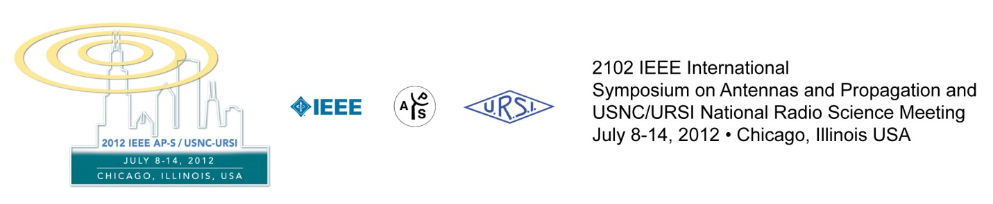
Report on the 2012 IEEE AP-S/USNC-URSI
Danilo Erricolo, Mahta Moghaddam, Christos Christodoulou

The 2012 IEEE International Symposium on Antennas and Propagation and USNC-URSI National Radio Science Meeting was held from July 8 –July 14 in Chicago, IL, USA. On behalf of its Steering Committee, we are thankful to all of the attendees for their participation and scientific contributions, which resulted in the symposium breaking numerous records. We received overwhelming positive feedback and hope you benefitted from many of the innovations of the 2012 symposium, including the impressive plenary speakers at the Global Plenary Session and the Funding Opportunities Plenary Session. We strived to make the attendees and their families, representing 54 countries, feel welcome. We provided numerous opportunities for interaction during the oral and poster sessions, the Opening Reception at the world-famous Art Institute of Chicago, the continental breakfasts before the plenary sessions, the sold-out Awards Banquet, the Student/GOLD Reception luncheon, the Women-in-Engineering Reception at Navy Pier, and the various formal and informal meetings at the conference hotel. The conference hotel, the Sheraton Chicago Hotel & Towers, was selected also because of its layout that facilitated interaction among people, by providing large common spaces and keeping all attendees sufficiently close to each other. The Hospitality Suite welcomed a record number of registered guests, and the first-ever program for children of those attending the Awards Banquet was a success.
We would like to thank Dr. Steven Best, 2012 IEEE AP-S President, and the IEEE AP-S AdCom Committee, and Dr. Steven C. Reising, the USNC-URSI Chair, and USNC-URSI, and the Joint Future Symposia Committee, for their support of the year 2012 symposium and all of its innovations.
We also would like to thank the Steering Committee who worked tirelessly to plan this symposium. Particularly, we would like to acknowledge Prof. Susan Hagness, Technical Program Committee Chair; Prof. Tony Grbic and Prof. Nader Behdad, TPC Co-Chairs; Vittorio Picco, Webmaster and Exhibits Co-Chair; and all of the student and faculty volunteers who helped us lend a personal touch by being responsive and fluent in more than 12 languages.

Innovations of the 2012 IEEE AP-S/USNC-URSI Symposium

The achievements of the Steering Committee included the following:
- Created a very interesting technical program by
  - providing 2 plenary sessions,
  - organizing 1585 oral and poster presentations.
- Provided an exceptional social program to make everyone feel welcome. Events included
  - Opening Reception at Art Institute of Chicago on Sunday evening and,
  - Odyssey Dinner Cruise on Monday evening.
- Made the event economically feasible by
  - Reducing by $60 the student registration fee;
  - Reducing by 75% the short course registration fee, thanks to the AdCom support;
  - Introducing Poster Printing Service, where posters would be printed onsite and made available at the registration desk for only $54 for a 36" x 60" (approx. 91 x 152 cm) color poster, thanks to DTI, Inc.
- Improved the experience of attendees by
  - Making the abstracts of Technical Program available online during the week of the conference;
  - Extending the Student/ GOLD Reception on Monday thanks to the support of AdCom;
  - Hosting the Women in Engineering Reception offsite at Riva Restaurant at Navy Pier, on Tuesday evening;
  - Accommodating religious and dietary restrictions at all events, inside and outside;
  - Providing information about the city of Chicago through the conference website in 8 different languages to facilitate international visitors
  - Introducing the Children Program during the Awards Banquet, where children would be entertained by performing art projects under the supervision of art educators specially trained for children;
  - Staffing the Registration Desk with people fluent in more than 12 major languages.
  - Hiring a photographer to collect memories of the symposium.

Some Statistics
Number of attendees | 1902
Number of students | 575
Number of countries represented | 54
Paper presented | 1585
Number of reviewers | ≌ 230
Number of plenary sessions | 2
Number of short courses offered | 18
Total attendance at short courses | 236
Attendance at Monday Plenary Session | >800
Attendance at Tuesday Plenary Session | >800
Attendance at the Opening reception at the Art Institute of Chicago | >1000
Attendance at GOLD/Student Reception on Monday | ≌ 300
Attendance at Reviewers’ Luncheon on Tuesday | >300
Attendance at Women in Engineering Reception on Tuesday | >250
Attendance at Awards Banquet on Wednesday | 604
Number of Gold Sponsors and Exhibitors | 5
Number of Silver Sponsors and Exhibitors | 4
Total Number of Sponsors and Exhibitors | 42
Number of languages spoken at registration desk | >12

In the following, we show some of the pictures taken during the conference. All picture credits go to Chicago Corporate Photography.

Prof. Danilo Erricolo  University of Illinois at Chicago  General Chair, 2012 IEEE AP-S/USNC-URSI | 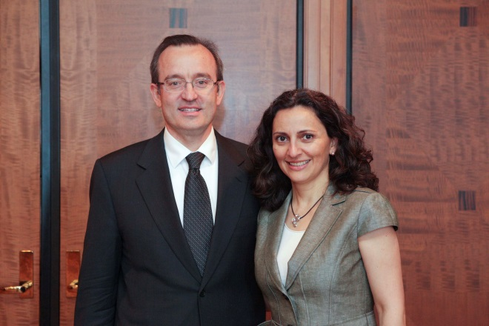
and
Prof. Mahta Moghaddam
University of Southern California
Vice General Chair, 2012 IEEE AP-S/USNC-URSI
Prof. Christos Christodoulou  University of New Mexico  Chair, IEEE AP-S Awards Committee | 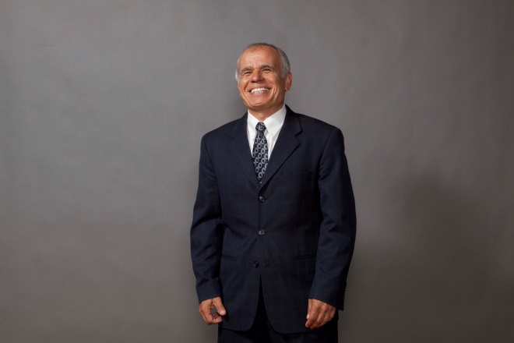

2012 IEEE AP-S Awards Banquet Ceremony
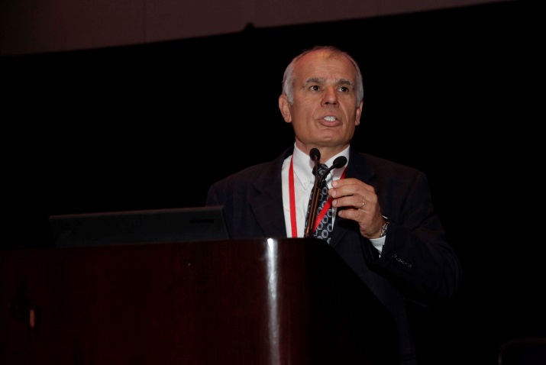  Figure 1. Prof. Christos Christodoulou, Chair, IEEE AP-S Awards Committee, is the master of ceremony at the 2012 IEEE AP-S Awards Banquet. |  | 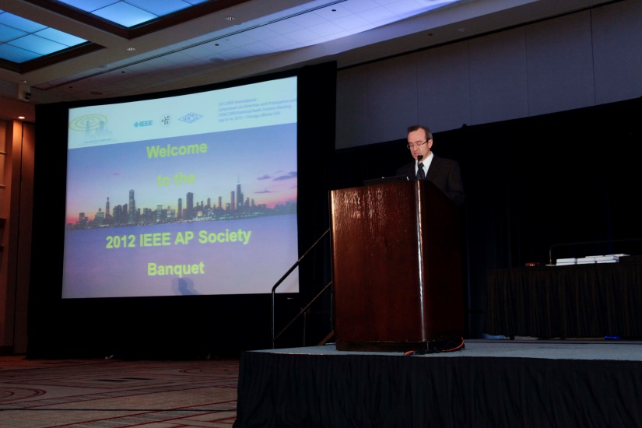  Figure 2. Prof. Danilo Erricolo, General Chair of the Steering Committee, gives the welcome address.
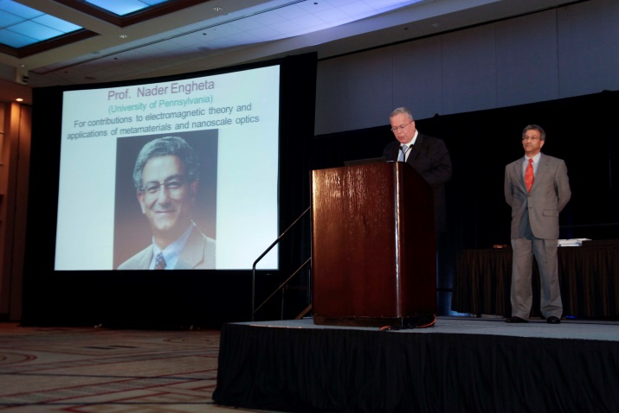  Figure 3. 2011 IEEE President Prof. Moshe Kam introduces Prof. Nader Engheta, who received the 2012 IEEE Electromagnetics Award. |  | 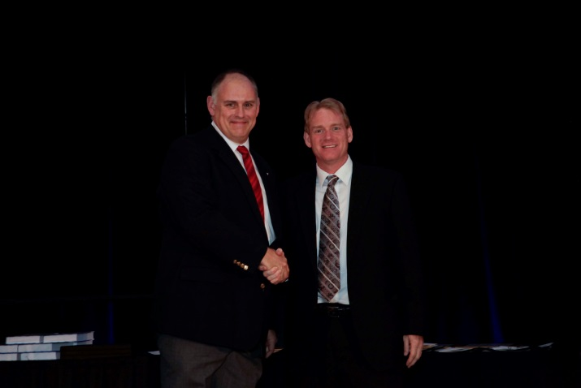  Figure 4. 2012 IEEE Fellow Prof. David Davidson (left) is congratulated by 2012 IEEE AP-S President Dr. Steven Best.
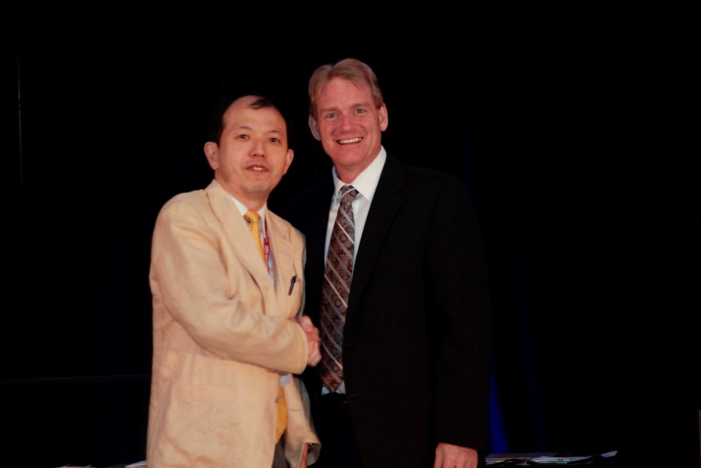  Figure 5. 2012 IEEE Fellow Prof. Jiro Hirokawa (left) is congratulated by 2012 IEEE AP-S President Dr. Steven Best. |  | 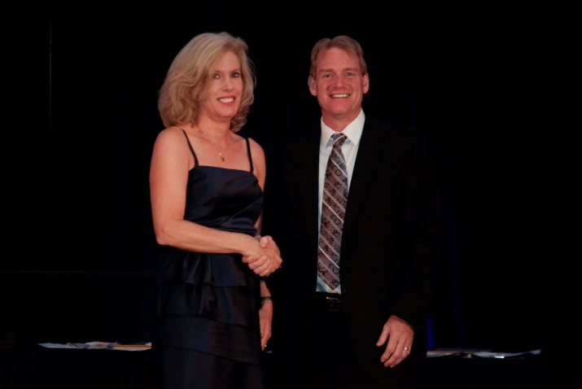  Figure 6. 2012 IEEE Fellow Prof. Kathleen Melde (left) is congratulated by 2012 IEEE AP-S President Dr. Steven Best.
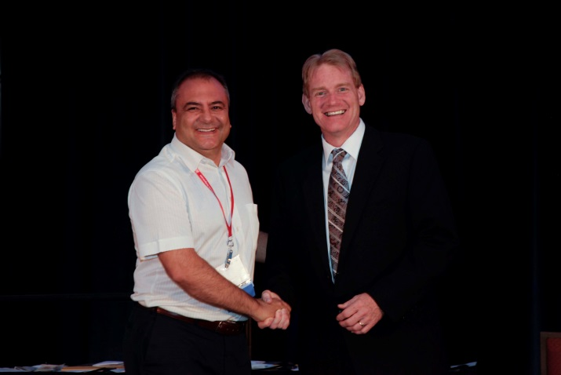  Figure 7. 2012 IEEE Fellow Prof. Agostino Monorchio (left) is congratulated by 2012 IEEE AP-S President Dr. Steven Best. |  | 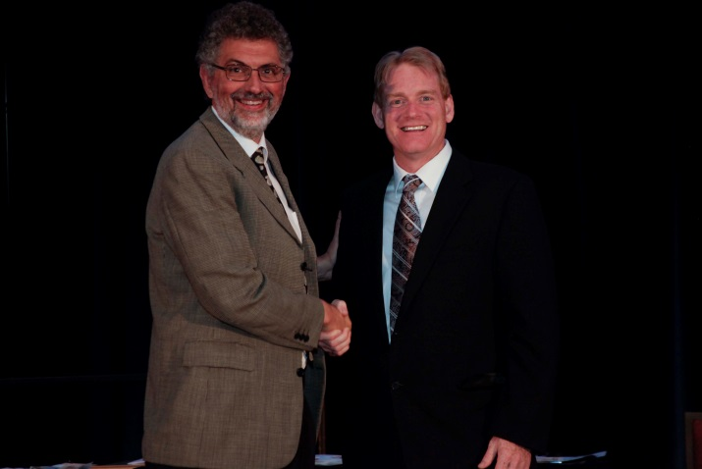  Figure 8. 2012 IEEE Fellow Prof. Jordi Romeu Robert (left) is congratulated by 2012 IEEE AP-S President Dr. Steven Best.
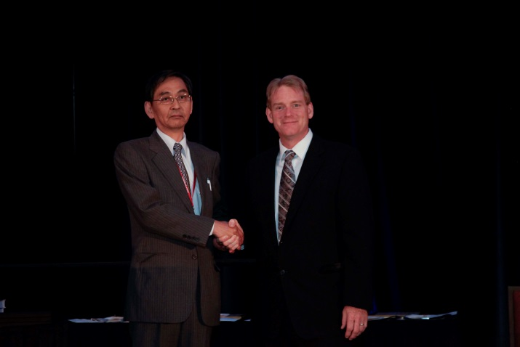  Figure 9. 2012 IEEE Fellow Prof. Kunio Sawaya (left) is congratulated by 2012 IEEE AP-S President Dr. Steven Best. |  | 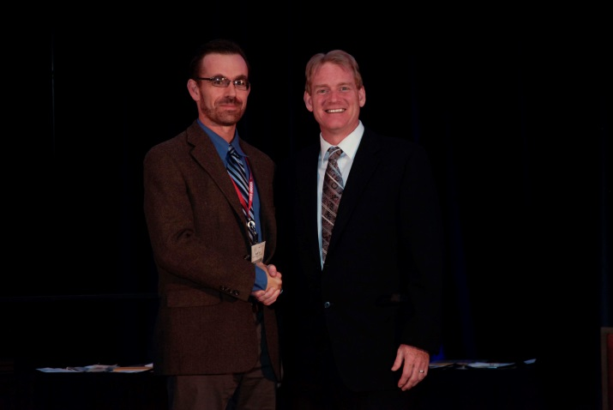  Figure 10. 2012 IEEE Fellow Prof. Scott Tyo (left) is congratulated by 2012 IEEE AP-S President Dr. Steven Best.
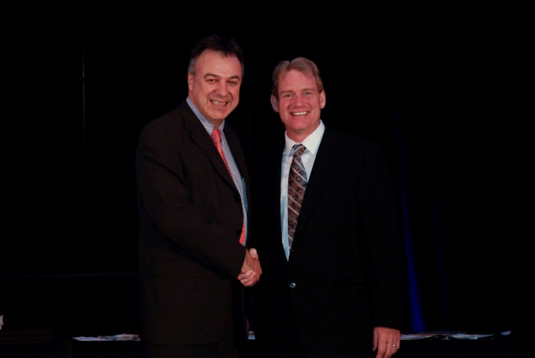  Figure 11. 2012 IEEE Fellow Prof. Yiannis Vardaxoglou (left) is congratulated by 2012 IEEE AP-S President Dr. Steven Best. |  | 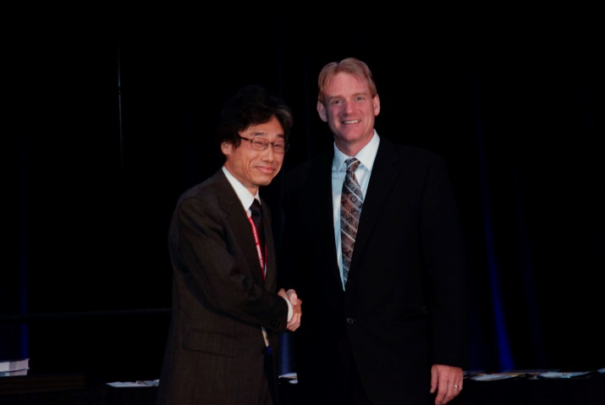  Figure 12. 2012 IEEE Fellow Prof. Junji Yamauchi (left) is congratulated by 2012 IEEE AP-S President Dr. Steven Best.
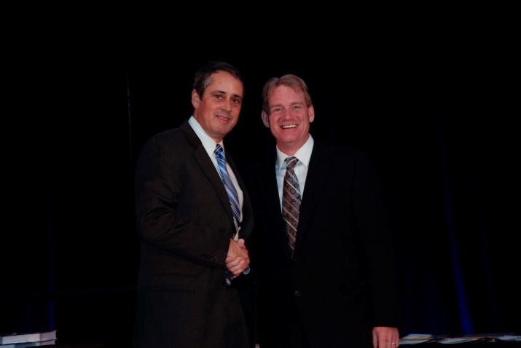  Figure 13. 2012 IEEE Fellow Dr. William Palmer (left) is congratulated by 2012 IEEE AP-S President Dr. Steven Best. |  | 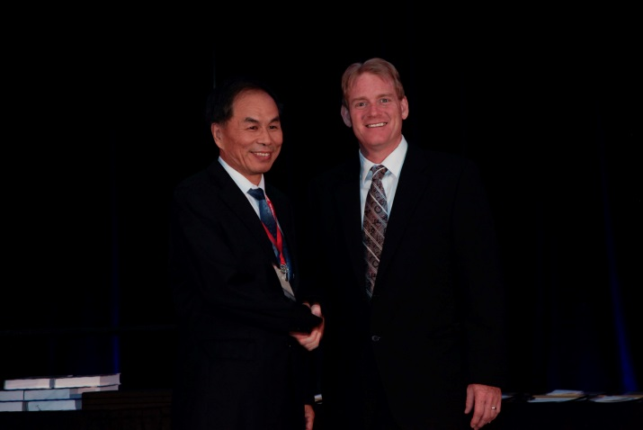  Figure 14. 2012 IEEE Fellow Prof. Zhenge Feng (left) is congratulated by 2012 IEEE AP-S President Dr. Steven Best.
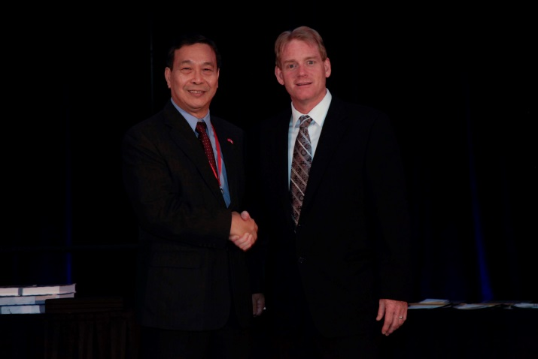  Figure 15. 2012 IEEE Fellow Prof. Edward Yung (left) is congratulated by 2012 IEEE AP-S President Dr. Steven Best. | 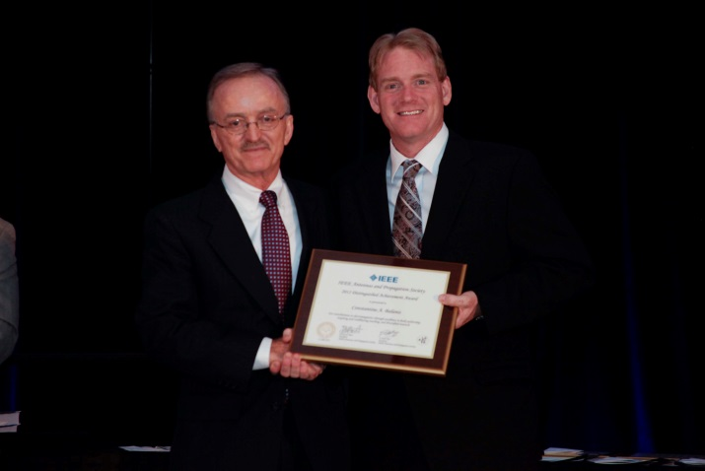  Figure 16. Prof. Constantine A. Balanis (left) receives the 2012 IEEE AP-S Distinguished achievement award “For contributions to electromagnetics through excellence in book authorship, inspiring and trailblazing teaching, and diversified research.”
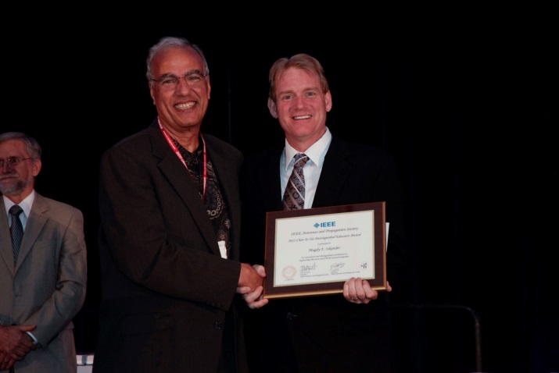  Figure 17. Prof. Magdy F. Iskander (left) receives the 2012 IEEE AP-S Chen-To Tai Distinguished Educator Award “For innovation and distinguished contribution to engineering education and STEM outreach programs.” | 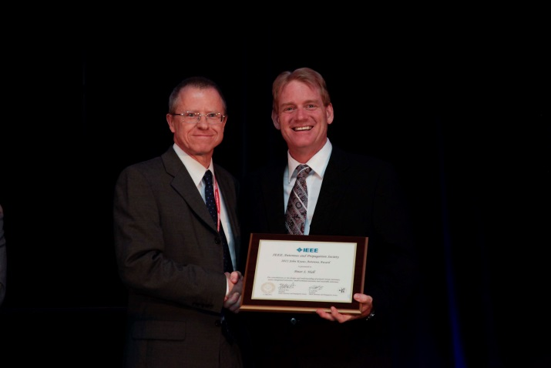  Figure 18. Prof. Peter S. Hall (left) receives the 2012 IEEE AP-S John Kraus Antenna Award “For contributions to the design and understanding of printed circuit antennas, active integrated antennas, small terminal antennas and wearable antennas.”
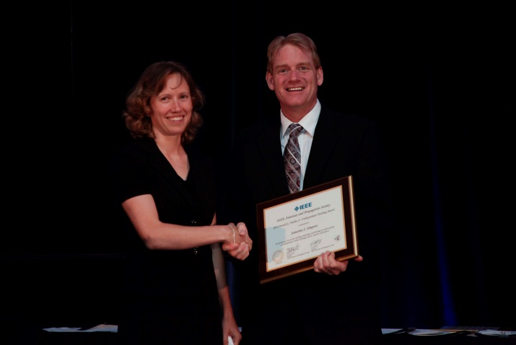  Figure 19. Prof. Jamesina J. Simpson (left), 2012 IEEE AP-S/USNC-URSI Special Session Chair, receives the 2012 IEEE AP-S Donald G. Dudley Undergraduate Teaching Award “For passionate one-on-one teaching, mentoring, and advising of a diverse group of undergraduate students through courses, research, and project.” | 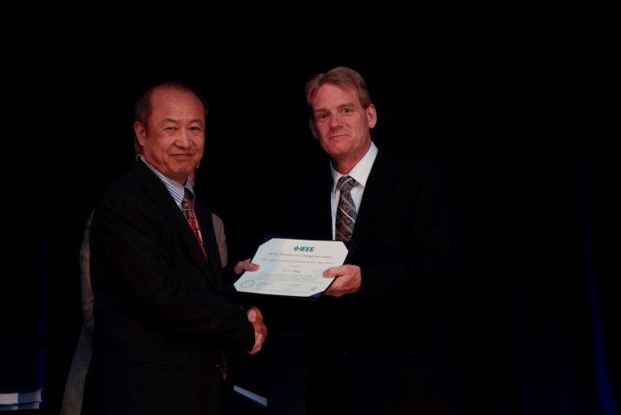  Figure 20. Prof. Y.P. Zhang (left) receives the 2012 IEEE AP-S Sergei A. Schelkunoff Prize Paper Award for the article [1].
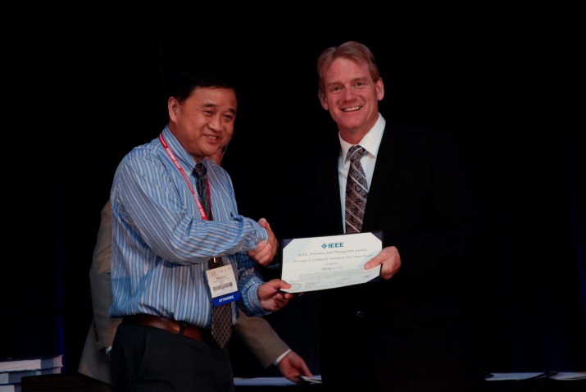  Figure 21. Prof. Yilong L. Lu (left) receives the 2012 IEEE AP-S Sergei A. Schelkunoff Prize Paper Award for the article [1]. | 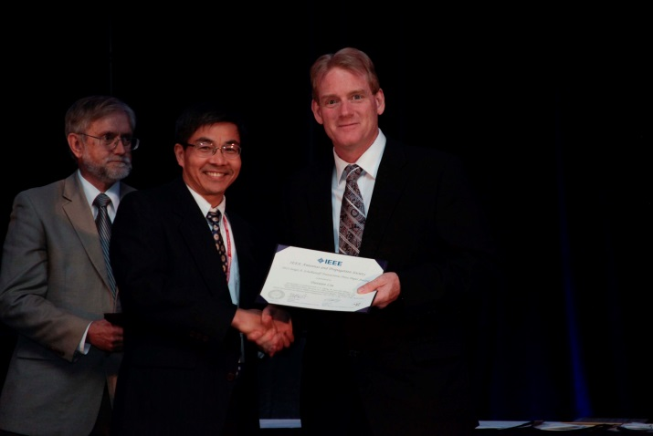  Figure 22. Dr. Duixian Liu (center) receives the 2012 IEEE AP-S Sergei A. Schelkunoff Prize Paper Award for the article [1].
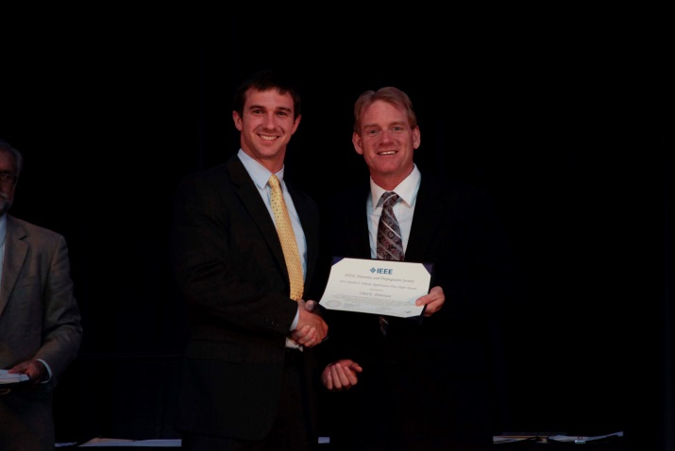  Figure 23. Chad E. Patterson (left) receives the 2012 IEEE AP-S Harold A. Wheeler Prize Paper Award for the article [2]. | 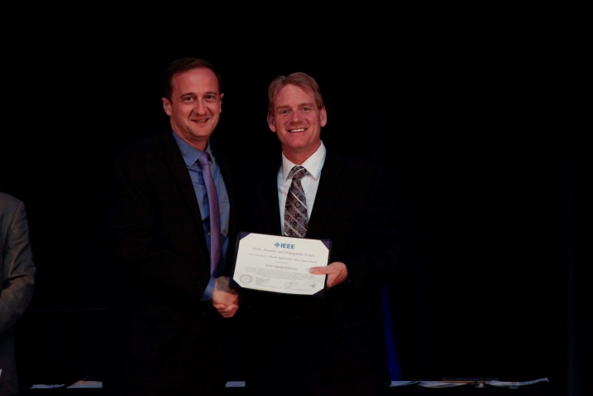  Figure 24. Prof. John Papapolymerou (left) receives the 2012 IEEE AP-S Harold A. Wheeler Prize Paper Award for the article [2].

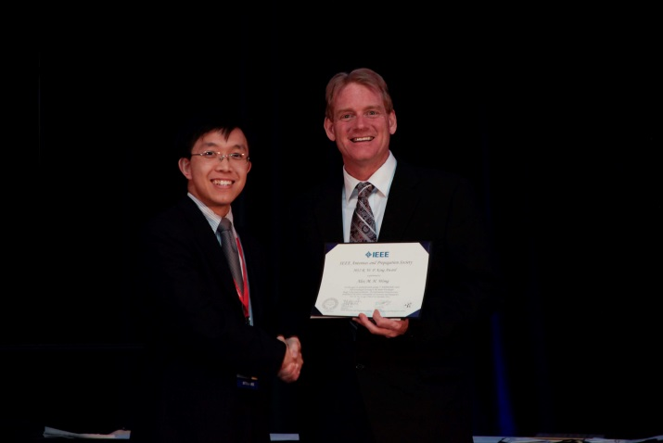  Figure 25. Alex M. H. Wong (left) receives the 2012 IEEE AP-S R.W.P. King Paper Award for the article [3]. | 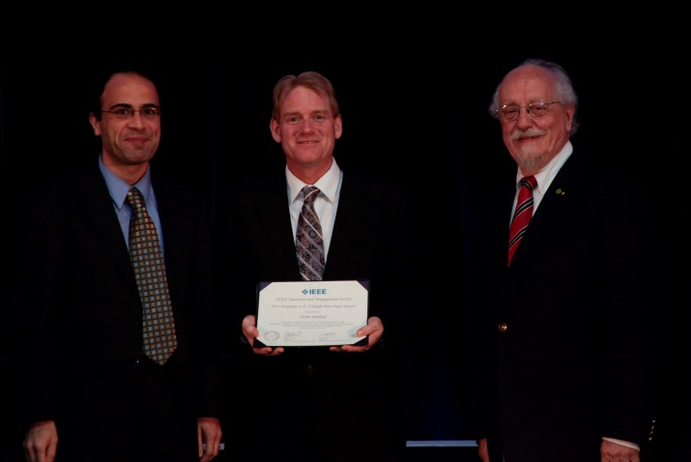  Figure 26. Prof. Nader Behdad (left) receives the 2012 IEEE AP-S Piergiorgio L.E. Uslenghi (right) Letter Prize Award for the article [4].
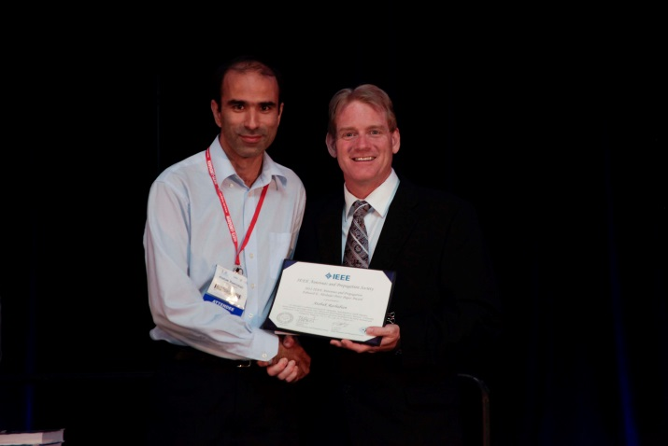  Figure 27. Atabak Rashidian (left) receives the 2012 IEEE AP-S Edward E. Altshuler Prize Paper Award for the article [5]. | 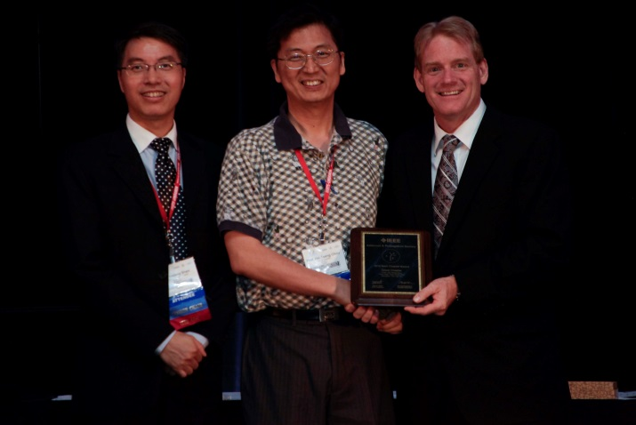  Figure 28. Prof. Hsi-Tseng Chou (center) receives the 2012 IEEE AP-S Best Chapter Award for the Taipei, Taiwan chapter from Prof. Shen Zhongxiang (left) and Dr. Steven Best (right).
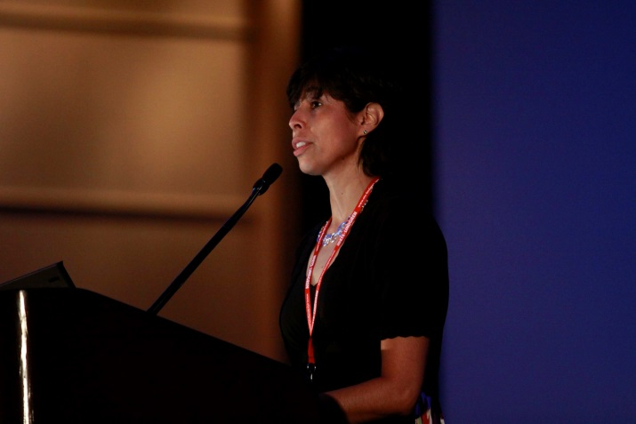  Figure 29. Dr. Lorena I. Basilio, 2012 IEEE AP-S/USNC-URSI Student Paper Contest Chair, announces the three winners of the 2012 IEEE AP-S Student Paper Award competition. | 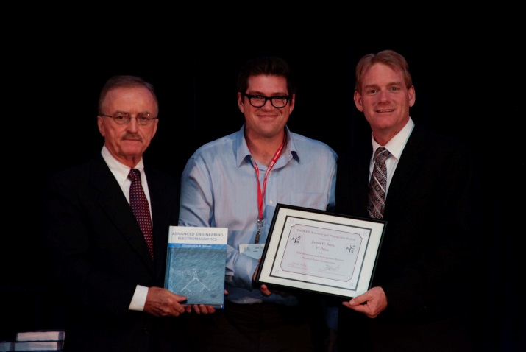  Figure 30. Jason C. Soric (center) receives from Prof. Balanis (left) and Dr. Best (right) the third-place 2012 IEEE AP-S Student Paper Award for the presentation “Experimental Demonstration of a Conformal Mantle Cloak for Radio-Waves” co-authored with Andrea Alù, Aaron Kerkhoff and David Rainwater.

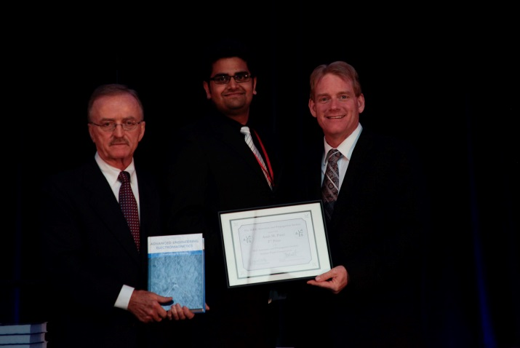  Figure 31. Amit M. Patel (center) receives from Prof. Balanis (left) and Dr. Best (right) the second-place 2012 IEEE AP-S Student Paper Award for the presentation “Dispersion Analysis of Printed-Circuit Tensor Impedance Surfaces” co-authored with Prof. Anthony Grbic. | 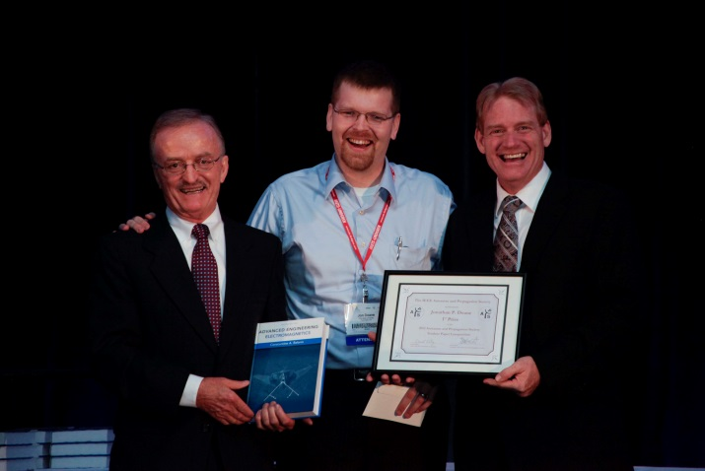  Figure 32. Jonathan P. Doane (center) receives from Prof. Balanis (left) and Dr. Best (right) the first-place 2012 IEEE AP-S Student Paper Award for the presentation “A 6.3:1 Bandwidth Scanning Tightly Coupled Dipole Array with Co-Designed Compact Balun,” co-authored with Dr. Kubilay Sertel and Prof. John L. Volakis.
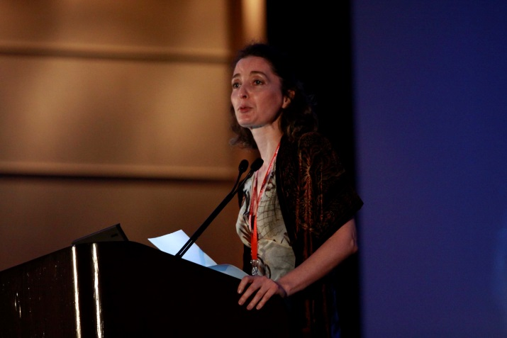  Figure 33. Prof. Ozlem Kilic, 2012 IEEE AP-S/USNC-URSI Student Design Contest Chair, announces the three winners of the 2012 AP-S Student Antenna Design Award. | 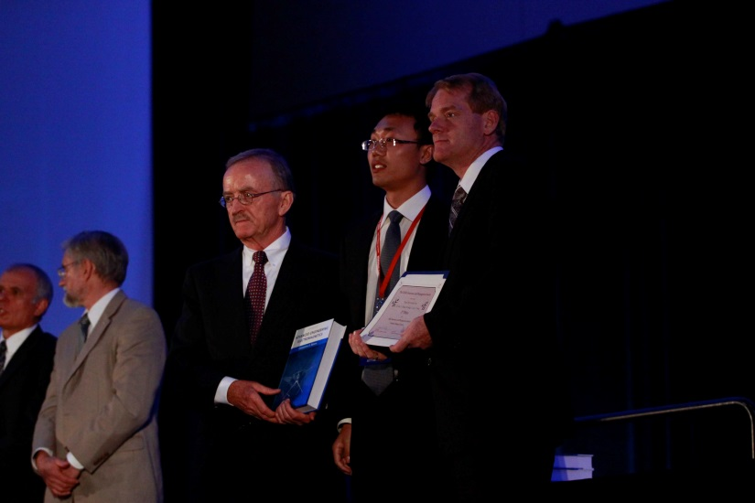  Figure 34. Lang Wang (center), of the team "The Furious Five" from the University of Electronic Science and Tech of China, receives from Prof. Balanis (left) and Dr. Best (right) the 2013 AP-S Student Antenna Design Award 3rd Prize for the project entitled "DNA Inspired Double-Helix."
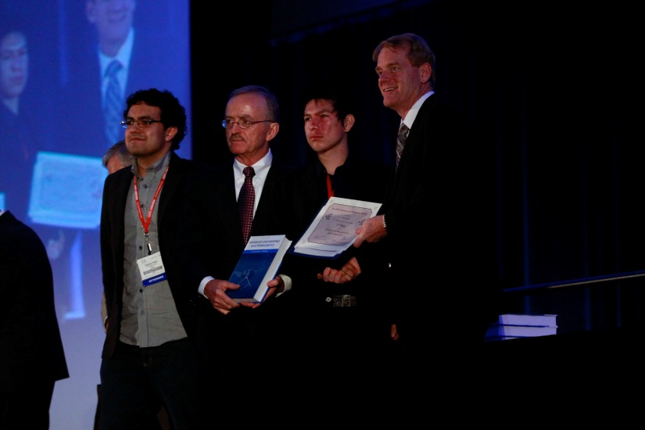  Figure 35. Carlos-Andres Viteri-Mera (left) and Jesus Alberto Viveros Delgado (second from right) of the team "UDN" from the Universidad de de Nariño, Colombia, receive from Prof. Balanis (second from left) and Dr. Best (right) the 2012 AP-S Student Antenna Design Award Second Prize for the project “A Bio-inspired Patch Antenna Array using Fibonacci sequences in trees.” | 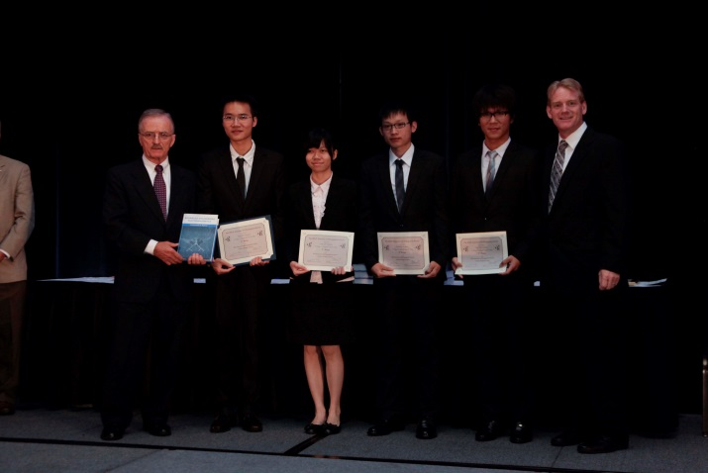  Figure 36. The team “Predator” from the Taiwan National University receives from Prof. Balanis and Dr. Best the 2012 AP-S Student Antenna Design Award First Prize for the project “Rattlesnake Antenna System”. From left to right: Prof. Balanis, Bing Zhang Tsai, Li-Yuan Fang, Chin-Chia Chang, Shih-An Yang, Dr. Best.
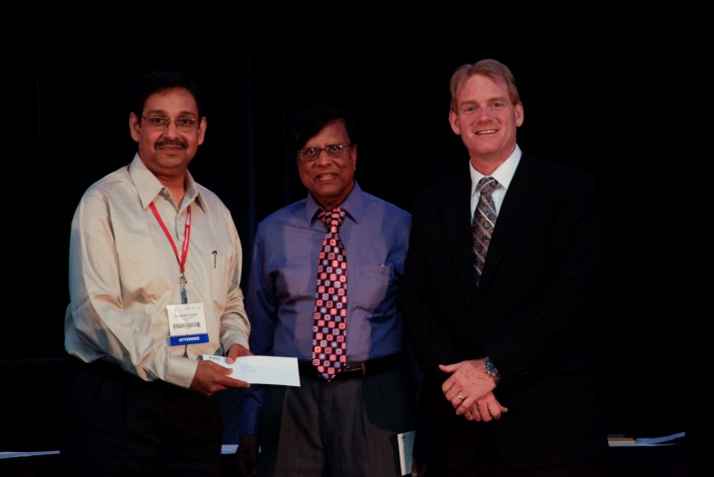  Figure 37. Dr. Debatosh Guha (left) receives the 2012 Raj Mittra Senior Researcher Award from Prof. Raj Mittra (center) and Dr. Best (right). | 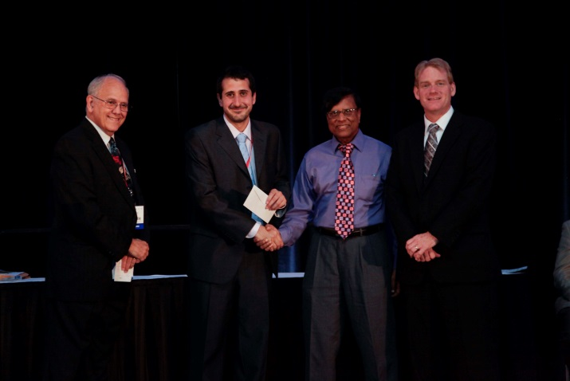  Figure 38. Oscar Quevedo-Teruel (second from left) receives the 2012 Raj Mittra Junior Researcher Award from Prof. Raj Mittra (second from right), Prof. Wilton (left) and Dr. Best (right).
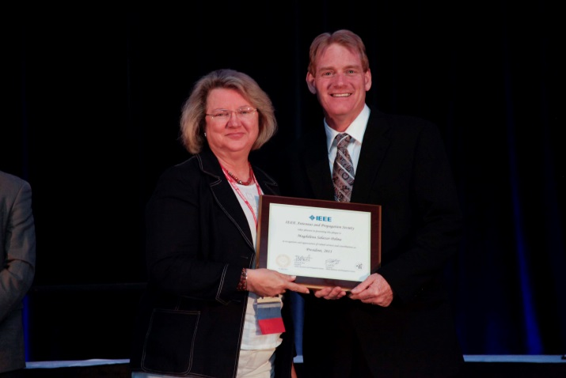  Figure 39. Prof. Magdalena Salazar Palma (left) receives a plaque for her service as 2011 IEEE AP-S President from Dr. Steven Best (right). | 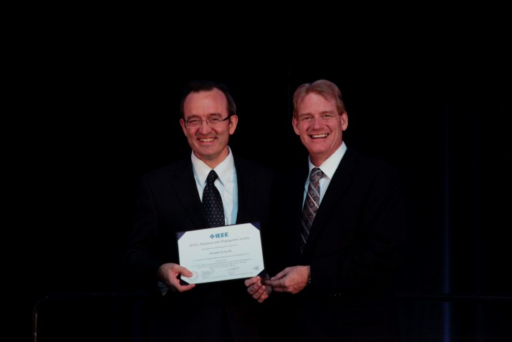  Figure 40. Prof. Danilo Erricolo (left) receives a certificate for his service as General Chair of the 2012 IEEE AP-S Symposium from Dr. Steven Best.

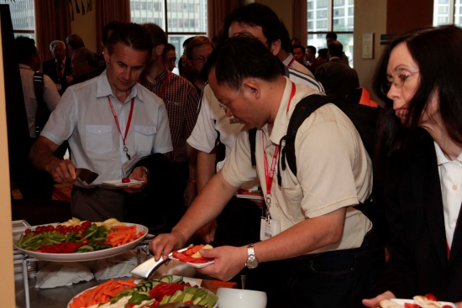  Figure 41. Some attendees enjoy the reception before the Awards Banquet. | 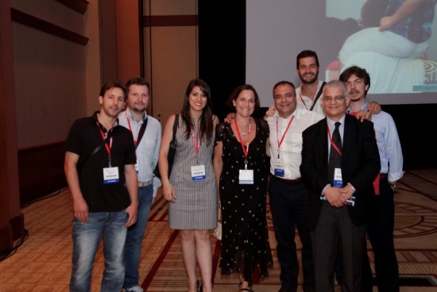  Figure 42. From left to right: Filippo Costa, Pierpaolo Usai, Gabriella Nastasia, Giovanna Monorchio, Prof. Agostino Monorchio, Davide Bianchi, Prof. Giuliano Manara, Prof. Simone Genovesi. | 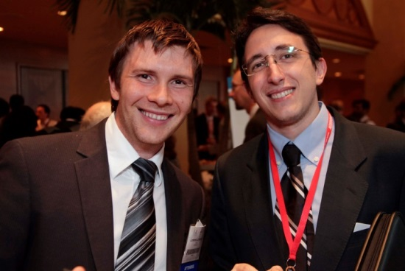  Figure 43. Dr. Lorenzo Lo Monte (left) and Dr. Giuseppe Carluccio (right).

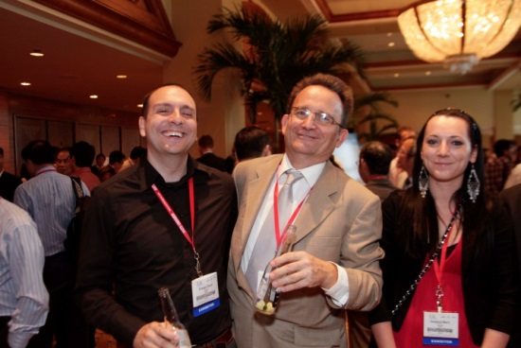  Figure 44. WIPL-D Gold Exhibitors: Prof. Dragan Olcan (left), Prof. Branko Kolundzija (center), and Sladjana Maric (right). | 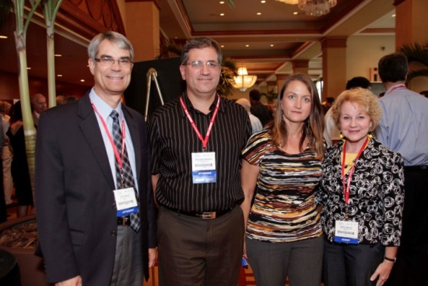  Figure 45. From left to right: Prof. Daniel Stancil, Prof. Branislav Notaros, Olivera Notaros, Kathy Stancil. | 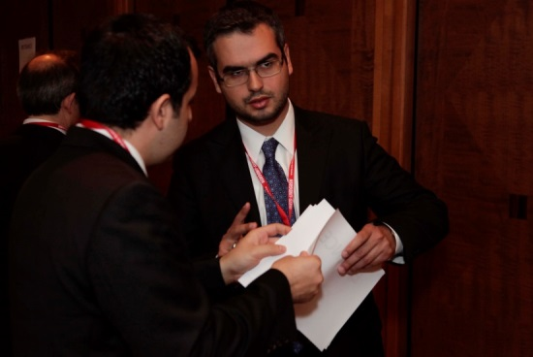  Figure 46. Dr. Harun Taha Hayvaci (right).
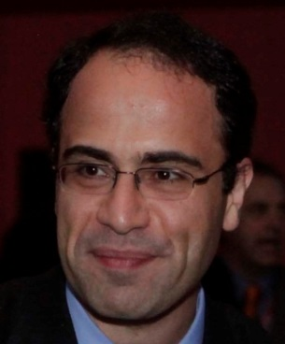  Figure 47. Prof. Nader Behdad, 2012 IEEE AP-S/USNC-URSI TPC Co-chair. | 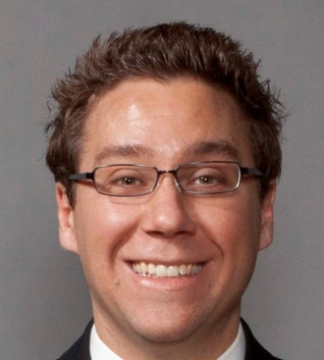  Figure 48. Prof. Anthony Grbic 2012 IEEE AP-S/USNC-URSI TPC Co-chair. | 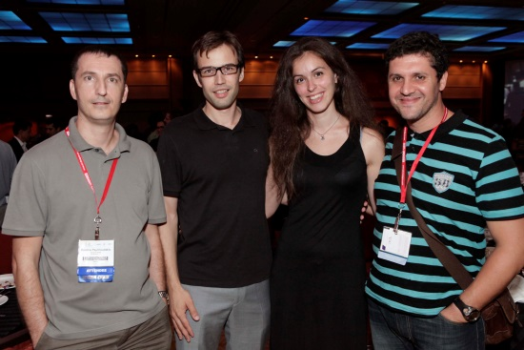  Figure 49
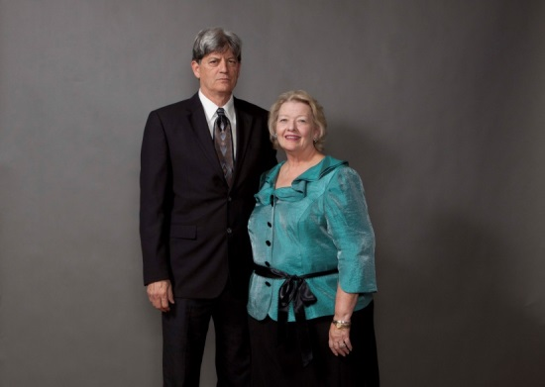  Figure 50. Prof. Stuart Long (left), IEEE AP-S Joint Meetings Committee Coordinator and Judy Long (right). | 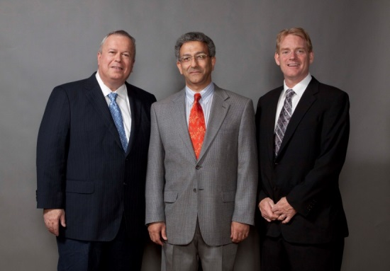  Figure 51. From left to right: Prof. Moshe Kam, 2011 IEEE President, Prof. Nader Engheta, 2012 IEEE Electromagnetics Award Recipient, and Dr. Steven Best, 2012 IEEE AP-S President. | 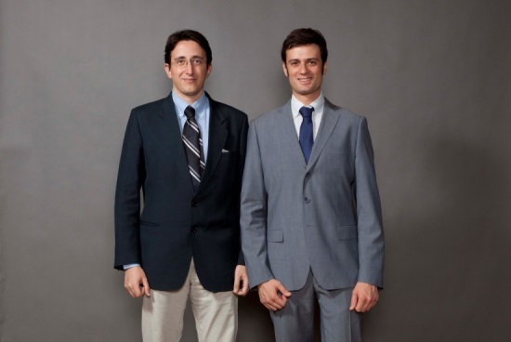  Figure 52. Dr. Giuseppe Carluccio (left) and Vittorio Picco (right), 2012 IEEE AP-S/USNC-URSI Communications Co-Chair and Webmaster and Exhibits Co-Chair, respectively.
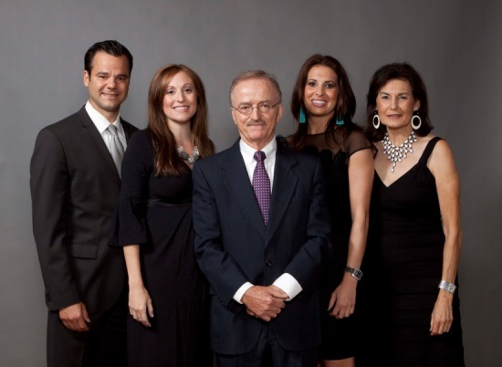  Figure 53. Prof. Constantine A. Balanis (center) and his family. | 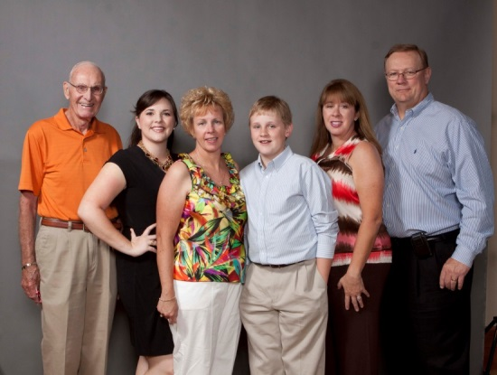  Figure 54. Dr. Charles Rhoads (right), 2007 IEEE AP-S President, and his family. | 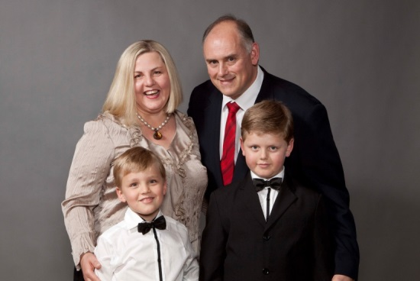  Figure 55. The family of Prof. David B. Davidson (top right): his wife Amor, Ethan (bottom left) and Bruce (bottom right).
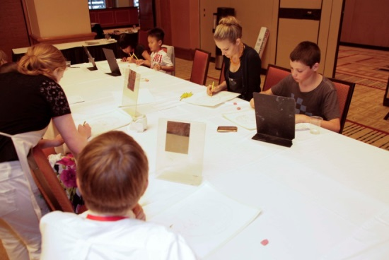  Figure 56. Children having fun at the Brickton Art Center Program while their parents attend the Awards Banquet. | 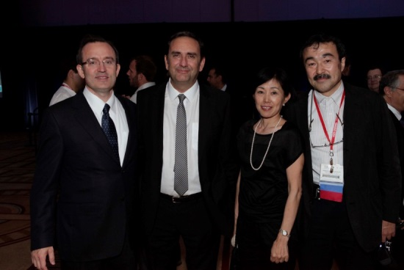  Figure 57. From left to right: Prof. Danilo Erricolo, Prof. Stefano Maci, Shinobu Ando, and Prof. Makoto Ando, 2009 IEEE AP-S President. | 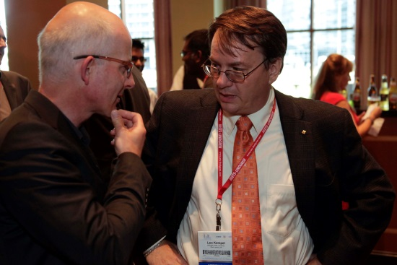  Figure 58. Prof. Michal Okoniewski (left) and Prof. Leo Kempel (right).
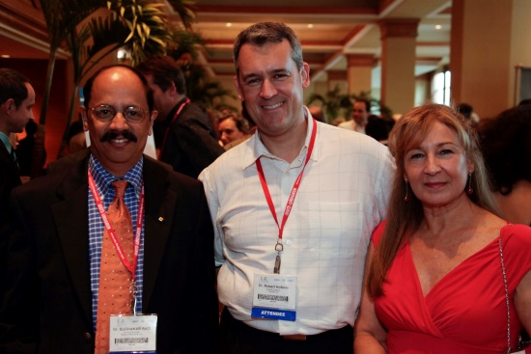  Figure 59. Dr. Sudhakar Rao (left), Dr. Robert Hoferer (center), and Margarita Talavera-Hoferer (right). | 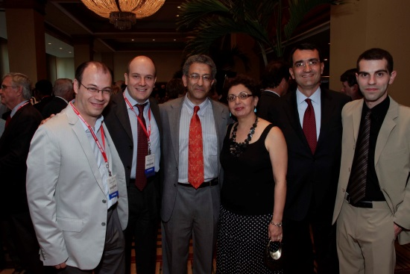  Figure 60. Prof. Vincenzo Galdi, Prof. Filiberto Bilotti, Prof. Nader Engheta, Susan Engheta, Prof. Alessandro Toscano, and Alessio Monti. | 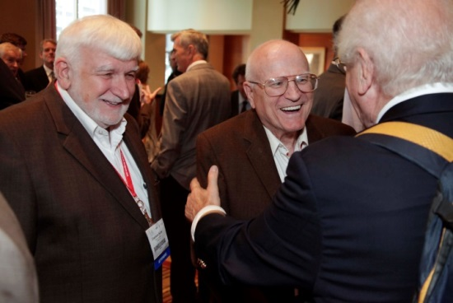  Figure 61. Prof. Chalmers M. Butler (left), URSI Liaison of the 2012 IEEE AP-S/USNC-URSI, and Prof. Roger Harrington (center).
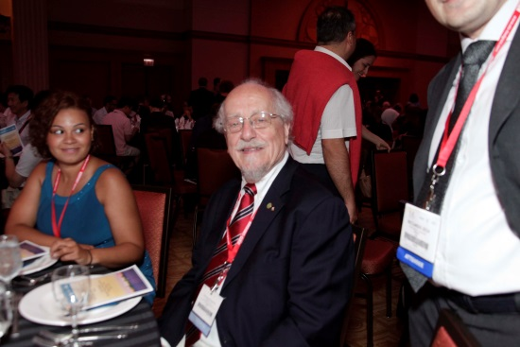  Figure 62. Raven Uslenghi (left), and Piergiorgio L. E. Uslenghi (right), URSI Vice-President and AP-S Liaison of the 2012 IEEE AP-S/USNC-URSI. | 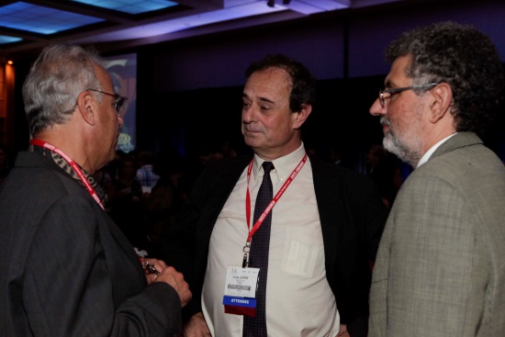  Figure 63. Prof. Magdy F. Iskander (left), Prof. Louis Jofre (center) and Jordi Romeu (right). | 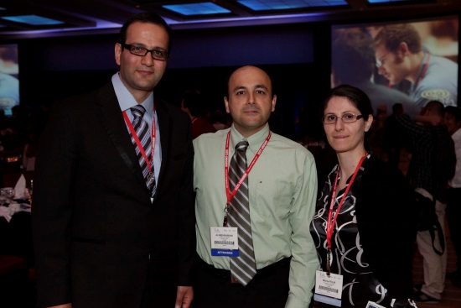  Figure 64. Hasan Mirzaei (left), Ali Mehrabani (center) and Maria Pour (right).
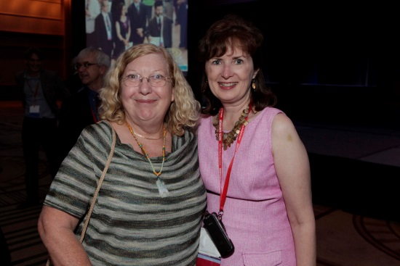  Figure 65. Sue Stone (left) and Marie Erricolo (right) the 2012 IEEE AP-S/USNC-URSI Chairs of Local Arrangements and Hospitality. | 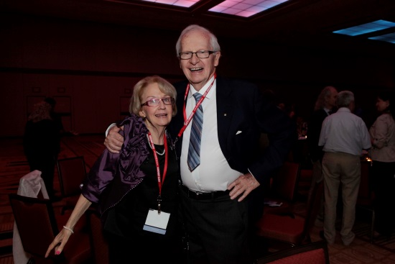  Figure 66. Cathy Macphie (left) and Prof. Robert Macphie (right). | 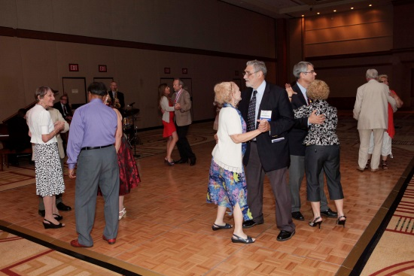  Figure 67. People dancing after the banquet.

Plenary sessions
We received great feedback about the two plenary sessions and the opportunities for interaction during the breakfasts that preceded them.
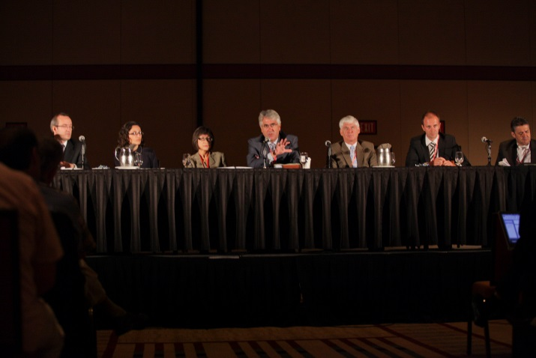  Figure 68. Plenary Session "Global Research Opportunities" on Monday morning. From left to right: Prof. Danilo Erricolo, Prof. Moghaddam, Ms. Heidi Shyu (U.S. Army), Prof. Lawrence B. Schook (VP Research, University of Illinois, USA), Dr. George Komar (Associate Director, Earth Science Technology Office, NASA, USA), Dr. Biber (Healthcare Sector, Siemens AG, Germany), and Dr. Julio Navarro (Senior Technical Fellow, Boeing, USA). | 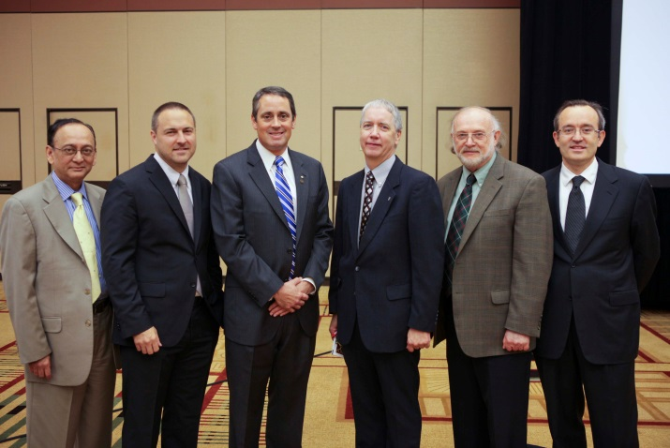  Figure 69. Plenary Session “Funding Research Opportunities” on Tuesday morning. From left to right: Dr. Mahbub Hoque (Chief Scientist, CERDEC, U.S. Army), Dr. Dr. William Chappell (Program Manager, DARPA, USA), Dr. Devereux Palmer (Program Manager, Army Research Office, USA), Dr. Brian M. Kent (Chief Scientist, Sensors Directorate, Air Force Research Laboratory, USA), Dr. Robert Trew (Division Director, National Science Foundation, USA), and Prof. Danilo Erricolo.

Opening Reception at the Art Institute of Chicago

The Opening Reception took place at the Art Institute of Chicago on Sunday July 8 from 18:00 to 22:00. The Museum was open only for our attendees, who had access to the Impressionists Gallery and the Modern Art Gallery. Docents were available to explain the beautiful masterpieces present in the second largest museum of art in the United States and also the second largest collection in the world of Impressionist arts, after the Musée d’Orsay in Paris. In addition, thanks to the generous sponsorship of the Ming Hsieh Institute of the University of Southern California, we could give access to the Roy Lichtenstein Special Exhibit, which was opened a few weeks earlier by First Lady Michelle Obama in occasion of the 2012 NATO G8 meeting, and would travel only to Washington D.C, London and Paris.
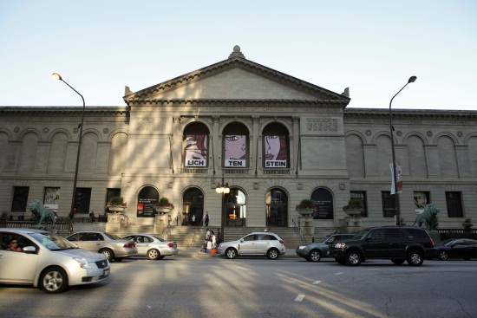  Figure 70. The Art Institute of Chicago. | 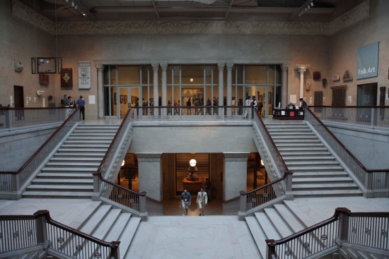  Figure 71. Entrance to the Impressionism Gallery. | 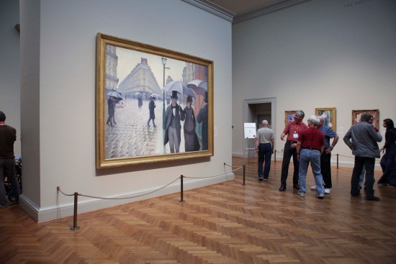  Figure 72. The painting of a Paris street during rainy weather by Gustave Caillebotte.

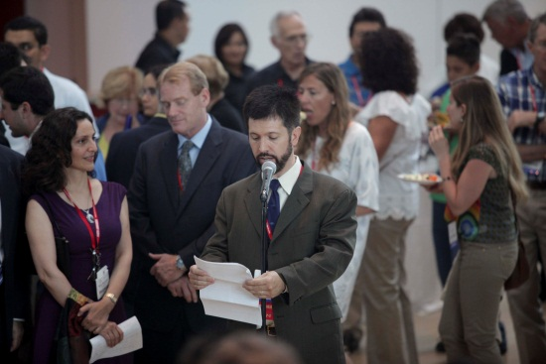  Figure 73. Prof. Steven C. Reising, USNC-URSI Chair, gives his introductory remarks. | 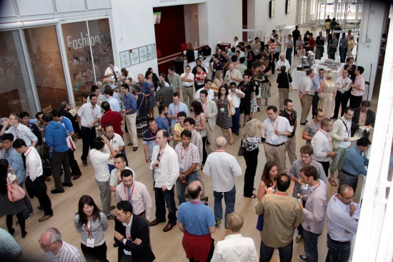  Figure 74. | 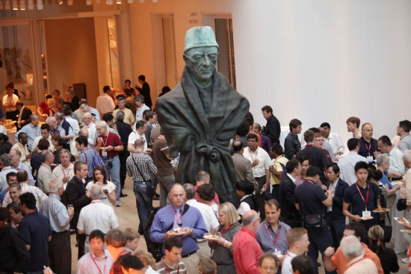  Figure 75.
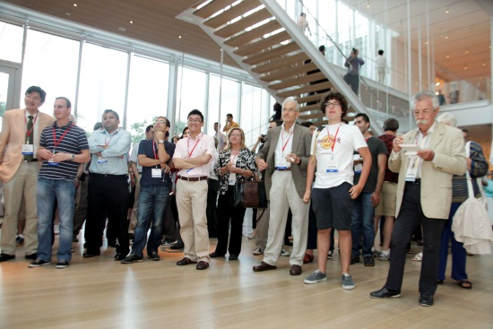  Figure 76. | 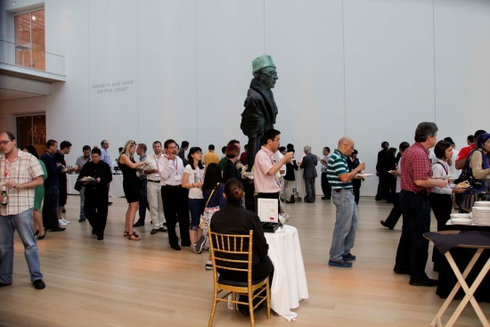  Figure 77. | 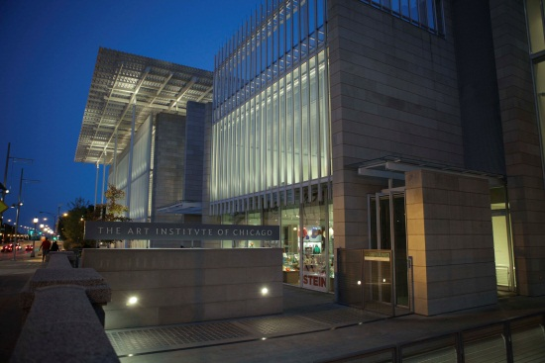  Figure 78. Night view of the Art Institute from Monroe Street.
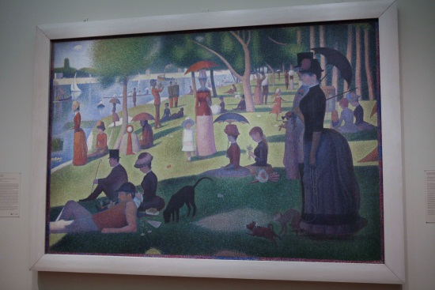  Figure 79. "A Sunday Afternoon on the Island of La Grande Jatte" by Georges-Pierre Seurat. | 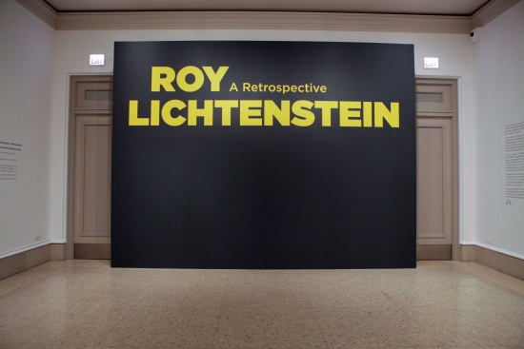  Figure 80. The Roy Lichtenstein Special Exhibit. | 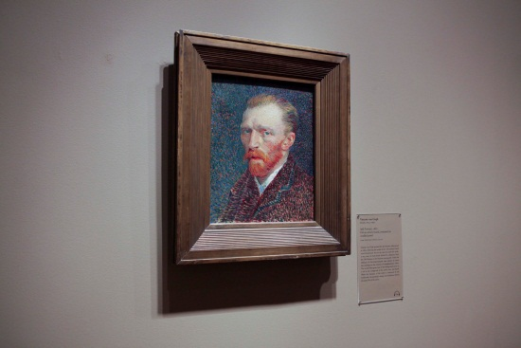  Figure 81. Self portrait of Vincent van Gogh.
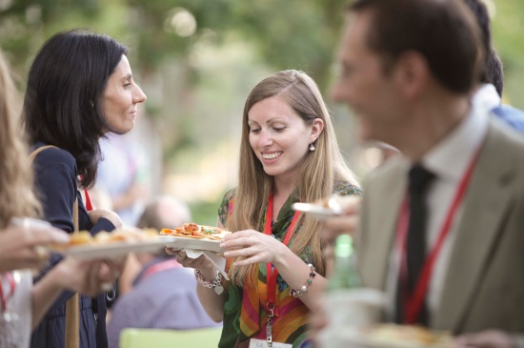  Figure 82. Dr. Enrica Martini (left) and Elena Pucci (right). | 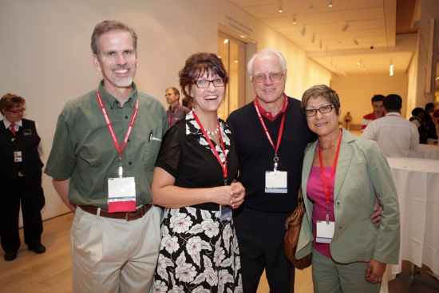  Figure 83. From left to right: Prof. Jeff Young, Elizabeth Young, Dr. Peder Hansen, Mary Hansen. | 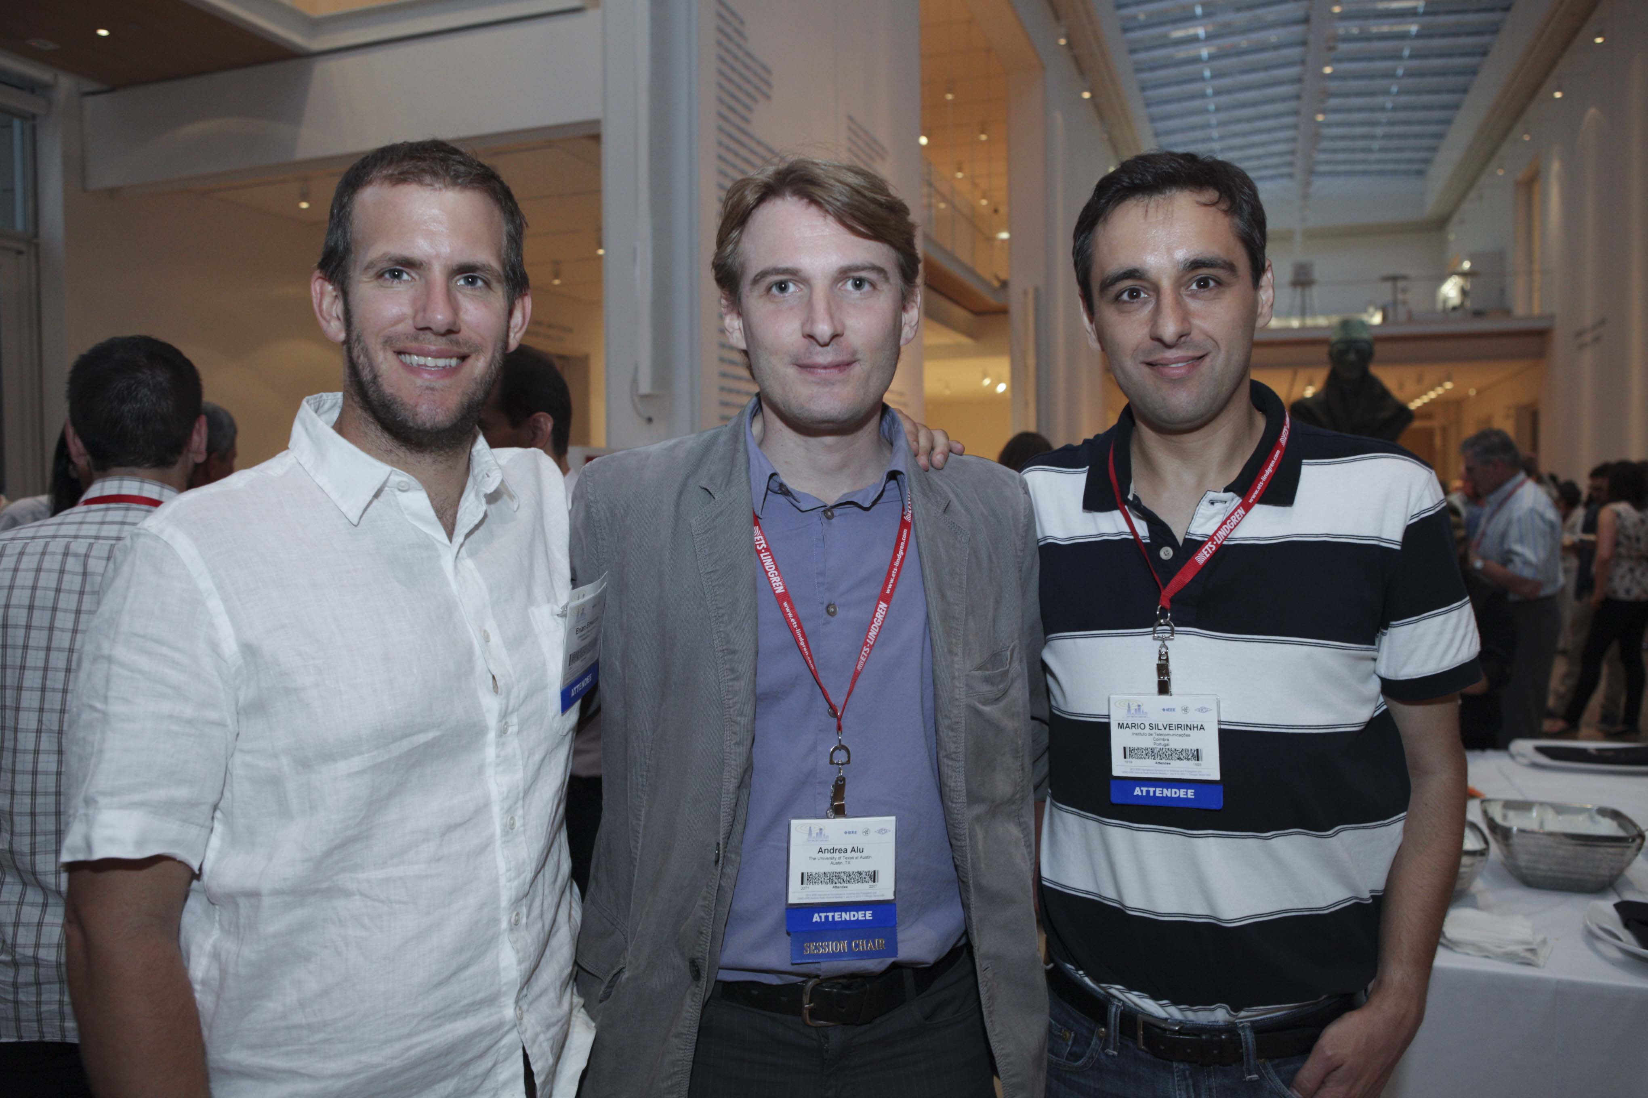  Figure 84. Prof. Andrea Alù (center) and Prof. Mario Silveirinha (right).

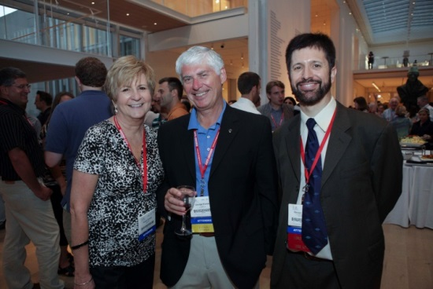  Figure 85. From left to right: Karen Komar, Dr. George Komar, and Prof. Steven C. Reising, USNC-URSI Chair. | 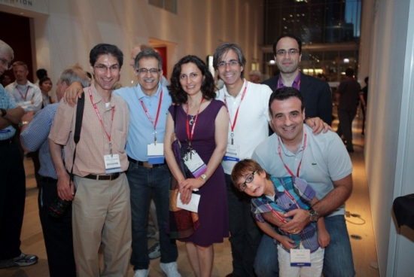  Figure 86. From left to right, first row: Prof. Amir Mortazawi, Prof. Kamal Sarabandi, Prof. Mahta Moghaddam, Prof. Gianluca Lazzi, Prof. Nader Behdad; second row: Adrian Lazzi and Prof. Erdem Topsakal. | 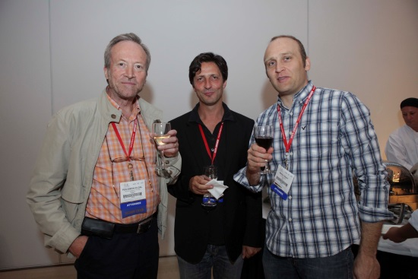  Figure 87. From left to right: Prof. Per-Simon Kildal, Prof. Filippo Capolino and Prof. Matteo Albani.
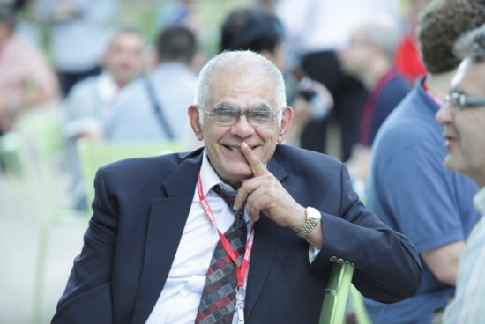  Figure 88. Prof. Yahia Antar. | 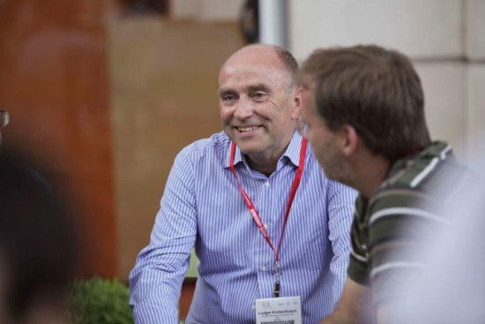  Figure 89. Prof. Ludger Klinkenbusch. | 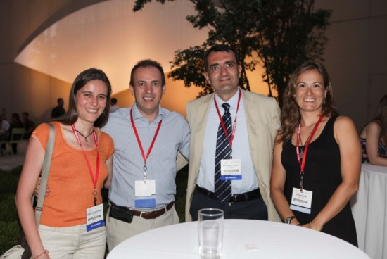  Figure 90. From left to right: Dr. Francesca Vipiana, Prof. Alberto Toccafondi, Prof. Alesandro Toscano, and Prof. Alessia Polemi.
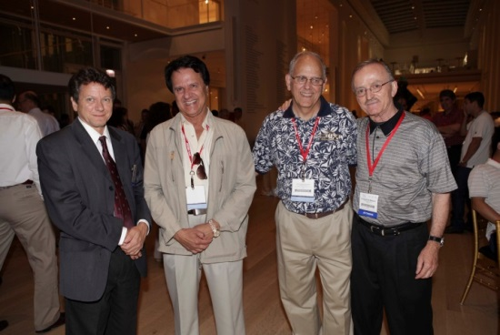  Figure 91. From left to right: Prof. David R. Jackson, Prof. Yahya Rahmat Samii, Prof. Donald Wilton, and Prof. Constantine A. Balanis. | 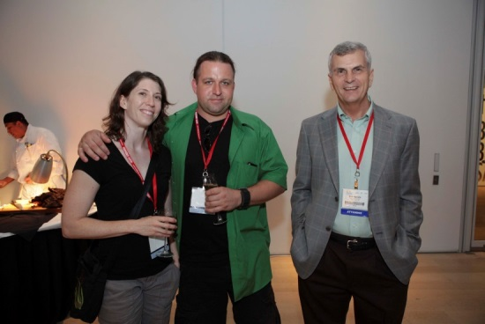  Figure 92. From left to right: Jacquelyn Huff, Prof. Gregory Huff, and Prof. Robert D. Nevels, 2010 IEEE AP-S President. | 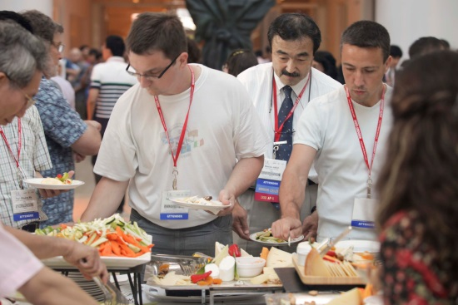  Figure 93. Prof. Makoto Ando (center), URSI Vice-President.
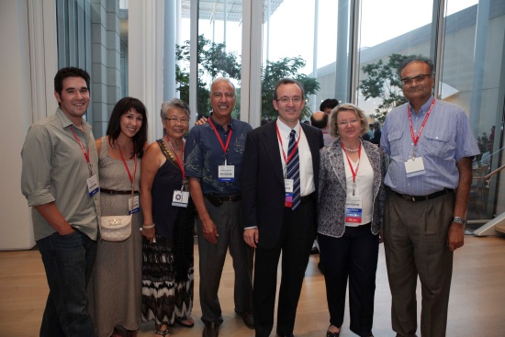  Figure 74. From left to right: Jason Cox, Tiffany Iskander, Sonia Iskander, Prof. Magdy F. Iskander, Prof. Danilo Erricolo, Prof. Magdalena Salazar Palma, 2011 IEEE AP-S President, Prof. Tapan K. Sarkar, 2013 IEEE AP-S President Elect. | 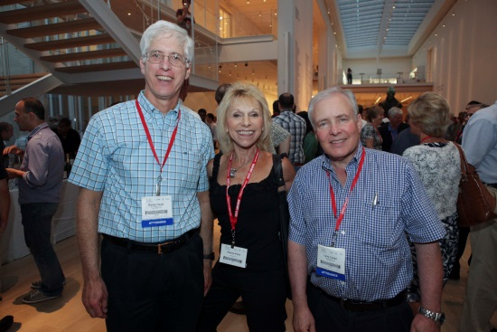  Figure 94. From left to right: Dr. Randy Haupt, Dianne Paris, Dr. Larry Cohen. | 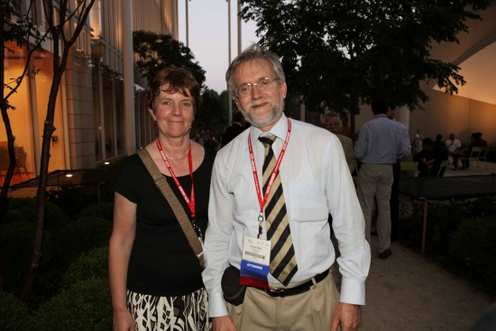  Figure 95. Val Bird (left) and Dr. Trevor Bird (right), 2012 IEEE AP-S President Elect.

Odyssey Dinner Cruise
The Odyssey Dinner Cruise was a great success and it was offered at a significantly discounted cost due to the volume of business that IEEE has brought in the past.
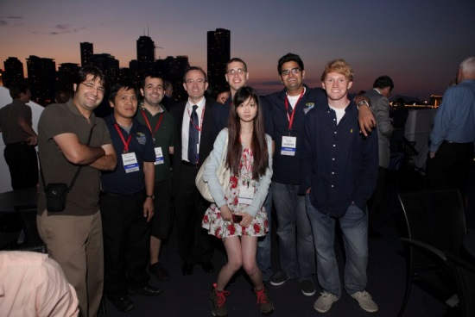  Figure 96. From left to right: Mohammadreza F. Imani, Chau Nguyen, Gurkan Gok, Prof. Danilo Erricolo, Carl Pfeiffer, Yi Lan, Amit Patel, and Brett Kuprel. | 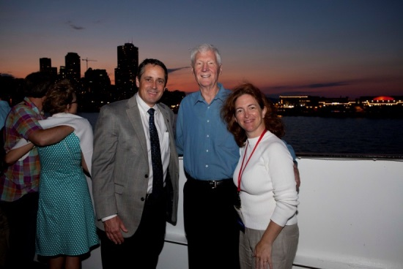  Figure 97. Dr. Dev Palmer (left), Prof. Bill Joines (center) and Prof. Jennifer T. Bernhard (right). | 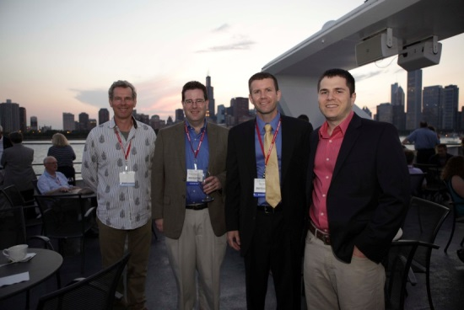  Figure 98. From left to right: Clifton Courtney, Dr. Robert Kipp, Matt Miller, Matthew Young.
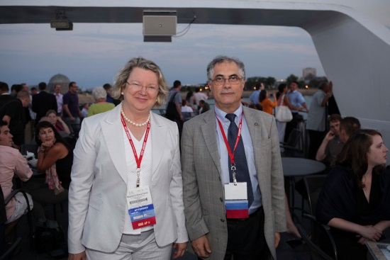  Figure 99. Prof. Magdalena Salazar Palma (left) and Prof. Silvio Ernesto Barbin (right). | 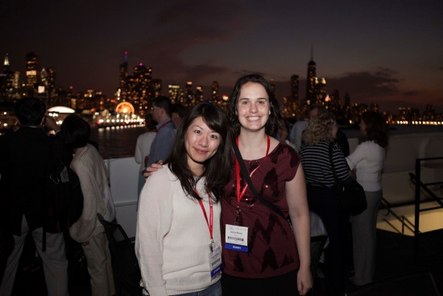  Figure 100. Takako Nishikata and Joanna Bovee. | 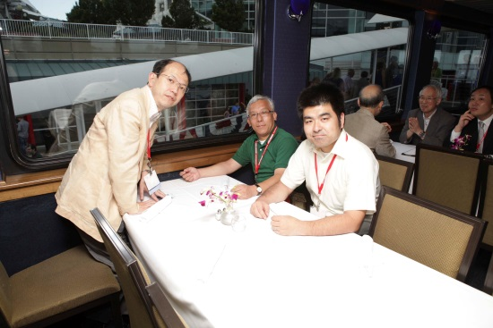  Figure 101. Prof. Jiro Hirokawa (left), Prof. Yoshihiko Konishi (center), and Dr.Satoshi Yamaguchi (right).
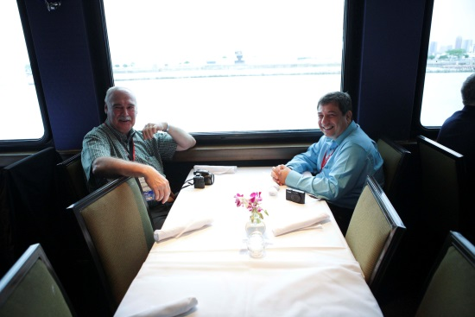  Figure 102.Prof. Juan R. Mosig (left) and Prof. George V. Eleftheriades (right). | 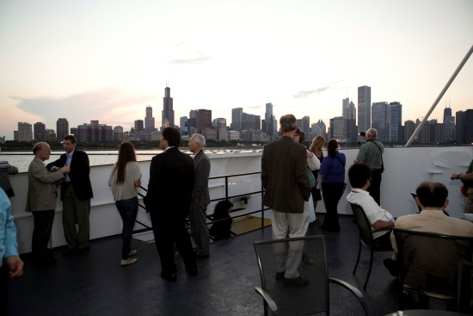  Figure 103 | 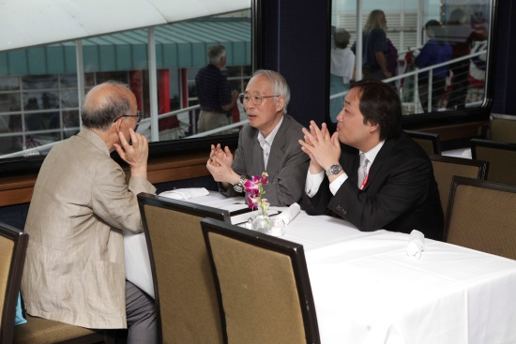  Figure 104. Prof. Kiyohiko Itoh (center) and Dr. Takashi Hikage (right).

Student and Graduate of the Last Decade (GOLD) Reception/Luncheon

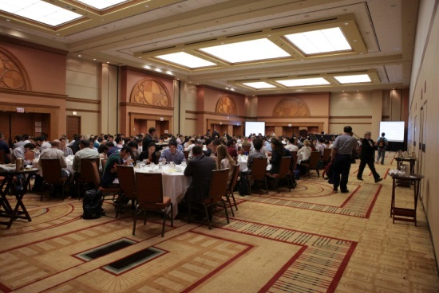  Figure 105 | 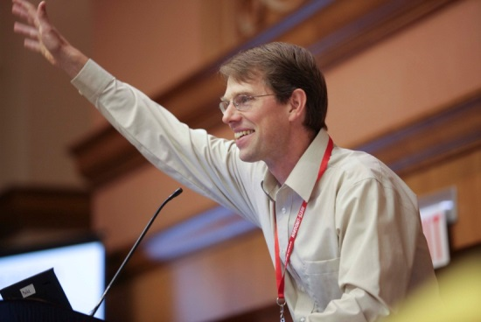  Figure 106. Prof. Karl Warnick, IEEE AP-S Education Committee Co-Chair. | 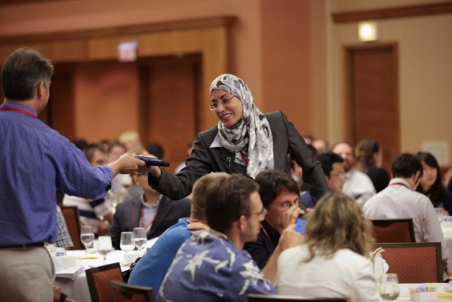  Figure 107
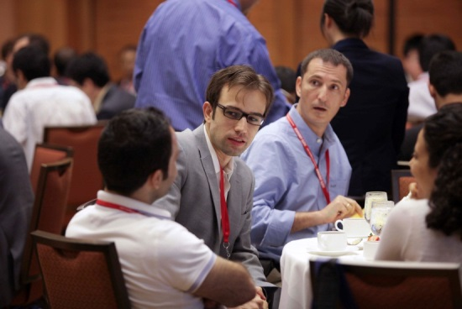  Figure 108 | 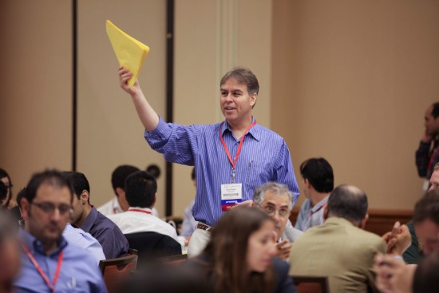  Figure 109. Prof. David Kelley, IEEE AP-S Education Committee Chair. | 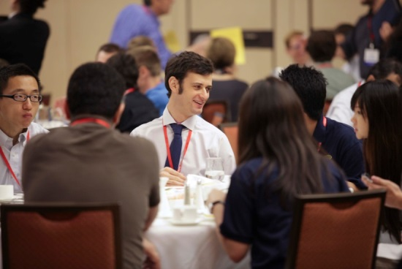  Figure 110
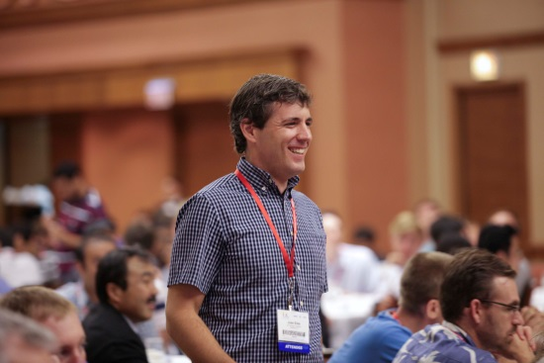  Figure 111. Jose Siles. | 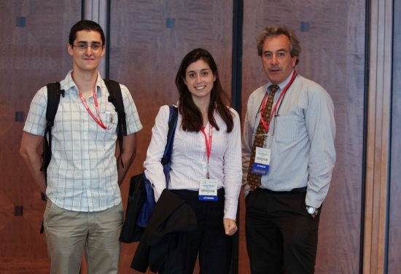  Figure 112. Borja Gonzales Valdes (left), Kathryn Williams (center), and Prof. Carey M. Rappaport (right). | 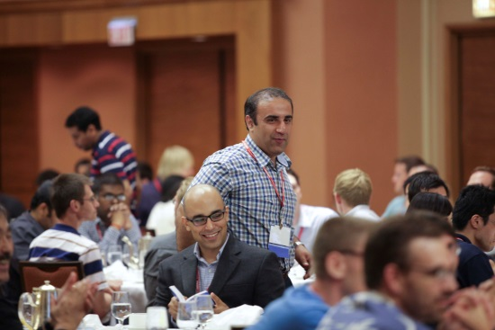  Figure 113. Dr Siamak Ebadi (seated at center).
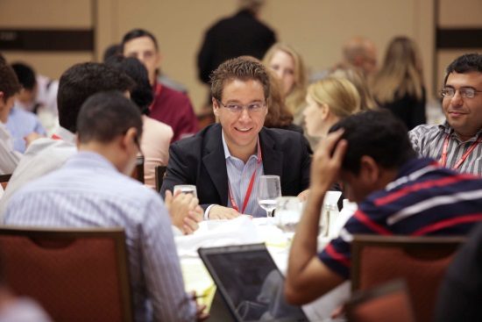  Figure 114. Prof. Anthony Grbic (center). | 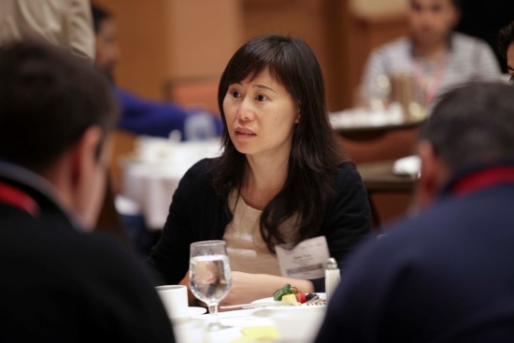  Figure 115 | 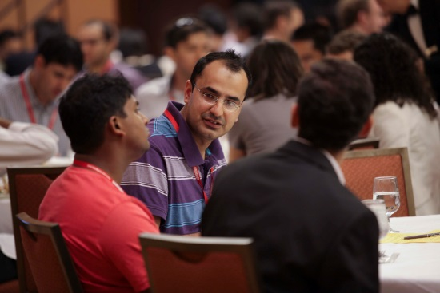  Figure 116

Women In Engineering Reception
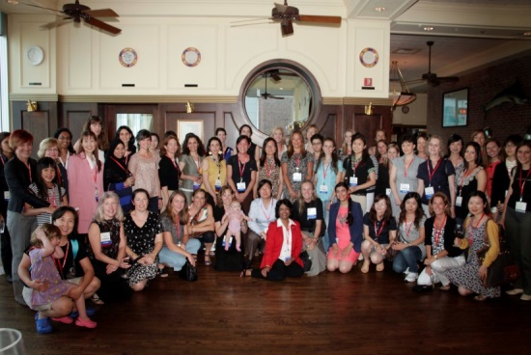  Figure 117 | 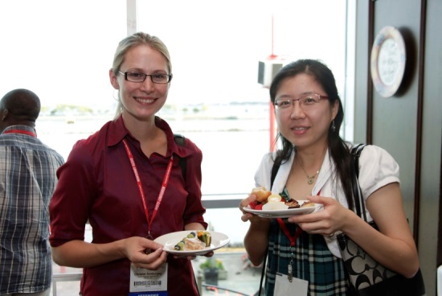  Figure 118. Christel Amburgey (left). | 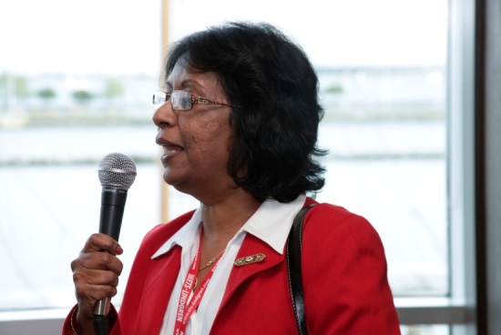  Figure 119. Prof. Parveen Wahid, IEEE AP-S Women in Engineering Chair.
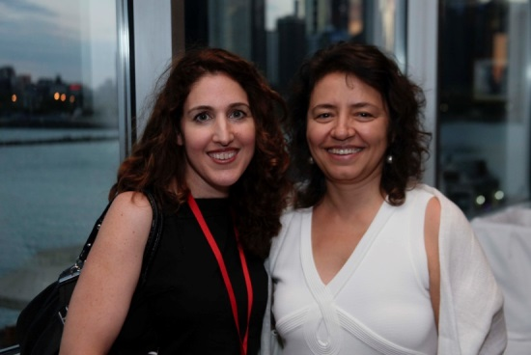  Figure 120. Prof. Alkim Akyurtlu (left) and Prof. Ozlem Aydin Civi (right). | 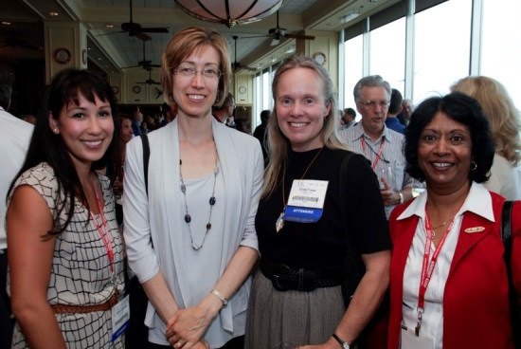  Figure 121. From left to right: Tiffany Iskander, Susan Hagness,2012 IEEE AP-S TPC Chair, Cynthia Furse, and Parveen Wahid. | 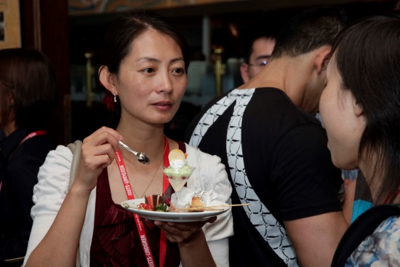  Figure 122
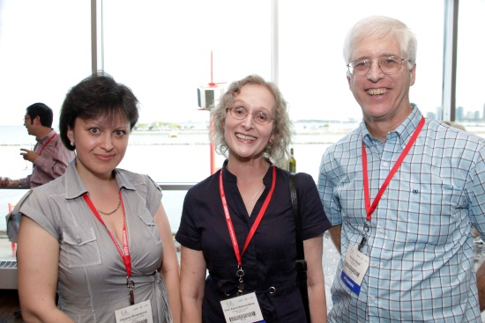  Figure 123. Dr. Oksana Shramkova (left), Prof. Elena Semouchkina (center) and Dr. Randy Haupt (right). | 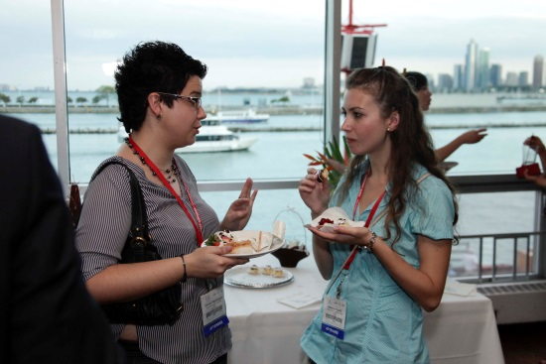  Figure 124. Dimitra Psychogiou (left) and Asimina Kiourti (right). | 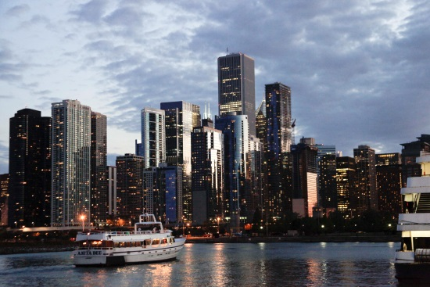  Figure 125. View of Chicago from Riva's restaurant.
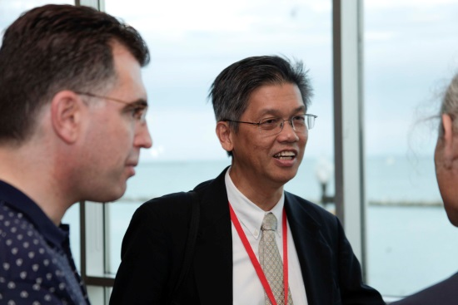  Figure 126. Prof. Levent Gurel (left) and Prof. Weng Cho Chew (right). | 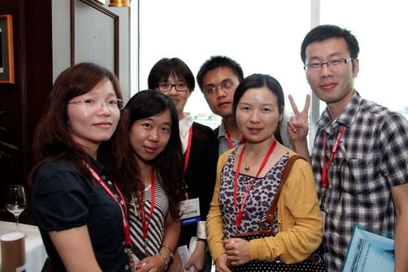  Figure 127 | Figure 128
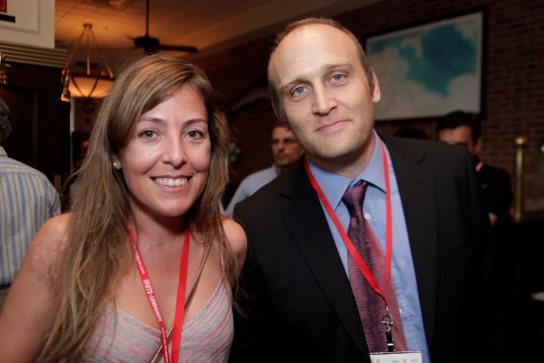  Figure 129. Prof. Eva Rajo-Iglesias (left), 2012 IEEE AP-S Short-Courses and Workshops Chair, and Prof. Matteo Albani (right). | 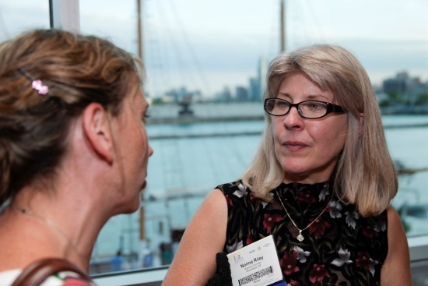  Figure 130. Dr. Marta Martinez-Vazquez (left) and Dr. Norma Riley (right). | 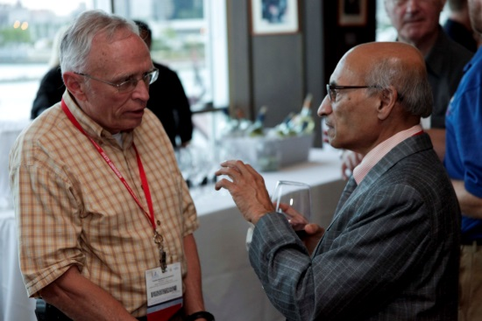  Figure 131. Dr. Mike Shields (left) and Prof. Prabhakar H. Pathak (right).

AP-S Reviewers’ Luncheon
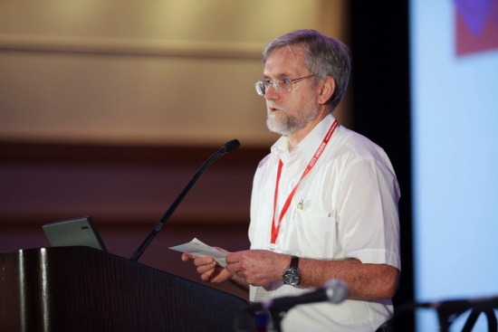  Figure 132. Dr. Trevor Bird, 2012 IEEE AP-S President Elect. | 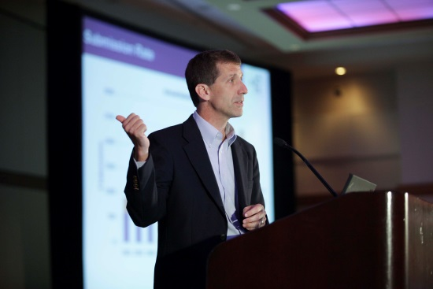  Figure 133. Prof. Michael A. Jensen, Editor in Chief of the IEEE Transactions on Antennas and Propagation. | 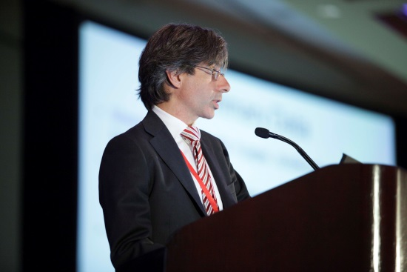  Figure 134. Prof. Gianluca Lazzi, Editor in Chief of the IEEE Antennas and Wireless Propagation Letters.
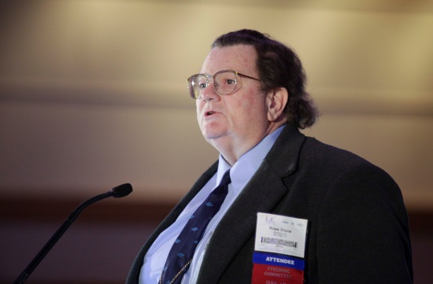  Figure 135. Dr. W. Ross Stone, Editor in Chief of the IEEE Antennas and Propagatio Magazine and 2012 IEEE AP-S/USNC-URSI International Liaison. | 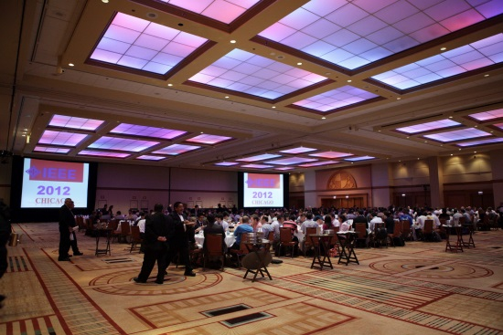  Figure 136 | 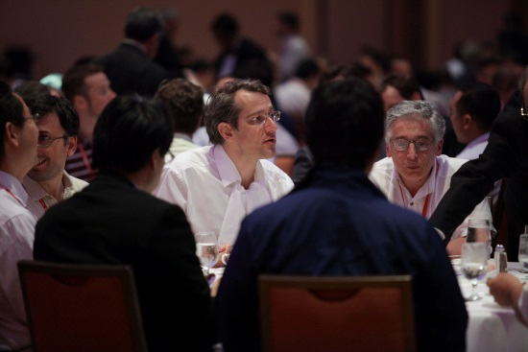  Figure 137

References
[1] Y. P. Zhang, M. Sun, D. Liu, and Y. Lu, “Dual Grid Array Antennas in a Thin-Profile Package for Flip-Chip Interconnection to Highly Integrated 60-GHz Radios,” IEEE Transactions on Antennas and Propagation, vol. 59, no. 4, pp. 1191-1199, April 2011.
[2] C. E. Patterson, T. K. Thrivikraman, A. M. Yepes, S. M. Begley, S. K. Bhattacharya, J. D. Cressler and J. Papapolymerou,“A Lightweight Organic X-Band Active Receiving Phased Array With Integrated SiGe Amplifiers and Phase Shifters,” IEEE Transactions on Antennas and Propagation, vol. 59, no. 1, January 2011.
[3] A. M. H. Wong and G. V. Eleftheriades, “Sub-Wavelength Focusing at the Multi-Wavelength Range Using Superoscillations: An Experimental Demonstration,” IEEE Transactions on Antennas and Propagation, vol. 59, no. 12, December 2011.
[4] N. Behdad, M. A. Al-Joumayly and M. Li, "Biologically Inspired Electrically Small Antenna Arrays With Enhanced Directional Sensitivity," IEEE Antennas and Wireless Propagation Letters, vol. 10, pp.36-364, 2011.
[5] A. Rashidian, D. M. Klymyshyn, M. T. Aligodarz, M. Boerner and J. Mohr, “Photoresist-Based Polymer Resonator Antennas: Lithography Fabrication, Strip-Fed Excitation, and Multimode Operation,” IEEE Antennas and Propagation Magazine, vol. 53, no. 4, pp.16-27, Aug. 2011

