**Simultaneous Magnetic Resonance and Optical Elastography Acquisitions: Comparison of Displacement Images and Shear Modulus Estimations using a Single Vibration Source**

Spencer Brinker1, Steven P. Kearney1, Thomas J. Royston1, 2, and Dieter Klatt1, 2

1Department of Mechanical & Industrial Engineering, University of Illinois at Chicago, Chicago, IL, USA

2Richard and Loan Hill Department of Bioengineering, University of Illinois at Chicago, Chicago, IL, USA

**Abstract**

The mechanical properties of tissue are sensitive to pathological changes, which is the basis for using dynamic elastography as a diagnostic tool. The purpose of this study is a concurrent cross-modality comparison of two dynamic elastography methods, Magnetic Resonance Elastography (MRE) and Scanning Laser Doppler Vibrometry (SLDV) using a single vibration source method. Cylindrical soft tissue mimicking specimens of Plastisol and Ecoflex are stimulated with 60, 100, 150, and 250 Hz sinusoidal vibration during imaging. Specimen stiffness was also varied by adjusting the softener amount in each material. Displacement fields acquired using the two methods show similarity in wave front geometry at all frequencies. Magnetic Resonance Elastography (MRE) with 3D inversion and Optical Elastography (OE) with averaged 1D curve fitting were used to derive complex shear moduli from each imaging modality. MRE and OE shear storage modulus (n = 3) results were closest at 150 Hz with Plastisol G’ (MRE) = 9.03 ± 0.43 kPa and G’ (OE) = 8.46 ± 0.14 kPa while Ecoflex was G’ (MRE) = 15.71 ± 0.95 kPa and G’ (OE) = 13.71 ± 0.03 kPa. Correlation between MRE and OE complex shear moduli related by all 36 coupled scans performed during this study yield a Pearson's correlation of ρ = 0.88 with p < 0.001 for G’ (storage modulus) and ρ = 0.85 with p < 0.001 for G” (loss modulus). The simultaneous imaging approach yields stiffness values within the same range and acceptable error margins for MRE and OE.

Key words: displacement fields; wave propagation; scanning laser doppler vibrometry; magnetic resonance elastography; optical elastography

**1. Introduction**

Cross-modality comparisons of experimental platforms for nondestructively probing mechanical wave propagation in viscoelastic media is important to further the development and measurement quality of soft tissue elastography, especially as elastographic methods continue to become more accessible as clinical diagnostic tools. MRE has recently become a clinical tool to determine liver stiffness and shows promise in measuring brain stiffness changes related to the early detection of neurodegenerative diseases and tumor diagnosis1. OE using SLDV has recently demonstrated the ability to yield clinically relevant stiffness estimations relevant to several biomedical applications2. The primary aim of this study is to combine the scanning capabilities of SLDV and MRI to collect displacement measurements on the surface and inside, respectively, of a viscoelastic homogeneous media undergoing mono-frequency steady state mechanical excitation. Technical challenges were overcome to enable the two imaging modalities to 1) operate within the ultra-high magnetic field and spatially confined environment of an MRI scanner and 2) simultaneously acquire displacement data from the same vibrating specimen. The investigation provides valuable insight to further understand mechanical wave propagation used in biomedical elastography applications. Using a simultaneous imaging approach eliminates several compromising factors, which would otherwise be present when conducting the imaging modalities separately under different testing conditions. Factors such as ambient temperature, specimen transport and using different methods to produce the excitation vibration may influence the ability to keep specimen stiffness constant. We have already compared MRE in a cross-modality comparison with tensile testing, a static elastography approach that is not based on shear wave imaging. We chose a concurrent data acquisition approach and thus eliminated the compromising factors described above3. The presented study is a continuation of our work of validating MRE by simultaneous cross-modality comparisons, but here we compare MRE to a more closely related material testing method, SLDV, that also belongs to the category of dynamic elastography.

Several studies have investigated OE using SLDV to acquire surface displacements for determining human tissue stiffness of skeletal muscle, skin, eye (cornea), facial muscle, and the lung parenchyma.2,4–8 A large number of MRE studies have also investigated tissue stiffness of organs such as brain, liver, lung, voluntary muscle, heart, breast, kidney, and spleen.9 In most MRE studies, inversion techniques are used to estimate shear modulus based on tissue internal displacement fields acquired using MRI phase data.10 To the best of the author’s knowledge, SLDV and MRI have not yet been performed concurrently in the same platform to collect displacements from the same specimen; however, SLDV has been used in MRE investigations to gauge the displacement amplitude of mechanical drivers. Rigid bar and passive drum drivers, being the most common MRE actuation designs, have been measured with SLDV for experimental design evaluation before use in MRI systems.11,12 In some studies laser position is reflected from a mirror attached to actuators to measure actuator displacements during experiments while synchronized with MRE data acquisition.13,14

The relationship between surface and internal displacement fields and the behavior of displacement fields within boundaries of neighboring media have been explored through computer simulation. Experimentally derived mechanical coefficients acquired from surface measurements have been used as boundary conditions to model surface displacement relationships to internal organ function. SLDV was used to measure displacement fields on human subjects’ backs while a rigid driver introduced steady state vibrations to the chest of the humans. The experimental surface displacement fields correlated well to the simulation fields derived from analytical solutions of sound transmission from human chest to back.15 Displacement fields within and on a spherical heterogeneity embedded within a cylindrically-shaped phantom subject to geometrically focused shear waves was analytically solved to better understand the boundary conditions of different oscillating geometries that mimic shear wave propagation through organs.16

Just like MRE, Ultrasound Elastography (UE) techniques are also capable of yielding mechanical properties by observing mechanical wave propagation inside biological tissue. Vibrations are transmitted into a ROI and then the resulting wave propagations are recorded with an ultrasound imaging probe. Strain imaging UE applies normal stresses to the tissue and then measures the normal strain for calculating Young’s modulus. Shear wave UE uses the induction of shear wave propagation into tissue where the shear wave speed is measured for deriving mechanical moduli. Vibrations can be transferred into the tissue ROI by acoustic radiation force impulses transmitted by an ultrasound imaging probe or by an external mechanical driver.17 While most ultrasound elastography methods use a 2D analysis, some studies acquire displacement fields over a 3D volume by moving the imaging probe with an automated motion machine18. Some 3D ultrasound elastography methods use a 2D multi-element array and 3D beam steering so the imaging probe can remain in a fixed position19. Past investigations have conducted cross-modality comparisons of ultrasound-based transient elastography compared to magnetic resonance elastography in soft tissue-mimicking gels and each modality yielded close stiffness values20,21.

One advantage of MRE and ultrasound elastography compared to SLDV is the ability to obtain mechanical properties of internal tissue, whereas SLDV can only image displacements at the tissue surface and calculate mechanical properties in limited depth. MRE is appealing to brain elastography since MRI can obtain volumetric imaging of the brain and the MR signal is not obstructed by the skull as is the case with the ultrasound signal. MRE is capable of obtaining full 3D displacement fields, where SLDV and UE are mostly limited to displacement fields relative to the direction of the imaging probe. A particular advantage of ultrasound elastography and OE is the cost of operation in clinical application. MRE requires MRI, which is high in operational costs.

Several material testing methods have been used for comparison to MRE-estimated shear modulus using synthetic viscoelastic materials and ex vivo tissue. Studies included compression tests, tensile testing, and rheometry. All the studies yield shear moduli values for both MRE and the validation methods22–24. Although shear modulus values derived from the material testing methods were in the same range as the ones determined using MRE, these methods do not analyze wave propagation as dynamic elastography does. The motivation and novelty of the presented work is a cross-comparison of two dynamic elastography techniques, MRE and OE, and the development of an experimental platform to measure MRE and OE displacement data simultaneously. This new approach incorporates two completely unrelated technical approaches to measure the state of vibration in soft tissue mimicking material, which offers a better comparison of mechanical property analysis of soft materials than prior elastography validation studies21,22,25. MRE encodes tissue vibrations into the phase of the MRE signal by synchronizing oscillating magnetic field gradients13 with the mechanical vibration, whereas SLDV measures frequency shifts of a laser beam reflected from a vibrating surface26.

**2. Methods**

**2.1. Specimens and actuation system**

Two synthetic materials are used as the specimens and are put through identical experiments. Ecoflex (00-01, SMOOTH-ON, INC., USA) and Plastisol (Soft Plastic, Alumilite Corporation, USA) can be imaged with 1H MRI and both have similar viscoelastic mechanical properties as human soft tissue.27,12 The benefits of the materials are that they are provided in liquid form from the manufacturer and can be poured into various mold containers before permanent solidification. Stiffness of the specimens can be adjusted depending on the amount of softener added to the initial mold liquid. While is liquid state, the specimen materials were poured and solidified into acrylic 14.0 cm and 5.7 cm outside diameter cylinders both with 0.3 cm wall thickness and 7.6 cm in length. All cylinders were left open on either side after curing occurred exposing the flat ends of all specimen surfaces (Fig. 1(A)). The exposed front ends of the specimen surfaces were coated with reflective microbeads to enhance laser reflection quality. The microbeads have a refractive index > 1.93 and size of 35 to 45 microns (Cole Safety Products, USA). The specimen cylinders are press fit onto an acrylic actuation disk during experiments, which is mounted to a piezoelectric stack (Model P-840.10, Physik Instrumente GmbH & Co, Germany) within the actuation system (see Fig 1.B). It was observed using SLDV that surface displacement attenuation of the vibration was very strong on the specimen front end in pre-testing of the actuation system. This was due to air being compressed in the changing airtight void between the disk and fluctuating specimen during vibration causing the specimen to be squeezed. To reduce wave attenuation, several holes were cut into the actuation disk to allow the air void to remain at atmospheric pressure during specimen vibration. A large cylinder specimen is seen connected to the actuation system in Fig. 1(B). Three small cylinder specimens where placed on an actuation disk at the same time during data acquisition. The entire actuation system was placed into a 15 cm diameter RF birdcage coil (RAPID Biomedical GmbH, Germany) within a 9.4 T MRI magnet (Model 310 mm Bore Actively Shielded Magnet System, Agilent Technologies, Research Products, USA) for all experiments. The specimen cylinders slide freely as the piezo oscillates. A thick walled rubber tube with an outside diameter of 0.8 cm was wrapped around the actuation system hub that is manually expanded to rigidly ground the hub to the magnet bore and can be loosened for specimen repositioning. The entire actuation system was machined out of plastic not including the piezoelectric.

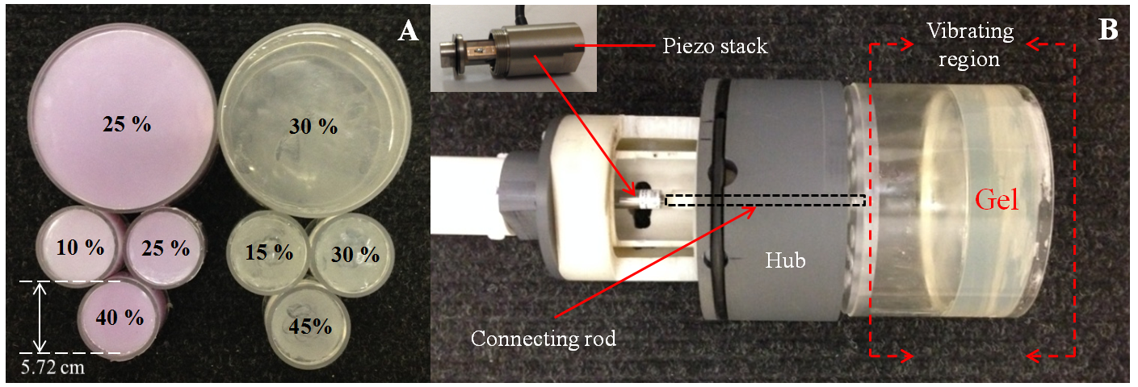

**Fig. 1** (A) Cylindrical specimens used in experiments (Ecoflex and Plastisol to the left and right, respectively). Numbers indicate softener concentration percentage. (B) Actuation system with piezoelectric stack connected to actuation disk pressed onto the large diameter Plastisol specimen.

**2.2. Experimental platform and data acquisition**

# Fig. 2 illustrates the specimen connected to the actuation system in the magnet center while SLDV (Model PSV-400 Scanning Vibrometry, Polytec GmbH, Germany) measures surface displacements and, simultaneously, MRE obtains internal displacements from the vibrating specimen. The SLDV system had to be positioned outside of the magnet room (SLDV system cannot operate inside fringe fields of the MRI magnet) where it was pointed towards a surface first mirror (0.485” thick glass sheet x 11" x 13" inches, Kaleidoscopes To You, USA) located in front of the magnet (Fig. 3(A)). The mirror was used to bend the SLDV optical view by reflecting the laser at a right angle down the magnet bore onto the specimen front surface (Fig. 3(B)).

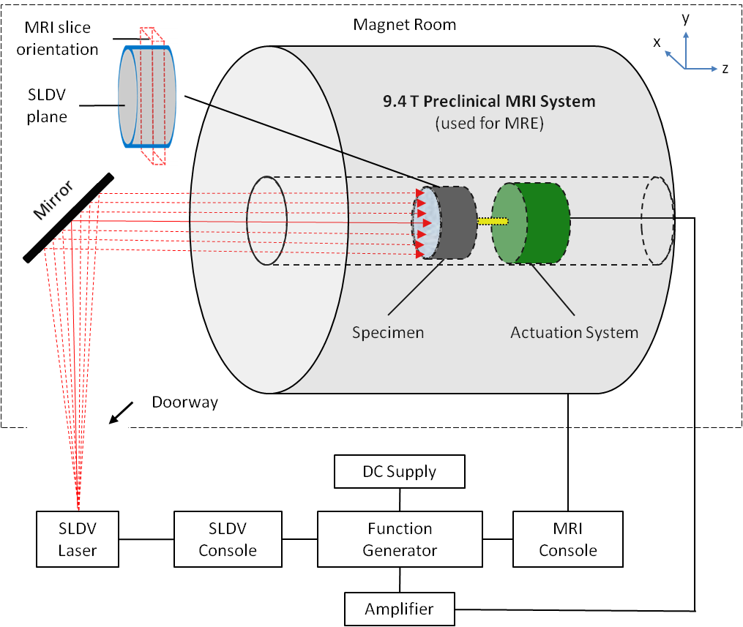

**Fig. 2**: Schematic representing the experimental platform used for simultaneous acquisition of SLDV and MRI of a large diameter cylindrical specimen. The positioning of the SLDV acquisition plane and MRI slice orientation over the specimen are shown in the top-left corner of the figure.

The scanning protocol was applied to Plastisol and Ecoflex. The piezoelectric was controlled and powered by a function generator connected in series with a variable audio amplifier and DC power supply. An output trigger was linked from the MRI console to the function generator and an output reference was connected from the function generator to the SLDV console. These communications were necessary to synchronize the mono-frequency and steady state mechanical excitation cycling of the piezoelectric with the MRI and SLDV data acquisitions. Mechanical excitation occurs as the external vibration source is activated with enough fore-run time so the specimen reaches a steady-state and harmonic vibration before MRE and SLDV data are acquired. The SLDV system acquired surface displacements perpendicular to the radial dimension of the specimens established by 8 lines of 79 spatial data points in a polar array distributed evenly over the specimen front surface (Fig. 3(C)) with 3 averages per point. Care was exercised that all spatial data points were acquired relative to zero phase of the function generator signal. The large specimens were scanned separately whereas the small specimens of the same material were all three attached to the actuation disk and scanned at the same time.

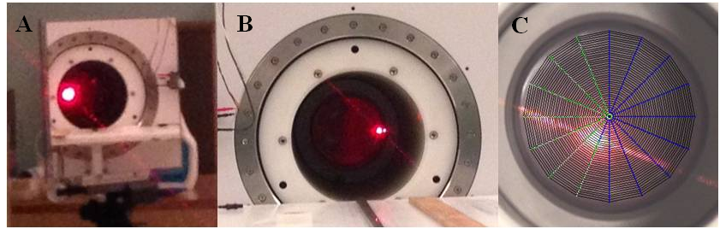

**Fig. 3**: (A) First-surface mirror used in experiments. (B) Large cylinder specimen in center of magnet with laser reflections on its surface. (C) Polar grid of SLDV data points seen through SLDV user interface overlaid onto specimen front surface.

A rapid SLIM MRE28 pulse sequence was used to acquire z, x, y direction internal displacements (z-direction is perpendicular to the axial image plane). The scan parameters are TR = 1,615 ms, TE = 72.67 ms, matrix = 96 x 96 (large specimens) or 128 x 128 (small specimens), field of view = 16 x 16 cm, slices = 8, thickness = 0.4 cm, slice plane = axial, number of motion encoding gradients = 2 (large specimen) or 4 (small specimen), gradient strength = 8 G/cm, phase offsets = 8. The piezo was powered with approximately 100 volts peak-to-peak and continuously oscillated at the excitation frequency throughout the entire scan, while the phase offset was controlled by the MRE pulse sequence. The large specimens were scanned at 60, 100, 150 Hz excitation frequency and the small specimens at 250 Hz with the motion encoding gradient frequency being matched to the mechanical excitation frequency. Each scan was repeated 3 times for averaging. Immediately after the onset of the MRI data acquisition, the SLDV data acquisition was manually started. The MRI scan time was approximately 40 minutes with the total SLDV acquisition time taking approximately 1/3 the MRI scan. A total of 36 coupled MRI-SLDV scans were conducted in the study with variations in excitation frequency, specimen stiffness, and material type.

**2.3. Magnetic resonance elastography inversion**

The top of Fig. 4 shows a visual of the processing steps for how the MRI based displacement fields in each direction are used to calculate the stiffness map in Fig. 4(D). All MRE moduli are calculated from inversion methods that are based on the equation of motion assuming a linear elastic, locally homogeneous material,

$$ρ\frac{∂^{2}}{∂t^{2}}u=\left(λ+μ\right)∇\left(∇∙u\right)+μ∆u. (1)$$

In equation (1) ***u*** is the 3D displacement vector of the propagating wave, $∇$ is the divergence operator, Δ is the Laplace operator and takes the form of (2), *λ* is the first Lame parameter, and ** corresponds to the second Lame parameter.

$$∆f=\frac{∂^{2}f}{{∂x}^{2}}+\frac{∂^{2}f}{{∂y}^{2}}+\frac{∂^{2}f}{{∂z}^{2}}. (2)$$

We note that the elastic moduli are functions of space, while the displacement vector is a function of space and time. The second Lame parameters ** is also referred to as the shear modulus. Young’s modulus, *E,* can be derived from *λ* and ** by (3).

Next the correspondence principle is applied to obtain the equation of motion of a linear viscoelastic solid in the frequency domain.29 First equation (1) is converted into frequency domain using the Fourier Transform

$$F\left(ω\right)=\int_{-∞}^{∞}{f(t)e^{-iωt}}dt \left\{\frac{df\left(t\right)}{dt} \left[iωF\left(ω\right)\right] and \frac{d^{2}f\left(t\right)}{{dt}^{2}} \left[-ω^{2}F\left(ω\right)\right]\right\}. (4)$$

Subsequently the elastic moduli ** and ** are replaced with the corresponding complex moduli *L*(**) and *G*(**) resulting in,

$-ρω^{2}U\left(ω\right)=\left(L\left(ω\right)+G\left(ω\right)\right)∇\left(∇∙U\left(ω\right)\right)+G\left(ω\right)∆U\left(ω\right). (5)$

The angular frequency of the wave motion and the complex displacement vector correspond to ** and ***U***,respectively. The complex moduli have real and imaginary parts corresponding to storage moduli and loss (damping) moduli, respectively that relate to the materials ability to store deformation energy and to absorb deformation energy during wave propagation.

Applying the curl to both sides of (5) mathematically filters *L* since the curl of a gradient is zero.30

resulting in,

$$-ρω^{2}Q\left(ω\right)=G\left(ω\right)∆Q\left(ω\right). (7)$$

Using the least squares solution yields *G* in each voxel, where *T* is the vector transpose.

$$G=-ρω^{2}{\left[{\left(∆Q\right)}^{T}∆Q\right]}^{-1}{(∆Q)}^{T}Q. (8)$$

Regions of Interest (ROI) were masked for each slice around the cylindrical perimeter of each specimen. At each phase offset, phase-difference images were calculated to filter contributions of static field inhomogeneities. The complex wave images were taken from the 1st(z), 2nd(x) and 3rd(z) harmonic after Fourier transformation of the temporally-resolved phase images acquired using multi-directional SLIM and plugged into (8) to calculate the complex shear modulus, *G*. Prior to 3D inversions, the complex wave images were filtered using a spatial Butterworth band pass filter with a lower limit of 6 pixels and upper limit using half of the matrix size and subsequently equation (6) was applied. *G* was spatially averaged over the two central slices in order to prevent edge effects while excluding outliers with |*G*| > 200 kPa.

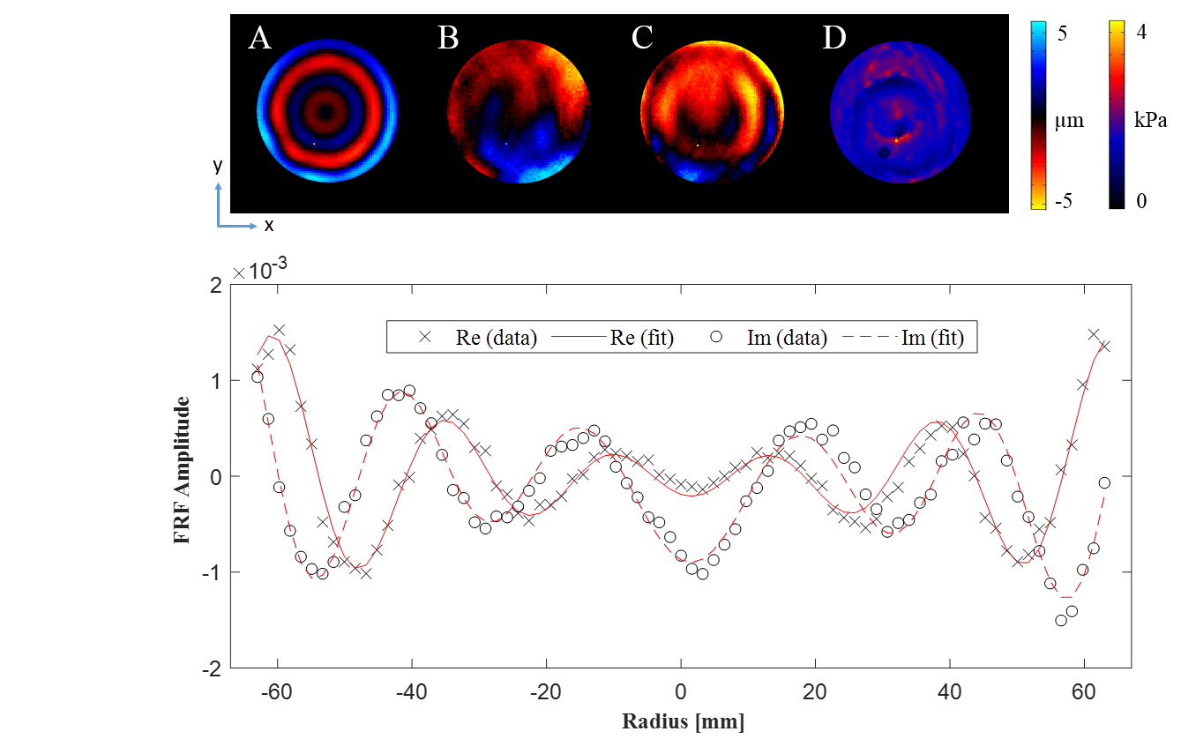

**Fig. 4** Top: MRE 3D Helmholtz inversion post processing example using a 3D displacement field to yield complex shear modulus. (A) z-axis displacement perpendicular to image plane. (B) x-axis displacement. (C) y-axis displacement. (D) Stiffness map (elastogram) representing spatial values of G’. The rad unit color bar is for (A), (B), and (C) while the kPa unit color bar is for (D). Bottom: OE curve fitting example of the SLDV post processing. The real and imaginary parts are from the Ecoflex big specimen SLDV horizontal line at 150 Hz and are used to yield OE complex shear modulus. FRF is the frequency response representation of the surface displacement acquired by the SLDV system.

**2.4 Optical Elastography Inversion**

The bottom of Fig. 4 shows a graphical representation of the displacements acquired at the surface in the form of a Frequency Response Function (FRF). Adapting Meral et al. (2011)31, in a cylindrical homogeneous, isotropic viscoelastic specimen of radius “a” and half thickness “b”, with free boundary conditions on the top and bottom flat surfaces at z = +/- b, that is axisymmetrically driven in the axial “z” direction at its curved outer radial surface, r = a, with a harmonic displacement (nonhomogeneous boundary condition) of amplitude $u_{za}$, it holds for the outer surface displacement *uz*:

We have the following steady state solution for the antisymmetric wave case depicting Rayleigh-Lamb wave behavior throughout the phantom:

$$u_{z}\left(r,z,t\right)=-A\frac{\overline{α}}{{\overline{α}}^{2}-{\overline{β}}^{2}}\left\{cosh\left(\overline{α}z\right)-\frac{{2k}_{RL}^{2}}{k_{RL}^{2}+{\overline{β}}^{2}}\frac{cosh\left(\overline{α}b\right)}{cosh\left(\overline{β}b\right)}cosh\left(\overline{β}z\right)\right\}J_{0}\left(k_{RL}r\right)e^{jωt}. (10)$$

Here, r is the radial distance from center and z is the axial distance from the center of the disk, A is an unknown constant to be determined based on boundary conditions, and *J0* denotes a zeroth order Bessel function of the first kind. Also, we define:

${\overline{α}}^{2}=k_{RL}^{2}-k_{p}^{2}$, ${\overline{β}}^{2}=k_{RL}^{2}-k_{sh}^{2}$, $k_{p}=ω/{\sqrt{{\left(L+2G\right)}/ρ}}$, and $k_{sh}=ω/{\sqrt{G/ρ}}. (11-14)$

Here, $k_{p}$, $k_{sh}$, and $k_{RL}$ are the compression, shear and Rayleigh-Lamb wavenumbers. Possible solutions for $k_{RL}$ are obtained from satisfying the following equation:

$$\frac{tanh\left(\overline{β}b\right)}{tanh\left(\overline{α}b\right)}=\frac{k_{sh}^{4}}{4k_{RL}^{2}\overline{α}\overline{β}}. (15)$$

Applying the nonhomogeneous boundary condition, equation (9), we obtain the following:

$$u_{za}=-A\frac{\overline{α}}{{\overline{α}}^{2}-{\overline{β}}^{2}}\left\{cosh\left(\overline{α}z\right)-\frac{{2k}_{RL}^{2}}{k_{RL}^{2}+{\overline{β}}^{2}}\frac{cosh\left(\overline{α}b\right)}{cosh\left(\overline{β}b\right)}cosh\left(\overline{β}z\right)\right\}J_{0}\left(k_{RL}a\right), (16)$$

which can be solved for *A*. We expect only the lowest order solution from equation (15) to be mechanically driven given the boundary condition. We expect that $k_{RL}$ will be close in value to, but slightly larger than $k_{sh}$, associated with a slightly slower wave propagation speed and shorter wavelength.

On the free flat surfaces, normal motion is governed by equation (10), evaluated at z = b, and is given by:

$$u_{z}\left(r,z=b,t\right)=A\frac{\overline{α}cosh\left(\overline{α}b\right)}{k_{sh}^{2}-k_{p}^{2}}\left\{\frac{k_{sh}^{2}}{{2k}_{RL}^{2}-k_{sh}^{2}}\right\}J_{0}\left(k_{RL}r\right)e^{jωt}=u_{za}\frac{J_{0}\left(k_{RL}r\right)}{J_{0}\left(k_{RL}a\right)}e^{jωt}. (17)$$

Note, in this equation the only “r” dependence is within $J_{0}\left(k_{RL}r\right)$.

1D surface displacement line profiles from the cylindrical specimen front surfaces were collected. Each of the 8 lines from the polar array was individually curve fit to the objective function, *FRFobj* (18), using MATLAB’s nonlinear curve fitting algorithm. The objective function includes variables of *r* = radial position along the specimen front surface, *a* = the specimen front surface radius, *X1* = amplitude correction, *X2* = phase correction, *X3* = center offset correction, *X4* = compression wave correction, *X5* = gravity correction, *X6* = surface wrap correction, *kRL* = Rayleigh-Lamb wave number, = density, *ω* = angular velocity, $G$ = complex shear modulus, and*ν* = Poisson’s ratio. The ‘Levenberg-Marquardt’ algorithm was used to minimize the error function in (19) (see equation 8 and equation 9 in 5 for further details on (18) and (19)).5 After *kRL* is estimated from curve fitting, the Rayleigh-Lamb wave number can then be related to the shear wave number as described in equation (15). (For the parameter values used in this study the ratio ${k_{sh}}/{k_{RL}}$ was 0.955, 0.965, 0.970 and 0.974 for 60, 100, 150 and 250 Hz, respectively.) Equations (14) can then be used to relate the shear wavenumber to *G* where the mean value is calculated from all 8 lines of the SLDV polar grid.

${FRF}_{obj}=X_{1}e^{jX_{2}}\frac{J_{0}(k_{RL}\left(r-X_{3}\right))}{J_{0}(k_{RL}a)}+X_{4}+X_{5}{r+X}_{6}r^{2}$. (18)

$Error=min\sum_{i=1}^{n}{{{(FRF}_{obj}\left(X,{xdata}_{i}\right)-{ydata}_{i})}^{2}}. (19)$

**3. Results**

**3.1. Comparison of displacement fields**

The out-of-plane displacement fields for MRE and corresponding SLDV measurements of the large Ecoflex specimen undergoing 60, 100, 150 Hz mechanical excitation and the small Ecoflex specimens of different stiffness at 250 Hz are shown in Fig. 5 and Fig. 6, respectively. Snapshots of wave images are illustrated with matched phase of MRE and SLDV. The images presented are from the first trials of each frequency data set where MRE and SLDV are acquired over Cartesian and polar coordinates, respectively.

.

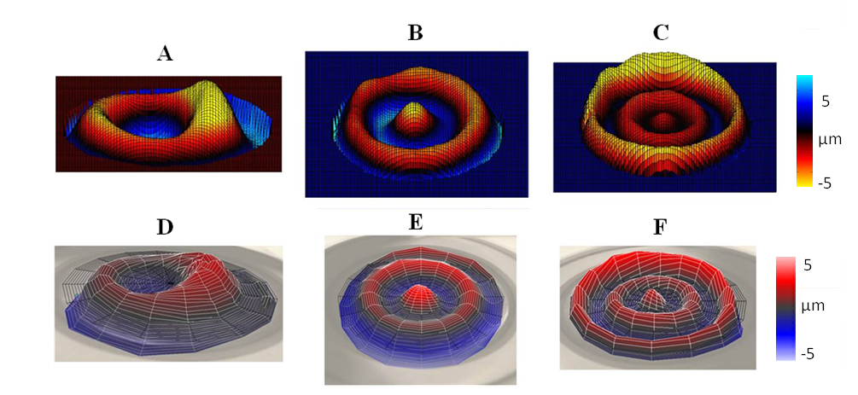



**G**

**H**

**I**

**Fig. 5** Comparison between surface and internal displacement fields for the large Ecoflex specimen with increasing frequency acquired by SLDV and MRE, respectively (perpendicular to specimen axial plane). Data was collected simultaneously with both imaging modalities for each individual excitation frequency. (A) 60, (B) 100, (C) 150 Hz MRE. MRE wave motion images are from the axial slice of 4 mm thickness closest to specimen front surface. (D) 60, (E) 100, (F) 150 Hz SLDV. SLDV wave images are acquired from the specimen front surface. (G) 60 Hz, (H) 100 Hz, (I) 150 Hz of a 1D displacement profile using a horizontal line across the entire specimen diameter passing though its center. Images in top two rows are illustrated as isosurface plots.

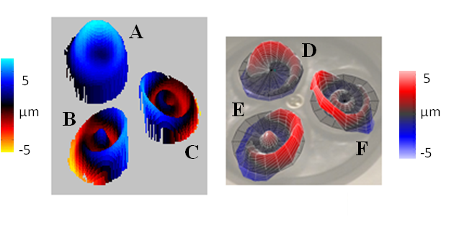

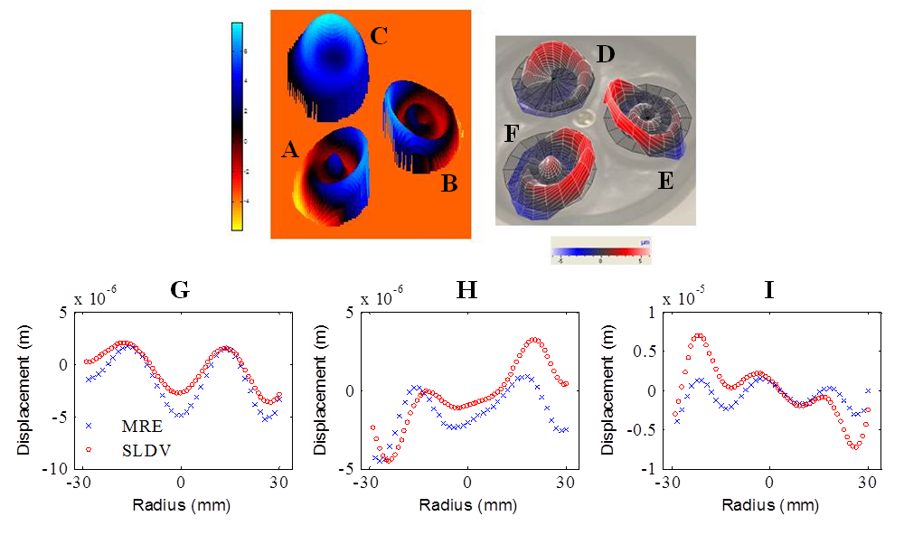

**Fig. 6** Comparison between surface and internal displacement fields for the small Ecoflex specimens with increasing specimen stiffness at 250 Hz acquired by SLDV and MRE, respectively (perpendicular to axial plane). (A) 10, (B) 25, (C) 40 % softener concentration from MRE. (D) 10, (E) 25, (F) 40 % softener concentration from SLDV. (G) 10, (H) 25, and (I) 40 % softener concentration of a 1D displacement profile using a horizontal line across each specimen diameter passing through its center. Images across the top of the figure are illustrated as isosurface plots

**3.2. Comparison of mechanical properties**

MRE and OE derived complex shear moduli (3 samples per data point) of Plastisol and Ecoflex are shown in Fig. 7 for 60, 100, 150, 250 Hz and for different specimen stiffnesses. Numerical values of Fig. 7 are listed in Table 1. Storage and loss shear moduli increase with frequency using MRE and OE. The storage and loss modulus for each MRE and OE set related by synchronized order of acquisition is plotted in Fig. 8. The comparison of all scans between the two modalities yield a Pearson's correlation of ρ = 0.88 with p < 0.001 for storage modulus and ρ = 0.85 with p < 0.001 for G” loss modulus.

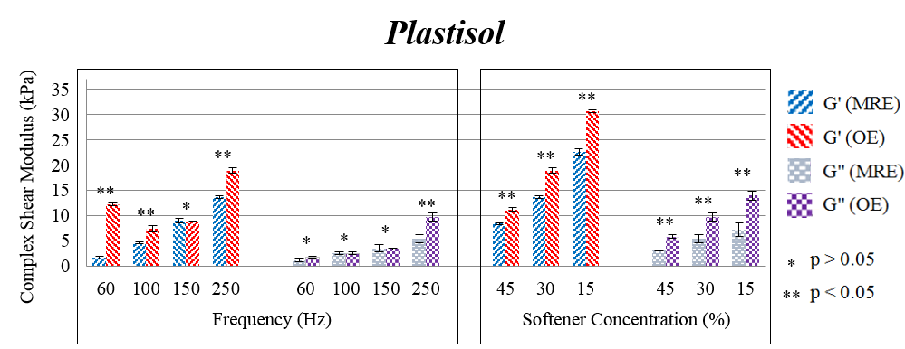

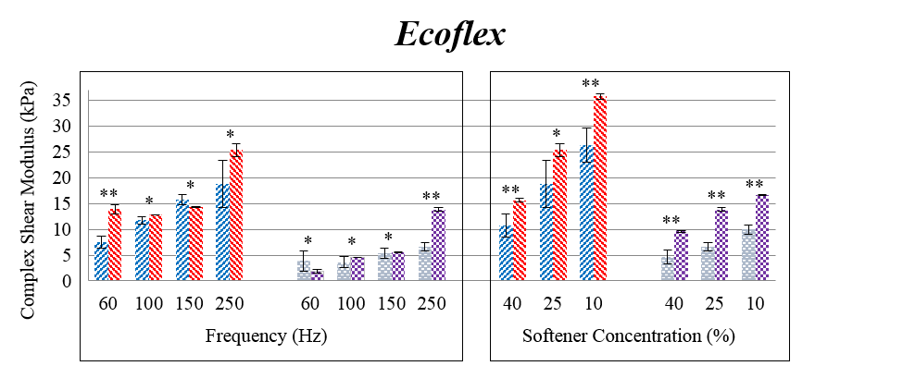

**Fig. 7** MRE and OE values for complex shear modulus for increasing frequency and specimen stiffness with Plastisol and Ecoflex. The p value represents a student t-test between MRE and OE moduli for each varying frequency and stiffness scenario with p > 0.05 meaning the differences in the comparison are not significant. Error bars represent standard deviation with 3 samples per shear modulus data point. The big Ecoflex and Plastisol phantoms used 30 % and 25 % softener, respectively. Every small specimen scan used 250 Hz excitation frequency. The small Ecoflex (30 %) and Plastisol (25 %) specimens from the softener variation sections were included in the frequency variation sections since each were made from the same gel batches as the large specimen.

|  |  |  |  |  |  |
| --- | --- | --- | --- | --- | --- |
| **Table 1** Complex shear modulus comparison between MRE and OE with variations in excitation frequency, stiffness, and material type. The error is given as the standard deviation over 3 averages of the moduli. | | | | | |
|  |  | **G' (kPa)** | | **G'' (kPa)** | |
| **Type** | **Frequency (Hz)** | **MRE** | **SLDV** | **MRE** | **SLDV** |
| **Plastisol** (30 % softener) | 60 | 1.65 ± 0.25 | 11.81 ± 0.41 | 1.19 ± 0.42 | 1.68 ± 0.17 |
| 100 | 4.58 ± 0.12 | 7.07 ± 0.56 | 2.5 ± 0.26 | 2.43 ± 0.2 |
| 150 | 9.03 ± 0.43 | 8.46 ± 0.14 | 3.54 ± 0.77 | 3.24 ± 0.14 |
| 250 | 13.6 ± 0.25 | 18.17 ± 0.58 | 5.44 ± 0.85 | 9.35 ± 0.72 |
| **Ecoflex** (25 % softener) | 60 | 7.52 ± 1.1 | 13.32 ± 0.87 | 3.86 ± 2.02 | 1.84 ± 0.34 |
| 100 | 11.76 ± 0.72 | 12.3 ± 0.05 | 3.6 ± 1.08 | 4.33 ± 0.02 |
| 150 | 15.71 ± 0.95 | 13.71 ± 0.03 | 5.31 ± 1.02 | 5.33 ± 0.12 |
| 250 | 18.74 ± 4.55 | 24.31 ± 1.21 | 6.6 ± 0.8 | 13.24 ± 0.32 |
|  |  |  |  |  |  |
|  |  | **G' (kPa)** | | **G'' (kPa)** | |
| **Type** | **Softener (%)** | **MRE** | **SLDV** | **MRE** | **SLDV** |
| **Plastisol** (250 Hz) | 45 | 8.4 ± 0.18 | 10.73 ± 0.35 | 3.11 ± 0.11 | 5.61 ± 0.37 |
| 30 | 13.6 ± 0.25 | 18.17 ± 0.58 | 5.44 ± 0.85 | 9.35 ± 0.72 |
| 15 | 22.59 ± 0.67 | 29.43 ± 0.23 | 7.19 ± 1.38 | 13.99 ± 0.89 |
| **Ecoflex** (250 Hz) | 40 | 10.74 ± 2.28 | 14.97 ± 0.37 | 4.62 ± 1.37 | 9.2 ± 0.2 |
| 25 | 18.74 ± 4.55 | 24.31 ± 1.21 | 6.6 ± 0.8 | 13.24 ± 0.32 |
| 10 | 26.27 ± 3.31 | 34.26 ± 0.47 | 9.99 ± 0.88 | 15.88 ± 0.08 |



**Fig. 8** Correlation between MRE and OE complex shear moduli related by coupled scan. Data points include all 36 sets of scans obtained in the study for variations in vibration frequency, stiffness, and specimen material.

**3.2.1 Optical elastography inversion applied to MRI and SLDV displacement profiles**

Fig. 9 shows the 1D displacement profiles acquired by MRI and SLDV from the same scan (similar to that of Fig 6(I)) but the wave profiles are both processed using the ‘Levenberg-Marquardt’ curve-fitting algorithm, which was used for the OE post processing to yield shear stiffness. Data used in Fig. 9 is a 1D displacement profile using a horizontal line across the entire specimen diameter passing though its center from the first scan of the Ecoflex big specimen at 150 Hz The processing yields storage shear stiffness of *G’MRE* = 14.9 kPa and *G’SLDV* = 14.2 kPa.

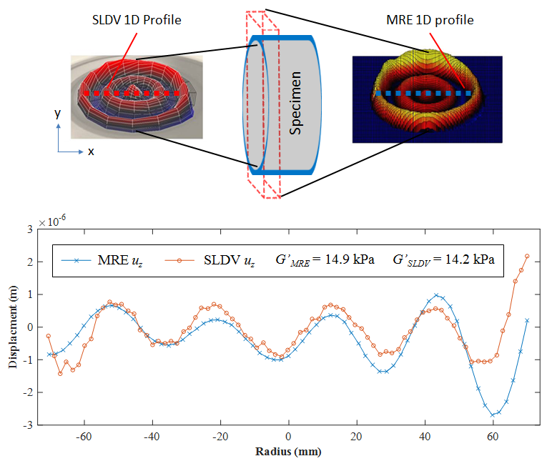

**Fig. 9** Top: Locations of the MRI and SLDV 1D displacement profiles in the specimen. Bottom: Direct comparison between 1D internal (MRI) vs. surface (SLDV) acquired displacement data from the first scan of the Ecoflex big specimen at 150 Hz. Both displacement measurements (MRE *uz* and SLDV *uz*) where processed using the 1D curve fitting algorithm introduced in Section 2.4 yielding *G’MRE* = 14.9 kPa and *G’SLDV* = 14.2 kPa. The data were collected simultaneously while the internal and surface displacements where created with the same vibration source.

**4. Discussion**

The distinct difference between the optical and MRI measurements is that the SLDV is recorded with changes in reflected laser frequency response due to oscillating surface velocity (Doppler Effect) and the MRI is obtained from the accumulation of MR signal phase within the 4 mm slice material media representing the oscillating internal displacement fields. When assessing the MRI and SLDV dynamic displacement fields in Fig. 5 and Fig. 6, shear wave motion in response to the mechanical excitation is visually perceptible using both methods.

The displacement field analysis is limited to a visual qualitative comparison in this study since there is some ambiguity in the data collection approach of SLDV in relation to the MRI regarding space and time. Spatially, the alignment of the coordinate systems were verified by line-of-sight through the overlay of the polar grid onto the front surface of the specimen through the SLDV camera field of view and from the specimen position within the MRI coordinate matrix. The visual positioning and angles of the mirror and SLDV laser scanning head may be partially responsible for the position offsets in Fig. 5 and Fig. 6 between MRE and SLDV in the displacement profiles. The center offset correction factor, *X3* in the SLDV curve-fitting algorithm partially compensates for positioning errors. Temporally, zero phase of the MRE data acquisition was not matched to that of the SLDV measurements. Although phase = zero for both MRE and SLDV were referenced to the starting phase of piezoelectric oscillations, the SLDV acquisition was manually initiated some unmeasured short time after the MRI data began recording. Therefore, the phase offset between the MRE and SLDV cycles were estimated by visualization in order to sync together the images between the two modalities in Fig. 5 and Fig. 6. An SLDV scan took approximately 1/3 the time of its corresponding MRI scan (≈ 40 minutes). Still, wave shapes using MRE clearly resemble the shapes of the SLDV wave images.

Analyzing the elastography comparison from Fig, 7 and Table 1 shows all OE storage moduli at 60 Hz are considerably higher than MRE moduli at 60 Hz, which can be explained by the observation that there were not enough wavelengths over the large specimen surface at 60 Hz. The ‘Levenberg-Marquardt’ curve-fitting algorithm used to estimate wavenumbers for calculating OE complex shear moduli appears to become inaccurate when there is a small number of wavelengths present in the 1D profile being assessed. The predetermined stiffness during construction of the large specimens were chosen to reflect storage shear modulus values of human soft tissue measured with MRE, where typical human MRE excitation frequencies used are between 60 to 150 Hz.6 MRE storage shear modulus for the large specimens were 1.65 ± 0.25 kPa for Plastisol (30 % softener) and 7.52 ± 1.10 kPa for Ecoflex (25 % softener) at 60 Hz and are within range of human soft tissue stiffness.

MRE and OE storage and loss modulus also increased with decreases in specimen softener concentration seen in the smaller diameter specimens, where the material stiffness was controlled (Fig. 7). The softener concentration was chosen so that it linearly decreased the stiffness over the 3 small specimens of each material type. This way multiple regions of different stiffness could be assessed in the same scan. Several MRE studies have investigated specimen stiffness variation embedded in a surrounding soft material media where vibrations were introduced to the exterior of the embedded material while shear wave propagation continued through to the varied stiffness ROIs.32 Here, each varied stiffness region was placed in its own individual rigid cylinder for excitation by geometric focusing. Although it is important to study MRE derived stiffness of inhomogeneous and anisotropic media, the presented setup was designed in order to study the wave propagations of each individual specimen in their own rigid container. This guaranteed no wave propagation interference from neighboring areas of different stiffness vs. if all the stiffness varied specimens had been embedded in the same background gel media within one rigid container. The data acquisition scan time was also significantly reduced by scanning all 3 specimens in one scan.

In general, the results show all OE moduli tend to be greater than MRE moduli. MRE shear modulus is derived using inverse methods where three numerical derivatives need to be applied to experimental data. This tends to amplify the noise, which inversion algorithms interpret as shorter wavelengths. Short wavelengths are related to softer materials and lowering the average MRE shear modulus compared to OE. Also, since MRE inversion included x, y, and z direction displacements, whereas OE only involved the z direction of displacement, these factors could impact the differences in complex shear moduli between the two elastography methods, as well. Student’s t-test was performed for each comparison between MRE- and OE-derived moduli (Fig. 7). For all materials storage and shear moduli using both methods are not statistically different (p > 0.05) at the excitation frequency of 150 Hz. This is most likely because the frequency had an adequate number of wavelengths propagating through the 14.0 cm diameter specimens at 150 Hz.

The entire study included 36 coupled sets of simultaneous MRI and SLDV acquisitions corresponding to MRE and OE complex shear moduli, respectively. When comparing individual scans as in Fig 8., it becomes obvious that there is some variation between the MRE and OE when yielding complex shear modulus. However, we observed similar displacement fields using simultaneous data acquisition of MRI and SLDV. Fig. 9 was constructed to demonstrate what storage shear moduli are yielded when using the same reconstruction method for processing both MRI and SLDV displacement data acquired from the same material, location, and time while also emanating from the same excitation source. Using the ‘Levenberg-Marquardt’ curve-fitting algorithm for both MRI and SLDV yields *G’MRE* = 14.9 kPa and *G’SLDV* = 14.2 kPa, which is close in value. These results insinuate that inconsistencies in shear modulus between Elastography methods are not mainly because of the measurement techniques but are a consequence of the post processing methods chosen, as well. A potential solution to this problem is for post processing standards to be formed among the research and clinical elastography communities.

The simultaneous comparison of MRE and OE in this experimental platform exhibits advantages compared to other MRE validation studies. Oscillatory rheometry, dynamic shear testing, and compression, which have been used to validate MRE derived shear modulus, do not have the ability to visualize shear wave propagation.24,33,22 These studies derive moduli values from strain and force gauges, whereas elastography uses image based measurements of mechanical wavelength. More similar to MRE, UE being a dynamic method has been shown to yield similar shear modulus values when compared to MRE.21,34,35 Optical imaging elastography methods are also similar to MRE in that they typically excite vibrations with mechanical drivers at steady state and mono frequencies.2

Geometric focusing excitation was chosen in the experiments since the resulting surface and internal wave motion primarily oscillates axisymmetrically over the axial plane of the specimen. Embedding the material into cylinders and using geometric focusing eliminates the need to physically grip specimens, as is the case when using mechanical testing devices. Pre-stresses from gripping the specimens during mechanical testing influences yielding shear moduli as observed in other MRE validation studies were the validation method required loading interaction with strain and force gauges.23,36 To the best of the authors’ knowledge, the presented work represents the first elastography study that examines wave propagation from one excitation source with two separate imaging modalities at the same time.

**5. Conclusions**

This study validates the precision of using MRI and SLDV as imaging modalities to acquire vibration displacement fields in soft tissue mimicking media. The two independent measurements mutually authenticate one another since the wave images obtained from each method are inherently similar. Performing simultaneous measurements from one vibration source negated or minimized many factors, which may have influenced the quality of the comparison. These may have included specimen stiffness changes related to different ambient temperatures or the inconsistency of the specimen to remain the same stiffness over time. In this head to head comparison of MRE and OE, the complex shear moduli are statistically not different while examining variations in frequency, stiffness, and testing material over 36 coupled scans. When stiffness measurements were averaged over multiple scans there were statistically different cases during the lower excitation frequencies and controlled softener variations. However, the primary reason for inconsistencies between elastography methods seems to occur as a result of using different post processing techniques. Future studies should focus on a means to calibrate complex shear modulus to a normative value of a standard specimen material for use in all elastography methods. The platform developed would also be useful for studying the relationship between surface and internal displacement fields in inhomogeneous and anisotropic media.

**Declarations of Interest**

None

**Acknowledgments**

This study was supported by internal funding from the Motion-Encoding MRI Laboratory at the University of Illinois at Chicago.

**References**

1. Ehman RL, Glaser KJ, Manduca A. Review of MR elastography applications and recent developments. *J Magn Reson Imaging*. 2012;36(4):757-774. doi:10.1002/jmri.23597

2. Tabatabai H, Oliver DE, Rohrbaugh JW, Papadopoulos C. Novel applications of laser doppler vibration measurements to medical imaging. *Sens Imaging*. 2013;14(1-2):13-28.

3. Brinker S, Klatt D. Demonstration of concurrent tensile testing and magnetic resonance elastography. *J Mech Behav Biomed Mater*. 2016;63. doi:10.1016/j.jmbbm.2016.06.020

4. Salman M, Sabra KG. Surface wave measurements using a single continuously scanning laser Doppler vibrometer: application to elastography. *J Acoust Soc Am*. 2013;133(3):1245-1254.

5. Kearney SP, Khan A, Dai Z, Royston TJ. Dynamic viscoelastic models of human skin using optical elastography. *Phys Med Biol*. 2015;60:6975.

6. Altaf A. Khan, Dai Z, Cortina S, Chamon W, Thomas J. Royston. Localized elastography map of human cornea through surface vibrations. In: *Proceedings of the ASME 2013 International Mechanical Engineering Congress & Exposition*. ; 2013:1-4.

7. Peng Y, Dai Z, Mansy H a., Sandler RH, Balk R a., Royston TJ. Sound transmission in the chest under surface excitation: an experimental and computational study with diagnostic applications. *Med Biol Eng Comput*. 2014:695-706.

8. Zhang X, Osborn T, Zhou B, et al. Lung Ultrasound Surface Wave Elastography: A Pilot Clinical Study. *IEEE Trans Ultrason Ferroelectr Freq Control*. 2017;64(9):1298-1304.

9. Yogesh K Mariappan, Kevin J Glaser RLE. Magnetic resonance elastography: a review. *Clin Anat*. 2011;23(5):497-511.

10. Manduca A, Oliphant TE, Dresner MA, et al. Magnetic resonance elastography: Non-invasive mapping of tissue elasticity. *Med Image Anal*. 2001;5(4):237-254.

11. Arani A, Plewes D, Chopra R. Transurethral prostate magnetic resonance elastography: Prospective imaging requirements. *Magn Reson Med*. 2011;65(2):340-349.

12. Leclerc GE, Debernard L, Foucart F, et al. Characterization of a hyper-viscoelastic phantom mimicking biological soft tissue using an abdominal pneumatic driver with magnetic resonance elastography (MRE). *J Biomech*. 2012;45(6):952-957.

13. Muthupillai R, Lomas DJ, Rossman PJ, Greenleaf JF, Manduca A, Ehman RL. Magnetic Resonance Elastogrphy by Direct Visualization of Propagating Acoustic Strain Waves. *Science (80- )*. 1995;269:1854–7.

14. Uwe Hamhaber, Uwe Klose, Frieder Grieshaber JN. Evaluation of Quantitative MR-Elastography Measurements. *Proc Int Soc Magn Reson Imaging Med*. 2001;9:1639.

15. Royston TJ, Dai Z, Chaunsali R, Liu Y, Peng Y, Magin RL. Estimating material viscoelastic properties based on surface wave measurements: A comparison of techniques and modeling assumptions. *J Acoust Soc Am*. 2011;130(6):4126.

16. Schwartz BL, Liu Y, Royston TJ, Magin RL. Axisymmetric diffraction of a cylindrical transverse wave by a viscoelastic spherical inclusion. *J Sound Vib*. 2016;364:222-233.

17. Sigrist RMS, Liau J, Kaffas A El, Chammas MC, Willmann JK. Ultrasound Elastography : Review of Techniques and Clinical Applications. *Theranostics*. 2017;7(5):1303-1329.

18. Hendriks GAGM, Branislav H, Menssen J, Milkowski A, Hansen HHG, Korte CL de. Automated 3D ultrasound elastography of the breast : a phantom validation study. *Phys Med Biol*. 2016;61:2665-2679.

19. Treece GM, Lindop JE, Gee AH, Prager RW. *Freehand Ultrasound Elastography with a 3D Probe*.; 2007.

20. Oudry J, Chen J, Glaser KJ, Miette V, Sandrin L, Ehman RL. Cross-validation of magnetic resonance elastography and ultrasound-based transient elastography: A preliminary phantom study. *J Magn Reson Imaging*. 2009;30(5):1145-1150. doi:10.1002/jmri.21929

21. Oudry J, Vappou J, Choquet P, Willinger R, Sandrin L, Constantinesco A. Ultrasound-based transient elastography compared to magnetic resonance elastography in soft tissue-mimicking gels. *Phys Med Biol*. 2009;54:6979-6990.

22. Hamhaber U, Grieshaber FA, Nagel JH, Klose U. Comparison of Quantitative Shear Wave MR- Elastography With Mechanical Compression Tests. *Magn Reson Med*. 2003;49:71-77.

23. Brinker S, Klatt D. Demonstration of Concurrent Tensile Testing and Magnetic Resonance Elastography. *J Mech Behav Biomed Mater*. 2016;63:232-243.

24. Klatt D, Friedrich C, Korth Y, Vogt R. Viscoelastic properties of liver measured by oscillatory rheometry and multifrequency magnetic resonance elastography. *Biorheology*. 2010;47:133-141.

25. Yengul SS, Madore B, Barbone PE. Toward validation of shear wave elastography using vibration rheometry in soft gels. *J Acoust Soc Am*. 2016;139(4):2027.

26. Longo R, Vanlanduit S, Nila A, Guillaume P. *Emerging Technologies in Non-Destructive Testing V*. (Alkiviadis S. Paipetis, Theodore E. Matikas, Dimitrios G. Aggelis DVH, ed.). Taylor & Francis Group; 2011.

27. Pickup BA, Thomson SL. Flow-induced vibratory response of idealized versus magnetic resonance imaging- based synthetic vocal fold models. *J Acoust Soc Am*. 2010;128(3):124-129.

28. Klatt D, Yasar TK, Royston TJ, Magin RL. Sample interval modulation for the simultaneous acquisition of displacement vector data in magnetic resonance elastography : theory and application. *Phys Med Biol*. 2013;58(24):8663-8675.

29. Carcione JM. *Wave Fields in Real Media: Wave Propagation in Anisotropic, Anelastic, Porous and Electromagnetic Media Handbook of Geophysical Exploration*. 3rd ed. United Kingdom: Elsevier Science; 2014.

30. Sinkus R, Siegmann K, Xydeas T, Tanter M, Claussen C, Fink M. MR Elastography of Breast Lesions : Understanding the Solid / Liquid Duality Can Improve the Specificity of Contrast-Enhanced MR Mammography. 2007;1144:1135-1144.

31. Meral FC, Magin RL. Rayleigh – Lamb wave propagation on a fractional order viscoelastic plate. *J Acoust Soc Am*. 2011;60607(2).

32. Yin Z, Schmid TM, Yasar TK, Liu Y, Royston TJ, Magin RL. Mechanical Characterization of Tissue-Engineered Cartilage Using Microscopic Magnetic Resonance Elastography. *Tissue Eng Part C Methods*. 2014;20(8):611-619.

33. Clayton EH, Okamoto RJ, Wilson KS, et al. Comparison of Dynamic Mechanical Testing and MR Elastography of Biomaterials Department of Biomedical Engineering. 2010;4:143-150.

34. H Tzschatzsch et al. Multifrequency time-harmonic elastography for the measurement of liver viscoelasticity in large tissue windows. 2015;41(3):724-733.

35. Xie H, Shamdasani V, Zhao H, et al. A phantom study to cross-validate multimodality shear wave elastography techniques. *IEEE Int Ultrason Symp IUS*. 2012:1858-1861.

36. Ringleb SI, Chen Q, Lake DS, Manduca A, Ehman RL, An K. Quantitative Shear Wave Magnetic Resonance Elastography : Comparison to a Dynamic Shear Material Test. *Magn Reson Med*. 2005;1201:1197-1201.

**Electronic Supplementary Information**

1) Photo of experimental platform in MRI room.

2) Wave motion animations at 100 Hz for MRE and SLDV.

**Ecoflex preparation instructions**

* “Ecoflex-0010” (Smooth-on)
* A+B.
* Always use an equal amount of A and B in calculation with softener. Softener is Silicon brake oil. (DOT 5 Silicone Brake Fluid, AGS Company, USA)
* Other silicon (USA standard Dot 5 brake fluid, purple in color) based oils may work to.
* 40 minutes before solidification starts (poor into mold before 40 minutes).
* Room temp.
* Evacuate bubbles with vacuum chamber.
* Pour Ecoflex on paper plate to spread out surface area. (will evacuate bubble faster).
* Let sit for 24 hours (1 week for total cure).

**Plastisol preparation instructions**

* “Liquid Plastic and Softener” (Alumilite Corporation)
* Comes looking milky white in factory container. Softener (Softener, Alumilite Corporation, USA)

is added before heating.

* Heat until milky white turns transparent (can use microwave).
* MUST use safety glasses and high temperature glove for handling heated container.
* Evacuate bubbles in vacuum chamber while liquid is still hot (no more than 3 minutes).
* Scrape solidified bubbles off of top surface after vacuum chamber.
* Reheat in microwave if needed.
* Poor about 3/4’s of heated liquid into new jar which will be used to poor into final mold (if you use original heated container, the bottom layer will contain contaminates).
* Never empty all liquid from container into mold (always make more than necessary for avoiding bottom container contaminates as the top layer experiences bubble solicitation.
* Let sit for 24 hours (1 week for total cure).

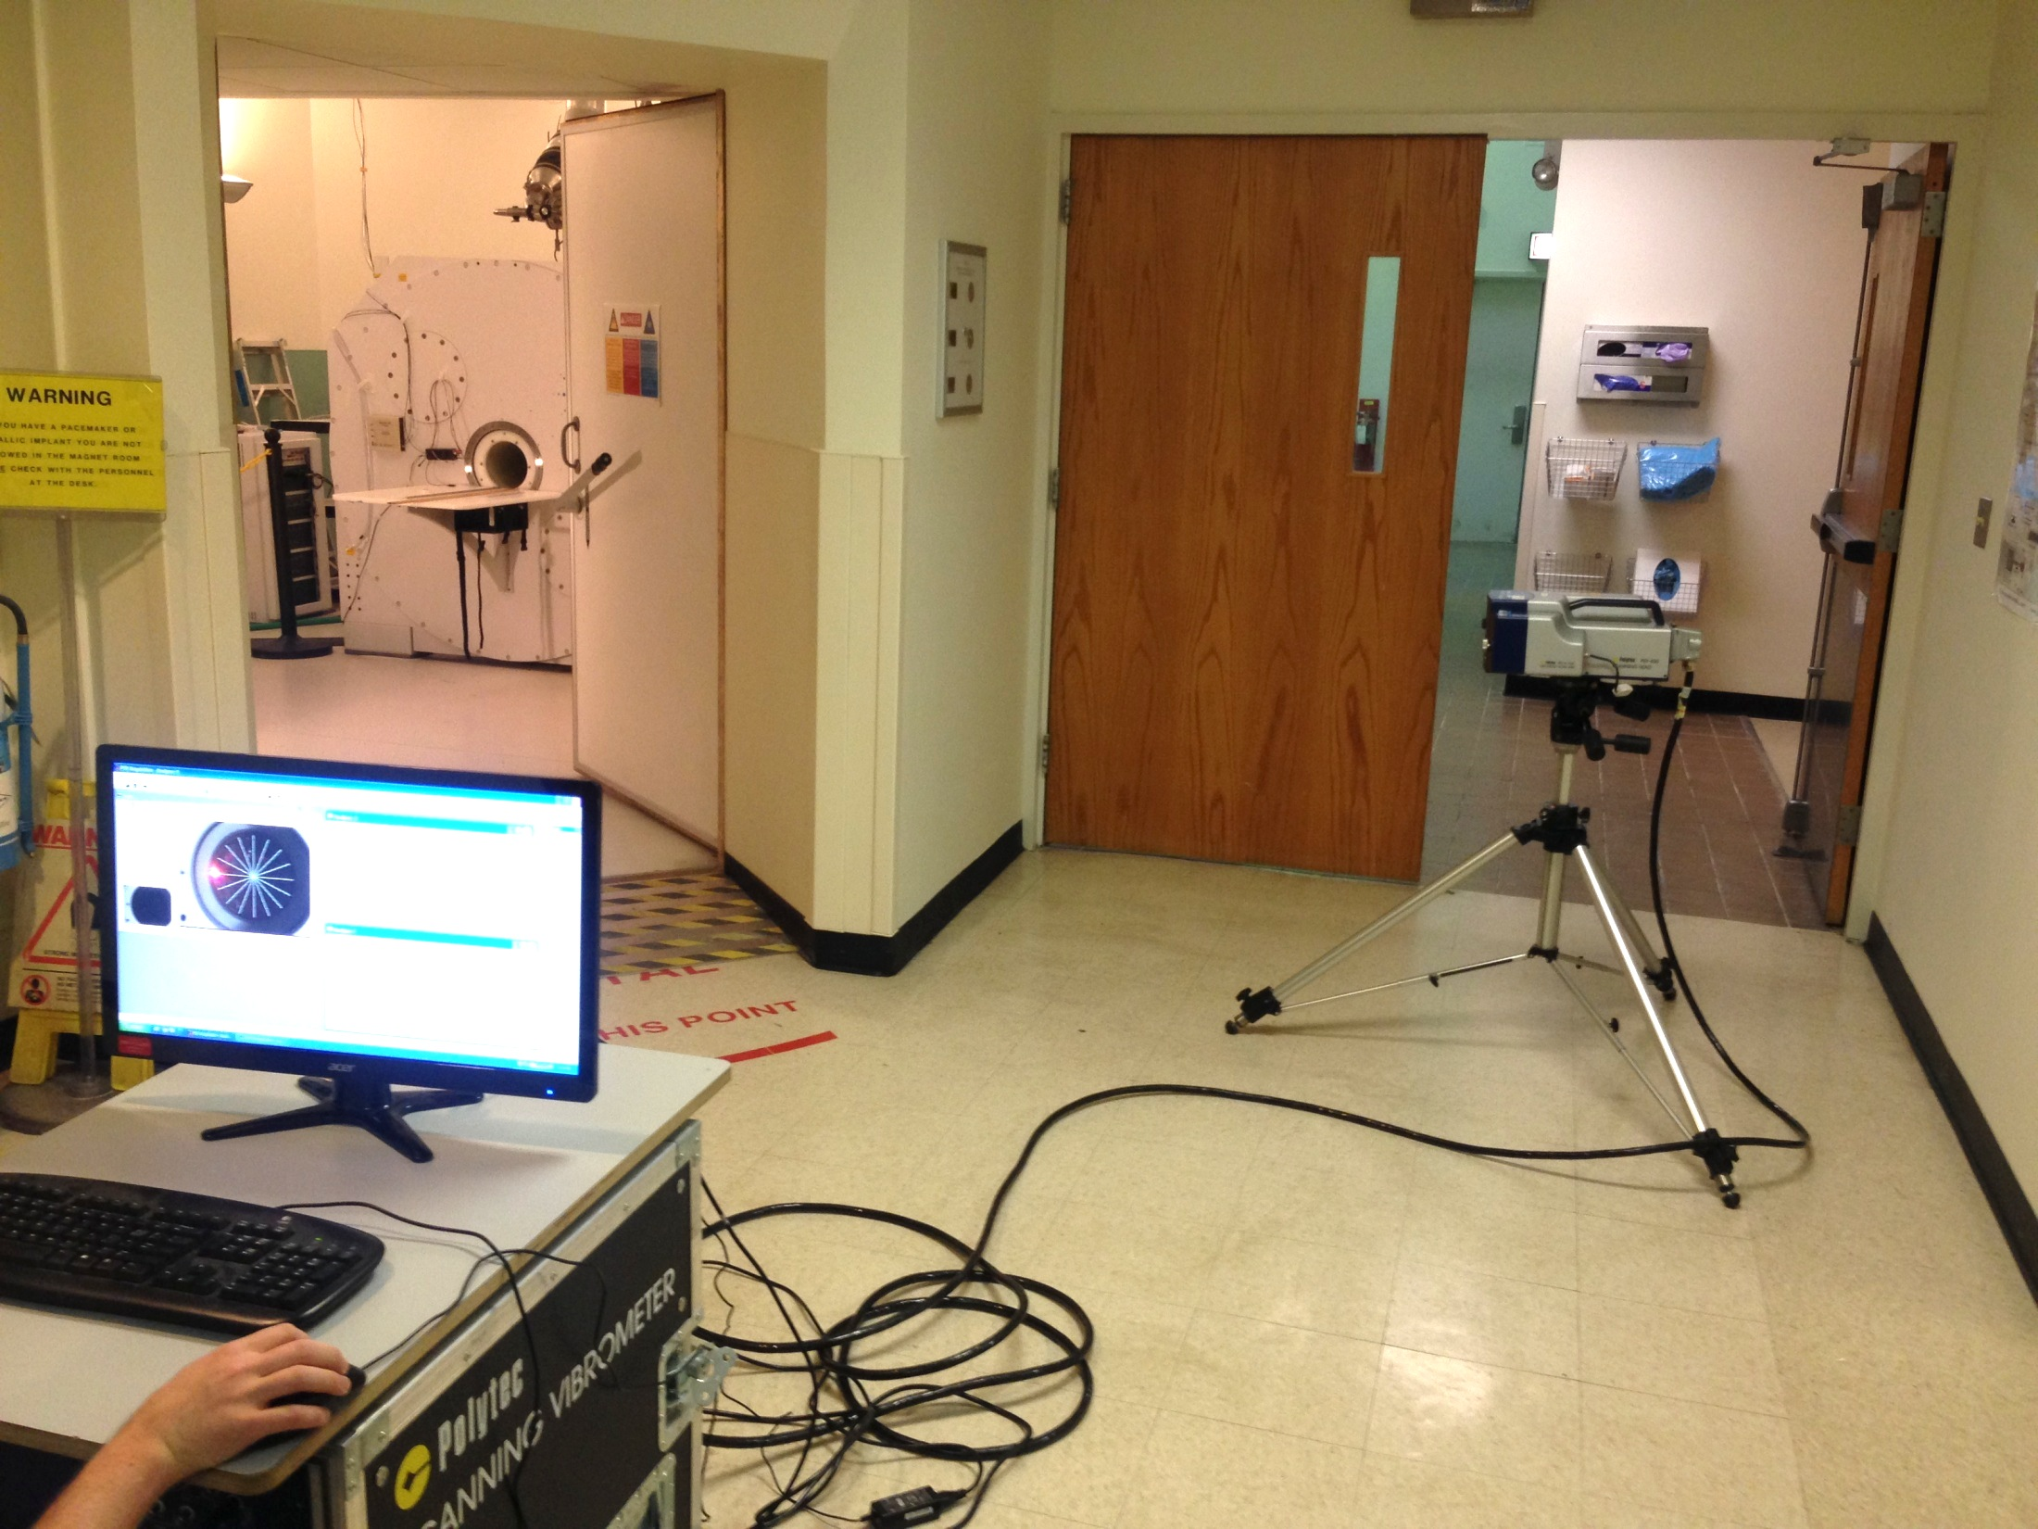

The SLDV system is shown pointing into MRI room. A red dotted line represents the SLDV laser path into the MRI system bore.