I. INTRODUCTION
This project analyzes two photographic series by Chicago-based artist Dawoud Bey, Night Coming Tenderly, Black (2017) and The Birmingham Project (2013), exploring how viewers become implicated in relation to the historical events addressed through the works. Bey’s photography often explores themes of community and identity, attending to the ways in which Black Americans have been represented in areas like Harlem and Chicago. Typically portrait- and documentary-oriented, Bey’s work began to take a shift toward the historical with the creation of The Birmingham Project. This programmatic occupation with history continues with Night Coming Tenderly, Black, while leaving portraiture behind entirely.
The title of this project addresses my concern with the diverse ways in which the issue of political action is addressed through art. To question answerability means to interrogate how works of art politically and socially implicate their viewers. How do we begin to understand the relationship of our responsibilities as citizens and our practices as art viewers? Throughout this project, I examine the ways in which these two series either invite viewers to deeply consider their place within the issue of collective political action, or else evade it altogether.
With The Birmingham Project, Bey commemorates the fiftieth anniversary of the bombing of the 16th Street Baptist Church in Birmingham, Alabama, in September 1963, honoring the lives of the six children who died in the bombing and its aftermath: Denise McNair, Carole Robertson, Addie Mae Collins, Cynthia Wesley, Virgil Ware, and Johnny Robinson, Jr. The series retains Bey’s signature style, with close-to-life-size black and white portraits of Birmingham residents, half of whom were the same age as one of the children at the time of their deaths, and the other half of whom were the same age as one of the children when Bey photographed them in 2012 and 2013.
The bombing of the church that Sunday morning in Birmingham was a part of an ongoing deliberate and heinous act of terrorism against the city’s Black community by White members of the Ku Klux Klan in the midst of the contentious Civil Rights movement. Including the bombing of the church, Birmingham saw around fifty such explosions between the years 1945 to 1965, targeting Black homes and public spaces in reaction to the progress of civil rights organizers in their efforts to desegregate the city. As political activist Angela Y. Davis, who was born and raised in Birmingham, recounts, “So common were the bombings on Dynamite Hill that the horror of them diminished.”
In this series, I argue that Bey calls into question the passivity of remembrance. In addition to honoring the lives lost in the bombing, The Birmingham Project presents portraits of current Birmingham residents that are paired with one another, calling attention to the ongoing need for justice. In its construction of a collective body through the pairing of individual portraits, The Birmingham Project interrogates the issue of accountability by asserting that the demand for justice for these lost lives resides in an act of collective action rooted in the pursuit of universal rights.
As a companion to the photographs of The Birmingham Project, Bey also produced an eleven-minute single-channel film titled 9.15.63. The film echoes the diptychs of the series with a split-screen projection of footage taken around Birmingham, in interior spaces such as lunch counters and barbershops, as well as footage from the back of a car that drives throughout the city, capturing the sunlight streaming through trees, neighborhood streets, and even the 16th Street Baptist Church itself. While I do not engage with 9.15.63 in this thesis, the film’s elegiac movement through the unpeopled landscape may have further paved the way for the visual and conceptual strategies Bey takes up with Night Coming Tenderly, Black.
Night Coming Tenderly, Black sees a continuation of Bey’s interest in “making history palpable, even though it has receded into an often mythically retold past.” In this series, Bey takes on the history of the Underground Railroad and the experiences of fugitive slaves who fled toward freedom along it. Taking the visualization of history one step further, Bey explores the act of photographing an unpeopled landscape, presenting images of spaces throughout Ohio that were believed to have been stops along the Underground Railroad.
Because of the railroad’s necessarily clandestine history, an accurate record of every stop does not exist. Bey thus exercises his imaginative and affective capacities with Night Coming Tenderly, Black, aiming to “convey the feeling of the unseen subject looking out onto space, to envision how it might have looked to those fugitive slaves.” Titling the project after the closing lines of Langston Hughes’s poem “Dream Variations,” and harking back to the visual and tonal style of Black photographer Roy DeCarava, Bey aims to fit the series within “a lineage of black expressive culture and extend Hughes’s idea of night as a tender embrace.” By inviting viewers into the experience of the Underground Railroad, I argue that Night Coming Tenderly, Black cultivates a feeling of empathy for the slave, an understanding of what they experienced on their journey to freedom, by enabling the viewer to situate themselves as the subject of the photographs.
Although The Birmingham Project was created in 2013, four years before Night Coming Tenderly, Black, I place it second in order of analysis. In its confrontation of the issue of accountability and its conjuration of a productive strategy for action through collectivity and historical consciousness, The Birmingham Project endeavors to answer the question that Night Coming Tenderly, Black opens up. Whereas Night Coming Tenderly, Black cultivates a sense of empathy that ultimately results in a destabilizing of the viewer’s ability to think critically and act collectively, the photographs of The Birmingham Project confront the viewer with directness, calling forth the notion of the social contract as a method for securing and maintaining rights and liberty. Though The Birmingham Project appeals also to feeling insofar as it is made in commemoration of a tragedy, it is also predicated upon the kind of rational thought and incitement to action that Night Coming Tenderly, Black foregoes.

II. METHODOLOGY
This thesis aims to interrogate the ways in which we understand and recall history, as well as the role of accountability (and a lack thereof) in contemporary politics. In drawing visual and conceptual distinctions between Night Coming Tenderly, Black and The Birmingham Project, I analyze the ways in which art can address history and politics. The explorations of empathy, disavowal, and memory in this thesis are salient to today’s political climate, wherein the sheer number of events and tragedies can be overwhelming, and their cooptation by the media exploits our capacity for empathy. Particularly with the role the internet plays in political discourse, it becomes ever more appealing to simply share a post and send thoughts and prayers. This thesis takes its cue from my belief that political and social change demand more of us than this, and that art and culture cannot exist outside of its political and historical context. To encounter an artist whose work approaches the question of political action and involvement in such deeply varied ways offers a unique opportunity to closely explore our desires, fears, and responsibilities as viewers and as political actors.

III. FUGITIVITY AND DISAVOWAL IN NIGHT COMING TENDERLY, BLACK
- Night Coming Tenderly, Black
Dawoud Bey’s 2018 photographic series Night Coming Tenderly, Black, produced in contribution to the Front International: Cleveland Triennial for Contemporary Art, is comprised of photographs of spaces that were thought to have served as stops along the portion of the Underground Railroad that routed through Ohio. Captured in the daylight and then manipulated to take on the appearance of nighttime, the photographs aim to communicate the experiences of slaves as they journeyed toward freedom in the shadows of night. At once crepuscular and luminous, captured from behind trees and bushes as well as in the face of the sublime expanse of Lake Erie, the photographs of Night Coming Tenderly, Black communicate not just the chilling sense of intimidation and risk involved in these attempts to escape; they also reveal a moment of liberatory opportunity made possible only through navigating what Bey calls “a munificent and blessed blackness.” Through this interpretation, dark and black are intended to serve as metaphors for freedom, with blackness understood as “a space of possibility and not something to be feared.” Taking its title from the Langston Hughes poem “Dream Variations,” the series explores Hughes’s envisioning of liberation from slavery as it was “achieved not only in the glare of daylight, but rather under the brooding, protective cover of night.”
In each photograph of Night Coming Tenderly, Black, the viewer is met with an expansive landscape in deep, tonal greys, almost glittering in their luminescence. Calling upon the visual language of photographer Roy DeCarava, Bey’s use of these rich greys serves not only to contextualize him within a Black artistic tradition to which DeCarava belongs; the tonalities of the photographs also work to communicate a depth, “[giving] the images a dark, material richness.” Some of the photographs, like Untitled #18 (Creek and House) [fig. 1], place the viewer in indiscriminate natural spaces. Other photographs like Untitled #14 (Site of John Brown’s Tannery) [fig. 2] or Untitled #3 (Cozad-Bates House) [fig. 3] situate the viewer in relation to spaces that carry historical significance and specificity, but they do so in a way that conjures the feeling of navigating the pathway to freedom traversed by fugitive slaves. Instead of capturing a recognizable view of the Cozad-Bates House, Bey photographs a nondescript portion of it, perhaps the side or back of the house. Through these more furtive views of the spaces, Bey creates what I want to understand as a more intimate reimagining of the journey undertaken by fugitive slaves, placing the viewer within the very spaces where slaves, a hundred and fifty years before, may have stood.
In nearly every photograph, some index of human life is present, most commonly in the visibility of a stately home, with dark windows serving to suggest the slumber that takes place inside. Within the photographs, the viewer is placed in harrowing proximity to properties, creating a feeling of precarity: While some of these homes (like the Cozad-Bates House) may be identifiable, others are unrecognizable, thus bringing forth the ever-brewing question of whether the home’s inhabitants might work to aid the fugitives on their journeys, or whether they are spaces of a heightened sense of danger and risk. For an escapee along the Underground Railroad, moving under cover of darkness, invisibility is a natural, even desired, condition. For fugitive slaves, the most dangerous thing would have been to be seen, and for this reason, the risk of any possible punishment loomed large.
Within the series, Bey utilizes differing views of the landscape to communicate the tension between a sense of protection and sheer vulnerability. In photographs like Untitled #17 (Forest) [fig. 4], the thick, overgrown branches and dense forestry serve to provide a cover for the fugitives. In Untitled #2 (Trees and Farmhouse) [fig. 5], too, the farmhouse is photographed from a distance behind trees, as if the subject is tucked away into the forest to await a signal alerting them of safety. But in photographs like Untitled #9 (The Field) [fig. 6], the viewer is met with an expansive, empty field, on the other side of which lies an abundant forest. Within this photograph, the fear inherent in traversing this field, and making it to the protection of the forest on the other side without being caught, is palpable. Throughout the series, Bey cultivates these dual feelings of fear, mixed with uncertainty, and the security provided by the natural landscape and the cover of darkness. These photographs evoke the sheer vulnerability that comes with being visible and call attention to the constant risk of violence associated with being caught. They reinforce the absolute necessity of camouflage and the heightened sense of fear inherent in the journey. Yet their near-glittering surfaces, with luminous tones that almost seem to catch the silver of the moonlight, also instill in the viewer a feeling of awe.
The choice to exhibit the photographs in St. John’s Episcopal Church, a Cleveland stop on the Underground Railroad that was christened Station Hope, was, for Bey, another layer of his endeavor to “‘almost involuntarily pull you back to the experience of the landscape through which those fugitive black bodies were moving in the 18th century to escape slavery.’” In this chapter, I take seriously Bey’s desire to “pull you back,” arguing that this objective is predicated upon a cultivation of empathy, appealing to the viewer’s emotions and ability to imagine themselves as someone else, in order to effectively convey the experience of slavery.
This chapter aims to attend to the complicated sense of freedom that Bey’s photographs offer their viewers, arguing that the sense of connection that Night Coming Tenderly, Black fosters is premised on the production of a feeling of empathy, appealing to the viewer’s emotions and ability to imagine themselves as someone else, in order to effectively convey the experience of slavery. By enabling the viewer to situate themselves as the subject of the photographs, the aesthetic beauty and affective emotion offered by the photographs invoke a sense of melancholia and “empathic mystification” that invite a sentimentalization of conflicts of the past, one that is opposed to a critical analysis of social and political realities or a motivation to action.
In remaining open and without subjects, the photographs invite the viewer to inhabit their landscapes. By immersing themselves in the depths of the darkness, I want to consider that the viewer is invited to disappear, to slip away into the night, as would the fugitive slave with whom they are called to connect. This disappearance I interpret is not unlike that of a liberal empathy premised on notions of sentimentality, moralism, and guilt. Through a consideration of the role of empathy, the absence of other figures, and the sublime and obliterative darkness, I argue that the photographs of Night Coming Tenderly, Black intensely appeal to the viewer’s sensory and bodily capacities, inviting a kind of disavowal through “a potentially uncomfortable destabilization of identity along the viewer’s perceptual borders—a sensation at once physical, psychological, and emotional.” I further argue that this form of disavowal itself can be located in current dialogues regarding race, accountability, and social action.
Because Night Coming Tenderly, Black thematizes slavery, or rather an experience of slaves, which fundamentally cannot be divorced from issues of race in America, the photographs cannot help but open themselves up to a racialized politics of looking, even in the absence of slave subjects. Photographs sublimate these interracial experiences; we become desensitized, and, in their proliferation throughout culture, entitled to these forms of looking. In their encouragement of empathy, the photographs can be understood to rely on the activity of the viewer’s imagination insofar as empathy is recognized as “‘the imaginative projection of one’s own consciousness into another being.’” In so doing, not only is the viewer invited to take up the experience of fugitivity; there also becomes a risk of mythologizing slavery, of confining it to the boundaries of one’s imaginative capacities.
Further, I argue that Bey’s effort to pull his viewers back into the experience of the Underground Railroad is premised upon an ontological impossibility articulated through writer and critic Frank B. Wilderson III’s theorization of the slave as fundamentally anti-Human. Bey directs his work toward the viewer’s emotions, particularly those of sentimentality and awe, immersing them in this environment that carries such charged historical resonances, to look upon the photographs as they seek to translate the views of the landscape as experienced by fugitive slaves. The absence of photographic subjects, combined with the emotional experience of the exhibition, come to evoke what historian and critic TJ Demos describes as “an experience of connection…achieved through mutual dislocation, [that] encourages an empathy between viewer and subject of representation on the basis of the singularity of experience, a relation established through the compassionate identification with the deprivations of the other” (italics mine). This singularity of experience that Demos speaks of can be understood within this series as the nighttime bid for freedom, enabled by positioning the viewer in the fugitive slave’s position. However, Wilderson articulates that the slave is defined not by humanity but by fungibility (the condition of being tradeable property), and because of this, the slave exists fundamentally as “a being outside of relationality.” Applying this definition of the ontological position of the slave to the experience of encountering the photographs of Night Coming Tenderly, Black, is central to my attempt to work through the ways in which the series invites this feeling of empathy.

- Empathy and Its Faults
I begin with psychology, psychiatry, and neuroscience historian Susan Lanzoni’s conceptualization that the “essential aspect of empathy is the capacity of the individual to feel into the needs, the aspirations, the frustrations, the joys, the sorrows, the anxieties, the hurt, indeed, the hunger of others as if they were his own.” This idea, articulated by Lanzoni in her book Empathy: A History, describes the ways in which empathy is premised on an ability to deeply engage with the feelings of others and “to inhabit, sometimes even bodily, the other’s perspective.” In order to work through the ways in which the photographs of Night Coming Tenderly, Black invite a feeling of empathy, I begin with an exploration of empathy and its developments throughout history, with particular emphasis on cross-racial empathy.
Arguing that the photographs of Night Coming Tenderly, Black can be understood to invite the viewer to empathize with the unphotographed enslaved subjects, I rely on Wilderson’s theorization of the slave to make sense of the ways in which this method of empathy is premised upon an ontological impossibility insofar as the viewer, a free subject, is asked to take up the position of an inherently unfree subject. Further, understanding the photographs of Night Coming Tenderly, Black as offering an empathizing experience clarifies the ways in which the series can be understood to individualize the viewer. The issue with this is that it invites the viewer to indulge in a form of disavowal, a divorcing from their sense of sociality and historical situatedness. While the absence of subjects in the photographs can be interpreted as Bey’s refusal to submit the Black body to a consumptive gaze, the photographs’ openness to the viewer through empathic identification becomes something of a paradox—the photographs purport to represent and make knowable for the viewer the experience of pursuing freedom along the Underground Railroad, but this experience exists outside of the realm of understanding for contemporary viewers.
To unpack this issue of unknowability, my analysis takes its cue from Wilderson’s conceptualization of the slave as “a being outside of relationality.” For Wilderson, nineteenth-century American slavery is “cathedralized. It ‘advances’ from a word which describes a condition that anyone can be subjected to, to a word which reconfigures the African body into the Black flesh. Far from being merely the experience of the African, slavery is now the African’s access to (or, more correctly, banishment from) ontology.” To understand the slave as existing outside the grasp of our relationality troubles Night Coming Tenderly, Black’s effort to “pull you back” to that historical moment. The absence of subjects grants the photographs a level of anonymity and universality, seemingly inviting viewers to in fact lose themselves in the darkness, to become fugitives themselves.
As the series invites viewers to consider, and partake in some semblance of, the experience of fugitivity, it encourages the feeling of empathy insofar as empathy “carries with it a spatial dimension—the ability to dwell in another’s place and to see it from this vantage point.” Thus, where Night Coming Tenderly, Black invites its viewers to situate themselves as the subject of the photographs, the series places an emphasis on emotional responses of sentimentality and moralization at the expense of critical reflection or a motivation to action. Further, assuming the burdens of others’ emotions in this way risks resulting in a kind of impotence, an inaction, and a retreat into interiority that precludes a recognition of one’s responsibility to history and to the social body to which they belong. While Bey succeeds in communicating the notion that, for fugitive slaves, “blackness and not whiteness functioned as a metaphor for hope and transcendence,” his series Night Coming Tenderly, Black troubles the idea of slavery as “a cultural and political fact” by inviting viewers to inhabit the photographs themselves.
Empathy, as it derives from the German concept of Einfühlung, was initially taken to mean a kind of self-allegorization through “the aesthetic activity of transferring one’s own feeling into the forms and shapes of objects.” It went on to become popularly associated with the attempt to undertake the experiences of another human being in order to better understand them and their struggles, but what persisted throughout this development was the idea of transference: empathy, in its numerous and somewhat elusive definitions, has seemingly always involved the practice of projecting oneself into the positionality of someone, or something, else. According to Lanzoni, it has, for this reason, become a prime strategy for working to fight against intolerance and injustice: “Some argue that empathy offers a way to understand one’s political opponents; others contend that if citizens imagine each child as one’s own, gun violence can be reduced, and still others claim that empathy can foster a connectedness that can ameliorate climate change.” This faith in empathy derives from the belief that simply working to understand someone better, stepping into their shoes and utilizing “emotional understanding to grasp others’ lives that are culturally or temporally distant from us,” can produce solutions to widespread social and political issues.
One of the most popular and fairly controversial examples of cross-racial empathy at work encircles White novelist John Howard Griffin and his 1961 book Black Like Me. In 1959, Griffin, a journalist and author from Fort Worth, Texas, took it upon himself to darken the color of his skin and live temporarily as a Black man in the Jim Crow South. In Griffin’s eyes, the motivation behind this experiment was well-intentioned; he believed that, in taking up the burden of Black men, he could help to validate the quotidian acts of violence and hatred toward Black people in America. Griffin wrote, “‘The only way I could see to bridge the gap between [Black and White people] was to become a Negro.’” Black Like Me, which became a controversial classic upon publication, follows Griffin’s journey through the south, from Alabama to Atlanta. Curiously enough, the book, like Night Coming Tenderly, Black, takes its name from Hughes’s “Dream Variations”:
To fling my arms wide
In the face of the sun,
Dance! Whirl! Whirl!
Till the quick day is done.
Rest at pale evening…
A tall, slim tree…
Night coming tenderly
Black like me.

Griffin’s experiment only lasted about a month, at which point he felt he “could stand no more.” When the book was published, responses were mixed: while some praised Griffin for his endeavors, he and his family received threats of death and he was violently attacked by White supremacists and police officers. Griffin also embarked on a book tour, lecturing at universities and events nationwide, invited to become “a white spokesman for black America.” As civil rights activist Stokely Carmichael articulated, Black Like Me was “‘an excellent book—for whites.’” In many ways, Griffin’s experiment, though intended as an act of solidarity, is premised on a notion of race as skin-deep, overlooking its structural and material influences. It also demonstrates a somewhat oversimplified attempt to navigate what scholar Alisha Gaines articulates as “simultaneously and paradoxically a confounding space of discomfort, pleasure, desire, anxiety, anticipated violence, fame, and care.” Griffin’s decision to hark back to Hughes in his book’s title, Black Like Me, exemplifies that, temporary though it was, Griffin—at least at the time—believed that his tenure as a “Black” man granted him the credentials to speak on behalf of Black Americans. In centering himself, Griffin, to his eventual dismay and regret, thus redirected the focus of the issue away from the ongoing lived realities of Black Americans.
Gaines goes on to refer to Swedish sociologist Gunner Myrdal’s claim in the introduction to his famed 1944 book An American Dilemma, “that the solution to the ‘embarrassing’ inconsistency between the country’s espoused democratic egalitarianism and the reality of its violent racial past and present, also known as the ‘Negro problem,’ was a decidedly ‘moral issue’ resting in the ‘heart of the [white] American.’” Myrdal’s conviction that the solution to American race relations could be attained through morality and cross-racial empathy is one that persists in contemporary political discourse.
Lanzoni writes, “Rather than an expansion of the self into a form or shape, empathy came to mean the very opposite: the reining in of the self’s expressiveness to grasp another’s emotion in service to a therapeutic goal or moral imperative.” While I do not deny that empathy strives to achieve this construction of relationality, I want to challenge the idea that the most effective strategy for approaching issues of race and racism has, in fact, solely a moral basis. I do believe that empathy can encourage people to see the humanity in one another. However, as psychologist Paul Bloom writes, “[t]he problems we face as a society and as individuals are rarely due to lack of empathy. Actually, they are often due to too much of it.” This influx of empathy becomes an overwhelming experience that risks rendering the empathizer impotent, as the sheer number of people with whom they try to identify makes it more and more difficult to take action to prevent their suffering. As Bloom writes, empathy “does poorly in a world where there are many people in need and where the effects of one’s actions are diffuse, often delayed, and difficult to compute, a world in which an act that helps one person in the here and now can lead to greater suffering in the future.”
Because it relies on the ability to engage with another person well enough that one feels they can truly and deeply understand them, it follows that an experience of empathy necessitates an individual with whom to empathize. This focus on the individual, Bloom writes, “makes us care more about them, but it leaves us insensitive to the long-term consequences of our acts and blind as well to the suffering of those [with whom] we do not or cannot empathize….It is innumerate, favoring the one over the many.” Empathy, Bloom argues, tends to result in a kind of parochialism, wherein we empathize with those whose suffering we see and recognize, while failing to account for the struggles of those whose experiences miss our radar.
Within the photographs of Night Coming Tenderly, Black, this narrow empathic view is cultivated, even in the photographs’ unpeopled landscapes. In the photographs, the subject cannot be found within the image—at least, not literally. Thus, the reflective quality of the photographs, and the openness with which they render their subject matter invite the viewer to take up the position of the photographic subject; the viewer is thus placed into a position of empathy that opens itself onto interiority, individualism, and ultimately impotence, as they are asked to empathize with a subject whom they are standing in as. This volleying of the viewer between the position of the subject and the spectator lends itself to Bloom’s suggestion that empathy “guides us to treat others as we treat ourselves and hence expands our selfish concerns to encompass other people.” The issue with empathy can further be articulated through Walt Whitman’s description in his 1855 poetry collection Leaves of Grass: “‘I do not ask the wounded person how he feels. I myself become the wounded person.’” Rather than fostering an expansion of one’s understanding, which might then lead to the tackling of structural or systemic issues that lie at the root of the suffering of others, empathy encourages one to instead step into the shoes of the other, to assume their subjecthood, turning away from the other in order to place themselves at the center of the situation.
Bey’s desire to bring viewers back to nineteenth-century slavery can be understood as an appeal to empathizing, through which the recognition of another’s humanity has the potential to foreground “‘the common predicament of mankind.’” However, centering Wilderson’s understanding of the slave as existing outside of the realm of relationality troubles this recognition of humanity insofar as the slave must be understood as “anti-Human, a position against which Humanity establishes, maintains, and renews its coherence, its corporeal integrity.” According to Wilderson, because of, and inextricable from, slavery, Blackness as an ontological position continues to exist in our cultural consciousness as the thing against which Whiteness defines itself; thus, in his terms, Whiteness and Blackness can be understood as dichotomous positionalities. The former, absolved of marks of racial distinction and associated with bodily and spiritual transcendence and rationality, stands as “the most impeccable embodiment of what it means to be Human.” The latter, conversely, is always subject to negotiations of race, always grounded in corporeality, and fundamentally exists extraneous to humanity. Thus, in Wilderson’s terms, if to be recognized as human is to be free, for the Black subject, freedom is an impossibility.

- The Sublime and the Romantic as Producers of Disavowal
Arguing that the photographs of Night Coming Tenderly, Black can be understood to invite the viewer to empathize with the unphotographed enslaved subjects, I rely on Wilderson’s theorization of the slave to make sense of the ways in which this method of empathy is premised upon an ontological impossibility insofar as the viewer, a free subject, is asked to take up the position of an inherently unfree subject. Further, understanding the photographs of Night Coming Tenderly, Black as offering an empathizing experience clarifies the ways in which the series can be understood to individualize the viewer. Through this experience, the photographs thus invite the viewer to indulge in a form of disavowal, a divorcing from their sense of sociality and historical situatedness.
In order to understand the ways in which individualism operates, I look to the works of German Romantic artist Caspar David Friedrich, whose paintings feature the Rückenfigur, a figure whose back is turned to the viewer, and whose presence is meant to serve as a site of mediation between the viewer and the landscape. Friedrich’s 1818 painting Wanderer above the Sea of Fog [fig. 7] conveys an experience of what German philosopher Immanuel Kant conceptualized as the sublime, the aesthetic quality of which is “to be found in a formless object, so far as in it or by occasion of it boundlessness is represented.” Through an understanding of the sublime as an experience of boundlessness for the viewer, I perceive the experience of disavowal as one that risks the possibility of rendering the viewer immobile and incapable of action.
That the rich, tonal darkness of the landscapes precludes total visibility in the photographs may be indicative of Bey’s interrogation of the accessibility and availability of narratives about slavery, and a challenge to the viewer to reckon with the inability to see. But the darkness of the landscapes also calls to mind artist and writer Coco Fusco’s assertion that “photography generates a distinct mise en scene and provides material that is visually reminiscent of but phenomenologically distinct from reality for voyeuristic engagement.” This darkness can be interpreted as at once a sublime titillation and an obstruction of the visibility of other bodies. The darkness of the photographs, the luminescent reflectiveness of their surfaces, and the gradient of rich DeCaravan greys render each photograph a kind of black mirror, through which the reflections of viewers become indiscernible, unrecognizable, almost spectral blurs.
In being invited to identify with the fugitive slave and to disidentify with themselves through the blurring of their own reflection, the viewer experiences a feeling of disavowal that not only renders the self fragmented, but also results in a destabilization, troubling the sense of cognitive clarity necessary for social and political action. In Freud’s terms, disavowal is a defense mechanism, a means of coping with danger by turning away from it, convincing oneself that “there is no reason for fear….Thus there is a conflict between the demand by the instinct and the prohibition by reality.” Instead of facing danger and experiencing the resultant feeling of anxiety, the subject convinces themselves there is nothing to be afraid of, yet their instincts continue to tell them otherwise. In this moment of splitting, the viewer somewhat represses reality in order to protect themselves from it; thus, their grasp of reality is partial. Within the photographs of Night Coming Tenderly, Black, the viewer is invited to immerse themselves. The rich tonal darkness of the photographs, and the lush landscapes they visualize, become all too alluring. The pleasure of submitting oneself to the experience of the photographs—cultivated through Bey’s recasting of the darkness of the Underground Railroad with an affirmational understanding of Blackness as “munificent and blessed”—troubles the viewer’s orientation toward the historical event the series addresses, divorcing it from its actual conditions and offering the viewer pride of place as the focus of the photographs.
Further, interpreting the obstruction, or frustration, of the visibility of other people as facilitating the individualizing nature of the photographs thus results in rendering the viewer the lone subject. In order to do this, I turn to the Romantic motif of the Rückenfigur, the universal figure meant to serve as a site of identification in works like those of German Romantic painter Caspar David Friedrich. German Romanticism, according to art historian Joseph L. Koerner, was notable for a number of characteristics:
a heightened sensitivity to the natural world,…a passion for the equivocal, the indeterminate, the obscure and faraway…; a celebration of subjectivity bordering on solipsism, often coupled with a morbid desire that that self be lost in nature’s various infinities; an infatuation with death; valorization of night over day, emblematizing a reaction against Enlightenment and rationalism; a nebulous but all-pervading mysticism; and a melancholy, sentimental longing or nostalgia which can border on kitsch.

Notions of loss of self and solipsistic subjectivity call to mind a sense of disavowal insofar as they evoke a turning away from reality and a submission to inaction. Further, with particular attention to the evocation of loss of self and the prioritization of mysticism, aspects of German Romanticism as Koerner outlines it can be aligned with Kant’s conceptualization of the experience of the sublime as an aesthetic category. Friedrich’s Rückenfigur served as a means for guiding the viewer through the experience of the sublime in his landscapes. The use of the Rückenfigur (German, meaning rear-view figure) was championed in a number of Friedrich’s paintings and worked “to infuse Friedrich’s art with a heightened subjectivity.” It served as a point of mediation between the viewer and the landscape; through the Rückenfigur, the viewer could experience the landscape as humanized and situate themselves in relation to it. The sublime of the landscape, with its infinite expansiveness, could be experienced through the presence of the Rückenfigur: “‘The motif of the Rückenfigur,’ one recent historian concludes, ‘is therefore no symbol of separation.’” In Friedrich’s Wanderer above the Sea of Fog (1818), a lone traveler stops along his journey to stand before the landscape, imbued with mysticism. Placed in the center of the composition, the traveler communicates a sense of awe as he gazes out across the fog-bathed mountaintops. The traveler is arrested by the boundlessness, the infinitude of the view, which envelops his attention. In the act of gazing, he is held stagnant, unable to move as the experience of the sublime engulfs him.
Though meant to serve as a universal figure with whom any viewer can identify, the traveler in Wanderer above the Sea of Fog appears, to us, as actually far from universal: a White man clothed in a dark overcoat, carrying a walking stick and indulging in the leisurely act of wandering, Friedrich’s traveler is the ultimate bourgeois subject. Interpreting the solitude and distance of the Rückenfigur as a removal both from the landscape he contemplates and from a sense of sociality, Friedrich’s traveler thus becomes representative of an idea of the hyper-individualized bourgeois subject who gazes down upon the world of the masses without deigning to participate in it. From his heightened placement, the obstruction of the landscape through thick plumes of fog prevents him from having to face the lived realities of the people who actually inhabit the landscape.
In the photographs of Night Coming Tenderly, Black, there is, of course, no Rückenfigur, as there is no subject within the photographs at all—no figure to serve as a site of identification. Yet I want to argue that within both Wanderer above the Sea of Fog and the photographs of Night Coming Tenderly, Black, what the viewer is asked to confront is an experience of the sublime as they are isolated from other beings. In Night Coming Tenderly, Black, the obstructiveness of the darkness and the blurring of viewers’ reflections produce a similar isolating effect as the solitude and distance from civilization exemplified in paintings like Wanderer above the Sea of Fog, insofar as these visual characteristics result in the reflected detachment of the viewer from their surroundings and, more importantly, from their fellow viewers. By standing before the photographs of Night Coming Tenderly, Black, then, the viewer is invited to take up a position similar to the Rückenfigur.
Kant articulates that the sublime in nature can be identified “in its chaos or in its wildest and most irregular disorder and desolation, provided size and might are perceived.” In these terms, the sublime is associated with a sense of terror and sheer awe brought on by the perceived vastness and mightiness of the beheld object. The paired experiences of fear and awe invoked in the photographs of Night Coming Tenderly, Black can thus be understood in terms of the sublime. The expansiveness of the landscapes, the ways in which their open fields or sinister forests seem to stretch on forever, renders them boundless, infinite, overwhelming. Placed into these settings, the viewer, rather than feeling a sense of haste or risk, is instead paralyzed by the sheer magnitude of the landscape before them. Kant writes: “We must seek a ground external to ourselves for the Beautiful of nature; but seek it for the Sublime merely in ourselves and in our attitude of thought which introduces sublimity into the representation of nature.” The experience of the sublime, rather than inviting a desire to seek understanding elsewhere, instills a sense of groundlessness and thus turns one in on themselves, troubling the capacity for movement or action. It stops the beholder in their tracks and, like the subject in Friedrich’s Wanderer above the Sea of Fog, suspends them there.
The experience of the sublime can be felt most strongly in Untitled #25 (Lake Erie and Sky) [fig. 8], the final photograph in the series, meant to recall the slaves’ “final leg of their journey towards freedom.” The frame of the photograph is fully occupied by the expanse of Lake Erie, possibly placing the viewer in the bell tower of the St. John’s Episcopal Church in Cleveland (the so-called Station Hope), where slaves would hide until they received a signal alerting them that it was safe to cross. However, the bell tower itself is not visible. The photograph instead refrains from granting the viewer a place on which to ground themselves; positioned above the water, with no land in sight, the photograph communicates a feeling akin to floating in midair. The lake before the viewer is massive and boundless.
Though intended to communicate that the end of the journey, and thus freedom, is nigh, Untitled #25 (Lake Erie and Sky) poses a feeling of total uncertainty through its groundlessness. This photograph, in precluding from the viewer a sense of orientation or stability, instead invites the viewer to submit themselves to the lush darkness, losing their sense of grounding and capacity for critical reflection and action. The experience of standing before this photograph can instead be interpreted as an act of self-absolution, of disappearing into the depths of the water (the depths of the photograph) and immersing oneself in its power and magnitude. Faced with views of a landscape evoking at once fear and awe, the viewer is consigned to submit themselves to the embrace of precarity, and in so doing, to reify the romantic notion of total resignation.
To engage with Untitled #25 seems as though it is also to be confronted by a sheer temptation to jump in and submit oneself to the possibility of escape offered by death, a notion that carries irrevocable historical resonance with the idea of suicide as a means of escape for slaves along the Middle Passage. Historian Terri Snyder writes that, for captive Africans, suicide might be seen as an act of “choosing death rather than dishonor, or it might be seen as an entirely reasonable—if not outright revolutionary—response to enslavement.” Snyder expresses that, as an act of revolutionary resistance, slave suicide, either by plunging into the sea or by starvation, was widespread enough that captors used nets and forcible feeding measures to prevent its occurrence. Slave suicide was commemorated as a self-destructive act of such honor that it became the subject of flying African folklore, tales of those “who literally had the power to take flight to escape enslavement.” As the final photograph in the series, Untitled #25 (Lake Erie and Sky) can be understood to signal the beginning of the end of the journey, but what lies beyond continues to remain ominously ambiguous. The photograph brings the experience to a close on an open-ended question of survival, one that is posed in the midst of the sublime.
Within the photographs of Night Coming Tenderly, Black, the primacy of the viewer runs the risk of triumphing over the measured apprehension of the institution of slavery as a historical fact whose legacy lives on in everyday acts of racism, ongoing instances of segregation, police brutality, mass incarceration, and the general dehumanization of nonwhite peoples. In exploring the limits of empathy in addressing these widespread instances of suffering and injustice, I want to argue that empathy responds better to individuals and encounters than to statistical information and the realities of far-reaching systemic issues. This chapter has explored the ways in which empathy, while often good-intentioned, risks producing an effect of inaction in viewers. The next chapter attempts to propose an alternative solution to empathy by foregrounding collectivity, rationality, and the influence of historical consciousness on the possibility of political action.

IV. THE BIRMINGHAM PROJECT AND THE MATTER OF COLLECTIVITY
- The Birmingham Project
On the morning of Sunday, September 15, 1963, four young Black girls were killed by a bomb planted by White members of the Ku Klux Klan to explode the 16th Street Baptist Church in Birmingham, Alabama, one of the city’s predominantly Black churches. The bodies of Denise McNair, Addie Mae Collins, Cynthia Wesley, and Carole Robertson, who had slipped away from choir rehearsal to the bathroom, were uncovered in the rubble. In the midst of the riots and protests the bombing sparked throughout the city, two teenaged boys, Johnny Robinson and Virgil Ware, were also killed—the former by a Birmingham police officer, and the latter by a couple of young White boys. The six adolescents’ deaths brought a renewed sense of combativeness and uncertainty to the city, which had already been playing a major role in the movement for civil rights. One woman cried at the scene of the bombing, “‘In Church! My God, you’re not even safe in church.’”
Bey’s 2012 photographic series The Birmingham Project was created fifty years after the bombing in commemoration of the lives that were lost that day. The series consists of a number of diptychs in which Bey juxtaposes a portrait of a young sitter of the same age as one of the children who was killed, beside a portrait of an older sitter who was the same age as one of the children at the time of the events in 1963. All of the subjects in the series are themselves Birmingham residents; thus, through these pairings, Bey captures the identity of each sitter at the same time as he attempts to depict both the loss of life and the passage of time.
Soliciting the participation of Birmingham residents, Bey presents large-scale diptychs that pair portraits of the sitters in such a way as to call attention to the similarities between their clothing, poses, and for some, even their physical likenesses. Trentin Williams and Willie Robinson [fig. 9], in their white collared shirts and vests, fold their arms and face the viewer with the same somber, expectant expressions. In their portraits, Maxine Adams and Amelia Maxwell [fig. 10] take on different poses: the younger subject conveys a more reserved demeanor, though her mouth plays at a smile, while the elder subject, one hand on her hip, expresses vivacity and comfort. Both subjects meet the camera’s eye with intense focus.
Within these diptychs, Bey establishes a sense of relationality between his younger and older sitters, so that some of them come to appear almost as two versions of the same person; other diptychs at least suggest a shared demeanor or mannerism between the two. The portraits of The Birmingham Project seem to conjure the youthful presence of the victims lost to the bombing and its aftermaths, through the young sitters; yet through the elder sitters, we are reminded of the abruptness with which those lives were ended, and the fullness of life the victims were denied. At the same time, though, Bey refrains from collapsing the sitters altogether into similarity, by retaining a sense of individual personality in each portrait, striving to capture the distinctiveness of each sitter, and naming them in the titles of the diptychs. In standing before these photographs, we are not looking upon the actual victims of the events of September 15, 1963. Instead, we face the inheritors of the legacy of those events.
Bey’s method of pairing the portraits invokes a sense of shared identity that goes beyond the subjects’ statuses as residents of the city in which bombings occurred with alarming frequency during the fight for civil rights—so often, in fact, that the city would come to be known as “Bombingham.” Within each diptych, the subjects have been photographed in the same spaces—either in the Bethel Baptist Church or the Birmingham Museum of Art, both in Birmingham—and further, captured in such a way as to suggest that they are sitting side by side: positioned in front of the same painting at the museum, or kneeling in the same pew at the church. Photographed separately yet placed in these spaces together, the paired portraits of the subjects thus communicate a balance of individuality and collectivity.
As the presence of the Birmingham bombing and its legacy loom in the photographs, by bringing these subjects together into the same space, Bey makes his viewer conscious of not simply the fact of the bombing in 1963, but also by its lingering presence through the continued terrorization of Black lives. Bey recalls: “At the time I was making this work in 2012, Trayvon Martin was killed. So clearly, the horrifying issue of the slaughter of innocents is still very much with us…” Not unlike Angela Davis’s proclamation regarding the frequency of the bombings, instances of police brutality and hate-fueled violence against Black people have become so common that, as the victims’ names become hashtags and protest sign slogans, there is a fear of desensitization. Despite the hopes of many that the six children “‘did not die in vain,’” the legacy of violence and brutality against Black Americans continues to live on. Through The Birmingham Project’s twofold emphasis on both the bombing of the 16th Street Baptist Church and the contemporary ongoing struggle against racial injustice, the series, rather than merely encouraging reflection upon history, lays emphasis on the concerns of the present moment and foregrounds the question of what methods can be taken up as a means of working to end this violence.

- The State as a Unit for Collective Action
In this section, I will argue that to stand before each of the diptychs of The Birmingham Project can be understood to become, for the viewer, an entrance into a kind of social contract, of which the intended result is the invocation of a feeling of accountability, an interrogation of the ways in which we remember a national tragedy and how justice is sought for its victims. Within the photographs of The Birmingham Project, I suggest that the viewer is made aware of their own implication in events such as the Birmingham bombing. In this project, the theory of the social contract helps to articulate the need for the enactment of actionable measures, not moral-based proposals, to work toward preventing the racialized killing of Black people in the United States. Because the social contract structures and preserves the state as a unit of governance and collective political representation, it serves as an appropriate vehicle for interrogating the issue of accountability—or lack thereof—surrounding events of anti-Black violence. As entrants into the social contract, citizens are ensured equal rights and civil liberty, though they also hold a sense of duty to the state. In its depiction of Birmingham citizens, The Birmingham Project articulates a connection between the photographic subject and the subject as it is understood by Swiss philosopher Jean-Jacques Rousseau, who writes, “Those who are associated in [the state] take collectively the name of people, and severally are called citizens, as sharing in the sovereign power, and subjects, as being under the laws of the State.” The social contract, in maintaining the collective body that comprises the state, makes possible the enactment of a set of laws, according to which each citizen must abide, or else risk jeopardizing the social order altogether. In the terms of the Birmingham bombing, then, I will work to demonstrate how the theory of the social contract articulates the necessity of laws that ensure accountability for such crimes.
Because the series is commemorative in nature, this chapter asserts that it differs from Night Coming Tenderly, Black not simply in its call for accountability through rational, measured reflection and collective action, but in its evocation of an altogether different kind of feeling. While the photographs of The Birmingham Project invite feelings of mourning and tragedy, they also appeal to a feeling of sobriety and a foreclosure of swirling emotions of guilt and sentimentality. Further, the sense of symmetry in each diptych invokes a balance that can be associated with order and formality. In the photographs, the subjects’ somber expressions and stately postures conjure a sense of emotional distance from the viewer. Returning to the portraits of Trentin Williams and Willie Robinson [fig. 9], the subjects’ folded arms, solemn looks, and white collared shirts paired with vests construct what feels like a formal encounter. Even the setting of the portraits reinforces this sense of sobriety: photographed in the pews of the Bethel Baptist Church, the subjects seem contemplative and quiet.
Portraits of subjects captured in the Birmingham Museum of Art also convey the sense of a formal encounter, this one reinforced not through the respectable seriousness of the church, but rather through the quietude and decorum of the museum space. In their portraits, Taylor Falls and Deborah Hackworth [fig. 11] are seated before a painting in the museum, in straight-backed wooden chairs that recall the uprightness of the church pews. Their expressions, too, are serious, even expectant. In the portraits of The Birmingham Project, the subjects do not invite the viewer to relate with or understand their feelings; in fact, the somberness of their countenances forecloses a recognition of their feelings altogether. Further, each sitter is distanced from the viewer by the back of the church pew, or the arms of the chair; they are visually bracketed off from the viewer in a composition that I also want to interpret as the bracketing off of emotion, preventing the viewer from empathizing with them. In so doing, they make a clear separation between themselves and the viewer, seeming to invoke a sense of higher order. Through their proper postures, their placement in institutions like the church and the museum, and the visual boundaries that serve to distance them from the viewer, the subjects of The Birmingham Project put forth questions of rationality and emotional restraint that are necessary in the realization of the social contract and the pursuit of universal justice.
In Rousseau’s words, the social contract serves to establish “a form of association which will defend and protect with the whole common force the person and goods of each associate”—in other words, it is a set of measures agreed upon and put into practice by all members of a collective body that ensures equal protection and liberty, or what Rousseau refers to as the general will, the common good, of a society. According to Rousseau, in underwriting the social contract, individuals become indivisible parts of a collective body that secures not simply their freedom, but the freedom of all of its other members. This body, Rousseau argues, takes the form of the state and provides a means of governance, a set of laws, under which the rights of each citizen are secured.
The argument that, in reality, the state itself is largely at fault for anti-Black violence, must be addressed. Further, Rousseau’s theory of the social contract is a product of the Enlightenment practice of categorizing individuals based on race and utilizing those categorizations in the service of power. Though the central claim of the social contract is the assertion “that people have rights and duties…because of their nature as human beings,” in his book The Racial Contract, philosopher Charles W. Mills argues for an understanding of the social contract as securing natural freedom, equality, and rights for strictly White subjects based on the notion that nonwhite peoples were not considered fully human. Thus, according to Mills, theories of the social contract like that of Rousseau necessarily exclude nonwhite peoples.
This thesis thus takes to heart Mills’s assertion that the social contract has been “very versatile, depending on how different theorists viewed the state of nature, human motivation, the rights and liberties people gave up or retained, the particular details of the agreement, and the resulting character of the government.” I will not attempt to deny the role the state has played in the perpetuation of anti-Black violence, nor do I endeavor to absolve philosophers like Rousseau of their racially exclusionary mentalities. Instead, this thesis is based on a reconfigured understanding of the theory of the social contract, because it is necessary to strive for a state that recognizes each of its subjects, no matter their race, as equal and deserving of the liberties and rights afforded to humans. My use of social contract theory thus falls in line with the endeavor to hold the state answerable to its possibilities. The state as it currently operates is untenable; a better one is achievable.
Rousseau writes: “What man loses by the social contract is his natural liberty and an unlimited right to everything he tries to get and succeeds in getting; what he gains is civil liberty and the proprietorship of all he possesses.” Thus the social contract articulates a sacrifice insofar as involvement constitutes rescinding one’s natural impulses and self-motivated interests; however, by entering into the social contract and becoming a subject to the state, the citizen is ensured protection of rights and the guarantees of justice. We need this unification through the state, Rousseau argues, in order to maintain strength of political power, of representation, of humanity. The social order, he writes, “is a sacred right which is the basis of all other rights.” Without it, we risk reverting back to what Rousseau calls a state of nature, in which the absence of laws and sociality produce an anarchical state where every person serves themselves and there are no rights to be ensured, no question of justice. By not only foregrounding the acts of racial terror and injustice that littered the 1960s struggle for civil rights, but also recognizing the multitude of ways in which those injustices persist today, The Birmingham Project renders evident the urgency of the need to re-engage with social contract theory in order to articulate a basis on which to fight for and to ensure equal rights and protection for all.
German philosopher G.W.F. Hegel’s ideas about the state provide a means for understanding the ways in which it is founded upon a contract and works to provide protection for all of its citizens. Hegel agrees with Rousseau regarding the foundation of the state upon the will of the individual and further articulates that the “determinations of the will of the individual acquire an objective existence through the state, and it is only through the state that they attain their truth and actualization. The state is the sole precondition of the attainment of particular ends and welfare.” For Hegel, the stable state merges the particularity of individual will and liberty with the universal law of reason. The “soul which animates it…is subjectivity, which creates distinctions on one hand but preserves their unity on the other.” As Rousseau made the case for the indivisibility of the state, so Hegel concurs that its basis necessarily lies with the individual citizen.
Within the photographs of The Birmingham Project, this balance between the individual citizen and the indivisibility of collectivity can be visualized. Through their unwavering stares, each individual subject expresses an assertive power on their own. However, it is through the pairing of the portraits that the series takes its effect. In the diptych of Fred Stewart II and Tyler Collins [fig. 12], by juxtaposing a young man of thirteen, as Virgil Ware was at the time of his death, with an older man of sixty-three, as he would’ve been when Bey was making this work in 2012, the photograph renders palpable the notion of lost time as it applies to Ware’s death. However, it also demonstrates Hegel’s notion that “individuals do not live as private persons merely for those particular interests without at the same time directing their will to a universal end and acting in conscious awareness of this end.” Far from simply representing what was taken from Ware, Stewart and Collins—as well as the other combinations of subjects in each diptych—also present the expression of the universal that occupies Hegel insofar as together, they reach beyond questions of individual interest.
Through the portraits, the subjects, whose steady gazes and sober expressions hold the viewer, propose a query that is universal in nature. Rather than merely appealing to the viewer’s emotions and sentimentality, the subjects seem instead to convey a sense of cool rationality. Through the state, Hegel asserts, the system of rights “is no longer essentially confined to the form of feeling and faith, but belongs to determinate thought.” Without the balance of particular will and universal realization, the social order becomes corrupted, “its strength resides solely in the power of a few individuals and the unruliness of everyone,” and questions of the preservation of justice and equality are groundless. Hegel further contends, though, that the question of virtue within the state, or the individual citizens that govern it, becomes a precarious one:
…as the condition of society grows more advanced and the powers of particularity are developed and liberated, it is not enough for the heads of state to be virtuous; another form of rational law is required apart from that of the [individual] disposition if the whole is to have the strength to maintain its unity and to grant the forces of developed particularity their positive as well as negative rights.

From this, Hegel suggests that virtue and morals are not forceful enough to serve as the answer to the question of rights. Virtue is subjective and unreliable, but rational law is objective and universal. Earlier in The Philosophy of Right, Hegel asserts that even “the ugliest man, the criminal, the invalid, or the cripple is still a living human being,” and that life, “the affirmative aspect,” is reason enough for the protections of justice and freedom.
This, I want to argue, is a far more actionable proposal than one based on an appeal to morals and sentiment. As Newsweek’s September 30, 1963 issue, in its feature article on the bombing, stated: “[Birmingham mayor Albert] Boutwell’s response to the bombing now seemed characteristic. Graying and thin-mouthed, he wept real tears, but his words were self-exonerating: ‘All of us are victims,’ he said, ‘and most of us are innocent victims.’” This moralistic response to the Bombing—an event for whom there were clear perpetrators—proclaims that all involved, including bystanders and said perpetrators, suffer equally. In so doing, it not only diverts attention from the true victims of the violence; it also suggests a widespread innocence and largely evades the pointed question of culpability.
Within the project and in response to the ongoing and unresolved problem of racialized violence, I thus want to explore the possibility that what we could use is a return to the question of the social contract. The city of Birmingham was thrust into media spotlight and became a central backdrop in the series of protests, demonstrations, and demands for racial justice that defined the struggle for civil rights. In The Birmingham Project, Bey works to honor the lives of those who fell victim to the violence with which the strides for civil rights were met. Yet he also foregrounds their loss and places at the center of the series the issue of accountability. Some of the photographic subjects, like Maxine Adams and Amelia Maxwell [fig. 10], even express a sense of expectation and demand in their posture.
As the social contract “sets up among the citizens an equality of such kind, that they all bind themselves to observe the same conditions and should therefore all enjoy the same rights,” it follows that all those who are bound to the social contract are also responsible for ensuring its equal application to other members of the body politic, since what holds the body together is the involvement of the individual citizens. I turn again to Hegel to articulate the structure that binds individuals:
If the state is confused with civil society and its determination is equated with the security and protection of property and personal freedom, the interest of individuals as such becomes the ultimate end for which they are united….But the relationship of the state to the individual is of a quite different kind. Since the state is objective spirit, it is only through being a member of the state that the individual himself has objectivity, truth, and ethical life.

In other words, this analysis strives not to address simply the security of the rights of individuals (in Hegel’s words, “the interest of individuals”) as the reason for their entrance into the social contract. Instead, it is the state that makes possible the security of individual rights. Without the state, we have no laws, and without the collectivity of citizens, bound to one another through the social contract, we have no state. If, then, the Birmingham bombing is fully reckoned with as a national tragedy, at the heart of which lies white supremacy and domestic terrorism, the viewer becomes implicated insofar as to be an American citizen is to be, in some capacity, held accountable for the instances of violence and death produced by the divisions amongst citizens, divisions which, in the words of Rousseau, weaken the social order and invite a return to the state of nature.

- Memory and Historical Materialism
Within this section, I also argue for the application of historical consciousness as a means of understanding the relationship our current social and political situation has to those of the past. I will thus turn to Karl Marx and Friedrich Engels’s conceptualization of historical materialism as a method for comprehending how the social conditions and historical events leading up to our current moment have contributed to shaping it. Following political science professor Adolph L. Reed, Jr.’s Marxist claim that “[all] politics in capitalist society is class, or at least a class-inflected, politics,” I employ historical materialism to explore the embeddedness of race and racism within systems of capitalism since the beginnings of slavery, arguing that the structures of alienation that have produced the conditions of possibility for anti-Black violence can be traced back to the relationship between race and class. Drawing distinctions between the results of the functions of memory and historical materialism, I use the latter in response to the question of accountability as a strategy for the “demystification” of race and racism in the United States.
A comparison between memory and historical materialism are central to this issue of what methods can be employed as a means of working to end anti-Black violence. Here, in opposition to historical materialism, I attend to what African American studies professor Leigh Raiford identifies as critical black memory, “an ongoing, engaged practice through which a range of participants speak back to history and assess ongoing crises faced by black subjects.” Through critical black memory, Raiford argues, we acquire both a framework for understanding the re-presentation and reconsideration of the past as well as a consideration of the future. Memory might be understood to inhere in The Birmingham Project insofar as the paired portraits of the adolescent and older subjects invite a consideration of the amount of time that has elapsed since the bombing. The presence of the older subjects, some of whom may have actually known one of the victims of the bombing and were old enough at the time of the event to remember it personally, expresses a sense of individual memory. In contrast, the younger subjects, all of whom are also Birmingham residents, might be said to remember the bombing through stories passed down from older relatives. Additionally, the commemorative function of the photographs—to evoke the presence of the victims—seems to render the series itself something of a testament to memory.
However, while memory serves an important function insofar as “the losses of the past motivate us and give meaning to our experience,” I instead want to attend to its emphasis on the subjective, and to argue that, while memory can be an important tool for the construction of communities and meaning on a personal and embodied level, the photographs of The Birmingham Project communicate an intention to move beyond the personal and embodied, instead sparking questions that, to return to Hegel, address rationality as it “consists in general in the unity and interpenetration of universality and individuality….it therefore consists in self-determining action in accordance with laws and principles based on thought and hence universal.” Memory errs on the side of the individual and the bodily: the invocation of phrases like “I remember” or “we remember” is inherently subjective and personified. These claims are fundamental to the constructions of communities and relationships based on shared trauma. But in response to universal questions of justice and freedom, I believe, they are insufficient.
For this reason, I turn to historical materialism as an alternative means for interpreting the past. Of historical materialism, Marx writes, “Man makes his own tragedy, but he does not make it out of the whole cloth; he does not make it out of conditions chosen by himself, but out of such as he finds close at hand. The tradition of all past generations weighs like [a nightmare] upon the brain of the living.” According to him and Engels, historical materialism enables one to engage with a close inspection of history in order to make sense of the ways in which it influences one’s current situation. As Hungarian Marxist philosopher Georg Lukács articulates in his book History and Class Consciousness, historical materialism “permits us to view the present historically and hence scientifically so that we can penetrate beneath the surface and perceive the profounder historical forces which in reality control events.” Further, through historical materialism, a connecting line is drawn through events throughout history that have appeared isolated from one another. Within the photographs of The Birmingham Project, Bey’s establishment of intergenerational relationality between his sitters, and their presentation to the contemporary viewer, works to draw a connecting line between the events of the Birmingham bombings and the issues of anti-Black violence which we currently face. Through The Birmingham Project, Bey works to convey the fact that these issues are not historically unrelated, and the more closely we as viewers understand how matters like those of police brutality and mass incarceration are connected to Jim Crow violence and the struggle for civil rights, the more possible it is for us to deconstruct the systems that enable them.
Importantly, for Marx and Engels, historical materialism revolved around the idea that “‘economics does not treat of things, but of the relations between persons, and in the last analysis, between classes.’” Historical materialism thus encircles the development of economic relations and their impact on the social sphere. According to Marx, “[the] mode of production in material life determines the general character of the social, political, and spiritual processes of life. It is not the consciousness of men that determines their existence, but, on the contrary, their social existence [which] determines their consciousness.” Systems of economic production influence all aspects of life insofar as they determine labor and material wealth, which goes on to determine things such as housing, access to education, and leisure time—in other words, basic needs as well as things that improve the quality of one’s life. These systems of production also wield influence upon social relations: Lukács writes, “At every stage of social evolution each economic category reveals a definite relation between men.”
Reed’s emphasis on demystification further crystallizes the relationship between race and class. As Lukács writes, historical materialism provides a tool for demystifying the connections between different moments throughout history, but for Reed, it also enables an understanding of the ways in which “‘race’—which includes ‘racism,’ as one is unthinkable without the other—is a historically specific ideology that emerged, took shape, and has evolved as a constitutive element within a definite set of social relations anchored to a particular system of production.” In his article “Marx, Race, and Neoliberalism,” Reed explains that the concept of race (and thus of racism) in the United States is inextricably linked to the development of the institution of New World slavery as a product of “the contest between free- and slave-labor systems and the related class struggle that eventually produced the modern notion of free labor as the absolute control of a worker over her or his person.” If the agency of free laborers was in fact constitutive to their freedom, it follows then that slave laborers not only had no freedom, but also no agency. Class thus comes to dictate the recognition of personhood. Further, the distinction between free and slave labor develops parallel the distinction between Black and White as separate categories, resulting in an understanding of these categories as mutually exclusive.
Reed continues: “After the defeat of the Confederate insurrection led to slavery’s abolition, race as white supremacy evolved in the South as an element in the struggle over what freedom was to mean and how it would be harmonized with the plantocracy’s desired labor system and the social order required to maintain it.” The development of White supremacy as a result of the question of freedom in relation to labor clarifies the connections between class and categories of race. The anxieties of losing slave labor, and its potential effects on systems of production in the South, continue to reveal the ways in which “racial formation [serves as] an aspect of class formation, as a ‘social condition of production.’” Understanding the interconnectedness of the concepts of class and race through historical materialism provides a more concrete method for action, as it was intended to produce the means for organizing: “…the chief function of historical materialism did not lie in the elucidation of pure scientific knowledge, but in the field of action…In the capitalist era, then, historical materialism was an instrument of war.” For Marx and Engels, the possibility of action is enabled in tracing the developments of class through historical materialism.
Capitalism utilizes race as a means of division, to subordinate the working class and cultivate competition amongst subjects of different races. Turned against one another in this way, they each become convinced that the other is the problem; their attention is diverted away from the bourgeois society who benefits from their labor. As soon as race becomes critically examined as a tool used to divide the working class, the wakening of class and historical consciousness are signaled, and the possibility of action becomes attainable through organization. The demands for an economy that meets the needs of all of its subjects, rather than benefiting few on the backs of many, can be realized through a historical materialist perspective. The photographs of The Birmingham Project work to evoke this method of organized action, which is rooted in rationality and critical historical reflection.
As Reed helpfully states, “…racial essentialism helped reify the struggles against southern segregation, racial discrimination, inequality, and poverty during the 1960s by separating discussions of injustice from capitalism’s logic of reproduction…Poverty was reinvented as a cultural dilemma, and ‘white racism’ singled out as the root of racial inequality.” Not unlike the issue at hand with The Birmingham Project and its interrogation of accountability, the use of historical materialism, with emphasis on material, favors a more precise analysis over claims regarding morals, that posit racial formation as distinct from capitalist systems and thus portray racism as something of an aberration. In so doing, they “reify racism by disconnecting it from the discrete historical circumstances and social structures in which it is embedded, and treating it as an autonomous force….Racism becomes an independent variable in a moralistic argument that is idealist [intellectually] and ultimately defeatist politically.” For Reed, neglecting to situate the development of racism within the capitalist structures of production that helped form it ultimately leaves it untethered, and with no means of redress.
Marxist historical materialism, on the other hand, can be used as a tool to resituate race within the context of class and capitalism. Attention to capitalism’s material impacts on subjects’ lives makes action more possible because, unlike claims to morality or treatments of racism as aberrant, a materialist analysis follows the line of connection and enables subjects to understand the development of the conditions that produced their situation. Scholar Keeanga-Yamahtta Taylor writes, “…it is the material and economic structure of society that gave rise to a range of ideas and ideologies to justify, explain and help perpetuate that order.” Historical materialism as a perspective enables a critical understanding of the ways in which capitalist systems encourage and enhance racial divisiveness and competition in the United States. Identifying the concrete developments that produced contemporary racism, as Reed does by tracing back through postbellum systems of production to slavery, is a productive means of scrutinizing racism, one that offers the possibility of action. As Lukács articulates, “the chief function of historical materialism did not lie in the elucidation of pure scientific knowledge, but in the field of action. Historical materialism did not exist for its own sake, it existed so that the proletariat could understand a situation and so that, armed with this knowledge, it could act accordingly.” By first understanding the conditions that have produced and solidified social and class relations, one attains a kind of self-knowledge through which the means to organize and act become practicable.
Within the photographs of The Birmingham Project, I want to explore the possibility that what Bey aims to evoke is not merely an appeal to the consciousness of the viewer through remembrance and emotions. Instead, the subjects of the photographs, in their individual gazes and collective sense of expectation, invoke for the viewer a feeling of accountability that can be understood through the theory of the social contract, into which the collective body enters as a method for universal rights and justice for all citizens. How, Bey’s project implores us to consider, do we not only comprehend the kind of violence that robbed six young people of their lives, but also conceptualize means of redressing it?
In response, I argue that a historical materialist perspective is the first step in understanding the conditions that produced such an act of violence as the bombing of the 16th Street Baptist Church. Through this perspective, one becomes acutely aware of the ways in which race has been developed and shaped by systems of economic production, utilized as a tool for dividing and antagonizing people and preventing them from taking action against the systems that exploit them. A historical materialist perspective enables the possibility of collectivity that is fundamental to the success and maintenance of the social contract through the establishment of the state. The Birmingham Project addresses the viewer as an involved party and, in so doing, foregrounds the need for a kind of civil association that fulfills and secures the common good for all citizens. In its articulation of the necessity of collective politics that will make justice possible, The Birmingham Project allows for feelings of shame and regret for the tragedy. Yet it also reaches beyond these feelings, ultimately focusing on the issue of action through critical historical reflection and the pursuit of universal rights.

IV. CONCLUSION
Placing Night Coming Tenderly, Black and The Birmingham Project in conversation with each other reveals not simply the ways that Bey’s artistic approach toward history has developed. It also sparks a consideration of how the viewer is implicated within the work. For Bey, both photographic series constitute a shift away from a more documentary-oriented artistic practice toward one that aims to address the modes of the representation of Black people in American history. While The Birmingham Project continues with Bey’s method of portraiture in its commemoration of the fiftieth anniversary of the 16th Street Baptist Church bombing, Night Coming Tenderly, Black demonstrates Bey’s honoring of a Black artistic tradition that utilizes rich, tonal grays in the style of Roy DeCarava and the embracing of Blackness as munificent through the titular reference to the poetry Langston Hughes. The series also expresses Bey’s developed interest in the ways in which the absence of fugitive slaves exert a force upon the landscape.
In their focus on representations of Blackness, both series also endeavor to draw connections between the historical past and the viewer’s present. The Birmingham Project, in its thematization of the loss of young Black people to instances of racist violence, might incite the viewer to consider our more recent tragedies involving police brutality and the targeting of Black and Brown bodies. Night Coming Tenderly, Black, Bey articulates, might thus speak to the “hundreds of thousands of people fleeing persecution and moving across the global landscape seeking their own freedom.” Contemporary connections can be drawn from both series.
What I have aimed to consider in this analytical project, however, is the kinds of socially and politically motivated engagement encouraged within each series. Because of the absence of a photographed subject in Night Coming Tenderly, Black, I have argued that the viewer becomes invited to take up the position of the subject, thus stepping into the place of the fugitive slave. In so doing, a feeling of empathy is established on the viewer’s part. The photographs of Night Coming Tenderly, Black, in their richness and dark mysticism, place an emphasis on the viewer’s emotional and sentimental sense of connection, a connection which does not ask the viewer to critically reflect on the historical and material realities of slavery and its legacies, and does not incite the viewer to a form of action in the process, but rather invites them to lose themselves in the photographs and to submit to a kind of surrender, a disavowal, of their active and social capacities.
If Night Coming Tenderly, Black can be understood to shy away from the question of answerability, then The Birmingham Project confronts it directly. The portraits of The Birmingham Project make palpable the need for a historical perspective that emphasizes the intertwining of race and class and the essentiality of a collective political body that pursues universal rights for all citizens. Within the portraits of The Birmingham Project and the sense of expectancy cultivated by their subjects, knowledge and rational thought produce the possibility of action, and, confronted with and implicated in the question of accountability, the viewer becomes involved in that political body. Throughout this thesis, I have attempted to make the case for the impact of these photographs on how the viewer understands the histories they address, and how the methods Bey uses to address these histories can be located within the realm of contemporary dialogues surrounding race, class, and political responsibility.

FIGURES
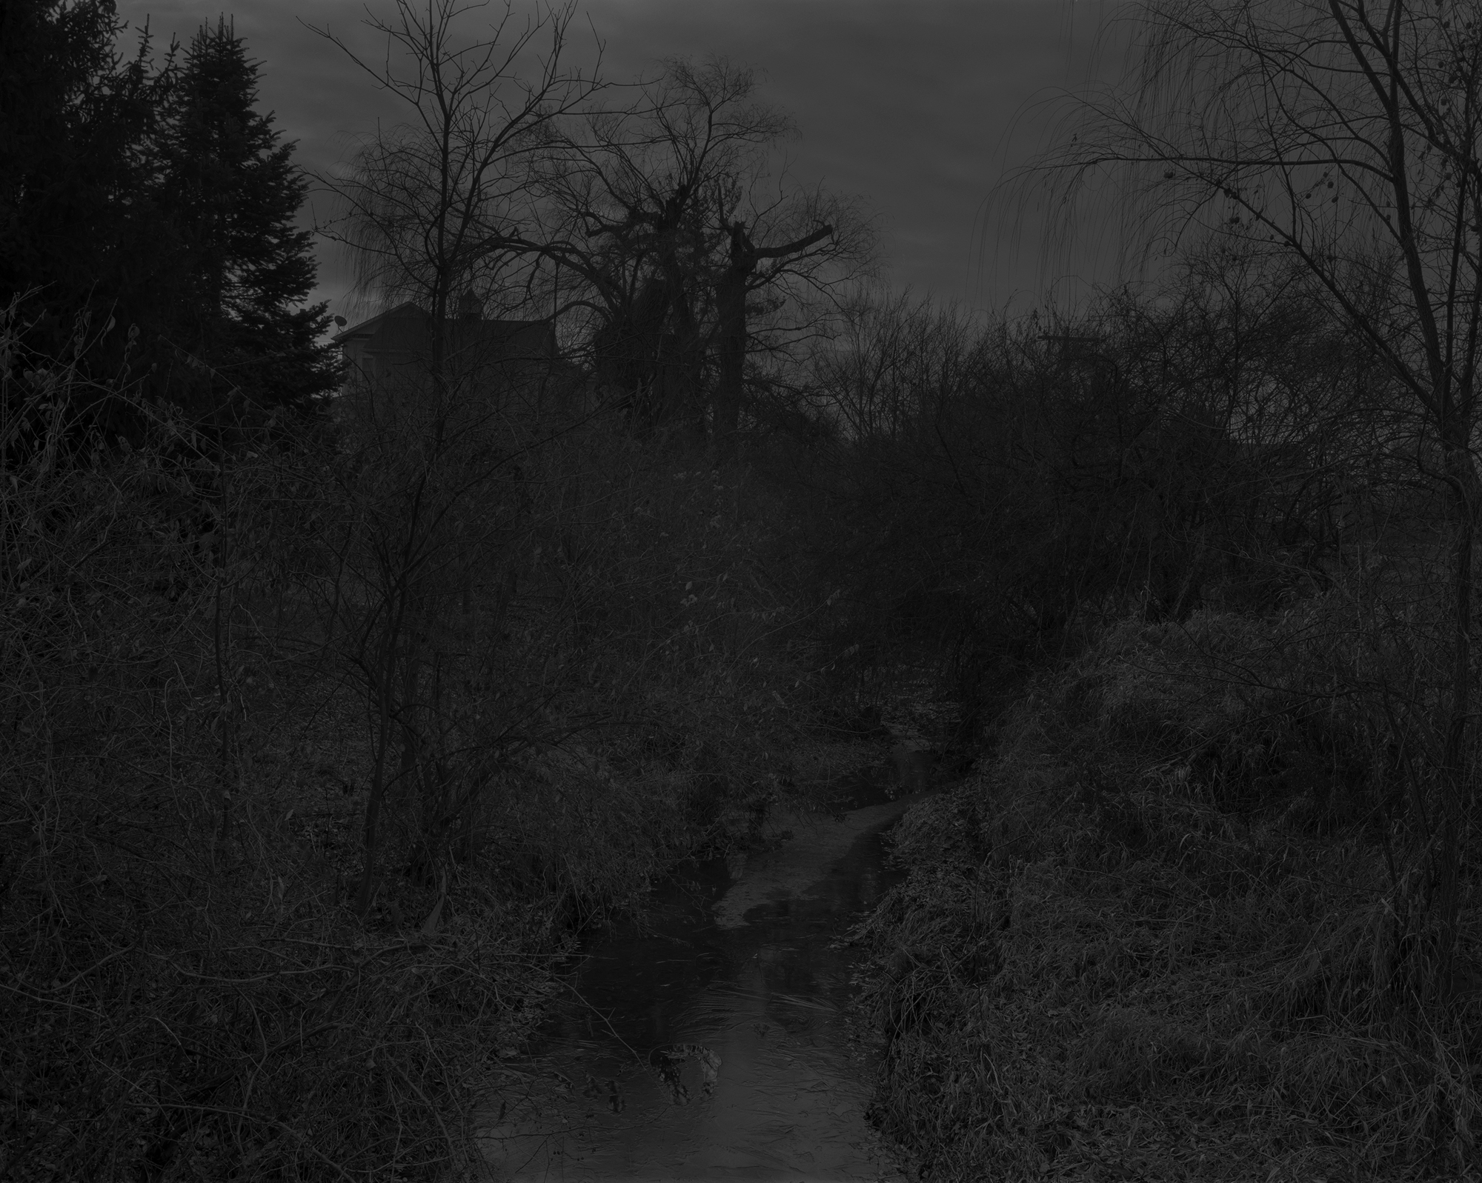

fig. 1
Dawoud Bey, Night Coming Tenderly, Black: Untitled #18 (Creek and House), 2017
Gelatin silver print, 44 by 55 in
Courtesy Rena Bransten Gallery

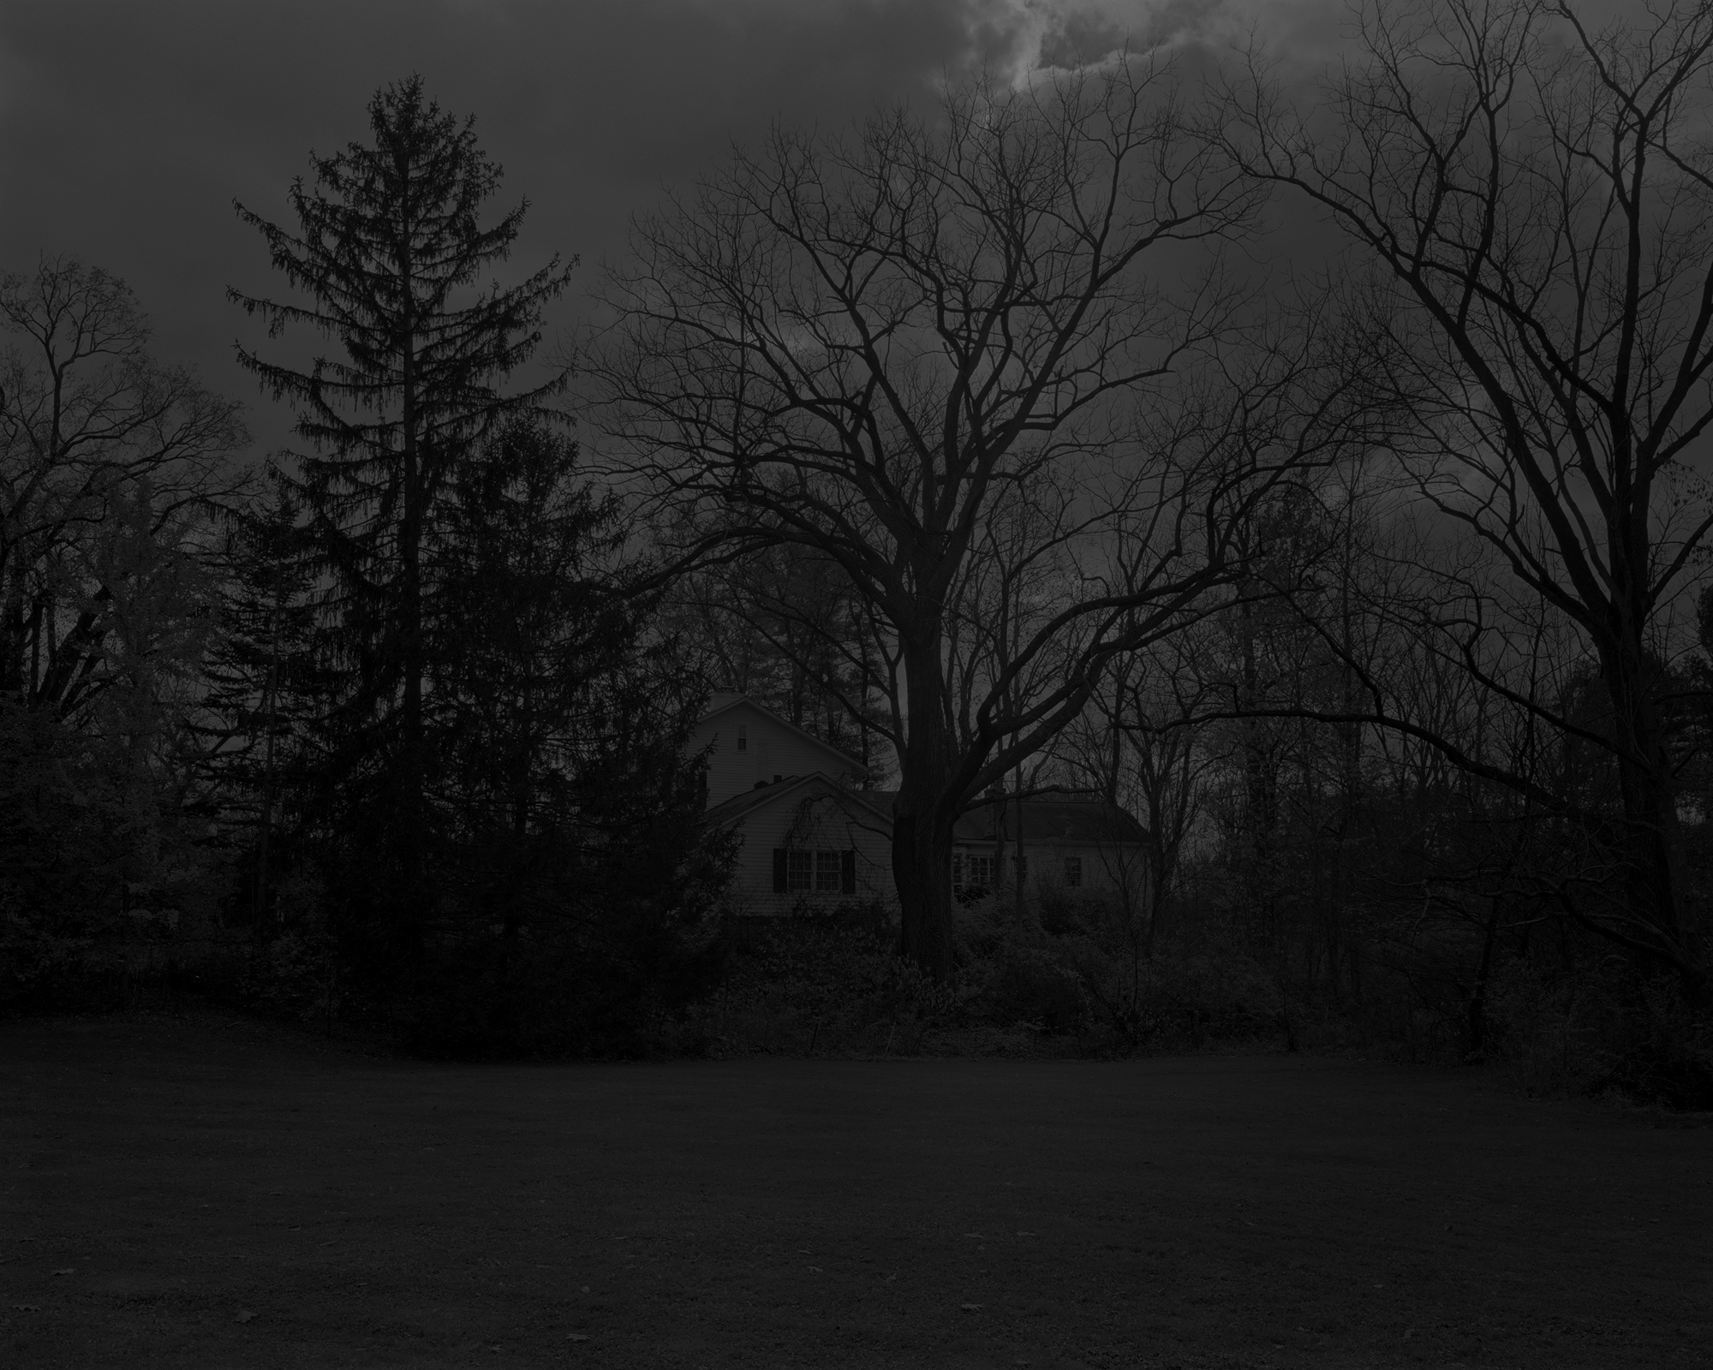

fig. 2
Dawoud Bey, Night Coming Tenderly, Black: Untitled #14 (Site of John Brown’s Tannery), 2017
Gelatin silver print, 44 by 55 in
Courtesy Rena Bransten Gallery

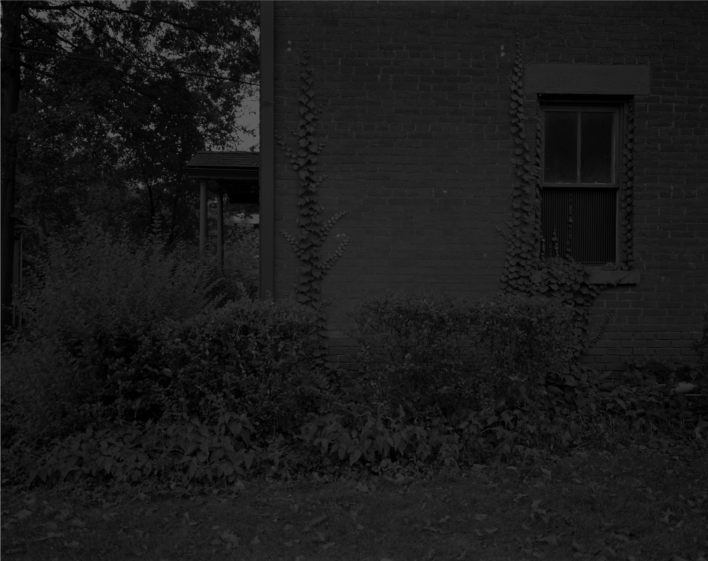

fig. 3
Dawoud Bey, Night Coming Tenderly, Black: Untitled #3 (Cozad-Bates House), 2017
Gelatin silver print, 44 by 55 in
Courtesy Rena Bransten Gallery

fig. 4
Dawoud Bey, Night Coming Tenderly, Black: Untitled #17 (Forest), 2017
Gelatin silver print, 44 by 55 in
Courtesy Rena Bransten Gallery

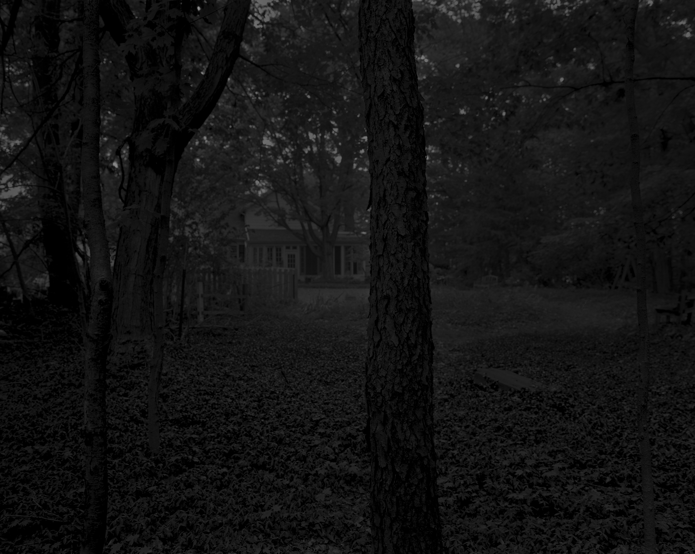

fig. 5
Dawoud Bey, Night Coming Tenderly, Black: Untitled #2 (Trees and Farmhouse), 2017
Gelatin silver print, 44 by 55 in
Courtesy Rena Bransten Gallery

fig. 6
Dawoud Bey, Night Coming Tenderly, Black: Untitled #9 (The Field), 2017
Gelatin silver print, 44 by 55 in
Courtesy Rena Bransten Gallery

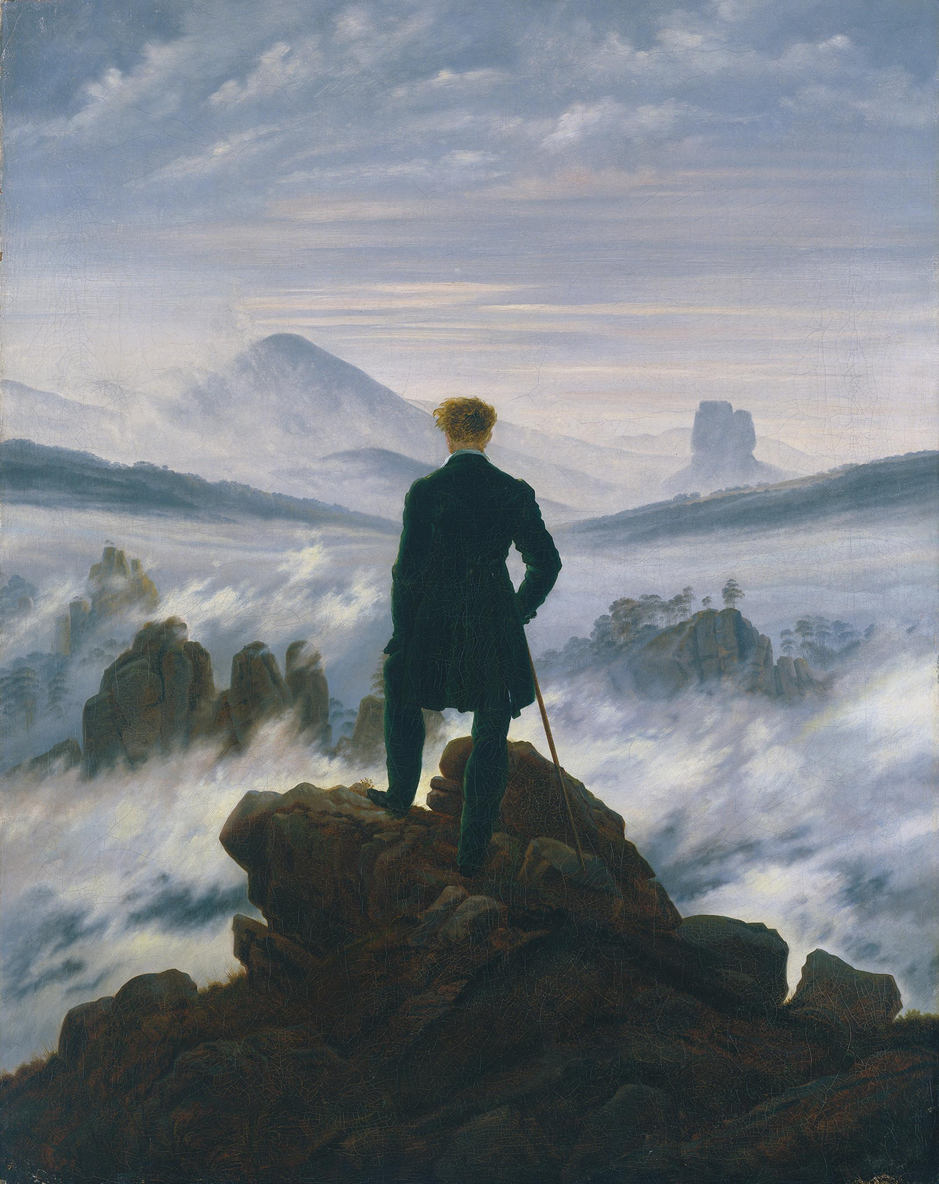

fig. 7
Caspar David Friedrich, Wanderer above the Sea of Fog, 1818
Oil on canvas, 94.8 x 74.8 cm
Courtesy Hamburger Kunsthalle

fig. 8
Dawoud Bey, Night Coming Tenderly, Black: Untitled #25 (Lake Erie and Sky), 2017
Gelatin silver print, 44 by 55 in
Courtesy Rena Bransten Gallery

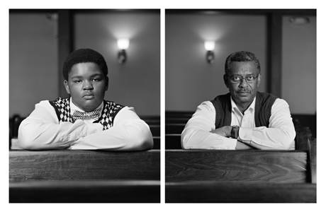

fig. 9
Dawoud Bey, The Birmingham Project: Trentin Williams and Willie Robinson, 2012
Archival pigment prints mounted to dibond, 40 x 64 in.
Courtesy Rena Bransten Gallery

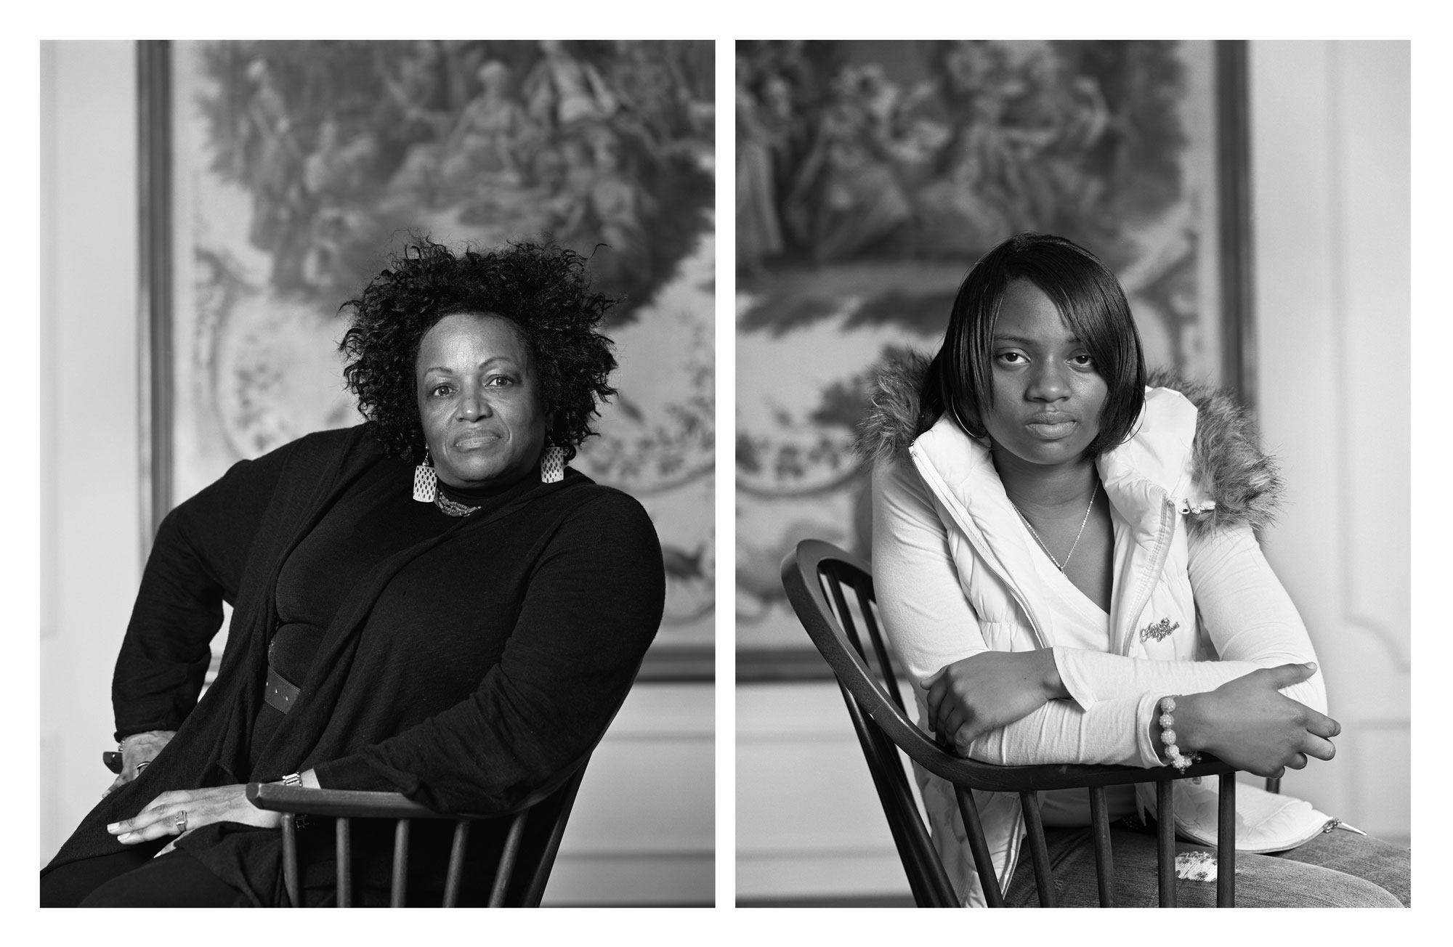

fig. 10
Dawoud Bey, The Birmingham Project: Maxine Adams and Amelia Maxwell, 2012
Archival pigment prints mounted to dibond, 40 x 64 in.
Courtesy Rena Bransten Gallery

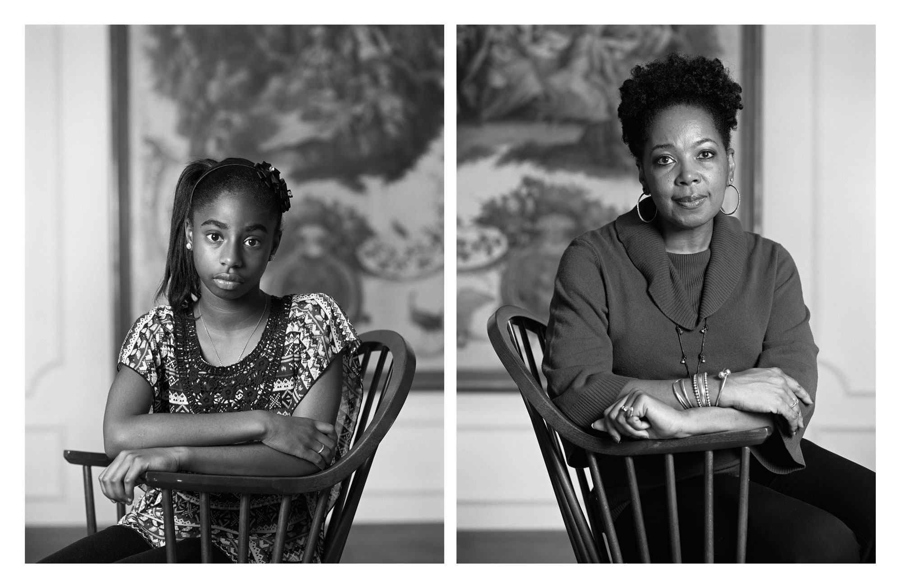

fig. 11
Dawoud Bey, The Birmingham Project: Taylor Falls and Deborah Hackworth, 2012
Archival pigment prints mounted to dibond, 40 x 64 in.
Courtesy Rena Bransten Gallery

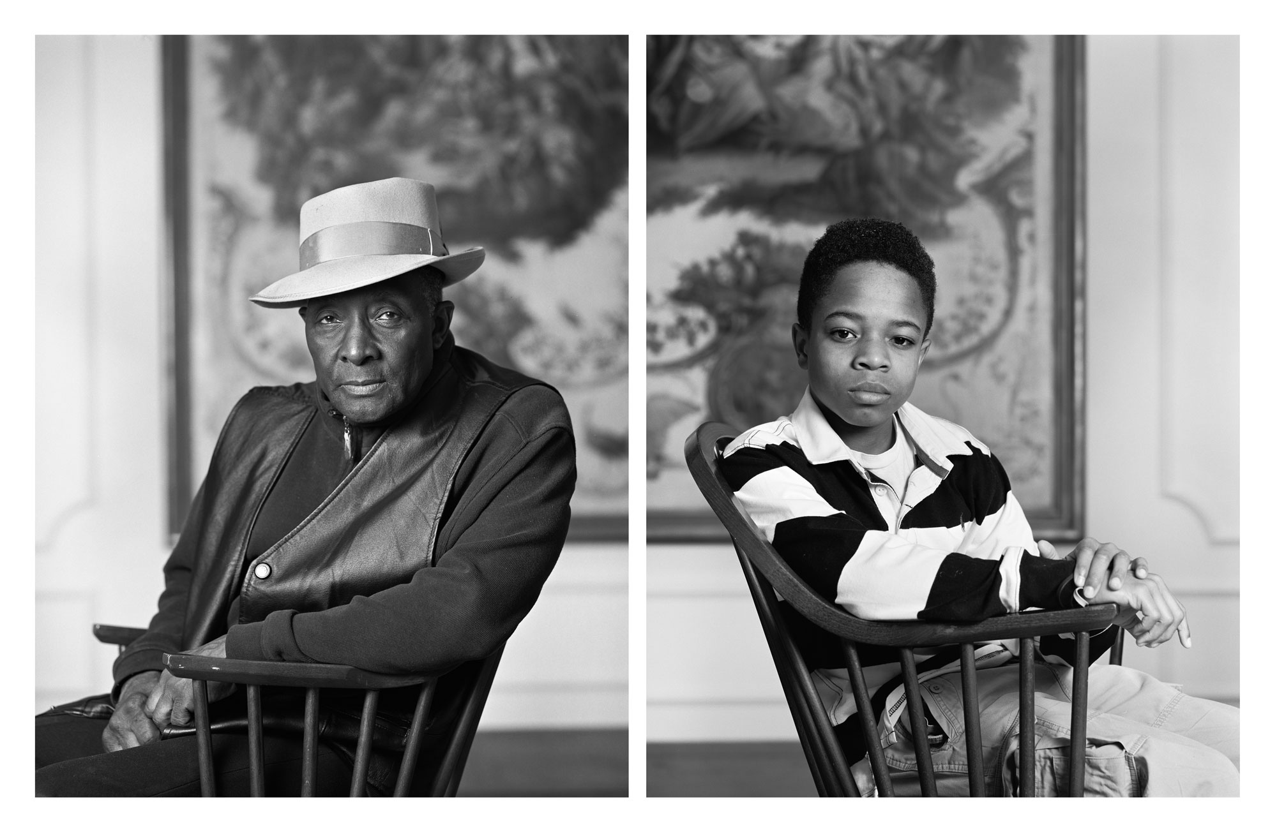
fig. 12
Dawoud Bey, The Birmingham Project: Fred Stewart II and Tyler Collins, 2012
Archival pigment prints mounted to dibond, 40 x 64 in.
Courtesy Rena Bransten Gallery

CITED LITERATURE
“About the Cozad-Bates House.” Restore Cleveland Hope, n.d. http://www.restoreclevelandhope.com/cozad-bates-house/.

Berger, Maurice. ‘Reimagining a Tragedy, 50 Years Later’, The New York Times. https://lens.blogs.nytimes.com/2013/09/13/reimagining-a-tragedy-50-years-later/

“Birmingham: 'My God, You're Not Even Safe in Church'.” Newsweek, September 30, 1963.

Bloom, Paul. Against Empathy: the Case for Rational Compassion. Londres: Vintage, 2018.

Bury, Louis. “Making Interiority Visible: Dawoud Bey Interviewed by Louis Bury.” BOMB, April 5, 2019. https://bombmagazine.org/articles/making-interiority-visible-dawoud-bey-interviewed/.

Copeland, Huey. Bound to Appear: Art, Slavery, and the Site of Blackness in Multicultural America. University of Chicago Press, 2013.

Demos, TJ. "Life Full of Holes." Grey Room 24 (2006): 72-87. 2006. doi:10.1162/grey.2006.1.24.72.

Eskew, Glenn T. (1997) But for Birmingham: the local and national movements in the civil rights struggle. 1st edn. University of North Carolina Press: Chapel Hill, NC.

Freud, Sigmund. “The Splitting of the Ego in the Process of Defense.” Philosophical Explorations, n.d. http://braungardt.trialectics.com/projects/psychoanalysis/sigmund-freud/splitting-of-the-ego/.

Fusco, Coco. "Racial Time, Racial Marks, Racial Metaphors." In Only Skin Deep: Changing Visions of the American Self, edited by Brian Wallis, 13-50. New York: Abrams, 2003.

Gaines, Alisha. Black for a Day: White Fantasies of Race and Empathy. Chapel Hill: The University of North Carolina Press, 2017.

Hegel, G.W.F. Hegel: Elements of the Philosophy of Right. Edited by Allen W. Wood. Translated by H.B. Nisbet. Cambridge, MA: Cambridge University Press, 1991.

Hughes, Langston. “Dream Variations.” Poets.org, n.d. https://poets.org/poem/dream-variations.

Kant, Immanuel. The Critique of Judgment. Translated by J.H. Bernard. New York: Prometheus Books, 2000.

Koerner, Joseph Leo. Caspar David Friedrich and the Subject of Landscape. London: Reaktion, 1990.

Koss, Juliet. “On the Limits of Empathy.” The Art Bulletin 88, no. 1 (2006): 139–57. https://doi.org/10.1080/00043079.2006.10786282.

Lanzoni, Susan. Empathy: A History. New Haven: Yale University Press., 2018.

Love, Heather. Feeling Backward: Loss and the Politics of Queer History. Cambridge, MA: Harvard University Press, 2009.

Lukacs, Georg. History and Class Consciousness. Cambridge, MA: The Merlin Press Limited, 1971.

Marx, Karl. The Eighteenth Brumaire of Louis Bonaparte. Translated by Daniel De Leon. New York: International Publishing Company, 2003. http://www.slp.org/pdf/marx/eighteenth_brum.pdf.

Marx, Karl. A Contribution to the Critique of Political Economy. Translated by S.W. Ryazanskaya. Marxists.org, 1999. https://www.marxists.org/archive/marx/works/download/Marx_Contribution_to_the_Critique_of_Political_Economy.pdf.

“May 1, 1992 | Rodney King Asks, ‘Can We All Get Along?’” The New York Times, May 1, 1992. https://learning.blogs.nytimes.com/2012/05/01/may-1-1992-victim-rodney-kings-asks-can-we-all-get-along/.

McWhorter, Diane. Carry Me Home: Birmingham, Alabama, the Climactic Battle of the Civil Rights Revolution. New York: Simon & Schuster, 2013.

Mills, Charles W. The Racial Contract. Ithaca, NY: Cornell University Press, 1999.

Nielsen, Erik. “On The Run: Interview with Dawoud Bey.” Musée, April 1, 2019. https://museemagazine.com/features/2019/4/1/on-the-run-interview-with-dawoud-bey.

Raiford, Leigh. ‘Photography and the Practices of Critical Black Memory’, History and Theory, 48(4), p112-129.

Reed, Adolph L. “Marx, Race, and Neoliberalism.” New Labor Forum 22, no. 1 (January 1, 2013): 49–57.

Rousseau, Jean-Jacques. (1920) The social contract: & discourses. J.M. Dent & Sons: New York.

Sayej, Nadja. "The Birmingham Project: Behind Dawoud Bey's Haunting Portraits." The Guardian. October 9, 2018. https://www.theguardian.com/artanddesign/2018/oct/09/dawoud-bey-the-birmingham-project-photo-series.

Snyder, Terri. "Suicide, Slavery, and Memory in North America." Journal of American History 97, no. 1 (June 2010): 39-62. doi:10.2307/jahist/97.1.39.

Taylor, Keeanga-Yamahtta. “Race, Class, and Marxism.” SocialistWorker.org, January 4, 2011. https://socialistworker.org/2011/01/04/race-class-and-marxism.

Watson, Bruce. “Black Like Me, 50 Years Later.” Smithsonian Magazine, October 2011. https://www.smithsonianmag.com/arts-culture/black-like-me-50-years-later-74543463/#fKHV1VPrzhZ07Xk1.99.

Wickens, Joseph. "St. John's Episcopal Church." Cleveland Historical. April 16, 2014. https://clevelandhistorical.org/items/show/652?tour=44&index=1.

Wilderson, Frank B. Red, White & Black: Cinema and the Structure of U.S. Antagonisms. Durham: Duke University Press, 2010.

VITA
NAME Isabelle Martin

EDUCATION B.A., Art History & Visual Studies (Minor: Music Performance), University of Kentucky, Lexington, Kentucky, 2018

M.A., Art History, University of Illinois at Chicago, Chicago, Illinois, 2019

EXPERIENCE Teaching Assistant, University of Illinois at Chicago, Global Asian Studies, Chicago, IL, August 2019 – December 2019

Curatorial and Exhibitions Graduate Assistant, University of Illinois at Chicago, Gallery 400, Chicago, IL, May 2019 – August 2019

Graduate Reference Assistant, University of Illinois at Chicago, Richard Daley Library IDEA Commons, Chicago, IL, February 2019 – present

Development Intern, United States Artists, Chicago, IL, August 2018 – June 2019

Curatorial Intern, Faulkner-Morgan Archive, Lexingotn, KY, January 2018 – May 2018

AWARDS & Fall 2019 President’s Research in Diversity Travel Award, University of
HONORS Illinois, November 2019.

2019 Hillary Chute Award for Best Graduate Student Conference Presentation, Comics Studies Society Graduate Student Caucus, May 2019.

53rd Annual Oswald Research and Creativity Competition, First Prize – Humanities-Critical Category, University of Kentucky, December 2017.

CONFERENCES & Presenter, “Fugitivity and Disavowal in Dawoud Bey’s Night Coming
SYMPOSIA Tenderly, Black,” Twelfth Biennial Bryn Mawr College Graduate Group Symposium, Bryn Mawr, PA, November 16, 2019.

Presenter, “Disappearance and Disavowal in Dawoud Bey’s Night Coing Tenderly, Black,” UIC School of Art and Art History BA and MA Symposium, Chicago, IL, May 3, 2019.

Presenter, “Becoming Boat People: The Theme of Water and the Construction of Refugee Subjectivity in Thi Bui’s The Best We Could Do,” 2019 International Comic Arts Forum (ICAF), Davenport, IA, April 6, 2019.

Presenter, “Reconstructing Memory and History: The Role of Photographs in Thi Bui’s The Best We Could Do,” 2019 MSU Comics Forum, East Lansing, MI, February 22, 2019.

Presenter, “‘The Weight of Their Past’: Reconstructing Memory and History Through Reproduced Photographs in Thi Bui’s Graphic Novel The Best We Could Do,” 2018 Comics Arts Conference, San Diego Comic-Con, San Diego, CA, July 21, 2018.

Presenter, “Visions of Infinity: Singularity, Proliferation, and Transcendence in Yayoi Kusama’s Infinity Mirror Rooms,” 7th Annual Virtual Ability Mental Health Symposium 2018: “I Am Not My Illness: Identity and Mental Health,” Virtual Ability Island, Second Life, April 21, 2018.

Co-chair and Organizer, “Politics and Aesthetics: An Interdisciplinary View,” Student Organization for Art History Undergraduate and Graduate Symposium, Lexington, KY, April 15, 2018.

Presenter, “Outside and Between: Networks of Invisibility in David Hammons’s Concerto in Black and Blue,” 45th Annual Midwest Art History Society (MAHS), Indianapolis, IN, April 7, 2018.

Presenter, “A Single Particle Among Billions: Yayoi Kusama and the Power of the Minute,” Southeastern College Art Conference (SECAC), Columbus, OH, October 28, 2017.

Presenter, “Fallen and Forgotten: The Role of Orange is the New Black in the Age of Racial Justice Movements,” First Annual Kentucky Gender and Women’s Studies Conference, Lexington, KY, September 16, 2017.

EXHIBITIONS Curatorial Assistant, “The Last Judgment/El Juicio Final,” Gallery 400, University of Illinois at Chicago, August 27 – November 23, 2019.

Co-Organizer, “artOUT popOUT: home,” Latino Cultural Center, University of Illinois at Chicago, Chicago, IL, May 2, 2019.

Student Contributor, “Pushing the Envelope: Mail Art from the Smithsonian’s Archives of American Art,” Lawrence A. Fleischman Gallery, Smithsonian American Art Museum, Washington, DC, August 10 – January 4, 2019.

Curatorial Intern, “Out in Plain Sight: Lexington’s LBTQ Places,” Lexington Public Library, Central Branch, Lexington, KY, May 20 – June 30, 2018.

PUBLICATIONS “The Role of Water in the Construction of Refugee Subjectivity in Thi Bui’s The Best We Could Do,” International Journal of Comic Art, vol. 21, no. 1, Spring/Summer 2019.

“Give up Art/Save the Starving” (Mail Art to John Held), Pushing the Envelope: Mail Art from the Archives of American Art, catalogue entry (Washington, DC: Smithsonian, 2018): https://www.aaa.si.edu/exhibitions/pushing-the-envelope/poltical-dissent

“Blue Bodies, Black Shadows: The Politics of Invisibility in David Hammons’s Concerto in Black and Blue,” TransScripts vol. 7: Digital Media and Society, eds. Evan Conaway, Anat Schwartz, and Heather Thomas (University of California, Irvine, 2018): https://www.sites.uci.edu/transscripts/home/current-issue/

SOCIETIES & Member, Comics Studies Society, 2019 - present
ORGANIZATIONS
Member, artOUT (Gallery 400 Student Advisory Committee), 2019

Member & Graduate Student Council Primary Representative, UIC Art History Graduate Student Association, 2018 – present

Member, University of Kentucky Chapter, National German Honor Society (Delta Phi Alpha), 2018

President, University of Kentucky Student Organization for Art History (SOfAH), 2017 – 2018

Member, Midwest Art History Society (MAHS), 2017 – present

Member, Southeastern College Art Conference (SECAC), 2017 – 2019

Glenn T. Eskew, But for Birmingham: The Local and National Movements in the Civil Rights Struggle (Univ. of North Carolina Press, 2000): 53.
Dynamite Hill was a name given to one of Birmingham’s predominantly Black neighborhoods, College Hills, in which Davis spent her childhood. The neighborhood was so named because of the frequency with which bombings occurred there. Ibid., 83.
Louis Bury, “Making Interiority Visible: Dawoud Bey Interviewed by Louis Bury,” BOMB, April 5, 2019, https://bombmagazine.org/articles/making-interiority-visible-dawoud-bey-interviewed/.
Ibid.
Ibid.
Maurice Berger, "Escaping to Freedom, in the Shadows of Night," The New York Times, July 5, 2018, https://www.nytimes.com/2018/07/05/lens/escaping-to-freedom-in-the-shadows-of-the-night.html.
Erik Nielsen, “On The Run: Interview with Dawoud Bey,” Musée, April 1, 2019, https://museemagazine.com/features/2019/4/1/on-the-run-interview-with-dawoud-bey.
Ibid.
Bury, “Making Interiority Visible.”
The Cozad-Bates House was home to the Cozad family, a prominent family in Cleveland that was active in antislavery efforts. Scholars believe the house may have been a stop on the Underground Railroad. “About the Cozad-Bates House,” Restore Cleveland Hope, n.d., http://www.restoreclevelandhope.com/cozad-bates-house/.
It’s unclear whether it is St. John’s Episcopal Church specifically or the city of Cleveland that was known as Station Hope; regardless, St. John’s was indeed a stop on the Underground Railroad. Joseph Wickens, "St. John's Episcopal Church," Cleveland Historical, April 16, 2014, https://clevelandhistorical.org/items/show/652?tour=44&index=1.
Berger, “Escaping to Freedom.”
Frank B. Wilderson, Red, White & Black: Cinema and the Structure of U.S. Antagonisms (Durham: Duke University Press, 2010): 338.
Juliet Koss, “On the Limits of Empathy,” The Art Bulletin 88, no. 1 (2006): pp. 139-157, https://doi.org/10.1080/00043079.2006.10786282, 139.
In the next chapter I work to outline why race, further, cannot be extracted from the history of capitalism and the development of class.
Susan Lanzoni, Empathy: A History (New Haven: Yale University Press., 2018): 208.
TJ Demos, "Life Full of Holes," Grey Room 24 (2006): 81, 2006, doi:10.1162/grey.2006.1.24.72.
Frank B. Wilderson, Red, White & Black: Cinema and the Structure of U.S. Antagonisms (Durham: Duke University Press, 2010): 11.
Kenneth B. Clark in Lanzoni, Empathy: A History, 248.
Lanzoni, Empathy: A History, 5-6.
Wilderson, Red, White & Black, 18.
Lanzoni, Empathy: A History, 6.
Berger, “Escaping to Freedom.”
Huey Copeland, Bound to Appear: Art, Slavery, and the Site of Blackness in Multicultural America (University of Chicago Press, 2013): 4.
Lanzoni, Empathy: A History, 2.
Ibid., 4.
Ibid.
John Howard Griffin in Bruce Watson, “Black Like Me, 50 Years Later,” Smithsonian Magazine, October 2011, https://www.smithsonianmag.com/arts-culture/black-like-me-50-years-later-74543463/#fKHV1VPrzhZ07Xk1.99.
Langston Hughes, “Dream Variations,” Poets.org, n.d., https://poets.org/poem/dream-variations.
Watson, “Black Like Me, 50 Years later.”
Ibid.
Ibid.
Ibid.
Alisha Gaines, Black for a Day: White Fantasies of Race and Empathy (Chapel Hill: The University of North Carolina Press, 2017): 8.
Griffin’s book became sensationalized arguably because of the risk he took in willingly entering the Jim Crow South as a “Black” man, and because it conveyed experiences there that audiences were unwilling to accept from a Black person. Ultimately, though, it posed no solutions for civil rights.
Gaines, Black for a Day, 10.
Lanzoni, Empathy: A History, 14.
Paul Bloom, Against Empathy: The Case for Rational Compassion (Londres: Vintage, 2018): 8.
Ibid., 31.
Ibid., 9.
Ibid., 21.
Ibid.
Clark in ibid., 240.
Wilderson, Red, White & Black, 14.
Wilderson, Red, White & Black, 25.
Immanuel Kant, The Critique of Judgment, trans. J.H. Bernard (New York: Prometheus Books, 2000), 101-102.
Coco Fusco, "Racial Time, Racial Marks, Racial Metaphors," in Only Skin Deep: Changing Visions of the American Self, ed. Brian Wallis (New York: Abrams, 2003): 19-20.
Sigmund Freud, “The Splitting of the Ego in the Process of Defense,” Philosophical Explorations, n.d., http://braungardt.trialectics.com/projects/psychoanalysis/sigmund-freud/splitting-of-the-ego/.
Joseph Leo Koerner, Caspar David Friedrich and the Subject of Landscape (London: Reaktion, 1990): 23.
Ibid., 28.
Ibid., 211.
Kant, The Critique of Judgment, 104.
Ibid., 104.
Wickens, “St. John’s Episcopal Church.”
Terri Snyder, "Suicide, Slavery, and Memory in North America," Journal of American History 97, no. 1 (June 2010): 43, doi:10.2307/jahist/97.1.39.
Ibid., 40.
Ibid., 39.
“Birmingham: 'My God, You're Not Even Safe in Church',” Newsweek, September 30, 1963, pp. 20-23.
A predominantly Black neighborhood of Birmingham called College Hills==childhood home to activist and academic Angela Davis—was also known as “Dynamite Hill,” for its frequent bombings. Eskew, But for Birmingham, 53.
Maurice Berger, “Reimagining a Tragedy, 50 Years Later,” The New York Times, September 13, 2013, https://lens.blogs.nytimes.com/2013/09/13/reimagining-a-tragedy-50-years-later/.
Nadja Sayej, "The Birmingham Project: Behind Dawoud Bey's Haunting Portraits," The Guardian, October 9, 2018, https://www.theguardian.com/artanddesign/2018/oct/09/dawoud-bey-the-birmingham-project-photo-series.
Recall that Davis said the following: “So common were the bombings on Dynamite Hill that the horror of them diminished.” Eskew, But for Birmingham, 83.
Diane McWhorter, Carry Me Home: Birmingham, Alabama, the Climactic Battle of the Civil Rights Revolution (New York: Simon & Schuster, 2013): 519.
By moral-based proposals, I am thinking in particular of Rodney King’s famous phrase, “Can we all get along?” In 1991 Mr. King was brutally beaten by Los Angeles Police Department officers, sparking a series of riots across the city. While his sentiment is an admirable one, the desire for which I believe we can all relate to, it also expresses a utopian belief that things are as simple as that. The Learning Network, “May 1, 1992 | Rodney King Asks, 'Can We All Get Along?',” The New York Times (The New York Times, May 1, 2012), https://learning.blogs.nytimes.com/2012/05/01/may-1-1992-victim-rodney-kings-asks-can-we-all-get-along/.
Jean-Jacques Rousseau, The Social Contract & Discourses (New York: J.M. Dent & Sons, 1920): 16.
Ibid., 14.
Charles W. Mills, The Racial Contract (Ithaca, NY: Cornell University Press, 1999): 15.
Ibid., 4.
Rousseau, The Social Contract, 19.
Ibid., 6.
G.W.F. Hegel, Hegel: Elements of the Philosophy of Right, ed. Allen W. Wood, trans. H.B. Nisbet (Cambridge, MA: Cambridge University Press, 1991): 285.
Ibid., 303.
Ibid., 282.
Here Hegel is specifically addressing the role of the Church as an institution in relation to authority; however, his distinction between feeling and thought is, I think, pertinent to this discussion. We may feel that all persons deserve equal treatment, but unless that idea is protected by the law—a rational, universal (or at least, intended to be) system—its actualization is precarious. Ibid., 299.
Ibid., 310.
Ibid., 310-311.
Ibid., 279.
“Birmingham: 'My God, You're Not Even Safe in Church'.”
Rousseau, The Social Contract, 28.
Hegel, Elements of the Philosophy of Right, 276.
Adolph L. Reed, “Marx, Race, and Neoliberalism,” New Labor Forum 22, no. 1 (January 1, 2013): 54.
Ibid., 49.
Leigh Raiford, “Photography and The Practices Of Critical Black Memory,” History and Theory 48, no. 4 (2009): 114.
Heather Love, Feeling Backward: Loss and the Politics of Queer History (Cambridge, MA: Harvard University Press, 2009): 1.
Hegel, Elements of the Philosophy of Right, 276.
Karl Marx, The Eighteenth Brumaire of Louis Bonaparte, trans. Daniel De Leon (New York: International Publishing Company, 2003), http://www.slp.org/pdf/marx/eighteenth_brum.pdf: 12.
Georg Lukács, History and Class Consciousness (Cambridge, MA: The Merlin Press Limited, 1971): 224.
Engels in ibid., 14-15.
Karl Marx, A Contribution to the Critique of Political Economy, trans. S.W. Ryazanskaya (Marxists.org, 1999), https://www.marxists.org/archive/marx/works/download/Marx_Contribution_to_the_Critique_of_Political_Economy.pdf.
Lukács, History and Class Consciousness, 15.
Reed, “Marx, Race, and Neoliberalism,” 49.
Ibid., 50.
Ibid.
Ibid., 51.
Lukács, History and Class Consciousness, 224-225.
Reed, “Marx, Race, and Neoliberalism,” 52.
Ibid., 53.
Keeanga-Yamahtta Taylor, “Race, Class, and Marxism,” SocialistWorker.org, January 4, 2011, https://socialistworker.org/2011/01/04/race-class-and-marxism.
Lukács, History and Class Consciousness, 224-225.
Nielsen, “On the Run.”

