Mapping a World of Urban Planning Literature: GIS Analysis to Address Equity Gaps in a Library Collection
Benjamin Grantham Aldred
This is an Accepted Manuscript of an article published by Taylor & Francis in Journal of Map and Geography Libraries on July 6, 2022 available at: https://www.tandfonline.com/doi/full/10.1080/15420353.2022.2091079.
Abstract: Where does one look to study cities around the world? How does a librarian build a collection that moves beyond a limited Western focus to incorporate post-colonial and indigenous experiences? And how can such analysis be automated to allow practitioners at disparate institutions to diversify their own collections? These questions are important as Urban Planning tries to incorporate a variety of practices in human settlement from across the world.
Building on previous research related to an Urban Planning book collection, this study uses GIS analysis to address DEI questions on a global scale by highlighting disparities in scholarly focus. By analysing the geographic subject content of top journal articles in the field of Urban Planning in comparison to books within the library, the study examines ways that a collection can address gaps in analysis of human settlements around the world, especially in the global south.
These analyses are then used to guide collection development, building a global focus in the book collection, filling in gaps that may arise from limits in the current journal coverage. Material is analysed both in the specific collection, but also in the larger scholarly community, comparing the specific gaps in the collection to larger gaps in the scholarship of Urban Planning.
In addition to the primary study, this article includes details about using Excel macros for textual analysis of a corpus of metadata, with instructions for how to use these open-source macros to do analysis at a variety of institutions.
Keywords: collection development; DEI; geoparsing; geocoding

Introduction
Developing a collection to support an academic program involves balancing many different goals. The librarian must make sure the collection is timely, useful, accessible and authoritative. In the 21st Century, librarians have increasingly recognized an additional goal in collection development: seeking to improve diversity, equity and inclusion (DEI) within a collection by bringing in perspectives that allow for a more holistic and intersectional understanding of a given subject. While this goal has been explored in contexts such as large academic libraries (Cruz 2019; Ciszek and Young 2010) and in academic subjects such as Indigenous Studies (Vasquez-Fernandez et al. 2017), fields where collection decisions are based on geographic subject information can provide challenges, as it can be difficult to identify what DEI means in those situations. However, looking to the subjects themselves can provide additional guidance.
In the field of Urban Planning, significant efforts are underway to ‘de-colonize’ the field, focusing on gaps in the research and teaching landscape that show the long-term legacy of colonialism. These efforts include things like teaching courses on approaches to city design rooted in the practices of the Global South (used in this paper to refer to countries outside of Europe and North America), bringing in global scholars from diverse backgrounds, and facilitating international knowledge exchange. To the field of Urban Planning, one major component of DEI is the process of de-colonization.
The de-colonizing model provides librarians both a method for moving forward and a challenge, as these academic programs need access to relevant resources to support de-colonization efforts, so that faculty can perform research and students can access material for classes and projects. This puts pressure on the libraries that support those programs to have diversified collections that match the communities they support.
This presents a potential goal for research, to find a way to assess a collection’s geographic diversity. Can a collection’s subject matter be assessed for representation of the Global South in a way that supports the DEI efforts of an Urban Planning Program? This study seeks to provide a methodology for collection analysis that can identify geographic gaps and explore whether those gaps can be filled through conventional collection development methods. The study builds on a 2019 study of the collection of books related to Urban Planning at the University of Illinois Chicago (Aldred 2019). That study showed how to use geographic annotation to create visualizations of the subject matter of a collection. These visualizations could be used to guide collection decisions, both purchasing and weeding. However, the human annotation process proved time consuming when applied to a large corpus of texts and was not easily replicable. Additionally, the study only considered a single collection of owned texts, while the library exists in a larger publishing context.
This study seeks to address both of those limitations to make such studies available to a larger population. Related to time and replicability, a method of text mining for geographic terminology using Excel macros was created. With this approach, analysis of an additional corpus of texts for comparison was possible, allowing the comparison of contemporary journal literature with the collection of books, placing the available geographic information in context, allowing more nuanced collection decisions.
Overall, the goals of this study are to highlight the need for active collection development to prevent neglect of international approaches to Urban Planning. Approaches taken in Indigenous settlements and post-colonial cities can provide valuable perspectives and methodologies suited to diverse needs, especially in the face of challenges such as climate change and political instability. Visualizing gaps in coverage can make the process of improving DEI within collections easier for all libraries. And this study addresses the question of whether these goals can be met by librarians alone. Are there even materials to fill these gaps and what can librarians and library users do to help fill those needs?

Literature Review
Prior research touched on several aspects of this study, in the 2019 article (Aldred 2019) a review of the literature supported library access to geographic analysis software (Abresch 2008; Bishop and Mandel 2010; Lafia 2016) and a need for geographic scope related to patron needs (Jones et al 2008; Sanderson and Han 2007). Several additional considerations were examined within the literature for consideration related to expanded research.
First, there is extensive work in the field of Urban Planning on addressing biases and ‘de-colonizing’ the field (Andres et al 2009; Cilliers 2020; Wesely and Allen 2019; Garcia 2021; Watson 2009a; Watson 2009b; Watson 2016; Watson 2019; Robinson 2016; Miraftab 2009; Hirsh 2020). This literature points to the need for more focus on knowledge practices of the Global South and the post-colonial world, including increasing educational resources and developing international scholarly networks. Developing such inclusive programs require supporting resources within the library field, as the accreditation process requires analysis of available information resources and in general, there is a desire within the field for a greater variety of voices.
This trend in the research points toward the goal of creating a diversified collection, but also opens the deeper question ‘how does one know the biases within the collection?’ In designing an approach for such analysis, the focus on visualizing a collection allows for a broader perspective on the collection that can perform such analysis.
Second, the literature shows there is technical support for the development of text mining tools for geospatial information, also known as geoparsing. Studies have examined tools such as XML markup language, Java APIs, and web-based tools, identifying multiple approaches that each have strengths and weaknesses. (Leidner and Lieberman 2011; Leidner 2006). Studies have been conducted on a variety of text corpora, including geology research (Leveling 2015), social media (Middleton et al. 2018; Zhang and Gelernter 2014), newspaper archives (Yzaguirre, Smit, and Warren 2016) and medical research (Acheson and Purves 2021), showing that geoparsing can be done across fields for a variety of goals. Variously, these approaches have shown that there is useful information that can be gained by automated geoparsing and accompanying geocoding, allowing this information to be mapped.
By creating a tool that can be shared for librarians to use on local collections, this can be shared out to allow this analysis to happen on a larger, decentralized scale, allowing programs around the world to diversify their collections. Geoparsing and geocoding are known approaches that can open a collection for analysis if a tool can be developed to support the process.
Together, these findings support the approach in this study, a shareable tool for automated geoparsing and geocoding, with the goal of increasing geographic diversity within a collection supporting an Urban Planning program.

Methods
This study follows the model established in the prior study. In the 2019 study (Aldred 2019), a corpus of books from the collection at the University of Illinois Chicago was examined to determine geographic subject matter. Examining several fields from MARC records, specifically title, subject headings, table of contents and notes, the author noted mentions of geographic terms within a spreadsheet. For example, the book Urban Achievement in Early Modern Europe: Golden Ages in Antwerp, Amsterdam, and London was annotated to include mentions of Antwerp, Amsterdam, and London. These mentions were then matched to geographic coordinates for cities, countries, and in the case of North America states and provinces. These annotations were mapped in ArcGIS to visualize the scope of the collection. This information was then analysed to determine strengths and gaps in the collection and materials were ordered to fill several international gaps and strengthen the collection.
In the 2019 study, this was done by human annotation of individual fields, which was highly accurate, but time consuming. To address this issue and improve replicability, this study seeks to duplicate the process in Microsoft Excel using custom built macros as seen in Figure 1. While several tools were examined, including Python and JavaScript based toolkits for geoparsing, Excel had several advantages for this study. First, Excel works well with information formatted as a spreadsheet, which was both the input from the library catalog and Web of Science and the output for use in ArcGIS. Second, Excel is widely available at a range of institutions and does not require advanced training, which makes it more accessible. These macros are available at https://github.com/BenjaminAldred/GeographicTextMining.
[Figure 1- Example macros used to geoparse locations from library catalog records.]
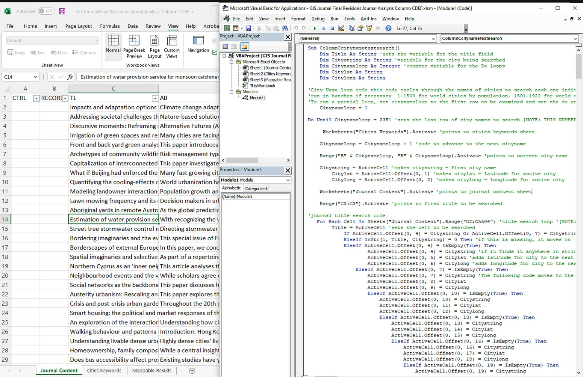
The macros each used the following process. For the search process, city details were obtained from geonames.org and converted to Excel format, a list of cities was created using a mixture of methods. First, the list included the 1,500 most populous world cities with no filter for country. Second, to ensure evaluation of urban areas in less populated countries, the two most populous cities for each country in the world were added, if not already present. Third, given the geographic focus of the collection to be analyzed, the 428 most populous US cities (all US cities over a hundred thousand population) were added. In creating a list of this length, the goal was to balance a manageable size of datapoints, given the time and computing power necessary to run a long list of names, with an appropriately comprehensive set of options. While the list did not include smaller urban areas, especially in countries without large cities, the risks of false negatives (worst case scenario, an area is slightly less underrepresented than it seems and the diversity of the collection is improved) were considered low enough that the list was limited. Separate macros were created for each potential text field to allow comparison of results.
- Set the current search string to a specific city name using the list of cities
- Compare current search string to the text of the specified search field (title, abstract, etc.) in the first text.
- If search string is present within search field, add note to results section along with geographic coordinates.
- Move to specified search field in next text.
- Repeat until last text in list.
- Set search string to next city on list of cities
- Repeat until set number of cities reached.
After the initial set of results was produced with the first set of macros, a secondary macro was used to collate results into a single mappable dataset. This dataset was produced by copying each individual place name and coordinates into a separate sheet on the spreadsheet, along with the corresponding title information for quality control purposes.
The geoparsing process had several quirks that needed to be addressed, in many cases through human annotation which consisted of examining the mappable results dataset and comparing annotation results to the associated title.

City Names and Common Words
For example, Rome within promenade. To solve this problem, I added spaces at the beginning and end of some city names to avoid false positives. The largest problems were Lomé, Togo which in ascii text appears within the word agglomeration, and Mobile, Alabama for the common word mobile A linked problem came from cities named York, which gave false positives for every mention of New York City, and Ontario, California for the Canadian province, which required human annotation.

The Springfield Problem
The United States has 12 cities named Springfield, six of them over a hundred thousand in population. For these, the text mining method took two approaches. First, search strings were added with a comma and first letter of state name, leaning on the likelihood that these will be disambiguated in the text itself. Second, human annotation was added for these names to clarify individual Springfields/San Juans/Santiagos.

City Names with Personal Names
For example, Allen, Texas had false positives when a personal name Allen was mentioned. This process required human annotation.

Non-Adjectival Forms and Old City Names
Rome vs Roman, St. Petersburg vs. Leningrad, this issue remains an ongoing issue and would require the addition of new search strings related to many different cities. However, a general examination did not show a significant number of false negatives from this gap.

Language Limitations
The names of cities were represented solely in English. The collections being examined were almost entirely in English, but this did limit location identification in non-Western scripts and alternate names. This could be addressed with expanding the list of cities using alternate names but would greatly expand the runtime of the macros.
These macros were applied to two datasets. First, a collection of 10 years of journal articles. This set was pulled from Web of Science and included titles and abstracts and subject headings for all articles for the top 16 journals listed in Urban Planning, a total of 6,265 articles.
Second, a collection of books and e-books from the University of Illinois Chicago Library, in the LC ranges of HT51 through HT399, a total of 5,447 titles after deduplication. For these materials, the Title (245), Contents (505) and General Note (500) fields were pulled from the MARC records for examination. Examining only these fields prevented false positives based on publisher and focused on the fields with the most geographic content. This dataset was originally analysed by human annotation for the 2019 study but was re-examined using the automated method for consistency purposes.
The geographic annotation macros produced 3,652 initial results for the journal collection and 1,807 initial results for the book collection. Human annotation of the journal results for false positives resulted in the removal of 375 false positives and the disambiguation of 8 ambiguous positives. Human annotation of the book results for false positives resulted in the removal of 527 false positives and the disambiguation of 10 ambiguous positives. These results were then converted into csv format to import into ArcGIS Pro for geographic analysis.

Results
Initial results, as seen in Figure 2, show two different but very similar datasets.” . They show significant overlap, but do not necessarily show specific details. On a base level, these results seem promising, there are cities in all areas of human habitation, while there are large gaps in the map, they match areas without sizable human settlements, the Sahara Desert, the Amazon rainforest, Siberia. These maps represent a sample of available information, one of the advantages of using ArcGIS is the ability to view the map at different scales, allowing detailed examination by continent or region.
[Figure 2- Mapped results of place names identified in book and journal Urban Planning collections]
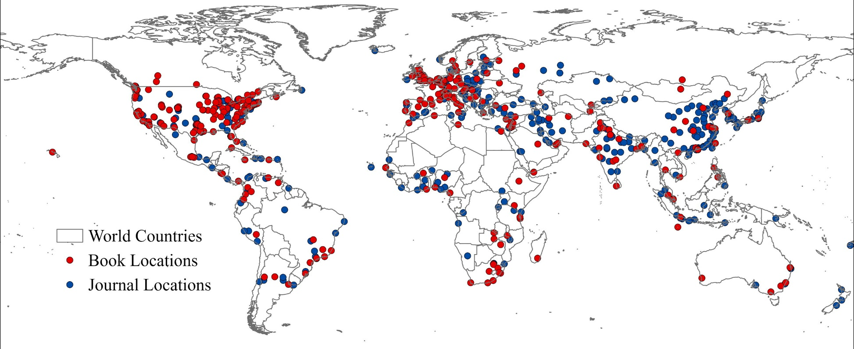
More information emerges using advanced mapping tools. Choropleth maps, seen in Figure 3, were created to compare the number of cities within different countries. These maps show several similarities and differences between the datasets. While both have significant collections in the USA, UK, China, India and Germany, there are a few disparate areas of strength. Journal articles have more information about Oceania and Southeast Asia, books have more information related to North Africa and Eastern Europe. But both show notable gaps in Sub-Saharan Africa and parts of South and Central America, with many countries portrayed in white, representing less than 2 mentions.
[Figure 3- A choropleth map of locations identified in Urban Planning book and journal collections ] 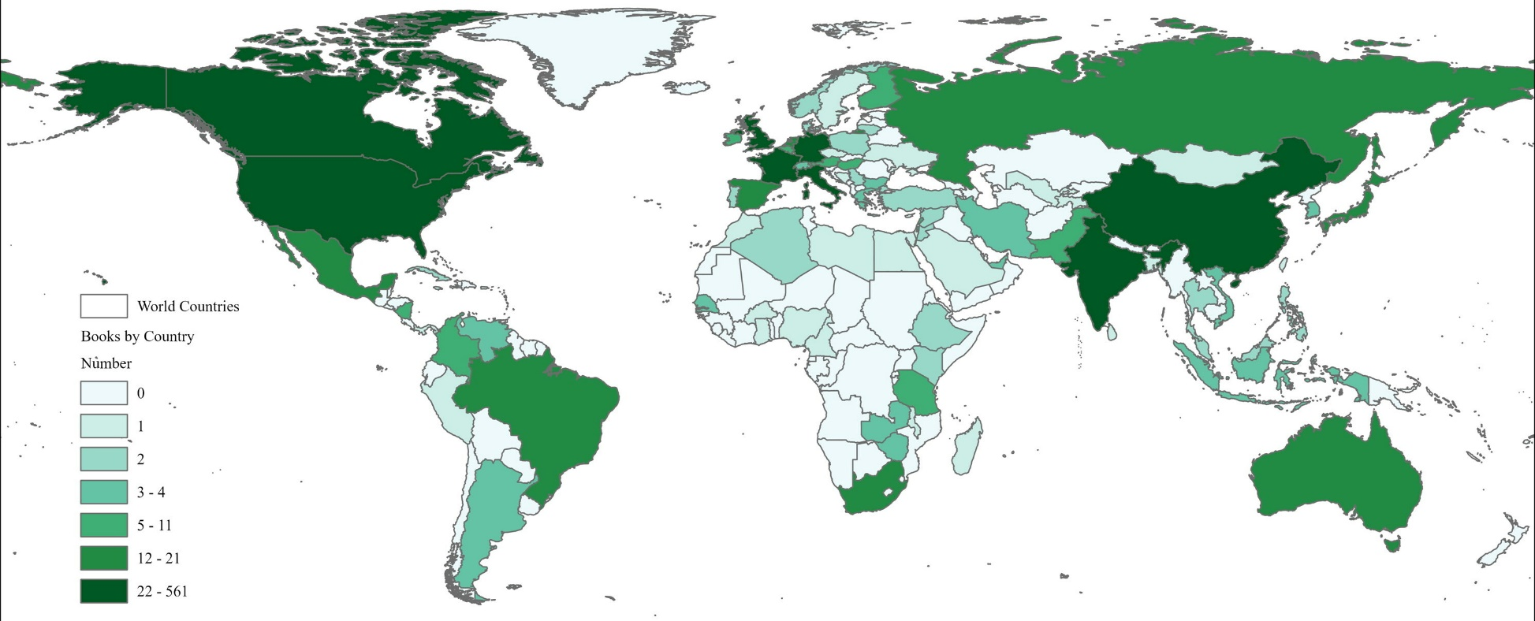
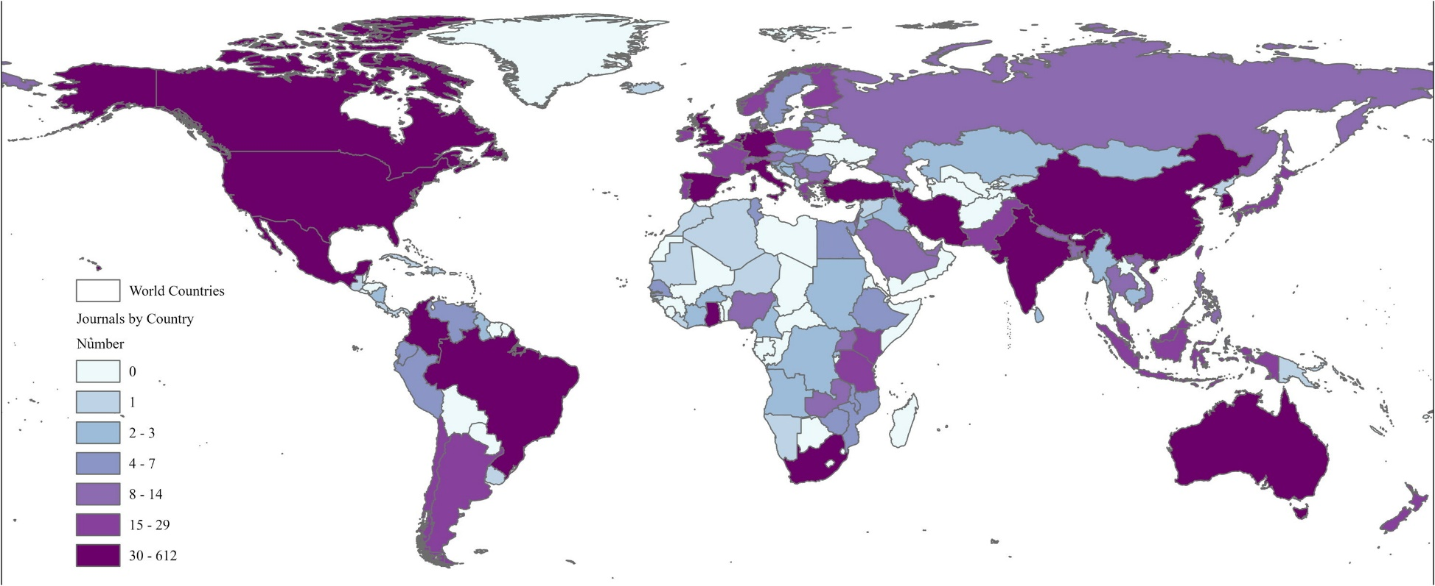
Using the heatmap function, shown in Figure 4, also gives a sense of regional strengths within the collections and further highlights several differences between them. The book collection has a distinct Chicago focus, an artifact of being from a program located in Chicago. The heatmap also surfaces the number of materials in the journal collection around nations that are hard to see in a world map, like Cabo Verde, Fiji, or the Bahamas.
[Figure 4- A choropleth map of locations identified in Urban Planning book and journal collections]
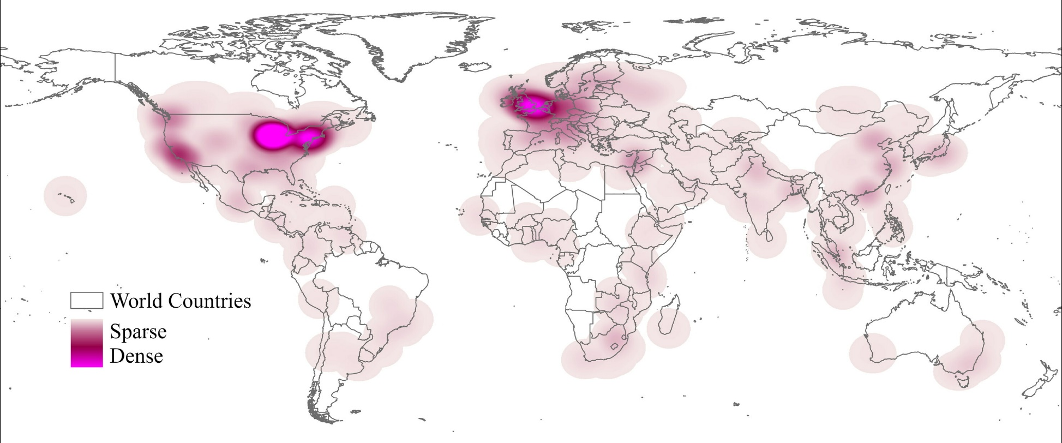
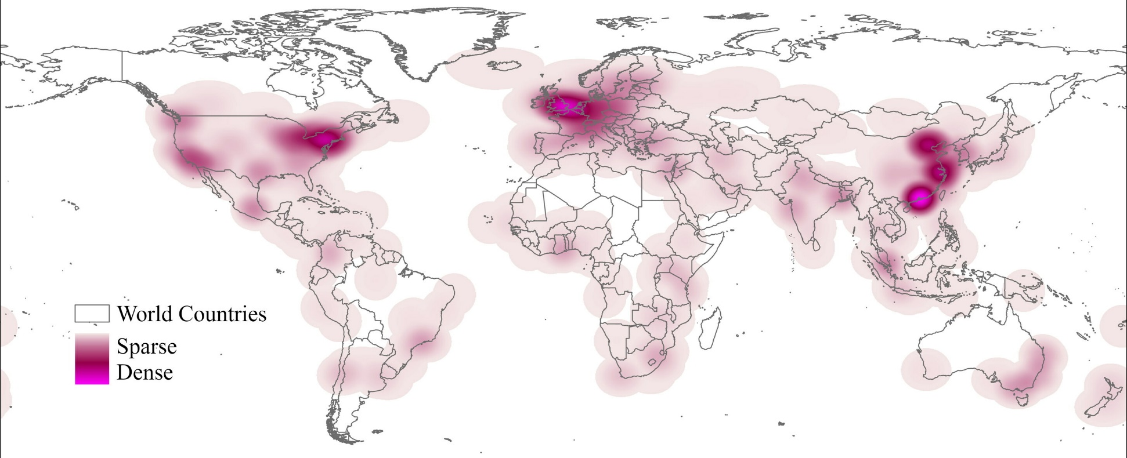
Overall, this collection of maps displays differences in the collections, but also shared informational gaps. These results are promising for the analysis of the global diversity of the collection, highlighting DEI related issues relevant to the collection.

Discussion
These maps show that the process of city name geoparsing and geocoding by macro can work and produce usable datasets for analysis. Compared to the human annotation process in the original research which took months of human work to achieve, the automated process was able to automatically annotate both datasets over 3 days, with human annotation to correct errors taking only a few hours of work.
However, the maps highlight significant DEI related issues in the research landscape around Urban Planning materials. The visible gaps in the research point to notable biases towards the US, Europe, and East Asia, with all the densest points on the heat maps in those areas and large swathes of the Global South unrepresented.
Some of this may be explained by linguistic bias. The focus of the research on primarily English language materials means that material written in other languages is mostly absent in the dataset. Even the corpus of search terms only surfaces English language articles. The list of cities includes Florence, not Firenze, Mexico City, not Ciudad de México, Seoul, not 서울, which excludes literature in languages other than English. This bias has interesting secondary effects, with the vestiges of colonialism visible on the map, especially in the line of former British colonies stretching from South Africa to Kenya, all represented within the collections. However, even taking linguistic bias and colonial history into account, massive inequities appear in the maps, excluding large portions of the world.
Why is this important? Why does it matter if Urban Planning literature underrepresents the Global South? In the next hundred years, Urban Planning is going to face multiple challenges, many of which relate to adapting to climate change. Part of why this issue matters so much is that many parts of the Global South are particularly vulnerable to climate change, small island nations are facing the significant threat of rising sea levels, tropical nations are facing increased weather volatility and all nations are facing increased heat. Urban Planning should focus efforts to meet these challenges directly and support the needs of underserved countries in the Global South.
(Scholz, Stober, and Sassen 2021; Anguelovski et al. 2016; Schindler and Silver 2019)
However, local expertise may also bring solutions that help not just the Global South but the whole world. Historically, European colonizers have ignored expertise from colonized people. Europeans struggled for centuries with Pellagra due to not incorporating Native American technologies of nixtamalization along with corn (Morabia 2008). When European colonists came to West Africa, they built colonial towns in the lowlands by the rivers while the indigenous groups often settled on nearby hills. The colonists did not recognize the expertise of local groups that led them to plan settlements away from the mosquito infested lowlands (Webb 2009). This general phenomenon is reflected in wider research in Urban Planning, ‘Indigenous knowledge systems’ have been identified as a major resource for climate change adaptation by multiple studies. (e.g. Mbah, Ajaps, and Molthan-Hill 2021). This points to a major benefit to diversification of knowledge systems represented in library collections, enabling these potentially useful exchanges.

Conclusion
This study set out with several goals: to assess whether Urban Planning collections could be analysed for geographic diversity, to create a shareable tool for collection analysis through geoparsing and geocoding to allow the creation of visualizations, to fill gaps within a collection to advance the diversification process with a collection. While the study has addressed the first two, the final goal has proven elusive due to larger factors.
A comparative study of books and journals could theoretically inform purchasing decisions to fill gaps in the journal literature, but pursuing this course revealed larger systemic roadblocks, namely, books just do not exist to fill all these gaps. A search on WorldCat for books with a subject of city planning, limited to the Library of Congress HT range and to materials published in the last 10 years, revealed a total of 12,674 books, but a tiny minority of these could help in globally diversifying an Urban Planning collection. Performing focused searches on individual countries that were unrepresented in either the book collection or the journal literature only turned up 104 total volumes, many of which were either not available from library vendors or were in languages other than English. In contrast, there were 139 volumes published during this time period just about New York City. In the end, thirteen books were able to be ordered to fill gaps for fifteen countries (Afghanistan, Armenia, Bahrain, Botswana, Belarus, Brunei, Eritrea, Guinea, Honduras, Laos, Mauritius, Montenegro, North Macedonia, Trinidad and Tobago, Yemen) but many countries had no available materials and gaps persisted.
To solve these problems, a more significant shift is necessary in the pipeline of knowledge. Publishers need to seek out materials from underrepresented parts of the world, grants for travel and research need to be put into place for the exchange of knowledge, international conferences need to be planned to bring together researchers from around the world to collaborate on Urban Planning solutions. Libraries cannot solve these problems alone, but we can commit to building globally diverse collections when materials are available, showing publishers that there is a market for such materials. Blume and Roylance’s development of a workflow for de-colonization in collection development shows this is a promising direction. (Blume and Roylance 2020).
Further research into the topics here could focus on the geographic diversity of authors within a collection, finding ways to elevate the voices on colonized people. Additionally, comparative studies of collections at different institutions could explore ways in which diversity means different things to different populations. Finally, searches done in languages other than English could show different opportunities available in global scholarly communities. This may require search in different databases with more non-English results, with an adapted set of place names.
I want to end with an example of the material that exists out there but isn’t accessible, the kind of things that we are missing. “Fire, looting and a church: re-imagining the socio-political position of civic architecture in Maseru” is a 2017 thesis by Mokhele Ntho (Ntho 2017). This is the only city planning book that surfaces in WorldCat related to Lesotho, and it explores the potential of traditional Sotho political gathering spaces in Urban Planning and the implications in the realm of public trust in institutions. It is material like this that needs to be more widely published, to be brought to the world because without it, we are all navigating the future with an incomplete map.

References
Abresch, J. (2008). Integrating geographic information systems into library services: a guide for academic libraries. Hershey, PA: Information Science Pub. 10.4018/978-1-59904-726-3
Acheson, E., & Purves, R. S. (2021). Extracting and modeling geographic information from scientific articles. PLoS One, 16(1), e0244918. http://dx.doi.org/10.1371/journal.pone.0244918
Aldred, B. (2019). Mapping the Inside of a Collection: ArcGIS as Content Analysis Tool. Qualitative and Quantitative Methods in Libraries, 8(4), 479-493. http://qqml-journal.net/index.php/qqml/article/view/553
Andres, L., Bakare, H., Bryson, J. R., Khaemba, W., Melgaço, L., & Mwaniki, G. R. (2019). Planning, temporary urbanism and citizen-led alternative-substitute place-making in the Global South. Regional Studies, 55, 1-11. 10.1080/00343404.2019.1665645
Anguelovski, I., Shi, L., Chu, E., Gallagher, D., Goh, K., Lamb, Z., Reeve, K., & Teicher, H. (2016). Equity Impacts of Urban Land Use Planning for Climate Adaptation: Critical Perspectives from the Global North and South. Journal of Planning Education and Research, 36(3), 333-348. 10.1177/0739456X16645166
Bishop, B. W., & Mandel, L. H. (2010). Utilizing geographic information systems (GIS) in library research. Library Hi Tech, 28(4), 536-547. //dx.doi.org/10.1108/07378831011096213
Blume, R and A. Roylance, Decolonization in collection development: Developing an authentic authorship workflow, The Journal of Academic Librarianship, Volume 46, Issue 5, 2020, 102175, ISSN 0099-1333, https://doi.org/10.1016/j.acalib.2020.102175. Cilliers, E. J. (2020). Reflecting on Global South planning and planning literature. Development Southern Africa (Sandton, South Africa), 37(1), 105-129. 10.1080/0376835X.2019.1637717
Ciszek, M. P., & Young, C. L. (2010). Diversity collection assessment in large academic libraries. Collection Building, 29(4), 154-161. 10.1108/01604951011088899
Cruz, A. M. (2019). Intentional integration of diversity ideals in academic libraries: A literature review. The Journal of Academic Librarianship, 45(3), 220-227.
Garcia, B. (2021). Scanning for Cultural Competency in Online Urban Planning Programs. Urban Planning, 6(4), 273-282. http://dx.doi.org/10.17645/up.v6i4.4574
Hirsh, H., Eizenberg, E., & Jabareen, Y. (2020). A New Conceptual Framework for Understanding Displacement: Bridging the Gaps in Displacement Literature between the Global South and the Global North. Journal of Planning Literature, 35(4), 391-407. 10.1177/0885412220921514
Jones, R., Zhang, W. V., Rey, B., Jhala, P., & Stipp, E. (2008). Geographic intention and modification in web search. International Journal of Geographical Information Science, 22(3), 229-246. 10.1080/13658810701626186
Lafia, S., Jablonski, J., Kuhn, W., Cooley, S., & Medrano, F. A. (2016). Spatial discovery and the research library. Transactions in GIS; Trans.in GIS, 20(3), 399-412. 10.1111/tgis.12235
Leidner, J. L. (2006). An evaluation dataset for the toponym resolution task. Computers, Environment and Urban Systems, 30(4), 400-417. 10.1016/j.compenvurbsys.2005.07.003
Leidner, J., & Lieberman, M. (2011). Detecting geographical references in the form of place names and associated spatial natural language. SIGSPATIAL Special, 3(2), 5-11. 10.1145/2047296.2047298
Leveling, J. (2015). Tagging of temporal expressions and geological features in scientific articles. Paper presented at the 1-10. 10.1145/2837689.2837701
Mbah, M., Ajaps, S., & Petra Molthan-Hill. (2021). A Systematic Review of the Deployment of Indigenous Knowledge Systems towards Climate Change Adaptation in Developing World Contexts: Implications for Climate Change Education. Sustainability (Basel, Switzerland), 13(4811), 4811. 10.3390/su13094811
Middleton, S., Kordopatis-Zilos, G., Papadopoulos, S., & Kompatsiaris, Y. (2018). Location Extraction from Social Media: Geoparsing, Location Disambiguation, and Geotagging. ACM Transactions on Information Systems, 36(4), 1-27. 10.1145/3202662
Miraftab, F. (2009). Insurgent Planning: Situating Radical Planning in the Global South. Planning Theory (London, England), 8(1), 32-50. 10.1177/1473095208099297
Morabia, A. (2008). Joseph Goldberger's research on the prevention of pellagra. Journal of the Royal Society of Medicine; J R Soc Med, 101(11), 566-568. 10.1258/jrsm.2008.08k010
Ntho, M. (2017). Fire, looting and a church: re-imagining the socio-political position of civic architecture in Maseru http://wiredspace.wits.ac.za/handle/10539/23631
Robinson, J. (2016). Thinking cities through elsewhere. Progress in Human Geography, 40(1), 3-29. http://dx.doi.org/10.1177/0309132515598025
Sanderson, M., & Han, Y. (2007). Search words and geography. Proceedings of the 4th ACM workshop on geographical information retrieval (pp. 13-14). ACM. 10.1145/1316948.1316952
Schindler, S., & Silver, J. (2019). Florida in the Global South: How Eurocentrism Obscures Global Urban Challenges—and What We Can Do about It. International Journal of Urban and Regional Research, 43(4), 794-805. 10.1111/1468-2427.12747
Scholz, W., Stober, T., & Sassen, H. (2021). Are Urban Planning Schools in the Global South Prepared for Current Challenges of Climate Change and Disaster Risks? Sustainability (Basel, Switzerland), 13(1064), 1064. 10.3390/su13031064
Vasquez-Fernandez, A., Hajjar, R., María Shuñaqui Sangama, Raúl Sebastián Lizardo, Miriam Pérez Pinedo, Innes, J., & Kozak, R. (2017). Co-creating and Decolonizing a Methodology Using Indigenist Approaches: Alliance with the Asheninka and Yine-Yami Peoples of the Peruvian Amazon. ACME: An International Journal for Critical Geographies, 17(3): 720-749 https://www.acme-journal.org/index.php/acme/article/view/1420
Watson, V. (2009a). ‘The planned city sweeps the poor away…’: Urban planning and 21st century rbanization. Progress in Planning, 72(3), 151-193. 10.1016/j.progress.2009.06.002
Watson, V. (2009b). Seeing from the South: Refocusing Urban Planning on the Globe’s Central Urban Issues. Urban Studies, 46(11), 2259-2275. http://dx.doi.org/10.1177/0042098009342598
Watson, V. (2016). Shifting Approaches to Planning Theory: Global North and South. Urban Planning, 1(4), 32-41. 10.17645/up.v1i4.727
Watson, V. (2019). The return of the city-region in the new urban agenda: is this relevant in the Global South? Regional Studies, 55, 1-10. 10.1080/00343404.2019.1664734
Webb, J. L. A. (2009). Humanity’s burden : a global history of malaria. New York, NY: Cambridge University Press.
Wesely, J., & Allen, A. (2019). De-Colonising Planning Education? Exploring the Geographies of Urban Planning Education Networks. Urban Planning, 4(4), 139-151. http://dx.doi.org/10.17645/up.v4i4.2200
Yzaguirre, A., Smit, M., & Warren, R. (2016). Newspaper archives + text mining = rich sources of historical geo-spatial data. IOP Conference Series.Earth and Environmental Science, 34(1)http://dx.doi.org/10.1088/1755-1315/34/1/012043
Zhang, W., & Gelernter, J. (2014). Geocoding location expressions in Twitter messages: A preference learning method. Journal of Spatial Information Science, 9, 37-7010.5311/JOSIS.2014.9.170

