Title: First-year College Students’ Library Experience and its Impact on their Perceptions of Academics during the Pandemic
Jung Mi Scoulas ª*

ª Assistant Professor and Assessment Coordinator, University Library, University of Illinois Chicago, Chicago, USA

* Correspondence concerning this article should be addressed to Jung Mi Scoulas, jscoulas@uic.edu. Assistant Professor and Assessment Coordinator, University Library, University of Illinois Chicago, Chicago, IL 60607, USA
ORCID ID: https://orcid.org/0000-0002-7536-295X

First-year College Students’ Library Experience and its Impact on their Perceptions of Academics during the Pandemic

Abstract
How did the COVID-19 pandemic affect first-year college students’ library experience and how did their experience affect their GPA? By employing both quantitative and qualitative data collected at a public research university during spring 2021, this article found that first-year students rarely used the physical library, used the online library more often than other undergraduates, perceived the library as having a positive impact on their coursework, and determined that the online library resources and services were a primary contributor to their academic performance. Recommendations on how to improve library service and avenues for future research are provided.

Keywords: College first-year students; COVID-19; academic success; undergraduate students; library survey; GPA

Introduction
It is well known that the first year of college is vital not only to students’ academic success but also their psychological well-being. First-year students may feel overwhelmed by the new learning environment which includes expectations of faculty, course requirements, balancing their academic needs, part-time jobs, and socializing with their peers. For their academic tasks, first-year students navigate various academic resources offered in and outside of campus (e.g., tutoring), attend orientations and writing seminars, and some join student organizations. The fall 2020 semester was an exceptional year for all students. For most undergraduates and graduates, they had to adapt to a new environment with health safety guidelines and classes converting to online learning. As most classes went virtual, other campus services were also offered online, such as the writing center, the counseling center, the wellness center, tutoring, etc.
In response to the pandemic, the UIC University Library radically adjusted its operations in multiple ways based on the University’s mandated health safety policies and protocols. These changes altered the expected social interactions that would normally occur on campus, migrating many services to a remote interface as well as implementing processes which made navigating physical spaces more challenging. Among these challenges were mandatory Corona Virus of 19 (hereafter, COVID-19) testing, an integrated daily electronic health check, mandatory mask wearing, and limiting library entry to campus-affiliates. In addition, the library solicited students’ feedback through focus groups regarding how these health safety protocols might be best implemented (Scoulas, Carrillo and Naru, 2021a). Changes were made to library access including the creation of an online seat reservation system and the removal of furniture to reduce occupancy for proper social distancing. Additional low- and no-contact services were also provided including curbside materials pickup, virtual library orientation, and online consultations and instruction. Library building hours were reduced during the fall 2020 semester (Scoulas, Carrillo and Naru, 2021a); however, online reference services (e.g., Chat with a Librarian) continued with its original hours from early morning to late at night.
Some of the new health safety guidelines altered the library spaces in an extreme way (food and drink were now also prohibited in addition to the many other protocols), the University Library wanted to learn about patrons’ experiences given all of the changes in response to the pandemic. The findings from the UIC patron survey during fall 2020 indicated that, overall, patrons were satisfied with the changes made and considered the library a safe place where they could go to study on campus. Some respondents, however, expressed a desire to return to extended library hours and have access to collaborative and group study spaces (Scoulas, Carrillo, and Naru, 2021b).
While the findings above allowed the UIC library administration to learn what worked well and identify gaps for improvement, it was uncertain whether first-year college students’ library experience differed substantively from other undergraduates. Also, the UIC patron survey was directed to patrons who visited the physical library building, so the experience of students using online or remote services is still unknown. Given that the first-year is the beginning of college life, having to navigate almost everything virtually under health safety limitation posed a unique challenge. This raised critical questions: how do first-year students experience the library; how do they perceive the library’s value on their academic success; and does their library use affect their academic success during the pandemic? The findings in this article will provide valuable information for library administrations, liaisons, and librarians working with first-year students, and identify what is needed to support them as they transition to a hybrid environment.

Literature Review

First-year students’ library experience
For first-year students, making use of academic resources (e.g., tutoring), attending orientations, participating in writing seminars, and being involved in student organizations are all important. Equally important to academic success is the library. Several studies have explored the experience of first-year students using the library, examining the factors that influenced their library use and information seeking behaviors when working on coursework or research papers. Perruso (2016) conducted a longitudinal study tracking a first-year student cohort over four years to examine how their research behaviors changed over time. Using a Research Habits Survey, Perruso found that the majority of first-year students started their research using Google whereas some started with library resources. Another key finding revealed that first-year students who began using library resources were more likely to use them as they progressed through college. Also, first-year students who had library instruction tended to use library resources more than those who did not have library instruction.
Regarding the factors that determine undergraduates’ library use, a study conducted by Whitmire (2001) found that students’ high school library experience, level of interaction with faculty, attitudes in learning such as participating in the classroom (active learning), and writing activities, predicted their library use for the first three years of their undergraduate lives. During their first year, students’ involvement in active learning and writing activities were positively correlated with their library use. Using the qualitative approach by analyzing 92 essays, Dempsey and Jagman (2016) examined how the work of first-year students in an academic skills course reflected their learning process when searching for library resources and what kinds of support they needed for academic success. The findings uncovered that while the majority of first-year students completed their tasks—such as following the instructions, searching the catalog, and finding items—some students randomly selected items without following instructions. Another key finding from the essays revealed that when students encountered difficulties in searching for items, they perceived the issue was related to “the library’s lack of organization” rather than their own lack of skills or understanding. First-year students’ responses ranged from resolving the issue on their own (self-reliance) and asking experts for help when needed. Another qualitative study conducted by Insua, Lantz, and Armstrong (2018) also explored how first-year students experienced the research process by what challenges they encountered and how they overcame them. They found three major challenges included understanding academic articles, comprehending the topic of the course, and “navigating the physical space of the library” (Insua, Lantz, and Armstrong 2018, 91).

First-year students’ academic success: Grade point average (GPA)
Numerous studies have examined how first-year students’ GPAs were related to physical library use (e.g., space and using computers), resources (e.g., databases), and services (e.g., library instruction and consultation). For example, Soria, Fransen, and Nackerud (2013) studied whether first-year students’ use of library resources and services were associated with their GPA and found that first-year students who used library resources and at least one library service had a GPA higher than those who never used library resources and services. Another study using propensity matching analysis also discovered that students’ library uses (e.g., utilizing a library workstation and a research clinic) were positively correlated with their first term GPA (Kot and Jones 2015). By using a self-reported survey for three years, Stemmer and Mahan (2015) examined what factors predicted students’ GPAs for first-year students and seniors. They found that first-year students studying alone, using printers or photocopiers, accessing the online catalogue, using computers for academic purposes, and consulting a reference librarian, were positively correlated with their GPA. However, for seniors, after controlling for American College Testing (ACT) scores, checking out books was a positive predictor of their GPA while group study room use was not a predictor. Hill et al. (2018) studied whether first-year students taking library writing seminars has an impact on academic success and found that seminar attendance was correlated to both GPAs and graduation rate. A recent study by Wright (2021) found that first-year students attending library instruction had a higher GPA than those students who did not have library instruction.
However, these studies were conducted in the pre-COVID-19 environment. As such, it is uncertain how first-year students are currently experiencing library use (in person library visits or online library visits) as compared with other undergraduates during COVID-19, how they perceived the library’s impact on their coursework and research, and whether the extent of their library use was related to their GPA. While the author examined and published the impact of students’ library use on their GPA during the pandemic, the aggregated level included both undergraduates and graduates and found that students’ physical and online library use were associated with their GPA (Scoulas and De Groote, 2021).
Therefore, the purpose of this article is to learn about first-year students’ library use experience (in-person visits, online use and frequency, and perceptions of library resource use) during the pandemic by comparing them with other undergraduates (sophomores, juniors, and seniors). Also, this study examines whether: (1) there are any statistically significant differences in GPA between students who never used the library as compared to students who used the library and (2) first-year students’ perceptions of the library’s impacted their coursework and research. In this article, students’ library use refers to their visits to the physical library building (in-person visits), which may include use of online resources, as well as online library use (e.g., accessing library resources only via the library website).

Methods

Institutional Setting
University of Illinois Chicago (UIC) has an unusual status as a Carnegie Research 1 (R1) university, a Minority Serving Institution (MSI), a Hispanic Serving Institution (HIS) and an Asian American and Native American Pacific Islander Serving Institution (AANAPSI). UIC consists of over 33,000 ethnically and racially diverse undergraduate and graduate students enrolled in 16 colleges as of fall 2020; 65% of students are undergraduate students and, among them, 11% are first-year students (UIC Office of Institutional Research n.d.). Overall, in fall 2020 UIC’s undergraduate students increased 1%, whereas first-year students decreased 3% compared to fall 2019. As of fall 2020, about 22,000 undergraduates were enrolled in nine colleges (Liberal Arts and Sciences, Applied Health Sciences, Architecture, Design and the Arts, Business Administration, Education, Engineering, Nursing, School of Public Health, and Urban Planning) with 86 bachelor’s programs.

Survey instrument, data collection, and compensation
This study used data collected during spring 2021 from a locally developed student library experience survey that was tested for reliability and validity (Scoulas, Aksu Dunya, and De Groote, 2021) with some new sets of questions that were pilot-tested (Scoulas and De Groote, 2021). This article included survey questions focusing on: 1) frequency of library visits (in-person and online); 2) frequency and importance of library resource use; 3) user friendliness of the library website; and 4) students’ perceptions of the library’s impact on their coursework or research (open-ended question). For the survey questions, please see the Appendix (see also Scoulas and De Groote, 2021).
Prior to disseminating the survey, the author obtained students’ UIC email addresses and demographics (e.g., class level/year, college, and GPA, etc.) from the UIC Office of Institutional Research (OIR) and imported them as a “panel” into the online survey platform, Qualtrics. While students’ demographics were linked to their responses, all personal identifiable information (e.g., email address and IP address) were anonymized when collecting the data in order to protect their privacy. The survey was distributed to all university undergraduate and graduate students who were enrolled in spring 2021 (N=31,332) via their UIC email address. To encourage students’ participation in the survey, students who completed the survey were automatically entered to win one of six lottery prizes (e.g., an iPod, smart watch, or headphones, etc.) valued at $100 to $200 each, and a recruiting message was posted via social media including Facebook, Twitter and Instagram. A total of 3,379 students completed the survey (10.8%). Given that the primary focus of this article is first-year students, only 1,791 undergraduate students were selected from all the survey respondents; 294 of those undergraduate students were first-year students. For more information on the data collection procedures and survey compensation, please refer to the previous studies conducted by the author (Scoulas and De Groote, 2019, 2021).

Data preparation and analysis

Quantitative data:
The 1,791 undergraduate responses selected were imported into Tableau for descriptive statistics and data visualization and Statistical Package for Social Sciences (SPSS) 28 for advanced statistical analysis. Afterward, the data was divided into two groups: 294 first-year students and 1,497 other undergraduates (sophomores, juniors, and seniors) to see the differences in library use between first-year students and other undergraduates. To examine whether there is a statistically significant difference in the mean scores of GPA for students who never used the library compared to students who used the library, Independent Sample T-Tests were employed in SPSS 28. The Independent Sample T-Test was conducted twice: one for first-year students and one for other undergraduates. Library users refer to any students who reported using the physical library or online library website while non-library users were those who never visited the library or used any library resources and services.

Qualitative data
For the open-ended responses related to students’ perceptions on the library’s impact on their coursework, 201 first-year students’ responses were selected and imported into NVivo12 for the qualitative analysis. The qualitative data was analyzed by using thematic analysis. Thematic analysis is “a method for identifying, analyzing and reporting patterns (themes) within data” and is widely used as a qualitative descriptive method (Braun and Clarke 2006, 79). Themes emerged from the data by utilizing an inductive approach. The steps of analyzing qualitative data involved: 1) reading the open-ended responses twice as a whole; 2) creating initial codes; 3) reviewing codes; 4) searching for themes based on codes; 5) revising codes and themes; 6) having internal reviewers assess themes for clarity; and 7) finalizing themes.

Results

Participants

Table 1 displays the demographic information of survey respondents and the university population. While the primary focus of the current article is to examine first-year students’ library use experiences during the pandemic, the information of other undergraduates (sophomores, juniors and seniors) is also included to show any differences between them. Among 1,791 undergraduate survey respondents, 16% (n=294) are first-year students and the rest are other undergraduates, including sophomores, juniors and seniors. Over 80% of respondents for both first-year students and other undergraduates are from three colleges: Liberal Arts and Sciences, Engineering, and Business Administration. About 40% of first-year students are Hispanic, followed by Asian (19.4%) and White (19.0%), whereas the percentages of race/ethnicity for other undergraduates are equally comprised of Hispanic, Asian and White (27% each). Over 65% of respondents for both first-year students and other undergraduates are female. While the majority of the respondents among first-year students and other undergraduates are commuters, slightly fewer first-year students (84%) are commuters than other undergraduates (91%). More first-year students are Pell Grant recipients and first generation college students than other undergraduates.
Demographics for the university population are also included in Table 1 to demonstrate whether the survey respondents represent the university population. Except for gender, the demographics between survey respondents and the university population are similar; however, more female respondents for both first-year students and other undergraduates participated in the survey (a difference of 13%). Overall, survey respondents for both first-year students and other undergraduates are representative of the university population.
[Insert Table 1]

Library visits (in-person and online: first-year students vs. other undergraduates)
When students were asked how often they visited the library either in-person or online during fall 2020 (pandemic), the patterns in library visits between first-year students and other undergraduates were different. As shown in Figure 1, for in-person visits, almost 90% of first-year students indicated that they never visited the library, and only 11% visited the library in person “once a month” or more. On the other hand, 65% of other undergraduate respondents answered that they never visited the library, followed by visits to the library “once a week” or more (20%). This finding suggests that during the pandemic first-year students rarely used the physical library compared to other undergraduates.
On the other hand, online library use patterns for undergraduates are the opposite of in-person library visits (Figure 1). Seventy-six percent of first-year students used the online library “once a month” or more, whereas 60% of other undergraduates used the online library “once a month” or more. Among them, more first-year students used the online library “once a week” or more than other undergraduates (42% versus 28%, respectively). Twenty-four percent of first-year students indicated they never used the online library, whereas 40% of other undergraduates indicated they never used the online library, suggesting that overall, more first-year students frequently used the online library than other undergraduates.
[Insert Figure 1]

Frequency of library resource use: first-year students vs. other undergraduates
The top four library resources frequently used by all undergraduates are: journal articles, databases, electronic books, and library subject and course guides (Figure 2). However, there were differences in the frequency of library resource use by first-year students and other undergraduates: more first-year students frequently used journal articles, databases, electronic books and library subject and course guides than other undergraduates. Over 80% of undergraduates never used the other library resources, and the patterns were similar between first-year students and other undergraduates.
[Insert Figure 2]

Students’ perceptions of library resources between first-year students and other undergraduates
Students were asked how they perceived the list of library resources from “I don’t use this tool or service” to “very important.” The top five library resources considered as important by all undergraduates were Blackboard, journal articles, databases, electronic books, and library instruction arranged by the professor. While those resources were perceived as important by both first-year students and other undergraduates, one resource was perceived by them differently: a higher percentage of first-year students (68%) rated library instruction arranged by the professor as “important” or “very important” compared to other undergraduates (50%), suggesting that more first-year students valued library instructions than other undergraduates (Figure 3). First-year students and other undergraduates’ perceptions of other library resources were similar with two exceptions (print books and library workshops): slightly fewer first-year students (32%) perceived print books as important or “very important” compared to other undergraduates (39%), whereas more first-year students (41%) perceived library workshops as important or “very important” compared to other undergraduates (31%). Overall, the findings suggest that first-year students are more likely to consider library instruction and workshops as important compared to other undergraduates.
[Insert Figure 3]

Library website use: First-year students and other undergraduates
The differences in the ease of library website use between first-year students and other undergraduates is displayed in Figure 4. Overall, when using the library website, the patterns for both first-year students and other undergraduates were similar except for three activities: requesting a print book, asking for help, and reserving a seat. Compared to other undergraduates, fewer first-year students found the library website “easy” and “very easy” to use when requesting a print book, asking for help, and reserving a seat. Given that the earlier finding shows that fewer first-year students used the physical library and print books from the library, it is possible that first-year students may not be familiar with library visit protocols, such as how to reserve a seat. This is in comparison to students who visited the library once and were more accustomed to reserving a seat and familiar with using print books. This unfamiliarity may result in more difficulty reserving a seat and requesting a print book via the library website.
[Insert Figure 4]

Mean differences in GPA between library users and non-library users among first-year students
An independent-samples t-test was conducted to compare the mean of GPAs for first-year students who never visited the library nor used the online library (non-library users) with first-year students who used either the physical building or online library (library users). As shown in Table 2, there was no significant difference in scores for non-library users (M= 3.24, SD= 0.88) and library users (M= 3.36, SD= 0.81): t(252)= -.94, p=.348, two-tailed). The magnitude of the differences in the mean (mean difference= -0.12, 95% CI [-0.38, 0.13]) was small (eta squared=.003), guided by Cohen (1988). While there was no statistically significant difference in the GPA between these two groups, the mean score of GPA for first-year students who never used the library was lower than those who used the library.

Mean differences in GPA between library users and non-library users among other undergraduates
Another independent-samples t-test was conducted to compare the mean of GPAs for other undergraduates who never visited the library nor used the online library (non-library users) with other undergraduates who used either the physical building or the online library (library users). There was a statistically significant difference in the mean of GPAs for non-library users (M= 3.35, SD= 0.52) and library users (M= 3.45, SD= 0.51): t(1335)= -2.92, p=.002, two-tailed). The magnitude of the mean differences (mean difference= -0.093, 95% CI [-0.16, -0.03]) was small (eta squared=.006), guided by Cohen (1988). While there was a statistically significant difference in the GPAs between them, the degree of mean differences between library users and non-library users among other undergraduates was small. Despite this finding, it is important to note that, similar to the first-year students, the mean score of GPA for other undergraduates who never used the library was lower than those who used the library.
[Insert Table 2]

First-year students’ perceptions of the library’s impact on coursework or research
A total of 201 respondents provided feedback on an open-ended question: “Thinking about your overall UIC library experience, please describe how the library has impacted your coursework or research.” Using a thematic analysis, there were four themes generated from this open-ended question.

Theme 1: The library has an impact on my coursework or research
The majority of first-year students (64%) expressed the view that the library has a positive impact on their coursework or research. When describing the library’s impact, overwhelmingly students used words like “helped,” “helpful,” “beneficial,” “easy,” and “essential” for class/course, research projects, writing papers, and assignments. For example, a Black/African American female student from the College of Engineering described how the library had an impact on her academics:
“UIC library honestly helped me pass my courses. Many courses require evidence or MLA to back up your arguments in essays, etc. Without the help of UIC library resources, I wouldn’t know where I would be. I would 100% recommend relying on UIC library.”
Similarly, a Hispanic female student from the College of Liberal Arts and Sciences commented:
“The library has positively impacted my coursework/ or research because it has provided me with real and effective journals, articles, etc. that could be used for assignments.”
Some students elaborated how their library use had an impact on specific academic tasks. For instance, one White female student from the College of Liberal Arts and Sciences explained:
“My research becomes more developed as I use the library resources. It provides me the opportunity to examine sources in which have information that I would never have thought about. Using these resources, it is known that the sources are reliable and with citations already done, it is a guaranteed grade booster.”
Other examples of the library’s impact on first-year students’ academics include: “reach my full potential and aided me with the work I needed to be successful (Asian, Male, College of Liberal Arts and Sciences),” “improved the quality of my papers (Black/African American, Female, College of Liberal Arts and Sciences),” and “without the library I would have failed (Black/African American, Female, College of Liberal Arts and Sciences).”
While most of the first-year students (64%) commented that the library helped their coursework or research, three students stated that the library did not have an impact on their coursework or research because their courses do not require library resources or they did not visit the library due to concerns about COVID-19. For instance, a Black/African American female student from the Liberal Arts and Sciences College stated: “I don't think it had much impact, since I've never been in the UIC library and only use their services very minimally now.”

Theme 2: Online resources and services impacting students’ coursework and research
When describing the library’s impact on their coursework or research, about 43% first-year students mentioned accessing online library resources such as databases, journal articles, resources, the library website, and online library. As with the earlier findings from quantitative data, databases and journal articles were the most impactful resources for their course work or research. A Hispanic male student from the Liberal Arts and Sciences College explained:
“The UIC Library helped me complete research on various assignments throughout the course of my Freshman Year. The databases were extremely helpful in finding information and they were easy to use.”
Also, six students explained why those library resources were important for their coursework or research. It is because those resources are “credible,” “accurate,” “reliable” and “peer-reviewed.” One Asian male student from the Architecture, Design and Arts College explained the importance of accessing online resources:
“It helped me be able to find articles and many much more resources online that couldn't be accessed or be found anywhere easily all in one place. And yet the library has a lot of information that could be used accessibly anywhere online so its portable online whenever I need help on finding some things online and not able to find it on Google or so.”
While most first-year students acknowledged accessing databases and journal articles was important for their coursework or research, three first-year students mentioned other resources were helpful, such as e-books and films. Additional factors affecting coursework and research acknowledged by respondents were instruction and workshops. For example, a Hispanic female from the Applied Health and Sciences College commented:
I have been able to receive an introduction into the UIC library website and resources from two librarians who have also kindly offered to help me more if I ever needed help. Additionally, I have come to realize that the content within the library is very reliable and convenient, especially with COVID. I have two research projects this semester and I have already found some helpful sources, therefore I feel more at ease and a bit more confident about my ability to do well with my projects.
Similarly, a White female student from the Business Administration College stated:
“…I was very pleased to have a librarian come to our class to show us how to utilize the resources found in the UIC virtual library, from there I was able to find scholarly sources that I plan to use for my research paper.”
Two students acknowledged that being able to access all the resources during the pandemic affected their academic success. A Hispanic female student from the Architecture, Design and Arts College explained:
“I am happy that even during a pandemic I am able to access all of the resources needed to achieve academic success. This isn't an ideal situation for anyone so the fact that I am still able to get everything done without relying on anyone else is comforting.”

Theme 3: Library resources required for courses
Twenty-six first-year students commented on the specific courses for which they used the library resources. Among them, 85% mentioned they used library resources for “English” courses.” For example, one Asian male student from the College of Liberal Arts and Sciences noted: “…to use within my research for English 161.” A Hispanic female student from the Business Administration College stated: “…when accomplishing my English papers and Communications research speeches.” Four students said that they used library resources for STEM classes such as biology and engineering.

Theme 4: Rarely used the library and challenges
While more than 40% first-year students revealed that the library online resources had an impact on their coursework or research, nine students commented that they never used the library due to concerns about COVID-19 and they would utilize the library for the next semester. For example:
“I haven’t used it at all but that’s my fault, I should be using the UIC library to benefit me in the future.” (Hispanic, Male, College of Liberal Arts and Sciences)
“I was at home so I never had a chance to visit in person, but as soon as we go back in person I am likely to go there for research questions.” (White, Male, College of Engineering)
Seven students elaborated on some challenges they encountered using the library. Some challenges were related to finding resources on the library website. Some examples included: “Last semester I had trouble sometimes finding articles or books for certain writing projects” (Hispanic, Male, College of Applied Health and Science), “the results I got were either too specific and not related to my research or were too vague” (White, Male, College of Business Administration), “it was annoying that it would sometimes link to a website that had articles hidden behind a paywall” (White, Male, College of Liberal Arts and Sciences) and “I had no idea on how to approach a research question (Hispanic, Male, College of Business Administration).” Only one Hispanic female student from the Liberal Arts and Sciences College expressed difficulties when visiting the library in person: “I think it would very much positively impact me if it was easier to use the library in person.” Table 3 has a summary of the themes and responses.
[Insert Table 3]

Discussion
By analyzing quantitative and qualitative data, this article examined how first-year students utilized a university library compared to other undergraduates during the COVID-19 pandemic and explored how they perceived their library use impacting their coursework and research. The results from the quantitative data showed that the overall patterns of first-year students’ library use differed from other undergraduates during the pandemic. Almost 90% of first-year students never visited the library in-person, whereas 65% of other undergraduates never used the physical library, indicating a 25% gap in physical library use between first-year students and other undergraduates. Prior to the pandemic, only about 12% of students reported that they never visited the library, and both first-year students and other undergraduate students visited the library multiple days in a week on average (Scoulas and De Groote, 2019). The findings from the qualitative data provided further insight and revealed that some first-year students commented that they never visited the library in person due to concerns about COVID-19 and they were willing to utilize the library during the next semester. Given the findings of the previous study conducted by the author indicating that 69% of students, including both undergraduates and graduates, never visited the library in person during the pandemic (Scoulas and De Groote, 2021), the lower number of visits of first-year students to the physical library needs special attention. While reduced library hours during the pandemic may also impact first-year students’ physical library use, there are no comments confirming this in the qualitative data. While it may not only relate to first-year students, previous studies examining the reasons for students’ library use proved that students relied on library spaces a lot and perceived library spaces as a place where they study, focus, work or meet friends (Stemmer and Mahan 2015; Scoulas and De Groote, 2019; Mayer et al. 2020). For other undergraduates who already experienced visiting the library pre-COVID, they can easily re-visit and navigate the physical library. However, for those first-year students with little experience visiting the physical library, it may be difficult for them to familiarize themselves with the library building, which was addressed by Insua, Lantz, and Armstrong (2018). Also, it may be difficult for first-year students to discover what resources are available to them in the library or to socialize with their peers in the library. Further studies are needed to assess whether the patterns of first-year students’ library use remain as they progress in college and to examine what challenges they experience in using the library as higher education provides a hybrid learning environment.
Regarding the patterns of students’ online library use and the library resources they use, the results from the quantitative data indicated that overall, more first-year students used the online library than other undergraduates; additionally, more first-year students frequently used journal articles, databases, electronic books, and library subject and course guides than other undergraduates. This suggests that because first-year students experienced their first college courses in an online learning environment, it may have been easier for them to navigate online library resources, which resulted in more use of online library resources. Additionally, the quantitative data showed that more first-year students valued library instruction than other undergraduates. This quantitative finding was supported by the findings from the qualitative data uncovering the fact that first-year students valued online library resources, library instruction, and workshops and, first-year students perceived their use of the online library resources as positively impacting their coursework or research. The qualitative data further provided information on how first-year students utilized online library resources, for what courses, and how it affected their coursework or research. First-year students primarily used databases and journals for their English courses; they perceived those resources as reliable and accurate sources, and they explained that librarians helped them learn how to search for items via library instruction and workshops.
For first-year students there was no statistical difference in the mean of GPA between non-library users and library users. This finding differs from previous studies showing that first-year students library users had a GPA higher than non-library users (Soria, Fransen, and Nackerud 2013; Kot and Jones 2015; Wright 2021). Despite there being no statistical difference in the mean of GPA, descriptive statistics indicated that first-year students who never used the library had a GPA lower than those who used the library. Additionally, the qualitative data revealed that first-year students perceived that the library has a positive impact on their coursework and research, and the online library resources and services were primary contributors to their academics. For other undergraduates, there was a statistically significant difference in the mean of GPA between non-library users and library users, indicating that the non-library users had a GPA lower than library users, which is aligned with the study conducted by the author for all students showing that students’ library use was associated with their GPA (Scoulas and De Groote, 2021). However, it is uncertain whether no statistical difference was only for first-year students during the COVID-19 pandemic or whether this pattern will persist as they progress in college post-COVID-19. Further research is needed to investigate this issue.
While most first-year students stated that the library has positively impacted their coursework and research, some first-year students expressed difficulties in requesting a print book, using the library website, and reserving a seat. This qualitative data is also aligned with the quantitative data indicating that, compared to other undergraduates, fewer first-year students found it easy to request a print book, ask for help, and reserve a seat on the library website. Given that the university library no longer requires reserved seating, the last issue is no longer relevant. With respect to the library website, the university library recently revamped the home page focusing on improving the search interface so that users can easily access the library collections and increase accessible user experience for both new and experienced users. Additionally, some new features such as a new Help Center, featuring answers to frequently asked questions about using the library, were added to the library website. To help users familiarize themselves with the redesigned library website, the university library provided a virtual tour of the library website’s key features followed by Q & A sessions. Ongoing assessment is needed to determine whether users’ experiences, including first-year students, remain the same or change after using the re-designed library website.

Implications and Recommendations
Overall, both the quantitative and qualitative data indicated that most first-year students primarily used the online library over the physical library. The findings of first-year students limited experience in the physical library building have several implications. For first-year students who have never been in the library, it may be difficult for them to navigate the library and find resources they need, or they may not be aware of what resources are available to them. When providing support for incoming students, librarians should include sophomores who missed the first-year in-person student experience in a library building tour or information on how to use the library. Libraries can also promote spaces where first-year students can have discussions and socialize with their peers. However, those first-year students whose first college experience was through the online learning environment missed an opportunity not only to study in the library, but also to collaboratively work in-person in the library with their peers. As such, libraries must take extra steps to contact first-year students who are reluctant to visit the library and provide what support they can offer them. This does not mean that libraries have to create a new program or design a new space. Instead, libraries should promote their existing programs, services, and spaces via various communication tools (social media, listserv, student organizations, and signage throughout the campus), and review library use statistics regularly to assess whether any patterns change (e.g., gate count and usage of each floor).
Conclusion
Contrary to first-year students’ low use of the physical library, the quantitative data showed that first-year students rely heavily on the online library resources, and this finding was supported by the qualitative data which revealed that many students primarily used databases and journals for coursework or research, and some students used online library resources for English course(s) integrated with library instruction. Also, both the quantitative and qualitative data illustrate that more first-year students valued library instruction than other undergraduates. This finding confirms that the university library’s efforts to provide information literacy through a first-year composition course worked well during the pandemic. As higher education offers a hybrid environment, depending on the users’ needs, the university library should consider offering the option of either in-person or virtual workshops/instruction and reference consultations.

Data Availability Statement
The data that support the findings of this study are available on request from the corresponding author. The data are not publicly available due to participants’ privacy and ethical restrictions.

Acknowledgment
This article used data from the previous study approved by the University Institutional Review Board (IRB research protocol: #2019-1445) examining a public research university students’ library experiences and its impact on their GPA during the COVID-19 pandemic. Special thanks to my colleagues Elena Carrillo and Paula Dempsey for their review and valuable feedback on this article.

References
Braun, Virginia, and Victoria Clarke. 2006. “Using thematic analysis in psychology.” Qualitative Research in Psychology 3 (1): 77–101. https://doi.org/10.1191/1478088706qp063oa
﻿Cohen, Jacob. 1988. Statistical Power Analysis for the Behavioral Sciences, 2nd ed. New York: Routledge.
Dempsey, Paula R., and Heather Jagman. 2016. ““I felt like such a freshman”: First-year students crossing the library threshold.” portal: Libraries and the Academy 16 (1): 89–107. https://doi.org/10.1353/pla.2016.0011
Hill, Leslie, Daniel Maier-Katkin, Roshni Ladny, and Kirsten Kinsley. 2018. “When in doubt, go to the library: the effect of a library-intensive freshman research and writing seminar on academic success.” Journal of Criminal Justice Education 29 (1): 116–136. https://doi.org/10.1080/10511253.2017.1372498
Insua, Glenda M., Cathy Lantz, and Annie Armstrong. 2018. “Navigating roadblocks: First-year writing challenges through the lens of the ACRL framework.” Communications in Information Literacy 12 (2): 86–106. https://doi.org/10.15760/comminfolit.2018.12.2.3
Kot, Felly Chiteng, and Jennifer L. Jones. 2015. “The impact of library resource utilization on undergraduate students’ academic performance: A propensity score matching design.” College and Research Libraries 76 (5): 566–586. https://doi.org/10.5860/crl.76.5.566
Mayer, Jennifer, Rachel Dineen, Angela Rockwell, and Jayne Blodgett. 2020. “Undergraduate student success and library use: A multimethod approach.” College and Research Libraries 81 (3): 378–398. https://doi.org/10.5860/crl.81.3.378
Perruso, Carol. 2016. “Undergraduates’ use of Google vs. library resources: A four-year cohort study.” College and Research Libraries 77 (5): 614–630. https://doi.org/10.5860/crl.77.5.614
Scoulas, Jung Mi, and Sandra L. De Groote. 2019. “The Library’s Impact on University Students’ Academic Success and Learning.” Evidence Based Library and Information Practice 14 (3): 2–27. https://doi.org/10.18438/eblip29547.
Scoulas, Jung Mi, Elena Carrillo, and Linda Naru. 2021a. “Student Voice in Administrative Decision-Making: Inclusive Planning during the Pandemic.” Journal of Library Administration 61 (4): 458–75. https://doi.org/10.1080/01930826.2021.1906554.
Scoulas, Jung Mi, Elena Carrillo, and Linda Naru. 2021b. “Assessing User Experience: Incorporating Student Voice in Libraries’ Pandemic Response.” Journal of Library Administration 61 (6): 686–703. https://doi.org/10.1080/01930826.2021.1947058.
Scoulas, Jung Mi, and Sandra L. De Groote. 2021. “University Students’ Library Experience and Its Impact on Their GPA During the Pandemic.” Journal of Library Administration 61 (7): 813–37. https://doi.org/10.1080/01930826.2021.1972730.
Scoulas, Jung Mi, Beyza Aksu Dunya, and Sandra L. De Groote. 2021. “Validating Students’ Library Experience Survey Using Rasch Model.” Library and Information Science Research 43 (1): 101071. https://doi.org/10.1016/j.lisr.2021.101071.
Soria, Krista M., Jan Fransen, and Shane Nackerud. 2013. “Library use and undergraduate student outcomes: new evidence for students’ retention and academic success.” portal: Libraries and the Academy 13 (2):147–164. https://doi.org/10.1353/pla.2013.0010
Stemmer, John. K., and David M. Mahan. 2015. “Assessing the library’s influence on freshman and senior level outcomes with user surveys.” Evidence Based Library and Information Practice 10 (2): 8–20. https://doi.org/10.18438/b8pg62
UIC Office of Institutional Research (n.d). Student Data Book Dashboards. https://oir.uic.edu/data/student-data/data-book-dashboards-2/
Whitmire, Ethelene. 2001. “The relationship between undergraduates’ background characteristics and college experiences and their academic library use.” College and Research Libraries 62 (6): 528–540. https://doi.org/10.5860/crl.62.6.528
Wright, Laura B. 2021. “Assessing library instruction: A study of the relationship between attendance, retention, and student success.” The Journal of Academic Librarianship 47 (5): 102431. https://doi.org/10.1016/j.acalib.2021.102431

Appendix

2021 UIC student library experience survey questions

Q1. I have read the “Agreement to Participate” document and agree to participate in this research.
- Yes
- No

Q2. Last semester, how often did you visit the university library?
 | Daily | Multiple days in a week | Once a week | Once a month | Never
In Person
Online

Q3. How satisfied are you with the library spaces listed below at your library?
 | Very satisfied | Satisfied | Dissatisfied | Very dissatisfied | I don’t use this space in the library
Individual study spaces
Computer areas
Q4. How was your overall experience in the library? Please indicate your Level of Agreement with each of the following statement.

 | Strongly agree | Agree | Disagree | Strongly Disagree | Not Applicable
I was able to reserve a space easily
I was able to find my reserved seat easily
There were enough cleaning supplies (e.g., sanitizers)
I feel my health is not at risk in the library
I feel the library is clean
The building hours worked with my schedule
Expectations in the library are clear to me (e.g., wearing masks at all times)
It seems that everyone was following the health safety guidelines in the library
My experience with library staff and security was positive

Q5. Last semester, how often did you use each of the library resources listed below?
 | Daily | Multiple days in a week | Once a week | Once a month | Never
Journal articles
Databases
Print books from the library
Textbooks on reserve
Electronic books
Library Subject & Course Guides
Special Collections & University Archives
Digital images
Streaming media (films and music)
DVDs, CDs or LPs
Patient care tools
Q6. Please indicate the relative Importance of each of the library resources/services for your research or coursework

 | Very important | Important | Somewhat important | Not at all important | I don’t use this tool/service
Journal articles
Databases
Print books from the library
Textbooks on reserve
Electronic books
Library Subject & Course Guides
Special Collections & University Archives
Digital images
Streaming media (films and music)
DVDs, CDs or LPs
Patient care tools
UIC Blackboard
Library instruction arranged by your professor
Library workshops that you self-selected to attend
Other (Please specify)

Q7. How easy is it to use the university library website to do the following?
 | Very easy | Easy | Difficult | Very difficult | I didn't do this
Finding journal articles using the search box on the library home page
Finding an e-book using the search box on the library home page
Finding a print book using the search box on the library home page
Accessing a database to search for articles and other scholarly materials
Requesting a print book from another library
Requesting an article from another library
Logging into my library account to renew a book
Asking for help from a librarian by IM/chat
Using library Subject & Course Guides to access materials by subject
Finding media (e.g., films, videos, online images, etc.)
Reserving a seat
Other (Please specify)

Q8. How likely are you to recommend the following library services to another student?
 | Very likely | Likely | Unlikely | Very unlikely | I don’t use this service
One on one research consultation with a librarian
Library workshops about library research (e.g., finding resources, requesting materials, etc.)
IM/Online chat research help
E-mail research help

Q9. Please indicate your Level of Agreement with each of the following statement.
 | Strongly agree | Agree | Neutral | Disagree | Strongly disagree | Not Applicable
I feel like I belong at the UIC Library
I feel that all aspects of my identity are respected at the UIC Library
I feel that materials at the UIC Library reflect diverse cultural identities

Q10. What comments do you have about inclusion at the UIC Library?
________________________________________________________________

Q11. If you required any accommodations due to a disability, were your needs met?
- My needs were met
- My needs were not met
- I did not need any accommodations

Q12. Please tell us more about any issues you encountered with respect to accommodations.
________________________________________________________________

Q13. Thinking about your overall UIC library experience, please describe how the library has impacted your coursework or research.
________________________________________________________________

Table 1. Demographics of undergraduates (first-year students vs. other undergraduates): survey respondents and university population.

 | First-year students |  | Other undergraduates
 | Survey respondents | Population | Survey respondents | Population
 | (n=294) | (N=2,751) | (n=1,497) | (N=16,989)
College
Liberal Arts & Sciences | 168 (57.1%) | 1,470 (53.4%) | 747 (49.1%) | 7,546 (44.4%)
Engineering | 38 (12.9%) | 396 (14.4%) | 307 (20.5%) | 3,460 (20.4%)
Business Administration | 42 (14.3%) | 378 (13.7%) | 173 (11.6%) | 2,771 (16.3%)
Applied Health Sciences | 17 (5.8%) | 156 (5.7%) | 77 (5.1%) | 998 (5.9%)
Architecture, Design, and the Arts | 20 (6.8%) | 184 (6.7%) | 90 (6.0%) | 885 (5.2%)
Others (Nursing, Education, Public Health, Urban Planning and Public Affairs) | 9 (3.0%) | 167 (6.1%) | 117 (7.8%) | 1,329 (7.8%)
Race
Hispanic | 121 (40.2%) | 1,150 (41.8%) | 410 (27.4%) | 5,558 (32.7%)
Asian | 57 (19.4%) | 505 (18.4%) | 404 (27.0%) | 3,687 (21.7%)
White | 56 (19.0%) | 551 (20.0%) | 412 (27.5%) | 4,538 (26.7%)
Black/African American | 26 (8.8%) | 233 (8.5%) | 105 (7.0%) | 1,238 (7.3%)
International | 24(8.2%) | 202 (7.3%) | 96 (6.4%) | 1,155 (6.8%)
Others | 10 (3.4%) | 110 (4.0%) | 70 (4.7%) | 813 (4.8%)
Gender
Female | 198 (67.3%) | 1,486 (54.0%) | 977 (65.3%) | 8,906 (52.4%)
Male | 96 (32.7%) | 1,265 (46.0%) | 519 (34.7%) | 8,076 (47.6%)
Residency
Commuter | 246 (83.7%) | 2,352 (85.5%) | 1,359 (90.8%) | 15,900 (93.6%)
Resident | 48 (16.3%) | 364 (13.2%) | 118 (7.9%) | 786 (4.6%)
Online | 0 (0%) | 35 (1.3%) | 20 (1.3%) | 303 (1.8%)
Pell Status
Pell Yes | 158 (53.7%) | 1,480 (53.8%) | 665 (44.4%) | 8,014 (47.2%)
Pell No | 136 (46.3%) | 1,271 (46.2%) | 832 (55.6%) | 8,975 (52.8%)
First Generation
Yes | 104 (35.4%) | 1,041 (37.8%) | 388 (25.9%) | 5208 (30.7%)
No | 190 (64.6%) | 1,710 (62.2%) | 1,109 (74.1%) | 11,781 (69.3%)

Note: Other undergraduates includes sophomores, juniors and seniors.

Table 2. GPA differences between non-library users and library users: first-year students and other undergraduates.

 | Non-library users (library usersª)
 | n | M | SD | t | df | p | 95% CI |  | eta squared
First-year students | 49 (205) | 3.24 (3.36) | 0.88 (0.81) | -0.94 | 252 | .348 | [-0.38, | 0.13] | 0.003
Other undergraduates | 350 (987) | 3.35 (3.45) | 0.52 (0.51) | -2.92 | 1335 | .002** | [-0.16, | -0.03] | 0.006

ª Results from library users are presented in parenthesis.
**p <.01

Table 3. Themes of library impact derived from the open-ended responses: first-year students (n=201).
Themes | Examples of Code | n
Library has an impact on my coursework or research | Impacted, helpful, helped, beneficial, vital, essential, easy, accessible, resourceful | 128
 | Paper, research, class/courses, assignments | 128
 | No impact | 3
Online resources and services impacting students’ coursework and research | Articles, database, e-books, library website, media, instruction, and workshops | 87
 | Credible, accurate, reliable, needed, right, and peer-reviewed | 6
Library resources required for courses | English, engineering, psychology, and biology | 26
Rarely used the library and challenges | Not much to say because never used the library | 9
 | Challenges (difficult to find articles, navigate in the library website, don’t know how to approach a research question, difficult to use in-person library) | 7

Figure 1. Frequency of library visits (in-person and online) between first-year students and other undergraduates.
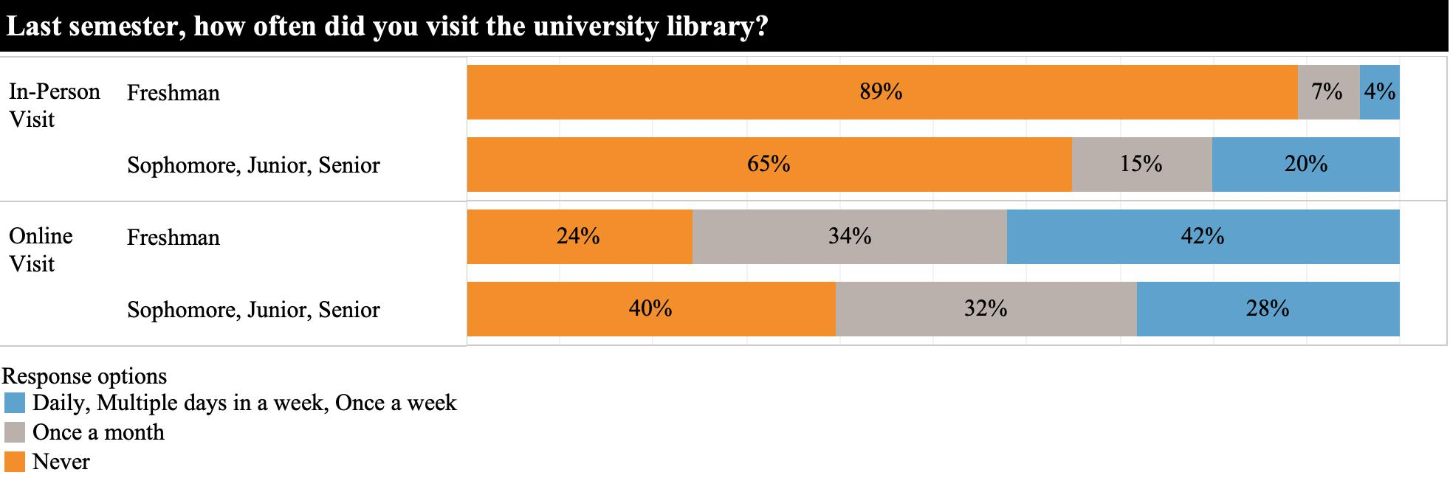

Figure 2. Frequency of library resource use between first-year students and other undergraduates.

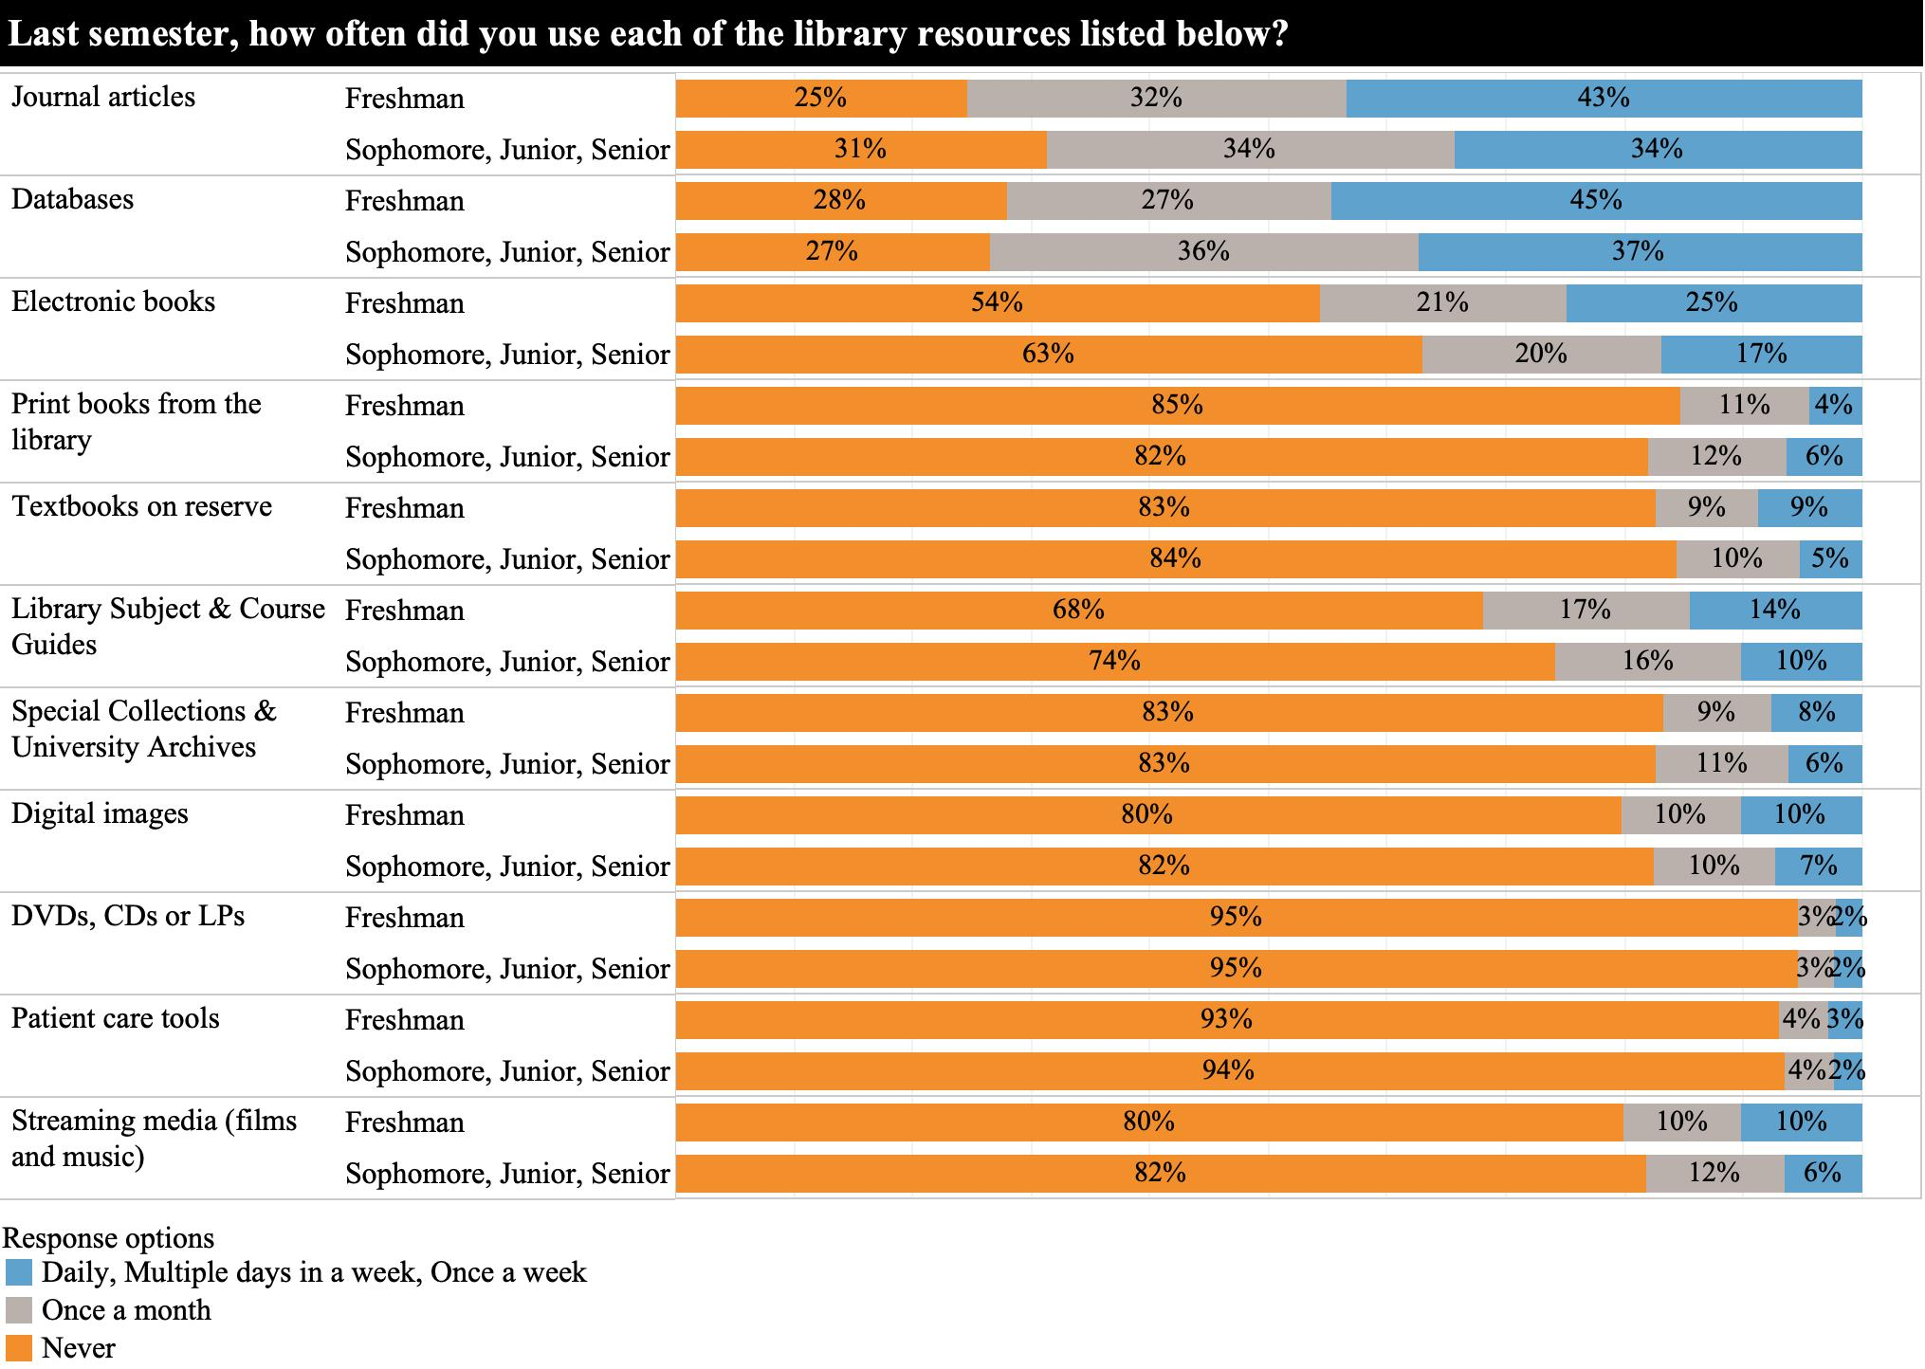

Figure 3. Students’ perceptions of library resources between first-year students and other undergraduates.
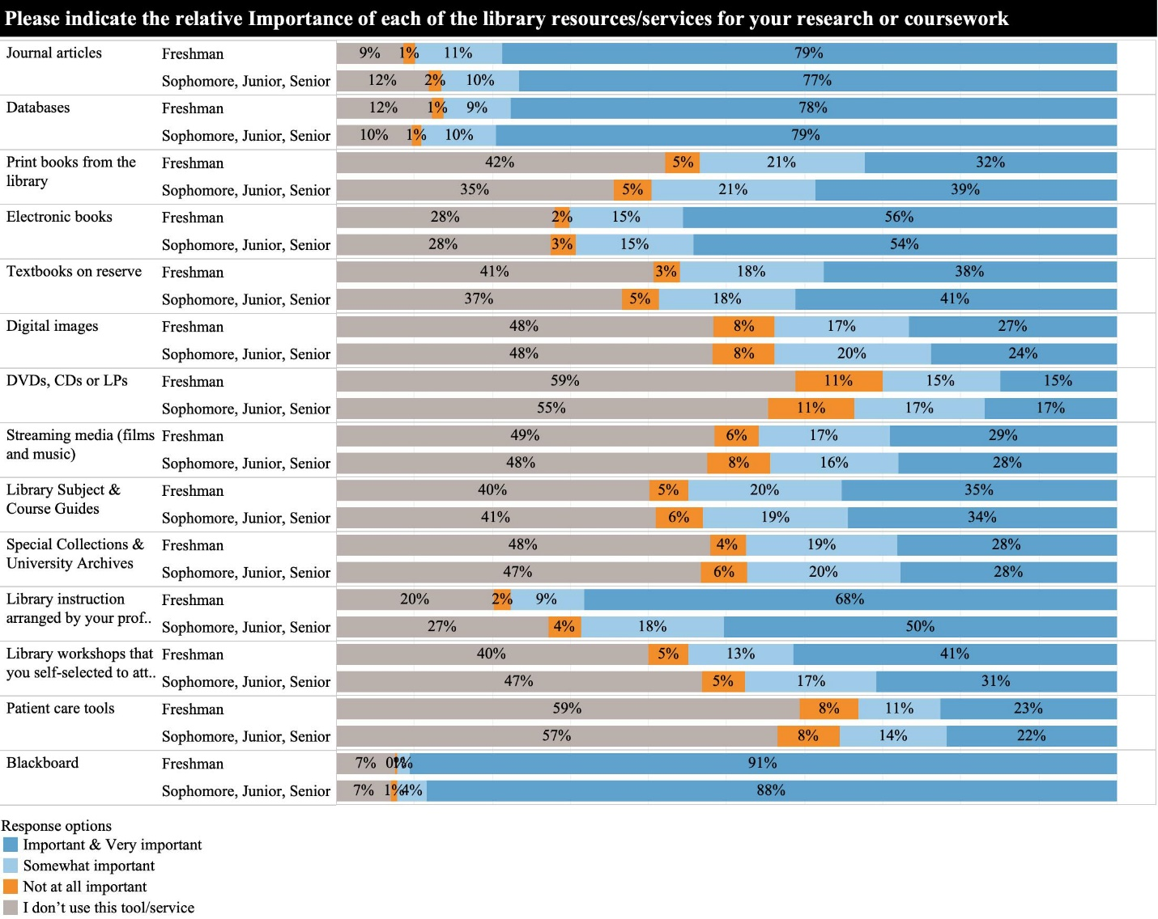

Figure 4. Students’ ease of library website use between first-year students and other undergraduates.
