Assessing User Experience: Incorporating Student Voice in Libraries’ Pandemic Response

Jung Mi Scoulas, ª* Elena Carrillo,^{b} and Linda Naru^{c}

ª Clinical Assistant Professor and Assessment Coordinator, University Library, University of Illinois Chicago, Chicago, USA; ^{b} Clinical Assistant Professor and Head of Access Services,
University Library, University of Illinois Chicago, Chicago, USA; ^{c} Associate Dean and Associate University Librarian for Administrative Services, University Library, University of Illinois Chicago, Chicago, USA

* Correspondence concerning this article should be addressed to Jung Mi Scoulas, jscoulas@uic.edu. Clinical Assistant Professor and Assessment Coordinator, University Library, University of Illinois Chicago, Chicago, IL 60607, USA
ORCID ID: https://orcid.org/0000-0002-7536-295X

Title: Assessing User Experience: Incorporating Student Voice in Libraries’ Pandemic Response

Abstract
This article demonstrates how a public research university library responded to user needs following radical service changes during Fall 2020 and assesses whether the library met challenges resulting from COVID-19. The library reduced hours and occupancy and implemented a reservation system and new health safety guidelines with the goal of a safe environment. During Fall 2020, 540 survey respondents reported feeling their health was not at risk, suggesting the goal was accomplished. Additionally, users provided feedback about the altered landscape. This article will benefit administrators and user experience librarians who need to balance user preferences and administrative reality.

Keywords: survey, user experience, COVID-19, university students, planning, assessment

Word counts: 5,915

Introduction

During June 2020, the University of Illinois Chicago (UIC) Library conducted student focus group sessions to help the library gain a deeper understanding of students’ perceptions of health and safety and to gauge their concerns about visiting the library. The key findings from the focus groups revealed concerns about physical distancing in the library, having sufficient cleaning supplies, and the implementation and enforcement of health safety guidelines (e.g., wearing masks) (Scoulas, Carrillo & Naru, 2021). During summer 2020, library administration and library reopening working groups used this feedback to develop reopening plans for the Richard J. Daley Library (Daley Library) and Library of the Health Sciences-Chicago (LHS-Chicago). Changes that were made due to COVID-19 and validated by the concerns raised through the focus groups included addressing distancing concerns by using an online reservation system, ordering and deploying personal protective equipment (PPE) at accessible locations in the library buildings, training and assigning compliance monitors, and communicating new policies through social media and library websites (Scoulas et al., 2021). The implementation of a “Wellness Ambassador” program and methods of communication were distinctly guided by focus group responses. For more information on how the library took action based on student feedback, please refer to the article by Scoulas, Carrillo, and Naru (2021).

After reopening, the UIC Library wanted to follow up with library users to assess their perceptions and experiences in the library and determine whether their needs were being met through a user survey continuously available throughout the Fall 2020 semester. In this article, the authors present the findings of these surveys, discuss how the UIC Library used the findings and the challenges encountered throughout the Fall semester and propose steps for preparing Fall 2021. This article will benefit library administrators, user experience librarians, and others involved with providing in-person services, planning, and decision-making who need to balance student preferences and complex administrative issues.

Literature Review

The protracted period of the pandemic created many challenges for libraries with regard to planning operations, services, resources, staffing, and budgets. To measure how libraries dealt with uncertainty and health concerns, some organizations conducted or published the results of surveys or other assessments. The Scholarly Publishing and Academic Resources Coalition produced the “SPARC Survey on Impact of COVID on Libraries” which primarily focuses on budget-related questions and anticipation of future investments on resources and services (Scholarly Publishing and Academic Resources Coalition, 2020). ITHAKA S+R also published the results of their library survey in “Academic Library Strategy and Budgeting During the COVID-19 Pandemic” which presented similar data focusing on questions of decision-making, budget allocations and cuts, acquisitions, and other COVID management issues (Frederick, & Wolff-Eisenberg, 2020). Despite the availability of so much data, however, little has been shared about the detailed process of how libraries respond to users' needs, implement changes, and tackle the challenges experienced during this unprecedented time.

User Experience before COVID-19 in the University Library

COVID-19 has significantly impacted the operations of libraries in higher education. Like other libraries, UIC Library had to quickly adapt to an online learning environment with limited face-to-face interactions while continuing to serve the university community through informational and instructional services.

Before discussing how the UIC Library made changes during COVID-19, it is important to provide a description of users’ attitudes, perceptions, behaviors, and preferences prior to the pandemic. Since 2016, the UIC Library has conducted biennial surveys to identify students’ needs and expectations and to learn the value of the library on their academic success. The findings were used for decision-making and improvements over the years and in some ways informed the Library plan for reopening in Fall 2020 after a period of COVID-19 lockdown from March to July 2020.

Key findings from previous surveys showed that the services students valued most were 24-hour access, group study rooms, and open and flexible collaborative space. The primary use of the library was for studying, accessing library resources for research, and working on coursework. The median value of undergraduate student in-person visits was “multiple days in a week” whereas their online use was only once a month. Graduate students reported the opposite: their median value of in-person visits was once a month whereas online visits were multiple days in a week. Additionally, library use positively impacted students’ academic grade point average (GPA), suggesting that the more frequent use of library resources, the higher their GPA (Scoulas & De Groote, 2019). In the open-ended questions, students indicated that being able to choose a specific type of space for their academic and learning needs (collaborative open space, group study rooms, quiet zones, etc.) was an important factor in positive outcomes for their performance on coursework. Students also expressed their desire for longer study stretches in the library to be facilitated by the installation of microwaves and more food vending machines so that they would not have to leave the building to get snacks or meals.

During COVID-19 in the University Library

Due to COVID-19, the University Library’s physical buildings were closed on March 29, 2020. Reference services continued to provide online assistance remotely through already-established chat and email services. When planning to reopen the libraries for Fall 2020, the University Library sought users’ feedback about their feelings and concerns regarding returning to campus. In June 2020, the Library conducted 12 focus groups with a total of 56 university students. In the focus groups, participants were asked about their health safety concerns, ways to encourage peers to follow safety guidelines (e.g., wearing masks), strategies for monitoring health safety, and whether they planned to return to campus. Findings from the focus groups revealed that users had concerns about physical distancing, sufficient personal protective equipment (PPE), staff monitoring and the use of contract security to enforce guidelines, and clear communications regarding the new norms (Scoulas et al., 2021).

The University Library incorporated users’ feedback into reopening plans. It provided a booking reservation system, reorganized and reduced the number of seats to address physical distancing, and assigned library employees to monitor compliance. The Library communicated the new norms through email, social media, and internal and external signage. For more information on the process of conducting these focus groups and for a complete analysis and implementation of the findings, please refer to a previous study published in the Journal of Library Administration (Scoulas et al., 2021).

This article follows up on the implementation of the new health safety guidelines at the UIC Library during reopening. It discusses the process and result of conducting regular surveys throughout Fall 2020 semester to assess whether users’ preference and needs were being met.

Methods

Project goal

The goal of the assessment described in this article was to measure how users perceived radical library service changes during the Fall 2020 semester and whether the libraries met challenges resulting from the COVID-19 situation. By conducting monthly surveys regarding user experiences, the library assessed what was working, areas needing improvement, and where it could try to be flexible in addressing space needs or accommodating unique requests while still maintaining safety protocols.

This article discusses the following questions.

  - How do users perceive their overall experience in the university libraries after implementing new policies during COVID?
  - How has the University Library used the assessment findings throughout the semester?
  - What are the challenges the University Library encountered?
  - How will the University Library prepare for Fall 2021?

Context

The UIC is a public research university with more than 33,000 students enrolled in 16 colleges. The University includes two locations in Chicago; Daley Library and LHS-Chicago, a law school, and two additional regional health science locations. This article focuses only on the Chicago library locations as the regional campuses and the law school follow their own local guidelines. Also, 90% of the University student populations use the Chicago libraries.

Only 10% of the students enrolled live on campus. Because the majority of students don’t live in the residence halls, they need spaces to go between classes while on campus, and the library has typically supplied this space. During the Fall 2020 semester, for a myriad of reasons including limited on-campus teaching, reduced occupancy for social distancing, and barriers potentially created by the new protocols, the gate count numbers plummeted (Figure 1).

[Insert Figure 1 here]

The significant decrease in gate counts for Fall 2020 reduced the number of users who could potentially respond to surveys deployed by the University Library. As shown in Table 1, for the Fall 2020 semester, total gate counts at both Chicago libraries were 9,485 and 2,472 users, representing about 1% of the usual user traffic (Figure 1).

[Insert Table 1 here]

Survey instrument

The survey was initially developed by the Assessment Coordinator. It was revised based on feedback from the Assessment Coordinator Advisory Committee and the Monitoring Compliance Working Group which was one of several groups planning for reopening the libraries. The instrument included five questions to identify the status of the primary users (students, faculty, or staff); their preferred library and which spaces they used the most; their reasons for visiting the library; their overall experience in the library; and whether the library provided accommodations for those with a disability. The survey also provided an open-ended question for any additional feedback. To view the survey, please see the appendix, which provides the complete set of questions that was sent to potential users.

Data collection

The survey was available via multiple channels including the library website and social media throughout the Fall 2020 semester. Due to a low response rate, every month the Assessment Coordinator retrieved the list of students who reserved space at either the Daley Library or LHS-Chicago from the online library space reservation system (Springshare’s LibCal) and sent the survey directly to their university emails. A student who made multiple reservations in a month received only one email from the University Library. The survey was emailed to 3,658 users during this period. A total of 540 respondents completed the survey; the overall response rate was 15%.

[ Insert Table 2 here]

Data analysis

Data from Qualtrics were exported and analyzed in Excel. Given that operations were slightly different based on library locations, data were analyzed and reported separately to provide useful information for improvements and decision-making. Any responses that indicated “no,” “not at this time,” “not that I’m aware of,” or “none” were excluded from the further analysis. When analyzing the open-ended data, the Assessment Coordinator used thematic analysis--interpreting the patterns of the meaning in the qualitative data—for each library location. For Daley Library, ten categories were initially generated from the responses. For LHS-Chicago, 14 categories were initially generated from the responses. In both locations, new categories emerged every month and the six most frequent categories are presented in this article.

Compensation
Users who completed surveys were eligible to enter their contact information to win a $20 e-gift card. Three winners received gift cards via their email each month during September, October, and November 2020.

Results

Respondents
Almost all the respondents (99%) completed the survey from email messages; only 6 out of 540 completed the survey via links from social media. A total of 540 participants completed the survey throughout the Fall 2020 semester. Among them, 76% respondents were from Daley Library.

[Insert Table 3 here]

About users, spaces, primary reasons for visiting, and accommodations

Overall, most respondents in Daley Library (94%) and LHS-Chicago (87%) were students. The most used space in Daley Library and LHS-Chicago was the 1st floor. Each library has four floors and in each library, the third floor was the least used space throughout the Fall 2020 semester. Participants indicated that the top reasons for visiting the library were studying, homework, or research projects (Figure 2). More than 80% of respondents (82% in Daley Library and 87% in LHS-Chicago) did not need any accommodations due to a disability. When accommodations were needed, most of their needs were met; however 4 users in Daley Library and 1 in LHS-Chicago responded that their accommodation requests were not met.

[Insert Figure 2 here]

Overall experiences: Daley Library and LHS-Chicago.

Users were asked to rate their overall experience in the library by indicating their level of agreement with 9 statements:
- I was able to reserve a space easily.
- I was able to find my reserved seat easily.
- There were enough cleaning supplies (e.g., sanitizers and wipes).
- I feel my health is not at risk in the library.
- I feel the library is clean.
- The building hours worked with my schedule.
- Expectations in the library are clear to me (e.g., wearing masks at all times).
- It seems that everyone is following the health safety guidelines in the library.
- My experience with library staff and security personnel was positive.

Daley Library
As shown in Figure 3, many respondents (more than 90%) rated “strongly agree” or “agree,” in most areas. Among them, the most positive ratings (96%) were in the areas of users feeling not at risk in the library and that the library was clean. In the month of November 2020, 100% of respondents rated both agree and strongly agree in the area of feeling that the library was clean.

More than 10% of the respondents rated “disagree” and “strongly disagree” in the area of building hours (21% disagree or strongly disagree), sufficiency of cleaning supplies (10% disagree or strongly disagree), and, early in the semester, 10% of respondents reported difficulty in finding their reserved seat easily.

In two areas -- reserving a space easily and finding reserved seats -- there was a significant increase in positive responses over time, suggesting that users who visited the library more than once were likely to have mastered the complexity of the new reservation system.

[Insert Figure 3 for Daley Library]

LHS-Chicago
As shown in Figure 4, similar to Daley Library, over 90% positive ratings indicated that users felt that the library was clean, that their health was not at risk, and that everyone was following the guidelines in the library.

At the beginning of the semester, 17% percent of participants reported that they strongly disagreed with the statement “My experience with library staff and security was positive.” The library hours did not work with the schedule of 23% of the respondents, and 18% of respondents in October and 16% in November thought the cleaning supplies were not sufficient.

There were areas that improved over time, including reserving and finding reserved seats, experience with library staff, and the feeling that users were following the guidelines.

Similar to Daley Library regarding finding reserved seats, improved ratings over time suggests users who visited the library more than once were more likely to become familiar with the reservation system. A dramatic increase in the positive percentage of participants reporting about their experience with library staff indicates that users and staff became more comfortable with changes in the library protocols.

[Insert Figure 4 for LHS-Chicago]

Further feedback: Daley Library and LHS-Chicago.

Daley Library. A total of 134 participants from the Daley Library provided further feedback in response to: “Are there any other comments or suggestions for what could improve your experience in the library?” Please note that any responses that indicated “no,” “not at this time,” “not that I’m aware of,” or “none” were deleted from further analysis. Student feedback was grouped by categories and the frequency of each category expressed is presented in Figure 5.

The largest number of respondents provided feedback about wanting to have extended hours, such as weekends or late nights. The next highest number of comments were related to positive experiences such as being satisfied with the current library system, appreciating the library staff and faculty, and expressing that the library is the only place that students can study. The third highest responses were about the reservation system. Examples include:
- making it easier to find seats
- clear instructions for booking a seat
- wanting to know which seats are close to an electrical outlet
- being able to book reservations in advance
The respondents provided space-related feedback including the desire to have rooms for meetings, taking online classes and exams, and for group study (online learning challenges). Respondents also commented that they wanted more cleaning supplies in the PPE stations and for sanitizers to be in more visible spaces. Some respondents expressed that they would like to be allowed to bring food and drinks into the library. Other feedback included users wanted the Library to allow moving furniture, remove the reservation system, display clearer signage on the main door of the library, provide in-house campus computer center technical support service for personal devices as well as library equipment (to ensure computers and printers are working), and open more entrances for access.
[Insert Figure 5 here]

LHS-Chicago. There were 49 respondents who completed the survey to provide further information in response to: “Are there any other comments or suggestions for what could improve your experience in the library?” Figure 6 presents the overall open-ended responses from LHS-Chicago. Respondents wanting to reserve their seats for more than 4 hours was the most common feedback in LHS-Chicago. Some commented that the library space reservation system was difficult to use and they wanted to reserve a seat more than 24 hours in advance. The second highest feedback pertained to the perception that getting in the library seemed complicated and discouraged use. Respondents suggested a “speed check-in” with QR codes or self check-in kiosks. Comments related to extended hours on weekends and after 8 p.m. during weekdays, were recorded as the third highest. The respondents expressed positive experience with staff and appreciation for the library continuing to be accessible during COVID-19, but also wanted staff to be friendlier and more flexible when users make mistakes. Respondents asked for more accessible sanitizers or wipes near study desks, tables, as well as near the copier/scanner, and clearer signage indicating where to find it. Other feedback asked for more scanners, access to books and journals on the 2nd floor, a curbside pick-up service, more supervision of users not wearing masks, and permission to bring food and coffee into the library.

[Insert Figure 6 here]

Discussion

The goal of the current project is to assess how users perceive radical library service changes during the Fall 2020 semester and whether the libraries met challenges resulting from the COVID-19 situation. In this section, the authors will also report how the findings were disseminated and used.

Internal communication about users’ responses was critical. The Assessment Coordinator regularly reviewed and analyzed the survey data and presented the preliminary findings to various stakeholders such as department heads and managers and Library faculty throughout the Fall 2020 semester. The goal of each presentation was to address any issues that were raised by the survey results and discuss implementing suggestions for changes and improvements when practical. Open-ended responses were also shared with the Library’s public services staff throughout the process so they would be aware of concerns that should be addressed immediately. The findings were also regularly presented to department heads, comparing how users’ experiences changed on a monthly basis. This led to discussions about what improvements could be made and a number of changes were implemented. A final report was shared with all University Library employees in January 2021 to let them know how the users experienced the library during their first full semester under COVID-19.

Key findings showed that users’ most positive experience in both locations was feeling that the library was clean and that their health was not at risk. This feedback is unusual in comparison with previous survey findings which reflected negative feedback on library facilities (Scoulas & De Groote, 2019). The authors speculate that the Library’s efforts to keep the facilities clean were recognized by the users, which resulted in positive feedback in the current survey. Given that the primary goal of reopening was to make the library as safe and clean as possible during the pandemic, this finding suggests that this goal was accomplished.

Another highlight was that the users’ experience significantly improved over time regarding easily reserving a space and finding reserved seats. In both locations, more than 92% of the users positively reported that the expectations were clear to them and they felt that everyone was following the guidelines.

Changes made based on the feedback

Issues immediately addressed. Library staff responded to several user requests during fall semester by providing additional sanitizing stations. The Library changed the reservation system to allow users to book up to 8 hours total per day instead of the original 4. The system was also modified to allow users to book seats on the first floor more than 24 hours in advance. A time-buffering feature that had been creating confusion and difficulty for users was removed. Signage was improved by creating large and uncluttered signboards to clarify expectations for entering the libraries, adding QR codes to help users quickly access URLs for booking seats and displaying online verification that they completed the university-mandated daily health check. Graphics communicating library protocols (such as what items are not permitted in the library) were updated to be clearer and simpler (Figure 7 and Figure 8).

[Insert Figure 7 here]

[Insert Figure 8 here]

Data collected during Fall 2020 was also shared with a Library working group charged with reviewing the data from an equity perspective using rubrics developed in September 2020. The goal is to determine whether further changes might be needed for services based on an equity lens. An early accommodation was made at Daley Library to place a publicly available computer at the entrance of the Library for users who did not have technology to book seats or had difficulty accessing the booking system from their phones. Other changes resulting from recommendations for more inclusiveness were improving signage on the exterior of Daley Library to direct people with physical accessibility issues to the single entrance and providing staff with clear masks to better communicate with users who read lips. Service points were also provided with thermometers for health screenings and extra masks to help users meet compliance requirements for building access.

Issues considered but not possible to implement

The University Library wanted users to be provided with the best learning environment, balancing their requests with the restrictions created by both the health safety guidelines and the limitations on the number of staff who were available to monitor compliance. Throughout the process, the libraries had to determine whether the number of requests were enough to consider making changes and whether changes would diminish the effectiveness of the health safety measures already in place.

The desire for extended hours was a common theme for both library locations. Other themes for Daley Library included opening group study rooms and allowing eating and drinking in the libraries. LHS-Chicago users were more focused on easier access to the building and availability of cleaning supplies. But the three issues consistently requested throughout the semester revolved around hours, group study, and food.

Extended hours. Prior to the pandemic, both Daley Library and LHS-Chicago were open 140 hours a week, including weekends and overnight hours. After reopening in the Fall of 2020, Daley Library reduced its hours by more than half and eliminated weekend hours. LHS-Chicago similarly reduced its hours although it maintained some Sunday hours.

The most frequent negative user feedback was related to library hours. Findings showed that among the 9 statements about overall experience, more than 17% respondents rated “disagree” or “strongly disagree” with the statement “the library building hours worked with my schedule.” Additionally, the open-ended responses revealed that users requested the libraries to open longer hours at both library locations. There were 50 students who requested changes in Daley Library, and 6 students who requested changes in LHS-Chicago. In response, Daley Library planned to offer weekend hours during final exams. However, due to a surge in COVID-19 cases in Chicago and a concern for further increases or potential lockdown measures, it was decided in the interest of health safety that the library should continue to limit hours and access. Another reason that the libraries did not offer extended hours was the disproportionate amount of resources required to keep the buildings open compared to the anticipated low number of users who would be using them. The number of users on campus each day was a fraction of the normal numbers: almost all classes were online only and staff in academic support units such as advising and tutoring worked remotely. And based on past experience, the library was not certain whether users requesting extended hours would actually use them. Building occupancy throughout Fall 2020 demonstrated that although the peak occupancy was about 50 in Daley Library throughout the day, neither library had more than 10 users at closing time on average throughout the semester, and sometimes had none at all (See Table 1).

Group study rooms. Findings from open-ended responses revealed that users requested the libraries open the group study rooms which were closed due to health safety management. Before COVID-19, group study rooms were one of the most used library spaces, popular with students working on projects and doing collaborative work (Scoulas & De Groote, 2019). Even after face-to-face classes transitioned to online learning, users still wanted to use these study spaces for privacy in attending classes, meetings, and for participating in employment interviews. They also wanted to continue to work in the collaborative style they had been accustomed to.

Similar to the issues with whether to increase the extended hours, the University Library had to consider if this change was feasible. However, not having enough staff to adequately monitor compliance with health safety in terms of cleaning, and a concern that users in these spaces would not respect the social distancing guidelines made reopening these spaces impractical.

Eating and drinking. Prior to COVID-19 users had no restrictions related to eating and drinking in the library which was a significant factor that enabled them to stay longer in the building and concentrate on their work through mealtimes. Findings from a 2018 survey showed that students wanted microwaves for their food and more vending machines (Scoulas & De Groote, 2019). Microwaves were installed in 2019 to meet these requests. Daley Library also has a café on the first floor which normally is open and provides coffee and snacks.

Due to health safety concerns, the University Library prohibited users from eating food and drinking from disposable containers in the library during COVID-19. The café in Daley Library was shuttered and the microwaves were removed. The vending machines were also disabled. Although users consistently requested to be allowed to eat and bring outside beverages into the buildings, the University Library was not able to accommodate these requests because of the riskier behavior involved such as taking off masks and potentially spreading the virus through disposables.

Overall, most users had a positive experience in the libraries, and the University Library was able to immediately address issues related to the reservation system, signage, and more cleaning supplies. However, user requests for longer building hours, access to group study rooms, and allowances for food and drink in the libraries were not implemented after thorough consideration and discussion by the Library management group.

Future Considerations for Both Libraries

A campus announcement stating a full return to on-site learning for Fall 2021 was disseminated in February 2021, and will serve as the foundation for Fall 2021 planning for the Libraries. In previous years, a biennial survey helped the Libraries take the pulse of student satisfaction, concerns, and suggestions for improvement of library services and spaces. For 2021, it was decided to incorporate the 9 statements used in the monthly survey described in this article into this single survey, distributed in February. This was done to avoid survey fatigue while still collecting data to compare the experiences of users from Fall 2020 to Spring 2021. The comparative data will help inform library management in their discussions.

Currently the University Library is planning in a vacuum. Despite careful planning for Fall 2020, the libraries had to remain flexible to meet the challenges of a constantly changing environment. As we plan for Fall 2021, it is critical to continue to engage the students and incorporate their feedback as much as it is realistic to do so. Unknowns over which we have no control are based on state or local mandates and guidelines: testing, vaccination rates, occupancy changes, limits on group meetings, what in-person services will be available on campus, etc.

Results of the survey could impact the direction of planning, matching campus expectations for being fully-reopened with user concerns about health safety. A series of focus groups is planned for the first week of May 2021 to gather information from students about their expectations for services for Fall 2021, similar to what was done for Fall 2020. There will be an emphasis on focusing on students who enrolled as freshmen in the 2020/21 academic year and commuter students because understanding their specific concerns and needs returning to campus or coming to campus for the first time are critical. The primary goal is for the University Library to encourage students to come back to campus and to enhance their learning experience in a hybrid environment.

Conclusion

As the University Library plans for Fall 2021, it is apparent that there is not enough conclusive information to make final decisions; and yet planning must proceed. So many variables can impact decision-making: state directives, vaccines and variants, how many users will be returning to campus, the fears students may have, and more. The climate is going to change, and whatever the situation is, the Library will continue to consult users in order to balance their requests and this reality.

In spite of not being able to fulfill all of the users’ requests for services in Fall 2020 and Spring 2021, the Library’s efforts were appreciated. Users expressed gratitude to the Library for inviting them to the focus groups and for making space and services available. The Library was explicitly identified as one of the only places on campus where students felt safe and could study while most of the buildings were closed.

The pandemic--and what hopefully will be a post-pandemic environment--will likely continue to take the libraries through a series of evolutions. Library administration will have to be prepared to persistently and rapidly adapt in a sustainable way. Throughout any operational changes, the University Library will focus on users’ academic success and will continue efforts to collect feedback and engage with users. It will be an ongoing challenge to balance these user expectations and preferences particularly with students who remember the culture of the libraries pre-COVID-19. The goal, nevertheless, is to make the user experience positive and welcoming, and to continue to help users succeed in their academic performance. Other libraries’ leadership teams can find value in asking for and incorporating or addressing user feedback during these challenging times. This dialogue between administrators and users can also increase users’ confidence that the libraries support an inclusive environment in which their voices are heard.

References

Scholarly Publishing and Academic Resources Coalition (SPARC) (2020). Impact of COVID on Libraries. https://survey.alchemer.com/s3/5985664/SPARC-2020

Frederick, J. K., & Wolff-Eisenberg, C. (2020, December 9). Academic Library Strategy and Budgeting During the COVID-19 Pandemic: Results from the Ithaka S+R US Library Survey 2020. https://doi.org/10.18665/sr.314507

Scoulas, J. M., Carrillo, E., & Naru, L. (2021). Student Voice in Administrative Decision-Making: Inclusive Planning during the Pandemic. Journal of Library Administration, 0(0), 1–18. https://doi.org/10.1080/01930826.2021.1906554
Scoulas, J. M., & De Groote, S. L. (2019). The library’s impact on university students’ academic success and learning. Evidence Based Library and Information Practice, 14(3), 2–27. https://doi.org/10.18438/eblip29547

Acknowledgement

Reopening libraries during the pandemic was a challenge for the University Library. Overcoming this difficult time would not have been possible without library employees’ collaboration and strong commitment to the University of Illinois Chicago community.

Figure 1. Total gate count numbers per semester between Fall 2017 and Fall 2020 at Daley Library and LHS-Chicago

Figure 2. Primary Reasons for Visiting the Libraries

Figure 3. Overall experience in Daley Library (n= 410)
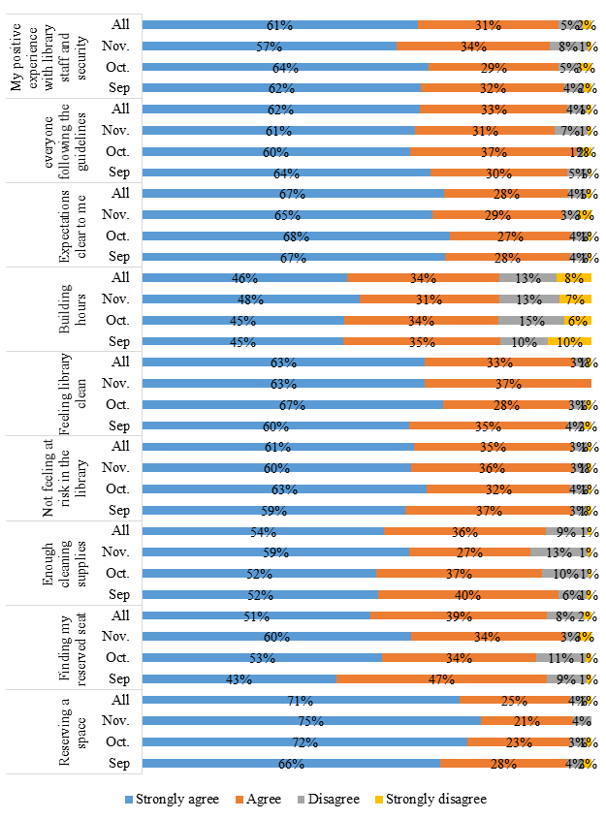

Figure 4. Overall experience in LHS-Chicago (n= 130)

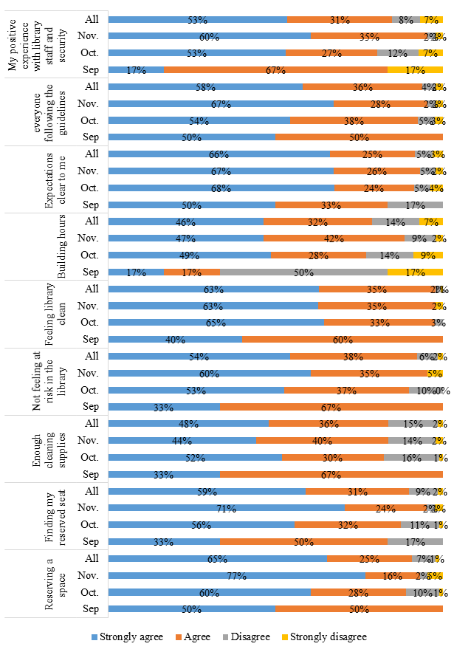

Figure 5. Most frequent feedback in Daley Library (n=134)

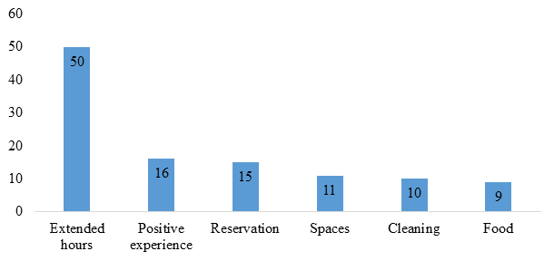

Figure 6. Most frequent feedback in LHS-Chicago (n=49)

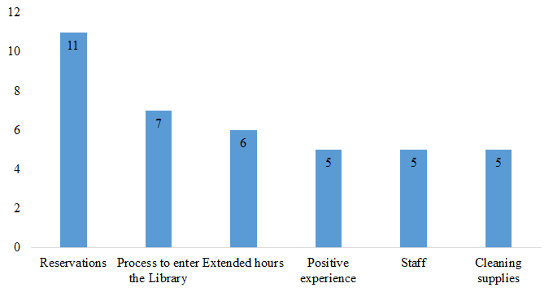

Figure 7. Original Signage

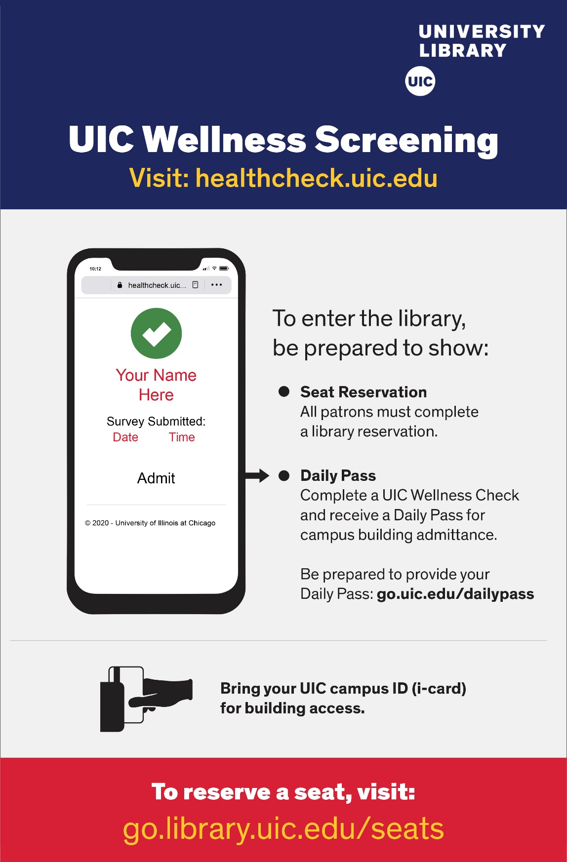

Figure 8. Changed signage
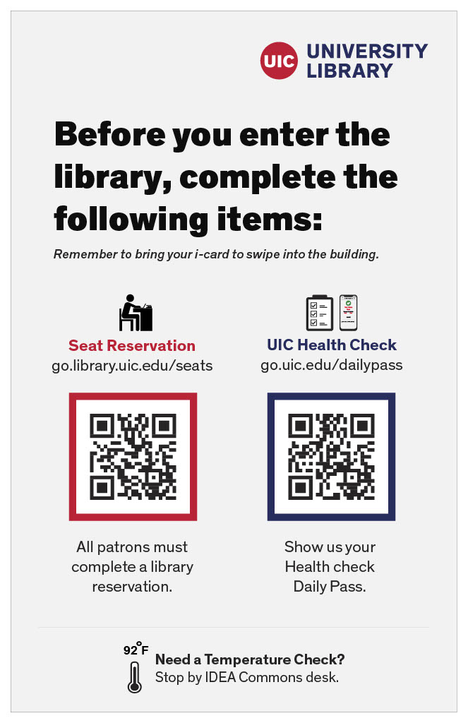

Table 1. Average Weekly, Daily and Hourly Counts in Daley Library and LHS-Chicago

 | Avg. Weekly Counts | Avg. Daily  Counts | Avg. Hourly Counts | Avg. Peak Counts
Daley Library | 673 | 137 | 10 | 52
LHS-Chicago | 165 | 34 | 2 | 14
Data from August 24 -November 23, 2020

Table 2. Monthly email distribution to users at Daley Library and LHS-Chicago

Email Distribution | Sep. | Oct. | Nov. | All
Daley Library | 974(74%) | 1,050 (75%) | 698 (74%) | 2,722
LHS-Chicago | 342 (26%) | 350 (25%) | 244 (26%) | 936
Total (Daley Library+ LHS-Chicago) | 1,316 | 1,400 | 942 | 3,658

Table 3. Monthly Responses at Daley Library and LHS-Chicago

 | Sep.ª | Oct.^{b} | Nov.^{c} | All ^{d}
Daley Library | 149 | 163 | 97 | 410
LHS-Chicago | 6 | 81 | 43 | 130
Total (Daley Library+ LHS-Chicago) | 155 | 244 | 138 | 540
Responses during ª8/24~9/30; ^{b}10/1~11/1; ^{c}11/2~11/30; ^{d}8/24~12/7

Appendix: Survey Questions for Users

The following letter and subsequent questions were disseminated in the survey sent out in August of 2020:

Dear Students, Staff and Faculty,
Thank you for visiting the UIC library. Please take a moment to complete this survey. We would like your feedback on your experiences in the library. Your feedback will be valuable for making improvement and supporting your needs.
If you would like to participate in the lottery, please enter your contact information. Your personal information is not linked to your responses. Three winners will be selected each month during September, October and November, 2020.
If you have questions about this survey, you may contact [Contact Information].
Thank you,
UIC Library

Q1 Have you visited the UIC libraries (Daley Library or LHS-Chicago) during Fall 2020?
- Daley Library -1st floor
- Daley Library -2nd floor
- Daley Library -3rd floor
- Daley Library -4th floor
- LHS-Chicago - lower level
- LHS-Chicago -1st floor
- LHS-Chicago - 2nd floor
- LHS-Chicago - 3rd floor
- None of the above

Q2 How was your overall experience in the library? Please indicate your level of agreement with each of the following statement.
 | Strongly agree | Agree | Disagree | Strongly disagree
I was able to reserve a space easily.
I was able to find my reserved seat easily.
There were enough cleaning supplies (e.g., sanitizers)
I feel my health is not at risk in the library.
I feel the library is clean.
The building hours worked with my schedule.
Expectations in the library are clear to me (e.g., wearing masks at all times)
It seems that everyone was following the health safety guidelines in the library
My experience with library staff and security was positive

Q3 Please tell us about any issues that you encountered in the library.
________________________________________________________________

Q4 What is the primary reason you visited the library?
- Pick up books
- Use printers
- Use spaces for online classes
- Use spaces for studying, homework or research project
- Other. Please specify: ________________________________________________

Q5 If you required any accommodations due to a disability, were your needs met?
- My needs were met
- My needs were not met
- I did not need any accommodations

Q6 Please tell us more about any issues you encountered with respect to accommodations.
________________________________________________________________

